# Form 3: Methodology

**1. Team No: 1**5

**2. Project Title:** Efficiency & Security in Blockchain: A Voting Consensus Strategy

**3. Proposed Method:** blockchain-based voting system:-

Step-1: Research and Install Necessary Technologies

Step-2: Design the Voting System Architecture

Step-3: Develop Smart Contracts for Voting

Step-4: Implement a User Interface

Step-5: Deploy the System

Step-6: Documentation and Community Engagement

**4. Proposed Method illustration:**

**1)**In the simple E-method voting system the database can be tampered by database

Administrator

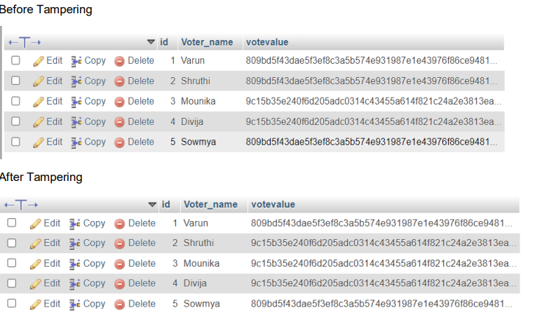

**2.)** To Overcome this we are using block chain created voting system environment  
 **3.)** create the block chain based voting

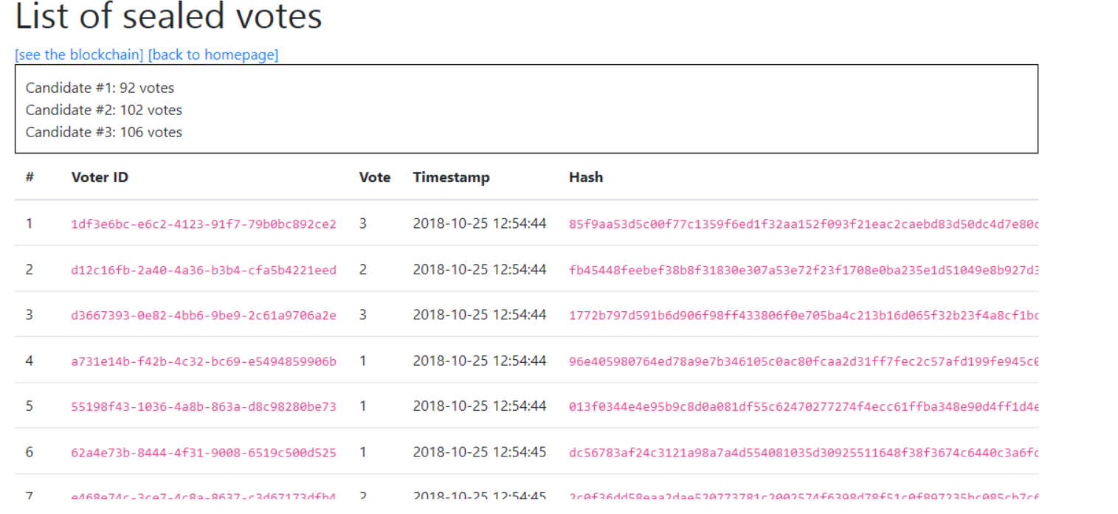

This are the sealed votes in the block chain environment

**4.)**If the database administrator tries to tamper any block then issue raises like

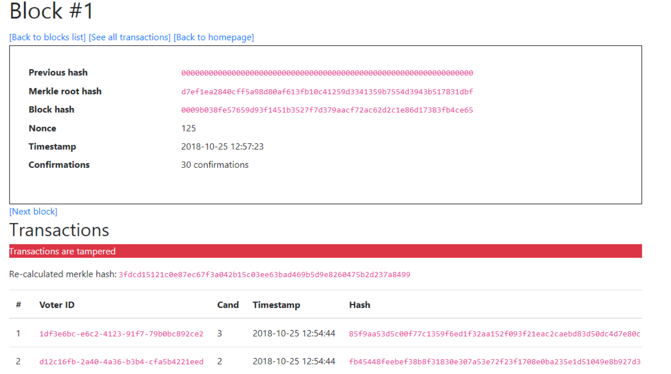

**5. Parameter Formulas:**

1. **Registration and Verification**:

Number of Registered Voters (N): Total count of individuals who have registered.

Verification Rate (V): Percentage of registered voters successfully verified.



1. **Blockchain Account Creation:**

**Account Creation Success Rate (A): Percentage of voters who successfully created a blockchain account.**



1. **Voting Process:**

**Voter Turnout (T): Percentage of registered voters who actually voted.**



**Blockchain Transaction Rate (B): Rate of successful blockchain transactions for vote casting.**



1. **Vote Validation and Counting:**

**Valid Votes (VV): Number of votes that are validated and counted.**

**Invalid Votes (IV): Number of votes that are rejected during validation.**



**Signature Team Members Signature Supervisor**

**1. (Dr. Pallam Ravi )**

**2.**

**3.**