EXP.NO:1

Step-1: Go to zoho.com and sign in or sing up.

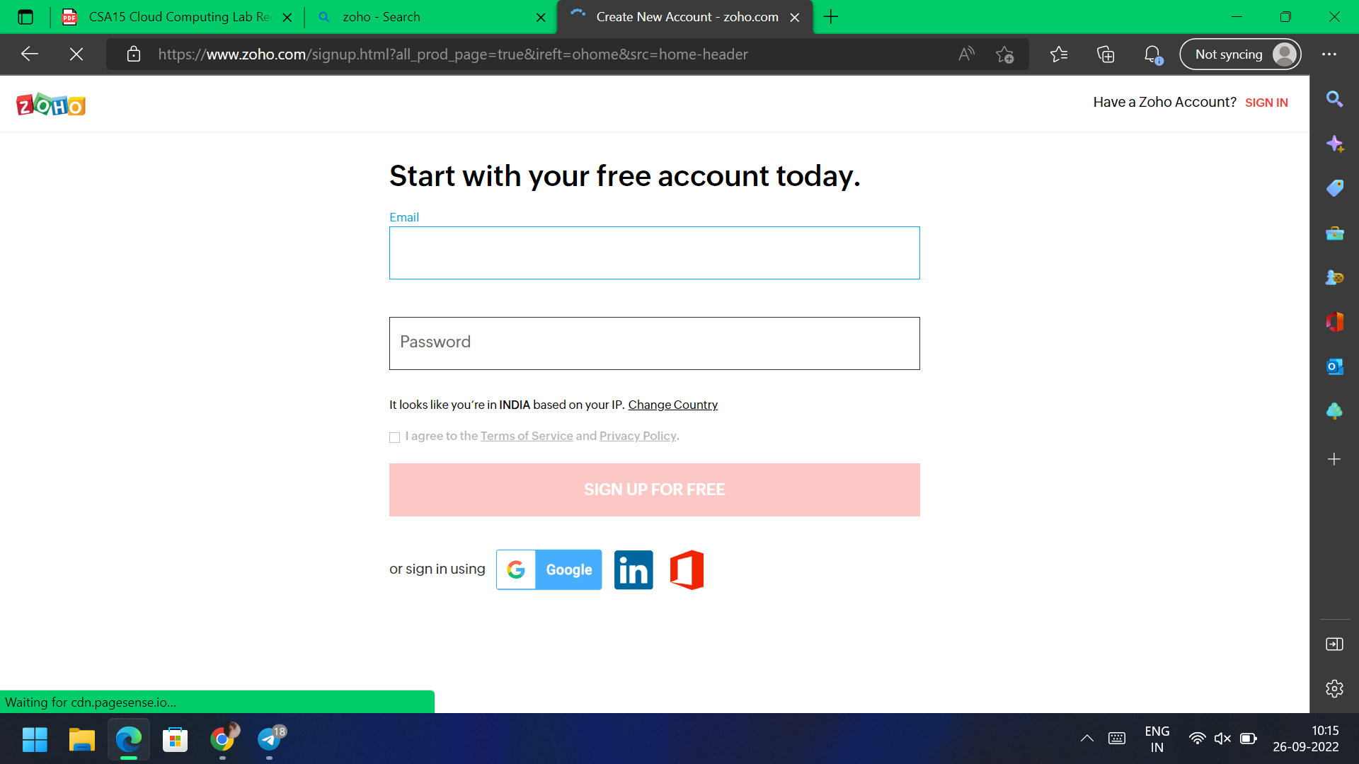

Step-2: Go to creator section.

Me 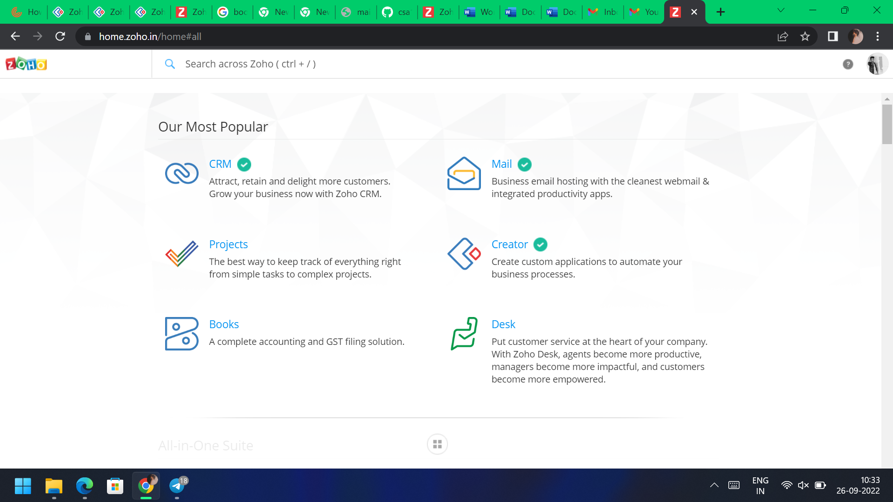

Step-3: Click on create new application and name application.

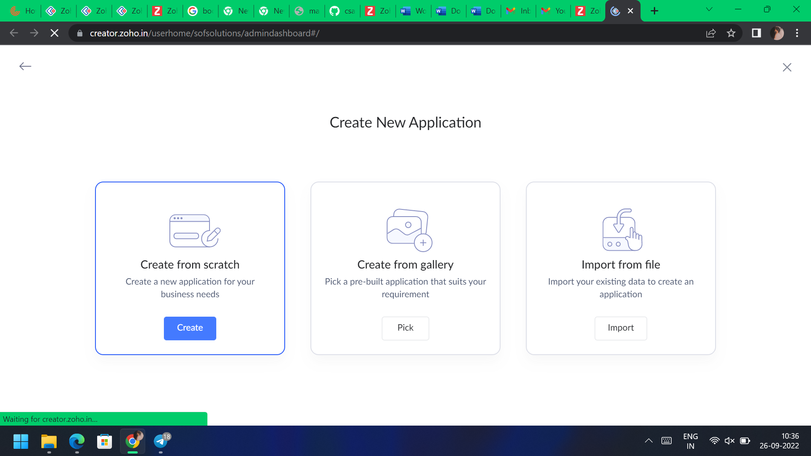

Step-4: Add new forms and templets as per the application.

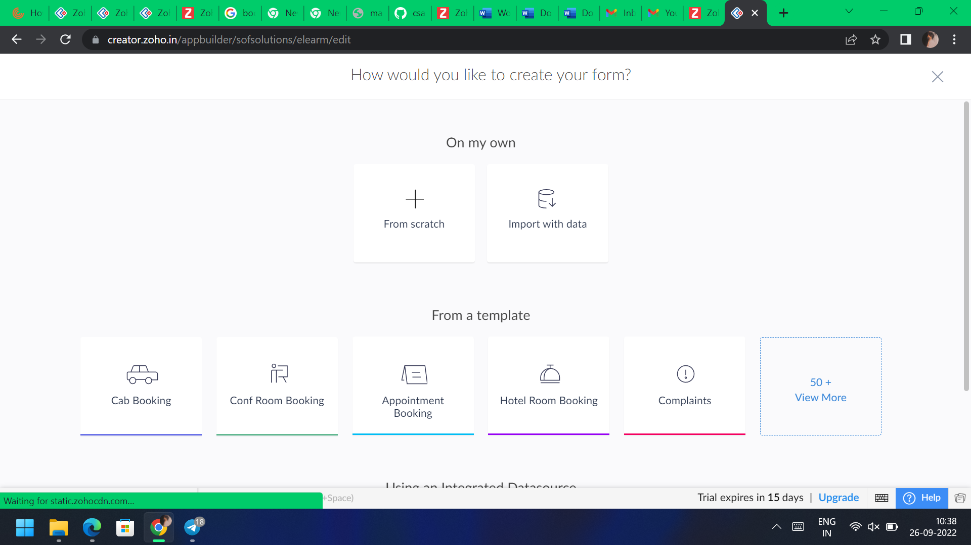

Step-5: Click on access application and check it.

Outputs:

