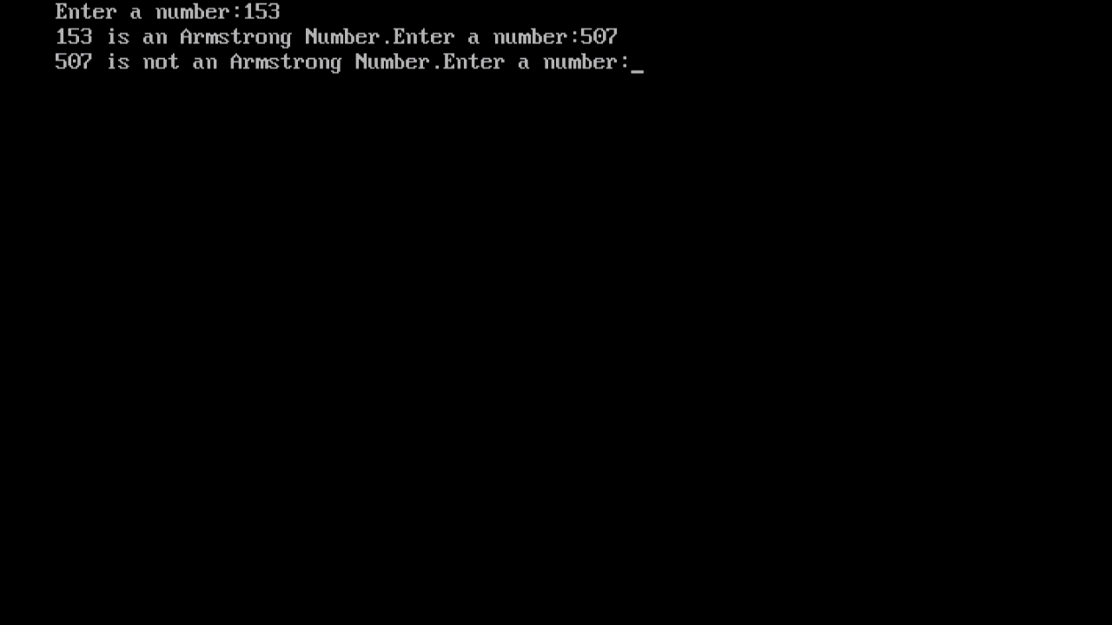

#include<stdio.h>

void main()

{

int num,x,t,sum=0;

printf("Enter a number:");

scanf("%d",&num);

t= num;

while(t!=0)

{

r=t%10;

sum=sum + r\*r\*r;

t=t/10;

}

if(num==sum)

{

printf ("%d is an Armstrong Number.", num);

}

else

{

printf ("%d is not an Armstrong Number.", num);

}

}