What is git and github?

GIT 🡪 Global information tracker

Git 🡪 It is a open source environment where used to deploy code globally and build a code project with team members by remotely. Git here we have repositories to store our data. In git we can store our local machine files in remotely and can access it globally. The main concept of git is to store our progress in cloud and access it globally. In git we have HTTPS and SSH to store and access our data. If we keep our repo as public anybody can access the files if we keep it as private only the admin can access the files.

GITHUB- It is a cloud based platform. Here github is one of the application of git to store our data globally. In github only we have Https and SSH. Here we write the code in vscode or gitbash and after connecting it with remote link. We can see that files in github repository. GITHUB is mainly a cloud based platform to store the data and can be able to access it globally.

What is CVCS and DVCS ?

Create a project of any and push the project?

To create a project in github here first we need to dump that file in vscode. Orelse need to create a new file in VS code.

Created a gitexam as project name and written code in it saved as gitexam.py in vscode

Not in terminal this steps has been written

>> git init

>> git add .

>> git commit -m “exam”

>> git branch

>> git remote add origin ”link https/ssh”

>> git push -u origin main

After successful insertion now referesh in git hub repo

Create 3 branches and 5 tags?

Here if we want to create branches we need to go to github and select one repository where we need to create branches

No select branch ruleset first and select what are the rules need to be applied first next open repository and we can see branch option in that click on branch and create new branch.

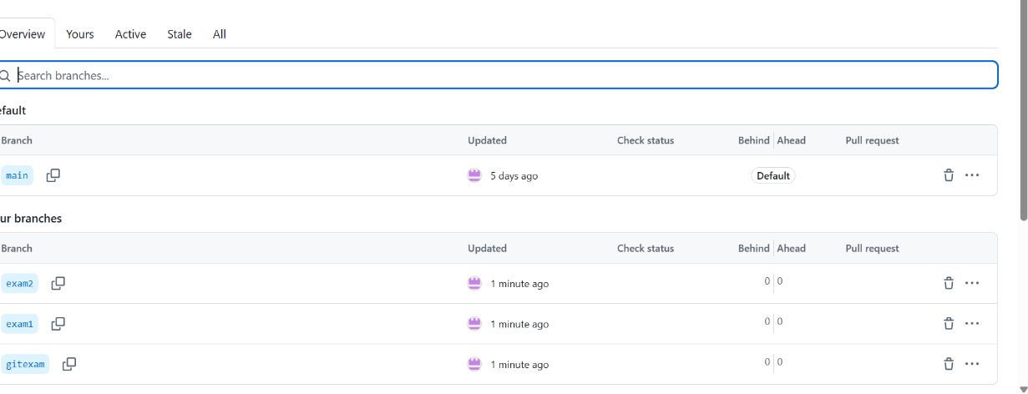

Tags-Tags are used to highlight the commits in a project

Create of tags here we can create tags as same as branches here first we need to set ruleset of tags.

Now click on the repository where tags need to be created. Click on tags and give tag name add descrption add click on realease now.

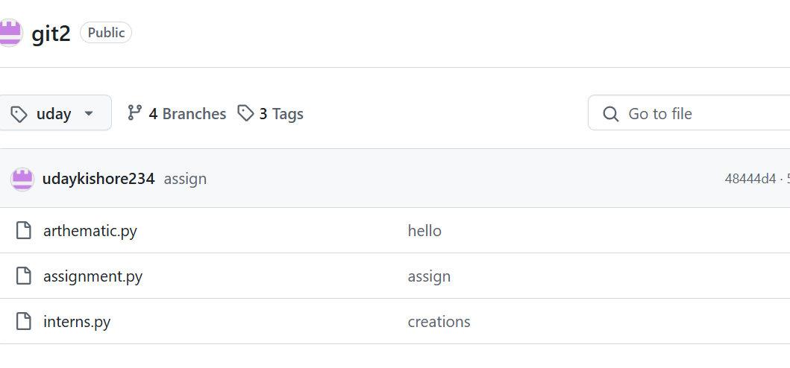

What is the importance of git merge?

Git merge is used to merge the different branches in same repository. Here this merge concept is main used when we have a main branch and subbranch. So here comes the merge command to merge the branches .

What is Linux and how is it different from other operating systems?

Linux 🡪 Linux is a open source operating system. It is developed by Torvalds in the year of 1993.

It is mainly used by the developers and Hackers because this operating is completely different from the general purpose windows operating system. In windows we have mouse to operate but in linux we need to operate it completely using commands itself. It is difficult to operate but it is easy once we are familiar with it. Linux is a most secured os because by using this os no body can hack into our systems. Here the main difference is this os is open source and free of cost. It uses very less storage place to compared to others.

In this linux have 3 users ROOT user, source user, admin user.

Widows os is very easy and normal person can also use windows os for general and business use. But this linux it is hard to understand but easy to use.

What are the basic Linux commands for file operations?

Commands🡪

ls- to know the directories

mkdir- to create a new directory

touch filename – create a file

echo “huvsagvdsf”> filename – inserts data in the file

Explain the basic features of the Linux OS.

Linux operations are fast compared to other os. We can manage or update all the system tasks with commands itself. It is more secured and reliable compared with windows. In windows there is a fear of losing files by windows crash. But in linux no fear of it.

What are the major differences between Linux and Windows?

|  |  |
| --- | --- |
| Linux | Windows |
| It is a free and open source | It is a paid version |
| It is maintained by kernel | It is maintained by CPUs |
| It has GUI and CLI | It has only GUI |
| The files are stored by using forward slash / | The files are stored by using backward slash \ |
| It is more secure | It is less secured |

What are the most important Linux commands?

Directory creation

>>mkdir name

File creation in it

>> touch file name

Adding data in it

>> echo “data”> filename

To see how many directories and what data in it

>>ls

To see the present directory

>> PWD

TO remove a directory

>> rmdir

To remove a single file from one directory

>> rm filename

How do you create,remove and copy files in linux?

Create a file in linux

First need to create a directory or use the existing directory

>> mkdir name

Or cd name

>>touch filename

Remove a file

rm filename

copyfile

cp filename

what is ssh?

SSH – secure shell