Skin Disease Detection and Classification Using Deep Learning Algorithms

Software requirements
• Programming Language : Python, Colab
• Packages : Numpy,Matplotlib, Tensorflow, Pandas, Flask Framework,Keras
• Tool : Python 3.7

Framework

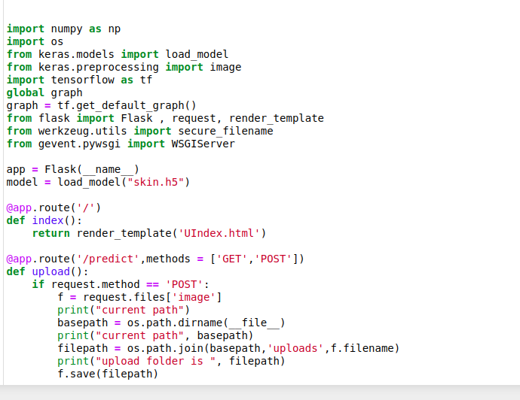
Localhost
In cmd - python app.py

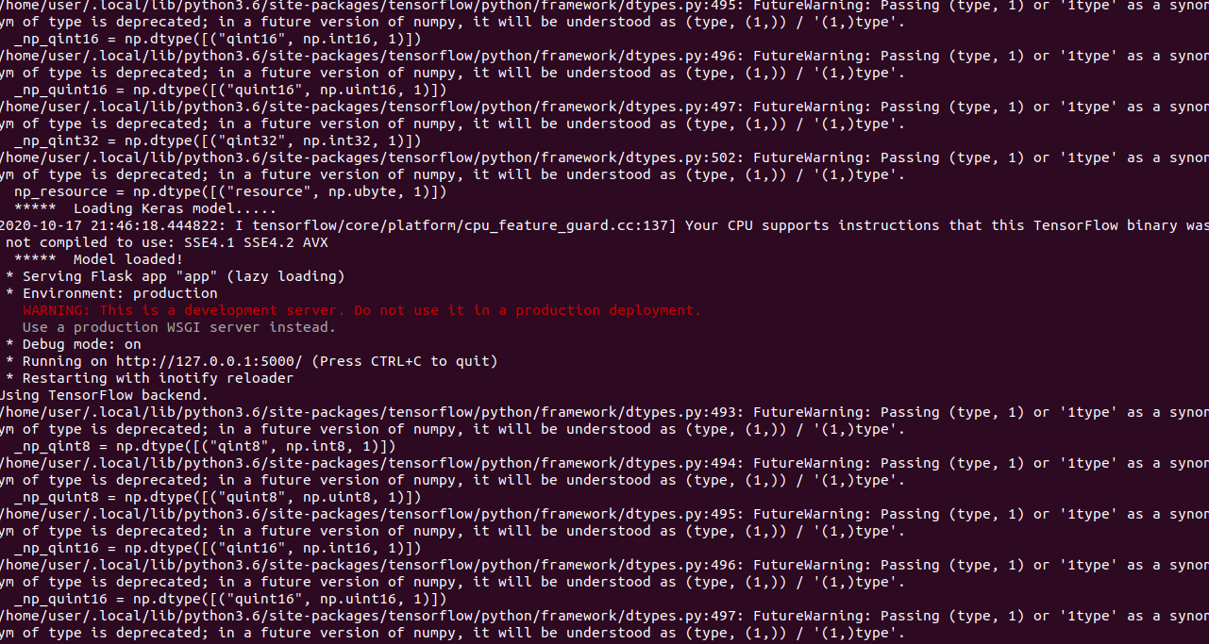

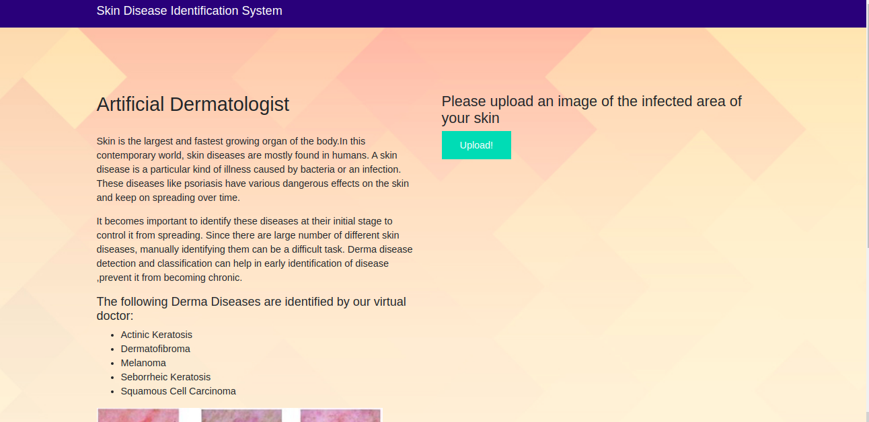

Artificial Dermatologist

Skin is the largest and fastest growing organ of the body.In this contemporary world, skin diseases are mostly found in humans. A skin disease is a particular kind of illness caused by bacteria or an infection. These diseases like psoriasis have various dangerous effects on the skin and keep on spreading over time.
It becomes important to identify these diseases at their initial stage to control it from spreading. Since there are large number of different skin diseases, manually identifying them can be a difficult task. Derma disease detection and classification can help in early identification of disease ,prevent it from becoming chronic.
we are collect 5 images it contains img1-actinic keratosis, img2-dermatofibroma, img3-melanoma, img4-seborrheic keratosis, img5-squamous cell carcinoma

The following Derma Diseases are identified by our virtual doctor:
- Actinic Keratosis
- Dermatofibroma
- Melanoma
- Seborrheic Keratosis
- Squamous Cell Carcinoma
Upload an image using upload button

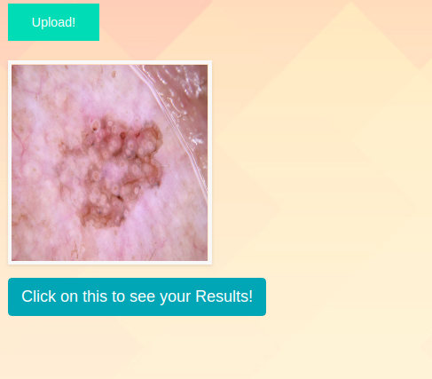
Click for results
