1. Create a SQL Database and Create a Table to work with

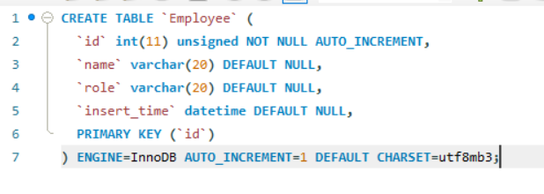

C:\Users\inn909\OneDrive - Innover Digital Private Limited\Pictures\Screenshots\Screenshot 2024-07-11 115024.png

1. Create pom.xml file with all the required dependencies

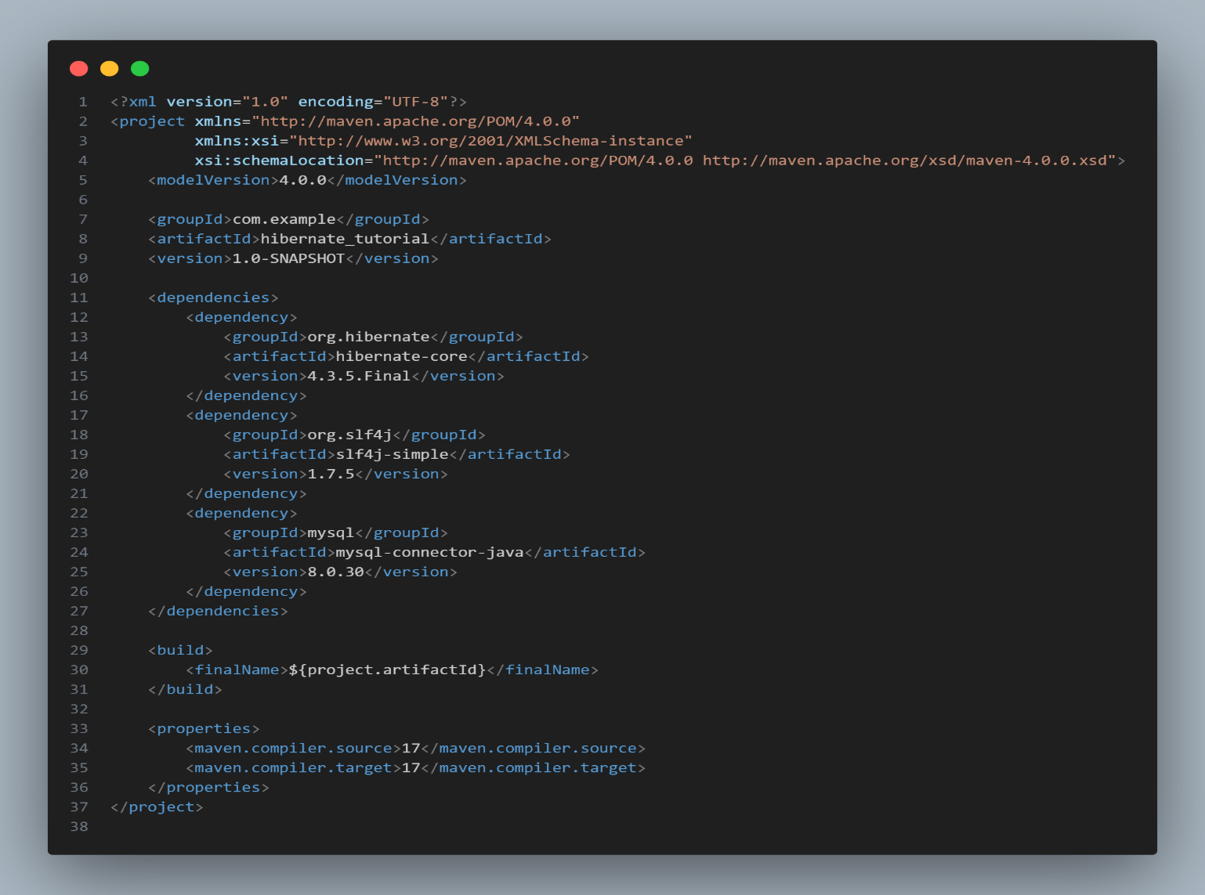

1. Creating the Persistent Class

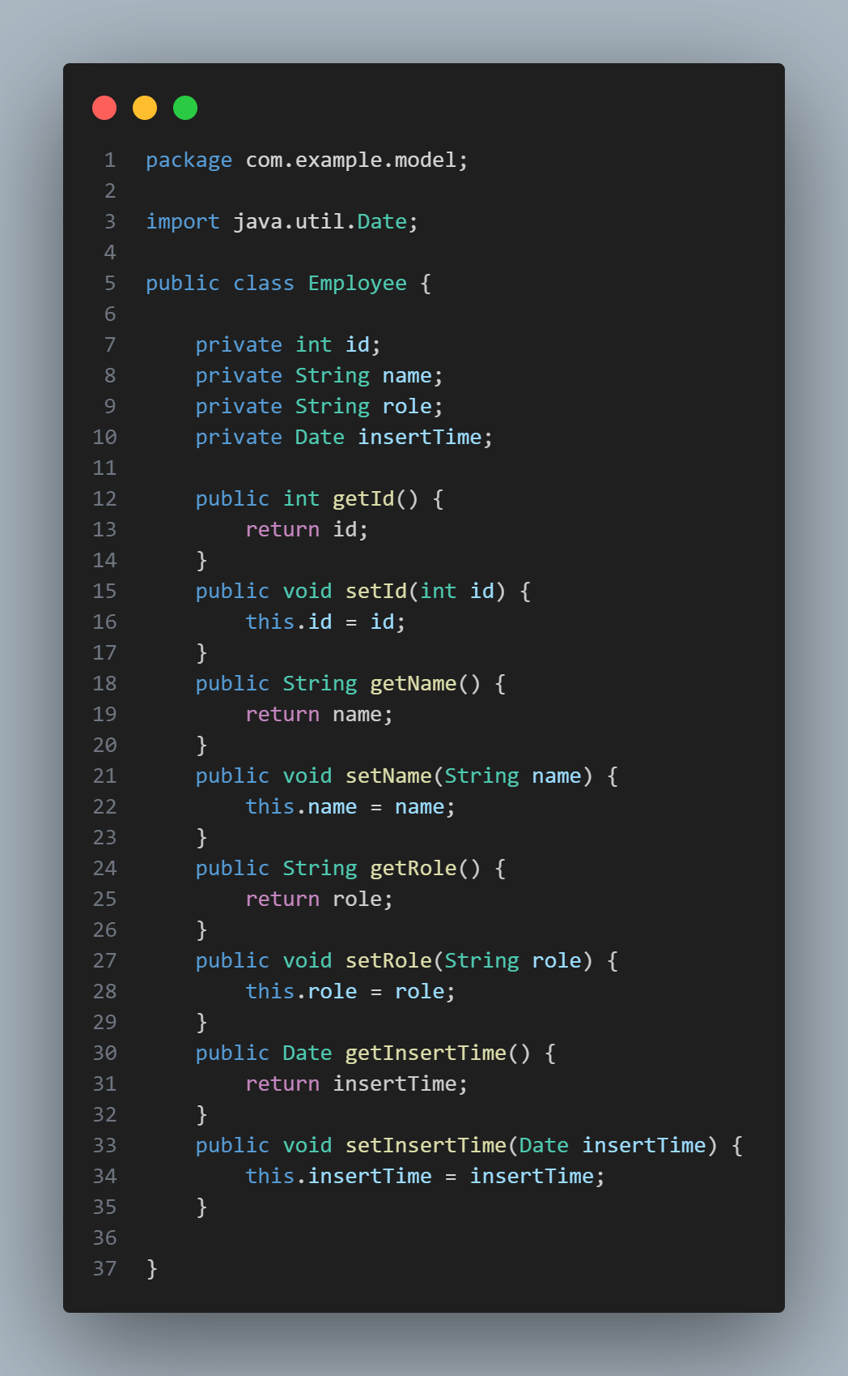

1. Create the Mapping file

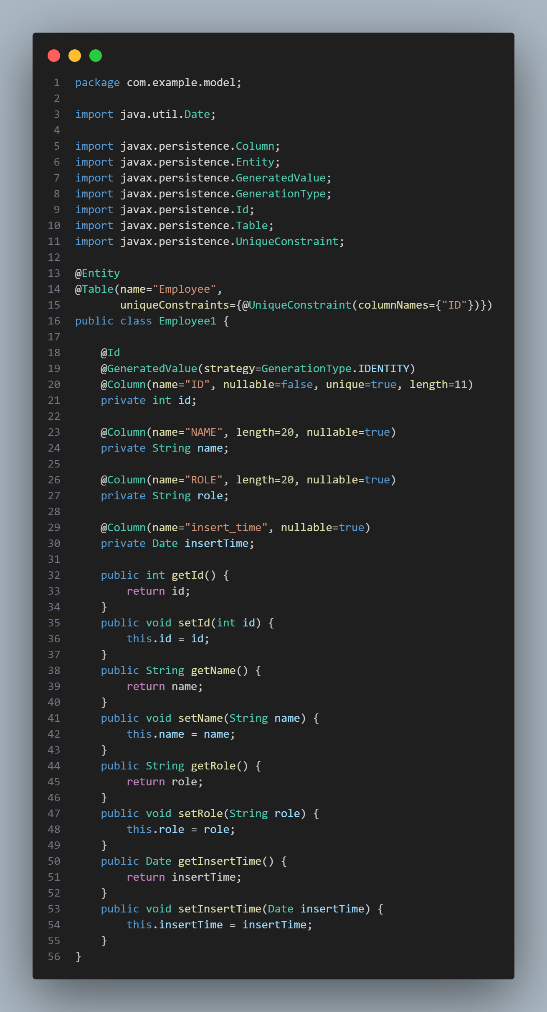

1. Create the Mapping file “employee.hbm.xml”:

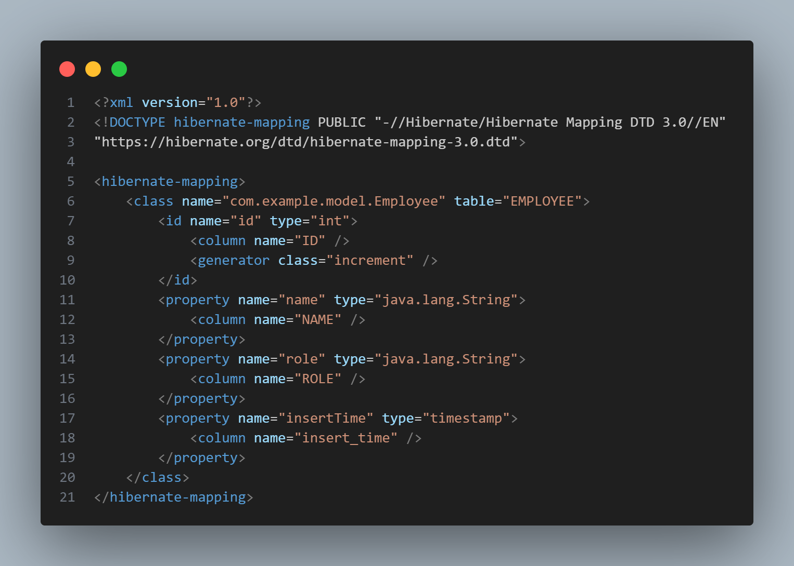

1. Create the configuration file “hibernate.cfg.xml”:

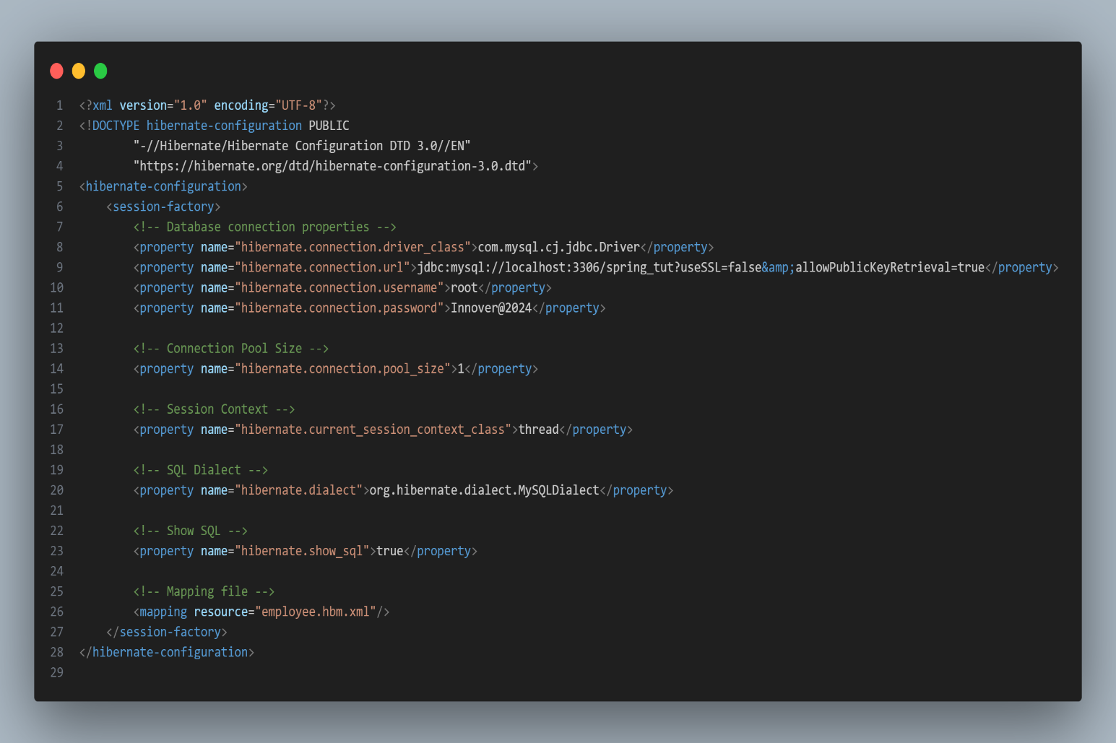

1. Create the Utility Class:

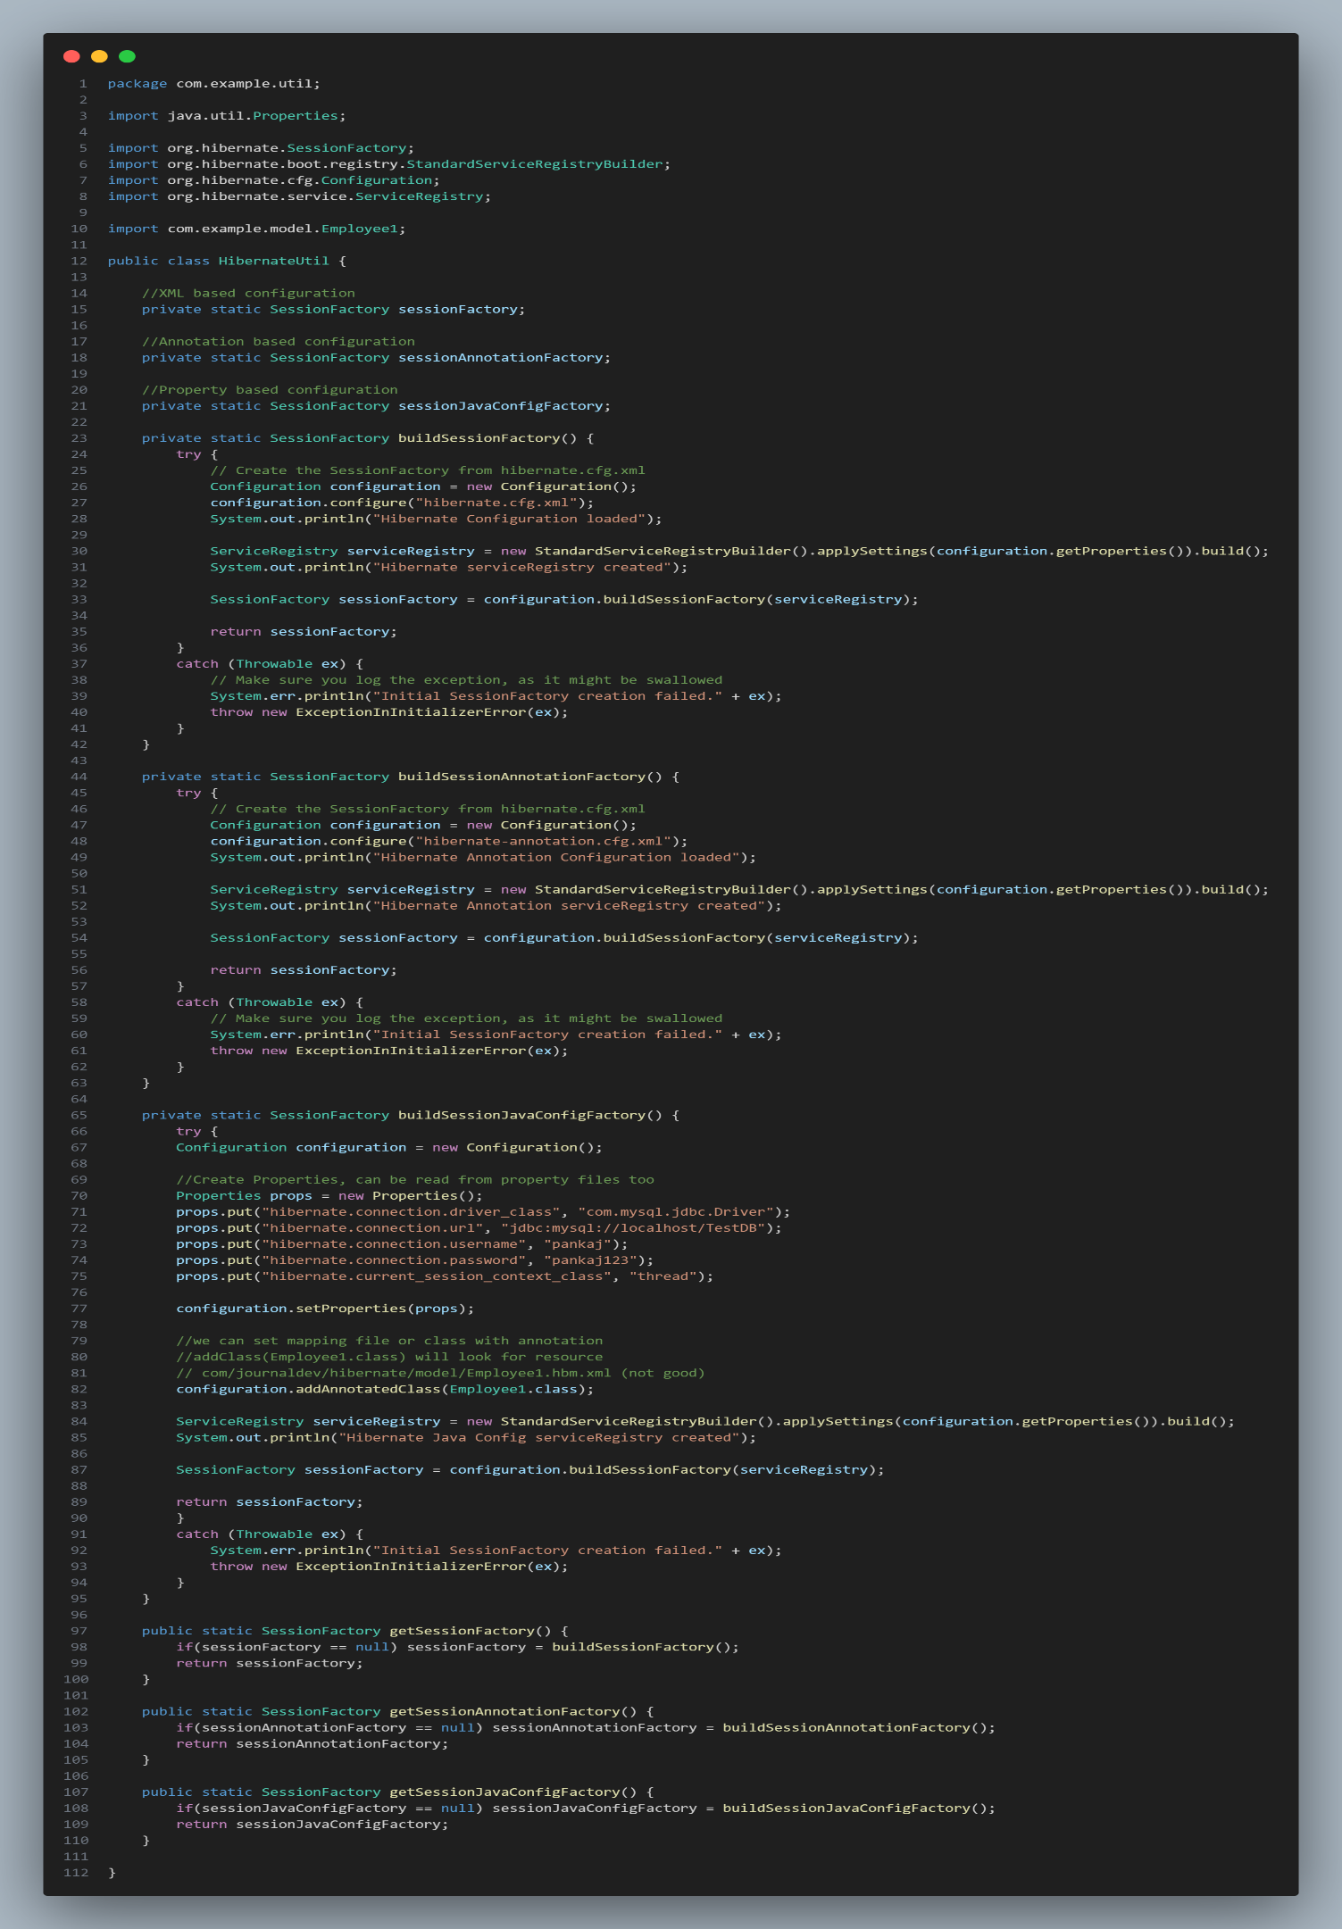

1. Create the Main Class for CRUD operations:

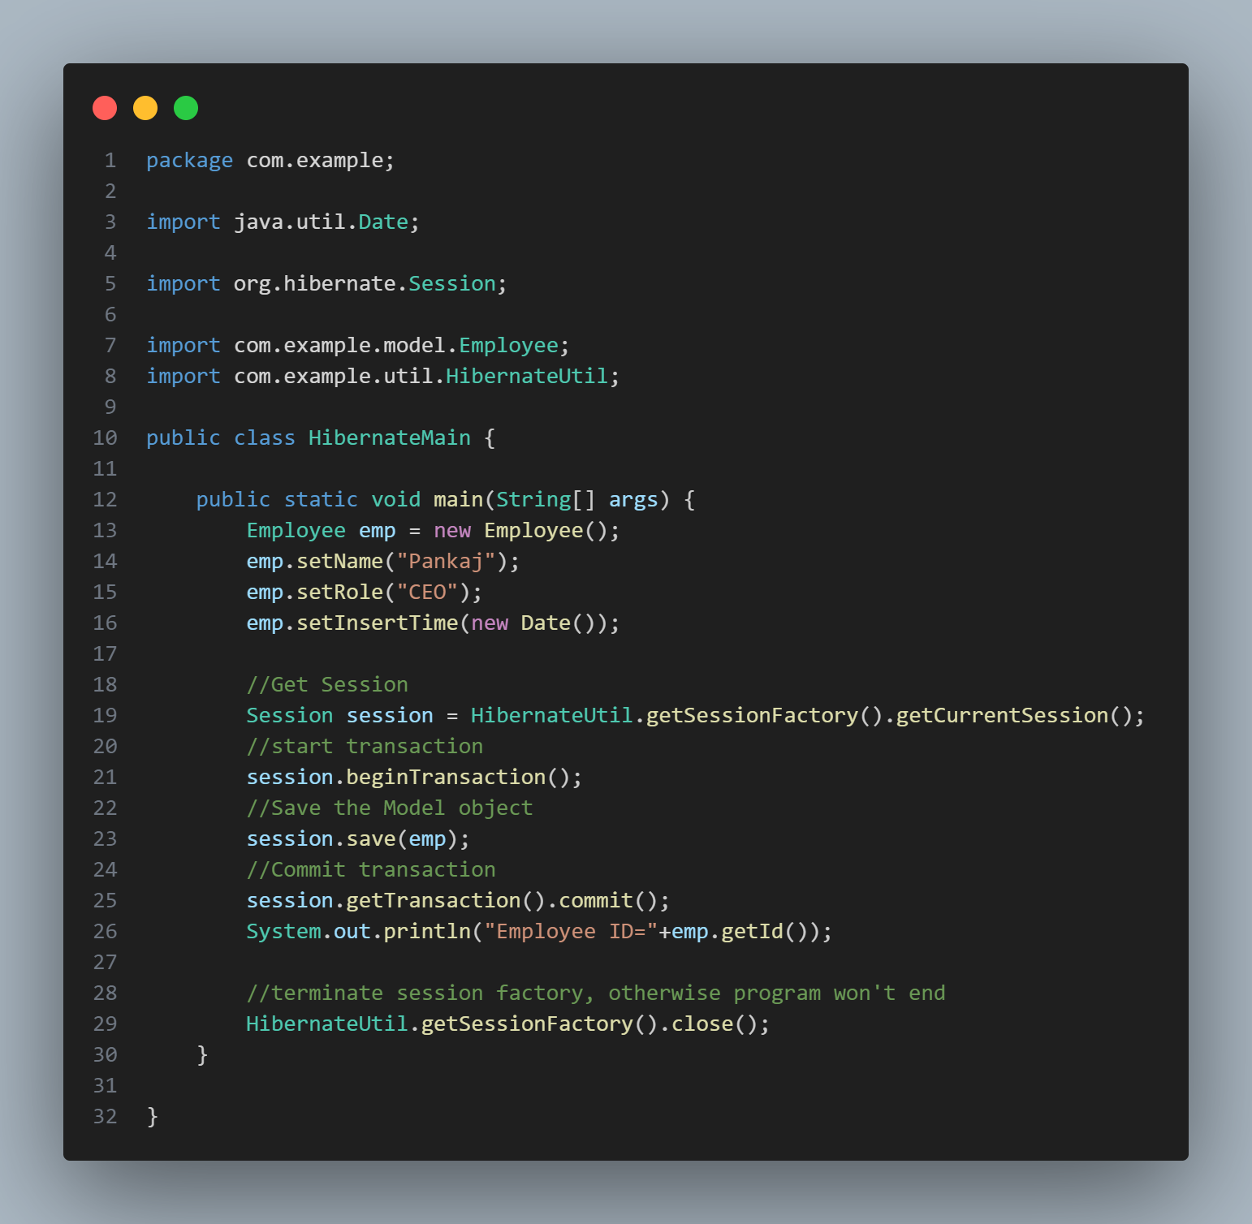

1. Running the application:

