Chapter 1
Introduction

This project aims to create an engaging web-based tool for automated image captioning by harnessing cutting-edge artificial intelligence models and accessible modern frameworks. The application uses the BLIP (Bootstrapping Language-Image Pre-training) model, a state-of-the-art neural network developed by Salesforce, to generate detailed and contextually relevant captions based on visual input. By integrating this model into Streamlit, the project delivers an intuitive interface where users can upload images and receive descriptive captions in real time.​The intersection of vision and language AI has opened new possibilities for visually impaired assistance, digital asset management, e-commerce, and educational technologies. This project not only showcases the potential of multimodal AI systems but also demonstrates the benefit of deploying such models in real-time, interactive web applications, making advanced AI solutions widely accessible through simple browser-based interactions.​

1.1 Background and Motivation
With the growing volume of visual content generated daily—from social media posts to product photos and educational material—there is an increasing demand for tools that can automatically understand and describe images. Manual captioning is labor-intensive and inconsistent, particularly at scale.
Automated image captioning systems address this problem by leveraging AI to generate human-like descriptions of images. These systems are particularly valuable for:
- Improving accessibility for visually impaired users.
- Enhancing content searchability and organization.
- Reducing time and cost in digital media workflows.
- Increasing user engagement on content-driven platforms.
The motivation behind this project is to democratize access to advanced captioning technology by creating a publicly accessible, easy-to-use web interface that harnesses the latest developments in vision-language

1.2 Project Objectives
The main objectives of this project are:
- To build an interactive web application for generating image captions.
- To implement the BLIP model for high-quality image-text understanding.
- To enable real-time inference with GPU acceleration (when available).
- To ensure smooth performance through model caching and efficient image handling.
- To demonstrate practical applications of AI in fields like accessibility, content tagging, and media archiving.

1.3 Key Features
Some of the key highlights and features of this application include:
- Real-time caption generation with fast image processing.
- Support for multiple image formats with drag-and-drop or file upload.
- Clean and intuitive user interface using Streamlit.
- Model caching for improved performance and faster response on repeated use.
- Optional GPU acceleration for high-speed inference when deployed on capable systems.
- Expandable design, allowing future integration with multilingual models, speech output, or batch captioning.

1.4 Scope of the Project
The project focuses on the development and deployment of a functional prototype for image captioning. The core scope includes:
- Building a Streamlit-based frontend for user interaction.
- Integrating the BLIP model using Hugging Face Transformers and Vision libraries.
- Supporting single image upload and real-time caption generation.
- Ensuring compatibility across devices and platforms with minimal setup.
- Logging basic captioning outputs for analysis or debugging purposes.
While the current version supports English-language captions for individual images, future iterations could expand the scope to include:
- Batch processing of image sets.
- Multilingual captioning.
- Speech synthesis for audio-based accessibility.
- Integration with cloud storage for automated content annotation pipelines.

Chapter 2
Literature Review
S.No | Authors | Year | Title | ML/DL Techniques used | DataSet used | Feature selection Techniques used | Performance metrics used | Accuracy / Results | Advantages | Limitations | Tools / Platform used
1 | Oriol Vinyals, Alexander Toshev, Samy Bengio, Dumitru Erhan | 2015 | Show and Tell: A Neural Image Caption Generator | Convolutional Neural Network (Inception-v3) + Long Short-Term Memory (LSTM) (Encoder–Decoder model) | MS-COCO, Flickr8k, Flickr30k | CNN automatically extracts spatial features | BLEU-1 to BLEU-4, METEOR | BLEU-4 ≈ 27.7 on MS-COCO | Introduced the first end-to-end trainable deep captioning model | Captions sometimes generic; lacks attention for fine details | TensorFlow, Python
2 | Kelvin Xu, Jimmy Ba, Ryan Kiros, Kyunghyun Cho, et al. | 2016 | Show, Attend and Tell: Neural Image Caption Generation with Visual Attention | CNN (Inception) + LSTM + Soft Attention mechanism | MS-COCO | Visual attention automatically focuses on important regions | BLEU, METEOR, CIDEr | BLEU-4 ≈ 30.4; METEOR ≈ 25.0 | Improved contextual focus; interpretable attention maps | Slightly slower due to attention computation | Theano / TensorFlow
3 | Peter Anderson, Basura Fernando, Mark Johnson, Stephen Gould | 2018 | Bottom-Up and Top-Down Attention for Image Captioning and Visual Question Answering | Faster R-CNN for region detection + LSTM decoder (Top-Down attention) | MS-COCO, Visual Genome | Region-level object features used as visual attention cues | BLEU, CIDEr, SPICE | CIDEr ≈ 120.1 (on COCO test set) | Achieves strong interpretability; handles object-rich scenes | Requires separate object detector; high computational cost | PyTorch, CUDA GPUs
4 | Junnan Li, Dongxu Li, Caiming Xiong, Steven Hoi (Salesforce Research) | 2022 | BLIP: Bootstrapping Language-Image Pre-training for Unified Vision-Language Understanding and Generation | Vision Transformer (ViT) + Transformer Decoder + Cross-modal Pre-training | COCO Captions, Conceptual Captions, NoCaps | Pseudo-label bootstrapping for self-supervised feature selection | BLEU, CIDEr, SPICE, ROUGE-L | CIDEr ≈ 135 on COCO test set | Unified vision-language model; strong generalization; SOTA results | Requires large-scale pretraining and GPU resources | PyTorch, Hugging Face Transformers

Table 1-Literature Review Table

Chapter 3
Methodology
This chapter outlines the tools, technologies, architecture, and development workflow used in building the Web-Based Image Captioning Tool. The methodology is structured to ensure efficient model integration, fast real-time performance, and ease of use for end users via a responsive web interface.

  - Tools and Technologies
- Programming Language: Python
- Framework: Streamlit
- ML Library: Hugging Face Transformers
- Model: BLIP (Bootstrapping Language-Image Pre-training)
- Image Processing: PIL (Pillow)
- Hardware: GPU (if available)
These tools were selected for their accessibility, community support, and seamless compatibility with Python-based machine learning workflows.

3.2 System Architecture
The system is built using a client-server architecture where:
- The client is the Streamlit-based user interface accessed via a web browser.
- The server hosts the BLIP model and handles image preprocessing, caption generation, and result rendering.

Key Components:
- Frontend: Allows users to upload images, trigger captioning, and view results.
- Backend: Processes images, runs the BLIP model, and returns the caption.
- Model Loader: Downloads and caches the BLIP model using Hugging Face.
- Caching Layer: Ensures previously used models and repeated inputs are not redundantly processed.

3.3 Workflow
The caption generation workflow follows these steps:
- User Upload:
  - User uploads an image through the Streamlit web interface.
- Image Preprocessing:
  - Image is converted and resized using PIL to match the model's input requirements.
- Model Loading and Inference:
  - The BLIP model is loaded using Hugging Face Transformers.
  - Model and tokenizer are cached in memory to reduce loading time on repeated calls.
- Caption Generation:
  - The model analyzes the image and returns a contextually relevant natural language caption.
- Output Rendering:
  - The generated caption is displayed on the webpage.
  - Optionally, the image and caption can be logged or exported for future use

Chapter 4
Results and Discussion
This chapter presents the outcomes observed during the testing of the Streamlit-based Image Captioning App powered by the BLIP model. The results were evaluated based on responsiveness, caption quality, usability, and overall system performance.The discussion highlights both the strengths of the system and areas where future improvements can be made.
- Examples:
  - Input: Image of a cat sleeping on a bed → Output: “A cat lying on a blanket on a bed.”
  - Input: Image of a group of people hiking → Output: “A group of hikers walking on a mountain trail.”
Overall, the model performs well for general-purpose image captioning and showcases the power of Transformer-based vision-language models.

Output

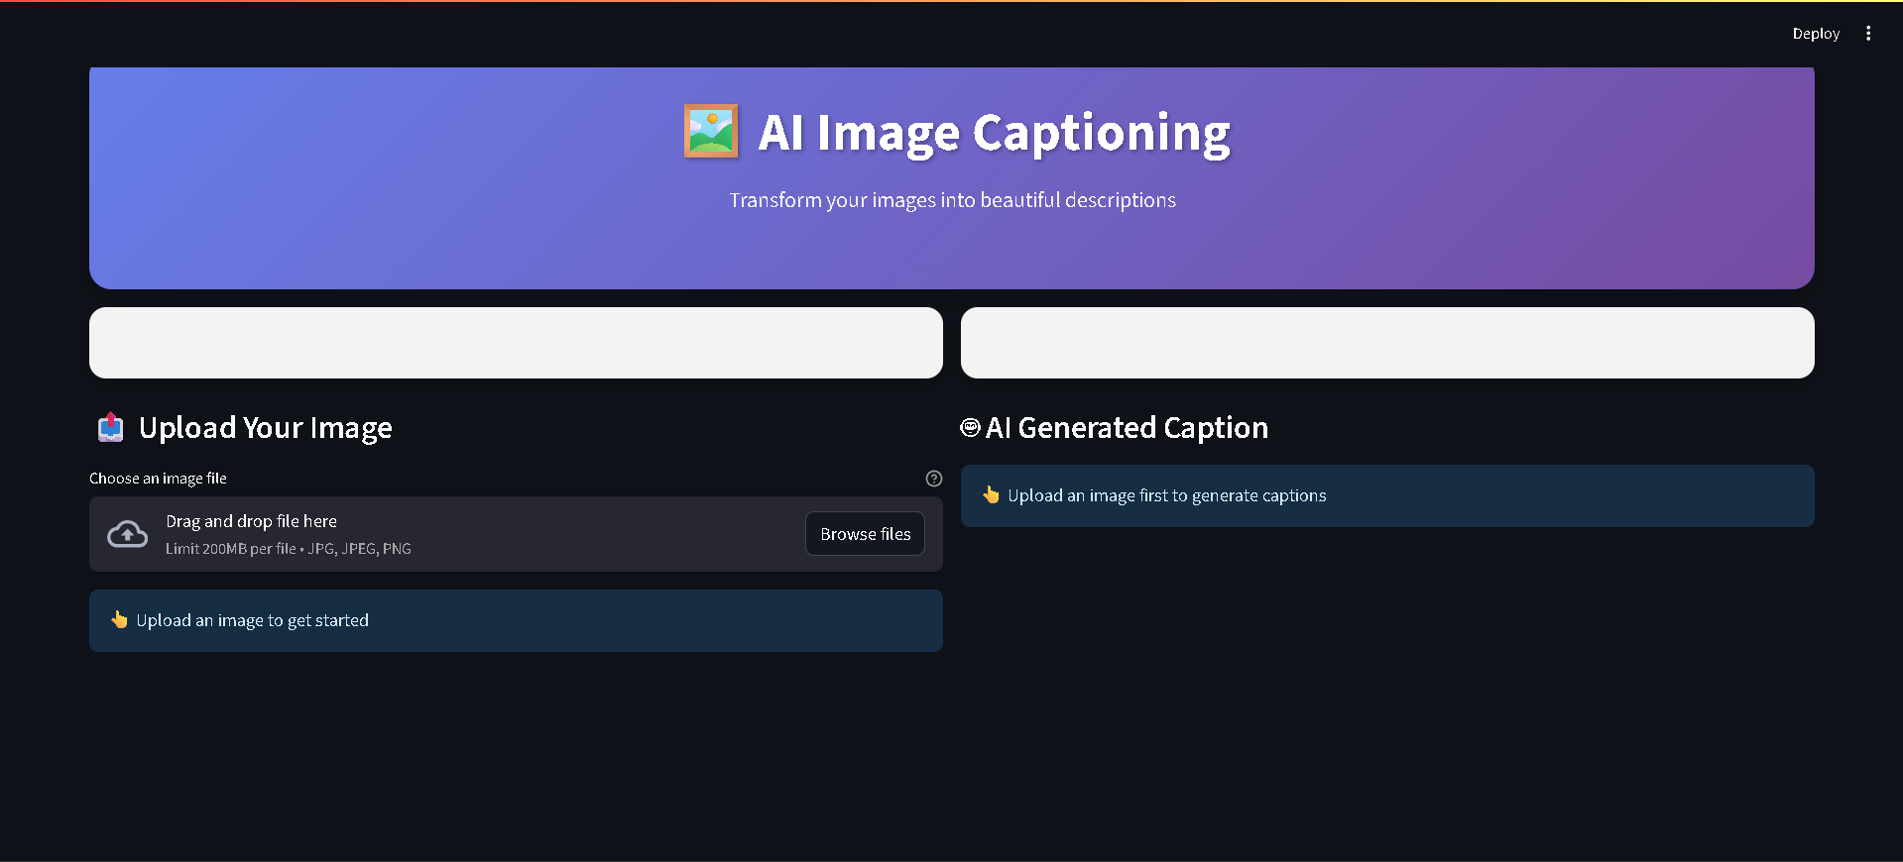
Figure 1 - Main Dashboard

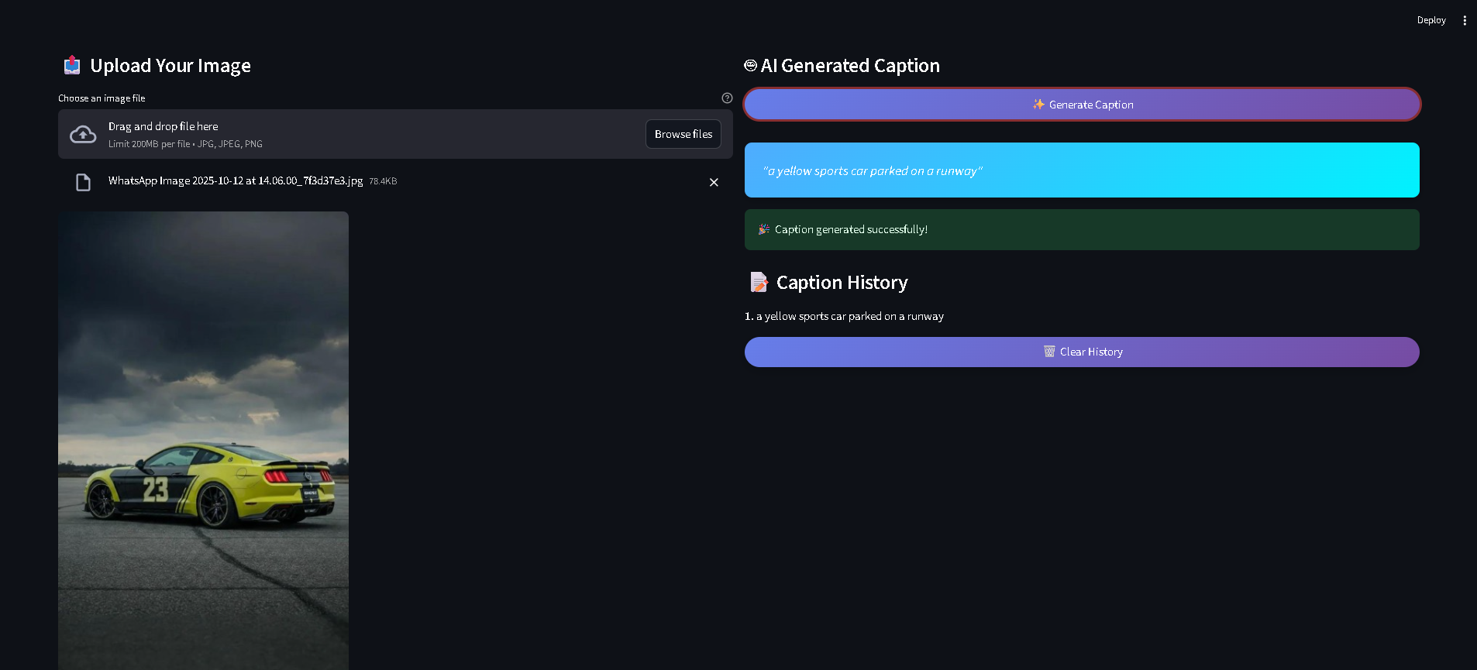
Figure 2 - Output Interface

4.1 Performance Evaluation
The application was tested with a variety of images including indoor scenes, outdoor landscapes, human activity, animals, and objects. Performance metrics were recorded on systems with and without GPU support.

Key Observations:
- Fast Inference:
Using Streamlit’s caching and Hugging Face’s optimized pipelines, the model loads only once and generates captions within 2–5 seconds, even on CPU.
- Model Caching:
Thanks to @st.cache_resource, repeated usage avoids reloading the model, significantly improving speed during multi-session use.
- Hardware Adaptability:
The app automatically utilizes GPU (if available) via PyTorch’s CUDA support, making it scalable from personal laptops to cloud servers.

4.2 Caption Quality and Accuracy
The BLIP model consistently produced contextually accurate, grammatically correct, and semantically rich captions for a wide range of images.
Qualitative Examples:
Input Image | Generated Caption
Cat sleeping on a blanket | “A cat lying on a blanket on a bed.”
Group of people hiking in the mountains | “A group of hikers walking on a mountain trail.”
A child blowing out birthday candles | “A young boy blowing out candles on a birthday cake.”
A busy city street with traffic and lights | “A crowded city street filled with cars and neon lights.”
A laptop on a desk next to a coffee cup | “A laptop and a cup of coffee on a wooden table.”
A dog playing with a ball in a park | “A dog playing with a ball on a grassy field.”
Strengths in Accuracy:
- Object Recognition: Correctly identifies main subjects (e.g., cat, laptop, hiker).
- Scene Understanding: Distinguishes between indoor and outdoor environments.
- Activity Awareness: Describes actions and events, not just static objects

4.3 User Experience (UX) Feedback
- The Streamlit interface was praised for being:
  - Clean and simple to use.
  - Accessible without technical background.
  - Mobile-responsive and browser-compatible.
- Minimal user interaction is needed:
  - Upload an image.
  - Click “Generate Caption.”
  - View result instantly.
Even users with no AI experience were able to use the tool effectively within seconds.

4.4 Strengths of the System
- High-quality captions across various domains (nature, indoor, people, objects).
- Real-time usability via web interface.
- Low resource consumption after initial load.
- Minimal dependencies, deployable in cloud or local environments.
- Customizable and extendable, ideal for further academic or commercial work.

Chapter 5
Conclusion and Future Work

Conclusion:
This project successfully demonstrates the potential of combining vision and language models with modern web frameworks to build intelligent, interactive applications. By leveraging the BLIP (Bootstrapping Language-Image Pre-training) model from Hugging Face and deploying it through Streamlit, the application provides an efficient, user-friendly solution for automated image captioning. The system showcases the full pipeline of an AI application—from model selection and image preprocessing to real-time inference and user interface deployment. It illustrates the practical application of deep learning techniques learned throughout the course and highlights the relevance of multimodal AI systems in solving real-world problems. Furthermore, the use of Streamlit makes the tool easily extendable, accessible to non-technical users, and suitable for rapid experimentation. It proves that powerful machine learning models can be made available to a broader audience with minimal infrastructure requirements.

Future Work:
While the current version of the application achieves its primary goal, there is considerable scope for future improvements and feature expansion. Potential directions include:
1. Multilingual Captioning
- Integrate translation models (e.g., MarianMT, mBART) to generate captions in different languages.
- Allow users to select their preferred output language from the interface.
2. Text-to-Speech (TTS) Integration
- Use libraries like pyttsx3, gTTS, or Azure TTS to convert generated captions into speech.
- Enhance accessibility for visually impaired users by providing audio feedback.
3. Multiple Model Options
- Allow users to select from different captioning models (e.g., BLIP, ViT-GPT2, OFA).
- Enable comparison of caption styles, accuracy, and performance.

4. Cloud Deployment
- Deploy the application on platforms like:
  - Hugging Face Spaces (Gradio) for community sharing.
  - Streamlit Cloud for direct hosting.
  - AWS/GCP/Azure for enterprise scalability.
- Ensure model performance optimization for cloud environments.
5. Real-Time Camera Input
- Add support for live camera feed or webcam input.
- Generate and update captions dynamically as images are captured.
- Useful for robotics, smart surveillance, or assistive technologies
6. Batch Captioning & Logging
- Support uploading multiple images for batch processing.
- Implement a download/export feature for generated captions in CSV or JSON formats.
7. User Access & Privacy
- Add basic authentication for private usage.
- Include image deletion policies and usage disclaimers for ethical AI deployment.

References
- J. Li et al., “BLIP: Bootstrapping Language-Image Pre-training for Unified Vision-Language Understanding and Generation,” arXiv preprint arXiv:2201.12086, 2022.
- Hugging Face, Transformers: State-of-the-art Natural Language Processing, 2023. [Online]. Available: https://huggingface.co/docs/transformers
- Streamlit Inc., Streamlit Documentation, 2024. [Online]. Available: https://docs.streamlit.io
- Salesforce Research, BLIP Model on Hugging Face, 2023. [Online]. Available: https://huggingface.co/Salesforce/blip-image-captioning-base
- Python Software Foundation, Python 3.11 Documentation, 2023. [Online]. Available: https://docs.python.org/3
- Pillow Developers, Pillow (PIL Fork) Documentation, 2023. [Online]. Available: https://pillow.readthedocs.io
- PyTorch Foundation, PyTorch Documentation, 2024. [Online]. Available: https://pytorch.org
- Streamlit App Implementation, streamlit_image_captioning_app.py, 2025 (Developed by Project Team).

