COURSE END PROJECT REPORT
A8517 – DATABASE MANAGEMENT SYSTEMS LABORATORY

Library Management system

Submitted in the Partial Fulfillment of the
Requirements
for the Award of the Degree of

Bachelor of Technology
in
DEPARTMENT OF COMPUTER SCIENCE AND ENGINEERING (AI & ML)
Submitted
By
H.Uday kumar 24885A6609
K.Pranay 24885A6610
M.Madhan 24885A6611
Under the Esteemed Guidance of
Mr. Allamaprabhu Swamy
Assistant Professor


VARDHAMAN COLLEGE OF ENGINEERING
(AUTONOMOUS)
Affiliated to JNTUH, Approved by AICTE, Accredited by NAAC with A++ Grade, ISO 9001:2015 Certified
Kacharam, Shamshabad, Hyderabad – 501218, Telangana, India

June,2024

VARDHAMAN COLLEGE OF ENGINEERING
(AUTONOMOUS)
Affiliated to JNTUH, Approved by AICTE, Accredited by NAAC with A++ Grade, ISO 9001:2015 Certified
Kacharam, Shamshabad, Hyderabad – 501218, Telangana, India

DEPARTMENT OF COMPUTER SCIENCE AND ENGINEERING

CERTIFICATE

This is to certify that the short technical report work entitled “Library Management System” carried out by Mr. H. Uday Kumar ,24885A6609, Mr. K. Pranay, 24885A6610, Mr. M. Madhan ,24885A6611 towards A8517 – Database Management Systems Laboratory course and submitted to Department of Computer Science & Engineering (AI&ML), in partial fulfilment of the requirements for the award of degree of Bachelor of Technology during the academic year 2024-25.

Name & Signature of the Instructors
Mr. Allamaprabhu Swamy
Assistant Professor

Name & Signature of the HOD
Dr. M.A.Jabbar
Professor,HOD

ACKNOWLEDGEMENT
The satisfaction that accompanies the successful completion of the task would be put incomplete without the mention of the people who made it possible, whose constant guidance and encouragement crown all the efforts with success.
We wish to express my deep sense of gratitude to Mr. Allamaprabhu Swamy, Assistant Professor for his able guidance and useful suggestions, which helped us in completing the design part of potential project in time.
We particularly thankful to Dr.M.A.Jabbar, Professor & Head, Department of Computer Science & Engineering for his guidance, intense support and encouragement, which helped us to mould our project into a successful one.
We show gratitude to our honorable Principal Dr.J.V.R.Ravindra, for having provided all the facilities and support.
We avail this opportunity to express our deep sense of gratitude and heartful thanks to Dr Teegala Vijender Reddy, Chairman and Sri Teegala Upender Reddy, Secretary of VCE, for providing congenial atmosphere to complete this project successfully.
We also thank all the staff members of Computer Science & Engineering for their valuable support and generous advice. Finally, thanks to all our friends and family members for their continuous support and enthusiastic help.

H.Uday kumar 24885A6609
K.Pranay 24885A6610
M.Madhan 24885A6611

INDEX
S.No | Content Detail | Page No
1 | Abstract | 1
2 | Objectives of the Project | 2-3
3 | Introduction to problem statement | 4
4 | Software and hardware requirements | 5
5 | Requirements for project | 6
6 | ER Diagram for project | 7
7 | Overall database schema of project | 8
8 | Project screenshots | 9
9 | List of all SQL queries used in project | 10
10 | Complete source code of projects | 11-26
11 | Conclusion | 27
12 | References | 28

1.ABSTRACT

This project is a simple yet effective Library Management System designed to help manage books and student registrations in a digital way. It allows users (such as librarians) to easily add, update, delete, and search for both books and student records. The system also handles the process of issuing and returning books, helping to track which books are available and which are currently issued to students.
Built using Python (for the GUI) and MySQL (for the database), this system ensures data accuracy, reduces manual work, and improves efficiency in library operations. The user interface is developed using Tkinter, making it simple and easy to use for anyone.
This project helps in avoiding problems such as misplaced records, duplicate entries, or confusion over book availability. It also makes it possible to search any book or student instantly, saving time and effort. Overall, this system is ideal for small to medium-sized libraries looking to digitize their book management process in a simple and cost-effective manner.

2. OBJECTIVES OF PROJECT

To automate the manual work of maintaining library records
Traditional library systems rely heavily on paper registers and manual entries. This project aims to automate these tasks by storing all data digitally in a structured database. It reduces the burden on librarians and ensures that records are systematically maintained without the need for physical files or paperwork.
To enable easy tracking of issued and available books.
Keeping track of which books are currently issued and which are available can be difficult in manual systems. Our system automatically updates the status of each book whenever it is issued or returned. This makes it easy to know the real-time availability of any book, reducing confusion and improving book circulation.
To maintain a digital record of students using the library
Each student who uses the library is registered in the system with a unique Card ID. Their borrowing history, personal details, and current issued books are stored digitally. This helps maintain accountability, prevent misuse of library resources, and provide accurate records when needed.
To reduce errors, improve efficiency, and save time
Manual work is prone to errors such as duplicate entries, incorrect book IDs, or misplaced records. Automating the system reduces such risks and ensures data accuracy. Moreover, operations like searching, adding, updating, and deleting records become much faster, saving valuable time for both staff and students.
To provide a user-friendly interface for non-technical users
The system uses a simple GUI built with Tkinter, which is easy to understand and use even by those without technical knowledge. This ensures that librarians and staff can manage records without needing to write any code or work directly with the database.

To improve the overall management of the library
With proper structure and digital tools, library management becomes more organized. Reports can be generated easily, data can be backed up regularly, and decision-making becomes easier with access to complete and accurate data.

3. INTRODUCTION TO PROBLEM STATEMENT AND EXISTING SYSTEMS

Problem Statement:

In many schools, colleges, and small institutions, libraries are still managed using traditional paper-based systems. These systems involve maintaining handwritten records in registers for books, students, and transactions such as issuing and returning books. While this method has been used for years, it comes with several major drawbacks.
1. Risk of Missing or Damaged Records.
Paper records are vulnerable to physical damage due to water, fire, or simply wear and tear over time. Important data can be lost permanently if records are misplaced, torn, or accidentally destroyed.
2. Duplicate or Incorrect Entries
Manual entry often leads to duplication of data or incorrect information being recorded. For example, the same book or student may be entered multiple times with slight variations, making it difficult to track accurate information.
3. Time-Consuming Searches
Looking up a book or a student in a large register can take a lot of time. For instance, checking whether a book is available or finding which student has issued a particular book can take several minutes, especially in a library with a large collection.
4. Limited Access and No Backup
In manual systems, access to records is restricted to one person at a time, and there's no easy way to create backups of the data. If someone wants to analyze usage patterns or generate a report, they must go through pages of registers.
5. Difficulty in Generating Reports
Manual systems do not provide any quick way to generate reports like a list of books issued in a month, books due for return, or the most issued books. This makes data analysis and decision-making difficult.

4. SOFTWARE AND HARDWARE REQUIREMENTS

Hardware Requirements:

Processor Brand | : Intel
Processor Type | : Core i5
Processor Speed | : 2 GHz
Processor Count | : 1
RAM Size | : 4 GB
Memory Technology | : DDR3
Computer Memory Type | : DDR3 ,SDRAM
Hard Drive Size | : 160 GB

Software Requirements :

Operating system : Windows 11

Programming language : Python 3.x

GUI Library : TKinter

Database : MySQL / XAMPP with phpMyAdmin

IDE : VS Code

My sql connector : mysql-connector-python

5. REQUIREMENTS FOR PROJECT

Requirements for University Management System

Functional Requirements:

Add, update, delete, and search book records.

Manage student information with unique IDs.

Issue and return books with date tracking.

Search functionality for books and students.

Generate reports (e.g., available books, issued books, overdue).

Non-Functional Requirements:

User-friendly interface (Tkinter GUI).

Fast performance and quick response time.

Scalable to handle more books and users.

Reliable data handling and integrity.

Secure access for authorized users.

Maintainable and modular code structure.

6. ER DIAGRAM FOR PROJECT

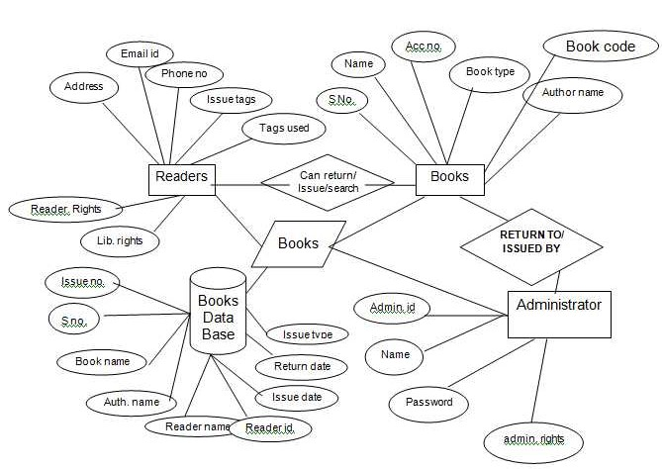
Figure 1: ER Diagram of Library Managment System

7. OVERALL DATABASE SCHEMA OF PROJECT

Library Table:

BK_NAME: VARCHAR

BK_ID: VARCHAR (Primary Key)

AUTHOR_NAME: VARCHAR

GENRE: VARCHAR

BK_STATUS: VARCHAR (Issued/Available)

CARD_ID: VARCHAR (Foreign Key from Students table)

Students Table:

Card_ID: VARCHAR (Primary Key)

Name: VARCHAR

Email: VARCHAR

Course: VARCHAR

Year: INT

8.PROJECT SCREENSHOTS

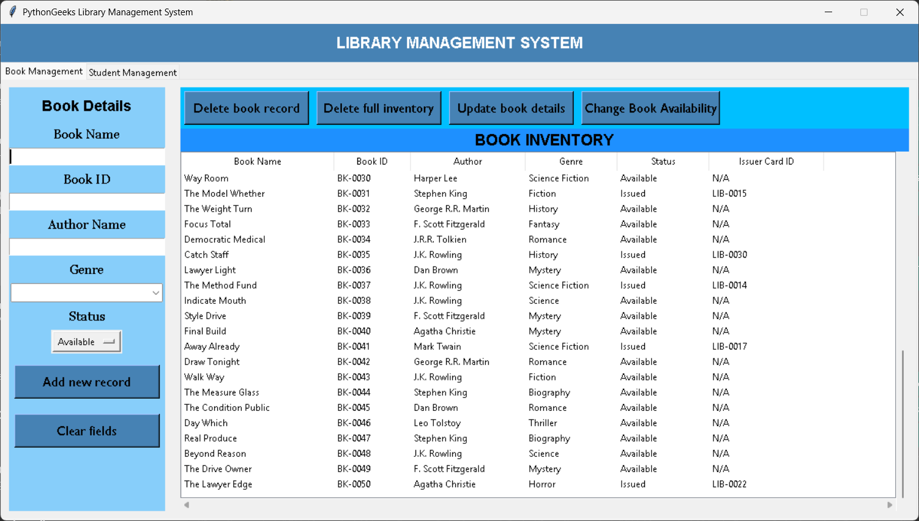
Figure 2 : Book Management

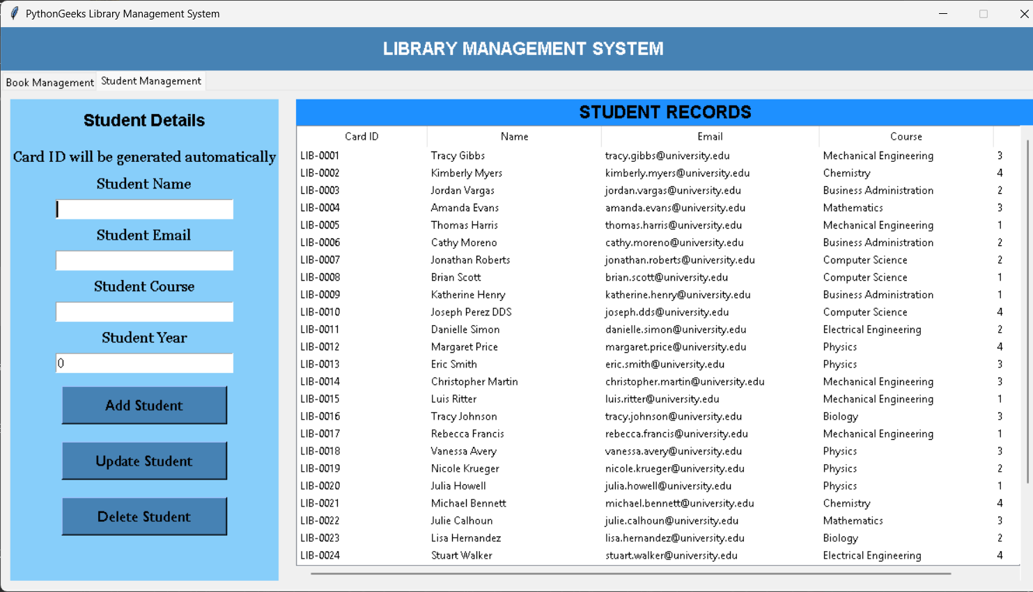
Figure 3: Student Management

9. LIST OF ALL SQL QUERIES USED IN PROJECT

CREATE TABLE IF NOT EXISTS Library (
BK_NAME VARCHAR(255),
BK_ID VARCHAR(50) PRIMARY KEY,
AUTHOR_NAME VARCHAR(255),
GENRE VARCHAR(50),
BK_STATUS VARCHAR(20),
CARD_ID VARCHAR(50)
);

CREATE TABLE IF NOT EXISTS Students (
Card_ID VARCHAR(50) PRIMARY KEY,
Name VARCHAR(255),
Email VARCHAR(255),
Course VARCHAR(100),
Year INT
);

SELECT * FROM Library;
SELECT * FROM Students;
INSERT INTO Library (...) VALUES (...);
INSERT INTO Students (...) VALUES (...);
DELETE FROM Library WHERE BK_ID = ...;
DELETE FROM Students WHERE Card_ID = ...;
UPDATE Library SET ... WHERE BK_ID = ...;
UPDATE Students SET ... WHERE Card_ID = ...;

10. COMPLETE SOURCE CODE

import mysql.connector
from tkinter import *
import tkinter.ttk as ttk
import tkinter.messagebox as mb
import tkinter.simpledialog as sd

# Connecting to MySQL
connector = mysql.connector.connect(
host="localhost",
user="root",
password="password",
database="librarydb"
)
cursor = connector.cursor()

# Creating tables if not exists
cursor.execute("""
CREATE TABLE IF NOT EXISTS Library (
BK_NAME VARCHAR(255),
BK_ID VARCHAR(50) PRIMARY KEY,
AUTHOR_NAME VARCHAR(255),
GENRE VARCHAR(50),
BK_STATUS VARCHAR(20),
CARD_ID VARCHAR(50)
)
""")

cursor.execute("""
CREATE TABLE IF NOT EXISTS Students (
Card_ID VARCHAR(50) PRIMARY KEY,
Name VARCHAR(255),
Email VARCHAR(255),
Course VARCHAR(100),
Year INT
)
""")
connector.commit()

# Common genres for suggestions
COMMON_GENRES = [
"Fiction", "Science Fiction", "Fantasy", "Mystery", "Thriller",
"Romance", "Horror", "Biography", "History", "Science", "Non-Fiction",
"Adventure", "Crime", "Drama", "Poetry", "Self-Help"
]

# Functions
def issuer_card():
Cid = sd.askstring('Issuer Card ID', 'What is the Issuer\'s Card ID?\t\t\t')
if not Cid:
mb.showerror('Issuer ID cannot be empty!', 'Please enter a valid Card ID.')
return None

# Check if the card ID exists in Students table
cursor.execute('SELECT * FROM Students WHERE Card_ID = %s', (Cid,))
student = cursor.fetchone()

if not student:
mb.showerror('Invalid Card ID', 'This Card ID is not registered. Please register as a student first.')
return None
else:
return Cid

def display_records():
tree.delete(*tree.get_children())
cursor.execute('SELECT BK_NAME, BK_ID, AUTHOR_NAME, GENRE, BK_STATUS, CARD_ID FROM Library')
data = cursor.fetchall()
for record in data:
tree.insert('', END, values=record)

def display_students():
student_tree.delete(*student_tree.get_children())
cursor.execute('SELECT * FROM Students')
data = cursor.fetchall()
for record in data:
student_tree.insert('', END, values=record)

def clear_fields():
bk_status.set('Available')
for var in [bk_id, bk_name, author_name, card_id, genre_var]:
var.set('')
bk_id_entry.config(state='normal')
try:
tree.selection_remove(tree.selection()[0])
except:
pass

def clear_student_fields():
for var in [student_name_var, student_email_var, student_course_var]:
var.set('')
student_year_var.set(0)
try:
student_tree.selection_remove(student_tree.selection()[0])
except:
pass

def clear_and_display():
clear_fields()
clear_student_fields()
display_records()
display_students()

def generate_next_card_id():
cursor.execute("SELECT MAX(Card_ID) FROM Students")
last_id = cursor.fetchone()[0]
if last_id:
# Extract numeric part and increment
num = int(last_id[3:]) + 1 # Assuming format LIB-0001
return f"LIB-{num:04d}"
else:
return "LIB-0001" # First student

def add_record():
if not (bk_name.get() and bk_id.get() and author_name.get() and genre_var.get()):
mb.showerror("Error", "Please fill all fields including genre!")
return

if bk_status.get() == 'Issued':
card_id_val = issuer_card()
if not card_id_val:
return
card_id.set(card_id_val)
else:
card_id.set('N/A')

surety = mb.askyesno('Are you sure?',
'Are you sure you want to add this book?\nNote: Book ID cannot be changed later.')

if surety:
try:
values = (bk_name.get(), bk_id.get(), author_name.get(),
genre_var.get(), bk_status.get(), card_id.get())
cursor.execute('''
INSERT INTO Library
(BK_NAME, BK_ID, AUTHOR_NAME, GENRE, BK_STATUS, CARD_ID)
VALUES (%s, %s, %s, %s, %s, %s)
''', values)
connector.commit()
clear_and_display()
mb.showinfo('Success', 'Book added successfully!')
except mysql.connector.IntegrityError:
mb.showerror('Error', 'This Book ID already exists!')

def view_record():
if not tree.selection():
mb.showerror('Error', 'Please select a book!')
return

selected = tree.focus()
values = tree.item(selected)['values']
bk_name.set(values[0])
bk_id.set(values[1])
author_name.set(values[2])
genre_var.set(values[3]) # Set genre from record
bk_status.set(values[4])
card_id.set(values[5])

def update_record():
if not tree.selection():
mb.showerror('Select a row!', 'Please select a record to update.')
return

view_record()

def update():
if bk_status.get() == 'Issued':
card_id_val = issuer_card()
if not card_id_val:
return
card_id.set(card_id_val)
else:
card_id.set('N/A')

cursor.execute('''
UPDATE Library SET
BK_NAME=%s, BK_STATUS=%s, AUTHOR_NAME=%s, GENRE=%s, CARD_ID=%s
WHERE BK_ID=%s
''', (bk_name.get(), bk_status.get(), author_name.get(),
genre_var.get(), card_id.get(), bk_id.get()))
connector.commit()
clear_and_display()
edit.destroy()
bk_id_entry.config(state='normal')
clear.config(state='normal')

bk_id_entry.config(state='disabled')
clear.config(state='disabled')
edit = Button(left_frame, text='Update Record', font=btn_font, bg=btn_hlb_bg, width=20, command=update)
edit.place(x=50, y=425)

def remove_record():
if not tree.selection():
mb.showerror('Error!', 'Please select a book to delete.')
return
selected = tree.focus()
values = tree.item(selected)['values']
cursor.execute('DELETE FROM Library WHERE BK_ID=%s', (values[1],))
connector.commit()
tree.delete(selected)
mb.showinfo('Deleted', 'Record deleted successfully.')
clear_and_display()

def delete_inventory():
if mb.askyesno('Are you sure?', 'Do you really want to delete the entire inventory?'):
tree.delete(*tree.get_children())
cursor.execute('DELETE FROM Library')
connector.commit()
mb.showinfo('Inventory Cleared', 'All books have been deleted from inventory.')

def change_availability():
if not tree.selection():
mb.showerror('Error!', 'Please select a book from the database')
return

selected = tree.focus()
values = tree.item(selected)['values']
BK_id = values[1]
BK_status = values[4] # Updated index to account for genre

if BK_status == 'Issued':
if mb.askyesno('Return Confirmed?', 'Has the book been returned?'):
cursor.execute('UPDATE Library SET BK_STATUS=%s, CARD_ID=%s WHERE BK_ID=%s', ('Available', 'N/A', BK_id))
connector.commit()
mb.showinfo('Success', 'Book has been returned and marked as Available.')
else:
mb.showinfo('Not returned', 'Cannot mark as Available until returned.')
else:
new_card = issuer_card()
if new_card:
cursor.execute('UPDATE Library SET BK_STATUS=%s, CARD_ID=%s WHERE BK_ID=%s', ('Issued', new_card, BK_id))
connector.commit()
mb.showinfo('Success', 'Book has been issued successfully.')

clear_and_display()

def add_student():
student_name = student_name_var.get()
student_email = student_email_var.get()
student_course = student_course_var.get()
student_year = student_year_var.get()

if not (student_name and student_email and student_course and student_year):
mb.showerror("Error", "All fields except Card ID are required!")
return

# Generate the next Card ID
new_card_id = generate_next_card_id()

try:
cursor.execute("""
INSERT INTO Students (Card_ID, Name, Email, Course, Year)
VALUES (%s, %s, %s, %s, %s)
""", (new_card_id, student_name, student_email, student_course, student_year))
connector.commit()
mb.showinfo("Success", f"Student added successfully. Card ID: {new_card_id}")
clear_student_fields()
display_students()
except mysql.connector.IntegrityError:
mb.showerror('Error!', 'This student already exists.')
except Exception as e:
mb.showerror("Error", f"An error occurred: {str(e)}")

def view_student():
if not student_tree.selection():
mb.showerror('Select a student!', 'To view a record, you must select it in the table.')
return

current_item_selected = student_tree.focus()
values_in_selected_item = student_tree.item(current_item_selected)
selection = values_in_selected_item['values']

# Card ID is displayed but not editable
card_id_label.config(text=f"Card ID: {selection[0]}")
student_name_var.set(selection[1])
student_email_var.set(selection[2])
student_course_var.set(selection[3])
student_year_var.set(selection[4])

def update_student():
if not student_tree.selection():
mb.showerror('Select a student!', 'To update a record, you must select it in the table.')
return

# Get Card ID from the label
card_id = card_id_label.cget("text").split(": ")[1]

student_name_val = student_name_var.get()
student_email_val = student_email_var.get()
student_course_val = student_course_var.get()
student_year_val = student_year_var.get()

if not (student_name_val and student_email_val and student_course_val and student_year_val):
mb.showerror("Error", "All fields are required!")
return

try:
cursor.execute("""
UPDATE Students
SET Name = %s, Email = %s, Course = %s, Year = %s
WHERE Card_ID = %s
""", (student_name_val, student_email_val, student_course_val, student_year_val, card_id))

connector.commit()
mb.showinfo("Success", "Student details updated successfully.")
clear_student_fields()
display_students()
except Exception as e:
mb.showerror("Error", f"An error occurred: {str(e)}")

def delete_student():
if not student_tree.selection():
mb.showerror('Select a student!', 'To delete a record, you must select it in the table.')
return

current_item_selected = student_tree.focus()
values_in_selected_item = student_tree.item(current_item_selected)
selection = values_in_selected_item['values']

cursor.execute('DELETE FROM Students WHERE Card_ID = %s', (selection[0],))
connector.commit()

mb.showinfo('Success', 'Student record deleted successfully.')
clear_student_fields()
display_students()

# GUI Config
lf_bg = 'LightSkyBlue'
rtf_bg = 'DeepSkyBlue'
rbf_bg = 'DodgerBlue'
btn_hlb_bg = 'SteelBlue'

lbl_font = ('Georgia', 13)
entry_font = ('Times New Roman', 12)
btn_font = ('Gill Sans MT', 13)

root = Tk()
root.title('PythonGeeks Library Management System')
root.geometry('1200x650')
root.resizable(0, 0)

# Variables
bk_status = StringVar(value='Available')
bk_name = StringVar()
bk_id = StringVar()
author_name = StringVar()
card_id = StringVar()
genre_var = StringVar()

student_name_var = StringVar()
student_email_var = StringVar()
student_course_var = StringVar()
student_year_var = IntVar()

# Main container
main_container = Frame(root)
main_container.pack(fill=BOTH, expand=True)

# Header
header = Frame(main_container, bg=btn_hlb_bg)
header.pack(fill=X)
Label(header, text='LIBRARY MANAGEMENT SYSTEM', font=("Noto Sans CJK TC", 15, 'bold'), bg=btn_hlb_bg, fg='White').pack(pady=10)

# Notebook for tabs
notebook = ttk.Notebook(main_container)
notebook.pack(fill=BOTH, expand=True)

# Book Management Frame
book_frame = Frame(notebook)
notebook.add(book_frame, text='Book Management')

# Student Management Frame
student_frame = Frame(notebook)
notebook.add(student_frame, text='Student Management')

# ========== Book Management Tab ==========
# Left Frame (Book Form)
left_frame = Frame(book_frame, bg=lf_bg)
left_frame.pack(side=LEFT, fill=Y, padx=10, pady=10)

# Right Frame (Book List)
right_frame = Frame(book_frame)
right_frame.pack(side=LEFT, fill=BOTH, expand=True, padx=10, pady=10)

# Top Right Buttons (Book Management)
button_frame = Frame(right_frame, bg=rtf_bg)
button_frame.pack(fill=X)

Button(button_frame, text='Delete book record', font=btn_font, bg=btn_hlb_bg, width=17, command=remove_record).pack(side=LEFT, padx=5, pady=5)
Button(button_frame, text='Delete full inventory', font=btn_font, bg=btn_hlb_bg, width=17, command=delete_inventory).pack(side=LEFT, padx=5, pady=5)
Button(button_frame, text='Update book details', font=btn_font, bg=btn_hlb_bg, width=17, command=update_record).pack(side=LEFT, padx=5, pady=5)
Button(button_frame, text='Change Book Availability', font=btn_font, bg=btn_hlb_bg, width=19, command=change_availability).pack(side=LEFT, padx=5, pady=5)

# Book Form (Left Frame)
Label(left_frame, text='Book Details', bg=lf_bg, font=("Arial", 14, 'bold')).pack(pady=10)

Label(left_frame, text='Book Name', bg=lf_bg, font=lbl_font).pack()
Entry(left_frame, width=25, font=entry_font, textvariable=bk_name).pack(pady=5)

Label(left_frame, text='Book ID', bg=lf_bg, font=lbl_font).pack()
bk_id_entry = Entry(left_frame, width=25, font=entry_font, textvariable=bk_id)
bk_id_entry.pack(pady=5)

Label(left_frame, text='Author Name', bg=lf_bg, font=lbl_font).pack()
Entry(left_frame, width=25, font=entry_font, textvariable=author_name).pack(pady=5)

# Genre Combobox
Label(left_frame, text='Genre', bg=lf_bg, font=lbl_font).pack()
genre_combo = ttk.Combobox(left_frame, textvariable=genre_var, values=COMMON_GENRES)
genre_combo.pack(pady=5)
genre_combo.config(font=entry_font, width=22)

Label(left_frame, text='Status', bg=lf_bg, font=lbl_font).pack()
OptionMenu(left_frame, bk_status, 'Available', 'Issued').pack(pady=5)

submit = Button(left_frame, text='Add new record', font=btn_font, bg=btn_hlb_bg, width=20, command=add_record)
submit.pack(pady=10)

clear = Button(left_frame, text='Clear fields', font=btn_font, bg=btn_hlb_bg, width=20, command=clear_fields)
clear.pack(pady=10)

# Book Treeview (Right Frame)
Label(right_frame, text='BOOK INVENTORY', bg=rbf_bg, font=("Noto Sans CJK TC", 15, 'bold')).pack(fill=X)

tree_frame = Frame(right_frame)
tree_frame.pack(fill=BOTH, expand=True)

tree = ttk.Treeview(tree_frame, selectmode=BROWSE,
columns=('Book Name', 'Book ID', 'Author', 'Genre', 'Status', 'Issuer Card ID'))

scroll_y = ttk.Scrollbar(tree_frame, orient=VERTICAL, command=tree.yview)
scroll_y.pack(side=RIGHT, fill=Y)

scroll_x = ttk.Scrollbar(tree_frame, orient=HORIZONTAL, command=tree.xview)
scroll_x.pack(side=BOTTOM, fill=X)

tree.configure(yscrollcommand=scroll_y.set, xscrollcommand=scroll_x.set)

tree.heading('Book Name', text='Book Name', anchor=CENTER)
tree.heading('Book ID', text='Book ID', anchor=CENTER)
tree.heading('Author', text='Author', anchor=CENTER)
tree.heading('Genre', text='Genre', anchor=CENTER)
tree.heading('Status', text='Status', anchor=CENTER)
tree.heading('Issuer Card ID', text='Issuer Card ID', anchor=CENTER)

tree.column('#0', width=0, stretch=NO)
tree.column('#1', width=200, stretch=NO)
tree.column('#2', width=100, stretch=NO)
tree.column('#3', width=150, stretch=NO)
tree.column('#4', width=120, stretch=NO)
tree.column('#5', width=120, stretch=NO)
tree.column('#6', width=150, stretch=NO)

tree.pack(fill=BOTH, expand=True)

# ========== Student Management Tab ==========
# Left Frame (Student Form)
student_left_frame = Frame(student_frame, bg=lf_bg)
student_left_frame.pack(side=LEFT, fill=Y, padx=10, pady=10)

# Right Frame (Student List)
student_right_frame = Frame(student_frame)
student_right_frame.pack(side=LEFT, fill=BOTH, expand=True, padx=10, pady=10)

# Student Form (Left Frame)
Label(student_left_frame, text='Student Details', bg=lf_bg, font=("Arial", 14, 'bold')).pack(pady=10)

card_id_label = Label(student_left_frame, text='Card ID will be generated automatically', bg=lf_bg, font=lbl_font)
card_id_label.pack(pady=5)

Label(student_left_frame, text='Student Name', bg=lf_bg, font=lbl_font).pack()
Entry(student_left_frame, width=25, font=entry_font, textvariable=student_name_var).pack(pady=5)

Label(student_left_frame, text='Student Email', bg=lf_bg, font=lbl_font).pack()
Entry(student_left_frame, width=25, font=entry_font, textvariable=student_email_var).pack(pady=5)

Label(student_left_frame, text='Student Course', bg=lf_bg, font=lbl_font).pack()
Entry(student_left_frame, width=25, font=entry_font, textvariable=student_course_var).pack(pady=5)

Label(student_left_frame, text='Student Year', bg=lf_bg, font=lbl_font).pack()
Entry(student_left_frame, width=25, font=entry_font, textvariable=student_year_var).pack(pady=5)

add_student_btn = Button(student_left_frame, text='Add Student', font=btn_font, bg=btn_hlb_bg, width=20, command=add_student)
add_student_btn.pack(pady=10)

update_student_btn = Button(student_left_frame, text='Update Student', font=btn_font, bg=btn_hlb_bg, width=20, command=update_student)
update_student_btn.pack(pady=10)

delete_student_btn = Button(student_left_frame, text='Delete Student', font=btn_font, bg=btn_hlb_bg, width=20, command=delete_student)
delete_student_btn.pack(pady=10)

# Student Treeview (Right Frame)
Label(student_right_frame, text='STUDENT RECORDS', bg=rbf_bg, font=("Noto Sans CJK TC", 15, 'bold')).pack(fill=X)

student_tree_frame = Frame(student_right_frame)
student_tree_frame.pack(fill=BOTH, expand=True)

student_tree = ttk.Treeview(student_tree_frame, selectmode=BROWSE, columns=('Card ID', 'Name', 'Email', 'Course', 'Year'))

student_scroll_y = ttk.Scrollbar(student_tree_frame, orient=VERTICAL, command=student_tree.yview)
student_scroll_y.pack(side=RIGHT, fill=Y)

student_scroll_x = ttk.Scrollbar(student_tree_frame, orient=HORIZONTAL, command=student_tree.xview)
student_scroll_x.pack(side=BOTTOM, fill=X)

student_tree.configure(yscrollcommand=student_scroll_y.set, xscrollcommand=student_scroll_x.set)

student_tree.heading('Card ID', text='Card ID', anchor=CENTER)
student_tree.heading('Name', text='Name', anchor=CENTER)
student_tree.heading('Email', text='Email', anchor=CENTER)
student_tree.heading('Course', text='Course', anchor=CENTER)
student_tree.heading('Year', text='Year', anchor=CENTER)

student_tree.column('#0', width=0, stretch=NO)
student_tree.column('#1', width=150, stretch=NO)
student_tree.column('#2', width=200, stretch=NO)
student_tree.column('#3', width=250, stretch=NO)
student_tree.column('#4', width=200, stretch=NO)
student_tree.column('#5', width=100, stretch=NO)

student_tree.pack(fill=BOTH, expand=True)

# Start program
clear_and_display()
root.mainloop()

11. CONCLUSION

The Library Management System is a Python-based application that integrates MySQL for database management and Tkinter for a user-friendly GUI. It streamlines key library operations such as managing books, student records, and book transactions like issuing and returning. Users can easily add, update, search, and delete records, while the system tracks book availability and overdue returns automatically. The MySQL database ensures reliable, quick access to data, and the GUI offers smooth, intuitive navigation. By automating routine tasks, the system improves efficiency, reduces errors, and enhances the overall user experience. This project effectively demonstrates how combining a database with a graphical interface can simplify and modernize library management.
.

12. REFERENCES

Books and Websites:

Python Documentation

MySQL Documentation

[Tkinter Tutorials - GeeksforGeeks, W3Schools]

Classroom notes and lectures

