K.UDAYKUMAR(192110467)

COURSE CODE:DSA0136

# 1.Program Add

#include<iostream>

using namespace std;

int main()

{

int x=6,y=8;

cout<<x+y;

}



2 .program eligible for vote

#include<iostream>

using namespace std;

int main()

{

int age;

cout<<"enter the age";

cin>>age;

if(age>0&&int(age))

if(age>=18)

{

cout<<"eligible for vote";

}

else

{

cout<<"not eligible for vote";

}

}

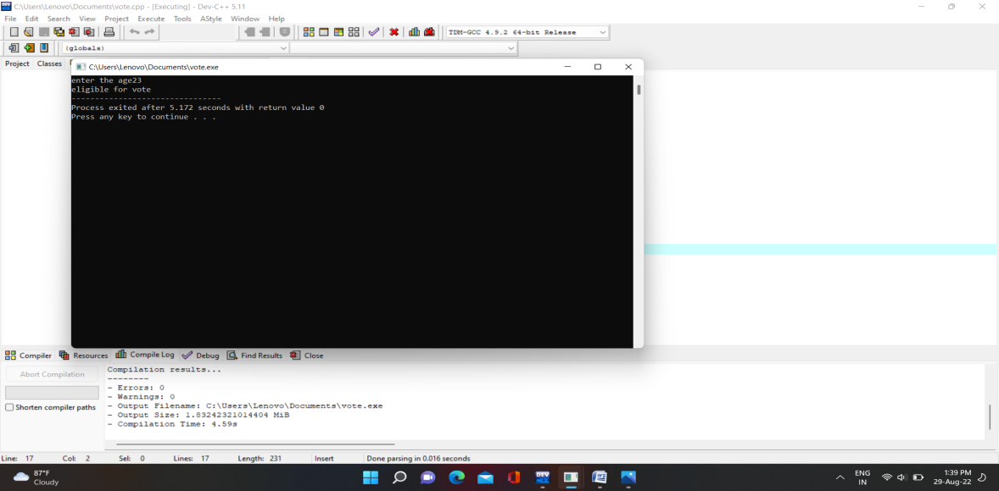

3.program sum of two numbers

#include<iostream>

#include<conio.h>

using namespace std;

int main()

{

int x,y;

cout<<"enter x and y values";

cin>>x>>y;

cout<<"sum of two numbers"<<x+y;

}

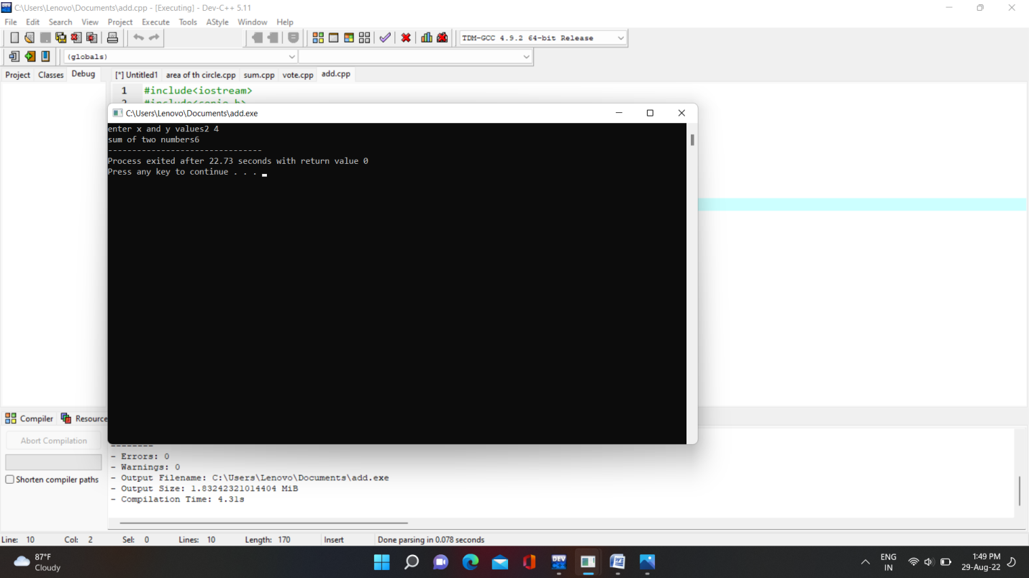

4.Program even or odd

#include<iostream>

using namespace std;

int main()

{

int num,even,odd;

cout<<"enter the number";

cin>>num;

if(int(num))

{

if(num%2==0)

{

cout<<"it is even number";

}

else

{

cout<<"it is odd number";

}

}

else

{

cout<<"it is not accepted";

}

return 0;

}

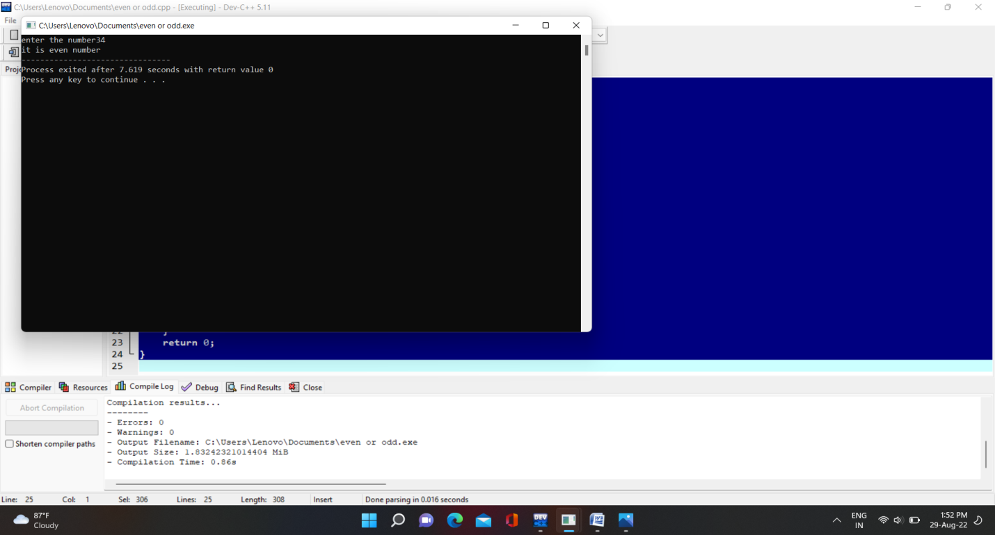

5.Program area of the circle

#include<iostream>

using namespace std;

int main()

{

float r;

cout<<"enter the radius";

cin>>r;

int exp;

cout<<"enter the choice( 1-3)";

cin>>exp;

switch(exp)

{

case 1:;

cout<<"area of the circle"<<3.14*r*r;

break;

case 2:;

cout<<"circumference of the circle"<<2*3.14*r;

break;

deafault:

cout<<"enter the valid choice";

}

}

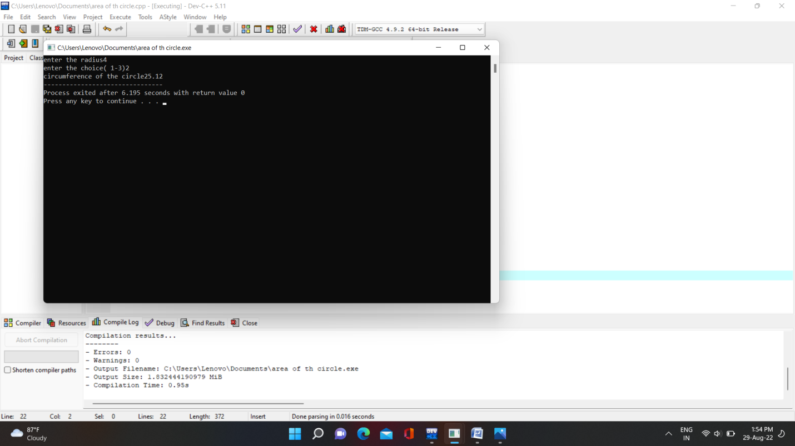

6.Program Biggest of three

#include<iostream>

using namespace std;

int main()

{

int x,y,z;

cout<<"enter the value of x,y,z";

cin>>x>>y>>z;

if(x>y&&x>z)

{

cout<<"x is greatest";

}

else if(y>z&&y>x)

{

cout<<"y is gratest";

}

else

{

cout<<"z is greatest";

}

}

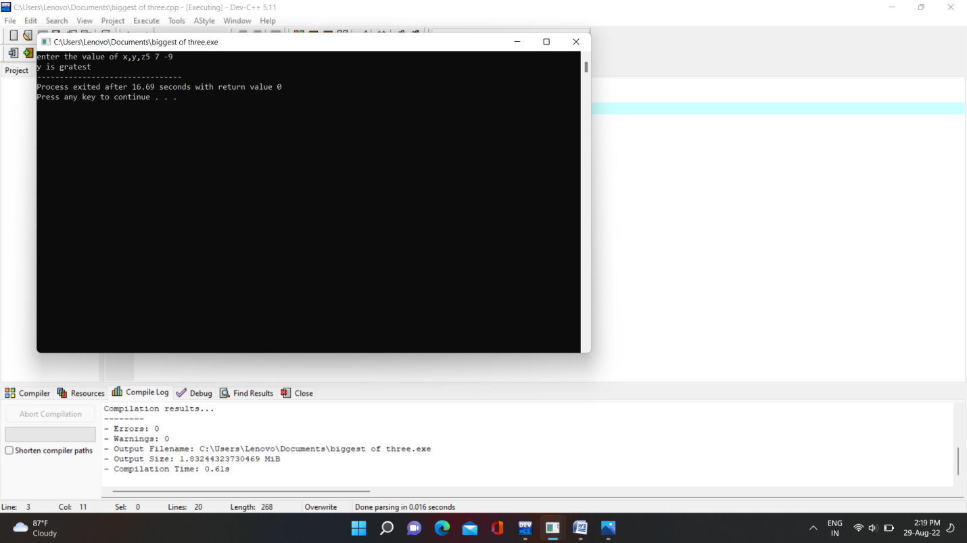

7.program S.I and C.I

#include<iostream>

#include<math.h>

using namespace std;

class interest

{

int p,t,r;

public:

int getdata();

int display();

};

int interest::getdata()

{

cout<<"enter the values of p,t,r";

cin>>p>>t>>r;

}

int interest::display()

{

cout<<"simple interest"<<p*t*r/100;

cout<<"compound interest"<<p*(1+r/100,t);

}

int main()

{

interest i;

i.getdata();

i.display();

}



8.program volume of the cone

#include<iostream>

using namespace std;

class volume

{

float r,h,y;

public:

int getdata();

int display();

};

int volume::getdata()

{

cout<<"enter the radius";

cin>>r;

cout<<"enter the height";

cin>>h;

return 0;

}

int volume::display()

{

cout<<"volume of cone";

y=0.33*3.14*r*r*h;

cout<<y;

return 0;

}

int main()

{

volume v;

v.getdata();

v.display();

}

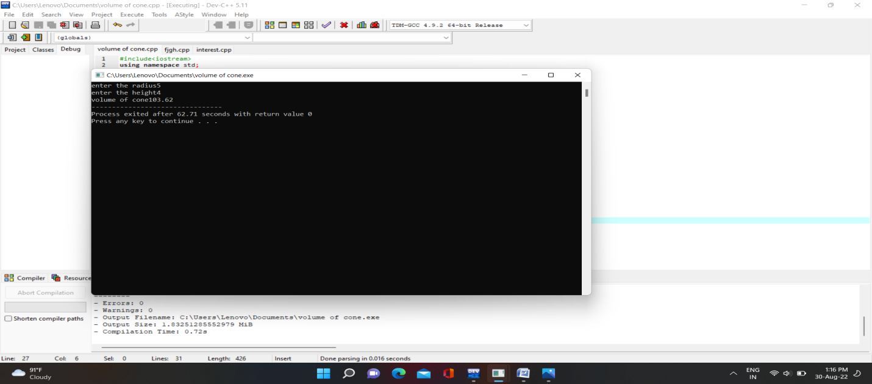

9.Program biggest of 3 numbers using class and object

#include<iostream>

using namespace std;

class big

{

int x,y,z;

public:

int getdata();

int display();

};

int big::getdata()

{

cout<<"enter the values of x,y,z";

cin>>x>>y>>z;

}

int big::display()

{

if(x>y&&x>z)

{

cout<<"x is greatest";

}

else if(y>z&&y>x)

{

cout<<"y is greatest";

}

else

{

cout<<"z is greatest";

}

}

int main()

{

big b;

b.getdata();

b.display();

}

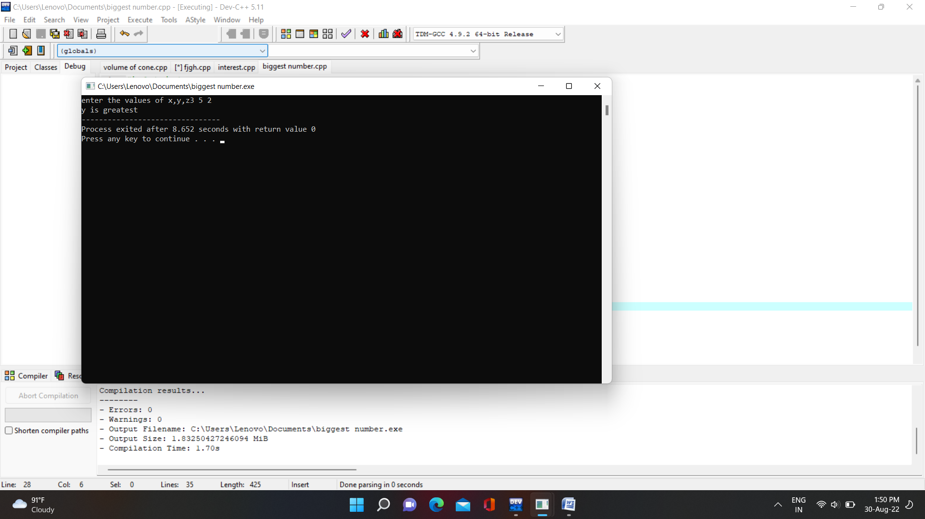

10.program leapyear

#include<iostream>

using namespace std;

int main()

{

int year;

cout<<"enter the year";

cin>>year;

if(year>0 && int(year))

{

if(year%4==0)

{

cout<<"it is the leapyear";

}

else

{

cout<<"it is not leap year";

}

}

else

{

cout<<"enter the valid year";

}

return 0;

}

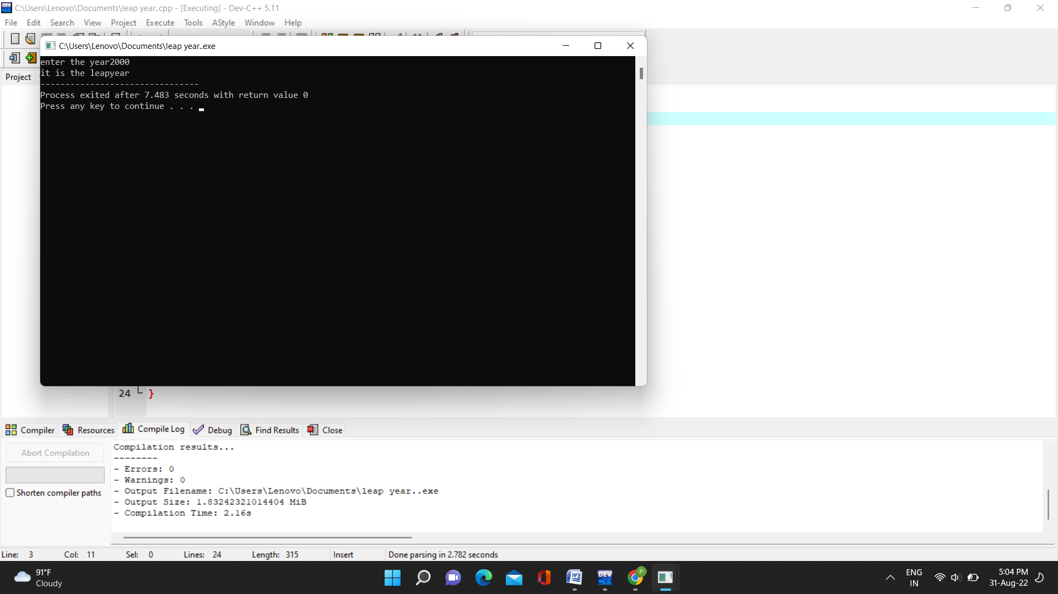

11.program