Department of Artificial Intelligence and Machine Learning

Computer Networks Laboratory
BCS502
B.E - V Semester
Lab Manual 2026-27

Department of Artificial Intelligence and Machine Learning

Computer Networks Laboratory
BCS502
B.E - V Semester
Lab Manual(2022 Scheme)
2026-2027

Prepared by:
Mrs.Nehabanu H Harlapur
Assistant Professor
Dept. of AIML
COMPUTER NETWORKS

Sub Code : BCS502 IA Marks : 50
Hrs / Week : 04I + 02P Exam Hours : 03
Total Hrs : 40 Exam Marks : 50

PART A - Simulation Exercises

For the experiments below modify the topology and parameters set for the experiment and
take multiple rounds of reading and analyze the results available in log files. Plot necessary
graphs and conclude. Use NS2/NS3.
1. Implement three nodes point – to – point network with duplex links between them. Set the
queue size, vary the bandwidth, and find the number of packets dropped.
2. Implement transmission of ping messages/trace route over a network topology consisting of
6 nodes and find the number of packets dropped due to congestion.
3. Implement an Ethernet LAN using n nodes and set multiple traffic nodes and plot congestion
window for different source / destination.
4. Develop a program for error detecting code using CRC-CCITT (16- bits).
5. Develop a program to implement a sliding window protocol in the data link layer.
6. Develop a program to find the shortest path between vertices using the Bellman-Ford and
path vector routing algorithm.
7. Using TCP/IP sockets, write a client – server program to make the client send the file name
and to make the server send back the contents of the requested file if present.
8. Develop a program on a datagram socket for client/server to display the messages on client
side, typed at the server side.
9. Develop a program for a simple RSA algorithm to encrypt and decrypt the data.
10.Develop a program for congestion control using a leaky bucket algorithm.

The student has to secure 40% of 25 marks to qualify in the CIE of the theory component of IPCC.
CIE for the practical component of the IPCC
➢ 15 marks for the conduction of the experiment and preparation of laboratory record, and 10
marks for the test to be conducted after the completion of all the laboratory sessions.
➢ On completion of every experiment/program in the laboratory, the students shall be evaluated
including viva-voce and marks shall be awarded on the same day.
➢ The CIE marks awarded in the case of the Practical component shall be based on the
continuous evaluation of the laboratory report. Each experiment report can be evaluated for 10
marks. Marks of all experiments’ write-ups are added and scaled down to 15 marks.
➢ The laboratory test (duration 02 hours) after completion of all the experiments shall be
conducted for 50 marks and scaled down to 10 marks.
➢ Scaled-down marks of write-up evaluations and tests added will be CIE marks for the
laboratory component of IPCC for 25 marks.
➢ The student has to secure 40% of 25 marks to qualify in the CIE of the practical component of
theIPCC.

Conduction of Practical Examination:
1. All laboratory experiments are to be included for practical examination.
2. Students are allowed to pick one experiment from a lot.
3. Strictly follow the instructions as printed on the cover page of answer script
4. Marks distribution: Procedure + Conduction + Viva: 50m
Continuous evaluation in every lab: Record, Observation, Data Sheet, Execution etc.:15m
Test: Procedure + Conduction + Viva =10m( scaled down from 50m)
5. Change of experiment is allowed only once and marks allotted to the procedure part to be made
zero.

Course Outcome

At the end of the course students will be able to
CO 1: Explain the fundamentals of computer networks.
CO2: Apply the concepts of computer networks to demonstrate the working of various layers and
protocols in communication network.
CO3: Analyze the principles of protocol layering in modern communication systems.
CO4: Demonstrate various Routing protocols and their services using tools such as Cisco packet
tracer.

‘ Instructions to the Candidates’

- Students should come with thorough preparation for the experiment to be conducted.

- Students will not be permitted to attend the laboratory unless they bring the practical record fully completed in all respects pertaing to the experiments conducted in the previous class.
- Practical record should be neatly maintained.
- They should obtain the signature of the staff-in –charge in the observation book after completing each experiment.

- Theory regardingeach experiment should be written in the practical record before procedure in own words.

- Ask lab technician for assistance for any problem.

- Save your class work assignments in system.

- Do not download or install software without the assistance of laboratory technician.

- Do not alter the configuration of system.

- Turn off the systems after use.

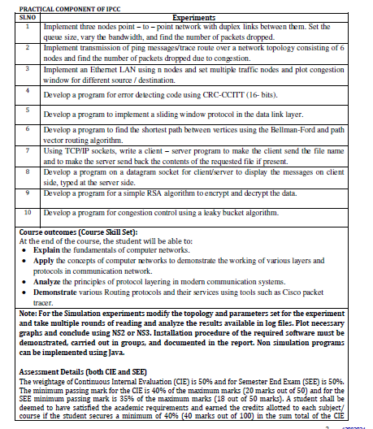

TABLE OF CONTENTS

Sl.N0 | Particulars | Page No
Basics of NS2
1. | Introduction to NS2 | 8
2. | XGraph | 15
3. | Awk-An Advanced | 16
Part-A
1. | Implement three nodes point – to – point network with duplex links between them. Set the  queue size, vary the bandwidth, and find the number of packets dropped. | 18
2. | Implement transmission of ping messages/trace route over a network topology consisting of 6 nodes and find the number of packets dropped due to congestion. | 22
3. | Implement an Ethernet LAN using n nodes and set multiple traffic nodes and plot congestion window for different source / destination. | 28
4. | Develop a program for error detecting code using CRC-CCITT (16- bits). | 35
5. | Develop a program to implement a sliding window protocol in the data link layer. | 38
6. | Develop a program to find the shortest path between vertices using the Bellman-Ford and path vector routing algorithm. | 41
7. | Using TCP/IP sockets, write a client – server program to make the client send the file name and to make the server send back the contents of the requested file if present. | 44
8. | Develop a program on a datagram socket for client/server to display the messages on client side, typed at the server side. | 46
9. | Develop a program for a simple RSA algorithm to encrypt and decrypt the data. | 49
10. | Develop a program for congestion control using a leaky bucket algorithm. | 53

PART-A
Introduction to NS-2:
- Widely known as NS2, is simply an event driven simulation tool.
- Useful in studying the dynamic nature of communication networks.
- Simulation of wired as well as wireless network functions and protocols (e.g., routing algorithms, TCP, UDP) can be done using NS2.
- In general, NS2 provides users with a way of specifying such network protocols and simulating their corresponding behaviors.

Basic Architecture of NS2
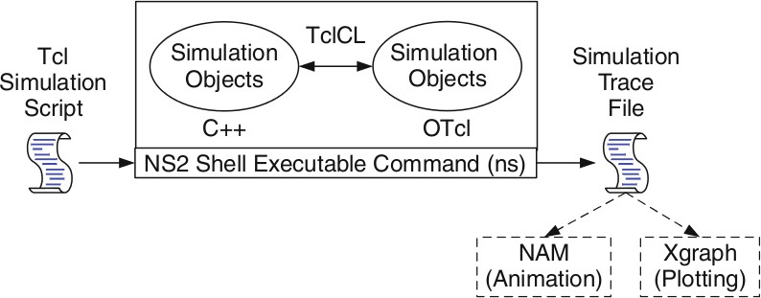

Tcl scripting
- Tcl is a general purpose scripting language. [Interpreter]
- Tcl runs on most of the platforms such as Unix, Windows, and Mac.
- The strength of Tcl is its simplicity.
- It is not necessary to declare a data type for variable prior to the usage.

Basics of TCL
Syntax: command arg1 arg2 arg3
- Hello World!
puts stdout{Hello, World!} Hello, World!
- Variables Command Substitution set a 5 set len [string length foobar]

set b $a set len [expr [string length foobar] + 9]
- Simple Arithmetic
expr 7.2 / 4
- Procedures
proc Diag {a b} {
set c [expr sqrt($a * $a + $b * $b)] return $c }
puts “Diagonal of a 3, 4 right triangle is [Diag 3 4]” Output: Diagonal of a 3, 4 right triangle is 5.0
- Loops
while{$i < $n} for {set i 0} {$i < $n} {incr i}
{ {

} }
Wired TCL Script Components
Create the event scheduler
Open new files & turn on the tracing Create the nodes
Setup the links
Configure the traffic type (e.g., TCP, UDP, etc) Set the time of traffic generation (e.g., CBR, FTP) Terminate the simulation
NS Simulator Preliminaries.
- Initialization and termination aspects of the ns simulator.
- Definition of network nodes, links, queues and topology.
- Definition of agents and of applications.
- The nam visualization tool.
- Tracing and random variables.

Initialization and Termination of TCL Script in NS-2
An ns simulation starts with the command
set ns [new Simulator]

Which is thus the first line in the tcl script? This line declares a new variable as using the set command, you can call this variable as you wish, In general people declares it as ns because it is an instance of the Simulator class, so an object the code[new Simulator] is indeed the installation of the class Simulator using the reserved word new.
In order to have output files with data on the simulation (trace files) or files used for visualization (nam files), we need to create the files using “open” command:
#Open the Trace file
set tracefile1 [open out.tr w]
$ns trace-all $tracefile1

#Open the NAM trace file
set namfile [open out.nam w]
$ns namtrace-all $namfile
The above creates a dta trace file called “out.tr” and a nam visualization trace file called “out.nam”.Within the tcl script,these files are not called explicitly by their names,but instead by pointers that are declared above and called “tracefile1” and “namfile” respectively.Remark that they begins with a # symbol.The second line open the file “out.tr” to be used for writing,declared with the letter “w”.The third line uses a simulator method called trace-all that have as parameter the name of the file where the traces will go.
The last line tells the simulator to record all simulation traces in NAM input format.It also gives the file name that the trace will be written to later by the command $ns flush-trace.In our case,this will be the file pointed at by the pointer “$namfile”,i.e the file “out.tr”.
The termination of the program is done using a “finish” procedure.
#Define a ‘finish’ procedure
Proc finish {} {
global ns tracefile1 namfile
$ns flush-trace Close $tracefile1 Close $namfile
Exec nam out.nam & Exit 0
}

DEPT. OF AIML,AGMRCET, NAVAGRAHATEERTH, VARUR

The word proc declares a procedure in this case called finish and without arguments. The word global is used to tell that we are using variables declared outside the procedure. The simulator method “flush-trace” will dump the traces on the respective files. The tcl command “close” closes the trace files defined before and exec executes the nam program for visualization. The command exit will ends the application and return the number 0 as status to the system. Zero is the default for a clean exit. Other values can be used to say that is a exit because something fails.
At the end of ns program we should call the procedure “finish” and specify at what time the termination should occur. For example,
$ns at 125.0 “finish”

will be used to call “finish” at time 125sec.Indeed,the at method of the simulator allows us to schedule events explicitly.
The simulation can then begin using the command
$ns run

Definition of a network of links and nodes
The way to define a node is
set n0 [$ns node]
The node is createdwhich is printed by the variable n0. When we shall refer to that node in the script we shall thus write $n0.
Once we define several nodes, we can define the links that connect them. An example of a definition of a link is:
$ns duplex-link $n0 $n2 10Mb 10ms DropTail

Which means that $n0 and $n2 are connected using a bi-directional link that has 10ms of propagation delay and a capacity of 10Mb per sec for each direction.
To define a directional link instead of a bi-directional one, we should replace “duplex-link” by “simplex-link”.

DEPT. OF AIML, AGMRCET, NAVAGRAHATEERTH, VARUR

In NS, an output queue of a node is implemented as a part of each link whose input is that node. The definition of the link then includes the way to handle overflow at that queue. In our case, if the buffer capacity of the output queue is exceeded then the last packet to arrive is dropped. Many alternative options exist, such as the RED (Random Early Discard) mechanism, the FQ (Fair Queuing), the DRR (Deficit Round Robin), the stochastic Fair Queuing (SFQ) and the CBQ (which including a priority and a round-robin scheduler).
In ns, an output queue of a node is implemented as a part of each link whose input is that node. We should also define the buffer capacity of the queue related to each link. An example would be:
#set Queue Size of link (n0-n2) to 20
$ns queue-limit $n0 $n2 20

Agents and Applications
We need to define routing (sources, destinations) the agents (protocols) the application that use them.
FTP over TCP
TCP is a dynamic reliable congestion control protocol. It uses Acknowledgements created by the destination to know whether packets are well received.
There are number variants of the TCP protocol, such as Tahoe, Reno, NewReno, Vegas. The type of agent appears in the first line:
set tcp [new Agent/TCP]
The command $ns attach-agent $n0 $tcp defines the source node of the tcp connection. The command

Defines the behavior of the destination node of TCP and assigns to it a pointer called sink.
set sink [new Agent /TCPSink]
#Setup a UDP connection

Dept. of AIML, AGMRCET VARUR
set udp [new Agent/UDP]
$ns attach-agent $n1 $udp set null [new Agent/Null]
$ns attach-agent $n5 $null
$ns connect $udp $null
$udp set fid_2

#setup a CBR over UDP connection
set cbr [new Application/Traffic/CBR]
$cbr attach-agent $udp
$cbr set packetsize_ 100
$cbr set rate_ 0.01Mb
$cbr set random_ false
Above shows the definition of a CBR application using a UDP agent
The command $ns attach-agent $n4 $sink defines the destination node. The command $ns connect $tcp $sink finally makes the TCP connection between the source and destination nodes.
TCP has many parameters with initial fixed defaults values that can be changed if mentioned explicitly. For example, the default TCP packet size has a size of 1000bytes.This can be changed to another value, say 552bytes, using the command $tcp set packetSize_ 552.
When we have several flows, we may wish to distinguish them so that we can identify them with different colors in the visualization part. This is done by the command $tcp set fid_ 1 that assigns to the TCP connection a flow identification of “1”.We shall later give the flow identification of “2” to the UDP connection.
CBR over UDP
A UDP source and destination is defined in a similar way as in the case of TCP.
Instead of defining the rate in the command $cbr set rate_ 0.01Mb, one can define the time interval between transmission of packets using the command.
$cbr set interval_ 0.005
The packet size can be set to some value using
$cbr set packetSize_ <packet size>

Scheduling Events
NS is a discrete event based simulation. The tcp script defines when event should occur. The initializing command set ns [new Simulator] creates an event scheduler, and events are then scheduled using the format:
$ns at <time><event>

The scheduler is started when running ns that is through the command $ns run.
The beginning and end of the FTP and CBR application can be done through the following command
$ns at 0.1 “$cbr start”

$ns at 1.0 “ $ftp start”

$ns at 124.0 “$ftp stop”

$ns at 124.5 “$cbr stop”

Structure of Trace Files
When tracing into an output ASCII file, the trace is organized in 12 fields as follows in fig shown below, The meaning of the fields are:
Event | Time | From  Node | To  Node | PKT  Type | PKT  Size | Flags | Fid | Src  Addr | Dest  Addr | Seq  Num | Pkt  id
- The first field is the event type. It is given by one of four possible symbols r, +, -, d which correspond respectively to receive (at the output of the link), enqueued, dequeued and dropped.
- The second field gives the time at which the event occurs.
- Gives the input node of the link at which the event occurs.
- Gives the output node of the link at which the event occurs.
- Gives the packet type (eg CBR or TCP)
- Gives the packet size
- Some flags

- This is the flow id (fid) of IPv6 that a user can set for each flow at the input OTcl script one can further use this field for analysis purposes; it is also used when specifying stream color for the NAM display.
- This is the source address given in the form of “node.port”.
- This is the destination address, given in the same form.
- This is the network layer protocol’s packet sequence number. Even though UDP implementations in a real network do not use sequence number, ns keeps track of UDP packet sequence number for analysis purposes
- The last field shows the Unique id of the packet.

XGRAPH
The xgraph program draws a graph on an x-display given data read from either data file or from standard input if no files are specified. It can display upto 64 independent data sets using different colors and line styles for each set. It annotates the graph with a title, axis labels, grid lines or tick marks, grid labels and a legend.
Syntax:
Xgraph [options] file-name

Options are listed here
/-bd <color> (Border)
This specifies the border color of the xgraph window.
/-bg <color> (Background)
This specifies the background color of the xgraph window.
/-fg<color> (Foreground)
This specifies the foreground color of the xgraph window.
/-lf <fontname> (LabelFont)
All axis labels and grid labels are drawn using this font.
/-t<string> (Title Text)
This string is centered at the top of the graph.
/-x <unit name> (XunitText)
This is the unit name for the x-axis. Its default is “X”.
/-y <unit name> (YunitText)
This is the unit name for the y-axis. Its default is “Y”.

Awk- An Advanced
awk is a programmable, pattern-matching, and processing tool available in UNIX. It works equally well with text and numbers.
awk is not just a command, but a programming language too. In other words, awk utility is a pattern scanning and processing language. It searches one or more files to see if they contain lines that match specified patterns and then perform associated actions, such as writing the line to the standard output or incrementing a counter each time it finds a match.
Syntax:
awk option ‘selection_criteria {action}’ file(s)
Here, selection_criteria filters input and select lines for the action component to act upon. The selection_criteria is enclosed within single quotes and the action within the curly braces. Both the selection_criteria and action forms an awk program.
Example: $ awk ‘/manager/ {print}’ emp.lst Variables
Awk allows the user to use variables of there choice. You can now print a serial number, using the variable kount, and apply it those directors drawing a salary exceeding 6700:
$ awk –F”|” ‘$3 == “director” && $6 > 6700 { kount =kount+1
printf “ %3f %20s %-12s %d\n”, kount,$2,$3,$6 }’ empn.lst THE –f OPTION: STORING awk PROGRAMS IN A FILE

You should holds large awk programs in separate file and provide them with the awk extension for easier identification. Let’s first store the previous program in the file empawk.awk:
$ cat empawk.awk
Observe that this time we haven’t used quotes to enclose the awk program. You can now use awk with the –f filename option to obtain the same output:
Awk –F”|” –f empawk.awk empn.lst

THE BEGIN AND END SECTIONS
Awk statements are usually applied to all lines selected by the address, and if there are no addresses, then they are applied to every line of input. But, if you have to print something before processing the first line, for example, a heading, then the BEGIN section can be used gainfully. Similarly, the end section useful in printing some totals after processing is over.
The BEGIN and END sections are optional and take the form
BEGIN {action} END {action}
These two sections, when present, are delimited by the body of the awk program. You can use them to print a suitable heading at the beginning and the average salary at the end.

BUILT-IN VARIABLES
Awk has several built-in variables. They are all assigned automatically, though it is also possible for a user to reassign some of them. You have already used NR, which signifies the record number of the current line. We’ll now have a brief look at some of the other variable.
The FS Variable: as stated elsewhere, awk uses a contiguous string of spaces as the default field delimiter. FS redefines this field separator, which in the sample database happens to be the |. When used at all, it must occur in the BEGIN section so that the body of the program knows its value before it starts processing:
BEGIN {FS=”|”}
This is an alternative to the –F option which does the same thing.
The OFS Variable: when you used the print statement with comma-separated arguments, each argument was separated from the other by a space. This is awk’s default output field separator, and can reassigned using the variable OFS in the BEGIN section:

BEGIN { OFS=”~” }
When you reassign this variable with a ~ (tilde), awk will use this character for delimiting the print arguments. This is a useful variable for creating lines with delimited fields.
The NF variable: NF comes in quite handy for cleaning up a database of lines that don’t contain the right number of fields. By using it on a file, say emp.lst, you can locate those lines not having 6 fields, and which have crept in due to faulty data entry:
$awk ‘BEGIN {FS = “|”} NF! =6 {
Print “Record No “, NR, “has”, “fields”}’ empx.lst

Experiment No: 1

FOUR NODE POINT TO POINT NETWORK

Implement three nodes point – to – point network with duplex links between them. Set the queue
size, vary the bandwidth and find the number of packets dropped.
Step1: Open text editor, type the below program and save with extention .tcl (prog1.tcl )set ns [new Simulator] # Letter S is capital
set nf [open prog1.nam w] # open a nam trace file in write mode
$ns namtrace-all $nf # nf nam filename
set tf [open PA1.tr w] # tftrace filename
$ns trace-all $tf
proc finish { } {
global ns nf tf
$ns flush-trace # clears trace file contents
close $nf close $tf
exec nam PA1.nam & exit 0
}
set n0 [$ns node] # creating 4 nodes set n1 [$ns node]
set n2 [$ns node] set n3 [$ns node]
$ns duplex-link $n0 $n2 200Mb 10ms DropTail # establishing links
$ns duplex-link $n1 $n2 200Mb 10ms DropTail
$ns duplex-link $n2 $n3 200Mb 10ms DropTail

$ns queue-limit $n0 $n2 10

$ns queue-limit $n1 $n2 10
# $ns queue-limit $n2 $n3 10
set udp0 [new Agent/UDP] # attaching transport layer protocols
$ns attach-agent $n0 $udp0
set cbr0 [new Application/Traffic/CBR] # attaching application layer protocols
$cbr0 set packetSize_500
$cbr0 set interval_0.005
$cbr0 attach-agent $udp0
set null0 [new Agent/Null] # creating sink(destination) node
$ns attach-agent $n3 $null0
$ns connect $udp0 $null0
$ns at 0.1 "$cbr0 start"
$ns at 1.0 "finish"
$ns run
AWK file:(Open a new editor using “vi command” and write awk file and save with “.awk” extension)
#immediately after BEGIN should open braces ‘{‘ BEGIN{c=0;}
{
if($1= ="d")
{ c++;
printf("%s\t%s\n",$5,$11);
}
}
END{printf("The number of packets dropped =%d\n",c);} Steps for execution
- Open vi editor and type program. Program name should have the extension “

.tcl ”
[root@localhost ~]# vi lab1.tcl
- Save the program by pressing “ESC key” first, followed by “Shift and :” keys simultaneously and type “wq” and press Enter key.
- Open vi editor and type awk program. Program name should have the extension “.awk ”
[root@localhost ~]# vi prog1.awk
- Save the program by pressing “ESC key” first, followed by “Shift and :” keys simultaneously and type “wq” and press Enter key.
- Run the simulation program
[root@localhost~]# ns prog1.tcl
- Here “ns” indicates network simulator. We get the topology shown in the snapshot.
- Now press the play button in the simulation window and the simulation will begins.
- After simulation is completed run awk file to see the output ,

[root@localhost~]# awk –f prog1.awk prog1.tr
- To see the trace file contents open the file as ,
[root@localhost~]# vi prog1.tr
Trace file contains 12 columns:
Event type, Event time, From Node, To Node, Packet Type, Packet Size, Flags (indicated by --------), Flow ID, Source address, Destination address, Sequence ID, Packet ID.
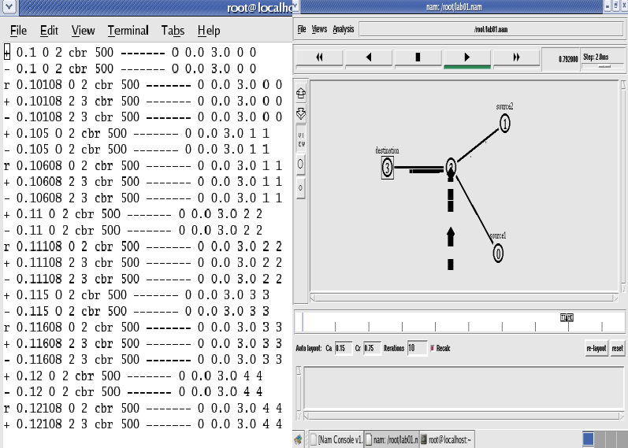
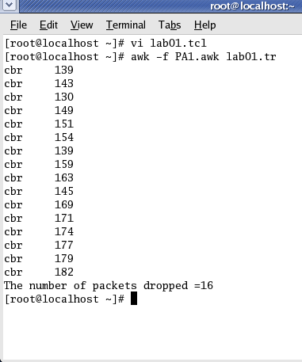
Contents of Trace File Topology Output

Experiment No: 2
FOUR NODE POINT TO POINT NETWORK WITH TCP and UDP
Implement transmission of ping messages/trace route over a network topology consisting of 6
nodes and find the number of packets dropped due to congestion.

Step1: Open text editor, type the below program and save with extention.tcl (prog3.tcl )
set ns [new Simulator]
set nf [open prog3.nam w]
$ns namtrace-all $nf
set nd [open prog3.tr w]
$ns trace-all $nd
proc finish {} {
global ns nf nd
$ns flush-trace
close $nf
close $nd
exec nam prog4.nam &
exit 0
}
set n0 [$ns node]
set n1 [$ns node]
set n2 [$ns node]
set n3 [$ns node]
set n4 [$ns node]
set n5 [$ns node]
set n6 [$ns node]
$ns duplex-link $n1 $n0 1Mb 10ms DropTail
$ns duplex-link $n2 $n0 1Mb 10ms DropTail
$ns duplex-link $n3 $n0 1Mb 10ms DropTail
$ns duplex-link $n4 $n0 1Mb 10ms DropTail
$ns duplex-link $n5 $n0 1Mb 10ms DropTail
$ns duplex-link $n6 $n0 1Mb 10ms DropTail
Agent/Ping instproc recv {from rtt} {
$self instvar node_
puts "node [$node_ id] recieved ping answer from \
$from with round-trip-time $rtt ms."
}
set p1 [new Agent/Ping]
set p2 [new Agent/Ping]
set p3 [new Agent/Ping]
set p4 [new Agent/Ping]
set p5 [new Agent/Ping]
set p6 [new Agent/Ping]
$ns attach-agent $n1 $p1
$ns attach-agent $n2 $p2
$ns attach-agent $n3 $p3
$ns attach-agent $n4 $p4
$ns attach-agent $n5 $p5
$ns attach-agent $n6 $p6
$ns queue-limit $n0 $n4 3
$ns queue-limit $n0 $n5 2
$ns queue-limit $n0 $n6 2
$ns connect $p1 $p4
$ns connect $p2 $p5
$ns connect $p3 $p6
$ns at 0.2 "$p1 send"
$ns at 0.4 "$p2 send"
$ns at 0.6 "$p3 send"
$ns at 1.0 "$p4 send"
$ns at 1.2 "$p5 send"
$ns at 1.4 "$p6 send"
$ns at 2.0 "finish"
$ns run

Step2: Open text editor, type the below program and save with extention .awk (prog3.awk )
BEGIN {
count=0;
}
{
event=$1;
if(event=="d")
{
count++;
}
}
END {
printf("No of packets dropped : %d\n",count);
}

Step3: Run the simulation program
[root@localhost~]# ns prog3.tcl
(Here “ns” indicates network simulator. We get the topology shown in the snapshot.)

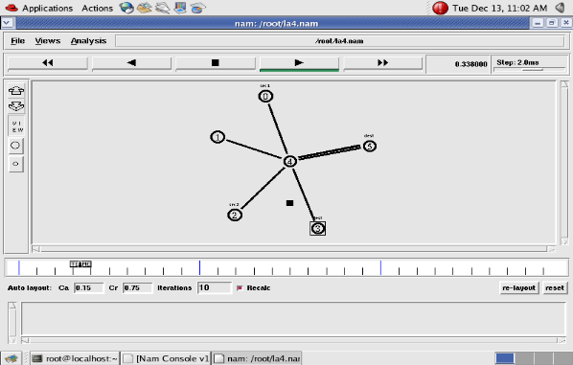

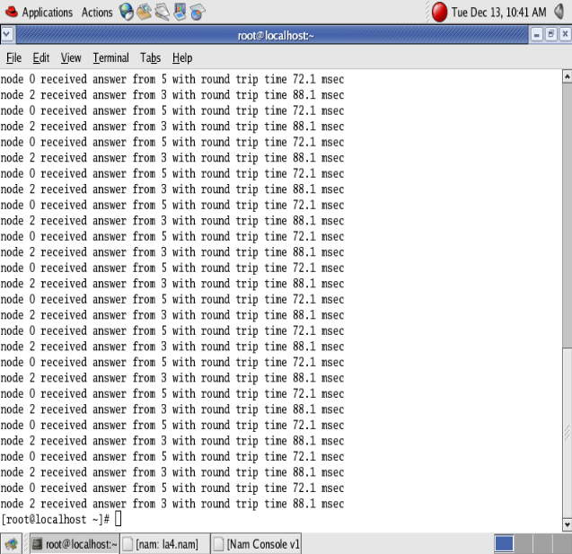

Step 4: Now press the play button in the simulation window and the simulation will begins.
Step 5: After simulation is completed run awk file to see the output ,
[root@localhost~]# awk –f prog3.awk prog3.tr
Step 6: To see the trace file contents open the file as ,
[root@localhost~]# vi prog3.tr

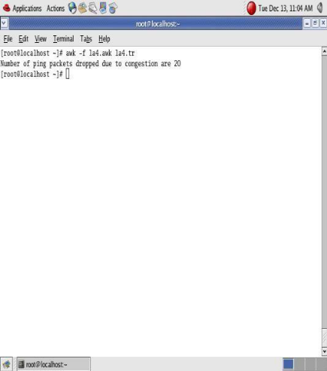

OR

set ns [new Simulator] set nf [open lab2.nam w]
$ns namtrace-all $nf set tf [open lab2.tr w]
$ns trace-all $tf proc finish { }
{
global ns nf tf
$ns flush-trace close $nf
close $tf
exec nam lab2.nam & exit 0
}
set n0 [$ns node] set n1 [$ns node] set n2 [$ns node] set n3 [$ns node]
$ns duplex-link $n0 $n2 10Mb 1ms DropTail
$ns duplex-link $n1 $n2 10Mb 1ms DropTail
$ns duplex-link $n2 $n3 10Mb 1ms DropTail

set tcp0 [new Agent/TCP] # letters A,T,C,P are capital
$ns attach-agent $n0 $tcp0
set udp1 [new Agent/UDP] # letters A,U,D,P are capital
$ns attach-agent $n1 $udp1
set null0 [new Agent/Null] # letters A and N are capital
$ns attach-agent $n3 $null0
set sink0 [new Agent/TCPSink] # letters A,T,C,P,S are capital
$ns attach-agent $n3 $sink0 set ftp0 [new Application/FTP]
$ftp0 attach-agent $tcp0
set cbr1 [new Application/Traffic/CBR]
$cbr1 attach-agent $udp1
$ns connect $tcp0 $sink0
$ns connect $udp1 $null0
$ns at 0.1 "$cbr1 start"
$ns at 0.2 "$ftp0 start"
$ns at 0.5 "finish"
$ns run

AWK file:(Open a new editor using “vi command” and write awk file and save with “.awk” extension)

BEGIN
{
udp=0; tcp=0;
}
{
if($1= = “r” && $5 = = “cbr”)
{
udp++;
}
else if($1 = = “r” && $5 = = “tcp”)
{
tcp++;
}
}

END
{
printf(“Number of packets sent by TCP = %d\n”, tcp); printf(“Number of packets sent by UDP=%d\n”,udp);
}

Steps for execution:

Open vi editor and type program. Program name should have the extension “ .tcl ”
[root@localhost ~]# vi lab2.tcl
- Save the program by pressing “ESC key” first, followed by “Shift and :” keys simultaneously and type “wq” and press Enter key.
- Open vi editor and type awk program. Program name should have the extension “.awk ”
[root@localhost ~]# vi lab2.awk
- Save the program by pressing “ESC key” first, followed by “Shift and :” keys simultaneously and type “wq” and press Enter key.
- Run the simulation program
[root@localhost~]# ns lab2.tcl
  - Here “ns” indicates network simulator. We get the topology shown in the snapshot.
  - Now press the play button in the simulation window and the simulation will begins.
- After simulation is completed run awk file to see the output ,
[root@localhost~]# awk –f lab2.awk lab2.tr
- To see the trace file contents open the file as ,
[root@localhost~]# vi lab2.tr

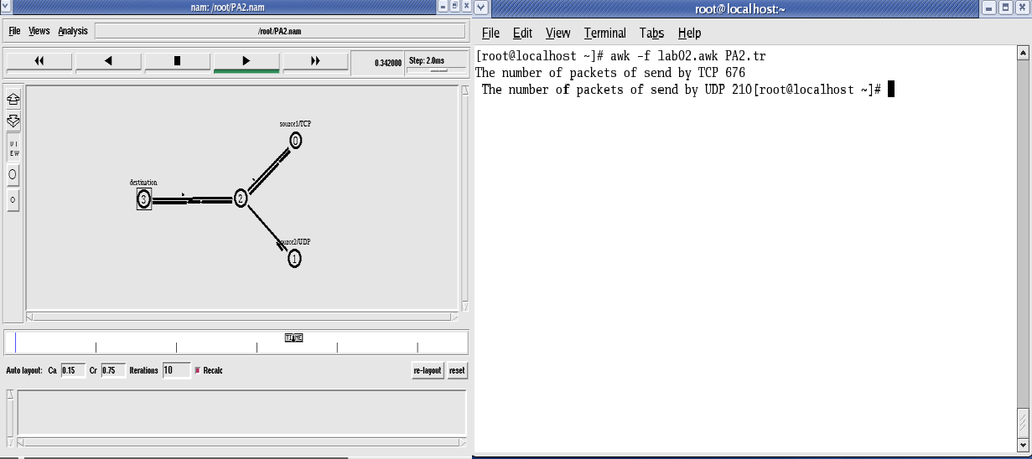
Topology Output

Experiment No: 3

ETHERNET LAN USING N-NODES
Aim: Simulate an Ethernet LAN using ‘n’ nodes, change error rate and data rate and compare throughput.

Step1: Open text editor, type the below program and save with extention .tcl (prog5.tcl )
set ns [new Simulator]
set nf [open prog5.nam w]
$ns namtrace-all $nf
set nd [open prog5.tr w]
$ns trace-all $nd
$ns color 1 Blue
$ns color 2 Red
proc finish { } {
global ns nf nd
$ns flush-trace
close $nf
close $nd
exec nam prog5.nam &
exit 0
}
set n0 [$ns node]
set n1 [$ns node]
set n2 [$ns node]
set n3 [$ns node]
set n4 [$ns node]
set n5 [$ns node]
set n6 [$ns node]
set n7 [$ns node]
set n8 [$ns node]
$n7 shape box
$n7 color Blue
$n8 shape hexagon
$n8 color Red
$ns duplex-link $n1 $n0 2Mb 10ms DropTail
$ns duplex-link $n2 $n0 2Mb 10ms DropTail
$ns duplex-link $n0 $n3 1Mb 20ms DropTail
$ns make-lan "$n3 $n4 $n5 $n6 $n7 $n8" 512Kb 40ms LL Queue/DropTail Mac/802_3
$ns duplex-link-op $n1 $n0 orient right-down
$ns duplex-link-op $n2 $n0 orient right-up
$ns duplex-link-op $n0 $n3 orient right
$ns queue-limit $n0 $n3 20
set tcp1 [new Agent/TCP/Vegas]
$ns attach-agent $n1 $tcp1
set sink1 [new Agent/TCPSink]
$ns attach-agent $n7 $sink1
$ns connect $tcp1 $sink1
$tcp1 set class_ 1
$tcp1 set packetsize_ 55
set ftp1 [new Application/FTP]
$ftp1 attach-agent $tcp1
set tfile [open cwnd.tr w]
$tcp1 attach $tfile
$tcp1 trace cwnd_
set tcp2 [new Agent/TCP/Reno]
$ns attach-agent $n2 $tcp2
set sink2 [new Agent/TCPSink]
$ns attach-agent $n8 $sink2
$ns connect $tcp2 $sink2
$tcp2 set class_ 2
$tcp2 set packetSize_ 55
set ftp2 [new Application/FTP]
$ftp2 attach-agent $tcp2
set tfile2 [open cwnd2.tr w]
$tcp2 attach $tfile2
$tcp2 trace cwnd_
$ns at 0.5 "$ftp1 start"
$ns at 1.0 "$ftp2 start"
$ns at 5.0 "$ftp2 stop"
$ns at 5.0 "$ftp1 stop"
$ns at 5.5 "finish"
$ns run
Step2: Open text editor, type the below program and save with extention .awk (prog5.awk )
BEGIN {
}
{
if($6=="cwnd_") {
printf("%f\t%f\n",$1,$7);
}
}
END {
}
Step3: Run the simulation program
[root@localhost~]# ns prog5.tcl
(Here “ns” indicates network simulator. We get the topology shown in the snapshot.)
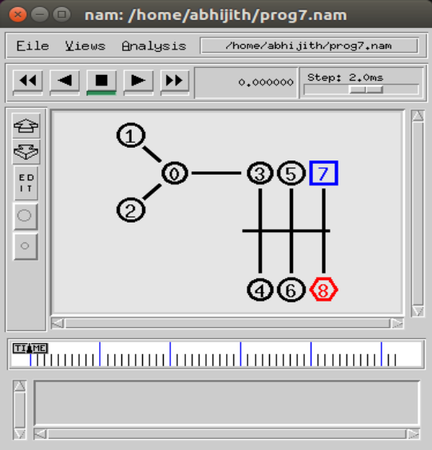
Step 4: Now press the play button in the simulation window and the simulation will begins.
Step 5: After simulation is completed run awk file and generate the graph ,
[root@localhost~]# awk –f prog5.awk cwnd.tr > a1
[root@localhost~]# awk –f prog5.awk cwnd2.tr > a2
[root@localhost~]#xgraph a1 a2
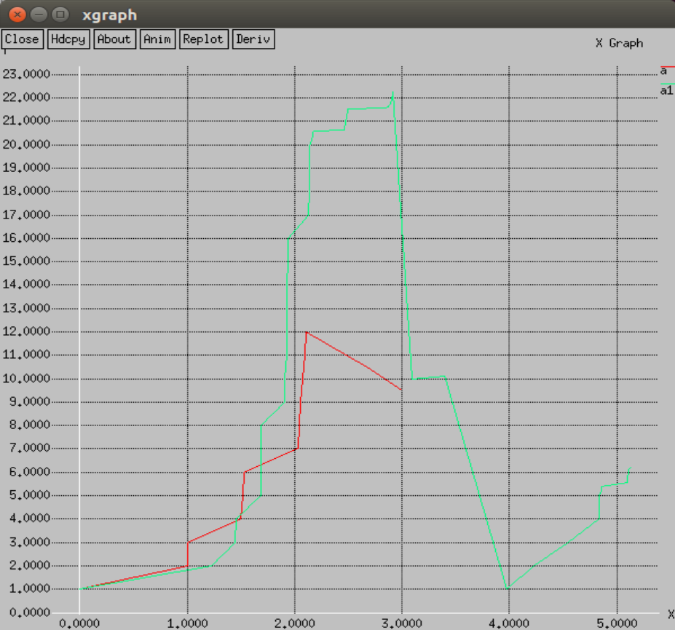

Step 6: To see the trace file contents open the file as ,
[root@localhost~]# vi prog5.tr

OR
set ns [new Simulator]
set tf [open lab3.tr w]
$ns trace-all $tf

set nf [open lab3.nam w]
$ns namtrace-all $nf
$ns color 0 blue set n0 [$ns node]
$n0 color "red" set n1 [$ns node]
$n1 color "red" set n2 [$ns node]
$n2 color "red" set n3 [$ns node]
$n3 color "red" set n4 [$ns node]

$n4 color "magenta" set n5 [$ns node]
$n5 color "magenta" set n6 [$ns node]
$n6 color "magenta" set n7 [$ns node]
$n7 color "magenta"

$ns make-lan "$n0 $n1 $n2 $n3" 100Mb 300ms LL Queue/ DropTail Mac/802_3
$ns make-lan "$n4 $n5 $n6 $n7" 100Mb 300ms LL Queue/ DropTail Mac/802_3

$ns duplex-link $n3 $n4 100Mb 300ms DropTail
$ns duplex-link-op $n3 $n4 color "green"
# set error rate. Here ErrorModel is a class and it is single word and space should not be given between Error and Model
# lossmodel is a command and it is single word. Space should not be given between loss and model
set err [new ErrorModel]
$ns lossmodel $err $n3 $n4
$err set rate_ 0.1
# error rate should be changed for each output like 0.1,0.3,0.5…. */
set udp [new Agent/UDP]
$ns attach-agent $n1 $udp
set cbr [new Application/Traffic/CBR]
$cbr attach-agent $udp
$cbr set fid_ 0
$cbr set packetSize_ 1000
$cbr set interval_ 0.0001 set null [new Agent/Null]
$ns attach-agent $n7 $null
$ns connect $udp $null
proc finish { }

{
global ns nf tf
$ns flush-trace close $nf
close $tf
exec nam lab3.nam & exit 0
}
$ns at 0.1 "$cbr start"
$ns at 3.0 "finish"
$ns run
AWK file:(Open a new editor using “vi command” and write awk file and save with “.awk” extension)

BEGIN{

pkt=0; time=0;
}
{
if($1= ="r" && $3= ="9" && $4= ="7")
{
pkt = pkt + $6; time =$2;
}
}

END
{
printf("throughput:%fMbps",(( pkt / time) * (8 / 1000000)));
}

Steps for execution
- Open vi editor and type program. Program name should have the extension “ .tcl ”
[root@localhost ~]# vi lab3.tcl
- Save the program by pressing “ESC key” first, followed by “Shift and :” keys simultaneously and type “wq” and press Enter key.
- Open vi editor and type awk program. Program name should have the extension “.awk ”
[root@localhost ~]# vi lab3.awk
- Save the program by pressing “ESC key” first, followed by “Shift and :” keys simultaneously and type “wq” and press Enter key.
- Run the simulation program
[root@localhost~]# ns lab3.tcl
  - Here “ns” indicates network simulator. We get the topology shown in the snapshot.
  - Now press the play button in the simulation window and the simulation will begins.
- After simulation is completed run awk file to see the output ,
[root@localhost~]# awk –f lab3.awk lab3.tr
- To see the trace file contents open the file as ,
[root@localhost~]# vi lab3.tr

Here “h” indicates host.

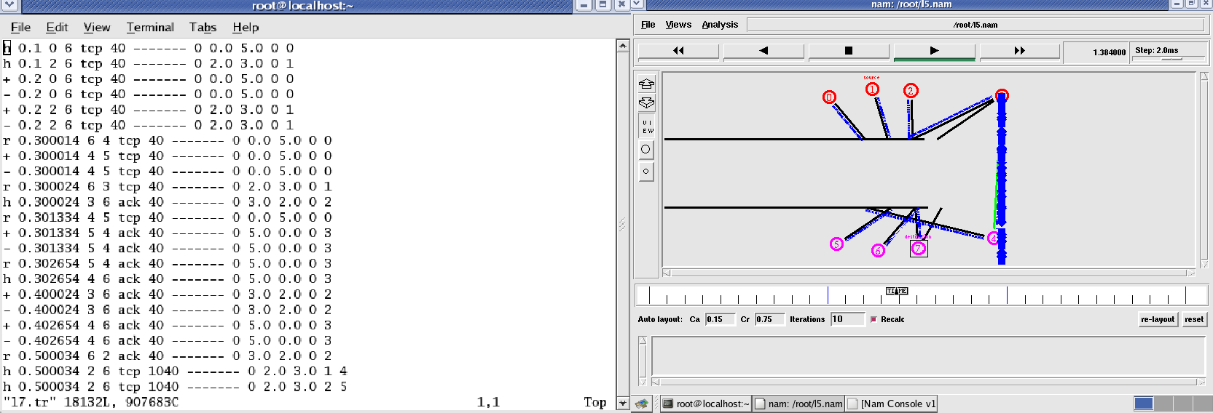
Topology Output
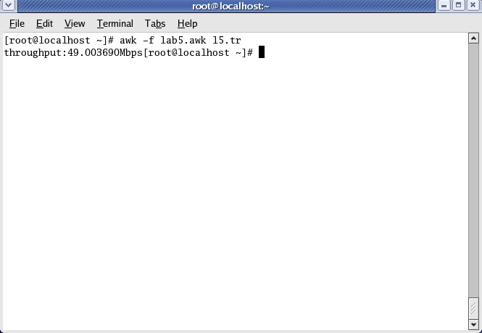
This above output is for error rate 0.1. During next execution of simulation change error rate to 0.3, 0.5,…..and check its effect on throughput.

Experiment No: 4
CRC
Problem Statement
Write a program for error detecting code using CRC-CCITT (16 bits).
Theory
CRC(Cyclic Redundancy Check) is an error detecting technique used in digital networks and
storage devices to detect the accidental changes to raw data. It cannot be used for correcting errors.
If an error is detected in the received message, a ‘Negative acknowledgement’ is sent to
the sender. The sender and the receiver agree upon a fixed polynomial called generator polynomial.
The standard agreed generator polynomial is x16+x12+x5+x0 (any polynomial can be considered, of
degree 16).
The CRC does error checking via polynomial division. The generated polynomial g(x) =
x16+x12+x5+x0

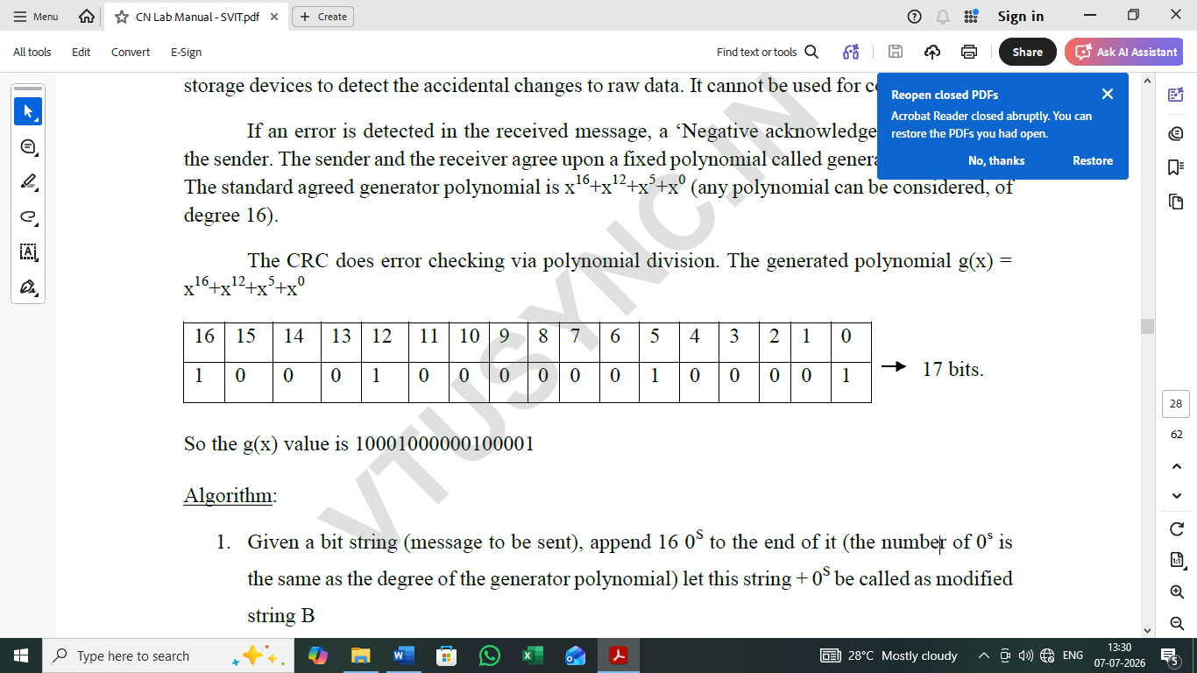

So the g(x) value is 10001000000100001
Algorithm:
1. Given a bit string (message to be sent), append 16 0S to the end of it (the number of 0s is
the same as the degree of the generator polynomial) let this string + 0S be called as modified
string B
2. Divide B by agreed on polynomial g(x) and determine the remainder R(x). The 16-bit
remainder received is called as checksum.
3. The message string is appended with checksum and sent to the receiver.
4. At the receiver side, the received message is divided by generator polynomial g(x).
5. If the remainder is 0, the receiver concludes that there is no error occurred otherwise, the
receiver concludes an error occurred and requires a retransmission.

import java.io.*;
class crc_gen
{
public static void main(String args[]) throws IOException
{
BufferedReader br=new BufferedReader(new InputStreamReader(System.in));
int[] data;
int[] div;
int[] divisor;
int[] rem;
int[] crc;
int data_bits, divisor_bits, tot_length;
System.out.println("Enter number of data bits : ");
data_bits=Integer.parseInt(br.readLine());
data=new int[data_bits];
System.out.println("Enter data bits : ");
for(int i=0; i<data_bits; i++)
data[i]=Integer.parseInt(br.readLine());
divisor_bits = 17;
divisor = new int[]{1,0,0,0,1,0,0,0,0,0,0,1,0,0,0,0,1};
tot_length=data_bits+divisor_bits-1;
div=new int[tot_length];
rem=new int[tot_length];
crc=new int[tot_length];
/* CRC GENERATION */
for(int i=0;i<data.length;i++)
div[i]=data[i];
System.out.print("Dividend (after appending 0's) are : ");
for(int i=0; i< div.length; i++)
System.out.print(div[i]);
System.out.println();
for(int j=0; j<div.length; j++){
rem[j] = div[j];
}
rem=divide(divisor, rem);
for(int i=0;i<div.length;i++) //append dividend and remainder
{
crc[i]=(div[i]^rem[i]);
}
System.out.println();
System.out.println("CRC code : ");
for(int i=0;i<crc.length;i++)
System.out.print(crc[i]);
/* ERROR DETECTION */
System.out.println();
System.out.println("Enter CRC code of "+tot_length+" bits : ");
for(int i=0; i<crc.length; i++)
crc[i]=Integer.parseInt(br.readLine());
for(int j=0; j<crc.length; j++){
rem[j] = crc[j];
}
rem=divide(divisor, rem);
for(int i=0; i< rem.length; i++)
{
if(rem[i]!=0)
{
System.out.println("Error");
break;
}
if(i==rem.length-1)
System.out.println("No Error");
}

System.out.println("THANK YOU. ....)");
}
static int[] divide(int divisor[], int rem[])
{
int cur=0;
while(true)
{
for(int i=0;i<divisor.length;i++)
rem[cur+i]=(rem[cur+i]^divisor[i]);
while(rem[cur]==0 && cur!=rem.length-1)
cur++;
if((rem.length-cur)<divisor.length)
break;
}
return rem;
}
}
OUTPUT:
RUN1

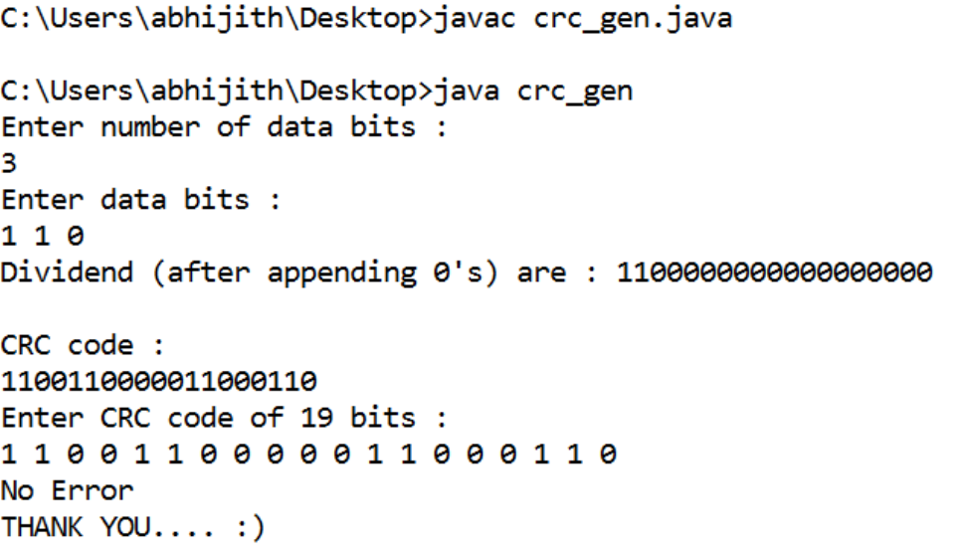

RUN 2:
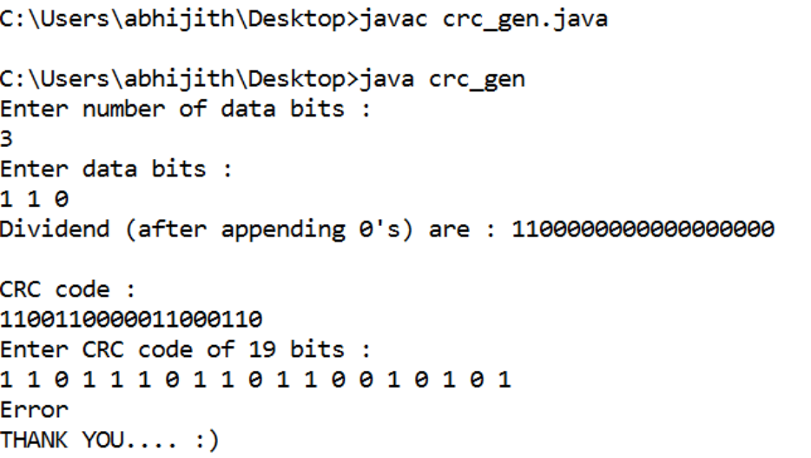

Experiment No: 5
Problem Statement:
Develop a program to implement a sliding window protocol in the data link layer.
Theory:
In computer networks sliding window protocol is a method to transmit data on a network. Sliding
window protocol is applied on the Data Link Layer of OSI model. At data link layer data is in the
form of frames. In Networking, Window simply means a buffer which has data frames that needs to be
transmitted.
Both sender and receiver agrees on some window size. If window size=w then after sending w frames
sender waits for the acknowledgement (ack) of the first frame.
As soon as sender receives the acknowledgement of a frame it is replaced by the next frames to be
transmitted by the sender. If receiver sends a collective or cumulative acknowledgement to sender
then it understands that more than one frames are properly received, for eg:- if ack of frame 3 is
received it understands that frame 1 and frame 2 are received properly.

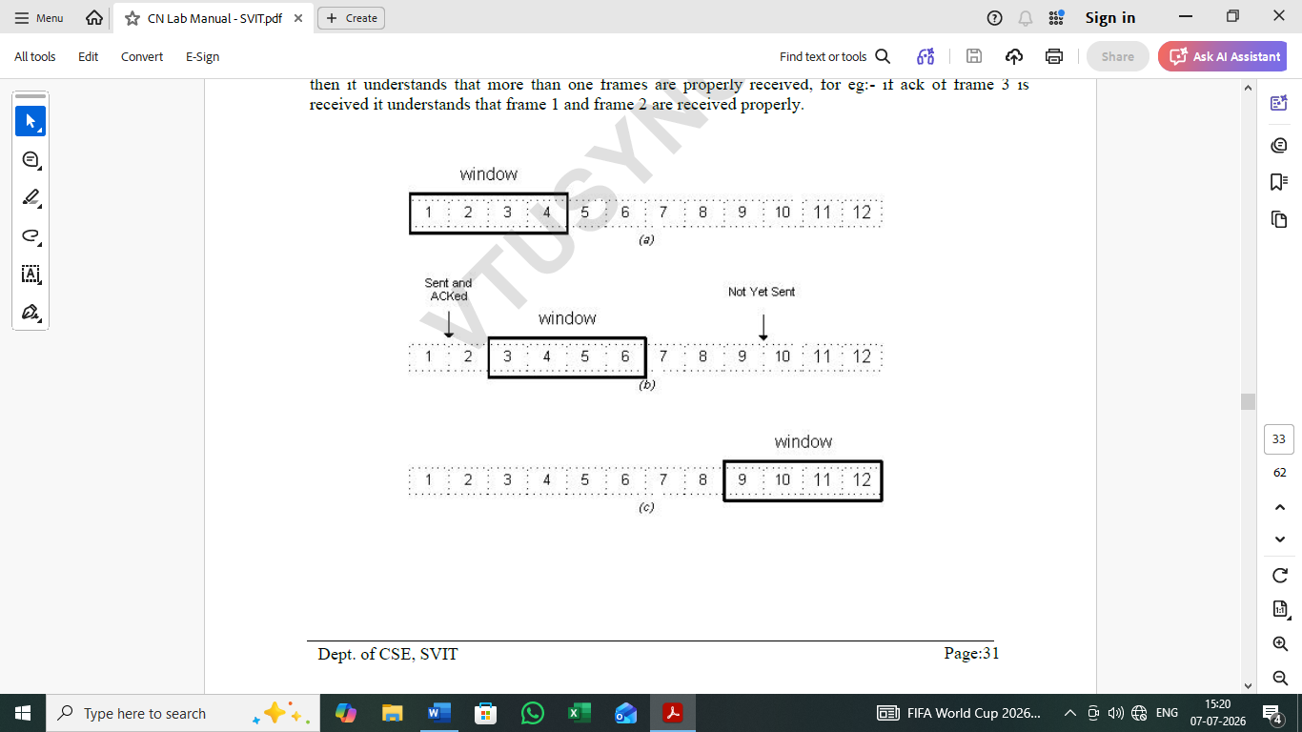

In sliding window protocol the receiver has to have some memory to compensate any loss in
transmission or if the frames are received unordered.
Efficiency of Sliding Window Protocol
η = (W*tx)/(tx+2tp)
W = Window Size
tx = Transmission time
tp = Propagation delay
Sliding window works in full duplex mode
It is of two types:-
1. Selective Repeat: Sender transmits only that frame which is erroneous or is lost.
2. Go back n: Sender transmits all frames present in the window that occurs after the error
bit including error bit also.
PROGRAM:
#include<stdio.h>
int main()
{
int w,i,f,frames[50];
printf("Enter window size: ");
scanf("%d",&w);
printf("\nEnter number of frames to transmit: ");
scanf("%d",&f);
printf("\nEnter %d frames: ",f);
for(i=1;i<=f;i++)
scanf("%d",&frames[i]);
printf("\nWith sliding window protocol the frames will be sent in the following manner
(assuming no corruption of frames)\n\n");
printf("After sending %d frames at each stage sender waits for acknowledgement sent by
the receiver\n\n",w);
for(i=1;i<=f;i++)
{
if(i%w==0)
{
printf("%d\n",frames[i]);
printf("Acknowledgement of above frames sent is received by sender\n\n");
}
else
printf("%d ",frames[i]);
}
if(f%w!=0)
printf("\nAcknowledgement of above frames sent is received by sender\n");
return 0;
}
OUTPUT:
Enter window size: 3
Enter number of frames to transmit: 5
Enter 5 frames: 12 5 89 4 6
With sliding window protocol the frames will be sent in the following manner (assuming no corruption of frames)
12 5 89
Acknowledgement of above frames sent is received by sender
4 6
Acknowledgement of above frames sent is received by sender

Experiment 6
Bellman-Ford algorithm
Problem Statement
Write a program to find the shortest path between vertices using bellman-ford algorithm.
Theory
Routing algorithm is a part of network layer software which is responsible for deciding which output
line an incoming packet should be transmitted on. If the subnet uses datagram internally, this decision must
be made anew for every arriving data packet since the best route may have changed since last time. If the
subnet uses virtual circuits (connection Oriented), routing decisions are made only when a new established
route is being set up.
Routing algorithms can be grouped into two major classes: adaptive and nonadaptive. Nonadaptive
algorithms do not base their routing decisions on measurement or estimates of current traffic and topology.
Instead, the choice of route to use to get from I to J (for all I and J) is compute in advance, offline, and
downloaded to the routers when the network ids booted. This procedure is sometime called static routing.
Adaptive algorithms, in contrast, change their routing decisions to reflect changes in the topology, and
usually the traffic as well. Adaptive algorithms differ in where they get information (e.g., locally, from
adjacent routers, or from all routers), when they change the routes (e.g., every ΔT sec, when the load
changes, or when the topology changes), and what metric is used for optimization (e.g., distance, number
of hops, or estimated transit time).
Two algorithms in particular, distance vector routing and link state routing are the most popular.
Distance vector routing algorithms operate by having each router maintain a table (i.e., vector) giving the
best known distance to each destination and which line to get there. These tables are updated by exchanging
information with the neighbors.
The distance vector routing algorithm uses Bellman-Ford routing algorithm and Ford-Fulkerson
algorithm. In distance vector routing, each router maintains a routing table that contains two parts: the
preferred out going line to use for that destination, and an estimate of the time or distance to that destination.
The metric used might be number of hops, time delay in milliseconds, total number of packets queued along
the path, or something similar.
The Routing tables are shared among the neighbors, and the tables at the router are updated, such that
the router will know the shortest path to the destination.

Program
import java.io.*;
import java.util.Scanner;
class dist_vec
{
public static void main(String args[])
{
int dmat[][];
int dist[][];
int via[][];
int n=0,i=0,j=0,k=0,count=0;
Scanner in = new Scanner(System.in);
System.out.println("enter the number of nodes\n");
n = in.nextInt();
dmat = new int[n][n];
dist = new int[n][n];
via = new int[n][n];
System.out.println("enter the cost matrix\n");
for(i=0;i<n;i++)
for(j=0;j<n;j++)
{
dmat[i][j] = in.nextInt();
dmat[i][i]=0;
dist[i][j]=dmat[i][j];
via[i][j]=j;
}
do
{
count=0;
for(i=0;i<n;i++)
for(j=0;j<n;j++)
for(k=0;k<n;k++)
if(dist[i][j]>dmat[i][k]+dist[k][j])
{
dist[i][j]=dist[i][k]+dist[k][j];
via[i][j]=k;
count++;
}
}while(count!=0);
for(i=0;i<n;i++)
{

System.out.println("state value for router"+i+" is");
for(j=0;j<n;j++)
{
System.out.println("To "+j+" -Via "+via[i][j]+" distance is "+dist[i][j]);
}
}
}
}
Output

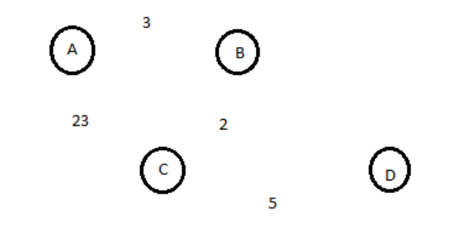

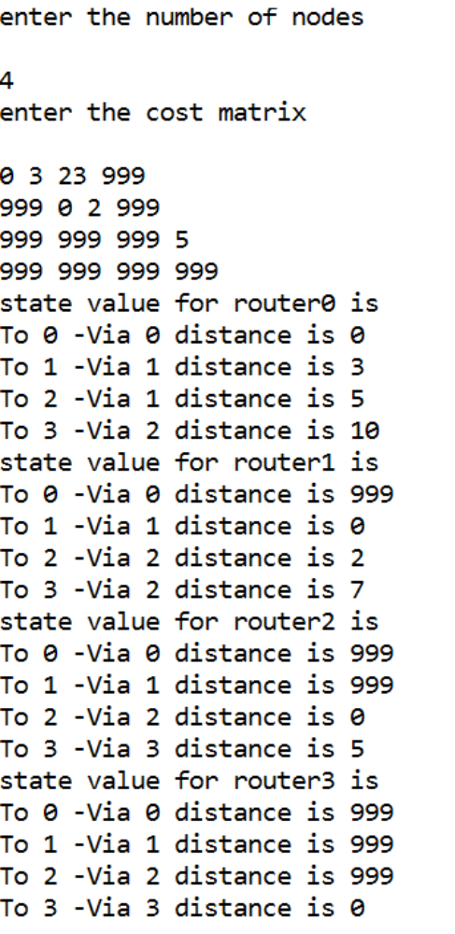

Experiment 7
Client-Server Program using TCP/IP sockets
Problem statement:
Using TCP/IP sockets, write a client – server program to make the client send the file name and
to make the server send back the contents of the requested file if present.
Theory:
Procedure:

Server Program
import java.net.*;
import java.io.*;
public class TCPServer
{
public static void main(String args[]) throws Exception
{
// establishing the connection with the server
ServerSocket sersock = new ServerSocket(4000);
System.out.println("Server ready for connection");
Socket sock = sersock.accept(); // binding with port: 4000
System.out.println("Connection is successful and wating for chatting");
// reading the file name from client
InputStream istream = sock.getInputStream( );
BufferedReader fileRead =new BufferedReader(new InputStreamReader(istream));
String fname = fileRead.readLine( );
// reading file contents
BufferedReader contentRead = new BufferedReader(new FileReader(fname) );
// keeping output stream ready to send the contents
OutputStream ostream = sock.getOutputStream( );
PrintWriter pwrite = new PrintWriter(ostream, true);
String str;
while((str = contentRead.readLine()) != null) // reading line-by-line from file
{
pwrite.println(str); // sending each line to client
}
sock.close(); sersock.close(); // closing network sockets
pwrite.close(); fileRead.close(); contentRead.close();
}
}
Client Program:
import java.net.*;
import java.io.*;

public class TCPClient
{
public static void main( String args[ ] ) throws Exception
{
Socket sock = new Socket( "127.0.0.1", 4000);
// reading the file name from keyboard. Uses input stream
System.out.print("Enter the file name");
BufferedReader keyRead = new BufferedReader(new InputStreamReader(System.in));
String fname = keyRead.readLine();
// sending the file name to server. Uses PrintWriter
OutputStream ostream = sock.getOutputStream( );
PrintWriter pwrite = new PrintWriter(ostream, true);
pwrite.println(fname);
// receiving the contents from server. Uses input stream
InputStream istream = sock.getInputStream();
BufferedReader socketRead = new BufferedReader(new InputStreamReader(istream));
String str;
while((str = socketRead.readLine()) != null) // reading line-by-line
{
System.out.println(str);
}
pwrite.close(); socketRead.close(); keyRead.close();
}
}
OUTPUT:
Create a text file say abc.txt and type some content in it.
Compile and execute server side program

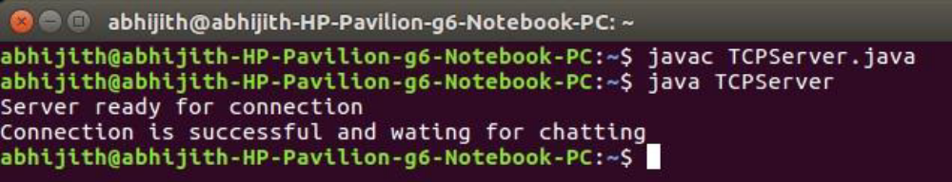

Open new terminal, compile and execute client side program
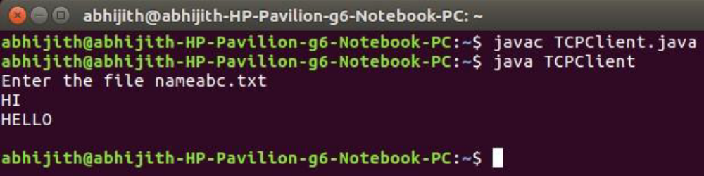

Experiment 8
Client-Server Program using UDP Socket
Problem Statement
Write a program on datagram socket for client/server to display the messages on client side, typed
at the server side.
Theory
Procedure:

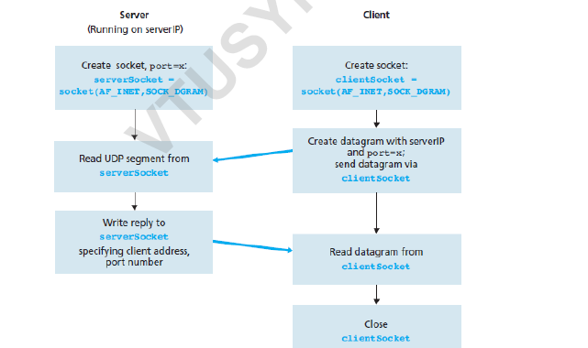

Server Program
import java.io.*;
import java.net.*;
class UDPServer
{
public static void main(String args[]) throws Exception
{
DatagramSocket serverSocket = new DatagramSocket(9876);
BufferedReader br = new BufferedReader(new InputStreamReader(System.in));
byte[] receiveData = new byte[1024];
byte[] sendData = new byte[1024];
DatagramPacket receivePacket = new DatagramPacket(receiveData, receiveData.length);
serverSocket.receive(receivePacket);
String sentence = new String( receivePacket.getData());
System.out.println("RECEIVED: " + sentence);
InetAddress IPAddress = receivePacket.getAddress();
int port = receivePacket.getPort();
System.out.println("Enter the Message");
String data = br.readLine();
sendData = data.getBytes();
DatagramPacket sendPacket = new DatagramPacket(sendData, sendData.length,
IPAddress, port);
serverSocket.send(sendPacket);
serverSocket.close();
}
}
Client Program
import java.io.*;
import java.net.*;
class UDPClient
{
public static void main(String args[]) throws Exception
{
BufferedReader in = new BufferedReader(new InputStreamReader(System.in));
DatagramSocket clientSocket = new DatagramSocket();
InetAddress IPAddress = InetAddress.getByName("localhost");
byte[] sendData = new byte[1024];
byte[] receiveData = new byte[1024];
String sentence = "Hello Server";
sendData = sentence.getBytes();
DatagramPacket sendPacket = new DatagramPacket(sendData, sendData.length, IPAddress,
9876);
clientSocket.send(sendPacket);
DatagramPacket receivePacket = new DatagramPacket(receiveData, receiveData.length);
clientSocket.receive(receivePacket);
String modifiedSentence = new String(receivePacket.getData());
System.out.println("FROM SERVER:" + modifiedSentence);
clientSocket.close();
}
}

OUTPUT
Compile and execute server side program
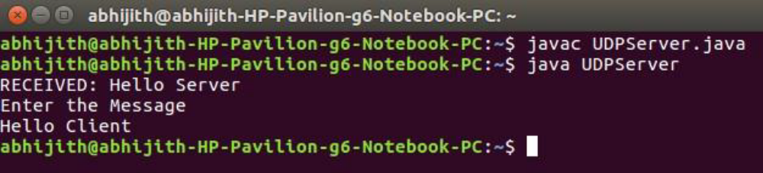
Open new terminal, compile and execute client side program
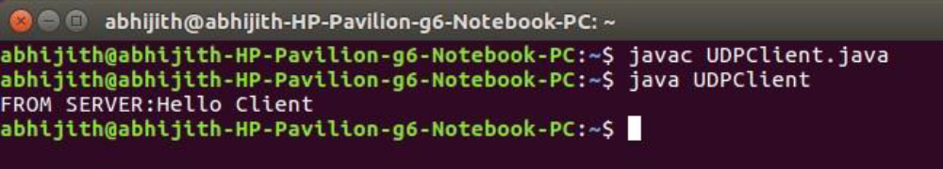

Experiment 9
RSA Algorithm
Problem Statement
Write a program for simple RSA algorithm to encrypt and decrypt the data.
Theory
Cryptography is the study of creating ciphers(cipher text) and breaking them (cryptanalysis). The
message to be encrypted, known as the plaintext, are transformed by a function that is parameterized by a
key. The output of the encryption process, known as the ciphertext, is then transmitted. often by messenger
or radio. The hacker, or intruder, hears and accurately copies down the complete ciphertext. However,
unlike the intended recipient, he does not know the decryption key and so cannot decrypt the ciphertext
easily.
There are several ways of classifying cryptographic algorithms. They are generally categorized based
on the number of keys that are employed for encryption and decryption, and further defined by their
application and use. The three types of algorithms are as follows:
1. Secret Key Cryptography (SKC): Uses a single key for both encryption and decryption. It is also known
as symmetric cryptography.
2. Public Key Cryptography (PKC): Uses one key for encryption and another for decryption. It is also
known as asymmetric cryptography.
3. Hash Functions: Uses a mathematical transformation to irreversibly "encrypt" information
Public-key cryptography has been said to be the most significant new development in cryptography.
Modern PKC was first described publicly by Stanford University professor Martin Hellman and graduate
student Whitfield Diffie in 1976. In public key cryptography, one key is used to encrypt the plaintext and
the other key is used to decrypt the ciphertext.
In PKC, one of the keys is designated the public key and may be advertised as widely as the owner
wants. The other key is designated the private key and is never revealed to another party. It is straight
forward to send messages under this scheme. Public key of the receiver is used for encryption, so that only
the receiver can decrypt the message (using his private key).
The RSA algorithm is named after Ron Rivest, Adi Shamir and Len Adleman, who invented it in 1977.
The RSA algorithm can be used for both public key encryption and digital signatures.
Algorithm
1. Generate two large random primes, P and Q, of approximately equal size.
2. Compute N = P x Q
3. Compute Z = (P-1) x (Q-1).
4. Choose an integer E, 1 < E < Z, such that GCD (E, Z) = 1
5. Compute the secret exponent D, 1 < D < Z, such that E x D ≡ 1 (mod Z)
bit stream.
6. The public key is (N, E) and the private key is (N, D).
Note: The values of P, Q, and Z should also be kept secret.
The message is encrypted using public key and decrypted using private key.
An example of RSA encryption
1. Select primes P=11, Q=3.
2. N = P x Q = 11 x 3 = 33
Z = (P-1) x (Q-1) = 10 x 2 = 20
3. Lets choose E=3
Check GCD(E, P-1) = GCD(3, 10) = 1 (i.e. 3 and 10 have no common factors except 1),
and check GCD(E, Q-1) = GCD(3, 2) = 1
therefore GCD(E, Z) = GCD(3, 20) = 1
4. Compute D such that E x D ≡ 1 (mod Z)
compute D = E^-1 mod Z = 3^-1 mod 20
find a value for D such that Z divides ((E x D)-1)
find D such that 20 divides 3D-1.
Simple testing (D = 1, 2, ...) gives D = 7
Check: (E x D)-1 = 3.7 - 1 = 20, which is divisible by Z.
5. Public key = (N, E) = (33, 3)
Private key = (N, D) = (33, 7).
Now say we want to encrypt the message m = 7,
Cipher code = M^E mod N
= 7^{^3} mod 33
= 343 mod 33
= 13.
Hence the ciphertext c = 13.
To check decryption we compute Message’ = C^{^D} mod N
= 13^{^7} mod 33
= 7.
Note that we don't have to calculate the full value of 13 to the power 7 here. We can make use of the
fact that a = bc mod n = (b mod n).(c mod n) mod n so we can break down a potentially large number into
its components and combine the results of easier, smaller calculations to calculate the final value.
Program:
import java.io.DataInputStream;
import java.io.IOException;
import java.math.BigInteger;
import java.util.Random;
public class RSA
{
private BigInteger p;
private BigInteger q;
private BigInteger N;
private BigInteger phi;
private BigInteger e;
private BigInteger d;
private int bitlength = 1024;
private Random r;
public RSA()
{
r = new Random();
p = BigInteger.probablePrime(bitlength, r);
q = BigInteger.probablePrime(bitlength, r);
N = p.multiply(q);
phi = p.subtract(BigInteger.ONE).multiply(q.subtract(BigInteger.ONE));
e = BigInteger.probablePrime(bitlength / 2, r);
while (phi.gcd(e).compareTo(BigInteger.ONE) > 0 && e.compareTo(phi) < 0)
{
e.add(BigInteger.ONE);
}
d = e.modInverse(phi);
}
public RSA(BigInteger e, BigInteger d, BigInteger N)
{
this.e = e;
this.d = d;
this.N = N;
}
@SuppressWarnings("deprecation")
public static void main(String[] args) throws IOException
{
RSA rsa = new RSA();
DataInputStream in = new DataInputStream(System.in);
String teststring;
System.out.println("Enter the plain text:");
teststring = in.readLine();
System.out.println("Encrypting String: " + teststring);
System.out.println("String in Bytes: "
+ bytesToString(teststring.getBytes()));
// encrypt
byte[] encrypted = rsa.encrypt(teststring.getBytes());
// decrypt
byte[] decrypted = rsa.decrypt(encrypted);
System.out.println("Decrypting Bytes: " + bytesToString(decrypted));
System.out.println("Decrypted String: " + new String(decrypted));
}
private static String bytesToString(byte[] encrypted)
{
String test = "";
for (byte b : encrypted)
{
test += Byte.toString(b);
}
return test;
}
// Encrypt message
public byte[] encrypt(byte[] message)
{
return (new BigInteger(message)).modPow(e, N).toByteArray();
}
// Decrypt message
public byte[] decrypt(byte[] message)
{
return (new BigInteger(message)).modPow(d, N).toByteArray();
}
}
Output
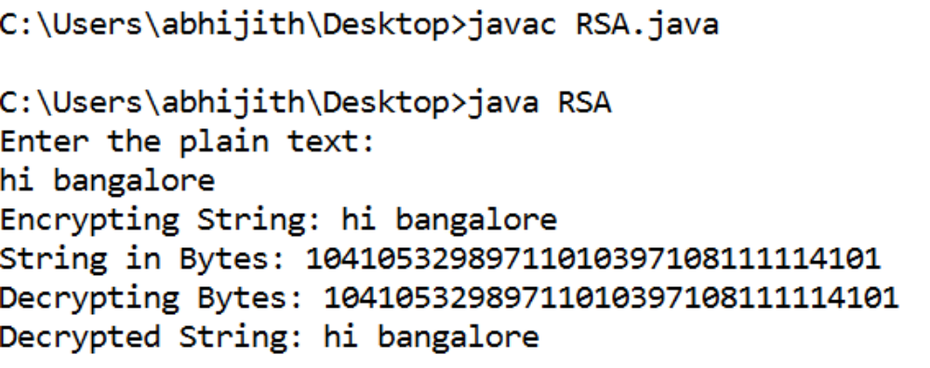

Experiment 10
Leaky Bucket
Problem Statement
Write a program for congestion control using leaky bucket algorithm.
Theory
The congesting control algorithms are basically divided into two groups: open loop and closed loop.
Open loop solutions attempt to solve the problem by good design, in essence, to make sure it does not occur
in the first place. Once the system is up and running, midcourse corrections are not made. Open loop
algorithms are further divided into ones that act at source versus ones that act at the destination.
In contrast, closed loop solutions are based on the concept of a feedback loop if there is any congestion.
Closed loop algorithms are also divided into two sub categories: explicit feedback and implicit feedback.
In explicit feedback algorithms, packets are sent back from the point of congestion to warn the source. In
implicit algorithm, the source deduces the existence of congestion by making local observation, such as the
time needed for acknowledgment to come back.
The presence of congestion means that the load is (temporarily) greater than the resources (in part of the
system) can handle. For subnets that use virtual circuits internally, these methods can be used at the network
layer.
Another open loop method to help manage congestion is forcing the packet to be transmitted at a more
predictable rate. This approach to congestion management is widely used in ATM networks and is called
traffic shaping.
The other method is the leaky bucket algorithm. Each host is connected to the network by an interface
containing a leaky bucket, that is, a finite internal queue. If a packet arrives at the queue when it is full, the
packet is discarded. In other words, if one or more process are already queued, the new packet is
unceremoniously discarded. This arrangement can be built into the hardware interface or simulate d by the
host operating system. In fact it is nothing other than a single server queuing system with constant service
time.
The host is allowed to put one packet per clock tick onto the network. This mechanism turns an uneven
flow of packet from the user process inside the host into an even flow of packet onto the network, smoothing
out bursts and greatly reducing the chances of congestion.
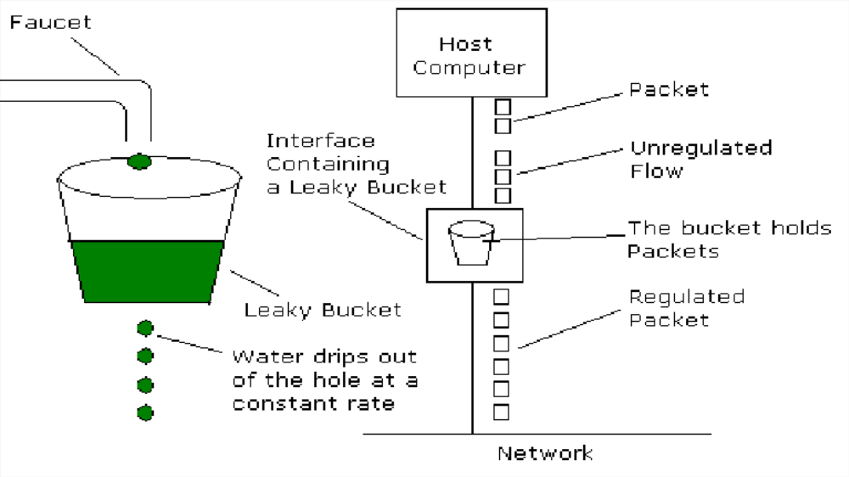
Program:
import java.lang.*;
import java.util.Random;
import java.io.*;
import java.util.Scanner;
class leaky_bucket
{
public static void main(String args[])
{
int drop=0,mini,nsec,p_remain=0;
int o_rate,b_size,i,packet[];
packet = new int[100];
Scanner in = new Scanner(System.in);
System.out.println("Enter bucket size:");
b_size = in.nextInt();
System.out.println("Enter the output rate:");
o_rate = in.nextInt();
System.out.println("Enter the number of seconds you want to simulate:");
nsec = in.nextInt();
Random rand = new Random();
for(i=0;i<nsec;i++)
packet[i]=((rand.nextInt(9)+1)*10);
System.out.println("Seconds|packets received|packets sent|packets left|packets dropped");
System.out.println(" ");
for(i=0;i<nsec;i++)
Program:
import java.lang.*;
import java.util.Random;
import java.io.*;
import java.util.Scanner;
class leaky_bucket
{
public static void main(String args[])
{
int drop=0,mini,nsec,p_remain=0;
int o_rate,b_size,i,packet[];
packet = new int[100];
Scanner in = new Scanner(System.in);
System.out.println("Enter bucket size:");
b_size = in.nextInt();
System.out.println("Enter the output rate:");
o_rate = in.nextInt();
System.out.println("Enter the number of seconds you want to simulate:");
nsec = in.nextInt();
Random rand = new Random();
for(i=0;i<nsec;i++)
packet[i]=((rand.nextInt(9)+1)*10);
System.out.println("Seconds|packets received|packets sent|packets left|packets dropped");
System.out.println(" ");
for(i=0;i<nsec;i++)

Output:
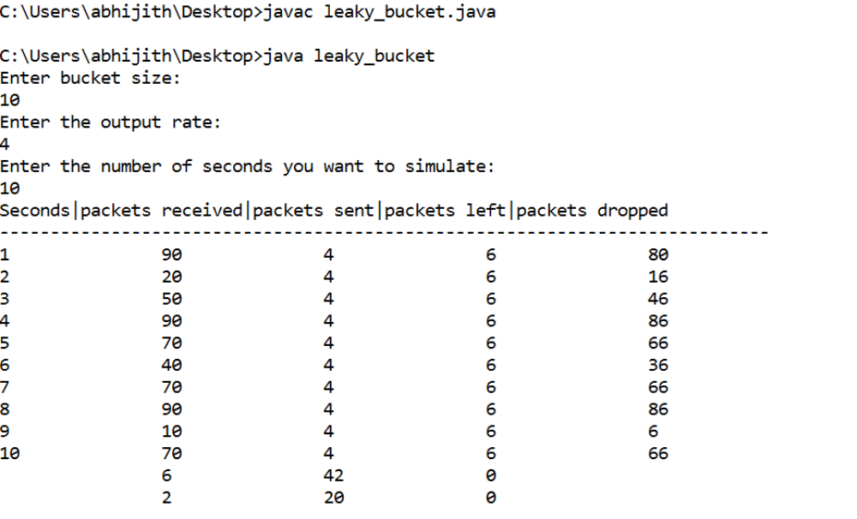
Viva Questions
1) What is a Link?
A link refers to the connectivity between two devices. It includes the type of cables and protocols
used in order for one device to be able to communicate with the other.
2) What are the layers of the OSI reference model?
There are 7 OSI layers: Physical Layer, Data Link Layer, Network Layer, Transport Layer, Session
Layer, Presentation Layer and Application Layer.
3) What is backbone network?
A backbone network is a centralized infrastructure that is designed to distribute different routes
and data to various networks. It also handles management of bandwidth and various channels.
4) What is a LAN?
LAN is short for Local Area Network. It refers to the connection between computers and other
network devices that are located within a small physical location.
5) What is a node?
A node refers to a point or joint where a connection takes place. It can be computer or device that
is part of a network. Two or more nodes are needed in order to form a network connection.
6) What are routers?
Routers can connect two or more network segments. These are intelligent network devices that
store information in its routing table such as paths, hops and bottlenecks. With this info, they are
able to determine the best path for data transfer. Routers operate at the OSI Network Layer.
7) What is point to point link?
It refers to a direct connection between two computers on a network. A point to point connection
does not need any other network devices other than connecting a cable to the NIC cards of both
computers.
8) What is anonymous FTP?
Anonymous FTP is a way of granting user access to files in public servers. Users that are allowed
access to data in these servers do not need to identify themselves, but instead log in as an
anonymous guest.
9) What is subnet mask?
A subnet mask is combined with an IP address in order to identify two parts: the extended network
address and the host address. Like an IP address, a subnet mask is made up of 32 bits.
10) What is the maximum length allowed for a UTP cable?
A single segment of UTP cable has an allowable length of 90 to 100 meters. This limitation can
be overcome by using repeaters and switches.
11) What is data encapsulation?
Data encapsulation is the process of breaking down information into smaller manageable chunks
before it is transmitted across the network. It is also in this process that the source and destination
addresses are attached into the headers, along with parity checks.
12) Describe Network Topology
Network Topology refers to the layout of a computer network. It shows how devices and cables
are physically laid out, as well as how they connect to one another.
13) What is VPN?
VPN means Virtual Private Network, a technology that allows a secure tunnel to be created across
a network such as the Internet. For example, VPNs allow you to establish a secure dialup
connection to a remote server.
14) Briefly describe NAT.
NAT is Network Address Translation. This is a protocol that provides a way for multiple
computers on a common network to share single connection to the Internet.
15) What is the job of the Network Layer under the OSI reference model?
The Network layer is responsible for data routing, packet switching and control of network
congestion. Routers operate under this layer.
16) How does a network topology
Network topology dictates what media you must use to interconnect devices. It also serves as basis
on what materials, connector and terminations that is applicable for the setup.
17) What is RIP?
RIP, short for Routing Information Protocol is used by routers to send data from one network to
another. It efficiently manages routing data by broadcasting its routing table to all other routers
within the network. It determines the network distance in units of hops.
18) What are different ways of securing a computer network?
There are several ways to do this. Install reliable and updated anti-virus program on all computers.
Make sure firewalls are setup and configured properly. User authentication will also help a lot. All
of these combined would make a highly secured network.
19) What is NIC?
NIC is short for Network Interface Card. This is a peripheral card that is attached to a PC in order
to connect to a network. Every NIC has its ownMAC address that identifies the PC on the network.
20) What is WAN?
WAN stands for Wide Area Network. It is an interconnection of computers and devices that are
geographically dispersed. It connects networks that are located in different regions and countries.
21) What is the importance of the OSI Physical Layer?
The physical layer does the conversion from data bits to electrical signal, and vice versa. This is
where network devices and cable types are considered and setup.
22) How many layers are there under TCP/IP?
There are four layers: the Network Layer, Internet Layer, Transport Layer and Application Layer.
23) What are proxy servers and how do they protect computer networks?
Proxy servers primarily prevent external users who identifying the IP addresses of an internal
network. Without knowledge of the correct IP address, even the physical location of the network
cannot be identified. Proxy servers can make a network virtually invisible to external users.
24) What is the function of the OSI Session Layer?
This layer provides the protocols and means for two devices on the network to communicate with
each other by holding a session. This includes setting up the session, managing information
exchange during the session, and tear-down process upon termination of the session
25) What is the importance of implementing a Fault Tolerance System? Are there
limitations?
A fault tolerance system ensures continuous data availability. This is done by eliminating a single
point of failure. However, this type of system would not be able to protect data in some cases, such
as in accidental deletions.
26) What does 10Base-T mean?
The 10 refers to the data transfer rate, in this case is 10Mbps. The word Base refers to base band,
as oppose to broad band. T means twisted pair, which is the cable used for that network.
27) What is a private IP address?
Private IP addresses are assigned for use on intranets. These addresses are used for internal
networks and are not routable on external public networks. These ensures that no conflicts are
present among internal networks while at the same time the same range of private IP addresses are
reusable for multiple intranets since they do not "see" each other.
28) What is NOS?
NOS, or Network Operating System, is specialized software whose main task is to provide network
connectivity to a computer in order for it to be able to communicate with other computers and
connected devices.
29) What is DoS?
DoS, or Denial-of-Service attack, is an attempt to prevent users from being able to access the
internet or any other network services. Such attacks may come in different forms and are done by
a group of perpetuators. One common method of doing this is to overload the system server so it
cannot anymore process legitimate traffic and will be forced to reset.
30) What is OSI and what role does it play in computer networks?
OSI (Open Systems Interconnect) serves as a reference model for data communication. It is made
up of 7 layers, with each layer defining a particular aspect on how network devices connect and
communicate with one another. One layer may deal with the physical media used, while another
layer dictates how data is actually transmitted across the network.
31) What is the purpose of cables being shielded and having twisted pairs?
The main purpose of this is to prevent crosstalk. Crosstalks are electromagnetic interferences or
noise that can affect data being transmitted across cables.
32) What is the advantage of address sharing?
By using address translation instead of routing, address sharing provides an inherent security
benefit. That's because host PCs on the Internet can only see the public IP address of the external
interface on the computer that provides address translation and not the private IP addresses on the
internal network.
33) What are MAC addresses?
MAC, or Media Access Control, uniquely identifies a device on the network. It is also known as
physical address or Ethernet address. A MAC address is made up of 6-byte parts.
34) What is the equivalent layer or layers of the TCP/IP Application layer in terms of OSI
reference model?
The TCP/IP Application layer actually has three counterparts on the OSI model: the Session layer,
Presentation Layer and Application Layer
35) How can you identify the IP class of a given IP address?
By looking at the first octet of any given IP address, you can identify whether it's Class A, B or C.
If the first octet begins with a 0 bit, that address is Class A. If it begins with bits 10 then that
address is a Class B address. If it begins with 110, then it's a Class C network.
36) What is the main purpose of OSPF?
OSPF, or Open Shortest Path First, is a link-state routing protocol that uses routing tables to
determine the best possible path for data exchange.
37) What are firewalls?
Firewalls serve to protect an internal network from external attacks. These external threats can be
hackers who want to steal data or computer viruses that can wipe out data in an instant. It also
prevents other users from external networks from gaining access to the private network.
38) Describe star topology
Star topology consists of a central hub that connects to nodes. This is one of the easiest to setup
and maintain.
39) What are gateways?
Gateways provide connectivity between two or more network segments. It is usually a computer
that runs the gateway software and provides translation services. This translation is a key in
allowing different systems to communicate on the network.
40) What is the disadvantage of a star topology?
One major disadvantage of star topology is that once the central hub or switch get damaged, the
entire network becomes unusable.
41) What is SLIP?
SLIP, or Serial Line Interface Protocol, is actually an old protocol developed during the early
UNIX days. This is one of the protocols that are used for remote access.
42) Give some examples of private network addresses.
10.0.0.0 with a subnet mask of 255.0.0.0
172.16.0.0 with subnet mask of 255.240.0.0
192.168.0.0 with subnet mask of 255.255.0.0
43) What is tracert?
Tracert is aWindows utility program that can used to trace the route taken by data from the router
to the destination network. It also shows the number of hops taken during the entire transmission
route.
44) What are the functions of a network administrator?
A network administrator has many responsibilities that can be summarize into 3 key functions:
installation of a network, configuration of network settings, and maintenance/troubleshooting of
networks.

ALGORITHM for BIT STUFFING:
Step1: Input data sequence
Step 2: Add start of frame to output sequence
Step 3: For every bit in input
- Append bit to output sequence
- Is bit a 1?
Yes: Increment count,
If count is 5, append 0 to output sequence and reset count.
No: Set count to 0
Step 4: Add stop of frame bits to output sequence.

ALGORITHM for BIT DESTUFFING:
Step 1: Input the stuffed sequence.
Step 2: Remove start of frame from sequence.
Step 3: For every bit in input,
- Append bit to output sequence.
- Is bit a 1?
Yes: Increment count. If count is 5, remove next bit (which is 0) & reset count. No: Set count to 0.
Step 4: Remove end of frame from bits from sequence.

C- LANGUAGE PROGRAM CODE
#include<stdio.h>
// #include<conio.h> #include<string.h>
void main() { char ch,array[50]={"01111110"},recd_array[50]; int counter=0,i=8,j,k;

// clrscr();
printf("Enter the original data stream for bit stuffing:\n");
while((ch=getchar())!='\n')
{ if(ch=='1')
++counter; else
counter=0; array[i++]=ch; if(counter==5)
{
array[i++]='0';
counter=0;
}
}
strcat(array,"01111110");
printf("\n The stuffed data stream is:\n");
for(j=0;j<i+8;++j) printf("%c",array[j]);
counter=0;
printf("\n The destuffed data stream is:\n"); for(j=8,k=0;j<i+8;++j)
{
if(array[j]=='1')
++counter; else counter=0;
recd_array[k++]=array[j]; if(counter==6)
break;
else if(counter==5 && array[j+1]=='0')
{
++j;
counter=0;
}
}
for(j=0;j<=k-strlen("01111110");++j) printf("%c",recd_array[j]);
// getch();
}

OUTPUT:
Enter the original data stream for bit stuffing: 0011011111000011110

The stuffed data stream is: 011111100011011111000001111001111110

The destuffed data stream is:
0011011111000011110

Experiment No: 2 Date:

CHARACTER STUFFING
AIM: Implement the data link layer framing using character-stuffing for a given character data.

THEORY:
The framing method gets around the problem of resynchronization after an error by having each frame start with the ASCII character sequence DLE. If the destination ever losses the track of the frame boundaries all it has to do is look for DLE characters to figure out. The data link layer on the receiving end removes the DLE before the data are given to the network layer. This technique is called character stuffing.

ALGORITHM:
Step 1: Start
Step 2 Read the character string to be transmitted in upper case.
Step 3: For stuffing process, append at begin with ‘DLE’ as starting flag byte and end with ‘DLE’ as ending flag byte of the string.
Step 4: Check the string whether it has ‘DLE’.
Step 5: If yes then insert the string ‘ESC’ before the character DLE transmit the next character.
Step 6: Continue this process until the completion of string.
Step 7: Stuffed data is obtained.
Step 8: Now destuffing process, remove the appended string at start and end of string.
Step 9: Continue this process until the last character of string.
Step 10: If yes then remove the string ‘DLE’ that is encountered first else transmit the data.
Step 11: Continue this process until the last character of string.
Step 12: Original data has been obtained.
Step 13 Stop.

C- LANGUAGE PROGRAM CODE
#include<stdio.h>
// #include<conio.h> #include<string.h> main()
{
char a[50],s1[100]={"DLE"},s2[10];
int i,j,l;

// clrscr();
printf("\n character stuffing and unstuffing program\n"); printf("\n @ SENDER --\n");
printf("\n enter the message to be sent:\n"); gets(a);
l=strlen(a); //string length for(i=0;i<l;i++)
{
if((a[i]=='D'&&a[i+1]=='L'&&a[i+2]=='E')||
(a[i]=='E'&&a[i+1]=='S'&&a[i+2]=='C'))
{
for(j=l+3;j>=i+3;j--)
{ a[j]=a[j-3]; //shifted data three position to the right
}
l=l+3; a[i]='E';
a[i+1]='S';
a[i+2]='C';
i=i+5;
}
}
printf("\n message after character stuffing:\n"); printf("%s\n",a);
strcpy(s2,s1); strcat(s1,a); strcat(s1,s2);
printf("\n the transmitted frame:\n"); printf("%s\n",s1);
printf("\n \n");
printf("\n @RECEIVER --\n");
l=strlen(s1); //lenght of flag+stuffed_message+flag s1[l-3]='\0'; //remove end delimiter(flag) l=strlen(s1);
for(i=0;i<l;i++)
s1[i]=s1[i+3]; //remove start delimiter(flag) l=strlen(s1);
printf("\nmessage after flag removal at receiver:\n"); printf("%s\n",s1);
for(i=0;i<l;i++)
{
if(s1[i]=='E'&&s1[i+1]=='S'&&s1[i+2]=='C')
{
for(j=i;j<=l;j++)

{ s1[j]=s1[j+3]; //shifted data three position to the left
}
l=l-3; i=i+2;
}
}
printf("\nmessage after unstuffing:\n"); printf("%s\n",s1);

// getch();
}
}
RESULT: Character stuffing and Unstuffing program

@SENDER --
Enter the message to be sent:
ETXWITHSTXCANDLE
Message after Character stuffing: ETXWITHSTXCANESCDLE
The transmitted frame:
DLE ETXWITHSTXCANESCDLE DLE

………………………………………………………… @RECEIVER –
Message after flag removal at receiver:
ETXWITHSTXCANESCDLE
Message after Unstuffing : ETXWITHSTXCANDLE

Experiment No: 3 Date:

DISTANCE VECTOR ALGORITHM
Aim: C Program for Distance Vector Algorithm to find suitable path for transmission

Distance Vector Algorithm is a decentralized routing algorithm that requires that each router simply inform its neighbors of its routing table. For each network path, the receiving routers pick the neighbor advertising the lowest cost, then add this entry into its routing table for re-advertisement. To find the shortest path, Distance Vector Algorithm is based on one of two basic algorithms: the Bellman-Ford and the Dijkstra algorithms.
Routers that use this algorithm have to maintain the distance tables (which is a one-dimension array -- "a vector"), which tell the distances and shortest path to sending packets to each node in the network. The information in the distance table is always upd by exchanging information with the neighboring nodes. The number of data in the table equals to that of all nodes in networks (excluded itself). The columns of table represent the directly attached neighbors whereas the rows represent all destinations in the network. Each data contains the path for sending packets to each destination in the network and distance/or time to transmit on that path (we call this as "cost"). The measurements in this algorithm are the number of hops, latency, the number of outgoing packets, etc.
The starting assumption for distance-vector routing is each node knows the cost of the link of each of its directly connected neighbors. Next, every node sends a configured message to its directly connected neighbors containing its own distance table. Now, every node can learn and up its distance table with cost and next hops for all nodes network. Repeat exchanging until no more information between the neighbors.
Consider a node A that is interested in routing to destination H via a directly attached neighbor J. Node A's distance table entry, Dx(Y,Z) is the sum of the cost of the direct-one hop link between A and J, c(A,J), plus neighboring J's currently known minimum-cost path

(shortest path) from itself(J) to H. That is Dx(H,J) = c(A,J) + minw{Dj(H,w)} The minw is taken over all the J's. This equation suggests that the form of neighbor-to-neighbor communication that will take place in the DV algorithm - each node must know the cost of each of its neighbors' minimum-cost path to each destination. Hence, whenever a node computes a new minimum cost to some destination, it must inform its neighbors of this new minimum cost.
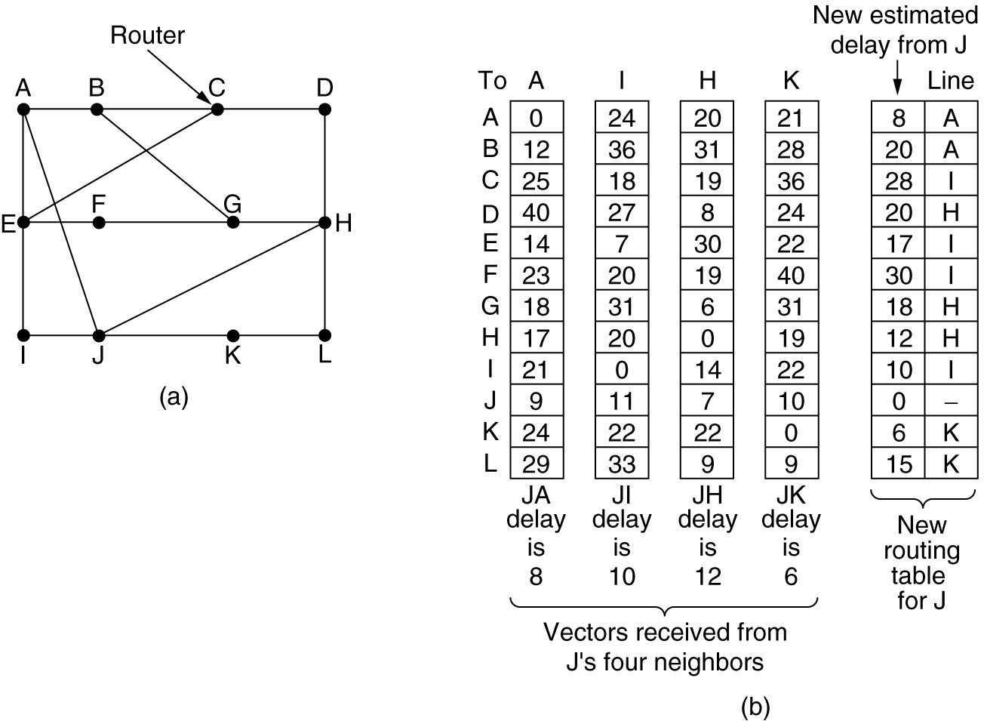
Figure (a) A subnet. (b) Input from A, I, H, K, and the new routing table for J.
Implementation Algorithm:
- send my routing table to all my neighbors whenever my link table changes
- when I get a routing table from a neighbor on port P with link metric M:
  - add L to each of the neighbor's metrics
  - for each entry (D, P', M') in the updated neighbor's table:
    - if I do not have an entry for D, add (D, P, M') to my routing table
    - if I have an entry for D with metric M", add (D, P, M') to my routing table if M' < M"
- if my routing table has changed, send all the new entries to all my neighbors.

C- LANGUAGE PROGRAM CODE
#include<stdio.h> #include<stdlib.h>
// void rout_table();

int d[10][10],via[10][10];
int i,j,k,l,m,n,g[10][10],temp[10][10],ch,cost; int main()
{
system("clear");
printf("enter the value of no. of nodes\n"); scanf("%d",&n);
// rout_table();
Printf(“Enter the cost matrix \n”); for(i=0;i<n;i++)
{
for(j=0;j<n;j++)
{
Scanf(” %d”, &g[i][j]); if(g[i][j]!=999)
d[i][j]=1;
}
}
for(i=0;i<n;i++) for(j=0;j<n;j++)
{
temp[i][j]=g[i][j]; via[i][j]=i;
}
while(1)
{
for(i=0;i<n;i++) for(j=0;j<n;j++)
if(d[i][j]) for(k=0;k<n;k++)
if(g[i][j]+g[j][k]<g[i][k])
{
g[i][k]=g[i][j]+g[j][k]; via[i][k]=j;
}
for(i=0;i<n;i++)
{

}
break;
}
printf("table for router %c\n" ,i+97); for(j=0;j<n;j++)
printf("%c:: %d via %c\n" ,j+97, g[i][j],via[i][j]+97);

}
}

OUTPUT:
[root@localhost ]# cc prg3.c [root@localhost ]# ./a.out
enter the value of no. of nodes 4
Enter the routing table:
|a b c d

a |0 5 1 4
b |5 0 6 2
c |1 6 0 3
d |4 2 3 0
table for router a a:: 0 via a
b:: 5 via a c:: 1 via a d:: 4 via a
table for router b a:: 5 via b
b:: 0 via b c:: 5 via d d:: 2 via b
table for router c a:: 1 via c
b:: 5 via d c:: 0 via c d:: 3 via c

table for router d a:: 4 via d
b:: 2 via d c:: 3 via d d:: 0 via d
do you want to change the cost(1/0) 1
enter the vertices which you want to change the cost 1 3

enter the cost 2
table for router a a:: 0 via a
b:: 5 via a c:: 2 via a d:: 4 via a
table for router b a:: 5 via b
b:: 0 via b c:: 5 via d d:: 2 via b
table for router c a:: 2 via c
b:: 5 via d c:: 0 via c d:: 3 via c
table for router d a:: 4 via d
b:: 2 via b c:: 3 via d d:: 0 via d
do you want to change the cost(1/0) 0

Experiment No: 4 Date:

SHORTEST PATH USING DIJKSTRA ALGORITHM
AIM: Write a C/C++ program to find the shortest path algorithm using Dijkstra’s algorithm.

THEORY:
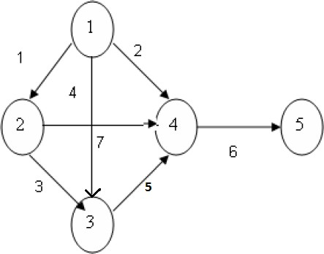
Dijkstra’s algorithm progressively identifies the closest no Dijkstra’s algorithm progressively identifies the closest nodes from the source node in order of increasing path cost. The algorithm is iterative. The Dijkstra’s algorithm calculates the shortest path between two points on a network using a graph made up of nodes and edges The algorithm divides the nodes into two sets : tentative and permanent . It chooses nodes, makes them tentative, examines them and if they pass the criteria makes them permanent.

ALGORITHM:
Step1: Declare array path [5] [5], min, a [5][5], index, t[5]; Step2: Declare and initialize st=1,ed=5
Step 3: Declare variables i, j, stp, p, edp Step 4: print “enter the cost “
Step 5: i=1

Step 6: Repeat step (7 to 11) until (i<=5)
Step 7: j=1
Step 8: repeat step (9 to 10) until (j<=5) Step 9: Read a[i] [j]
Step 10: increment j Step 11: increment i
Step 12: print “Enter the path” Step 13: read p
Step 14: print “Enter possible paths” Step 15: i=1
Step 16: repeat step(17 to 21) until (i<=p) Step 17: j=1
Step 18: repeat step(19 to 20) until (i<=5) Step 19: read path[i][j]
Step 20: increment j Step 21: increment i Step 22: j=1
Step 23: repeat step(24 to 34) until(i<=p) Step 24: t[i]=0
Step 25: stp=st
Step 26: j=1
Step 27: repeat step(26 to 34) until(j<=5) Step 28: edp=path[i][j+1]
Step 29: t[i]= [ti]+a[stp][edp] Step 30: if (edp==ed) then Step 31: break;
Step 32: else
Step 33: stp=edp Step 34: end if Step 35: min=t[st]
Step 36: index=st
Step 37: repeat step( 38 to 41) until (i<=p)
Step 38: min>t[i]

Step 39: min=t[i]
Step 40: index=i Step 41: end if
Step 42: print” minimum cost” min Step 43: print” minimum cost pth”
Step 44: repeat step(45 to 48) until (i<=5) Step 45: print path[index][i]
Step 46: if(path[idex][i]==ed) then Step 47: break
Step 48: end if End

C- LANGUAGE PROGRAM CODE
#include<stdio.h>
// #include<conio.h> void main()
{
int path[5][5], i, j, min, a[5][5], p, st=1,ed=5,stp,edp,t[5],index;
// clrscr();
printf("Enter the cost matrix\n"); for(i=1;i<=5;i++) for(j=1;j<=5;j++) scanf("%d",&a[i][j]); printf("Enter the paths\n"); scanf("%d",&p);
printf("Enter possible paths\n"); for(i=1;i<=p;i++) for(j=1;j<=5;j++) scanf("%d",&path[i][j]); for(i=1;i<=p;i++)
{
t[i]=0;
stp=st; for(j=1;j<=5;j++)
{
edp=path[i][j+1]; t[i]=t[i]+a[stp][edp]; if(edp==ed)
break; else

stp=edp;
}
}
min=t[st];index=st; for(i=1;i<=p;i++)
{
if(min>t[i])
{
min=t[i]; index=i;
}
}
printf("Minimum cost %d",min); printf("\n Minimum cost path "); for(i=1;i<=5;i++)
{
printf("--> %d",path[index][i]); if(path[index][i]==ed)
break;
}
getch();
}

OUTPUT:
Enter the cost matrix

0 | 1 | 4 | 2 | 0
1 | 0 | 3 | 7 | 0
4 | 3 | 0 | 5 | 0
2 | 7 | 5 | 0 | 6
0 | 0 | 0 | 6 | 0
Enter the paths 4
Enter possible paths
1 2 3 4 5
1 2 4 5 0
1 3 4 5 0
1 4 5 0 0
Minimum cost 8
Minimum cost path → 1→ 4 →5

Experiment No: 5 Date:
ERROR DETECTING CODE Using CRC-CCITT (16-bit)
AIM: C Program for ERROR detecting code using CRC-CCITT (16bit).

THEORY :
Whenever digital data is stored or interfaced, data corruption might occur. Since the beginning of computer science, developers have been thinking of ways to deal with this type of problem. For serial data they came up with the solution to attach a parity bit to each sent byte. This simple detection mechanism works if an odd number of bits in a byte changes, but an even number of false bits in one byte will not be detected by the parity check. To overcome this problem developers have searched for mathematical sound mechanisms to detect multiple false bits. The CRC calculation or cyclic redundancy check was the result of this. Nowadays CRC calculations are used in all types of communications. All packets sent over a network connection are checked with a CRC. Also each data block on your hard disk has a CRC value attached to it. Modern computer world cannot do without these CRC calculations. So let's see why they are so widely used. The answer is simple; they are powerful, detect many types of errors and are extremely fast to calculate especially when dedicated hardware chips are used.
The idea behind CRC calculation is to look at the data as one large binary number. This number is divided by a certain value and the remainder of the calculation is called the CRC. Dividing in the CRC calculation at first looks to cost a lot of computing power, but it

can be performed very quickly if we use a method similar to the one learned at school. We will as an example calculate the remainder for the character 'm'—which is 1101101 in binary notation—by dividing it by 19 or 10011. Please note that 19 is an odd number. This is necessary as we will see further on. Please refer to your schoolbooks as the binary calculation method here is not very different from the decimal method you learned when you were young. It might only look a little bit strange. Also notations differ between countries, but the method is similar.
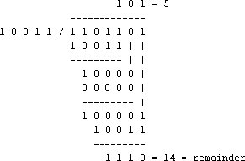
With decimal calculations you can quickly check that 109 divided by 19 gives a quotient of 5 with 14 as the remainder. But what we also see in the scheme is that every bit extra to check only costs one binary comparison and in 50% of the cases one binary subtraction. You can easily increase the number of bits of the test data string—for example to 56 bits if we use our example value "Lammert"—and the result can be calculated with 56 binary comparisons and an average of 28 binary subtractions. This can be implemented in hardware directly with only very few transistors involved. Also software algorithms can be very efficient.
All of the CRC formulas you will encounter are simply checksum algorithms based on modulo-2 binary division where we ignore carry bits and in effect the subtraction will be equal to an exclusive or operation. Though some differences exist in the specifics across different CRC formulas, the basic mathematical process is always the same:
- The message bits are appended with c zero bits; this augmented message is the dividend
- A predetermined c+1-bit binary sequence, called the generator polynomial, is the divisor
- The checksum is the c-bit remainder that results from the division operation Table 1 lists some of the most commonly used generator polynomials for 16- and 32-bit
CRCs. Remember that the width of the divisor is always one bit wider than the remainder.

So, for example, you’d use a 17-bit generator polynomial whenever a 16-bit checksum is required.
 | CRC-CCITT | CRC-16 | CRC-32
Checksum Width | 16 bits | 16 bits | 32 bits
Generator Polynomial | 10001000000100001 | 11000000000000101 | 100000100110000010001110110110111
Table 1. International Standard CRC Polynomials
Error detection with CRC
Consider a message represented by the polynomial M(x) Consider a generating polynomial G(x)
This is used to generate a CRC = C(x) to be appended to M(x). Note this G(x) is prime.
Steps: 1. Multiply M(x) by highest power in G(x). i.e. Add So much zeros to M(x).
- Divide the result by G(x). The remainder = C(x).
Special case: This won't work if bitstring =all zeros. We don't allow such an M(x).But M(x) bitstring = 1 will work, for example. Can divide 1101 into 1000.
- If: x div y gives remainder c
that means: x = n y + c , Hence (x-c) = n y (x-c) div y gives remainder 0
Here (x-c) = (x+c)
Hence (x+c) div y gives remainder 0
- Transmit: T(x) = M(x) + C(x)
- Receiver end: Receive T(x). Divide by G(x), should have remainder 0.
Note if G(x) has order n - highest power is xn, then G(x) will cover (n+1) bits
and the remainder will cover n bits. i.e. Add n bits (Zeros) to message. Some CRC polynomials that are actually used
Some CRC polynomials
- CRC-8:
x⁸+x²+x+1
  - Used in: 802.16 (along with error correction).
- CRC-CCITT: x¹⁶+x¹²+x⁵+1
  - Used in: HDLC, SDLC, PPP default

- IBM-CRC-16 (ANSI): x¹⁶+x¹⁵+x²+1
- 802.3:
x³²+x²⁶+x²³+x²² +x¹⁶+x¹²+x¹¹+x¹⁰ +x⁸+x⁷+x⁵+x⁴+x²+x+1
  - Used in: Ethernet, PPP rootion

C- LANGUAGE PROGRAM CODE
#include<stdio.h>
int a[100],b[100],i,j,len,k,count=0;
//Generator Polynomial:g(x)=x^16+x^12+x^5+1
int gp[]={1,0,0,0,1,0,0,0,0,0,0,1,0,0,0,0,1,};
int main()
{
void div(); system("clear");
printf("\nEnter the length of Data Frame :"); scanf("%d",&len);
printf("\nEnter the Message :"); for(i=0;i<len;i++) scanf("%d",&a[i]);
//Append r(16) degree Zeros to Msg bits
for(i=0;i<16;i++)
a[len++]=0;
//Xr.M(x) (ie. Msg+16 Zeros)
for(i=0;i<len;i++)
b[i]=a[i];
//No of times to be divided ie.Msg Length
k=len-16; div();
for(i=0;i<len;i++)
b[i]=b[i]^a[i]; //MOD 2 Substraction printf("\nData to be transmitted : "); for(i=0;i<len;i++)
printf("%2d",b[i]);
printf("\n\nEnter the Reveived Data : "); for(i=0;i<len;i++)
scanf("%d",&a[i]);
div(); for(i=0;i<len;i++)
if(a[i]!=0)
{
printf("\nERROR in Recived Data"); return 0;
}
printf("\nData Recived is ERROR FREE");

}
void div()
{
for(i=0;i<k;i++)
{
if(a[i]==gp[0])
{
for(j=i;j<17+i;j++) a[j]=a[j]^gp[count++];
}
count=0;
}
}
Output:
Enter the length of Data Frame :4 Enter the Message :1 0 1 1
Data to be transmitted : 1 0 1 1 1 0 1 1 0 0 0 1 0 1 1 0 1 0 1 1
Enter the Reveived Data : 1 0 1 1 1 0 1 1 0 0 0 0 0 1 1 0 1 0 1 1 ERROR in Recived Data
Remender is : 0000000100000000
**********************************************************
Experiment No: 6 Date:

STOP AND WAIT PROTOCOL
AIM: Implementation of Stop and Wait protocol using C.

THEORY:
If data frames arrive at the receiver site faster than they can be processed, the frames must be stored until their use. The protocol we discuss now is called the Stop-and-Wait Protocol because the sender sends one frame, stops until it receives confirmation from the receiver (okay to go ahead), and then sends the next frame.
We still have unidirectional communication for data frames, but auxiliary ACK frames (simple tokens of acknowledgment) travel from the other direction, so that we add flow control.

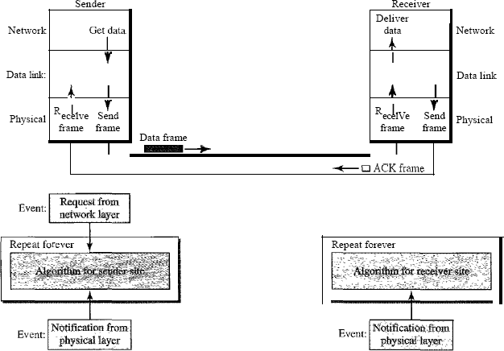

C- LANGUAGE PROGRAM CODE
#include<stdio.h> #include<conio.h> #include<stdlib.h> void main()
{
int i,j,noframes,x,x1=10,x2; noframes=10;
i=1; j=1;
printf("Number of frames is %d ",noframes);
getch(); while(noframes>0)
{
printf("\n Sending frames is %d",i); x=rand()%10;
if(x%10==0)
{
for(x2=1;x2<2;x2++)
{
printf("\n Waiting for %d seconds\n",x2); sleep(x2);
}
printf("\n Sending frames %d\n",i); x=rand()%10;
}

i++;
printf("\n Ack for frame %d\n",j); noframes=noframes-1;

j++;

}

}
printf("\n End of Stop and Wait protocol\n");

Output : Number of frames is 10 Sending frame is 1
Ack for frame 1
Sending frame is 2 Ack for frame 2
Sending frame is 3 Ack for frame 3
Sending frame is 4 Waiting for 1 Seconds
Sending frames 4
Ack for frame 4
Sending frame is 5 Ack for frame 5
Sending frame is 6 Ack for frame 6
Sending frame is 7 Ack for frame 7
Sending frame is 8 Ack for frame 8
Sending frame is 9 Ack for frame 9
Sending frame is 10 Ack for frame 10

End of Stop and Wait protocol

Experiment No: 7 Date:

SLIDING WINDOW PROTPCOL
AIM: Implementation of Sliding Window Protocol using C.

THEORY:
It allows multiple frames to be in transmit as compared to stop and wait protocol. In this the receiver has buffer of length W. Transmitter can send up to W frames without ACK. Each frame is numbered according to modular arithmetic. ACK includes number of next frame expected. Sequence number bounded by size of field (k).

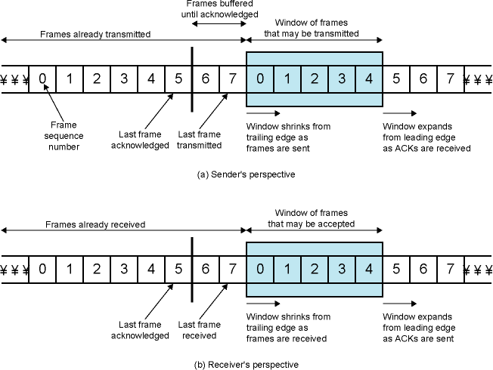
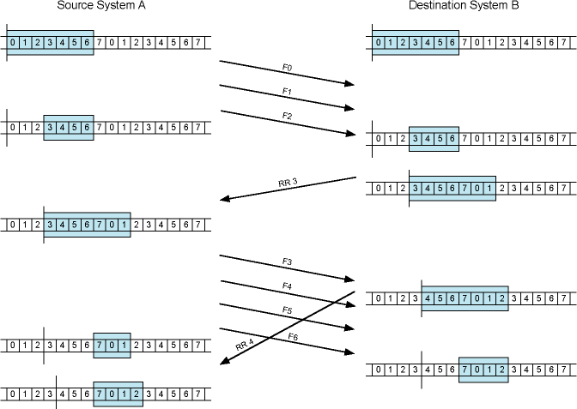

C- LANGUAGE PROGRAM CODE
#include<stdio.h>

#include<conio.h> void main()
{
char sender[50],receiver[50]; int i,winsize;
// clrscr();
printf("\n ENTER THE WINDOWS SIZE : ");
scanf("%d",&winsize);
printf("\n SENDER WINDOW IS EXPANDED TO STORE MESSAGE \n"); printf("\n ENTER THE DATA TO BE SENT: ");
fflush(stdin); gets(sender); for(i=0;i<winsize;i++) receiver[i]=sender[i]; receiver[i]=NULL;
printf("\n MESSAGE SEND BY THE SENDER:\n");
puts(sender);
printf("\n WINDOW SIZE OF RECEIVER IS EXPANDED\n"); printf("\n ACKNOWLEDGEMENT FROM RECEIVER \n");
for(i=0;i<winsize;i++); printf("\n ACK:%d",i);
printf("\n MESSAGE RECEIVED BY RECEIVER IS : ");
puts(receiver);
printf("\n WINDOW SIZE OF RECEIVER IS SHRINKED \n");
getch();
}

OUTPUT
ENTER THE WINDOW SIZE: 5
SENDER WINDOW IS EXPANDED TO STORE MESSAGE ENTER THE DATA TO BE SENT: CITGUBBI
MESSAGE SEND BY THE SENDER: CITGUBBI WINDOW SIZE OF RECEIVER IS EXPANDED ACKNOWLEDGEMENT FROM RECEIVER ACK: 5
MESSAGE RECEIVED BY RECEIVER IS: CITGU WINDOW SIZE OF RECEIVER IS SHRINKED

Experiment No: 8 Date:
Congestion Control Using LEAKY BUCKET ALGORITHM AIM: Implementation of Congestion Control using Leaky Bucket Algorithm.

THEORY:
The main concept of the leaky bucket algorithm is that the output data flow remains constant despite the variant input traffic, such as the water flow in a bucket with a small hole at the bottom. In case the bucket contains water (or packets) then the output flow follows a constant rate, while if the bucket is full any additional load will be lost because of spillover. In a similar way if the bucket is empty the output will be zero. From network perspective, leaky bucket consists of a finite queue (bucket) where all the incoming packets are stored in case there is space in the queue, otherwise the packets are discarded. In order to regulate the output flow, leaky bucket transmits one packet from the queue in a fixed time (e.g. at every clock tick). In the following figure we can notice the

main rationale of leaky bucket algorithm, for both the two approaches (e.g. leaky bucket with water (a) and with packets (b)).
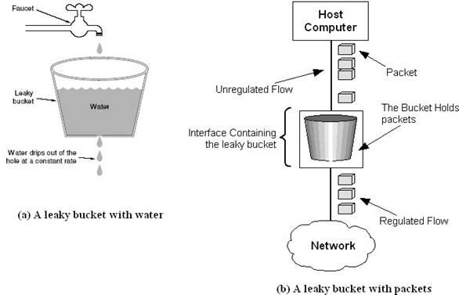
Figure 2.4 - The leaky bucket traffic shaping algorithm
While leaky bucket eliminates completely bursty traffic by regulating the incoming data flow its main drawback is that it drops packets if the bucket is full. Also, it doesn’t take into account the idle process of the sender which means that if the host doesn’t transmit data for some time the bucket becomes empty without permitting the transmission of any packet. Implementation Algorithm:
- Read The Data For Packets
- Read The Queue Size
- Divide the Data into Packets
- Assign the random Propagation delays for each packets to input into the bucket (input_packet).
- wlile((Clock++<5*total_packets)and (out_packets< total_paclets))
  - if (clock == input_packet)
    - insert into Queue
  - if (clock % 5 == 0 )
    - Remove paclet from Queue

- End

C- LANGUAGE PROGRAM CODE

#include<stdio.h> #include<strings.h> #include<stdio.h> int min(int x,int y)
{
if(x<y)
return x; else
return y;
}
int main()
{
int drop=0,mini,nsec,cap,count=0,i,inp[25],process; syste("clear");
printf("Enter The Bucket Size\n"); scanf("%d",&cap);
printf("Enter The Operation Rate\n"); scanf("%d",&process);
printf("Enter The No. Of Seconds You Want To Stimulate\n"); scanf("%d",&nsec);
for(i=0;i<nsec;i++)
{
printf("Enter The Size Of The Packet Entering At %d sec\n",i+1);
scanf("%d",&inp[i]);
}
printf("\nSecond|Packet Recieved|Packet Sent|Packet Left|Packet Dropped|\n");
printf(" \n");
for(i=0;i<nsec;i++)
{
count+=inp[i]; if(count>cap)
{
drop=count-cap; count=cap;
}
printf("%d",i+1);

printf("\t%d",inp[i]); mini=min(count,process); printf("\t\t%d",mini); count=count-mini; printf("\t\t%d",count); printf("\t\t%d\n",drop); drop=0;
}
for(;count!=0;i++)
{
if(count>cap)
{
drop=count-cap; count=cap;
}
printf("%d",i+1);
printf("\t0"); mini=min(count,process); printf("\t\t%d",mini); count=count-mini; printf("\t\t%d",count); printf("\t\t%d\n",drop);
}
}

OUTPUT:
Compile and run
$ cc –o Congestion Congestion.c
$ ./Congestion
Enter The Bucket Size 5
Enter The Operation Rate 2
Enter The No. Of Seconds You Want To Stimulate 3
Enter The Size Of The Packet Entering At 1 sec 5
Enter The Size Of The Packet Entering At 1 sec 4
Enter The Size Of The Packet Entering At 1 sec 3

Second|Packet Recieved|Packet Sent|Packet Left|Packet Dropped|

1 | 5 | 2 | 3 | 0
2 | 4 | 2 | 3 | 2
3 | 3 | 2 | 3 | 1
4 | 0 | 2 | 1 | 0
5 | 0 | 1 | 0 | 0

VIVA QUESTIONS
- What are functions of different layers?
- Differentiate between TCP/IP Layers and OSI Layers
- Why header is required?
- What is the use of adding header and trailer to frames?
- What is encapsulation?
- Why fragmentation requires?
- Differentiate between flow control and congestion control.
- Differentiate between Point-to-Point Connection and End-to-End connections.
- What are protocols running in different layers?

- What is Protocol Stack?
- Differentiate between TCP and UDP.
- Differentiate between Connectionless and connection oriented connection.
- What is meant by subnet?
- What is meant by Gateway?
- What is an IP address?
- What is MAC address?
- Why IP address is required when we have MAC address?
- What is meant by port addressing?
- How do you classify congestion control algorithms?
- What is Leaky bucket algorithm.
- How do you implement Leaky bucket?
- How do you generate busty traffic?
- What is the polynomial used in CRC-CCITT?
- What are the other error detection algorithms?
- What is difference between CRC and Hamming code?
- What is odd parity and even parity?
- What is meant by syndrome?
- What is generator matrix?
- What is spanning tree?
- What are Routing algorithms?
- How do you classify routing algorithms? Give examples for each.
- What are drawbacks in distance vector algorithm?
- How routers update distances to each of its neighbor?
- What is cryptography?
- How do you classify cryptographic algorithms?
- What are key, ciphertext and plaintext?
- What is simulation?
- What are advantages of simulation?
- Differentiate between Simulation and Emulation.
- What is meant by router?
- What is meant by bridge?
- What is meant by switch?

- What is meant by hub?
- Differentiate between route, bridge, switch and hub.
- What is FTP?
- What is BER?
- What is meant by congestion window?
- What is throughput?
- What is collision?
- How do you setup Ethernet LAN?
- What is meant by mobile host?
- Name few other Network simulators
- Differentiate between logical and physical address.
- Which address gets affected if a system moves from one place to another place?
- What is ICMP? What are uses of ICMP? Name few.
- Which layer implements security for data?

COMPUTER NETWORKS LABORATORY
MODEL QUESTIONS

Programs Based on Network Simulator(NS-2)
- Implement a point to pint network with four nodes and duplex links between them. Analyze the network performance by setting the queue size and varying the bandwidth using NS-2.
- Implement a four node point to point network with links n0-n2, n1-n2 and n2-n3. Apply TCP agent between n0-n3 and UDP between n1-n3. Apply relevant applications over TCP and UDP agents changing the parameter and determine the number of packets sent by TCP/UDP using NS-2.
- Implement Ethernet LAN using n (6-10) nodes. Compare the throughput by changing the error rate and data rate using NS-2.
- Implement Ethernet LAN using n nodes and assign multiple traffic to the nodes and obtain congestion window for different sources/ destinations using NS-2
- Implement ESS with transmission nodes in Wireless LAN and obtain the performance parameters using NS-2.
- Implement of Link state routing algorithm using NS-2.
- Programs Based on C Language
  - Write a C program to perform Bit stuffing in HDLC frame for a given data……….
  - Write a C program to perform Character stuffing in HDLC frame for a given data
  - Write a C program to implement distance vector algorithm to find suitable path for transmission.
  - Implement Dijkstra’s algorithm using C program to compute the shortest routing path.
  - Write a C program for error detection using CRC-CCITT (16bit) to obtain CRC code for a given CRC-CCITT polynomial.
  - Implement a Stop and Wait Protocol using ‘C’ Language.
  - Implement a Sliding Window Protocol using ‘C’ Language.

8 Write a C program for congestion control using leaky bucket algorithm.

REFERENCES

- Communication Networks: Fundamental Concepts and Key Architectures - Alberto Leon, Garcia and Indra Widjaja, 3rd Edition, Tata McGraw- Hill, 2004.
- Data and Computer Communication, William Stallings, 8^{tht}Edition, Pearson Education, 2007.
- Computer Networks: A Systems Approach - Larry L. Peterson and Bruce S. David, 4th Edition, Elsevier, 2007.
- Introduction to Data Communications and Networking – Wayne Tomasi, Pearson Education, 2005.
- Communication Networks – Fundamental Concepts and Key architectures – Alberto Leon- Garcia and Indra Widjaja:, 2rd Edition, Tata McGraw-Hill, 2004
- Computer and Communication Networks – Nader F. Mir:, Pearson Education, 2007.

Additional experiment Beyond the syllabus

DATA ENCRYPTION AND DECRYPTION

AIM:
To implement Data encryption and decryption

SOFTWARE REQUIREMENTS:
Turbo C software

THEORY: In encryption, each letter position in the file text which is given in encrypt mode is changed according to the ascending order of the key text. In decryption each letter position in the encrypted file text is changed according to the ascending order of the key text.

ALGORITHM-ENCRYPTION
Get the text to be encrypted (plain text) and key text.
The resulting value will be the encrypted format (cipher text) of the plain text
- Find the length of the plain text.
- For i=1 to length of plain text
- Find the binary equivalent of ith character of plain text.
- Find the binary equivalent of ith character of key text
- Find the XOR of above two values.

ALGORITHM-DECRYPTION
Get the text to be decrypted (cipher text) and key text. Find the length of the cipher text.
For i=1 to length of cipher text
The resulting value will be the decrypted format (original plain text) of the cipher plain text
- Find the binary equivalent of ith character of cipher text.
- Find the binary equivalent of ith character of key text
- Find the XOR of above two values
PROGRAM
# include <stdio.h> #include<conio.h> void main ( )
{ static int s, i, k,n,c[100];
printf(“\n program 1: encryption and 2. decryption”); scanf (“%d”, &s);
switch (s)
{ case 1: printf(“enter the key value:”); scanf(“%d”, &k);
printf(“enter the length of text:”); scanf(“%d”, &n);
printf(“enter the data to be encrypted:”); for (i=0;i<=n;i++)
scanf(“%c”, &c[i]); for (i=0;i<=n;i++)
{c[i]=c[i]+k; if (c[i]>90)

c[i]=c[i]-26;}
printf(“encrypted data”); for (i=1;i<=n;i++) printf(“%c”, c[i]); break;
case 2: printf(“enter the key value:”); scanf(“%d”, &k);
printf(“enter the length of text:”); scanf(“%d”, &n);
printf(“enter the data to be decrypted:”); for (i=0;i<=n;i++)
scanf(“%c”, &c[i]); for (i=0;i<=n;i++)
{c[i]=c[i]-k; if (c[i]<65) c[i]=c[i]+26;}
printf(“decrypted data”); for (i=1;i<=n;i++) printf(“%c”, c[i]); break;
case 3: break; getch ();
}
}
OUTPUT:
Program 1: encryption and 2. decryption
- ENCRYPTION

enter the key value: 1 enter the length of text: 5
enter the data to be encrypted: HELLO encrypted data : IFMMP
- DECRYPTION

enter the key value: 1 enter the length of text: 5
enter the data to be decrypted: IFMMP decrypted data : HELLO

VIVA QUESTIONS:
- What is meant by Encryption?
- What is Decryption?
- Encrypt the word “HELLO” using Caesar cipher.
- What are the different algorithms available for encryption?
- What type of information can be secured with Cryptography?
RESULT:
Thus the Data Encryption and Decryption was studied

