From 26/05/2025

1. Addition of two numbers :   
   Get/ take input from  
   Query parameters ( i.e two values ) and response should be “Sum of the numbers <value1> and <value2> is <sum>”

Gatway script to slove the problem:

var apim = require('apim');

var num1 = apim.getvariable('request.parameters.a');

var num2 = apim.getvariable('request.parameters.b');

var sum = Number(num1) + Number(num2);

apim.setvariable('message.body',"Sum of the numbers "+ num1 +"and"+ num2+ "is "+sum);

Output :

Sum of the two numbers 14 and 15 is 29.

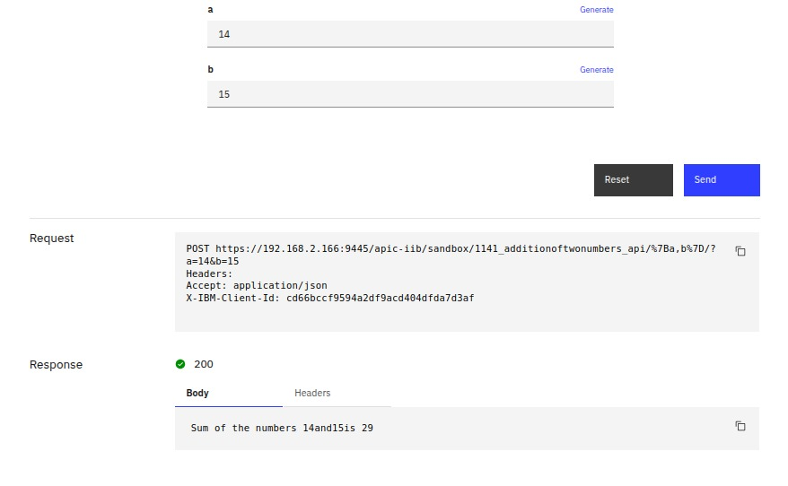

1. Json request:-   
   {   
    "AADHAARTYPE": "IND1",   
    "PANNUMBER": "1174843344",   
    "STATE": "UP",   
    "AADHAARID": "136211001811144",   
    "NAME": "GHOSH",   
    "IDTYPE": "CARD",   
    "IDNUMBER": "811144",   
    "PASSPORT": "M2264445",   
    "SECURITYCODE": "9",   
    "BIRTHDATE": "03/10/1999",   
    "BIRTHTIME": "15:43:10",   
    "REFNUMBER": "20251003AC1",   
    "PHONENUMBER": "9988888518221"   
     
   }   
   Check AADHAARID value in request is empty or not, if empty then below error throw in response by api connect   
   {   
      "ecode": "400",   
      "eMessage": "AADHAARID is missing"   
   }

Code in gatway script

var apim = require('apim');

var js = apim.getvariable('message.body');

var str = Number(js.AADHAARID); // Safe access

if (str>= 1) {

apim.setvariable('message.body', { "statuscode": "200" });

} else {

apim.setvariable('message.body', { "ecode": "400","emessage":"adhar is missing" });

}

Output :

Case 1:if AAdhAAr is present

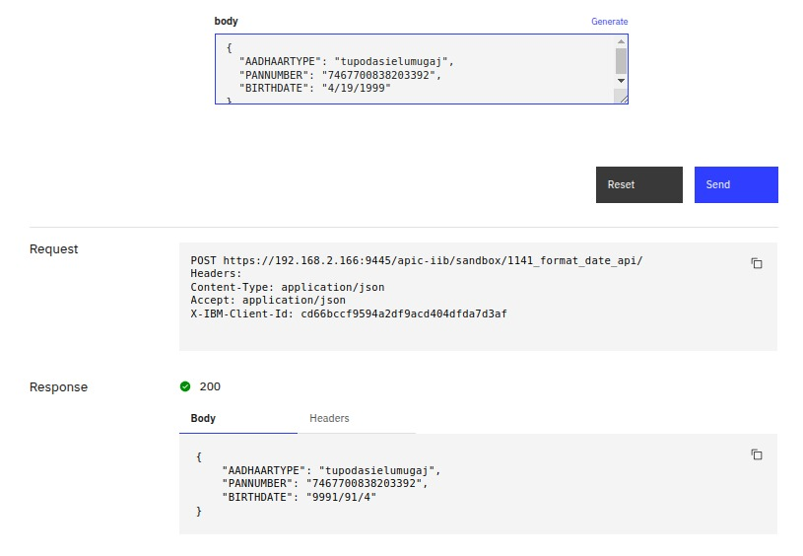

Case 2: if AADHAAR is not having the value

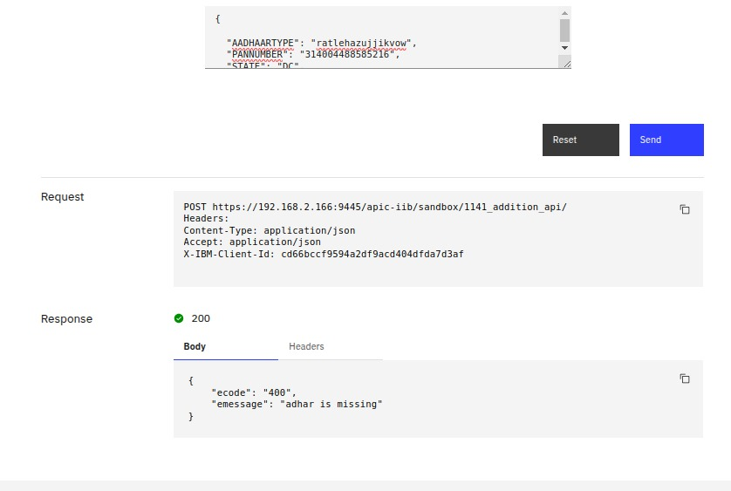

1. Convert Date format(DD/MM/YYYY -->  YYYY-MM-DD)  
   And print the same request

Request

{   
 "AADHAARTYPE": "IND1",   
 "PANNUMBER": "1174843344",   
 "STATE": "UP",   
 "AADHAARID": "136211001811144",   
 "NAME": "GHOSH",   
 "IDTYPE": "CARD",   
 "IDNUMBER": "811144",   
 "PASSPORT": "M2264445",   
 "SECURITYCODE": "9",   
 "BIRTHDATE": "03/10/1999",   
 "BIRTHTIME": "15:43:10",   
 "REFNUMBER": "20251003AC1",   
 "PHONENUMBER": "9988888518221"   
}

Gateway script to slove the problem

var apim = require('apim');

var req = apim.getvariable('message.body');

var aid = req.BIRTHDATE;

var rev = aid.split('').reverse().join(''); // Reverse the string

req.BIRTHDATE = rev; // Replace original BIRTHDATE with reversed string

apim.setvariable('message.body', req);

Output



1. Write a GatewayScript that checks the value of country and aborts the flow with a 403 response if it is not IN.

Gateway script to slove the problem

var apim = require('apim');

var var1 = apim.getvariable('request.parameters.queryparam');

if (var1 =='IN') {

apim.setvariable('message.headers.content-type', 'application/json');

apim.setvariable('message.body', { "success": "200" });

} else {

apim.setvariable('message.status.code', 403);

}

Output :

Case 1:if value is IN

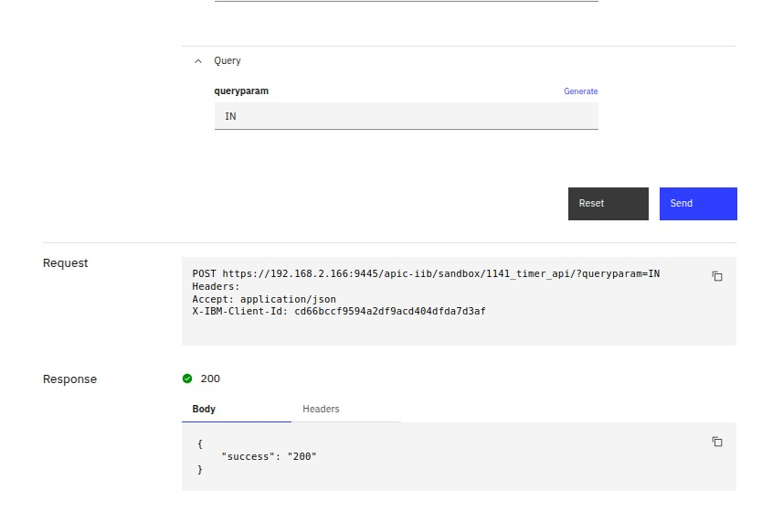

Case 2:if it is not IN

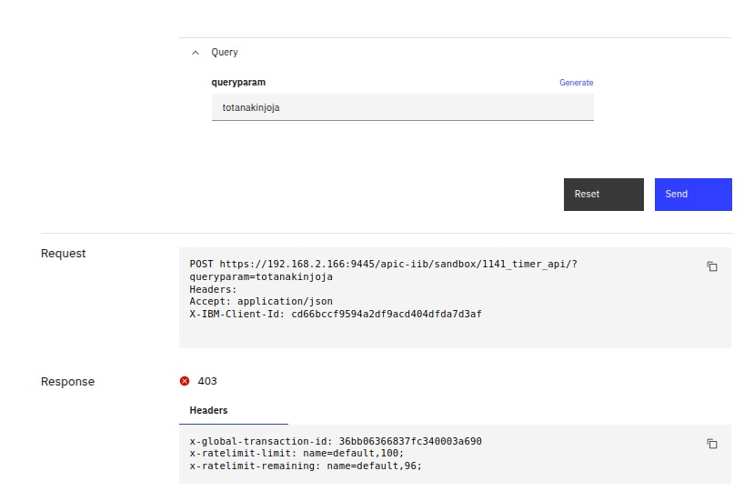

1. An internal API should only be accessible from 9 AM to 5 PM. Outside of this window, the API should respond with a 403.  
   Implement a gatewayscript.

Gatewayscript:

var apim=require('apim');

var var1=new Date();

var var2=Number(var1.getHours());

if (var2>9 && var2<23){

apim.setvariable('message.body',{"result":"the api is allowed to permit to process"});

}

Output:

Case 1:

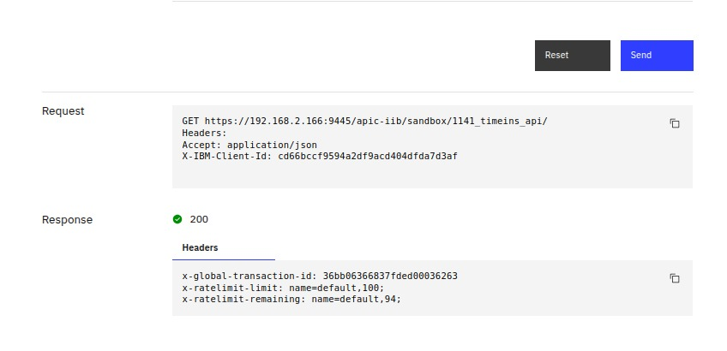

Case 2:

