Abstract

Managing library manually is both tedious and time consuming. Library Management System is computerized keeping in view all the operations that are to be carried out in the day to day functioning of the library. Maintaining this system is easier than maintaining manually. The advantage of this project is that it reduces paper work of entering data in records and helps to store the information of the members at the same time securely and reliably.

1. INTRODUCTION

It is a time consuming process to manage a library manually. This project is developed for computerizing the entire library management that makes the job of librarian easier. Computerizing a manual system provides a way to minimize human errors, which occur when huge data is to be updated manually.
In this application, there is an administrator and a user who can access the system. Administrator can add, update, delete, and view the data whereas users can only view the data.

1.1 OBJECTIVE OF THE PROJECT

The main objective for implementing the project “Library Management System” is to minimize the manual entry in the registers, and there by reducing lot of errors.

1.2 THE EXISTING SYSTEM

The existing system is a manual one. The entire process of library management is done through registers. This leads to lot of errors in the data entry process. When any student or teacher joins , his/her details are written in a register manually. Updating of data is a very tedious job. Especially maintaining the information about the books when students or teachers take books from the library is very difficult.

1.3 THE PROPOSED SYSTEM

The new system titled “Library Management System” is hence proposed to remove all the problems in the existing system discussed above.
Information is an important asset for the operation and management of any organization. Thus any system should have the ability to provide error-free information after processing the required data. This system has been taken up with a view for developing a more sophisticated system that can be easily handled by any person without any technical knowledge. The proposed system aims at efficient and error-free information for decision-making, and reduce duplication of work.

2. SYSTEM ANALYSIS AND DESIGN

System analysis is the performance management and documentation of activities related to the life cycle phases of any software namely:

- The Study Phase
- The Design Phase
- The Development Phase
- The Implementation Phase
- The Testing Phase

Software Analysis starts with a preliminary analysis and later switches on to a detailed one. During the preliminary analysis the Analyst takes a quick look at what is needed and whether the cost benefits. Detailed analysis studies in depth all the cornered factors, which builds and strengthens the software.

2.1 SRS

SRS (Software Requirement Specification) is a document that completely describes what the proposed should do, without describing how the software does it.

2.1.1 Performance Requirements

- The operation time should be small and the throughput should be high..
- It should produce timely and accurate result.

2.1.2 Software Quality Attributes

- Maintainability – Since it is directly associated with the database, so there is very little maintainability problem with this application.
- Easy to Learn – Since there are less number of forms, this application is very easy to learn with user-friendly screens.
- Flexibility – This application is very much flexible for future enhancements.

2.1.3 Hardware Requirements
- Processor : Pentium IV or later
- RAM : 1 GB
- HDD : 80 GB
- Peripherals : Keyboard, Mouse
2.1.4 Software Requirements
- Front End : Visual Basic 6.0
- Back End : MS Access
- Operating System : Windows XP
2.2 Software Design

System design is the second step in the system life cycle, in which overall design of the system is achieved. The functionalities of the system is designed and studied in this phase. The first step is designing of program specification. This determines the various data inputs to the system, data flow and the format in which output is to be obtained.
Design phase is a transmission phase because it is a transition from user oriented document to computer data. The activity in the design phase is the allocation of functions to manual operations, equipment and computer programs. Flow charts are prepared in the study time and is decomposed until all functions in the system perform evidently.
Design is a multi-step process that focuses on data structures, software architecture, procedural details( algorithms etc) and links between the modules. The design process goes through logical and physical stages. In logical design reviews are made linking existing system and specification gathered. The physical plan specifies any hardware and software requirement, which satisfies the local design.
Modularization of task is made in this phase. The success of any integrated system depends on the planning of each and every fundamental module. Usually a project is revised in step by step sequence. Inter-phase management of such module is also important. Software design methodology changes continually as new methods, better analysis and broader understanding evolve.
Various techniques for software design do exit with the availability of criteria for design quality. Software design leads three technical activities-design, code and test.
Each activity transforms information, which validates the software. The design system converts theoretical solution introduced by the feasibility study into a logical reality.

2.2.1 Modules of Library Management System

There are four modules in the Library Management System. They are :
Book
Student
Teacher
Book Transactions
Librarian should have access to all the four modules.
Book module :
This module handles the functions to add, modify, delete, and view book details such as book no, book name, author, publisher, no. of copies, and price of the book.
Student module :
This module handles the functions to add, modify, delete, and view student details such as roll no, student name, contact no., address, and course. It also relates student to book when the student takes a book from the library.
Teacher module :
This module handles the functions to add, modify, delete, and view teacher details such as teacher id, teacher name, contact no, address, and subject. It also relates teacher to book when the teacher takes a book from the library.
Book Transactions module :
This module handles the functions like book issue, book return, and book renewal. When member of library takes books, then the no. of copies is reduced by the appropriate number. Similarly, when member returns books to the library, the no. of copies is incremented by the appropriate number.

2.2.2 ER Diagrams

An entity-relationship model (ER model for short) is an abstract and conceptual representation of data. Entity-relationship modeling is a database modeling method, used to produce a type of conceptual schema of semantic data model of a system, often a relational database, and its requirements in a top-down fashion. Diagrams created by this process are called entity-relationship diagrams or ER diagrams.

An entity may be defined as a thing which is recognized as being capable of an independent existence and which can be uniquely identified. An entity is an abstraction from the complexities of some domain. When we speak of an entity we normally speak of some aspect of the real world which can be distinguished from other aspects of the real world.
An entity may be a physical object such as a house or a car, an event such as a house sale or a car service, or a concept such as a customer transaction or order. Although the term entity is the one most commonly used, following Chen we should really distinguish between an entity and an entity-type. An entity-type is a category. An entity, strictly speaking, is an instance of a given entity-type. There are usually many instances of an entity-type. Because the term entity-type is somewhat cumbersome, most people tend to use the term entity as a synonym for this term.
Entities can be thought of as nouns. Examples: a computer, an employee, a song, a mathematical theorem.

employee

Each entity has attributes, or particular properties that describe the entity. For example, employee John has properties of his own SSN, name, salary, and department. A particular value of an attribute, such as 10000 for salary, is a value of the attribute. Most of the data in a database consists of values of attributes. In ER model, an attribute name appears in an oval that has a line to the corresponding entity box.

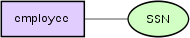

Entities and relationships can both have attributes. Examples: an employee entity might have a Social Security Number (SSN) attribute; the proved relationship may have a date attribute.

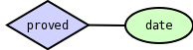

A relationship captures how entities are related to one another. Relationships can be thought of as verbs, linking two or more nouns. Examples: an owns relationship between a company and a computer, a supervises relationship between an employee and a department, a performs relationship between an artist and a song, a proved relationship between a mathematician and a theorem.

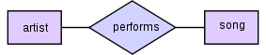

Entity-relationship diagrams don't show single entities or single instances of relations. Rather, they show entity sets and relationship sets. Example: a particular song is an entity. The collection of all songs in a database is an entity set. The eaten relationship between a child and her lunch is a single relationship. The set of all such child-lunch relationships in a database is a relationship set. In other words, a relationship set corresponds to a relation in mathematics, while a relationship corresponds to a member of the relation.
2.2.2.1 ER Diagram of Library Management System

Phone
course
Sname
tName
Email
rno

Student
Id
Teacher
teach

contactno
Year
Subject

returndate
issue
issuedate

author

bookno
price
Book

bookname
publisher

2.2.3 Table Design

2.2.3.1 STUDENT

rollno | Text
StudentName | Text
StudentAdd | Text
StudentPhone | Text
StudentEmail | Text
Course | Text
Year | Text
Sem | Text

2.2.3.2 TEACHER

TeacherId | Text
Teachername | Text
Subject | Text
Address | Text
Contactno. | Text
Email | Text

2.2.3.3 BOOK

Bookno | Text
Bookname | Text
Author | Text
Price | Number
Publisher | Text

2.2.3.4 ISSUES

MemberId | Text
Bookno | Text
Issuedate | Date/Time
Returndate | Date/Time
Returned | Text

2.2.4 UML Diagrams

UML stands for Unified Modeling Language. This object-oriented system of notation has evolved from the work of Grady Booch, James Rumbaugh, Ivar Jacobson, and the Rational Software Corporation. These renowned computer scientists fused their respective technologies into a single, standardized model. Today, UML is accepted by the Object Management Group (OMG) as the standard for modeling object oriented programs.

There are three classifications of UML diagrams:
- Behavior diagrams. A type of diagram that depicts behavioral features of a system or business process. This includes activity, state machine, and use case diagrams as well as the four interaction diagrams.
- Interaction diagrams. A subset of behavior diagrams which emphasize object interactions. This includes communication, interaction overview, sequence, and timing diagrams.
- Structure diagrams. A type of diagram that depicts the elements of a specification that are irrespective of time. This includes class, composite structure, component, deployment, object, and package diagrams.

Types of UML Diagrams
UML defines nine types of diagrams: class (package), object, use case, sequence, collaboration, statechart, activity, component, and deployment.

Class Diagrams
Class diagrams are the backbone of almost every object oriented method, including UML. They describe the static structure of a system.

Package Diagrams
Package diagrams are a subset of class diagrams, but developers sometimes treat them as a separate technique. Package diagrams organize elements of a system into related groups to minimize dependencies between packages.

Object Diagrams
Object diagrams describe the static structure of a system at a particular time. They can be used to test class diagrams for accuracy.

Use Case Diagrams
Use case diagrams model the functionality of system using actors and use cases.

Sequence Diagrams
Sequence diagrams describe interactions among classes in terms of an exchange of messages over time.

Collaboration Diagrams
Collaboration diagrams represent interactions between objects as a series of sequenced messages. Collaboration diagrams describe both the static structure and the dynamic behavior of a system.

Statechart Diagrams
Statechart diagrams describe the dynamic behavior of a system in response to external stimuli. Statechart diagrams are especially useful in modeling reactive objects whose states are triggered by specific events.

Activity Diagrams
Activity diagrams illustrate the dynamic nature of a system by modeling the flow of control from activity to activity. An activity represents an operation on some class in the system that results in a change in the state of the system. Typically, activity diagrams are used to model workflow or business processes and internal operation.

Component Diagrams
Component diagrams describe the organization of physical software components, including source code, run-time (binary) code, and executables.

Deployment Diagrams
Deployment diagrams depict the physical resources in a system, including nodes, components, and connections.

2.2.4.1 Use Case Diagram of Library Management System

Administrator
teachers
students
book transactions
Member
View book details
Login
book

2.2.4.2 Sequence Diagram for Administrator

home
Administration
Database
:admistrator
Enter user name ,Password
Invalid
End
add members, books to database
view book details
Login successful
change entity profile

2.2.4.3 Sequence Diagram for Member(student / teacher)

home
Database
:member
Enter user name ,Password
Invalid
End
view book details
Login successful

3. SCREENS

3.1 The Login form

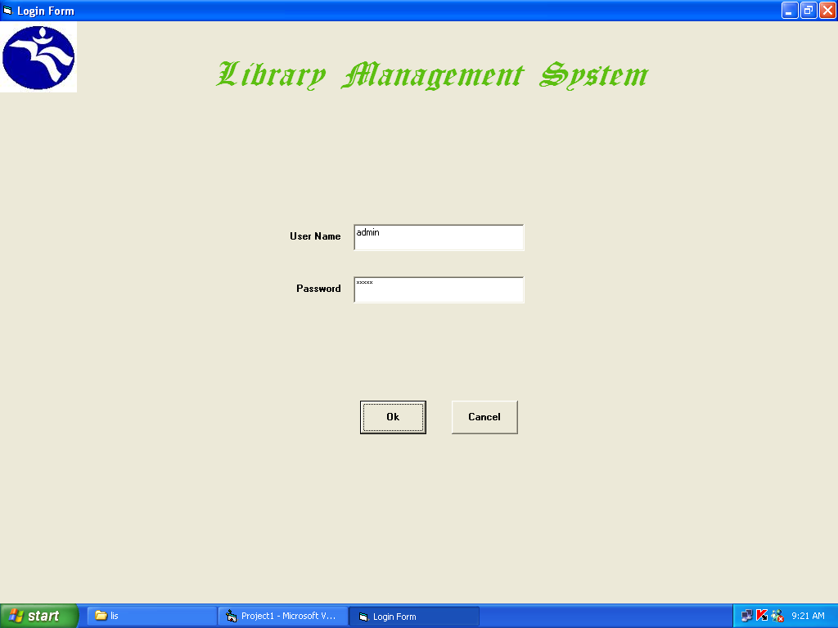

[This form verifies the user authentication and displays a message about the login status.]

3.2 The main form

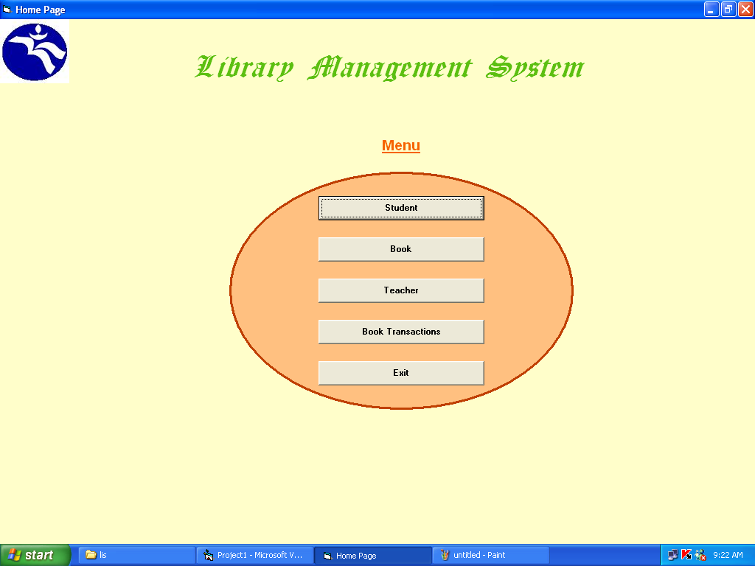

[ This is the main form showing the major modules of the project. Using this form, we can do the operations on book, student, and teacher entities. ]

3.3 The Submenu Form

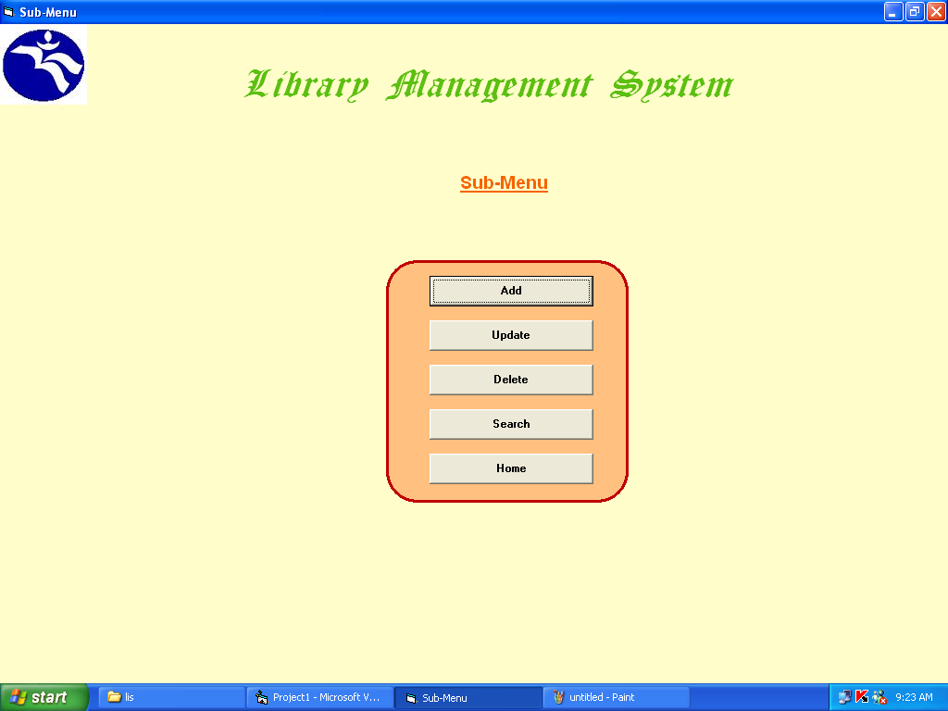
3.4 The form for adding book details

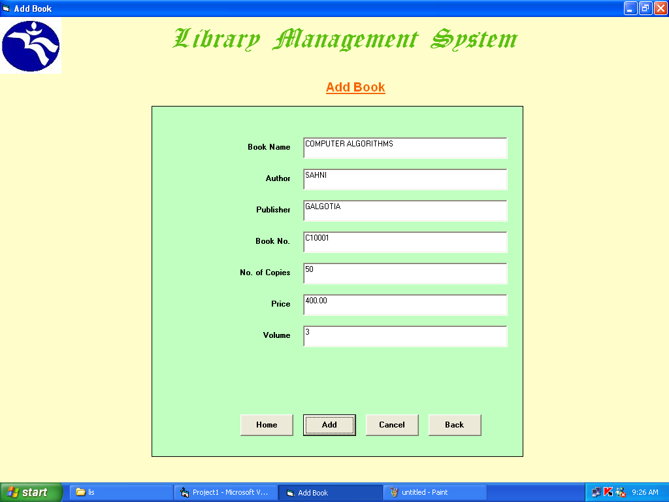

3.5 The form for adding student details

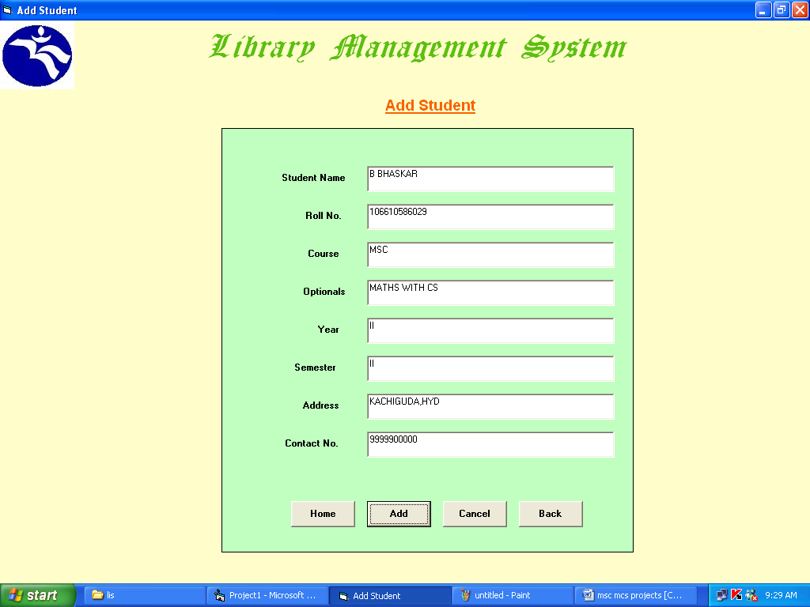

3.6 The form for adding teacher details

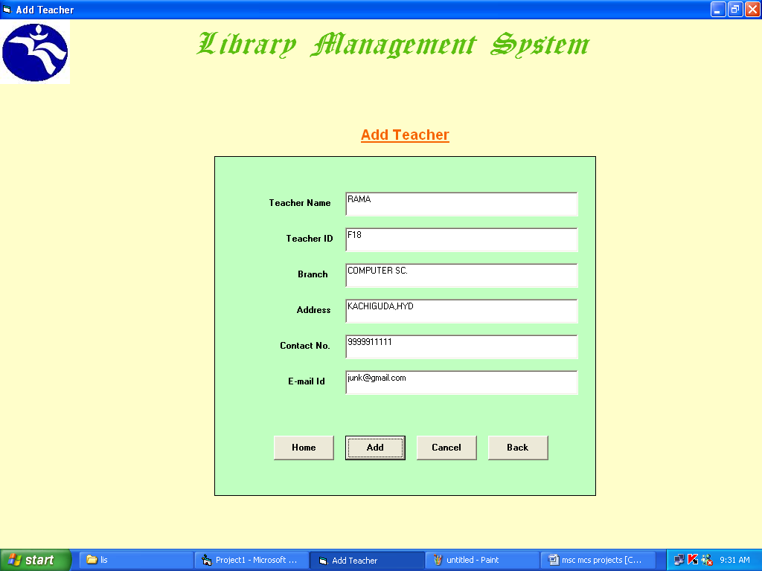

3.7 The form for editing book details

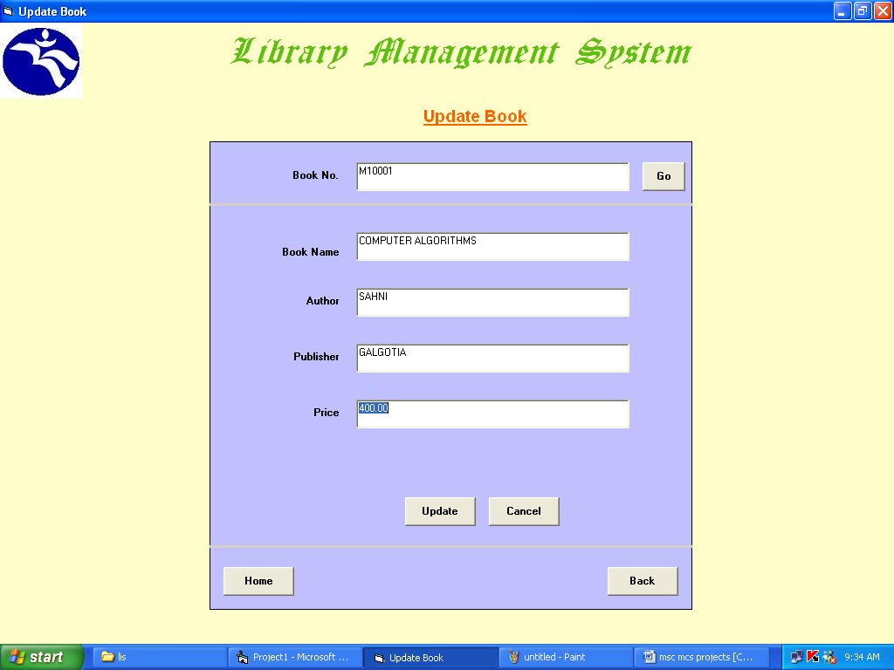

3.8 The form for editing student details

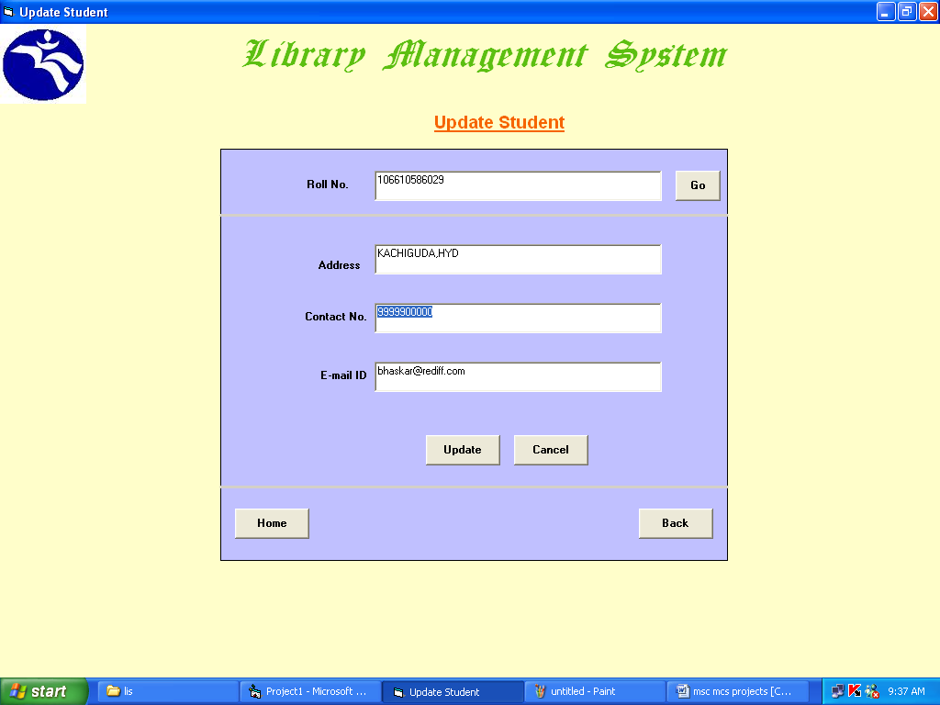

3.9 The form for editing teacher details

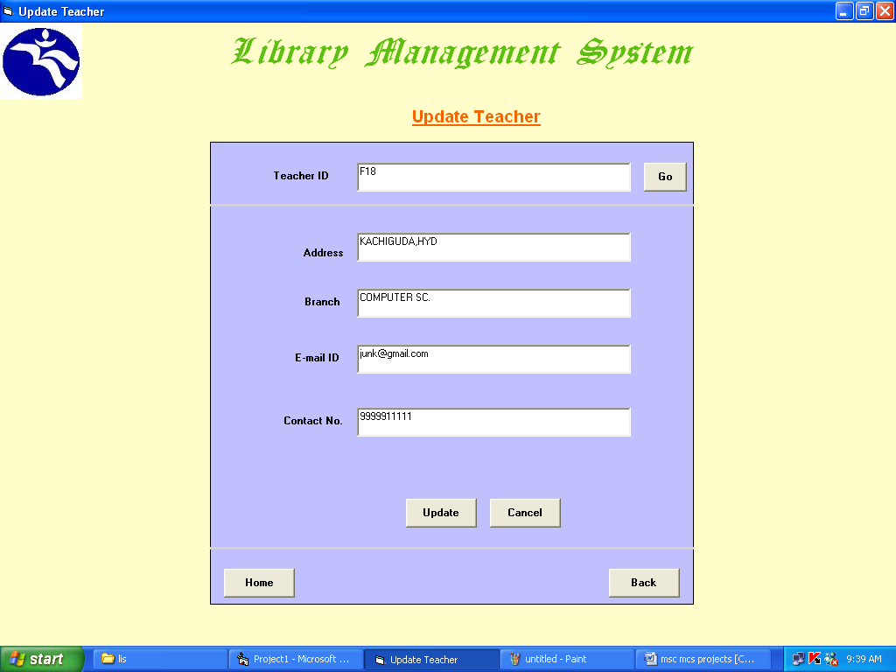

3.10 The form for deleting book details

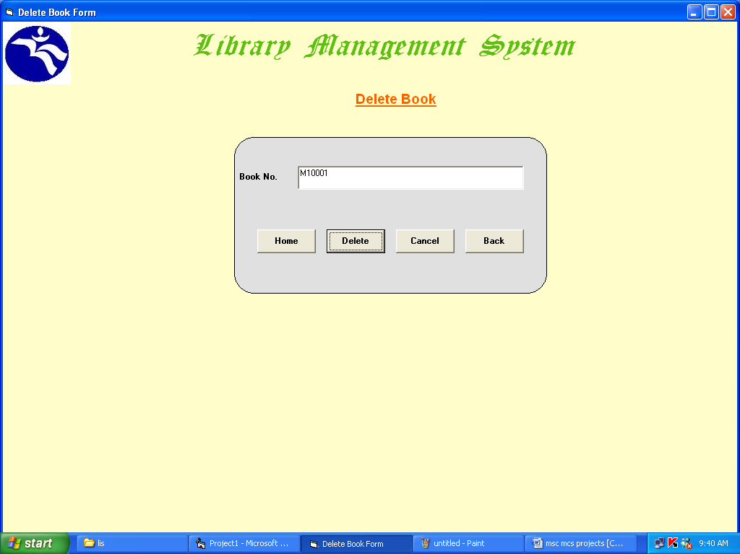

3.11 The form for deleting student details

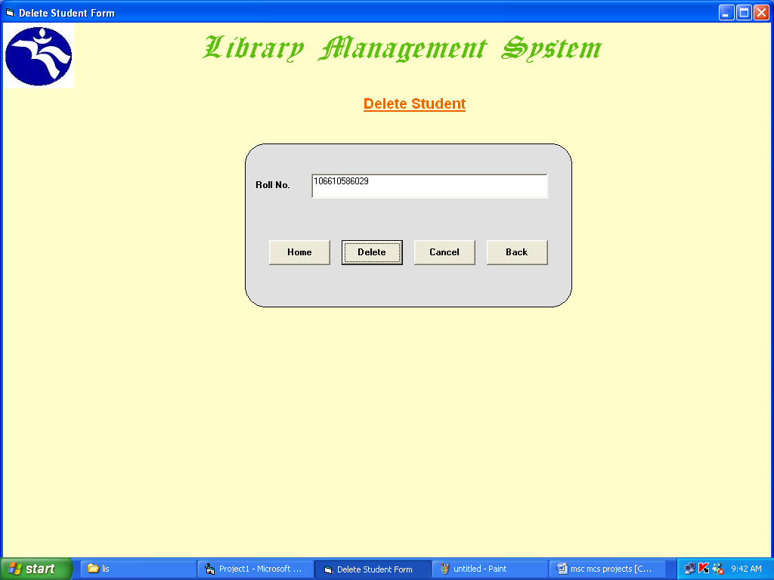

3.12 The form for deleting teacher details

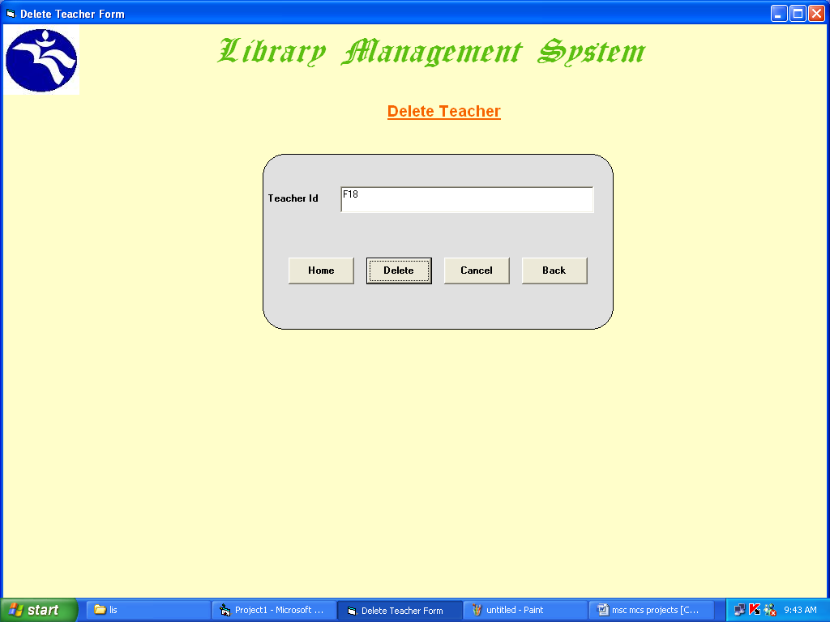

3.13 The form showing book transactions

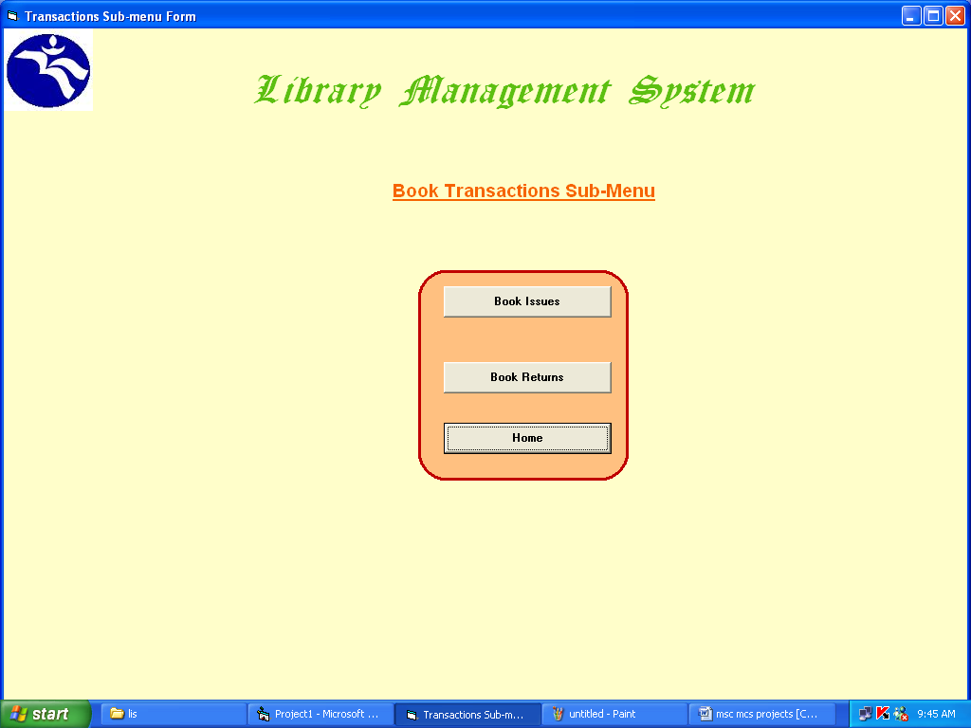

3.14 The form to issue book

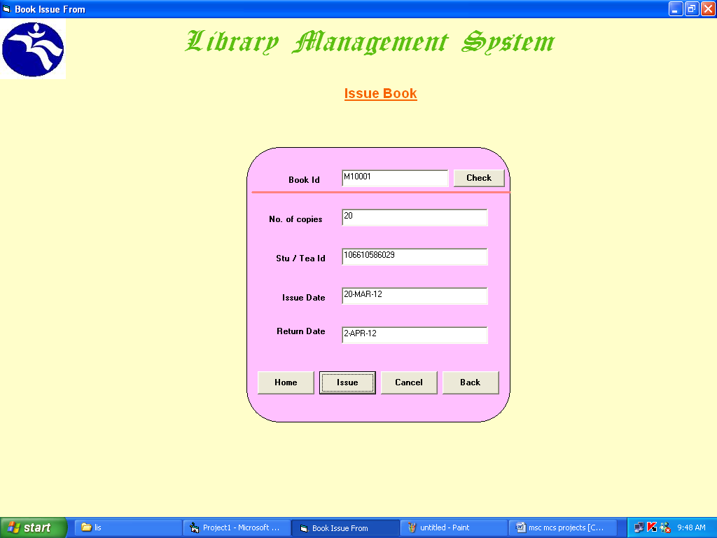

3.15 The form for book returns

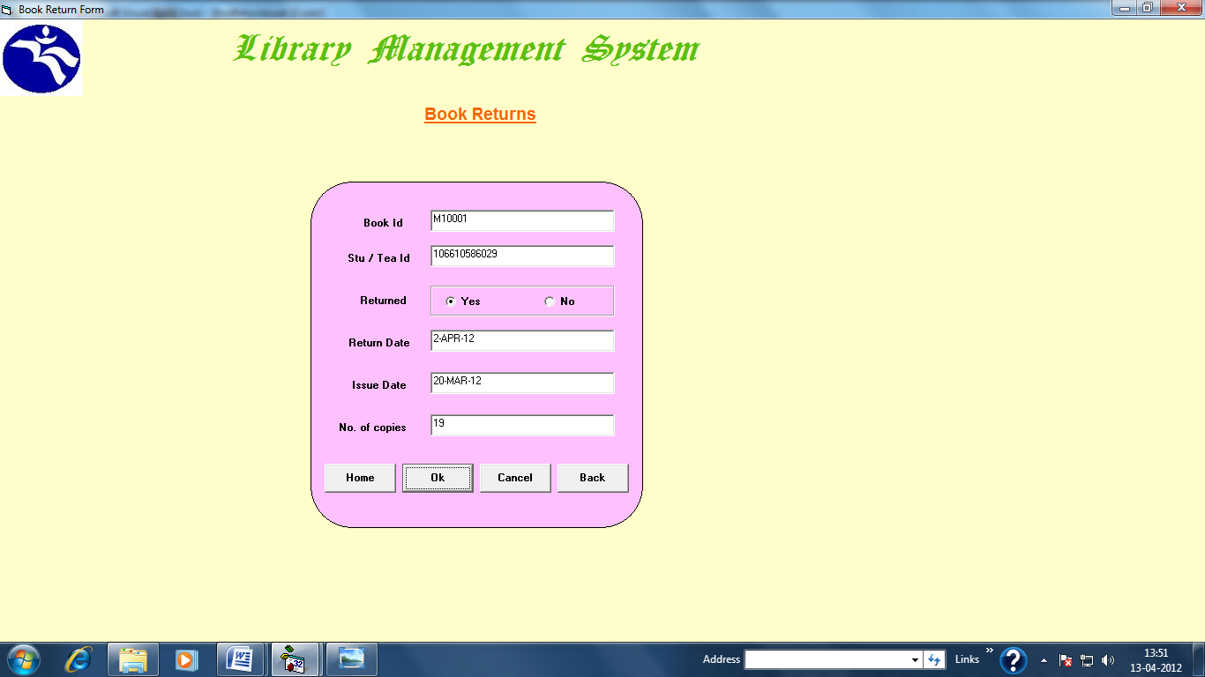

3.16 The report for student account

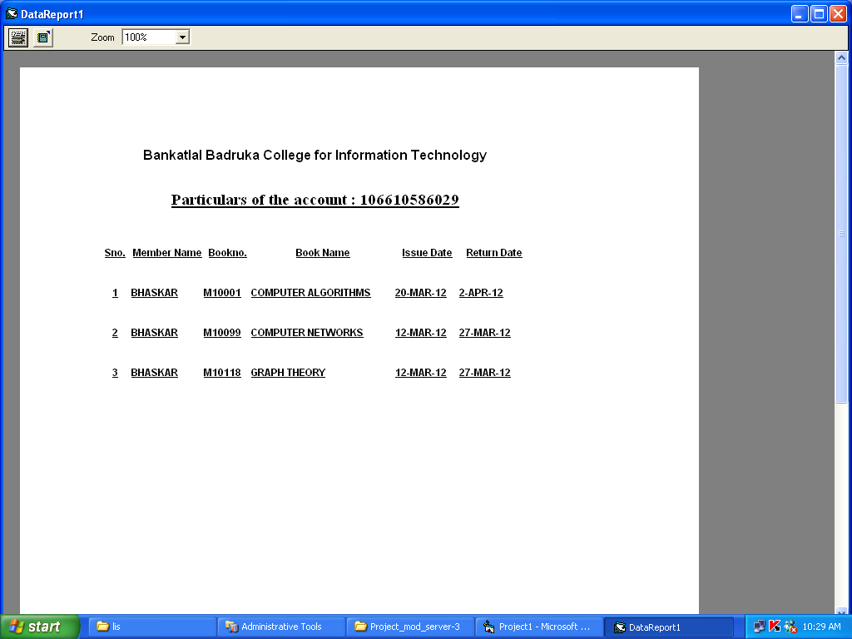

3.17 The report of books

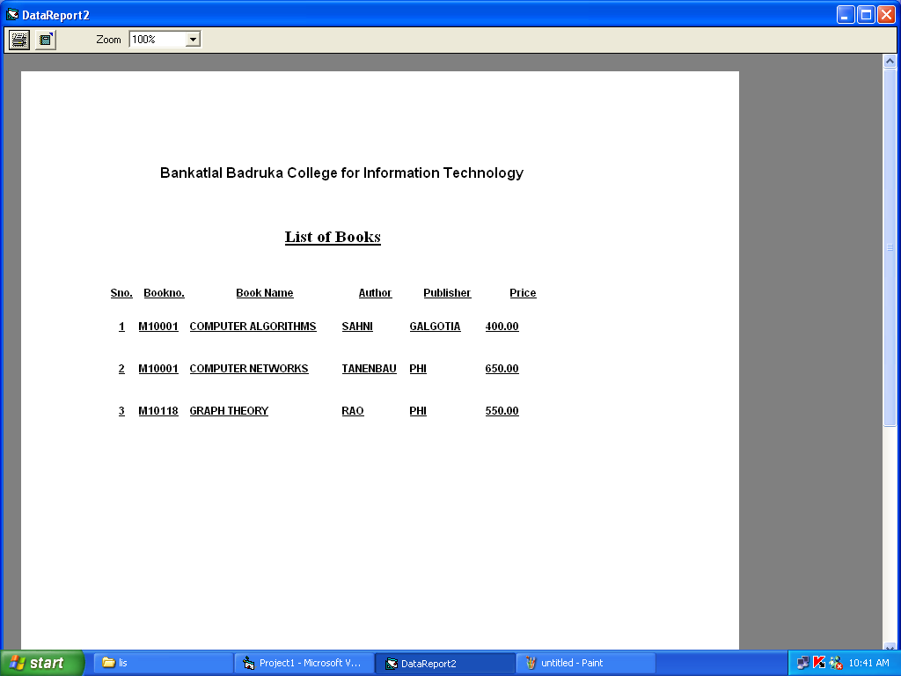

4. TESTING

Software testing is a critical element of software quality assurance and represents the ultimate reviews of specification, design and coding. Testing presents an interesting anomaly of the software. During earlier definition and development phases, it was attempted to build software from abstract concept to a tangible implementation.
The testing phase involves the testing of the developed system using various set data. Presentation of test data plays a vital role in system testing. After preparing the test data the system under study was tested using test data. While testing the system by using test data errors were found and corrected. A series of tests were performed for the proposed system before the system was ready for implementation. The various types of testing done on the system are:

- Unit Testing
- Integration Testing
- User Acceptance Testing
- System Testing

4.1 Unit Testing

Unit testing focuses verification effort on the smallest unit of software design, the module. It comprises the set of test performed by the programmer prior to integration of the unit into larger system. The testing was carried out during the coding stage itself. In this step each module is found to be working satisfactorily as regards to the expected output from the module.
Each form is treated as a unit and tested thoroughly for bugs. The following is a list of some of the test cases :
1) In the login form, if a member does not enter a value for userId and password, then the user is prompted with the error message “userId and password should not be blank”.
2) In the login form, if a member enters wrong values for userId and password, then the user is prompted with the error message “Invalid userId and password. Try again.”.
3) In book Entry screen and new student, teacher screen, all the fields should have a value. Otherwise, the user is prompted with an appropriate error messages.
4) In book transactions form, member id, book no,. issue date, and return date are mandatory. If not provided, then the system will prompt the user with the error message “Fields should not be blank”.

4.2 Integration Testing

Integration testing is a systematic technique for constructing the program structure while at the same time conducting tests to uncover error associated within the interface. The objective is to take unit tested modules and build a program structure that has been dictated by design. All modules are combined in this step. The entire program is tested as whole. And chaos in interfaces may usually result. A set of errors is encountered in such a case.

The integration testing can be carried out using two methodologies:

# Top Down Integration
# Bottom Up Integration

The first one is done where integration is carried out by addition of major modules to minor modules. While Bottom Up integration follows combination of smaller ones to larger one. Here, Bottom Up Integration is followed. Even though correction was difficult because the isolation of causes is complicated by the vastness of the entire program, all the errors found in the system were corrected and then forwarded to the next testing steps.
The navigation among all the screens have been thoroughly verified so that the user of the system can move from one form to another form.
The connectivity between the forms and the database has been checked. In case of any malfunctions, the user will be informed about the problem.
4.3 User Acceptance Testing

User acceptance of a system is the key factor for the success of any system. The system under consideration was tested for users acceptance by constantly keeping in touch with the perspective system user at the time of developing and making changes wherever required. This is done with the regards to the following points:
A system may be defined as a set of instructions combined in the same form and directed to some purpose.
Before any development is undertaken certain specifications are prepared which objectively describe the application system. The System specifications are made after consulting the end user managers of the relevant departments.
Software to be developed is planned on the basis of requirement of the user. The problem definition statement description of present situation and goal to be achieved by news system.
The success of system depends on how accurately a problem is defined, thoroughly investigated carried out through choice of solution. User need identification and analysis that are concerned with what the uses needs rather than what he/she wants. System explains how to perform specific activities or task, which does what and what.

4.4 System Testing

Testing the behavior of the whole software/system as defined in software requirements specification(SRS) is known as system testing, its main focus is to verify that the customer requirements are fulfilled.
System testing is done after integration testing is complete. System testing should test functional and non functional requirements of the software. The test types followed in system testing differ from organization to organization.
The project is executed and tested on the machines that satisfy the given hardware and software requirements. It was executed successfully with the specified hardware and operating system.

4.5 Test Cases

4.5.1 Login Test Case

[If user enters wrong user name and / or wrong password, then the application prompts the user with a message “ Invalid username or password”.]

5. CONCLUSION AND THE FUTURE WORK

5.1 Conclusion

The effect of implementations of new computerized system is found remarkable.
The following are the major improvement of the new system over the existing system.

- A fully menu driven user-friendly computerized system has been developed where librarian can perform tasks like adding and deleting students, teachers schemes, books, and updating the existing data in database.

- All the operations are carried out automatically preventing a lot of manual work.

- Additional checks have also been incorporated into the system to avoid duplications of data as far as possible.

5.2 Future Work

Even the best system developed has some flaws or others. There always exist scope of further improvement in the system. In some cases, the limitations are small while in other cases they may be broad also. The new system has got some limitations. Major areas where modifications can be done are as follows:

- Our system is not online so further it can be improved.

- The security is limited so some additional arrangement could be made to provide more security to the system.

- There is no provision of complaints handling, so further it can be added.

APPENDIX A

A 1 Software Environment

- The front end of the application is designed using Visual Basic 6.0.
- The database is designed using Microsoft Access.

A 2 About Microsoft Visual Basic 6.0

Visual Basic 6.0 is an enjoyable language due to its visual environment. Building a windows program in Visual Basic requires dragging and dropping graphic objects on to the screen from a toolbox. Thus Visual Basic is the efficient GUI tools to develop some exciting windows-based application.
Visual Basic 6.0 is much more than just a programming language. The programming language forms the background of all that takes place in a running Visual Basic program. The language is a secondary consideration to the user interface. A windows program offers a high degree of user interaction using the graphical elements that forms the objects on the window the user sees .If the user interface is not correct, user will not like the program.
Visual Basic lets one add menus, text boxes, command buttons, option buttons (for making exclusive choice), check boxes, list boxes, scroll bars and file and directory boxes to black windows. One can use Visual Basic to communicate with other applications, running under windows. Visual Basic offers: More Internet features, better support for data base development, more language feature to make programming job easier.
Some Features of Visual Basic 6.0

Toolbox: The Tool Box window differs from the tool bar. The Tool Box is a collection of tool that acts as a repository of controls we can place on forms. Some tools are Selection Pointer, Picture Box, Label, Text Box, Frame Button, Command Botany, Check Box, Option Button etc.
Form: Visual Basic uses a window; controls are the widgets one place of a form. In a form we will customize by adding controls such as command buttons, list boxes to it. At the top of the black form is the little bar with its caption.
There are several common properties to customize a form, these are: -
Caption: Caption is used as a title that the Microsoft Window for the application icon when the user minimizes the application.
Name: This property is used to give the name that one want to use to refer to the form.
Enabled: If user sets Enabled to false, the form cannot respond to any events such as the user checking on the form.
Icon: The icon property determines the icon users application will display when it is minimized on tool bar or turned into a stand-alone application on windows desktop.
Visible: If the value of the property is set to false, it will no longer be visible.
Text Box: It is used to display text or to accept user input. Most of the code is written to process the information users enter into them. Several properties of text boxes are as follows: -
Text: The text property in text box is the analog of the caption property for a command button or a form; it controls text the users see. It determines whether text on the control such as label or command button, is left justified, centered, or right justified on the control. The Alignment property take one of the three values: 0-Left justify, 1-Right justify, 2-Center.
Multiline: This property determines whether a text box can accept more than one line of text when the user runs the application, and it is usually combine with resulting the value of the scrollbar property. If true the property specifies the text box can hold more than a line of text.
Max Length: This property specifies the maximum number of characters that the text box will accept. A value of 0 indicates that the user can enter a value of any length.
Locked: This property determines whether the user can enter a value or change the default value of the text box. If true, the user cannot change the text box value until the program, at run time assigns a false to this property.
Password char: The Password property lets us limit what the text box displays.
Labels: Use Labels to display information programmer does not want the user to be able to change. Most common use for Labels is to identify a text box or other control by describing its contents. Another common use is to display help information.
Message Box: Message boxes display information in the dialog box superimposed on the form. They want for the user to choose a button before return to the application. User cannot switch to another form in programmers applications as long as Visual Basic is displaying a message box.

Value Named constant Description
0 vbOKOnly OK button
1 vbOKCancel OK and Cancel buttons
2 vbAboRetryIgnore Abort,Retry and Cancel buttons
3 vbYesNoCancel Yes and No and Cancel buttons
4 vbYesNo Yes and No buttons
Frames: Programmer usually frames passively to group images or controls.
Option Buttons: They all work together. When the user chooses one button, all other buttons in the group are turned off. The value property of the option button tells us whether a button was selected by the user. If the value property is true, the user selected that button; otherwise, its value property is false.
Check Boxes: Check Boxes differ from option button in that, regardless of how many Check Boxes one places on a form, they can all be turned on and off independently. If the user has selected Check Boxes, the value property switches to true. It stays true until the user deselects that box.
List and Combo boxes: Use list boxes when we have a fixed list of choices. Visual Basic automatically adds vertical scroll bars when the list box is small for all items it contains.
To allow users to input data as well as choices from a list, we use a Combo Box.
Following are some data controls:
- Data List
- Data Combo
- Data Grid
- Microsoft Flex Grid
- Microsoft Hierarchical Flex Grid
- Rich Textbox
- Microsoft Chart
- Date Time Picker
- Image Combo

References

Books :

1. VISUAL BASIC 6 Programming BLACK BOOK
--- Steven Holzner

2. MASTERING VISUAL BASIC 6.0
---- Evangelos Petroutsos

Web Sites :

- www.a1vbcode.com
- www.google.co.in

