UNIT –I Introduction to Artificial Intelligence:
Introduction, History, Intelligent Systems, Foundations of AI, Applications, Tic- tac toe game playing, development of AI languages, Current trends in AI.

Artificial Intelligence
- Modeling human cognition or mental faculties using computers
- Study of making computers do things which at the moment people are better
- Making computers do things which require intelligence

More Formal Definition of AI
    - AI is a branch of computer science which is concerned with the study and creation of computer systems that exhibit
      - some form of intelligence
OR
      - those characteristics which we associate with intelligence in human behavior
      - AI is a broad area consisting of different fields, from machine vision, expert systems to the creation of machines that can "think".
      - In order to classify machines as "thinking", it is necessary to define intelligence.

History
The history of Artificial Intelligence (AI) began in antiquity, with myths, stories and rumors of artificial beings endowed with intelligence or consciousness by master craftsmen. The seeds of modern AI were planted by classical philosophers who attempted to describe the process of human thinking as the mechanical manipulation of symbols. This work culminated in the invention of the programmable digital computer in the 1940s, a machine based on the abstract essence of mathematical reasoning. This device and the ideas behind it inspired a handful of scientists to begin seriously discussing the possibility of building an electronic brain.
The field of AI research was founded at a workshop held on the campus of Dartmouth College during the summer of 1956. Those who attended would become the leaders of AI research for decades. Many of them predicted that a

machine as intelligent as a human being would exist in no more than a generation and they were given millions of dollars to make this vision come true.
Eventually, it became obvious that they had grossly underestimated the difficulty of the project. In 1973, in response to the criticism from James Lighthill and ongoing pressure from congress, the U.S. and British Governments stopped funding undirected research into artificial intelligence, and the difficult years that followed would later be known as an "AI winter". Seven years later, a visionary initiative by the Japanese Government inspired governments and industry to provide AI with billions of dollars, but by the late 80s the investors became disillusioned by the absence of the needed computer power (hardware) and withdrew funding again.
In the 1980s a form of AI program called "expert systems" was adopted by corporations around the world and knowledge became the focus of mainstream AI research. In those same years, the Japanese government aggressively funded AI with its fifth generation computer project. Another encouraging event in the early 1980s was the revival of connectionism in the work of John Hopfield and David Rumelhart. Once again, AI had achieved success.
In the first decades of the 21st century, access to large amounts of data (known as "big data"), cheaper and faster computers and advanced machine learning techniques were successfully applied to many problems throughout the economy. In fact, McKinsey Global Institute estimated in their famous paper "Big data: The next frontier for innovation, competition, and productivity" that "by 2009, nearly all sectors in the US economy had at least an average of 200 terabytes of stored data".
By 2016, the market for AI-related products, hardware, and software reached more than 8 billion dollars, and the New York Times reported that interest in AI had reached a "frenzy". The applications of big data began to reach into other fields as well, such as training models in ecology and for various applications in economics. Advances in deep learning (particularly deep convolutional neural networks and recurrent neural networks) drove progress and research in image and video processing, text analysis, and even speech recognition.
Investment and interest in AI boomed in the first decades of the 21st century, when machine learning was successfully applied to many problems in academia and industry due to new methods, the application of powerful computer hardware, and the collection of immense data sets.

What is Intelligence?
- Intelligence is a property of mind that encompasses many related mental abilities, such as the capabilities to

  - reason
  - plan
  - solve problems
  - think abstractly
  - comprehend ideas and language and
  - learn

Characteristics of AI systems
- learn new concepts and tasks
- reason and draw useful conclusions about the world around us
  - remember complicated interrelated facts and draw conclusions from them (inference)
- understand a natural language or perceive and comprehend a visual scene
  - look through cameras and see what's there (vision), to move themselves and objects around in the real world (robotics)
- plan sequences of actions to complete a goal
- offer advice based on rules and situations
- may not necessarily imitate human senses and thought processes
  - but indeed, in performing some tasks differently, they may actually exceed human abilities
- capable of performing intelligent tasks effectively and efficiently
- perform tasks that require high levels of intelligence

Understanding of AI
- AI techniques and ideas seem to be harder to understand than most things in computer science
- AI shows best on complex problems for which general principles don't help much, though there are a few useful general principles

- Artificial intelligence is also difficult to understand by its content.
- Boundaries of AI are not well defined.
- Often it means the advanced software engineering, sophisticated software techniques for hard problems that can't be solved in any easy way.
- AI programs - like people - are usually not perfect, and even make mistakes.
- It often means, nonnumeric ways of solving problems, since people can't handle numbers well.
- Nonnumeric ways are generally "common sense" ways, not necessarily the best ones.
- Understanding of AI also requires an understanding of related terms such as intelligence, knowledge, reasoning, thought, cognition, learning, and a number of other computer related terms.

Categories of AI System
- Systems that think like humans
- Systems that act like humans
- Systems that think rationally
- Systems that act rationally

Systems that think like humans
      - Most of the time it is a black box where we are not clear about our thought process.
      - One has to know functioning of brain and its mechanism for prossessing information.
      - It is an area of cognitive science.
        - The stimuli are converted into mental representation.
        - Cognitive processes manipulate representation to build new representations that are used to generate actions.
      - Neural network is a computing model for processing information similar to brain.

Systems that act like humans
      - The overall behaviour of the system should be human like.
      - It could be achieved by observation

Systems that think rationally
      - Such systems rely on logic rather than human to measure correctness.
      - For thinking rationally or logically, logic formulas and theories are used for synthesizing outcomes.
      - For example,
        - given John is a human and all humans are mortal then one can conclude logically that John is mortal
      - Not all intelligent behavior are mediated by logical deliberation.

Systems that act rationally
      - Rational behavior means doing right thing.
      - Even if method is illogical, the observed behavior must be rational.

The Turing Test
Turing proposed operational test for intelligent behavior in 1950.

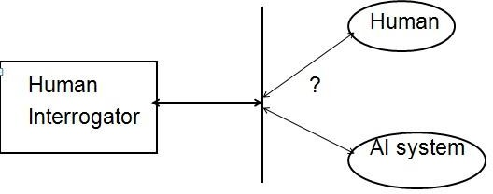

ELIZA
- Eliza was first program developed by Joseph Wiezbaum to converse in English in mid 1960's
  - It passed turing test.
- The following passage shows Eliza’s talking to a teenage girl. Blue text Eliza’s response
Men are all alike.
IN WHAT WAY
They're always bugging us about something or other. CAN YOU THINK OF A SPECIFIC EXAMPLE
Well, my boyfriend made me come here. YOUR BOYFRIEND MADE YOU COME HERE
He says that I am depressed all the time.
I AM SORRY TO HEAR THAT YOU ARE DEPRESSED
It's true that I am unhappy
DO YOU THINK COMING HERE WILL HELP YOU NOT TO BE UNHAPPY
I need help, that seems certain.
WHAT WOULD IT MEAN IF YOU GOT SOME HELP
Perhaps I could learn to get along with my mother. TELL ME MORE ABOUT YOUR FAMILY
My mother takes care of me.
WHO ELSE IN YOUR FAMILY TAKES CARE OF YOU
My father.
YOUR FATHER
You are like my father in some ways.

WHAT RESEMBLANCE DO YOU SEE
You are not very aggressive but I think you don't want me to notice that. WHAT MAKES YOU THINK THAT I AM NOT VERY AGGRESSIVE
You don’t argue with me.
WHY DO YOU THINK I DON’T ARGUE WITH YOU
You are afraid of me.
DOES IT PLEASE YOU TO BELIEVE, I AM AFRAID OF YOU
My father is afraid of everybody.
WHAT ELSE COMES TO MIND WHEN YOU THINK OF YOUR FATHER
Bullies.
DOES THAT HAVE ANYTHING TO DO WITH THE FACT THAT YOUR BOYFRIEND MADE YOU COME HERE

Foundations of AI
- Foundation of AI is based on
  - Mathematics
  - Neuroscience
  - Control Theory
  - Linguistics

Foundations – Mathematics
    - More formal logical methods
      - Boolean logic
      - Fuzzy logic
    - Uncertainty
      - The basis for most modern approaches to handle uncertainty in AI applications can be handled by

        - Probability theory
        - Modal and Temporal logics

Foundations – Neuroscience
    - How do the brain works?
      - Early studies (1824) relied on injured and abnormal people to understand what parts of brain work
      - More recent studies use accurate sensors to correlate brain activity to human thought
- By monitoring individual neurons, monkeys can now control a computer mouse using thought alone
      - Moore’s law states that computers will have as many gates as humans have neurons in 2020
      - How close are we to have a mechanical brain?
- Parallel computation, remapping, interconnections,….

Foundations – Control Theory
- Machines can modify their behavior in response to the environment (sense/action loop)
  - Water-flow regulator, steam engine governor, thermostat
- The theory of stable feedback systems (1894)
  - Build systems that transition from initial state to goal state with minimum energy
  - In 1950, control theory could only describe linear systems and AI largely rose as a response to this shortcoming

Foundations – Linguistics
    - Speech demonstrates so much of human intelligence

      - Analysis of human language reveals thought taking place in ways not understood in other settings
- Children can create sentences they have never heard before
- Language and thought are believed to be tightly intertwined

Two Views of AI Goals
    - AI is about duplicating what the (human) brain DOES
      - Cognitive Science
    - AI is about duplicating what the (human) brain SHOULD do
      - Rationality (doing things logically)

Cool Stuff in AI
    - Game playing agents
    - Machine learning
    - Speech
    - Language
    - Vision
    - Data Mining
    - Web agents

Useful Stuff
    - Medical Diagnosis
    - Fraud Detection
    - Object Identification
    - Space Shuttle Scheduling
    - Information Retrieval

AI Techniques
- Rule-based
- Fuzzy Logic
- Neural Networks
- Genetic Algorithms

Components of AI Program
- AI techniques must be independent of the problem domain as far as possible.
- AI program should have
  - knowledge base
  - navigational capability
  - inferencing

Knowledge Base
    - AI programs should be learning in nature and update its knowledge accordingly.
    - Knowledge base consists of facts and rules.
    - Characteristics of Knowledge:
      - It is voluminous in nature and requires proper structuring
      - It may be incomplete and imprecise
      - It may keep on changing (dynamic)

Navigational Capability
    - Navigational capability contains various control strategies
    - Control Strategy
      - determines the rule to be applied
      - some heuristics (thump rule) may be applied

Inferencing
    - Inferencing requires
      - search through knowledge base and
      - derive new knowledge

Sub-areas of AI
- Sub areas of AI are:
  - Knowledge representation
  - Theorem proving
  - Game playing
  - Vommon sense reasoning dealing with uncertainty and decision making
  - Learning models, inference techniques, pattern recognition, search and matching etc.
  - Logic (fuzzy, temporal, modal) in AI
  - Planning and scheduling
  - Natural language understanding
  - Computer vision
  - Understanding spoken utterances
  - Intelligent tutoring systems
  - Robotics
  - Machine translation systems
  - Expert problem solving
  - Neural Networks, AI tools etc

Applications of AI:
- Some of the applications are given below:
  - Business : Financial strategies, give advice
  - Engineering: check design, offer suggestions to create new product
  - Manufacturing: Assembly, inspection & maintenance
  - Mining: used when conditions are dangerous
  - Hospital : monitoring, diagnosing & prescribing
  - Education : In teaching
  - household : Advice on cooking, shopping etc.
  - farming : prune trees & selectively harvest mixed crops.

Latest Perception of AI
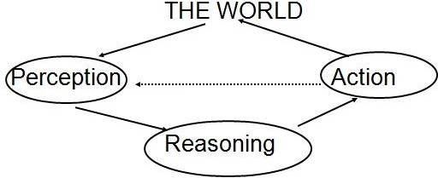

  - Recent AI
    - Heavy use of
      - probability theory
      - decision theory
      - statistics

      - logic (fuzzy, modal, temporal)
- Tic Tac Toe Game playing strategies
- Two players
  - human
  - computer.
- The objective is to write a computer program in such a way that computer wins most of the time.
- Three approaches are presented to play this game which increase in
  - Complexity
  - Use of generalization
  - Clarity of their knowledge
  - Extensibility of their approach
- These approaches will move towards being representations of what we will call AI techniques.

Tic Tac Toe Board- (or Noughts and crosses, Xs and Os)
It is two players, X and O, game who take turns marking the spaces in a 3×3 grid. The player who succeeds in placing three respective marks in a horizontal, vertical, or diagonal row wins the game.
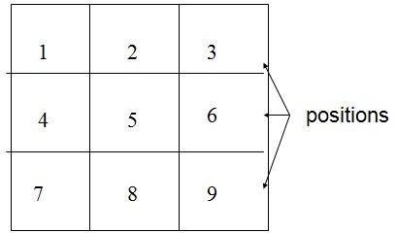

Approach 1
- Data Structure
  - Consider a Board having nine elements vector.
  - Each element will contain
    - 0 for blank
    - 1 indicating X player move
    - 2 indicating O player move
  - Computer may play as X or O player.
  - First player who so ever is always plays X.

Move Table MT
- MT is a vector of 39 elements, each element of which is a nine element vector representing board position.
- Total of 39 (19683) elements in MT
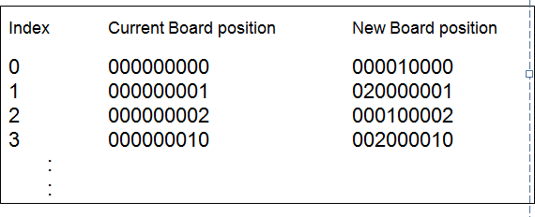

Algorithm
- To make a move, do the following:
  - View the vector (board) as a ternary number and convert it to its corresponding decimal number.
  - Use the computed number as an index into the MT and access the vector stored there.

    - The selected vector represents the way the board will look after the move.
  - Set board equal to that vector.

Comments
- Very efficient in terms of time but has several disadvantages.
  - Lot of space to store the move table.
  - Lot of work to specify all the entries in move table.
  - Highly error prone as the data is voluminous.
  - Poor extensibility
    - 3D tic-tac-toe = 327 board position to be stored.
  - Not intelligent at all.

Approach 2
- Data Structure
  - Board: A nine-element vector representing the board: B[1..9]
  - Following conventions are used
- - indicates blank
- - X
5 - 0
  - Turn: An integer
- - First move
9 - Last move

Procedures Used
- Make_2 → Tries to make valid 2
  - Make_2 first tries to play in the center if free and returns 5 (square number).

  - If not possible, then it tries the various suitable non corner square and returns square number.
  - Go(n) ← makes a move in square ‘n’ which is blank represented by 2.

Procedure – PossWin
- PossWin (P) → Returns
  - 0, if player P cannot win in its next move,
  - otherwise the number of square that constitutes a winning move for P.
  - Rule
  - If PossWin (P) = 0 {P can not win} then find whether opponent can win. If so, then block it.

Strategy used by PosWin
- PosWin checks one at a time, for each rows /columns and diagonals as follows.
  - If 3 * 3 * 2 = 18 then player X can win
  - else if 5 * 5 * 2 = 50 then player O can win
  - These procedures are used in the algorithm are showed below.

Algorithm
- Assumptions
  - The first player always uses symbol X.
  - There are in all 8 moves in the worst case.
  - Computer is represented by C and Human is represented by H.
  - Convention used in algorithm on next slide
- If C plays first (Computer plays X, Human plays O) - Odd moves

- If H plays first (Human plays X, Computer plays O) - Even moves
- For the sake of clarity, we use C and H.
Algo - Computer plays first – C plays odd moves
- Move 1: Go (5)
- Move 2: H plays
- Move 3: If B[9] is blank, then Go(9) else Go(3) {make 2}
- Move 4: H plays

Move 5: {By now computer has played 2 chances}
  - If PossWin(C) then {won} Go(PossWin(C))
  - else {block H} if PossWin(H) then Go(PossWin(H)) else if B[7] is blank then Go(7) else Go(3)
- Move 6: H plays

Moves 7 & 9 :
  - If PossWin(C) then {won} Go(PossWin(C))
  - else {block H} if PossWin(H) then Go(PossWin(H)) else Go(Anywhere)
- Move 8: H plays
Algo - Human plays first – C plays even moves
- Move 1: H plays
- Move 2: If B[5] is blank, then Go(5) else Go(1)
- Move 3: H plays
- Move 4: {By now H has played 2 chances}
  - If PossWin(H) then {block H} Go (PossWin(H))
  - else Go (Make_2)
- Move 5: H plays

Move 6: {By now both have played 2 chances}
  - If PossWin(C) then {won} Go(PossWin(C))
  - else {block H} if PossWin(H) then Go(PossWin(H)) else Go(Make_2)
- Moves 7 & 9 : H plays

Move 8: {By now computer has played 3 chances}
  - If PossWin(C) then {won} Go(PossWin(C))
  - else {block H} if PossWin(H) then Go(PossWin(H)) else Go(Anywhere)
Complete Algorithm – Odd moves or even moves for C playing first or second
- Move 1: go (5)
- Move 2: If B[5] is blank, then Go(5) else Go(1)
- Move 3: If B[9] is blank, then Go(9) else Go(3) {make 2}
- Move 4: {By now human (playing X) has played 2 chances} If PossWin(X) then {block H} Go (PossWin(X)) else Go (Make_2)
- Move 5: {By now computer has played 2 chances} If PossWin(X) then
{won} Go(PossWin(X)) else {block H} if PossWin(O) then Go(PossWin(O)) else if B[7] is blank then Go(7) else Go(3)
- Move 6: {By now both have played 2 chances} If PossWin(O) then
{won} Go(PossWin(O)) else {block H} if PossWin(X) then Go(PossWin(X)) else Go(Make_2)
- Moves 7 & 9 : {By now human (playing O) has played 3 chances} If PossWin(X) then {won} Go(PossWin(X)) else {block H} if PossWin(O) then Go(PossWin(O)) else Go(Anywhere)
- Move 8: {By now computer has played 3 chances} If PossWin(O) then
{won} Go(PossWin(O)) else {block H} if PossWin(X) then Go(PossWin(X)) else Go(Anywhere)

Comments
- Not as efficient as first one in terms of time.
- Several conditions are checked before each move.

- It is memory efficient.
- Easier to understand & complete strategy has been determined in advance
- Still can not generalize to 3-D.

Approach 3
- Same as approach 2 except for one change in the representation of the board.
  - Board is considered to be a magic square of size 3 X 3 with 9 blocks numbered by numbers indicated by magic square.
- This representation makes process of checking for a possible win more simple.

Board Layout – Magic Square
- Board Layout as magic square. Each row, column and diagonals add to 15.
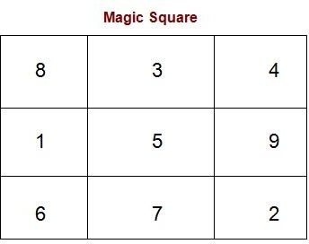

Strategy for possible win for one player
- Maintain the list of each player’s blocks in which he has played.
  - Consider each pair of blocks that player owns.

  - Compute difference D between 15 and the sum of the two blocks.
  - If D < 0 or D > 9 then
- these two blocks are not collinear and so can be ignored
- otherwise if the block representing difference is blank (i.e., not in either list) then a move in that block will produce a win.

Working Example of algorithm
- Assume that the following lists are maintained up to 3rd move.
- Consider the magic block shown in slide 18.
  - First Player X (Human)
8 3

  - Second Player O (Computer) 5

- Strategy is same as in approach 2
  - First check if computer can win.
- If not then check if opponent can win.
- If so, then block it and proceed further.
- Steps involved in the play are:
  - First chance, H plays in block numbered as 8
  - Next C plays in block numbered as 5
  - H plays in block numbered 3 Now there is a turn of computer
- Strategy by computer: Since H has played two turns and C has played only one turn, C checks if H can win or not.

  - Compute sum of blocks played by H
    - S = 8 + 3 = 11
    - Compute D = 15 – 11 = 4
    - Block 4 is a winning block for H.
    - So block this block and play in block numbered 4.
    - The list of C gets updated with block number 4 as follows: H 8 3 C 5 4
- Assume that H plays in block numbered 6.
- Now it’s a turn of C.
  - C checks, if C can win as follows:
    - Compute sum of blocks played by C
    - S = 5 + 4 = 9
    - Compute D = 15 – 9 = 6
    - Block 6 is not free, so C can not win at this turn.
  - Now check if H can win.
    - Compute sum of new pairs (8, 6) and (3, 6) from the list of H
    - S = 8 + 6 = 14
    - Compute D = 15 – 14 = 1
    - Block 1 is not used by either player, so C plays in block numbered as 1
- The updated lists at 6th move looks as follows:
  - First Player H
8 3 6
  - Second Player C
5 4 1

- Assume that now H plays in 2.
- Using same strategy, C checks its pair (5, 1) and (4, 1) and finds bock numbered as 9 {15-6 = 9}.
- Block 9 is free, so C plays in 9 and win the game.

Comments
- This program will require more time than two others as
  - it has to search a tree representing all possible move sequences before making each move.
- This approach is extensible to handle
  - 3-dimensional tic-tac-toe.
  - games more complicated than tic-tac-toe.

3D Tic Tac Toe (Magic cube)
- All lines parallel to the faces of a cube, and all 4 triagonals sum correctly to 42 defined by
S = m(m3 + 1)/2 , where m=3
- No planar diagonals of outer surfaces sum to 42. so there are probably no magic squares in the cube.

8 | 24 | 10 |  | 15 | 1 | 26 |  | 19 | 17 | 6
12 | 7 | 23 |  | 25 | 14 | 3 |  | 5 | 21 | 16
22 | 11 | 9 |  | 2 | 27 | 13 |  | 18 | 4 | 20

8 | 24 | 10 |  | 15 | 1 | 26 |  | 19 | 17 | 6
12 | 7 | 23 |  | 25 | 14 | 3 |  | 5 | 21 | 16
22 | 11 | 9 |  | 2 | 27 | 13 |  | 18 | 4 | 20

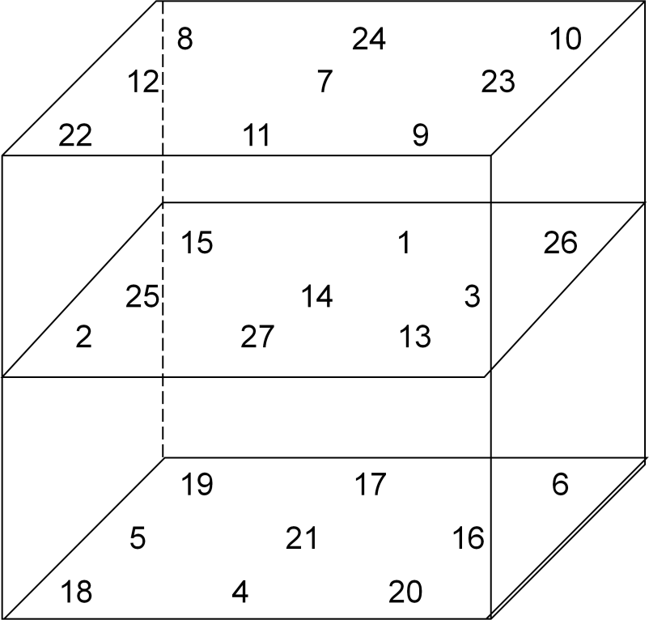

- Magic Cube has 6 outer and 3 inner and 2 diagonal surfaces
- Outer 6 surfaces are not magic squares as diagonals are not added to 42.
- Inner 5 surfaces are magic square.

UNIT –2 :Problem Solving: State-Space Search and Control Strategies: Introduction, General Problem Solving, Characteristics of Problem, Exhaustive searches, heuristic search techniques, iterative deepening a*, Constraint Satisfaction
Problem Reduction and Game Playing: Introduction, problem reduction, game playing, alpha-beta pruning, two-player perfect information games

Problem Solving – Basic Search methods Problem Characteristics
  - Heuristic search is a very general method applicable to a large class of problem.
  - In order to choose the most appropriate method (or combination of methods) for a particular problem it is necessary to analyze the problem along several key dimensions.
    - Is the problem decomposable into a set of independent smaller sub problems?
      - Decomposable problems can be solved by the divide-and- conquer technique.
  - Use of decomposing problems:
    - Each sub-problem is simpler to solve.
    - Each sub-problem can be handed over to a different processor. Thus can be solved in parallel processing environment.
    - There are non decomposable problems.
    - For example, Block world problem is non decomposable.

Problem Solving
    - AI programs have a clean separation of
      - computational components of data,
      - operations & control.
    - Search forms the core of many intelligent processes.

    - It is useful to structure AI programs in a way that facilitates describing the search process.

Production System – PS
    - PS is a formation for structuring AI programs which facilitates describing search process.
    - It consists of
      - Initial or start state of the problem
      - Final or goal state of the problem
      - It consists of one or more databases containing information appropriate for the particular task.
    - The information in databases may be structured
      - using knowledge representation schemes.

Production Rules
    - PS contains set of production rules,
      - each consisting of a left side that determines the applicability of the rule and
      - a right side that describes the action to be performed if the rule is applied.
      - These rules operate on the databases.
      - Application of rules change the database.
    - A control strategy that specifies the order in which the rules will be applied when several rules match at once.
    - One of the examples of Production Systems is an Expert System.

Advantages of PS
    - In addition to its usefulness as a way to describe search, the production model has other advantages as a formalism in AI.
      - It is a good way to model the strong state driven nature of intelligent action.

      - As new inputs enter the database, the behavior of the system changes.
      - New rules can easily be added to account for new situations without disturbing the rest of the system, which is quite important in real-time environment.

Example : Water Jug Problem
    - Problem statement:
      - Given two jugs, a 4-gallon and 3-gallon having no measuring markers on them. There is a pump that can be used to fill the jugs with water. How can you get exactly 2 gallons of water into 4- gallon jug.

Solution:
      - State for this problem can be described as the set of ordered pairs of integers (X, Y) such that
        - X represents the number of gallons of water in 4-gallon jug and
        - Y for 3-gallon jug.
      - Start state is (0,0)
      - Goal state is (2, N) for any value of N.

Production Rules
    - Following are the production rules for this problem.

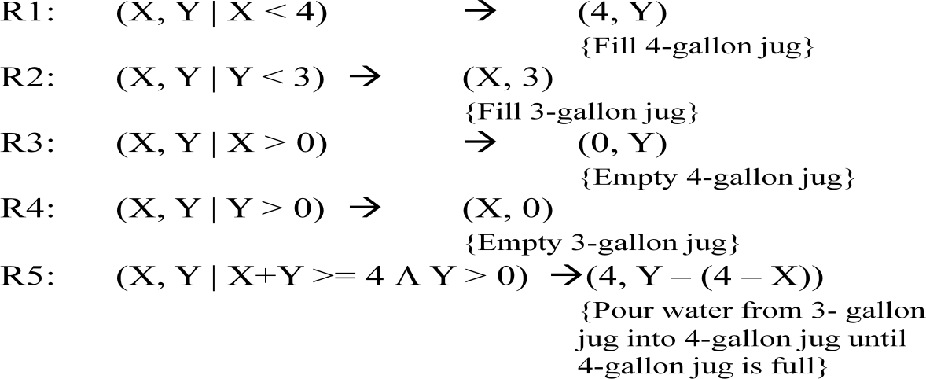

R6: (X, Y | X+Y >= 3 Λ X > 0) → (X – (3 – Y), 3)
{Pour water from 4-gallon jug into 3- gallon jug until 3-gallon jug is full}
R7: (X, Y | X+Y <= 4 Λ Y > 0) → (X+Y, 0)
{Pour all water from 3-gallon jug into 4-gallon jug }
R8: (X, Y | X+Y <= 3 Λ X > 0) → (0, X+Y)
{Pour all water from 4-gallon jug into 3-gallon jug }
Superficial Rules: {May not be used in this problem}
R9: (X, Y | X > 0) → (X – D, Y)
{Pour some water D out from 4-gallon jug} R10: (X, Y | Y > 0) → (X, Y - D)
{Pour some water D out from 3- gallon jug}

Trace of steps involved in solving the water jug problem - First solution

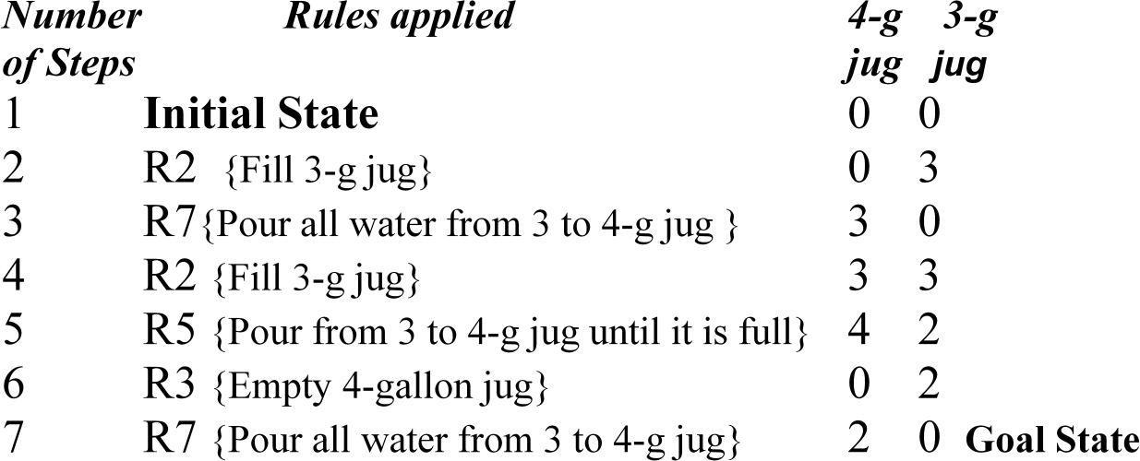

Trace of steps involved in solving the water jug problem - Second solution
    - Note that there may be more than one solutions.

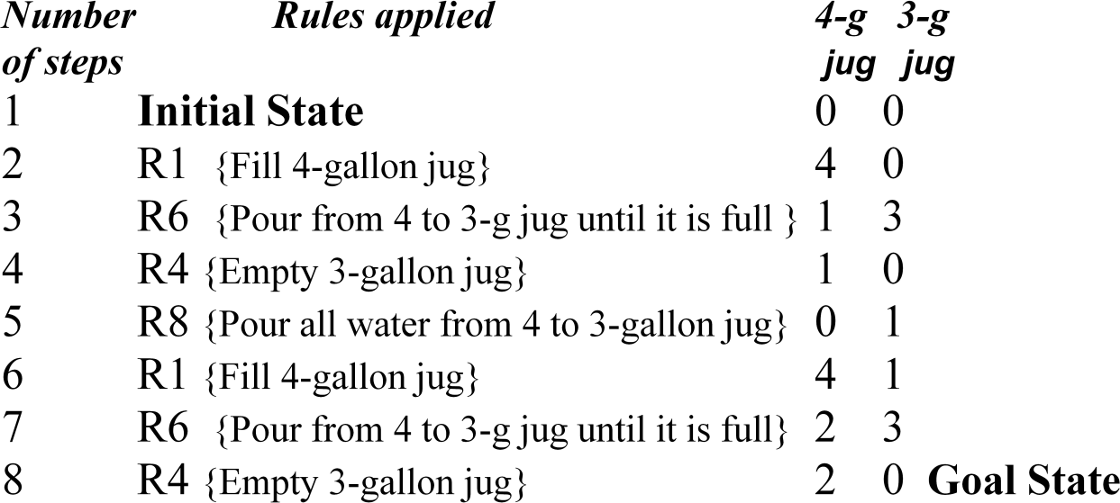

    - For each problem
      - there is an initial description of the problem.

      - final description of the problem.
      - more than one ways of solving the problem.
      - a path between various solution paths based on some criteria of goodness or on some heuristic function is chosen.
      - there are set of rules that describe the actions called production rules.
        - Left side of the rules is current state and right side describes new state that results from applying the rule.
    - Summary: In order to provide a formal description of a problem, it is necessary to do the following things:
      - Define a state space that contains all the possible configurations of the relevant objects.
      - Specify one or more states within that space that describe possible situations from which the problem solving process may start. These states are called initial states.
      - Specify one or more states that would be acceptable as solutions to the problem called goal states.
      - Specify a set of rules that describe the actions. Order of application of the rules is called control strategy.
      - Control strategy should cause motion towards a solution.

Control Strategies
- Control Strategy decides which rule to apply next during the process of searching for a solution to a problem.
- Requirements for a good Control Strategy

It should cause motion
In water jug problem, if we apply a simple control strategy of starting each time from the top of rule list and choose the first applicable one, then we will never move towards solution.

It should explore the solution space in a systematic manner
If we choose another control strategy, say, choose a rule randomly from the applicable rules then definitely it causes motion and eventually will lead to a solution. But one may arrive to same state several times. This is because control strategy is not systematic.
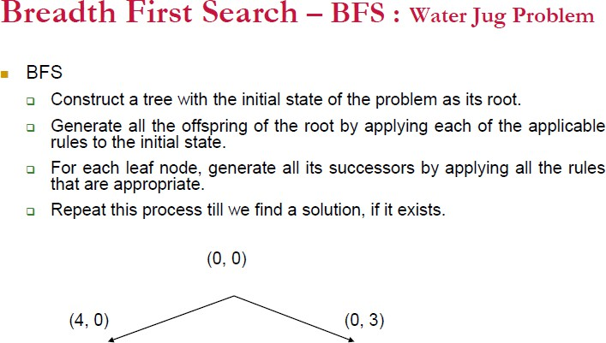

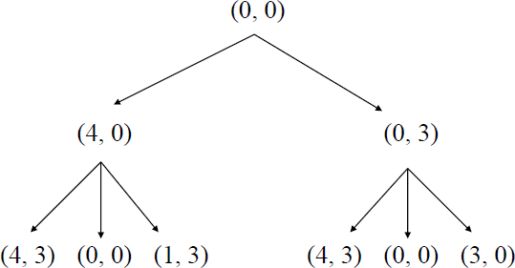

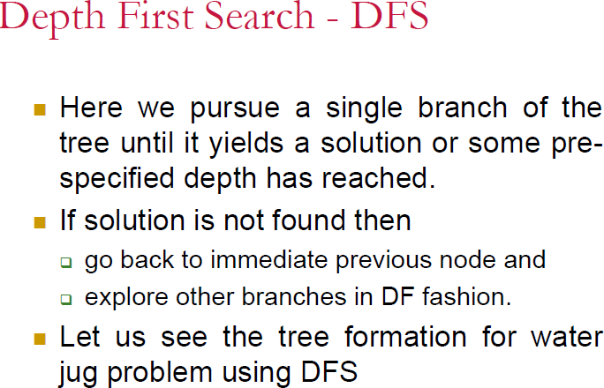

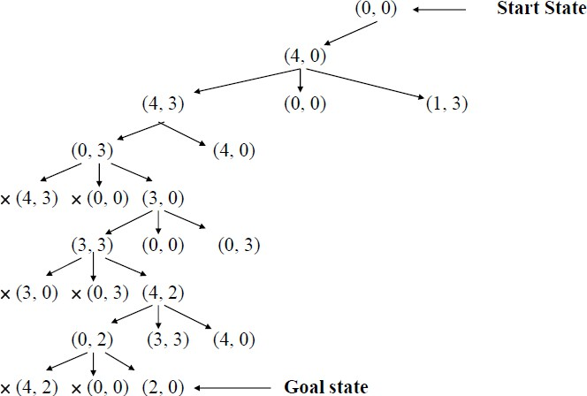

Traveling Salesman Problem
- Consider 5 cities.
  - A salesman is supposed to visit each of 5 cities.
  - All cities are pair wise connected by roads.
  - There is one start city.
  - The problem is to find the shortest route for the salesman who has to
    - visit each city only once and
    - returns to back to start city.
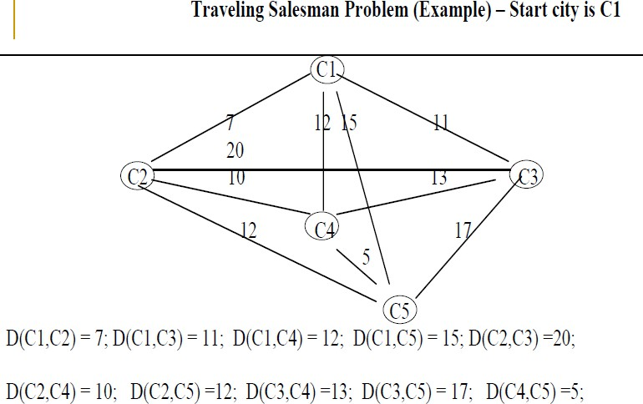

- A simple motion causing and systematic control structure could, in principle solve this problem.
- Explore the search tree of all possible paths and return the shortest path.
- This will require 4! paths to be examined.

- If number of cities grow, say 25 cities, then the time required to wait a salesman to get the information about the shortest path is of 0(24!) which is not a practical situation.
- This phenomenon is called combinatorial explosion.
- We can improve the above strategy as follows:
- Begin generating complete paths, keeping track of the shortest path found so far.
- Give up exploring any path as soon as its partial length becomes greater than the shortest path found so far.
- This algorithm is efficient than the first one, still requires exponential time ∝ some number raised to N (number of cities).

a. Missionaries and Cannibals
- Problem Statement: Three missionaries and three cannibals want to cross a river. There is a boat on their side of the river that can be used by either one or two persons.
  - How should they use this boat to cross the river in such a way that cannibals never outnumber missionaries on either side of the river? If the cannibals ever outnumber the missionaries (on either bank) then the missionaries will be eaten. How can they all cross over without anyone being eaten?
- PS for this problem can be described as the set of ordered pairs of left and right bank of the river as (L, R) where each bank is represented as a list [nM, mC, B]
  - n is the number of missionaries M, m is the number of cannibals C, and B represents boat.
- Start state: ( [3M, 3C, 1B], [0M, 0C, 0B] ),
  - 1B means that boat is present and 0B means it is not there on the bank of river.
- Goal state: ( [0M, 0C, 0B], [3M, 3C, 1B] )

- Any state: ([n1M, m1C, 1B], [n2 M, m2 C, 0B]) , with constraints/conditions as n1 (≠0) ≥ m1; n2 (≠0) ≥ m2; n1 + n2 = 3, m1 + m2 = 3
  - By no means, this representation is unique.
  - In fact one may have number of different representations for the same problem.
  - The table on the next slide consists of production rules based on the chosen representation.

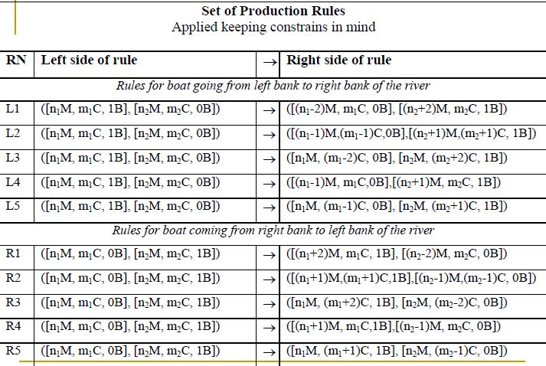

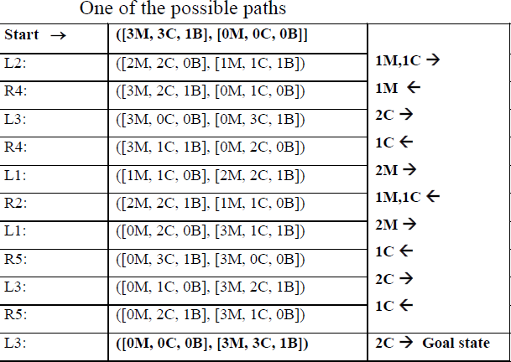

State Space Search for Solving problems
- State space is another method of problem representation that facilitates easy search similar to PS.
- In this method also problem is viewed as finding a path from start state to goal state.
- A solution path is a path through the graph from a node in a set S to a node in set G.
- Set S contains start states of the problem.
- A set G contains goal states of the problem.
- The aim of search algorithm is to determine a solution path in the graph.
- A state space consists of four components.
- Set of nodes (states) in the graph/tree. Each node represents the state in problem solving process.

- Set of arcs connecting nodes. Each arc corresponds to operator that is a step in a problem solving process.
- Set S containing start states of the problem.
- Set G containing goal states of the problem.

The 8-Puzzle
Problem Statement:
      - The eight puzzle problem consists of a 3 x 3 grid with 8 consecutively numbered tiles arranged on it.
      - Any tile adjacent to the space can be moved on it.
      - Solving this problem involves arranging tiles in the goal state from the start state.
Start state Goal state
3
7
6
5
1
2
4
8
5
3
6
7
2
4
1
8
Solution by State Space method
      - The start state could be represented as: [ [3,7,2], [5,1, 2], [4,0,6] ]
      - The goal state could be represented as: [ [5,3,6] [7,0,2], [4,1,8] ]
The operators can be thought of moving {up, down, left, right}, the direction in which blank space effectively moves.

Initial State
3 7 6
5 1 2
6 8
up 3
5
6
left
7 6
2
1 8
3
5
7 6
1 2
6 8
right
3 7 6
5 1 2
6 8
up
3 6
3
5 7 2
6 1 8 6
left
7 6
5 2
1 8
right
3 7 6
5 2
6 1 8

Searching for a Solution
      - Problem can be solved by searching for a solution.
      - Transform initial state of a problem into some final goal state.
      - Problem can have more than one intermediate states between start and goal states.
      - All possible states of the problem taken together are said to form
        - a state space or
        - problem state and
        - search is called state space search.
      - Search is basically a procedure to discover a path through a problem space from initial state to a goal state.
      - There are two directions in which such a search could proceed.
        - Data driven search, forward, from the start state Goal driven search, backward, from the goal state

Forward Reasoning (Chaining):
      - It is a control strategy that starts with known facts and works towards a conclusion.
      - For example in 8 puzzle problem, we start from initial state to goal state.
      - In this case we begin building a tree of move sequences with initial state as the root of the tree.
      - Generate the next level of the tree by finding all rules whose left sides match with root and use their right side to create the new state.
      - Continue until a configuration that matches the goal state is generated.
      - Language OPS5 uses forward reasoning rules. Rules are expressed in the form of “if-then rule”.
      - Find out those sub-goals which could generate the given goal.

Backward Reasoning (Chaining)
      - It is a goal directed control strategy that begins with the final goal.
      - Continue to work backward, generating more sub goals that must also be satisfied in order to satisfy main goal.
      - Prolog (Programming in Logic) uses this strategy.

General Purpose Search Strategies:
      - Breadth First Search (BFS)
        - It expands all the states one step away from the initial state, then expands all states two steps from initial state, then three steps etc., until a goal state is reached.
        - It expands all nodes at a given depth before expanding any nodes at a greater depth.
        - All nodes at the same level are searched before going to the next level down.
        - For implementation, two lists called OPEN and CLOSED are maintained.

          - The OPEN list contains those states that are to be expanded and CLOSED list keeps track of states already expanded.
          - Here OPEN list is used as a queue.

Algorithm (BFS)
Input: Two states in the state space START and GOAL Local Variables: OPEN, CLOSED, STATE-X, SUCCS Output: Yes or No
Method:
- Initially OPEN list contains a START node and CLOSED list is empty; Found = false;
- While (OPEN ≠ empty and Found = false) Do {
  - Remove the first state from OPEN and call it STATE-X;
  - Put STATE-X in the front of CLOSED list;
  - If STATE-X = GOAL then Found = true else
{- perform EXPAND operation on STATE-X, producing a list of SUCCESSORS;
    - Remove from successors those states, if any, that are in the CLOSED list;
    - Append SUCCESSORS at the end of the OPEN list /*queue*/
} } /* end while */
If Found = true then return Yes else return No and Stop

Depth-First Search
      - In depth-first search we go as far down as possible into the search tree / graph before backing up and trying alternatives.
        - It works by always generating a descendent of the most recently expanded node until some depth cut off is reached

        - then backtracks to next most recently expanded node and generates one of its descendants.
      - So only path of nodes from the initial node to the current node is stored in order to execute the algorithm.
      - For implementation, two lists called OPEN and CLOSED with the same conventions explained earlier are maintained.
        - Here OPEN list is used as a stack.
        - If we discover that first element of OPEN is the Goal state, then search terminates successfully else move it to closed list and stack its successor in open list.

Algorithms (DFS)
Input: Two states in the state space, START and GOAL
LOCAL Variables: OPEN, CLOSED, RECORD-X, SUCCESSORS
Output: A path sequence if one exists, otherwise return No

Method:
- Form a stack consisting of (START, nil) and call it OPEN list. Initially set CLOSED list as empty; Found = false;
- While (OPEN ≠ empty and Found = false) DO
{
- Remove the first state from OPEN and call it RECORD-X;
- Put RECORD-X in the front of CLOSED list;
- If the state variable of RECORD-X= GOAL, then Found = true
Else
{ - Perform EXPAND operation on STATE-X, a state variable of RECORD-X, producing a list of action records called SUCCESSORS; create each action record by associating with each state its parent.

  - Remove from SUCCESSORS any record whose state variables are in the record already in the CLOSED list.
  - Insert SUCCESSORS in the front of the OPEN list
/* Stack */
}
}/* end while */
- If Found = true then return the plan used /* find it by tracing through the pointers on the CLOSED list */ else return No
- Stop

Comparisons
      - DFS
        - is effective when there are few sub trees in the search tree that have only one connection point to the rest of the states.
        - can be dangerous when the path closer to the START and farther from the GOAL has been chosen.
        - Is best when the GOAL exists in the lower left portion of the search tree.
        - Is effective when the search tree has a low branching factor.

BFS
        - can work even in trees that are infinitely deep.
        - requires a lot of memory as number of nodes in level of the tree increases exponentially.
        - is superior when the GOAL exists in the upper right portion of a search tree.

Depth First Iterative Deepening (DFID)
      - DFID is an iterative method that expands all nodes at a given depth before expanding any nodes at greater depth.

      - For a given depth d, DFID performs a DFS and never searches deeper than depth d and d is increased by 1 in next iteration if solution is not found.
      - Advantages:
        - It takes advantages of both the strategies (BFS & DFS) and suffers neither the drawbacks of BFS nor of DFS on trees
        - It is guaranteed to find a shortest - length (path) solution from initial state to goal state (same as BFS).
        - Since it is performing a DFS and never searches deeper than depth
d. the space it uses is O(d) (same as DFS).
      - Disadvantages:
        - DFID performs wasted computation prior to reaching the goal depth but time complexity remains same as that of BFS and DFS

Various Heuristic Searches:
Heuristic Search
      - Heuristics are criteria for deciding which among several alternatives be the most effective in order to achieve some goal.
      - Heuristic is a technique that
        - improves the efficiency of a search process possibly by sacrificing claims of systematicity and completeness.
        - It no longer guarantees to find the best answer but almost always finds a very good answer.
        - Using good heuristics, we can hope to get good solution to hard problems (such as travelling salesman) in less than exponential time.
        - There are general-purpose heuristics that are useful in a wide variety of problem domains.
        - We can also construct special purpose heuristics, which are domain specific.

General Purpose Heuristics
      - A general-purpose heuristics for combinatorial problem is
        - Nearest neighbor algorithms which works by selecting the locally superior alternative.
        - For such algorithms, it is often possible to prove an upper bound on the error which provide reassurance that one is not paying too high a price in accuracy for speed.
      - In many AI problems,
        - it is often hard to measure precisely the goodness of a particular solution.
        - But still it is important to keep performance question in mind while designing algorithm.
      - For real world problems,
        - it is often useful to introduce heuristics based on relatively unstructured knowledge.
        - It is impossible to define this knowledge in such a way that mathematical analysis can be performed.
      - In AI approaches,
        - behavior of algorithms are analyzed by running them on computer as contrast to analyzing algorithm mathematically.
      - There are at least two reasons for the adhoc approaches in AI.
        - It is a lot more fun to see a program do something intelligent than to prove it.
        - AI problem domains are usually sufficiently complex, so generally not possible to produce analytical proof that a procedure will work.
        - It is even not possible to describe the range of problems well enough to make statistical analysisof program behavior meaningful.
      - One of the most important analysis of the search process is straightforward i.e.,

        - Number of nodes in a complete search tree of depth D and branching factor F is F*D .
      - This simple analysis motivates to
        - look for improvements on the exhaustive search.
        - find an upper bound on the search time which can be compared with exhaustive search procedures.

Informed Search Strategies- Branch & Bound Search
      - It expands the least-cost partial path. Sometimes, it is called uniform cost search.
      - Function g(X) assigns some cumulative expense to the path from Start
node to X by applying the sequence of operators .
        - For example, in salesman traveling problem, g(X) may be the actual distance from Start to current node X.
      - During search process there are many incomplete paths contending for further consideration.
      - The shortest one is extended one level, creating as many new incomplete paths as there are branches.
      - These new paths along with old ones are sorted on the values of function
g.
      - The shortest path is chosen and extended.
      - Since the shortest path is always chosen for extension, the path first reaching to the destination is certain to be nearly optimal.
      - Termination Condition:
        - Instead of terminating when a path is found, terminate when the shortest incomplete path is longer than the shortest complete path.
      - If g(X) = 1, for all operators, then it degenerates to simple Breadth-First search.
      - It is as bad as depth first and breadth first, from AI point of view,.

      - This can be improved if we augment it by dynamic programming i.e. delete those paths which are redundant.

Hill Climbing- (Quality Measurement turns DFS into Hill climbing (Variant of generate and test strategy)
      - Search efficiency may be improved if there is some way of ordering the choices so that the most promising node is explored first.
      - Moving through a tree of paths, hill climbing proceeds
        - in depth-first order but the choices are ordered according to some heuristic value (i.e, measure of remaining cost from current to goal state).

Hill Climbing- Algorithm:
Generate and Test Algorithm

Start
- Generate a possible solution
- Test to see, if it is goal.
- If not go to start else quit
End

Example of heuristic function
- Straight line (as the crow flies) distance between two cities may be a heuristic measure of remaining distance in traveling salesman problem .

Simple Hill climbing : Algorithm
- Store initially, the root node in a OPEN list (maintained as stack) ; Found = false;
- While ( OPEN ≠ empty and Found = false) Do
{
  - Remove the top element from OPEN list and call it NODE;

  - If NODE is the goal node, then Found = true else find SUCCs, of NODE, if any, and sort SUCCs by estimated cost from NODE to goal state and add them to the front of OPEN list.
} /* end while */
- If Found = true then return Yes otherwise return No
- Stop

Problems in hill climbing:
- There might be a position that is not a solution but from there no move improves situations?
- This will happen if we have reached a Local maximum, a plateau or a
ridge.
  - Local maximum: It is a state that is better than all its neighbors but is not better than some other states farther away. All moves appear to be worse.
Solution to this is to backtrack to some earlier state and try going in different direction.
  - Plateau: It is a flat area of the search space in which, a whole set of neighboring states have the same value. It is not possible to determine the best direction.
    - Here make a big jump to some direction and try to get to new section of the search space.
  - Ridge: It is an area of search space that is higher than surrounding areas, but that can not be traversed by single moves in any one direction. (Special kind of local maxima).
    - Here apply two or more rules before doing the test i.e., moving in several directions at once.

Beam Search:
- Beam Search progresses level by level.
- It moves downward from the best W nodes only at each level. Other nodes are ignored.

  - W is called width of beam search.
- It is like a BFS where also expansion is level wise.
- Best nodes are decided on the heuristic cost associated with the node.
- If B is the branching factor, then there will be only W*B nodes under consideration at any depth but only W nodes will be selected.

Algorithm – Beam search
- Found = false;
- NODE = Root_node;
- If NODE is the goal node, then Found = true else find SUCCs of NODE, if any with its estimated cost and store in OPEN list;
- While (Found = false and not able to proceed further)
{
  - Sort OPEN list;
  - Select top W elements from OPEN list and put it in W_OPEN list and empty OPEN list;
  - While (W_OPEN ≠ φ and Found = false)
{
    - Get NODE from W_OPEN;
    - If NODE = Goal state then Found = true else
{
      - Find SUCCs of NODE, if any with its estimated cost
      - store in OPEN list;
}
} // end while
} // end while
- If Found = true then return Yes otherwise return No and Stop

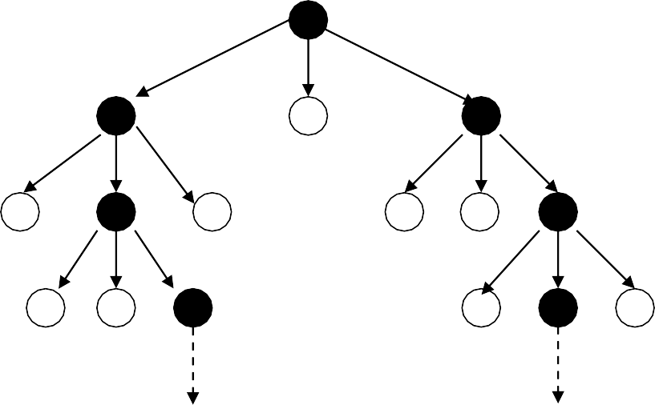
W = 2

Continue till goal state is found or not able to proceed further

Best First Search
- Expand the best partial path.
- Here forward motion is carried out from the best open node so far in the entire partially developed tree.

Algorithm (Best First Search)
- Initialize OPEN list by root node; CLOSED = φ;
- Found = false;
- While (OPEN ≠ φ and Found = false) Do
{
  - If the first element is the goal node, then Found = true else remove it from OPEN list and put it in CLOSED list.
  - Add its successor, if any, in OPEN list.
  - Sort the entire list by the value of some heuristic function that assigns to each node, the estimate to reach to the goal node
} /* end while */
- If the Found = true, then announce the success else announce failure.

- Stop.

Observations
- In hill climbing, sorting is done on the successors nodes whereas in the best first search sorting is done on the entire list.
- It is not guaranteed to find an optimal solution, but normally it finds some solution faster than any other methods.
- The performance varies directly with the accuracy of the heuristic evaluation function.

Termination Condition
- Instead of terminating when a path is found, terminate when the shortest incomplete path is longer than the shortest complete path.

A* Method
- A* (“Aystar”) (Hart, 1972) method is a combination of branch & bound and best search, combined with the dynamic programming principle.
- The heuristic function (or Evaluation function) for a node N is defined as f(N) = g(N) + h(N)
- The function g is a measure of the cost of getting from the Start node (initial state) to the current node.
  - It is sum of costs of applying the rules that were applied along the best path to the current node.
- The function h is an estimate of additional cost of getting from the current node to the Goal node (final state).
  - Here knowledge about the problem domain is exploited.
- A* algorithm is called OR graph / tree search algorithm.

Algorithm (A*)
- Initialization OPEN list with initial node; CLOSED= φ; g = 0, f = h, Found
= false;

- While (OPEN ≠ φ and Found = false )
{
  - Remove the node with the lowest value of f from OPEN to CLOSED and call it as a Best_Node.
  - If Best_Node = Goal state then Found = true else
{
    - Generate the Succ of Best_Node
    - For each Succ do
{
      - Compute g(Succ) = g(Best_Node) + cost of getting from Best_Node to Succ.
      - If Succ ∈ CLOSED then /* already processed */
{
        - Call the matched node as OLD and add it in the list of Best_Node successors.
        - Ignore the Succ node and change the parent of OLD, if required
- If g(Succ) < g(OLD) then make parent of OLD to be Best_Node and change the values of g and f for OLD.
- Propogate the change to OLD’s children using depth first search
- If g(Succ) >= g(OLD) then do nothing
}
  - If Succ ∉ OPEN or CLOSED
{
    - Add it to the list of Best_Node’s successors
    - Compute f(Succ) = g(Succ) + h(Succ)
    - Put Succ on OPEN list with its f value

}
} /* for loop*/
} /* else if */
} /* End while */
- If Found = true then report the best path else report failure
- Stop

Behavior of A* Algorithm Underestimation
If we can guarantee that h never over estimates actual value from current to goal, then A* algorithm is guaranteed to find an optimal path to a goal, if one exists
Example – Underestimation – f=g+h
Here h is underestimated A

Underestimated
(1+3)B (1+4)C (1+5)D

3 moves away from goal
(2+3) E

3 moves away from goal
(3+3) F

Explanation -Example of Underestimation
- Assume the cost of all arcs to be 1. A is expanded to B, C and D.
- ‘f’ values for each node is computed.

- B is chosen to be expanded to E.
- We notice that f(E) = f(C) = 5
- Suppose we resolve in favor of E, the path currently we are expanding. E is expanded to F.
- Clearly expansion of a node F is stopped as f(F)=6 and so we will now expand C.
- Thus we see that by underestimating h(B), we have wasted some effort but eventually discovered that B was farther away than we thought.
- Then we go back and try another path, and will find optimal path.

A
Overestimated
(1+3) B (1+4) C (1+5) D

(2+2) E
(3+1)F
(4+0) G

Explanation –Example of Overestimation
- A is expanded to B, C and D.
- Now B is expanded to E, E to F and F to G for a solution path of length 4.
- Consider a scenario when there a direct path from D to G with a solution giving a path of length 2.

- We will never find it because of overestimating h(D).
- Thus, we may find some other worse solution without ever expanding D.
- So by overestimating h, we can not be guaranteed to find the cheaper path solution.

Admissibility of A*:
- A search algorithm is admissible, if
  - for any graph, it always terminates in an optimal path from initial state to goal state, if path exists.
- If heuristic function h is underestimate of actual value from current state to goal state, then the it is called admissible function.
- Alternatively we can say that A* always terminates with the optimal path in case
  - h(x) is an admissible heuristic function.

Monotonicity
- A heuristic function h is monotone if
  - ∀ states Xi and Xj such that Xj is successor of Xi h(Xi)– h(Xj) ≤ cost (Xi, Xj)
where, cost (Xi, Xj) actual cost of going from Xi to Xj
  - h (goal) = 0
- In this case, heuristic is locally admissible i.e., consistently finds the minimal path to each state they encounter in the search.
- The monotone property in other words is that search space which is every where locally consistent with heuristic function employed i.e., reaching each state along the shortest path from its ancestors.
- With monotonic heuristic, if a state is rediscovered, it is not necessary to check whether the new path is shorter.
- Each monotonic heuristic is admissible
- A cost function f(n) is monotone if f(n) ≤f(succ(n)), ∀n.

- For any admissible cost function f, we can construct a monotone admissible function.
- Alternatively, the monotone property:
- that search space which is every where locally consistent with heuristic function employed i.e., reaching each state along the shortest path from its ancestors.
- With monotonic heuristic, if a state is rediscovered, it is not necessary to check whether the new path is shorter.
- Each monotonic heuristic is admissible
- A cost function f(n) is monotone. if f(n) ≤f(succ(n)), ∀n.
- For any admissible cost function f, we can construct a monotone admissible function.
Example: Solve Eight puzzle problem using A* algorithm
- Start state Goal state
3
7
6
5
1
2
4
8
5
3
6
7
2
4
1
8

- Evaluation function f (X) = g (X) + h(X)
h (X) = the number of tiles not in their goal position in a given state X
g(X) = depth of node X in the search tree
- Initial node has f(initial_node) = 4
- Apply A* algorithm to solve it.
- The choice of evaluation function critically determines search results.

Start state |  | Goal state
3 | 7 | 6 |  | 5 | 3 | 6
5 | 1 | 2 |  | 7 |  | 2
4 |  | 8 |  | 4 | 1 | 8

Evaluation function - f for Eight Puzzle Problem:
- The choice of evaluation function critically determines search results.
- Consider Evaluation function f (X) = g (X) + h(X)
  - h (X) = the number of tiles not in their goal position in a given state X
  - g(X) = depth of node X in the search tree
- For Initial node
  - f(initial_node) = 4
- Apply A* algorithm to solve it.
Search Tree
Start State
f = 0+4
3 7 6
5 1 2
4 8
up (1+3)
left (1+5)
right
(1+5)
3
5
4
7
1
6
2
8
3 7 6
5 1 2
4 8
3 7 6
5 1 2
4 8
up (2+3)
3 6
5 7 2
4 1 8
left (2+3)
3 7 6
5 2
4 1 8
right (2+4)
3 7 6
5 2
4 1 8
left (3+2)
3 6
5 7 2
4 1 8
down (4+1)
5 3 6
7 2
4 1 8
right (3+4)
3 6
5 7 2
4 1 8
right
5 3 6
7 2
4 1 8
Goal State

 |  |  |  | 3 7 |  | 6
 |  |  |  | 5 1 |  | 2
 |  |  |  | 4 |  | 8
up (1+3) |  |  |  | left (1+5) |  |  | right  (1+5)
3 | 7 | 6 |  | 3 | 7 | 6 |  | 3 | 7 | 6
5 |  | 2 |  | 5 | 1 | 2 |  | 5 | 1 | 2
4 | 1 | 8 |  |  | 4 | 8 |  | 4 | 8

3 6 |  | 3 | 6
5 7 2 |  | 5 | 7 | 2
4 1 8 |  | 4 | 1 | 8
down
(4+1)
5 3 6 | right | 5 | 3 | 6 | Goal
7 2 |  | 7 |  | 2 | State
4 1 8 |  | 4 | 1 | 8

Harder Problem
Search Tree
Start State
f = 0+4
up (2+3)
left (2+3)
right (2+4)
3 7 6
5 2
4 1 8
left (3+2)
right (3+4)
3 7 6
5 2
4 1 8
3 6
5 7 2
4 1 8
- Harder problems (8 puzzle) can’t be solved by heuristic function defined earlier.

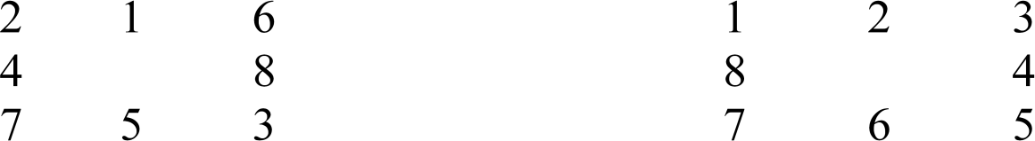

- A better estimate function is to be thought.
h (X) = the sum of the distances of the tiles from their goal position in a given state X
- Initial node has h(initial_node) = 1+1+2+2+1+3+0+2=12

2.5.7.Iterative Deepening A* & Constraint Satisfaction Problems IDA* Algorithm
- At each iteration, perform a DFS cutting off a branch when its total cost (g+h) exceeds a given threshold.
- This threshold starts at the estimate of the cost of the initial state, and increases for each iteration of the algorithm.
- At each iteration, the threshold used for the next iteration is the minimum cost of all values exceeded the current threshold.

Ist iteration ( Threshhold = 5) O 5

O O O O O
6 8 4 8 9
× ×× ×× ××
IInd iteration ( Threshhold = 6)
O 5
O
O

O O O O O O
7 5 9 8 4 7
× ×× ×× ×
IIIrd iteration ( Threshhold = 7) O 5

O O

O O O

O O O O O O Goal
8 9 4 4 8
×× ×× ××

- Given an admissible monotone cost function, IDA* will find a solution of least cost or optimal solution if one exists.

- IDA* not only finds cheapest path to a solution but uses far less space than A* and it expands approximately the same number of nodes as A* in a tree search.
- An additional benefit of IDA* over A* is that it is simpler to implement, as there are no open and closed lists to be maintained.
- A simple recursion performs DFS inside an outer loop to handle iterations.

Constrained Satisfaction:
    - Many AI problems can be viewed as problems of constrained satisfaction in which the goal is to solve some problem state that satisfies a given set of constraints.
    - Example of such a problem are
      - Crypt-Arithmetic puzzles.
      - Many design tasks can also be viewed as constrained satisfaction problems.
      - N-Queen: Given the condition that no two queens on the same row/column/diagonal attack each other.
      - Map colouring: Given a map, colour three regions in blue, red and black, such that no two neighbouring regions have the same colour.
    - Such problems do not require a new search methods.
They can be solved using any of the search strategies which can be augmented with the list of constraints that change as parts of the problem are solved.

Algorithm:
    - Until a complete solution is found or all paths have lead to dead ends
{
      - Select an unexpanded node of the search graph.
      - Apply the constraint inference rules to the selected node to generate all possible new constraints.

      - If the set of constraints contain a contradiction, then report that this path is a dead end.
      - If the set of constraint describes a complete solution, then report success.
      - If neither a contradiction nor a complete solution has been found, then
        - apply the problem space rules to generate new partial solutions that are consistent with the current set of constraints.
        - Insert these partial solutions into the search graph.
}

Crypt-Arithmetic puzzle
      - Problem Statement:
        - Solve the following puzzle by assigning numeral (0-9) in such a way that each letter is assigned unique digit which satisfy the following addition.
        - Constraints : No two letters have the same value. (The constraints of arithmetic).

+ | S M | E O | N R | D E
M | O | N | E | Y

      - Initial Problem State
        - S = ? ; E = ? ;N = ? ; D = ? ; M = ? ;O = ? ; R = ? ;Y = ?

- Carries | :
- C4 = ? ; | C3 = ? ; | C2 = ? ; | C1 = ?

C₄ | C₃ | C₂ | C₁ | Carry
 | S | E | N | D
+ | M | O | R | E
M | O | N | E | Y

Constraint equations:

Y = D + E C1

E = N + R + C1 C2

N = E + O + C2 C3

O = S + M + C3 C4 M = C4
      - We can easily see that M has to be non zero digit, so the value of C4 =1
- M = C4 ⇒ M = 1
- O = S + M + C3 → C4 For C4 =1, S + M + C3 > 9 ⇒
S + 1 + C3 > 9 ⇒ S+C3 > 8.
If C3 = 0, then S = 9 else if C3 = 1, then S = 8 or 9.
  - We see that for S = 9
    - C3 = 0 or 1

    - It can be easily seen that C3 = 1 is not possible as O = S + M + C3
⇒ O = 11 ⇒ O has to be assigned digit 1 but 1 is already assigned to M, so not possible.
    - Therefore, only choice for C3 = 0, and thus O = 10. This implies that O is assigned 0 (zero) digit.

Therefore, O = 0
M = 1, O = 0

C₄ | C₃ | C₂ | C₁ | Carry
 | S | E | N | D
+ | M | O | R | E
M | O | N | E | Y

Y = | D + E | → C1
E = | N + R + C1 | → C2
N = | E + O + C2 | → C3
O = | S + M + C3 | → C4
M = C4
Since C3 = 0; N = E + O + C2 produces no carry.
  - As O = 0, N = E + C2 .
  - Since N ≠ E, therefore, C2 = 1.

Hence N = E + 1
  - Now E can take value from 2 to 8 {0,1,9 already assigned so far }
    - If E = 2, then N = 3.
    - Since C2 = 1, from E = N + R + C1 , we get 12 = N + R + C1
      - If C1 = 0 then R = 9, which is not possible as we are on the path with S = 9
      - If C1 = 1 then R = 8, then

        - From Y = D + E , we get 10 + Y= D + 2 .
        - For no value of D, we can get Y.
    - Try similarly for E = 3, 4. We fail in each case.

 |  |  | C₄ | C₃ | C₂ | C₁ | Carry
 |  |  |  | S | E | N | D
 |  |  | + | M | O | R | E
 |  |  | M | O | N | E | Y
Y = | D + E | → C1
E = N + R + C1 → C2
N = E + O + C2 → C3
O = S + M + C3 → C4 M = C4

  - If E = 5, then N = 6
- Since C2 = 1, from E = N + R + C1 , we get 15 = N + R + C1 ,
- If C1 = 0 then R = 9, which is not possible as we are on the path with S = 9.
- If C1 = 1 then R = 8, then
  - From Y = D + E , we get 10 + Y= D + 5 i.e., 5 + Y = D.
  - If Y = 2 then D = 7. These values are possible.
    - Hence we get the final solution as given below and on backtracking, we may find more solutions.

S = 9 ; E = 5 ; N = 6 ; D = 7 ;
  - M = 1 ; O = 0 ; R = 8 ;Y = 2

Constraints:

Y = D + E C₁
E = N + R + C₁ C₂
N = E + O + C₂ C₃
O = S + M + C₃ C₄ M = C₄

Initial State

M = 1 → C₄ = 1 O = 1 + S + C₃

O
S = 9 S = 8
O
C₃ = 0 C₃ = 1
O = 0 O = 1
Fixed ×
M = 1
O = 0

N = E + O + C₂ = E + C₂ → C₂ = 1 (must) → N = E + 1 E = 2 E = 3 ….. E = 5

N = 3
E = N + R + C₁
10 + 2 = 3 + R + C₁
O × O
N = 6
E = N + R + C₁
10 + 5 = 6 + R + C₁

R = 9 R = 8 R = 9 R = 8
C₁ =0 C₁ = 1 C₁ = 0 C₁ = 1
× O × O
10 + Y = D + E = D + 2 10 + Y = D + E = D + 5
O O
D = 8 D = 9 D = 7
Y = 0 Y = 1 Y = 2
× × 3 ×
The first solution obtained is:

M = 1, O = 0, S = 9, E = 5, N = 6, R = 8, D = 7, Y = 2

Solve the following given problem using Constraint Satisfaction

C4 | C3 B | C2 A | C1 S | ← Carries  E
+ | B | A | L | L
G | A | M | E | S

Constraints equations are:

E + L = S | → | C1
S + L + C1= E | → | C2
2A + C2 = M | → | C3
2B + C3 = A  G = C4 | → | C4
Initial Problem State
G = ?; A = ?;M = ?; E = ?; S = ?; B = ?; L = ?

- G = C₄ ⇒ G = 1
- 2B+ C₃ = A → C₄
  - Since C₄ = 1, therefore, 2B+ C₃ > 9 ⇒ B can take values from 5 to 9.
  - Try the following steps for each value of B from 5 to 9 till we get a possible value of B.
if C₃ = 0⇒ A = 0 ⇒ M = 0 for C₂ = 0 or M = 1 for C₂ = 1 ×
- If B = 5
if C₃ = 1 ⇒ A = 1 × (as G = 1 already)
- For B = 6 we get similar contradiction while generating the search tree.
A = 4
B = 7

- If
, then for C₃ = 0, we get
⇒ M = 8 if C₂ = 0 that leads to

contradiction, so this path is pruned. If C₂ = 1, then M = 9 .
- Let us solve S + L + C₁ = E and E + L = S
L = 5
- Using both equations, we get 2L + C₁ = 0 ⇒

and C₁ = 0

- Using L = 5, we get S + 5 = E that should generate carry C₂ = 1 as shown above
- So S+5 > 9 ⇒ Possible values for E are {2, 3, 6, 8} (with carry bit C₂ = 1 )
- If E = 2 then S + 5 = 12 ⇒ S = 7 × (as B = 7 already)
- If E = 3 then S + 5 = 13 ⇒ S = 8.
S = 8
E = 3

- Therefore
and
are fixed up.

- Hence we get the final solution as given below and on backtracking, we may find more solutions. In this case we get only one solution.
G = 1; A = 4; M = 9; E = 3; S = 8;B = 7; L = 5

Problem Reduction & Game Playing 2..7.1.Problem Reduction
    - So far search strategies discussed were for OR graphs.
      - Here several arcs indicate a different ways of solving problem.
    - Another kind of structure is AND-OR graph (tree).
    - Useful for representing the solution of problem by decomposing it into smaller sub-problems.
    - Each sub-problem is solved and final solution is obtained by combining solutions of each sub-problem.
    - Decomposition generates arcs that we will call AND arc.
    - One AND arc may point to any number of successors, all of which must be solved.
    - Such structure is called AND–OR graph rather than simply AND graph.

Example of AND-OR Tree
Acquire TV
Steal TV Earn Money Buy TV

AND–OR Graph
    - To find a solution in AND–OR graph, we need an algorithm similar to A*
      - with the ability to handle AND arc appropriately.
    - In search for AND-OR graph, we will also use the value of heuristic function f for each node.

AND–OR Graph Search
    - Traverse AND-OR graph, starting from the initial node and follow the current best path.

    - Accumulate the set of nodes that are on the best path which have not yet been expanded.
    - Pick up one of these unexpanded nodes and expand it.
    - Add its successors to the graph and compute f (using only h) for each of them.
    - Change the f estimate of newly expanded node to reflect the new information provided by its successors.
- Propagate this change backward through the graph to the start.
- Mark the best path which could be different from the current best path.
- Propagation of revised cost in AND-OR graph was not there in A*.
- Consider AND-OR graph given on next slide.
  - Let us assume that each arc with single successor will have a cost of 1 and each AND arc with multiple successor will have a cost of 1 for each of its components for the sake of simplicity.
  - Here the numbers listed in the circular brackets ( ) are estimated cost and the revised costs are enclosed in square brackets [ ].
  - Thick lines indicate paths from a given node.

A


(20)
(19)

[28]
D

initially estimated values

[18]
B C
(8)
(19)
revised values estimated values

E | [17] | F | G | [9] | H | I | [17] | J revised values
(5) |  | (10) | (3) |  | (4) | (8) |  | (7) estimated values
- Initially we start from start node A and compute heuristic values for each of its successors, say {B, (C and D)} as {19, (8, 9)}.
(9)
- The estimated cost of paths from A to B is 20 (19 + cost of one arc from A to B) and from A to (C and D) path is 19 ( 8+9 + cost of two arcs A to C and A to D).

- The path from A to (C and D) seems to be better. So expend this AND path by expending C to {(G and H)} and D to {(I and J)}.
- Now heuristic values of G, H, I and J are 3, 4, 8 and 7 respectively.
- This leads to revised cost of C and D as 9 and 17 respectively.
- These values are propagated up and the revised costs of path from A through (C and D) is calculated as 28 (9 + 17 + cost of arcs A to C and A to D).
- Now the revised cost of this path is 28 instead of earlier estimation of 19 and this path is no longer a best path.
- Then choose path from A to B for expansion.
- After expansion we see that heuristic value of node B is 17 thus making cost of path from A to B to be 18.
- This path is still best path so far, so further explore path from A to B.
- The process continues until either a solution is found or all paths have lead to dead ends, indicating that there is no solution.

Cyclic Graph
- If a graph is cyclic (containing cycle) then the algorithm discussed earlier does not operate unless modified as follows:
- If successor is generated and found to be already in the graph, then
  - we must check that the node in the graph is not an ancestor of the node being expanded.
  - If not, then newly discovered path to the node be entered in the graph.
- We can now state precisely the steps taken for performing heuristic search of an AND-OR graph.
- Algorithm for searching AND-OR graph is called AO*
- Here we maintain single structure G, representing the part of the search graph explicitly generated so far rather than two lists, OPEN and CLOSED as in previous algorithms.

- Each node in the graph will
- point both down to its immediate successors and up to its immediate predecessor.
- have an h value (an estimate of the cost of a path from current node to a set of solution nodes) associated with it.
- We will not store g (cost from start to current node) as it is not possible to compute a single such value since there may be many paths to the same state.
- The value g is also not necessary because of the top-down traversing of the best-known path which guarantees that only nodes on the best path will ever be considered for expansion.
- So h will be good estimate for AND/OR graph search.

The "Solve" labeling Procedure
- A terminal node is labeled as
- "solved" if it is a goal node (representing a solution of sub-problem)
- "unsolved" otherwise (as we can not further reduce it)
- A non-terminal AND node labeled as
- "solved" if all of its successors are "solved".
- "unsolved" as soon as one of its successors is labeled "unsolved".
- A non-terminal OR node is labeled as
- "solved" as soon as one of its successors is labeled "solved".
- "unsolved" if all its successors are "unsolved".

Example

- After one cycle

- After two cycle

A (3)

B (2) C (1) D (1)
A (4)

B (5) C (1) D (1)
Best path
E (4) F (6)

- After three cycle
A (5)

B D (1)
(5)
C (2)

E (4) F (6)


G (2) H (0) I (0)
Solved

Solved Solved

- After four cycle

A (5)

Solved

B (5) C (2) D (1)

E (4) F (6)


G (2) H (0) I (0)
Solved

Solved Solved

2.7.2.AO* Algorithm
- Let graph G consists initially the start node. Call it INIT.
- Compute h(INIT).
- Until INIT is SOLVED or h(INIT) > Threshold or Un_Sol
{1
  - Traverse the graph starting from INIT and follow the current best path.
  - Accumulate the set of nodes that are on the path which have not yet been expanded or labeled as SOLVED.
  - Select one of these unexpanded nodes. Call it NODE and expand it.
  - Generate the successors of NODE. If there are none, then assign Threshold as the value of this NODE else for each SUCC that is also not ancestor of NODE do the following
{2

    - Add SUCC to the graph G and compute h for each.
    - If h(SUCC) = 0 then it is a solution node and label it as SOLVED. Propagate the newly discovered information up the graph as follows:
    - Initialize S with NODE.
    - Until S is empty
{3

    - Select from S, a node such that the selected node has no ancestor in G occurring in S /* to avoid cycle */.
    - Call it CURRENT and remove it from S.
    - Compute the cost of each arcs emerging from CURRENT.
    - Cost of AND arc = (h of each of the nodes at the end of the arc) + (cost of arc itself)

    - Assign the minimum of the costs as new h value of CURRENT.
    - Mark the best path out of CURRENT (with minimum cost).
    - Mark CURRENT node as SOLVED if all of the nodes connected to it through the new marked arc have been labeled SOLVED.
    - If CURRENT has been marked SOLVED or if the cost of CURRENT was just changed, then new status must be propagated back up the graph. So add to S all of the ancestors of CURRENT.
3}

2}

1}

Longer Path May be Better
- Consider another example

1

- 4 Unsolvable
3

5 6
8

7

9 10

Explanation
- Nodes are numbered in order of their generation.
- Now node 10 is expanded at the next step and one of its successors is node 5.
- This new path to 5 is longer than the previous path to 5 going through 3.

- But since the path through 3 will only lead to a solution as there is no solution to 4, so the path through 10 is better.

AO* may fail to take into account an interaction between sub-goals.

A (10)
D (3)
E (2) C (5)
- Assume that both C and E ultimately lead to a solution.
- According to AO* algorithm, both C and D must be solved to solve A.
- Algorithm considers the solution of D as a completely separate process from the solution of C.
- As there is no interaction between these two sub-goals).
- Looking just at the alternative from D, the path from node E is the best path but it turns out that C is must anyways, so it is better also to use it to satisfy D.
- But to solve D, the path from node E is the best path and will try to solve E.
AO* algorithm does not consider such interactions, so it will find a non-optimal path.

Game Playing
    - Games require different search procedures.
    - Basically they are based on generate and test philosophy.
    - The generator generates individual move in the search space, each of which is then evaluated by the tester and the most promising one is chosen.

    - Game playing is most practical and direct application of the heuristic search problem solving paradigm.
    - It is clear that to improve the effectiveness of a search for problem solving programs, there are two things that can be done:
- Improve the generate procedure so that only good moves (paths) are generated.
- Improve the test procedure so that the best moves (paths) will be recognized and explored first.
    - Let us consider only two player discrete, perfect information games, such as tic-tac-toe, chess, checkers etc.
- Discrete because they contain finite number of states or configurations.
- Perfect-information because both players have access to the same information about the game in progress (card games are not perfect - information games).
    - Two-player games are easier to imagine & think and more common to play.
    - Typical characteristic of the games is to ‘look ahead’ at future positions in order to succeed.
    - There is a natural correspondence between such games and state space problems.
    - For example,
State Space Game Problem states - legal board positions operators - legal moves
goal - winning positions
    - The game begins from a specified initial state and ends in position that can be declared win for one, loss for other or possibly a draw.
    - Game tree is an explicit representation of all possible plays of the game.

- The root node is an initial position of the game.
- Its successors are the positions that the first player can reach in one move, and
- Their successors are the positions resulting from the second player's replies and so on.
- Terminal or leaf nodes are represented by WIN, LOSS or DRAW.
- Each path from the root to a terminal node represents a different complete play of the game.

Correspondence with AND/OR graph
    - The correspondence between game tree and AND/OR tree is obvious.
- The moves available to one player from a given position can be represented by OR links.
- Whereas the moves available to his opponent are AND links.
    - The trees representing games contain two types of nodes:
- MAX- nodes (nodes with OR links, maximizing its gain)
- MIN - nodes (nodes with AND links, minimizing opponent’s its gain)
    - The leaf nodes are leveled WIN, LOSS or DRAW depending on
- whether they represent a win, loss or draw position from MAX's view point.
    - Each non-terminal nodes in the game tree can be labeled WIN, LOSS or DRAW by a bottom up process similar to the "Solve" labeling procedure in AND/OR graph.
    - If j is a non-terminal MAX node, then
WIN , if any of j's successor is a WIN STATUS (j) = LOSS , if all j's successor are LOSS
DRAW, if any of j's successor is a DRAW and none is WIN

    - If j is a non-terminal MIN node, then
WIN , if all j's successor is a WIN
STATUS (j) = LOSS , if any of j's successor are LOSS
DRAW, if any of j's successor is a DRAW and none is LOSS
    - The function STATUS(j) should be interpreted as the best terminal status MAX can achieve from position j, if MAX plays optimally against a perfect opponent.
    - Example: Consider a game tree on next slide.
- Let us denote
  - MAX → X
  - MIN → Y,
  - WIN → W,
  - DRAW → D and
  - LOSS → L.
- The status of the leaf nodes is assigned by the rules of the game whereas, those of non-terminal nodes are determined by the labeling procedure.
- Solving a game tree means labeling the root node by WIN, LOSS, or DRAW from Max player point of view.
MAX → X (W)

MIN → Y (D) Y (W) Y(L) MAX→ X (W) X (D) X (W) X (W) X(D) X (L)
MIN → Y(D) Y (L) Y(W) Y (L) Y(W) Y(L) Y(L) Y (D)

MAX → X (L) X (W) X (L) X (D) X (W) X (W) X (L) X (W)

- Labeling is done from MAX point of view.
- Associated with each root label, there is an optimal playing strategy which prescribes how that label can be guaranteed regardless of MIN.
- Highlighted paths are optimal paths for MAX to play.
- An optimal strategy for MAX is a sub-tree whose all nodes are WIN.(See fig on the previous slides)

Look-ahead Strategy
    - The status labeling procedure described earlier requires that a complete game tree or at least sizable portion of it be generated.
    - For most of the games, tree of possibilities is far too large to be generated and evaluated backward from the terminal nodes in order to determine the optimal first move.

Examples:
    - Checkers : Non-terminal nodes are 1040 and 1021 centuries required if 3 billion nodes could be generated each second.
    - Chess : 10120 nodes and 10101 centuries.
    - So this approach is not practical

Evaluation Function
    - Having no practical way of evaluating the exact status of successor game positions, one may naturally use heuristic approximation.
    - Experience shows that certain features in a game position contribute to its strength, whereas others tend to weaken it.
    - The static evaluation function converts all judgments about board situations into a single, overall quality number.

One - ply search
A (8)

B (8) C (3) D (-2)

Two - ply search
A (2)

B (-6) C (2) D (-4)
E F G H I J K
(9) (-6) (0) (3) (2) (-4) (-3)

Page 54

UNIT III
Logic Concepts: Introduction, propositional calculus, proportional logic, natural deduction system, axiomatic system, semantic tableau system in proportional logic, resolution refutation in proportional logic, predicate logic

Propositional Logic Concepts:
- Logic is a study of principles used to
  - distinguish correct from incorrect reasoning.
- Formally it deals with
  - the notion of truth in an abstract sense and is concerned with the principles of valid inferencing.
- A proposition in logic is a declarative statements which are either true or false (but not both) in a given context. For example,
  - “Jack is a male”,
  - "Jack loves Mary" etc.
- Given some propositions to be true in a given context,
  - logic helps in inferencing new proposition, which is also true in the same context.
- Suppose we are given a set of propositions such as
  - “It is hot today" and
  - “If it is hot it will rain", then
  - we can infer that “It will rain today".

Well-formed formula
    - Propositional Calculus (PC) is a language of propositions basically refers
      - to set of rules used to combine the propositions to form compound propositions using logical operators often called connectives such as Λ, V, ~, →, ↔
    - Well-formed formula is defined as:

      - An atom is a well-formed formula.
      - If α is a well-formed formula, then ~α is a well-formed formula.
      - If α and β are well formed formulae, then (α Λ β), (α V β ), (α → β), (α ↔
β ) are also well-formed formulae.
      - A propositional expression is a well-formed formula if and only if it can be obtained by using above conditions.

Truth Table
- Truth table gives us operational definitions of important logical operators.
  - By using truth table, the truth values of well-formed formulae are calculated.
- Truth table elaborates all possible truth values of a formula.
The meanings of the logical operators are given by the following truth table.

P | Q | ~P | P Λ Q | P V Q |  | P → | Q | P ↔ Q
T | T | F | T | T | T |  |  | T
T | F | F | F | T | F |  |  | F
F | T | T | F | T | T |  |  | F
F  1.4.Equivalence Laws: | F | T | F | F | T |  |  | T

Commutation
1. P Λ Q ≅ Q Λ P
2. P V Q ≅ Q V P

Association
- P Λ (Q Λ R) ≅ (P Λ Q) Λ R
- P V (Q V R) ≅ (P V Q) V R

Double Negation
~ (~ P) ≅ P

Distributive Laws
- P Λ ( Q V R) ≅ (P Λ Q) V (P Λ R)
- P V ( Q Λ R) ≅ (P V Q) Λ (P V R)

De Morgan’s Laws

1. ~ (P Λ Q) | ≅ |  | ~ P V ~ Q
2. ~ (P V Q)  Law of Excluded Middle | ≅ |  | ~ P Λ ~ Q
P V ~ P | ≅ | T (true)
Law of Contradiction
P Λ ~ P | ≅ | F (false)
2. Propositional Logic – PL
- PL deals with
- the validity, satisfiability and unsatisfiability of a formula
- derivation of a new formula using equivalence laws.
- Each row of a truth table for a given formula is called its interpretation under which a formula can be true or false.
- A formula α is called tautology if and only
  - if α is true for all interpretations.
- A formula α is also called valid if and only if
  - it is a tautology.
- Let α be a formula and if there exist at least one interpretation for which α is true,
  - then α is said to be consistent (satisfiable) i.e., if ∃ a model for α, then α is said to be consistent .
- A formula α is said to be inconsistent (unsatisfiable), if and only if
  - α is always false under all interpretations.

- We can translate
  - simple declarative and
conditional (if .. then) natural language sentences into its corresponding propositional formulae. Example
- Show that " It is humid today and if it is humid then it will rain so it will rain today" is a valid argument.
- Solution: Let us symbolize English sentences by propositional atoms as follows:
- : It is humid
- : It will rain
- Formula corresponding to a text:
α : ((A → B) Λ A) → B
- Using truth table approach, one can see that α is true under all four interpretations and hence is valid argument.

Truth Table for ((A → B) Λ A) → B
A | B | A → B = X | X Λ A = Y | Y→ B
T | T | T | T | T
T | F | F | F | T
F | T | T | F | T
F | F | T | F | T

- Truth table method for problem solving is
  - simple and straightforward and
  - very good at presenting a survey of all the truth possibilities in a given situation.
- It is an easy method to evaluate

  - a consistency, inconsistency or validity of a formula, but the size of truth table grows exponentially.
  - Truth table method is good for small values of n.
- For example, if a formula contains n atoms, then the truth table will contain 2^{n} entries.
  - A formula α : (P Λ Q Λ R) → ( Q V S) is valid can be proved using truth table.
  - A table of 16 rows is constructed and the truth values of α are computed.
  - Since the truth value of α is true under all 16 interpretations, it is valid.
- It is noticed that if P Λ Q Λ R is false, then α is true because of the definition of →.
- Since P Λ Q Λ R is false for 14 entries out of 16, we are left only with two entries to be tested for which α is true.
  - So in order to prove the validity of a formula, all the entries in the truth table may not be relevant.
- Other methods which are concerned with proofs and deductions of logical formula are as follows:
  - Natural Deductive System
  - Axiomatic System
  - Semantic Tableaux Method
  - Resolution Refutation Method

Natural deduction method – ND
- ND is based on the set of few deductive inference rules.
- The name natural deductive system is given because it mimics the pattern of natural reasoning.
- It has about 10 deductive inference rules.

Conventions:
  - E for Elimination.
  - P, P_{k} , (1 ≤ k ≤ n) are atoms.

  - α_{k}, (1 ≤ k ≤ n) and β are formulae.
Natural Deduction Rules:

Rule 1: I-Λ (Introducing Λ)
I-Λ : If P₁, P₂, …, P_{n} then P₁ Λ P₂ Λ …Λ P_{n}
Interpretation: If we have hypothesized or proved P₁, P₂, … and P_{n} , then their conjunction P₁
Λ P₂ Λ …Λ P_{n} is also proved or derived.

Rule 2: E-Λ ( Eliminating Λ)
E-Λ : If P₁ Λ P₂ Λ …Λ P_{n} then P_{i} ( 1 ≤ i ≤ n)
Interpretation: If we have proved P₁ Λ P₂ Λ …Λ P_{n} , then any P_{i} is also proved or derived. This rule shows that Λ can be eliminated to yield one of its conjuncts.

Rule 3: I-V (Introducing V)
I-V : If P_{i} ( 1 ≤ i ≤ n) then P₁V P₂ V …V P_{n}
Interpretation: If any Pi (1≤ i ≤ n) is proved, then P₁V …V P_{n} is also proved.

Rule 4: E-V ( Eliminating V)
E-V : If P₁ V … V P_{n}, P₁ → P, … , P_{n} → P then P
Interpretation: If P₁ V … V P_{n}, P₁ → P, … , and P_{n} → P are proved, then P is proved.

Rule 5: I- → (Introducing → )
I- → : If from α₁, …, α_{n} infer β is proved then α₁ Λ … Λα_{n} → β is proved
Interpretation: If given α₁, α₂, …and α_{n} to be proved and from these we deduce β then α₁ Λ α₂
Λ… Λα_{n} → β is also proved.
Rule 6: E- → (Eliminating → ) - Modus Ponen
E- → : If P₁ → P, P₁ then P

Rule 7: I- ↔ (Introducing ↔ )
I- ↔ : If P₁ → P₂, P₂ → P₁ then P₁ ↔ P₂

Rule 8: E- ↔ (Elimination ↔ )

E- ↔ : If P₁ ↔ P₂ then P₁ → P₂ , P₂ → P₁

Rule 9: I- ~ (Introducing ~)
I- ~ : If from P infer P₁ Λ ~ P₁ is proved then ~P is proved

Rule 10: E- ~ (Eliminating ~)
E- ~ : If from ~ P infer P₁ Λ ~ P₁ is proved then P is proved
- If a formula β is derived / proved from a set of premises / hypotheses { α₁,…, α_{n} },
  - then one can write it as from α₁, …, α_{n} infer β.
- In natural deductive system,
  - a theorem to be proved should have a form from α1, …, αn infer β.
- Theorem infer β means that
  - there are no premises and β is true under all interpretations i.e., β is a tautology or valid.
- If we assume that α → β is a premise, then we conclude that β is proved if α is given i.e.,
  - if ‘from α infer β’ is a theorem then α → β is concluded.
  - The converse of this is also true.
Deduction Theorem: To prove a formula α₁ Λ α₂ Λ… Λ α_{n} → β, it is sufficient to prove a theorem from α₁, α₂, …, α_{n} infer β.
Example1: Prove that PΛ(QVR) follows from PΛQ
Solution: This problem is restated in natural deductive system as "from P ΛQ infer P Λ (Q V R)". The formal proof is given as follows:

{Theorem} | from P ΛQ infer P Λ (Q V R)
{ premise} | P Λ Q | (1)
{ E-Λ , (1)} | P | (2)
{ E-Λ , (1)} | Q | (3)

{ I-V , (3) } Q V R (4)
{ I-Λ, ( 2, 4)} P Λ (Q V R) Conclusion Example2: Prove the following theorem:
infer ((Q → P) Λ (Q → R)) → (Q → (P Λ R))

Solution:
- In order to prove infer ((Q → P) Λ(Q → R)) → (Q → (P Λ R)), prove a theorem
from {Q → P, Q → R} infer Q → (P Λ R).
- Further, to prove Q → (P Λ R), prove a sub theorem from Q infer PΛ R

{Theorem} from Q → P, Q → R infer Q → (P Λ R)
{ premise 1} Q → P (1)
{ premise 2} Q → R (2)
{ sub theorem} from Q infer P Λ R (3)
{ premise } Q (3.1)
{ E- → , (1, 3.1) } P (3.2)
{E- →, (2, 3.1) } R (3.3)
{ I-Λ, (3.2,3.3) } P Λ R (3.4)
{ I- →, ( 3 )} Q → (P Λ R) Conclusion

Axiomatic System for Propositional Logic:
- It is based on the set of only three axioms and one rule of deduction.
  - It is minimal in structure but as powerful as the truth table and natural deduction approaches.
  - The proofs of the theorems are often difficult and require a guess in selection of appropriate axiom(s) and rules.
  - These methods basically require forward chaining strategy where we start with the given hypotheses and prove the goal.

Axiom1 (A1): α → (β → α)
Axiom2 (A2): (α →(β→γ)) →((α → β) → (α → γ))
Axiom3 (A3): (~ α → ~ β) → ( β → α)
Modus Ponen (MP) defined as follows:
Hypotheses: α → β and α Consequent: β

Examples: Establish the following:
- {Q} |-(P→Q) i.e., P→Q is a deductive consequence of {Q}.
{Hypothesis} Q (1)
{Axiom A1} Q → (P → Q) (2)

{MP, (1,2)} P → Q proved
- { P → Q, Q → R } |- ( P → R ) i.e., P → R is a deductive consequence of { P → Q, Q → R }.
{Hypothesis} | P → Q | (1)
{Hypothesis} | Q → R | (2)
{Axiom A1} | (Q→ R) → (P → (Q → R)) | (3)
{MP, (2, 3)}  {Axiom A2} | P → (Q → R)  (P → (Q → R)) →  ((P → Q) → (P → R)) | (4)  (5)
{MP , (4, 5)} | (P → Q) → (P → R) | (6)
{MP, (1, 6)} | P → R | proved

  - Deduction Theorems in Axiomatic System

Deduction Theorem:
If ∑ is a set of hypotheses and α and β are well-formed formulae , then {∑ ∪ α } |- β
implies ∑ |- (α → β ).

Converse of deduction theorem:
Given ∑ |- (α → β ),
we can prove { ∑ ∪ α } |- β.

Useful Tips
- Given α, we can easily prove β → α for any well-formed formulae α and β.

Useful tip
If α → β is to be proved, then include α in the set of hypotheses ∑ and derive β from the set {∑ ∪ α}. Then using deduction theorem, we conclude α → β.
Example: Prove ~ P → (P → Q) using deduction theorem.
Proof: Prove {~ P} |- (P → Q) and
|- ~ P→(P→Q) follows from deduction theorem.

Semantic Tableaux System in PL
- Earlier approaches require
  - construction of proof of a formula from given set of formulae and are called direct methods.

In semantic tableaux,
  - the set of rules are applied systematically on a formula or set of formulae to establish its consistency or inconsistency.
- Semantic tableau
  - binary tree constructed by using semantic rules with a formula as a root
- Assume α and β be any two formulae.

Semantic Tableaux Rules
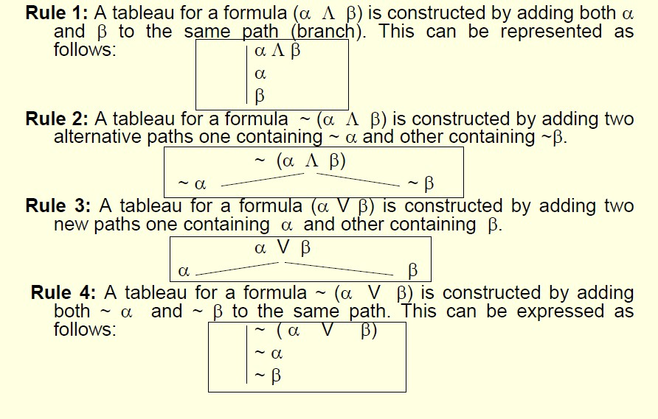
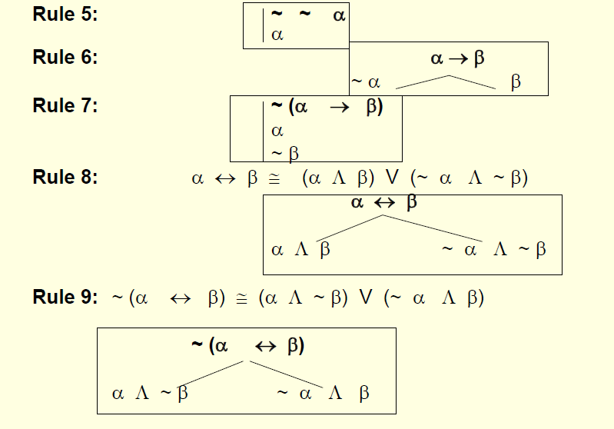

  - Consistency and Inconsistency
    - If an atom P and ~ P appear on a same path of a semantic tableau,
      - then inconsistency is indicated and such path is said to be contradictory or
closed (finished) path.
      - Even if one path remains non contradictory or unclosed (open), then the formula
α at the root of a tableau is consistent.

Contradictory tableau (or finished tableau):
      - It defined to be a tableau in which all the paths are contradictory or closed (finished).
    - If a tableau for a formula α at the root is a contradictory tableau,
      - then a formula α is said to be inconsistent.
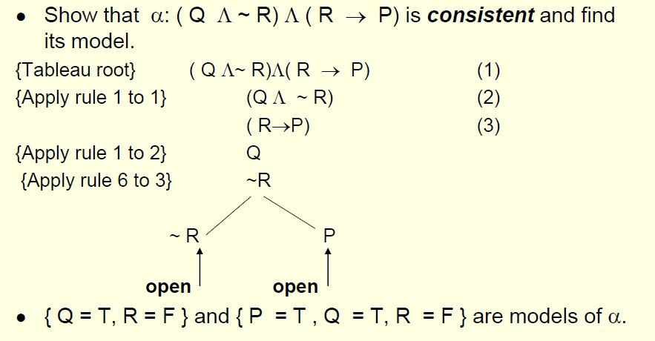

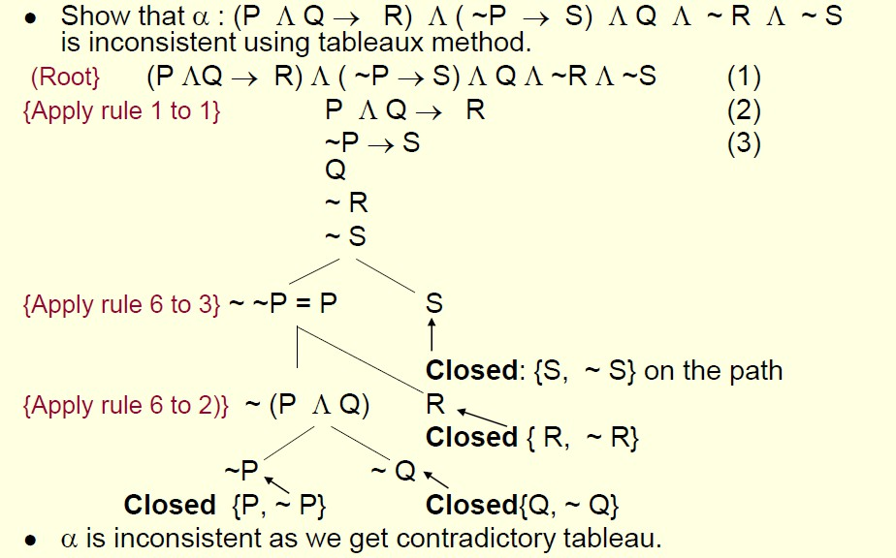

Resolution Refutation in PL
- Resolution refutation: Another simple method to prove a formula by contradiction.
- Here negation of goal is added to given set of clauses.
  - If there is a refutation in new set using resolution principle then goal is proved
- During resolution we need to identify two clauses,
  - one with positive atom (P) and other with negative atom (~ P) for the application of resolution rule.
- Resolution is based on modus ponen inference rule.

Disjunctive & Conjunctive Normal Forms
    - Disjunctive Normal Form (DNF): A formula in the form (L₁₁ Λ ….. Λ L_{1n} ) V ..… V (L_{m1} Λ ….. Λ L_{mk} ), where all L_{ij} are literals.
      - Disjunctive Normal Form is disjunction of conjunctions.
    - Conjunctive Normal Form (CNF): A formula in the form (L₁₁ V ….. V L_{1n} ) Λ …… Λ
(L_{p1} V ….. V L_{pm} ) , where all L_{ij} are literals.

      - CNF is conjunction of disjunctions or
      - CNF is conjunction of clauses
    - Clause: It is a formula of the form (L₁V … V L_{m}), where each L_{k} is a positive or negative atom.

Conversion of a Formula to its CNF
    - Each PL formula can be converted into its equivalent CNF.
    - Use following equivalence laws:
      - P → Q ≅ ~ P V Q
      - P ↔ Q ≅ ( P → Q) Λ ( Q → P)
- Double Negation
– ~ ~ P ≅ P
- (De Morgan’s law)
– ~ ( P Λ Q) ≅ ~ P V ~ Q
– ~ ( P V Q) ≅ ~ P Λ ~ Q
- (Distributive law)
P V (Q Λ R) ≅ (P V Q) Λ (P V R)

6.3Resolvent of Clauses
- If two clauses C₁ and C₂ contain a complementary pair of literals {L, ~L},
  - then these clauses may be resolved together by deleting L from C₁ and ~ L from C₂ and constructing a new clause by the disjunction of the remaining literals in C₁ and C₂.
- The new clause thus generated is called resolvent of C₁ and C₂ .
  - Here C1 and C2 are called parents of resolved clause.
- Inverted binary tree is generated with the last node (root) of the binary tree to be a resolvent.
This is also called resolution tree.

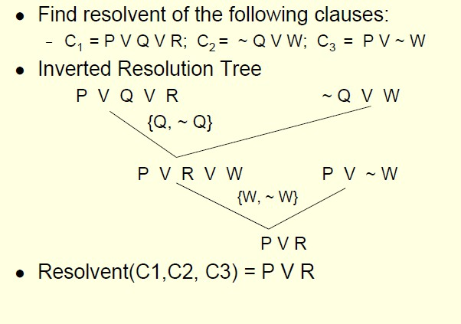

6.4Logical Consequence
- Theorem1: If C is a resolvent of two clauses C₁ and C₂ , then C is a logical consequence
of {C₁ , C₂ }.
  - A deduction of an empty clause (or resolvent as contradiction) from a set S of clauses is called a resolution refutation of S.
- Theorem2: Let S be a set of clauses. A clause C is a logical consequence of S iff the set S’= S ∪ {~ C} is unsatisfiable.
  - In other words, C is a logical consequence of a given set S iff an empty clause is deduced from the set S'.

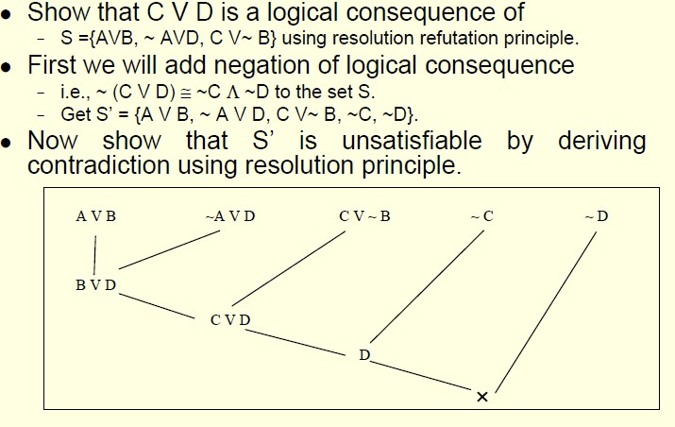

Page 16

UNIT –I Knowledge Representation:
Introduction, Approaches to Knowledge representation, Knowledge representation using Semantic Network, Extended Semantic Network for KR, Knowledge representation using Frames Advance Knowledge Representation Techniques: Introduction, Conceptual Dependency Theory, Script Structure, CYC Theory, Case Grammars, Semantic Web

Knowledge Representation
    - Knowledge representation (KR) is an important issue in both cognitive science and artificial intelligence.
      - In cognitive science, it is concerned with the way people store and process information and
      - In artificial intelligence (AI), main focus is to store knowledge so that programs can process it and achieve human intelligence.
    - There are different ways of representing knowledge e.g.
      - predicate logic,
      - semantic networks,
      - extended semantic net,
      - frames,
      - conceptual dependency etc.
    - In predicate logic, knowledge is represented in the form of rules and facts as is done in Prolog.

Semantic Network:
- Formalism for representing information about objects, people, concepts and specific relationship between them.
- The syntax of semantic net is simple. It is a network of labeled nodes and links.
  - It’s a directed graph with nodes corresponding to concepts, facts, objects etc. and
  - arcs showing relation or association between two concepts.

- The commonly used links in semantic net are of the following types.
  - isa → subclass of entity (e.g., child hospital is subclass of hospital)
  - inst → particular instance of a class (e.g., India is an instance of country)
prop → property link (e.g., property of dog is ‘bark)

Representation of Knowledge in Sem Net
“Every human, animal and bird is living thing who breathe and eat. All birds can fly. All man and woman are humans who have two legs. Cat is an animal and has a fur. All animals have skin and can move. Giraffe is an animal who is tall and has long legs. Parrot is a bird and is green in color”.

Representation in Predicate Logic
      - Every human, animal and bird is living thing who breathe and eat.
∀X [human(X) → living(X)]
∀X [animal(X) → living(X)]
∀X [bird(X) → living(X)]
      - All birds are animal and can fly.
∀X [bird(X) ∧ canfly(X)]
      - Every man and woman are humans who have two legs.
∀X [man(X) ∧ haslegs(X)]
∀X [woman(X) ∧ haslegs(X)]
∀X [human(X) ∧ has(X, legs)]
      - Cat is an animal and has a fur. animal(cat) ∧ has(cat, fur)
      - All animals have skin and can move.
∀X [animal(X) → has(X, skin) ∧ canmove(X)]

      - Giraffe is an animal who is tall and has long legs. animal(giraffe) ∧ has(giraffe, long_legs) ∧ is(giraffe, tall)
      - Parrot is a bird and is green in color. bird(parrot) ∧ has(parrot, green_colour)

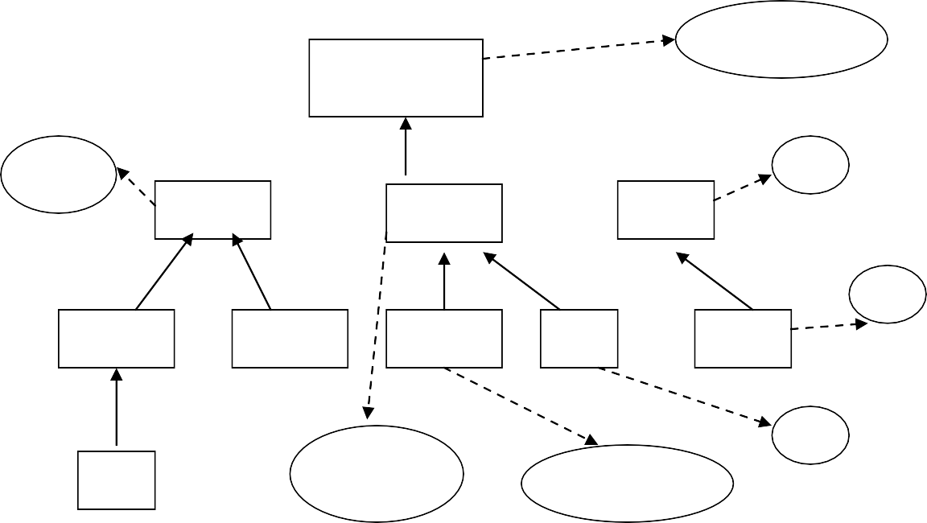
4.3.2.Representation in Semantic Net
Semantic Net
breathe, eat
Living_thing
isa
prop
isa
two legs
Human
isa
Animal inst
fly
Bird
isa
isa
isa
inst
prop green
Man
Woman
Giraffe
prop
Cat
prop
Parrot
prop
inst fur
john
skin, move
tall, long legs

  - Inheritance
- Inheritance mechanism allows knowledge to be stored at the highest possible level of abstraction which reduces the size of knowledge base.
  - It facilitates inferencing of information associated with semantic nets.
  - It is a natural tool for representing taxonomically structured information and ensures that all the members and sub-concepts of a concept share common properties.
  - It also helps us to maintain the consistency of the knowledge base by adding new concepts and members of existing ones.

- Properties attached to a particular object (class) are to be inherited by all subclasses and members of that class.

Property Inheritance Algorithm
Input: Object, and property to be found from Semantic Net; Output:Yes, if the object has the desired property else return false; Procedure:
- Find an object in the semantic net; Found = false;
- While {(object ≠ root) OR Found } DO
{ If there is a a property attribute attached with an object then
{ Found = true; Report ‘Yes’} else object=inst(object, class) OR isa(object, class)
};
- If Found = False then report ‘No’; Stop
Coding of Semantic Net in Prolog

Isa facts | Instance facts | Property facts
isa(living_thing, nil). isa(human, living_thing). isa(animals, living_thing). isa(birds, living_thing). isa(man, human ). isa(woman, human). isa(cat, animal). | inst(john, man). inst(giraffe, animal). inst(parrot, bird) | prop(breathe, living_thing). prop(eat, living_thing). prop(two_legs, human). prop(skin, animal). prop(move, animal). prop(fur, bird).  prop(tall, giraffe). prop(long_legs, giraffe). prop(tall, animal). prop(green, parrot).

    - Inheritance Rules in Prolog Instance rules:
instance(X, Y)  instance (X, Y) | :-  :- | inst(X, Y).  inst(X, Z), subclass(Z,Y).
Subclass rules:
subclass(X, Y) | :- | isa(X, Y).
subclass(X, Y) | :- | isa(X, Z), subclass(Z, Y) .
Property rules:
property(X, Y) | :- | prop(X, Y).
property(X, Y) | :- | instance(Y,Z), property(X, Z).
property(X, Y) | :- | subclass(Y, Z), property(X, Z).
Queries
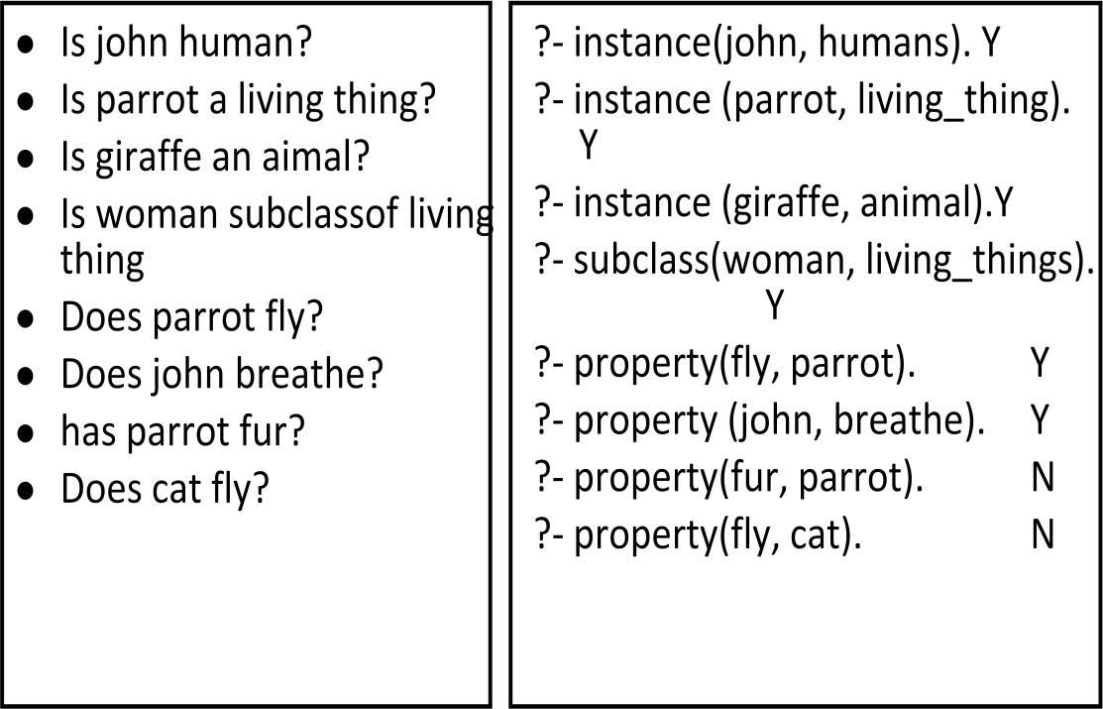

  - Knowledge Representation using Frames
- Frames are more structured form of packaging knowledge,
  - used for representing objects, concepts etc.
- Frames are organized into hierarchies or network of frames.
- Lower level frames can inherit information from upper level frames in network.
- Nodes are connected using links viz.,
  - ako / subc (links two class frames, one of which is subclass of other e.g., science_faculty class is ako of faculty class),
  - is_a / inst ( connects a particular instance of a class frame e.g., Renuka is_a science_faculty)
  - a_part_of (connects two class frames one of which is contained in other e.g., faculty class is_part_of department class).
Property link of semantic net is replaced by SLOT fields.
- A frame may have any number of slots needed for describing object. e.g.,
  - faculty frame may have name, age, address, qualification etc as slot names.
- Each frame includes two basic elements : slots and facets.
  - Each slot may contain one or more facets (called fillers) which may take many forms such as:
    - value (value of the slot),
    - default (default value of the slot),
    - range (indicates the range of integer or enumerated values, a slot can have),
    - demons (procedural attachments such as if_needed, if_deleted, if_added etc.) and
    - other (may contain rules, other frames, semantic net or any type of other information).

Frame Network – Example

university
a_part_of
department
hostel
a_part_of
is_a
faculty
nilgiri hostel
ako
science_faculty
is_a
renuka

    - Detailed Representation of Frame Network

frame0

frame1 frame2
f_name : department
a_part_of : frame0
programme : [Btech, Mtech, Ph.D]
f_name: university
phone: (default: - 011686971)
address : (default - IIT Delhi)
f_name : hostel a_part_of : frame0 room : (default - 100)

frame11 frame21
f_name : science faculty
ako : frame11
qual : (default - M.Sc)
f_name: faculty a_part_of : frame1 age : range (25 - 60)
nationality: (default - Indian)
qual: (default - Post graduate)
f_name : renuka is_a : frame12 qual : Ph.D age: 45
adrress: Janak Puri
f_name : nilgiri
is_a : frame2
phone : 0116862345

frame12 frame13

Description of Frames
      - Each frame represents either a class or an instance.
      - Class frame represents a general concept whereas instance frame represents a specific occurrence of the class instance.

      - Class frame generally have default values which can be redefined at lower levels.
      - If class frame has actual value facet then decedent frames can not modify that value.
      - Value remains unchanged for subclasses and instances.

Inheritance in Frames
      - Suppose we want to know nationality or phone of an instance-frame frame13 of renuka.
      - These informations are not given in this frame.
      - Search will start from frame13 in upward direction till we get our answer or have reached root frame.
      - The frames can be easily represented in prolog by choosing predicate name as frame with two arguments.
      - First argument is the name of the frame and second argument is a list of slot - facet pair.

Coding of frames in Prolog
frame(university, [phone (default, 011686971), address (default, IIT Delhi)]).
frame(deaprtment, [a_part_of (university), programme ([Btech, Mtech, Ph.d]))]). frame(hostel, [a_part_of (university), room(default, 100)]).
frame(faculty, [a_part_of (department), age(range,25,60), nationality(default, indian), qual(default, postgraduate)]).
frame(nilgiri, [is_a (hostel), phone(011686234)]). frame(science_faculty, [ako (faculty),qual(default, M.Sc.)]).
frame(renuka, [is_a (science_faculty), qual(Ph.D.), age(45), address(janakpuri)]).

Inheritance Program in Prolog
find(X, Y) :- frame(X, Z), search(Z, Y), !.

find(X, Y) :- frame(X, [is_a(Z),_]), find(Z, Y), !.
find(X, Y) :- frame(X, [ako(Z), _]), find(Z, Y), !.
find(X, Y) :- frame(X, [a_part_of(Z), _]), find(Z, Y).
      - Predicate search will basically retrieve the list of slots-facet pair and will try to match Y for slot.
      - If match is found then its facet value is retrieved otherwise process is continued till we reach to root frame

Extended Semantic Network
- In conventional Sem Net, clausal form of logic can not be expressed.
- Extended Semantic Network (ESNet) combines the advantages of both logic and semantic network.
- In the ESNet, terms are represented by nodes similar to Sem Net.
- Binary predicate symbols in clausal logic are represented by labels on arcs of ESNet.
  - An atom of the form “Love(john, mary)” is an arc labeled as ‘Love’ with its two end nodes representing ‘john’ and ‘mary’.
- Conclusions and conditions in clausal form are represented by different kinds of arcs.

  - Conditions are drawn with two lines and conclusions are drawn with one heavy line .
Example:
- Represent ‘grandfather’ definition
Gfather(X, Y) ← Father(X, Z), Parent(Z, Y) in ESNet.
Z
Father
Parent
X
Y
Gfather

- Represent clausal rule “Male(X), Female(X) ← Human(X)” using binary representation as “Isa(X, male), Isa(X, female) ← Isa( X, human)” and subsequently in ESNet as follows:
male
Isa
Isa
X
human
Isa
female

Inference Rules in ESNet
- Inference rules are embedded in the representation itself.
- The inference that “for every action of giving, there is an action of taking” in clausal logic written as

“Action(E, take) ← Action(E, give)”.
ESNet
Action
E
take
Action
E
give

- The inference rule such as “an actor of taking action is also the recipient of the action” can be easily represented in clausal logic as:
  - Here E is a variable representing an event where an action of taking is happening).

Recipient(E, Y) ← Acton(E, take), Actor (E, Y)
Action
E
take
Recipient
Actor
Y
ESNet

Example 2:
- Represent the following clauses of Logic in ESNet. Recipient(E, Y) ← Acton(E, take), Actor (E, Y) Object (e, apple).


Action(e, take). Actor (e, john) .
apple

Object
e
E
Recipient
Actor Action Actor Action
john
take
Y

    - Contradiction
      - The contradiction in the ESNet arises if we have the following situation.

Part_of
P
X
Isa
Part_of
Y

Deduction in ESNet
- Both of the following inference mechanisms are available in ESNet.
  - Forward reasoning inference (uses bottom up approach)
    - Bottom Up Inferencing: Given an ESNet, apply the following reduction (resolution) using modus ponen rule of logic ({A ← B, B} then A).

  - Backward reasoning inference (uses top down approach).
Top Down Inferencing: Prove a conclusion from a given ESNet by adding the denial of the conclusion to the network and show that the resulting set of clauses in the network is inconsistent
Example: Bottom Up Inferencing

Given set of clauses  Isa(X, human) ← Isa(X, man) Isa(john, man). | Inferencing  Isa(john, human)
human  Isa  X  Isa man  john Isa  Here X is bound to john | human  Isa john

Example: Top Down Inferencing

Given set of clauses  Isa(X, human) ← Isa(X, man) Isa(john, man). |  |  | Prove conclusion  Query: Isa(john, human)  denial of query
human  john | Isa  X  Isa | Isa man | human  Isa  john | Isa  X  Isa | Isa man

  - Advance Knowledge Representation Techniques: 4.7.1.Conceptual Dependency (CD)
- CD theory was developed by Schank in 1973 to 1975 to represent the meaning of NL sentences.
  - It helps in drawing inferences
  - It is independent of the language
- CD representation of a sentence is not built using words in the sentence rather built using conceptual primitives which give the intended meanings of words.
- CD provides structures and specific set of primitives from which representation can be built.

Primitive Acts of CD theory
- ATRANS Transfer of an abstract relationship (i.e. give)
- PTRANS Transfer of the physical location of an object (e.g., go)
- PROPEL Application of physical force to an object (e.g. push)
- MOVE Movement of a body part by its owner (e.g. kick)
- GRASP Grasping of an object by an action (e.g. throw)
- INGEST Ingesting of an object by an animal (e.g. eat)
- EXPEL Expulsion of something from the body of an animal (e.g. cry)
- MTRANS Transfer of mental information (e.g. tell)
- MBUILD Building new information out of old (e.g decide)
- SPEAK Producing of sounds (e.g. say)
- ATTEND Focusing of a sense organ toward a stimulus (e.g. listen)

Conceptual category
- There are four conceptual categories

– | ACT | Actions {one of the CD primitives}
– | PP | Objects {picture producers}
– | AA | Modifiers of actions {action aiders}
– | PA | Modifiers of PP’s {picture aiders}
Example:
I gave a book to the man. CD representation is as follows:

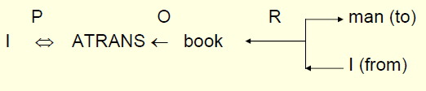
- It should be noted that this representation is same for different saying with same meaning. For example
  - I gave the man a book,
  - The man got book from me,
  - The book was given to man by me etc.

Few conventions
- Arrows indicate directions of dependency
- Double arrow indicates two way link between actor and action. O – for the object case relation
R – for the recipient case relation P – for past tense
D - destination

Some of Conceptualizations of CD
- Dependency structures are themselves conceptualization and can serve as components of larger dependency structures.
- The dependencies among conceptualization correspond to semantic relations among the underlying concepts.
- We will list the most important ones allowed by CD. Remaining can be seen from the book.

Rule 1: PP ⇔ ACT
- It describes the relationship between an actor and the event he or she causes.
  - This is a two-way dependency, since neither actor nor event can be considered primary.
  - The letter P in the dependency link indicates past tense.
- Example: John ran
P
CD Rep: John ⇔ PTRANS

Rule 2: ACT ← PP
- It describes the relationship between a ACT and a PP (object) of ACT.
  - The direction of the arrow is toward the ACT since the context of the specific ACT determines the meaning of the object relation.
  - Example: John pushed the bike CD Rep: John ⇔ PROPEL ← bike

Rule 3: PP ↔ PP
- It describes the relationship between two PP’s, one of which belongs to the set defined by the other.
- Example: John is doctor
CD Rep: John ↔ doctor

Rule 4: PP ← PP
- It describes the relationship between two PP’s, one of which provides a particular kind of information about the other.
  - The three most common types of information to be provided in this way are possession ( shown as POSS-BY), location (shown as LOC), and physical containment (shown as CONT).
  - The direction of the arrow is again toward the concept being described.
  - Example: John’s dog
poss-by
CD Rep dog ← John

Rule 5: PP ⇔ PA
- It describes the relationship between a PP and a PA that is asserted to describe it.
  - PA represents states of PP such as height, health etc.
- Example: John is fat
CD Rep John ⇔ weight (> 80)

Rule 6: PP ← PA
- It describes the relationship between a PP and an attribute that already has been predicated of it.
  - Direction is towards PP being described.
  - Example: Smart John
CD Rep John ← smart
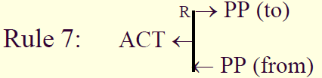

- It describes the relationship between an ACT and the source and the recipient of the ACT
- Example: John took the book from Mary

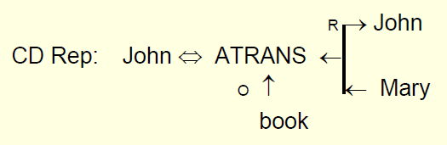
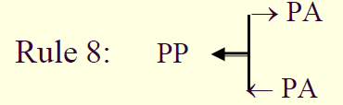

- It describes the relationship that describes the change in state.
  - Example: Tree grows

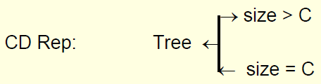
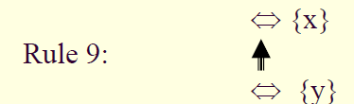

- It describes the relationship between one conceptualization and another that causes it.
– Here {x} is causes {y} i.e., if x then y Example: Bill shot Bob

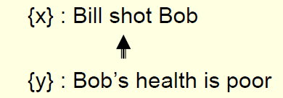
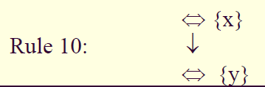
- It describes the relationship between one conceptualization with another that is happening at the time of the first.
- Here {y} is happening while {x} is in progress.
- Example: While going home I saw a snake I am going home
↓
I saw a snake

Generation of CD representations:

Sentences | CD Representations
Jenny cried | p o d ?  Jenny ⇔ EXPEL ← tears  eyes poss-by ⇑  Jenny
Mike went to India | p d India  Mike ⇔ PTRANS  ? (source is unknown)
Mary read a novel | p o d CP(Mary)  Mary ⇔ MTRANS ← info  novel  ↑ i (instrument)  p o d novel Mary ⇔ ATTEND ← eyes  ?

Sentence | CD Representation
Since drugs can kill, I stopped. | o r  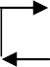  One ⇔ INGEST ← durgs  c  health = -10  One  health > -10 | One Mouth
 | c
 | t_{fp} o r I ⇔ INGEST ← durgs | I  mouth

Sentence | CD Representation
John warned Mike with dire consequence. | John ⇔ Do₁  p ↓ o r Mike John ⇔ MTRANS  John  f  State bad  ⇑ poss-by Mike  i  Poss-by  r memory ⇐ Mike  Mike ⇔ MTRANS  o ↑ John  Mike ⇔ Do₂  Mike  ⇓ poss-by  John ⇔ Do₁ State bad f

    - Inferences Associated with Primitive Act
      - General inferences are stored with each primitive Act thus reducing the number of inferences that need to be stored explicitly with each concept.
      - For example, from a sentence “John killed Mike”, we can infer that “Mike is dead”.
      - Let us take another example of primitive Act INGEST.
      - The following inferences can be associated with it.
        - The object ingested is no longer available in its original form.
        - If object is eatable, then the actor has less hunger.
        - If object is toxic, then the actor’s heath is bad.
        - The physical position of object has changed. So PTRANS is inferred.
      - Example: The verbs {give, take, steal, donate} involve a transfer of ownership of an object.
        - If any of them occurs, then inferences about who now has the object and who once had the object may be important.
        - In a CD representation, these possible inferences can be stated once and associated with the primitive ACT “ATRANS”.
- Consider another sentence “Bill threatened John with a broken nose”
  - Sentence interpretation is that Bill informed John that he (Bill) will do something to break john’s nose.
  - Bill did (said) so in order that John will believe that if he (john) does some other thing (different from what Bill wanted) then Bill will break John’s nose.

Problems with CD Representation:
      - It is difficult to
        - construct original sentence from its corresponding CD representation.

        - CD representation can be used as a general model for knowledge representation, because this theory is based on representation of events as well as all the information related to events.
      - Rules are to be carefully designed for each primitive action in order to obtain semantically correct interpretation.
      - Many verbs may fall under different primitive ACTs, and it becomes difficult to find correct primitive in the given context.
      - The CD representation becomes complex requiring lot of storage for many simple actions.
      - For example, the sentence “John bet Mike that Indian cricket team will win incoming world cup” will require huge CD structure.

Conceptual Parsing
      - Conceptual parsing is required for generating CD representation from source sentences in natural language.
      - The main steps involved in CD parsing are as follows:
        - Syntactic processor extracts main verb and noun along with syntactic category of the verb (transitive or intransitive) from the sentence.
        - Conceptual processor then makes use of verb−ACT dictionary.
        - Once the correct entry from dictionary is chosen, CD processor analyses the rest of sentence looking for arguments for empty slots of the verb.
        - CD processor examines possible interpretation in a well-defined order.

Example:
      - Case1: Handling of ‘with PP’ phrase by CD processor and formulating strategies to disambiguate the meanings.
        - Type1: John broke the door with hammer non animate
        - Type2: John broke the door with Mike animate

      - Rule 1: If PP in ‘with PP’ phrase is non-animate and CD Act requires instrument then the sentence is of Type1, where PP (hammer) is resolved to instrument.
      - Rule 2: If PP in ‘with PP’ phrase is animate and CD Act requires instrument then the sentence is of Type2, where PP (Mike) is resolved as co-actor.
      - Case2: If PPs in both the sentences are non-animate, then they have to be resolved using semantic lexicon.
        - Type3: John went to the garden with flowers
        - Type4: John went to the garden with bag
      - In Type3, non-animate noun ‘flowers’ is part of garden, whereas in Type4, non-animate ‘bag’ is some object not related to garden.
      - Such association of word senses could be found in Word-Net and then disambiguation is possible.
      - Here noun ‘bag’ is treated as possession by John.
      - Case 3: If PPs in the sentences are animate, then they have to be resolved using semantic lexicon and context.
      - Consider the following examples.
        - Type5: John went to the garden with Mike
        - Type6: John went to the garden with butterflies
        - Type7: John went to the garden with dog
      - In these sentences, Mike, butterflies and dog are animate PPs and can be resolved as follows:
Mike is easily resolved to co-actor of John as both are human and have similar characteristics
      - Word-Net can be used to check if butterfly and garden has some common sense.
      - Dog is still ambiguous.

      - It may be treated as possession of actor or may be a part of garden as animals many wonder in garden.
      - Such situations can be further resolved by considering the context of sentences.
      - We can use semantic lexicon dictionary to resolve some of the ambiguities.

Script Structure:
- Scripts were introduced by Schank and Abelson introduced in 1977 that used CD framework.
- The scripts are useful in describing certain stereotyped situations such as going to theater
- It consists of set of slots containing default values along with some information about the type of values similar to frames.
- It differs from FS as the values of the slots in scripts must be ordered and have more specialized roles.
- In real world situations, we see that event tends to occur in known patterns because of clausal relationship to the occurrence of events

Script Components:
      - Each script contains the following main components.
        - Entry Conditions: Must be satisfied before events in the script can occur.
        - Results: Conditions that will be true after events in script occur.
        - Props: Slots representing objects involved in the events.
        - Roles: Persons involved in the events.
        - Track: Specific variation on more general pattern in the script. Different tracks may share many components of the same script but not all.
        - Scenes: The sequence of events that occur. Events are represented in conceptual dependency form.

Script : Play in theater | Various Scenes
Track: Play in Theater Props:  - Tickets  - Seat  - Play  Roles:  - Person (who wants to see a play) – P  - Ticket distributor – TD  - Ticket checker – TC  Entry Conditions:  - P wants to see a play  - P has a money  Results:  - P saw a play  - P has less money  - P is happy (optional if he liked the play) | Scene 1: Going to theater  - P PTRANS P into theater  - P ATTEND eyes to ticket counter
Scene 2: Buying ticket
- P PTRANS P to ticket counter
- P MTRANS (need a ticket) to TD
- TD ATRANS ticket to P
Scene 3: Going inside hall of theater and sitting on a seat
- P PTRANS P into Hall of theater
- TC ATTEND eyes on ticket POSS_by P
- TC MTRANS (showed seat) to P
- P PTRANS P to seat
- P MOVES P to sitting position
Scene 4: Watching a play
- P ATTEND eyes on play
- P MBUILD (good moments) from play
Scene5: Exiting
- P PTRANS P out of Hall and theater

Script Invocation:
      - It must be activated based on its significance.
      - If the topic is important, then the script should be opened.
      - If a topic is just mentioned, then a pointer to that script could be held.
      - For example, given “John enjoyed the play in theater”, a script “Play in Theater” suggested above is invoked.
      - All implicit questions can be answered correctly.
      - Here the significance of this script is high.
        - Did john go to theater?

        - Did he buy ticket?
        - Did he have money?
      - If we have a sentence like “John went to theater to pick his daughter”, then invoking this script will lead to many wrong answers.
        - Here significance of the script theater is less.
Getting significance from the story is not straightforward. However, some heuristics can be applied to get the value.

Advantages / Disadvantages of Script
      - Advantages
        - Capable of predicting implicit events
        - Single coherent interpretation may be build up from a collection of observations.
      - Disadvantage
        - More specific (inflexible) and less general than frames.
        - Not suitable to represent all kinds of knowledge.
      - To deal with inflexibility, smaller modules called memory organization packets (MOP) can be combined in a way that is appropriate for the situation.

CYC

What is CYC?
- An ambitious attempt to form a very large knowledge base aimed at capturing commonsense reasoning.
- Initial goals to capture knowledge from a hundred randomly selected.
- Both Implicit and Explicit knowledge encoded.
Example: Suppose we read that Wellington learned of Napoleon's death
Then we (humans) can conclude Napoleon never new that Wellington had died. How do we do this?

We require special implicit knowledge or commonsense such as:
- We only die once.
- You stay dead.
- You cannot learn of anything when dead.
- Time cannot go backwards.
Why build large knowledge bases:

Brittleness
-- Specialised knowledge bases are brittle. Hard to encode new situations and non-graceful degradation in performance. Commonsense based knowledge bases should have a firmer foundation.

Form and Content
-- Knowledge representation may not be suitable for AI. Commonsense strategies could point out where difficulties in content may affect the form.

Shared Knowledge
-- Should allow greater communication among systems with common bases and assumptions.
How is CYC coded?
- By hand.
- Special CYCL language:
  - LISP like.
  - Frame based
  - Multiple inheritance
  - Slots are fully fledged objects.
  - Generalised inheritance -- any link not just isa and instance.

CASE GRAMMAR
- Case grammar is a system of linguistic analysis, focusing on the link between the valence, or number of subjects, objects, etc., of a verb and the grammatical context it requires. The system was created by the American linguist Charles J. Fillmore in (1968), in the context of Transformational Grammar. This theory analyzes the surface syntactic structure of sentences by studying the combination of deep cases (i.e. semantic roles) -- Agent, Object, Benefactor, Location or Instrument— which are required by a specific verb. For instance, the verb "give" in English requires an Agent (A) and Object (O), and a Beneficiary (B); e.g. "Jones (A) gave money (O) to the school (B).
- According to Fillmore, each verb selects a certain number of deep cases which form its case frame. Thus, a case frame describes important

aspects of semantic valency, of verbs, adjectives and nouns. Case frames are subject to certain constraints, such as that a deep case can occur only once per sentence. Some of the cases are obligatory and others are optional. Obligatory cases may not be deleted, at the risk of producing ungrammatical sentences. For example, Mary gave the apples is ungrammatical in this sense.
- A fundamental hypothesis of case grammar is that grammatical functions, such as subject or object, are determined by the deep, semantic valence of the verb, which finds its syntactic correlate in such grammatical categories as Subject and Object, and in grammatical cases such as Nominative, Accusative, etc. Fillmore (1968) puts forwards the following hierarchy for a universal subject selection rule:
- Agent < Instrumental < Objective
- That means that if the case frame of a verb contains an agent, this one is realized as the subject of an active sentence; otherwise, the deep case following the agent in the hierarchy (i.e. Instrumental) is promoted to subject.
- The influence of case grammar on contemporary linguistics has been significant, to the extent that numerous linguistic theories incorporate deep roles in one or other form, such as the so-called Thematic structure in Government and Binding theory. It has also inspired the development of frame-based representations in AI research

SEMATIC WEB
The Semantic Web is an extension of the World Wide Web through standards set by the World Wide Web Consortium (W3C). The goal of the Semantic Web is to make Internet data machine-readable. To enable the encoding of semantics with the data, technologies such as Resource Description Framework (RDF) and Web Ontology Language (OWL) are used. These technologies are used to formally represent metadata. For example, ontology can describe concepts, relationships between entities, and categories of things. These embedded semantics offer significant advantages such as reasoning over data and operating with heterogeneous data sources.
These standards promote common data formats and exchange protocols on the Web, fundamentally the RDF. According to the W3C, "The Semantic Web provides a common framework that allows data to be shared and reused across application, enterprise, and community boundaries." The Semantic Web is therefore regarded as an integrator across different content and information applications and systems.
The term was coined by Tim Berners-Lee for a web of data (or data web) that can be processed by machines—that is, one in which much of

the meaning is machine-readable. While its critics have questioned its feasibility, proponents argue that applications in library and information science, industry, biology and human sciences research have already proven the validity of the original concept.
In addition to the classic “Web of documents” W3C is helping to build a technology stack to support a “Web of data,” the sort of data you find in databases. The ultimate goal of the Web of data is to enable computers to do more useful work and to develop systems that can support trusted interactions over the network. The term “Semantic Web” refers to W3C’s vision of the Web of linked data. Semantic Web technologies enable people to create data stores on the Web, build vocabularies, and write rules for handling data. Linked data are empowered by technologies such as RDF, SPARQL, OWL, and SKOS.

UNIT –V Expert Sytems
Expert Systems, Phases in building expert systems, Expert System Architecture, Rule Based Systems, Forward Chaining,Blackboard Systems, Blackboard architecture, Blackboard System vs Rulebased system, Truth maintenance system

Expert Systems (ES):
    - Expert systems are knowledge based programs which provide expert quality solutions to the problems in specific domain of applications.
    - The core components of expert system are
      - knowledge base and
      - navigational capability (inference engine)
    - Generally its knowledge is extracted from human experts in the domain of application by knowledge Engineer.
      - Often based on useful thumb rules and experience rather than absolute certainties.
    - A process of gathering knowledge from domain expert and codifying it according to the formalism is called knowledge engineering.

Phases in building Expert System
    - There are different interdependent and overlapping phases in building an expert system as follows:

Identification Phase:
      - Knowledge engineer finds out important features of the problem with the help of domain expert (human).
      - He tries to determine the type and scope of the problem, the kind of resources required, goal and objective of the ES.

Conceptualization Phase:
      - In this phase, knowledge engineer and domain expert decide the concepts, relations and control mechanism needed to describe a problem solving.

Formalization Phase:
      - It involves expressing the key concepts and relations in some framework supported by ES building tools.
      - Formalized knowledge consists of data structures, inference rules, control strategies and languages for implementation.

Implementation Phase:
      - During this phase, formalized knowledge is converted to working computer program initially called prototype of the whole system.

Testing Phase:
      - It involves evaluating the performance and utility of prototype systems and revising it if need be. Domain expert evaluates the prototype system and his feedback help knowledge engineer to revise it.

5.3. Expert System Architecture

Expert System

Inference Engine
Inference & Control

Special Interfaces

Human Case History
Expert Knowledge Acquisition
& Learning Module
Knowledge Base

Static database
User User Interface
Dynamic database (working memory)

Explanation Module

Fig: Architecture of Expert System

Knowledge Base (KB)
- KB consists of knowledge about problem domain in the form of static and dynamic databases.
- Static knowledge consists of
  - rules and facts which is complied as a part of the system and does not change during execution of the system.
- Dynamic knowledge consists of facts related to a particular consultation of the system.
  - At the beginning of the consultation, the dynamic knowledge base often called working memory is empty.
  - As a consultation progresses, dynamic knowledge base grows and is used along with static knowledge in decision making.
Working memory is deleted at the end of consultation of the system

Inference Engine
- It consists of inference mechanism and control strategy.
- Inference means search through knowledge base and derive new knowledge.
- It involve formal reasoning involving matching and unification similar to the one performed by human expert to solve problems in a specific area of knowledge.
- Inference operates by using modus ponen rule.
- Control strategy determines the order in which rules are applied.
- There are mainly two types of control mechanism viz., forward chaining and backward chaining.

Knowledge Acquisition
- Knowledge acquisition module allows system to acquire knowledge about the problem domain.
- Sources of Knowledge for ES

  - text books, reports, case studies,
  - empirical data and
  - domain expert experience.
- Updation of Knowledge can be done using knowledge acquisition module of the system.
  - insertion,
  - deletion and
  - updation of existing knowledge

Case History
- Case History stores the file created by inference engine using the dynamic database created at the time of consultation.
- Useful for learning module to enrich its knowledge base.
- Different cases with solutions are stored in Case Base system.
- These cases are used for solving problem using Case Base Reasoning (CBR).

Explanation module
- Most expert systems have explanation facilities that allow the user to ask the system why it asked some question, and how it reached to conclusion.
- It contains 'How' and 'Why' modules attached to it.
  - The sub-module ‘How’ tells the user about the process through w
  - hich system has reached to a particular solution
  - ‘Why' sub-module tells that why is that particular solution offered.
- It explains user about the reasoning behind any particular problem solution.
- Questions are answered by referring to the system goals, the rules being used, and any existing problem data.

Explanation Modules Responses

User | Why module
System | Do you have running nose?
User | Yes.
System | I am trying to prove that you have cold. Do you have headache?
User | Yes
System | Do you have sore throat?
User | No
System | Then you do not have cold. Do you have fever?
User | Yes
System | Now I am looking at the possibility of measles. Do you have cough?
User | Yes
System | I can infer measles using rule “If symptoms are fever, cough,  running_nose, then patient has measles” measles is concluded.
User | How Module
System | Since you have fever, running_nose and cough and there is a rule “If symptoms are fever, cough, running_nose, then patient has measles”.  So measles is concluded for you.

User Interfaces
- Allows user to communicate with system in interactive mode and helps system to create working knowledge for the problem to be solved.

Dialogue Module (User Interface)
System | Do you have fever?
User | Yes
System | Do you have bad throat?
User | No
System | Do you have cough?
User | Yes
System | Are you suffering from running nose?
User | Yes
System | Are you suffering from headache?
User | No

Special interfaces
- It may be used for specialized activities such as handling uncertainty in knowledge.
- This is a major area of expert systems research that involves methods for reasoning with uncertain data and uncertain knowledge.

- Knowledge is generally incomplete and uncertain.
- To deal with uncertain knowledge, a rule may have associated with it a
confidence factor or a weight.
- The set of methods for using uncertain knowledge in combination with uncertain data in the reasoning process is called reasoning with uncertainty.

5.4 Rule Based Expert Systems
- A rule based expert system is one in which knowledge base is in the form of rules and facts.
– Knowledge in the form of rules and facts is most popular way in designing expert systems.
- It is also called production system.
- Example: Suppose doctor gives a rule for measles as follows:

"If symptoms are fever, cough, running_nose, rash and conjunctivitis then patient probably has measles".
- Prolog is most suitable for implementing such systems.
hypothesis(measles) :- symptom(fever), symptom(cough),
symptom(running_nose),symptom(conjunctivitis), symptom(rash).
Simple Medical diagnostic system with dynamic databases:
- The system starts with consultation predicate, that initiates dialog with user to get information about various symptoms.
- Positive and negative symptoms are recorded in dynamic database and
'hypothesis(Disease)' is satisfied based on stored facts about symptoms.
- If the hypothesis goal is satisfied then the disease is displayed otherwise display 'sorry not able to diagnose'.
- Finally in both the situations, symptom database for a particular user is cleared.
Query:?-consultation.

Medical Consultation System
consultation :- writeln(‘Welcome to MC System’), writeln(‘Input your name), readln(Name),
hypothesis(Dis), !,
writeln(Name, ‘probably has’, Dis), clear_consult_facts.
consultation :- writeln(‘Sorry, not able to diagnose’), clear_consult_facts
hypothesis(flu) :- symptom(fever), symptom(headache),
symptom(body_ache), symptom(sore_throat), symptom(cough), symptom(chills),
symptom(running_nose), symptom(conjunctivitis).
symptom(fever) :- positive_ symp(‘Do you have
fever(y/n) ?’, fever).
symptom(cough) :- positive_ symp(‘Do you have
cough (y/n) ?’, cough).
symptom(chills) :- positive_ symp(‘Do you have
chills (y/n) ?’, chills). positive_ symp(_, X) :- positive(X), !.
positive_ symp(Q, X) :- not(negative(X)),
query(Q, X, R), R = ‘y’.
query(Q, X, R) :- writeln(Q), readln(R), store(X, R).
store(X, ‘y’) :- asserta(positive(X)).
store(X, ‘n’) :- asserta(negative(X)).

clear_consult_facts :- retractall(positive(_)). clear_consult_facts :- retractall(negative(_)).

Forward Chaining
    - Prolog uses backward chaining as a control strategy, but forward chaining can be implemented in Prolog.
    - In forward chaining, the facts from static and dynamic knowledge bases are taken and are used to test the rules through the process of unification.
    - The rule is said to be fired and the conclusion (head of the rule) is added to the dynamic database when a rule succeeds.
    - Prolog rules are coded as facts with two arguments, first argument be left side of rule and second is the list of sub goals in the right side of the rule.
    - Represent prolog rule as a fact by rule_fact predicate and simple facts by fact predicate.
    - Consider the following Prolog rules and facts with their corresponding new fact representations.
a:-b⇒rule_fact(a, [b]).
c:-b, e, f.⇒rule_fact(c, [b, e, f]). b.⇒fact(b).
e.⇒fact(e).
f.⇒fact(f).
- Here a, b, c, e, f are atoms (predicates with arguments, if any).
- Newly generated facts are stored in database file ‘dfile’ which is consulted in the prolog program.

Blackboard System – BS
    - Blackboard systems are used to capture dynamic environment with the help of domain experts.

    - BS uses a functional modularization of expertise knowledge in the form of Knowledge Sources (KS).
    - KS are independent computational modules containing the expert knowledge needed to solve the problem.
      - Blackboard approach has an ability to integrate contributions dynamically for which relationships would be difficult to specify by the KS writer in advance.
    - BS consists of three main components viz., Knowledge Sources, Blackboard and Control Shell.
      - BS does not allow direct interaction among modules, as all communication is done via the blackboard through control shell.

Blackboard System Architecture
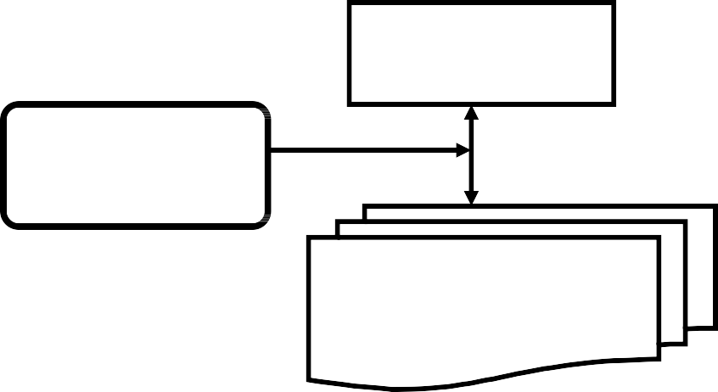
Blackboard
Control Shell
Knowledge Sources

Knowledge Source – KS
    - KS can be widely diverse in their internal representation and computational techniques and they do not interact directly with each other.
    - KS is a specialist at solving certain aspects of the overall application and is separate and independent of all other KSs.
    - Once it finds the information it needs on the blackboard, it can proceed without any assistance from other KSs.

    - Additional KSs can be added to the blackboard system, existing KS can be upgraded or even can be removed.
    - Each KS is aware of its conditions under which it can contribute toward solving the problem.

Blackboard
- The blackboard is a global data repository and shared data structure available to all KSs
- It contains raw input data, partial solutions and final solutions, control information, communication medium etc.
- The system can retain the results of problem-solved earlier, thus avoiding re-computing them later.
- Structuring of information on blackboard is important issue.
- It should enable a KS to efficiently inspect the blackboard to see if relevant information is present.

Control Shell
    - The control shell directs the problem-solving process by allowing KSs to respond opportunistically to changes made to the blackboard.
    - The control shell reports about the kind of events in which each KS is interested in.
    - It maintains this triggering information and directly considers the KS for activation whenever that kind of event occurs.

Information Representation on Blackboard
    - There are two ways for storing information on blackboard viz.,
      - specialized representation and
      - fully general representation.
    - In specialized representation,
      - KSs may only operate on a few classes of blackboard objects.
      - Sharing data by only a few KSs limits the extendibility and scalability of the system.

    - In fully general representation, all aspects of blackboard data are understood by all KSs.
There is a trade-off between these two representations

Blackboard System verses Rule Based System
    - A blackboard system is different from a rule-based system especially in the size and scope of rules versus the size and complexity of KSs.
    - The KSs are substantially larger and more complex than each isomorphic rule in an expert system.
    - While expert systems work by firing a rule in response to stimuli, a blackboard system works by executing an entire KS in response to an event.
    - A single KS in a blackboard system could be implemented as a complete rule-based system.

Truth Maintenance System (TMS)
    - Truth maintenance system (TMS) works with inference engines for solving problems within large search spaces.
    - The TMS and inference engine both put together can solve problems where algorithmic solutions do not exist.
TMS maintains the beliefs for general problem solving systems.

Problem Solver
KB
TMS
IE
    - TMS can be used to implement monotonic or non-monotonic systems.
    - In monotonic system, once a fact or piece of knowledge is stored in KB, it can not change.

      - In monotonic reasoning, the world of axioms continually increases in size and keeps on expending.
      - Predicate logic is an example of monotonic form of reasoning. It is a deductive reasoning system where new facts are derived from the known facts.
    - Non-monotonic system allows retraction of truths that are present in the system whenever contradictions arise.
      - So number of axioms can both increase and decrease and depending upon the changes in KB, it can be updated.

Example – Monotonic TMS
    - Suppose we are given the premise set ∑ = {P, W} and the internal constraint set
{P → Q, (P Λ W) → R, (Q Λ R) → S}.
    - TMS are able to derive S from these constraints and the premise set ∑.
    - TMS should provide the justifications of deriving S from constraints and premises.
    - Therefore, for any given set of internal constraints and premise set ∑, if a formula S can be derived from these, then justification functions generate a justification tree for S.

Justification Tree

S
(Q Λ R) → S
{Q, R}
P → Q
Q
R
(P ΛW) → R
{P}
{P, W}

Non-Monotonic TMS:
    - TMS basically operates with two kinds of objects
      - ‘Propositions’ declaring different beliefs and
      - ‘Justifications’ related to individual propositions for backing up the belief or disbelief expressed by the proposition.
    - For every TMS, there are two kinds of justifications required namely ‘Support list’ and ‘Conditional proof’.

Support list (SL):
    - It is defined as “SL(IN-node)(OUT-node)”, where IN-node is a list of all IN- nodes (propositions) that support the considered node as true.
      - Here IN means that the belief is true.
      - OUT-node is a list of all OUT nodes for the considered node to be true. OUT means that belief is not true.

Node number | Facts/assertions | Justification (justified belief)
1 | It is sunny | SL(3) (2,4)
2 | It rains | SL() ()
3 | It is warm | SL(1) (2)
4 | It is night time | SL() (1)

