DATABASE MANAGEMENT SYSTEMS

UNIT I: Introduction

Syllabus:
Introduction: Database system, Characteristics (Database Vs File System), Database Users (Actors on Scene, Workers behind the scene), Advantages of Database systems, Database applications. Brief introduction of different Data Models; Concepts of Schema, Instance and data independence; Three tier schema architecture for data independence; Database system structure, environment, Centralized and Client Server architecture for the database.

Objectives:
After studying this unit, you will be able to:
- Define database management system
- Explain database system applications
- State the characteristics and the database approach
- Understand different data models
- Discuss the advantages and disadvantages of database Discuss the database architecture

Introduction

The information storage and retrieval has become very important in our day-to-day life. The old era of manual system is no longer used in most of the places. For example, to book your airline tickets or to deposit your money in the bank the database systems may be used. The database system makes most of the operations automated. A very good example for this is the billing system used for the items purchased in a super market. Obviously this is done with the help of a database application package. Inventory systems used in a drug store or in a manufacturing industry are some more examples of database. We can add similar kind of examples to this list.
Apart from these traditional database systems, more sophisticated database systems are used in the Internet where a large amount of information is stored and retrieved with efficient search engines. For instance, http://www.google.com is a famous web site that enables users to search for their favorite information on the net. In a database we can store starting from text data to very complex data like audio, video, etc.

  - Database Management Systems (DBMS)

A database is a collection of related data stored in a standard format, designed to be shared by multiple users. A database is defined as “A collection of interrelated data items that can be processed by one or more application programs”.
A database can also be defined as “A collection of persistent data that is used by the application systems of some given enterprise”. An enterprise can be a single individual (with a small personal database), or a complete corporation or similar large body (with a large shared database), or anything in between.

Example: A Bank, a Hospital, a University, a Manufacturing company

Data
Data is the raw material from which useful information is derived. The word data is the plural of Datum. Data is commonly used in both singular and plural forms. It is defined as raw facts or observations. It takes variety of forms, including numeric data, text and voice and images. Data is a collection of facts, which is unorganized but can be made organized into useful information. The term Data and Information come across in our daily life and are often interchanged.
Example: Weights, prices, costs, number of items sold etc.
Information
Data that have been processed in such a way as to increase the knowledge of the person who uses the data. The term data and information are closely related. Data are raw material resources that are processed into finished information products. The information as data that has been processed in such way that it can increase the knowledge of the person who uses it.
In practice, the database today may contain either data or information.
Data Processing
The process of converting the facts into meaningful information is known as data processing. Data processing is also known as information processing.
Metadata
Data that describe the properties or characteristics of other data.

Data is only become useful when placed in some context. The primary mechanism for providing context for data is Metadata. Metadata are data that describe the properties, or characteristics of other data. Some of these properties include data definition, data structures and rules or constraints. The Metadata describes the properties of data but do not include that data.

  - Database System Applications

Databases are widely used. Here are some representative applications:
- Banking: For customer information, accounts, and loans, and banking transactions.
- Airlines: For reservations and schedule information. Airlines were among the first to use databases in a geographically distributed manner - terminals situated around the world accessed the central database system through phone lines and other data networks.
- Universities: For student information, course registrations, and grades.
- Credit card transactions: For purchases on credit cards and generation of monthly statements.
- Telecommunication: For keeping records of calls made, generating monthly bills, maintaining balances on prepaid calling cards, and storing information about the communication networks.
- Finance: For storing information about holdings, sales, and purchases of financial instruments such as stocks and bonds.
- Sales: For customer, product, and purchase information.
- Manufacturing: For management of supply chain and for tracking production of items in factories, inventories of items in warehouses / stores, and orders for items.
- Human resources: For information about employees, salaries, payroll taxes and benefits, and for generation of paychecks.

  - File Systems Versus A DBMS (Characteristics)
In earlier days, the databases were created directly on top of file systems. File system has many disadvantages.
- Not enough primary memory to process large data sets. If data is maintained in other storage devices like disks, tapes and bringing relevant data to main memory, it increases the cost of performance. Problem in accessing the large data due to addressing the data using 32 bit or 64 bit mode addressing mechanism.
- Programs must be written to process the user request to process the data stored in files which are complex in nature because of large volume of data to be searched.
- Inconsistent data and complexity in providing concurrent accesses.
- Not sufficiently flexible to enforce security policies in which different users have permission to access different subsets of the data.

A DBMS is a piece of software that is designed to make the preceding tasks easier. By storing data in a DBMS, rather than as a collection of operating system Files, we can use the DBMS's features to manage the data in a robust and efficient manner.

  - Advantages of DBMS

One of the main advantages of using a database management system is that the organization can exert via the DBA, centralized management and control over the data. The database administrator is the focus of the centralized control.

The following are the major advantages of using a Database Management System (DBMS): Data independence: Application programs should be as independent as possible from details of data representation and storage. The DBMS can provide an abstract view of the data to insulate application code from such details.

Efficient data access: A DBMS utilizes a variety of sophisticated techniques to store and retrieve data efficiently. This feature is especially important if the data is stored on external storage devices.

Data integrity and security: The DBMS can enforce integrity constraints on the data. The DBMS can enforce access controls that govern what data is visible to different classes of users.

Data administration: When several users share the data, centralizing the administration of data can offer significant improvements. It can be used for organizing the data representation to minimize redundancy and for fine-tuning the storage of the data to make retrieval efficient.

Concurrent access and crash recovery: A DBMS schedules concurrent accesses to the data in such a manner that users can think of the data as being accessed by only one user at a time. Further, the DBMS protects users from the effects of system failures. .

Reduced application development time: Clearly, the DBMS supports many important functions that are common to many applications accessing data stored in the DBMS.

  - Disadvantages of DBMS

The disadvantage of the DBMS system is overhead cost. The processing overhead introduced by the DBMS to implement security, integrity, and sharing of the data causes a degradation of the response and throughput times. An additional cost is that of migration from a traditionally separate application environment to an integrated one.
Even though centralization reduces duplication, the lack of duplication requires that the database be adequately backup so that in the case of failure the data can be recovered.
Backup and recovery operations are complex in a DBMS environment, and this is an increment in a concurrent multi-user database system. A database system requires a certain amount of controlled redundancies and duplication to enable access to related data items.
  - Data Models
A data model is a collection of high-level data description constructs that hide many low-level storage details. A DBMS allows a user to define the data to be stored in terms of a data model. Most database management systems today are based on the relational data model.
A schema is a description of a particular collection of data, using the given data model. The relational model of data is the most widely used model today.

Main concept: relation, basically a table with rows and columns. Every relation has a schema, which describes the columns, or fields.
Data Model is a collection of high-level data description constructs that hide many low-level storage details. A DBMS allows a user to define the data to be stored in terms of a data model. Most database management systems today are based on the Relational data model. Relational models include – IBM’s DB2, Informix, Oracle, Sybase, Microsoft’s Access, Foxbase, Paradox, Tandem and Teradata.
  - Categories of data models

    - Conceptual (high-level, semantic) data models: Provide concepts that are close to the way many users perceive data (Also called entity-based or object-based data models).
    - Physical (low-level, internal) data models: Provide concepts that describe details of how data is stored in the computer.
    - Implementation (representational) data models: Provide concepts that fall between the above two.

- Hierarchical models:
Advantages:
  - Hierarchical model is simple to construct and operate on.
  - Corresponds to a number of natural hierarchical organized domains – e.g., assemblies in manufacturing, personal organization in companies.
  - Language is simple; uses constructs like GET, GET UNIQUE, GET NEXT, GET NEXT WITHIN PARENT etc.,
Disadvantages:
  - Navigational and procedural nature of processing.
  - Database is visualized as a linear arrangement of records.
  - Little scope for “query optimization”.
  - One-to-many relationships.
- Network model:
Advantages:
  - Network model is able to model complex relationships and represents semantics of add/delete on the relationships.
  - Can handle most situations for modeling using record types and relationship types.
  - Language is navigational; uses constructs like FIND, FIND member, FIND owner, FIND NEXT within set, GET etc. Programmers can do optimal navigation through the database.
Disadvantages:
  - Navigational and procedural nature of processing.
  - Database contains a complex array of pointers that are expensive and difficult to update when inserting and deleting.
  - Little scope for automated “query optimization”.

- Relational model:
  - A relation, basically a table with rows and columns.
  - Every relation has a schema, which describes the columns, or fields.
  - Student information in a university database may be stored in a relation with the following schema
  - Students (sid: string, name: string, login: string, age: integer, gpa: real)

  - Levels of Abstraction in a DBMS (Three tier schema architecture )

The data in a DBMS is described at three levels of abstraction.
The database description consists of a schema at each of these three levels of abstraction.
External, Conceptual and Physical Views describe how users see the data. Conceptual schema defines logical structure.
Physical schema describes the files and indexes used.
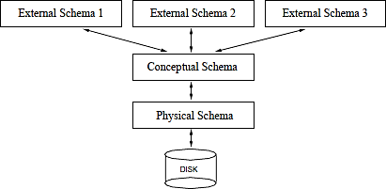

Conceptual schema:

- The conceptual schema(also called as logical schema) describes the stored data in terms of the data model of the DBMS.
- In a relational DBMS, the conceptual schema describes all relations that are stored in the database.
- In our sample university database, these relations contain information about entities, such as students and faculty, and about relationships, such as students’ enrollment in courses.
Students(sid: string, name: string, login: string, age: integer, gpa: real)
Faculty(fid: string, fname: string, salary : real) Courses(cid: string, cname: string, credits: integer) Rooms(nw: integer, address: string, capacity: integer) Enrolled (sid: string, cid: string, grade: string) Teaches (fid: string, cid: string)

The choice of relations, and the choice of fields for each relation, is not always obvious, and the process of arriving at a good conceptual schema is called conceptual database design.
Physical Schema:

- The physical schema specifies storage details.
- It summarizes how the relations described in the conceptual schema are actually stored on secondary storage devices such as disks and tapes.
- Decides what file organizations to use to store the relations and create auxiliary data structures, called indexes, to speed up data retrieval operations.
- A sample physical schema for the university database is to store all relations as unsorted files of records.
  - Create indexes on the first column of the students, faculty and courses relations, the salary column of faculty, and the capacity of column of rooms.
External Schema:

- This schema allows data access to be customized at the level of individual users or groups of users.
- A database has exactly one conceptual schema and one physical schema, but it may have several external schemas.
- An external schema is a collection of one or more views and relations from the conceptual schema.
- A view is conceptually a relation, but the records in a view are not stored in the DBMS.

  - Data Independence
Application programs are insulated from changes in the way the data is structured and stored. Data independence is achieved through use of the three levels of data abstraction.
Logical data independence: users can be shielded from changes in the logical structure of the data, or changes in the choice of relations to be stored. This is the independence to change the conceptual schema without having to change the external schemas and their application programs.
Physical data independence: the conceptual schema insulated users from changes in physical storage details. This is the independence to change the internal schema without having to change the conceptual schema.
  - Architecture of a DBMS
The functional components of a database system can be broadly divided into query processor components and storage manager components. The query processor includes:
- DML Compiler: It translates DML statements in a query language into low-level instructions that the query evaluation engine understands.
- Embedded DML Pre-compiler: It converts DML statements embedded in an application program to normal procedure calls in the host language. The pre-compiler must interact with the DML compiler to generate the appropriate code.
- DDL Interpreter: It interprets DDL Stateline its and records them in a set of tables containing

metadata.
- Transaction Manager: Ensures that the database remains in a consistent (correct) state despite system failures, and that concurrent transaction executions proceed without conflicting.
- File Manager: Manages the allocation of space on disk storage and the data structures used to represent information stored on disk.
- Buffer Manager: Is responsible for fetching data from disk storage into main memory and deciding what data to cache in memory.
Also some data structures are required as part of the physical system implementation:
- Data Files: The data files store the database by itself.
- Data Dictionary: It stores metadata about the structure of the database, as it is used heavily.
- Indices: It provides fast access to data items that hold particular values.
- Statistical Data: It stores statistical information about the data in the database. This information used by the query processor to select efficient ways to execute a query.

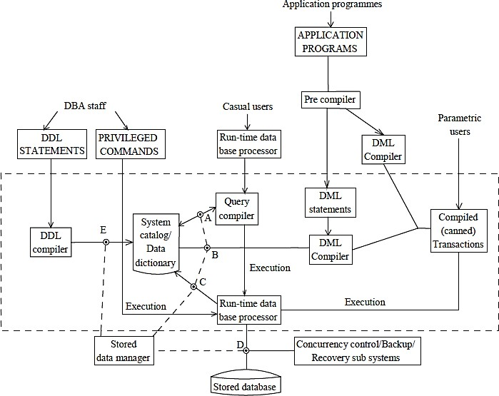

  - People Who Deal With Databases
Quite a variety of people are associated with the creation and use of databases. Obviously, there are database implementors, who build DBMS software, and end users who wish to store and use data in a DBMS.
Database implementors work for vendors such as IBM or Oracle. End users come from a diverse and increasing number of fields.

In addition to end users and implementors, two other classes of people are associated with a DBMS: application programmers and database administrators (DBAs).
Database application programmers develop packages that facilitate data access for end users, who are usually not computer professionals, using the host or data languages and software tools that DBMS vendors provide.
The task of designing and maintaining the database is entrusted to a professional called the
database administrator.

The DBA is responsible for many critical tasks:

- Design of the conceptual and physical schemas: The DBA is responsible for interacting with the users of the system to understand what data is to be stored in the DBMS and how it is likely to be used. Based on this knowledge, the DBA must design the conceptual schema (decide what relations to store) and the physical schema (decide how to store them).
- Security and authorization: The DBA is responsible for ensuring that unauthorized data access is not permitted. In general, not everyone should be able to access all the data. In a relational DBMS, users can be granted permission to access only certain views and relations.
- Data availability and recovery from failures: The DBA must take steps to ensure that if the system fails, users can continue to access as much of the uncorrupted data as possible.
- Database tuning: The needs of users are likely to evolve with time. The DBA is responsible for modifying the database, in particular the conceptual and physical schemas, to ensure adequate performance as user requirements change.

  - Database Environment
A database management system (DBMS) is a collection of programs that enables users to create and maintain a database. The DBMS is hence a general-purpose software system that facilitates the processes of defining, constructing, manipulating, and sharing databases among various users and applications.
Defining a database involves specifying the data types, structures, and constraints for the data to be stored in the database.
Constructing the database is the process of storing the data itself on some storage medium that is controlled by the DBMS.
Manipulating a database includes such functions as querying the database to retrieve specific data, updating the database to reflect changes in the mini world, and generating reports from the data.
Sharing a database allows multiple users and programs to access the database concurrently. Other important functions provided by the DBMS include protecting the database and maintaining
it over a long period of time.
Protection includes both system protection against hardware or software malfunction (or crashes), and security protection against unauthorized or malicious access. A typical large database may have a life cycle of many years, so the DBMS must be able to maintain the database system by allowing the system to evolve as requirements change over time. We can call the database and DBMS software together a database system.

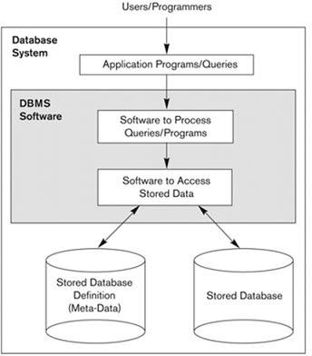

  - Database Architecture
Database architecture uses programming languages to design a particular type of software for businesses or organizations. Database architecture focuses on the design, development, implementation and maintenance of computer programs that store and organize information for businesses, agencies and institutions.
The architecture of a DBMS can be seen as either single tier or multi-tier. The tiers are classified as follows:
- tier architecture

- tier architecture

- tier architecture n-tier architecture

- tier architecture:
One-tier architecture involves putting all of the required components for a software application or technology on a single server or platform.

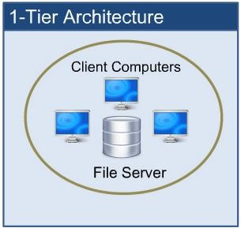

- tier architecture:
The two-tier is based on Client Server architecture. The two-tier architecture is like client server application. The direct communication takes place between client and server. There is no intermediate between client and server.
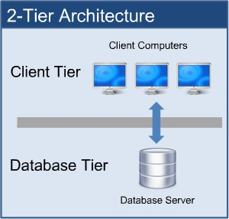
- tier architecture:
A 3-tier architecture separates its tiers from each other based on the complexity of the users and how they use the data present in the database. It is the most widely used architecture to design a DBMS.
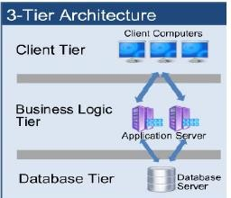

  - Centralized DBMS Architecture
Architectures for DBMSs have followed trends similar to those for general computer system architectures. Earlier architectures used mainframe computers to provide the main processing for all functions of the system, including user application programs and user interface programs, as well as all the DBMS functionality.

As prices of hardware declined, most users replaced their terminals with personal computers (PCs) and workstations. At first, database systems used these computers in the same way as they had used display terminals, so that the DBMS itself was still a centralized DBMS in which all the DBMS functionality, application program execution, and user interface processing were carried out on one machine.
Gradually, DBMS systems started to exploit the available processing power at the user side, which led to client/server DBMS architectures.
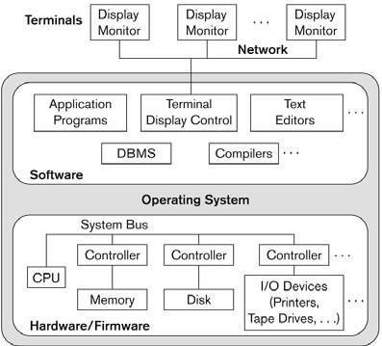

  - Client/Server Architecture:
The client/server architecture was developed to deal with computing environments in which a large number of PCs, workstations, file servers, printers, database servers, Web servers, and other equipment are connected via a network. The idea is to define specialized servers with specific functionalities.
The resources provided by specialized servers can be accessed by many client machines. The client machines provide the user with the appropriate interfaces to utilize these servers, as well as with local processing power to run local applications. This concept can be carried over to software, with specialized software-such as a DBMS or a CAD (computer-aided design) package being stored on specific server machines and being made accessible to multiple clients.
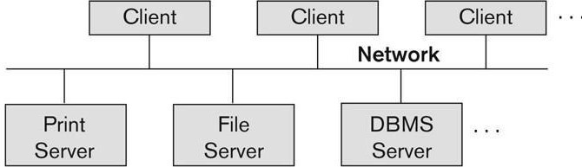

The concept of client/server architecture assumes an underlying framework that consists of many PCs and workstations as well as a smaller number of mainframe machines, connected via local area networks and other types of computer networks. A client in this framework is typically a user machine that provides user interface capabilities and local processing. When a client

requires access to additional functionality-such as database access-that does not exist at that machine, it connects to a server that provides the needed functionality.

A server is a machine that can provide services to the client machines, such as file access, printing, archiving, or database access. In the general case, some machines install only client software, others only server software, and still others may include both client and server software. However, it is more common that client and server software usually run on separate machines.

In client/server architecture, the user interface programs and application programs can run on the client side. When DBMS access is required, the program establishes a connection to the DBMS (which is on the server side); once the connection is created, the client program can communicate with the DBMS. A standard called Open Database Connectivity (ODBC) provides an application programming interface (API), which allows client-side programs to call the DBMS, as long as both client and server machines have the necessary software installed. Most DBMS vendors provide ODBC drivers for their systems.
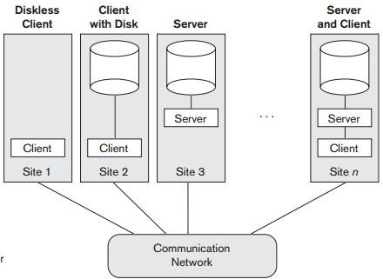

Review Questions

- Distinguish between database systems and file systems.
- Discuss about the client server architecture of the database.
- Define DBMS. Explain database users in detail.
- What are advantages of DBMS? Explain.
- With a neat diagram, explain the structure of Database Management System.
- What is data independence and how does a DBMS support it? Explain.
- What is a Database model? List out various database models and explain any two of them.
- Explain the difference between external, logical and physical level schemas. How are these different schema layers related to the concepts of logical and physical data independence?
- Compare and contrast various Data Models.
- Demonstrate data abstraction implementation in DBMS.
- List and explain various data models used for database design.
- Explain about Buffer management in DBMS.

- Who are the different database users? Explain their interfaces to database management system.
- Describe the client server architecture for the database with necessary diagram.
- Define Schema. Explain three level architecture in DBMS.
- Explain Data Independence and its types in detail.
- How does DBMS provide data abstraction? Explain the concept of data independence.
- With a neat diagram describe the overall system structure of DBMS.

References:
  - Raghurama Krishnan, Johannes Gehrke, Database Management Systems, 3rd Edition, Tata McGraw Hill.
  - C.J. Date, Introduction to Database Systems, Pearson Education.
  - Elmasri Navrate, Fundamentals of Database Systems, Pearson Education.

DATABASE MANAGEMENT SYSTEMS

UNIT II: Relational Model & Basic SQL

Syllabus:
Relational Model: Introduction to relational model, concepts of domain, attribute, tuple, relation, importance of null values, constraints (Domain, Key constraints, integrity constraints) and their importance
BASIC SQL: Simple Database schema, data types, table definitions (create, alter), different DML operations (insert, delete, update), basic SQL querying (select and project) using where clause, arithmetic & logical operations, SQL functions (Date and Time, Numeric, String conversion).

Objectives:
After studying this unit, you will be able to:
- Describe Relational model
- Describe SQL and data types
- Explain the basic structures of SQL queries
- Know how to create tables
- Realise aggregate functions and null values

  - ​Introduction
Relational Model was proposed by E.F Codd to model data in the form of relations or tables. After designing the conceptual model of database using ER diagram, we need to convert the conceptual model in the relational model which can be implemented using any RDBMS (Relational Data Base Management System) like SQL, MY SQL etc.
The relational model is very simple and elegant; a database is a collection of one or more relations, where each relation is a table with rows and columns.
This simple tabular representation enables even new users to understand the contents of a database, and it permits the use of simple, high-level languages to query the data.
  - ​Relational Model
Relational Model represents how date is stored in relational databases. A Relational database stores data in the form of relations (tables).
Consider a relation STUDENT with attributes ROLL_NO, NAME, ADDRESS, PHONE and AGE as shown in table.
ROLL_NO | NAME | ADDRESS | PHONE | AGE
1 | Nishma | Hyderabad | 9455123451 | 28
2 | Sai | Guntur | 9652431843 | 27
3 | Swetha | Nellore | 9156253131 | 26
4 | Raji | Ongole | 9215635311 | 25
Attribute: Attributes are the properties that define a relation. Ex: ROLL_NO, NAME
Tuple: Each row in a relation is known as tuple.
Ex:
1 | Nishma | Hyderabad | 9455123451 | 28
Degree: The number of attributes in the relation is known as degree.
Ex: The degree of the given STUDENT table is 5.
Column: Column represent the set of values for a particular attribute. The column ROLL_NO is extracted from the relation STUDENT.
Ex:

ROLL_NO
1

Null values: The value which is not known or unavailable is called NULL VALUE. It is represented by blank space.
Cardinality: The number of tuples are present in the relation is called as its cardinality.
Ex: The Cardinality of the STUDENT table is 4.

  - Concept Of Domain
The domain of a database is the set of all allowable values (or) attributes of the database.
Ex: Gender (Male, Female, Others).
Relation
    - A relation is defined as a set of tuples and attributes.
    - A relation consists of Relation schema and relation instance.
    - Relation schema: A relation schema represents the name of the relation with its attributes.
Ex: STUDENT (ROLL_NO, NAME, ADDRESS, PHONE and AGE) is Relation schema for STUDENT.
    - Relation instance: The set of tuples of a relation at a particular instance of a time is called Relation Instance.
An instance of „Employee „relation

Emp_code | Emp_Name | Dept_Name
01234 | John | HR
12567 | Smith | Sales
21678 | Sai | Production
12456 | Jay | Design
  - ​Importance of Null values:
    - SQL supports a special value known as NULL which is used to represent the values of attributes that may be unknown or not apply to a tuple.
    - For example, the apartment_number attribute of an address applies only to the address that is in apartment buildings and not to other types of residences.
    - It is important to understand that a NULL value is different from Zero value.
    - A Null value is used to represent a missing value, but that is usually has one of the following interpretations:
      - Value unknown (Value exists but it is unknown)
      - Value not available (exists but it is purposely withheld)
      - Attribute not applicable (undefined for this tuple)
    - It is often not possible to determine which of the meanings is intended.

  - Constraints
    - On modeling the design of the relational data base, we can put some rules(conditions) like what values are allowed to be inserted in the relation
    - Constraints are the rules enforced on the data columns of a table. These are used to limit the type of data that can go in to a table
    - This Ensure the accuracy and reliability of the data in the database. Constraints could be either on a column level on a table level.

  - ​Domain Constraints In DBMS
    - In DBMS table is viewed as a combination of rows and columns
    - For example, if you are having a column called month and you want only (jan, feb, march……) as values allowed to be entered for that particular column which is referred to as domain for that particular column
Definition: Domain constraint ensures two things it makes sure that the data value entered for that particular column matches with the data type defined by that column
It shows that the constraints (NOT NULL/UNIQUE/PRIMARY KEY/FOREIGN KEY/CHECK/DEFAULT)
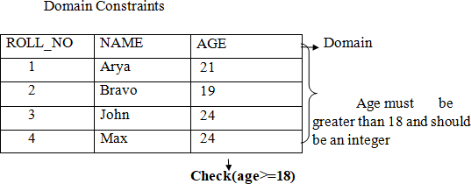
Domain constraint= data type check for the column +constraints.
Example:, we want to create a table “STUDENT” with “stu_id” field having a value greater than 100, can create a domain and table like this.
- Create domain id_value int constraint id_test check (value>=100);
- CREATE table STUDENT (stu_id id value primary key, stu_name varchar (30), stu_age int);

  - ​Key constraints in DBMS:
    - Constraints are nothing but the rules that are to be followed while entering data into columns of the database table.
    - Constraints ensure that the data entered by the user into columns must be within the criteria specified by the condition.
    - We have 6 types of key constraints in DBMS
- Not Null
- Unique
- Default
- Check
- Primary key
- Foreign key

- Not Null:
  - Null represents a record where data may be missing data or data for that record may be optional.
  - Once not null is applied to a particular column, you cannot enter null values to that column.
  - A not null constraint cannot be applied at table level.

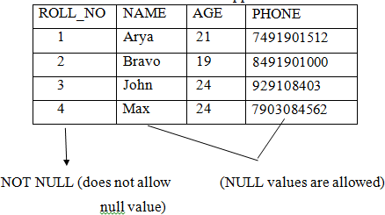

Example:

Create table EMPLOYEE (id int Not null, name varchar Not null, Age int not null, address char (25), salary decimal (18,2), primary key(id));
- In the above example we have applied not null on three columns id, name and age which means whenever a record is entered using insert statement all three columns should contain a value other than null.
- We have two other columns address and salary, where not null is not applied which means that you can leave the row as empty.

- Unique:
Some times we need to maintain only. Unique data in the column of a database table, this is possible by using a Unique constraint.
- Unique constraint ensures that all values in a column are Unique.
Example:

Create table PERSONS (id int unique, last_name varchar (25) not null, First name varchar (25), age int);
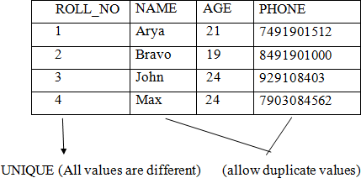
- In the above example, as we have used unique constraint on ID column we are not supposed to enter the data that is already present, simply no two ID values are same.

- Default:
Default in SQL is used to add default data to the columns.

- When a column is specified as default with same value then all the rows will use the same value i.e., each and every time while entering the data we need not enter that value.
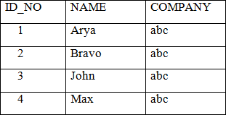
- But default column value can be customised i.e., it can be over ridden when inserting a data for that row based on the requirement.
(Row with default values “abc”)

Example:

Create table EMPLOYEE (id int Not null, last_name varchar (25) Not null, first_name varchar (25), Age int, city varchar (25) Default Hyderabad);
- As a result, whenever you insert a new row each time you need not enter a value for this default column that is entering a column value for a default column is optional.

- Check:
- Check constraint ensures that the data entered by the user for that column is within the range of values or possible values specified.
Example: Create table STUDENT (id int, name varchar (25), age int, check(age>=18));

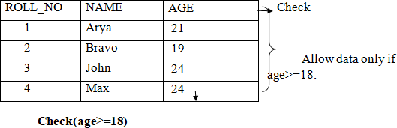

- As we have used a check constraint as (age>=18) which means value entered by user for this age column while inserting the data must be less than or equal to 18.

- Primary Key:
- A primary key is a constraint in a table which uniquely identifies each row record in a database table by enabling one or more column in the table as primary key.
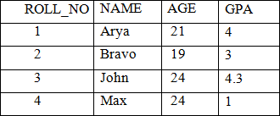

Creating a primary key:
- A particular column is made as a primary key column by using the primary key keyword followed by the column name.
Example:
Create table EMP (ID int, name varchar (20), age int, course varchar (10), Primary key (ID));
- Here we have used the primary key on ID column then ID column must contain unique values i.e., one ID cannot be used for another student.

- Foreign Key:
- The foreign key constraint is a column or list of columns which points to the primary key column of another table.
- The main purpose of the foreign key is only those values are allowed in the present table that will match to the primary key column of another table.
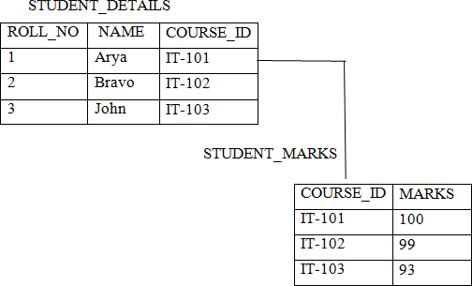

From the above two tables, COURSE_ID is a primary key of the table STUDENT_MARKS and also behaves as a foreign key as it is same in STUDENT_DETAILS and STUDENT_MARKS.

Example:

(Reference Table)

Create table CUSTOMER1 (id int, name varchar (25), course varchar (10), primary key (ID));
(Child table)

Create table CUSTOMER2 (id int, marks int, references customer1(ID));

  - ​Integrity Constraints in DBMS:
    - There are two types of integrity constraints
- Entity Integrity Constraints
- Referential Integrity Constraints
Entity Integrity constraints:
    - These constraints are used to ensure the uniqueness of each record or row in the data table.
    - Entity Integrity constraints says that no primary key can take NULL VALUE, since using primary key we identify each tuple uniquely in a relation.
Example:
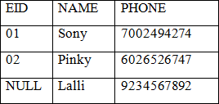

Explanation:
- In the above relation, EID is made primary key, and the primary key can‟t take NULL values but in the 3rd tuple, the primary key is NULL, so it is violating Entity integrity constraints.
Referential Integrity constraints:
- The referential integrity constraint is specified between two relations or tables and used to maintain the consistency among the tuples in two relations.
- This constraint is enforced through foreign key, when an attribute in the foreign key of relation R1 have the same domain as primary key of relation R2, then the foreign key of R1 is said to reference or refer to the primary key of relation R2.
- The values of the foreign key in a tuple of relation R1 can either take the values of the primary key for some tuple in Relation R2, or can take NULL values, but can‟t be empty.

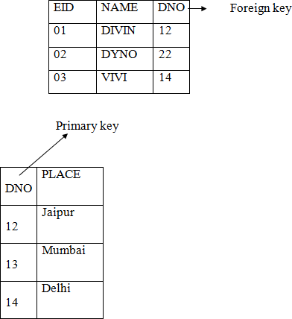

Explanation:

- In the above, DNO of the first relation is the foreign key and DNO in the second relation is the primary key
- DNO=22 in the foreign key of the first relation is not available in the second relation so, since DNO=22 is not defined in the primary key of the second relation therefore Referential integrity constraints is violated here.

  - Basic SQL (introduction)

    - SQL stands for Structure Query Language it is used for storing and managing data in relational database management system.
    - It is standard language for relational database system. It enables a user to create, read, update and delete relational databases and tables.
    - All the RDBMS like MYSQL, Oracle, MA access and SQL Server use SQL as their standard database language.
    - SQL allows users to Query the database in a number of ways using statements like common English.
Rules: SQL follows following rules
      - SQL is not a case sensitive. Generally, keywords are represented in UPPERCASE.
      - Using the SQL statements, you can perform most of the actions in a database.
      - Statements of SQL are dependent on text lines. We can use a single SQL statement on one or multiple text line.

  - SQL Process:
    - When an SQL command is executing for any RDBMS, then the system figure out the best way to carry out the request and the sql engine determines that how to interrupt the task.
    - In the process, various components are included. These components can be optimization engine, query engine, query dispatcher etc.,
    - All the non-sql queries are handled by the classic query engine, but sql query engine won‟t handle logical files.
  - Characteristics of SQL:
- SQL is easy to learn.
- SQL is used to access data from relational database management system.
- SQL is used to describe the data.
- SQL is used to create and drop the database and table.
- SQL allows users to set permissions on tables, procedures and views.
  - Simple database Schema:
    - A database schema is a structure that represents the logical storage of the data in the database.
    - It represents the organization of data and provides information about the relationships between the tables in a given database.
    - A database schema is the logical representation of a database, which shows how the data is stored logically in the entire database.
    - It contains list of attributes and instruction that informs the database engine that how the data is organized and how the elements are related to each other.
    - A database schema contains schema objects that may include tables, fields, packages, views, relationship, primary key, foreign key.
    - In actual, the data is physically stored in files that may be in unstructured form, but to retrieve it and use it, we need to keep them in a structured manner. To do this a database schema is used. It provides knowledge about how the data is organized in a database and how it is associated with other data.
    - A database schema object includes the following:
      - Consistent formatting for all data entries.
      - Database objects and unique keys for all data entries.
      - Tables with multiple columns, and each column contains its names and datatypes.
      - The given diagram is an example of a database schema it contains three tables, their data types. This also represents the relationships between the tables and primary keys as well as foreign keys.
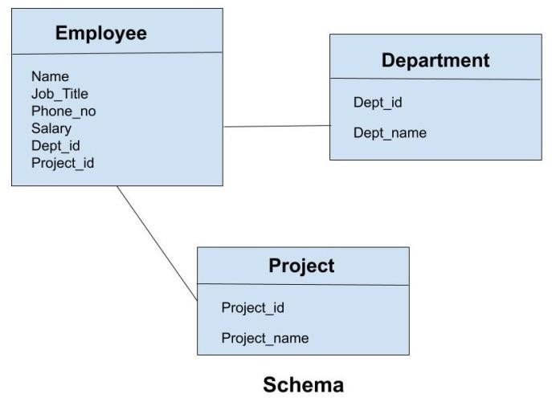

  - SQL Commands:
SQL commands are categorized into three types.

- Data Definition Language (DDL): used to create (define) a table.
- Data Manipulation Language (DML): used to update, store and retrieve data from tables.
- Data Control Language (DCL): used to control the access of database created using DDL and DML.
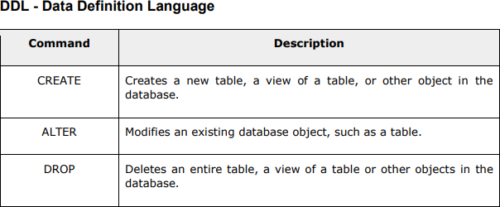

SQL DATATYPES :
SQL data type is used to define the values that a column can contain

Every column is required to have a name and data type in the database table. DATA TYPES OF SQL :
SQL DATA TYPES

Binary data type | Numeric data type | Extract  numeric data type | String data type | Date data type

BINARY DATATYPES:
There are three types of binary data types which are given below

DATA TYPE | DESCRIPTION
Binary | It has a maximum length of 800 bytes. It contains a fixed- length binary data
Var binary | It has a maximum length of 800 bytes. It contains a variable - length binary data
Image | It has a maximum length of 2,147,483,647 bytes. It contains  a variable - length binary data

- NUMERIC DATATYPE:

DATA TYPE | FROM | TO | DESCRIPTION
Float | -1.79 E  +308 | 1.79 E  +308 | It is used to specify a floating-point value.  Ex: 6.2, 2.9 etc
Real | -3.40 E  +38 | 3.40 E  +38 | It specifies a single precision floating point number.

- EXACT NUMERIC DATA TYPE:

DATA TYPE | DESCCRIPTION
Int | It is used to specify an integer value
Small int | It is used to specify small integer value
Bit | It has the number of bits to store
Decimal | It specifies a numeric value that can have a decimal number
Numeric | It is used to specify a numeric value

- DATE AND TIME DATATYPES:

DATA TYPE | DESCRIPTION
Date | It is used to store the year, month, and days value
Time | It is used to store the hour, minute, and seconds value
Time stamp | It stores the year, month, hour, minute, and the second value

- STRING DATATYPE:

DATA TYPE | DESCRIPTION
Char | It has a maximum length of 8000 characters. It contains fixed-length non-  Unicode characters.
Varchar | It has a maximum length of 8000 characters. It contains variable-length  non-Unicode characters.
Text | It has a maximum length of 2,147,483,647 characters. It contains variable-  length non-Unicode characters.

  - ​ TABLE DEFINITIONS: (CREATE, ALTER)
SQL TABLE: SQL table is a collection of data which is organized in terms of rows and columns.

- In DBMS, the table is known as relation and row as a tuple
- Let‟s see an example of the “EMPLOYEE “table

EMP_ID | EMP_NAME | CITY | PHONE_ID
1 | Kristen | Washington | 7289201223
2 | Anna | Franklin | 9378282882
3 | Jackson | California | 9264783838
4 | Daniel | Hawaii | 9638482678
- In the above table, “EMPLOYEE” is the table name, “EMP_ID, “EMP_NAME”, “CITY”,” PHONE-NO” are the column names.
- The combination of data of multiple columns forms a row
EG: 1, “Kristen”, “Washington” and “7289201223 “are the data of one row

OPERATIONS ON TABLE:
- Create table
- Alter table
- Drop table
- Create table: SQL create table is used to create a table in the database. To define the table, you should define the name of the table and also define its column and column‟s data type.
SYNTAX:

Create table table_name (“column1” “datatype”,

“column2” “datatype”, “column3” “datatype”,
….

“column N” “datatype”);

EXAMPLE:

SQL > create table employee (emp_id int, emp_name varchar (25), phone_no int, address char (30));
- If you create the table successfully, you can verify the table by looking at the message by the sql server. else you can use DESC command as follows
SQL > DESC employee;

FIELD | TYPE | NULL | DEFAULT | EXTRA
Emp_id | Int (11) | No | NULL
Emp_name | Varchar (25) | No | NULL
Phone_no | No | Int (11) | NULL
address | yes |  | NULL | Char(30)

ALTER TABLE:
  - The alter table command adds, delete or modifies columns in a table
  - The alter table command also adds and deletes various constraints in a table
  - The following SQL adds an “EMAIL” column to the “EMPLOYEE “table
SYNTAX:

ALTER table table_name add column1 datatype;

EXAMPLE:

ALTER table employee add email varchar (255);

SQL > DESC employee;

FIELD | TYPE | NULL | DEFAULT | EXTRA
Emp_id | Int (11) | No | NULL
Emp_name | Varchar (25) | No | NULL
Phone_no | No | Int (11) | NULL
Address | Yes |  | NULL | Char (30)
Email | Varchar (255) |  | NULL

DROP TABLE:

  - The drop table command deletes a table in the data base
  - The following example SQL deletes the table “EMPLOYEE”
SYNTAX :

DROP table table_name;

EXAMPLE:

DROP table employee;

    - Dropping a table results in loss of all information stored in the table.
  - Different DML Operations (insert, delete, update):
    - DML-Data Manipulation Language.
    - Data Manipulation Commands are used to manipulate data to the database.
    - Some of the data manipulation commands are
- Insert
- Update
- Delete

- Insert:
SQL insert statement is a sql query. It is used to insert a single multiple records in a table.

Syntax:

Insert into table name values (value 1, value 2, value 3);

Let‟s take an example of table which has 3 records within it.

  - insert into student values(„alekhya‟,501,‟hyderabad‟);
  - insert into student values(„deepti‟,502,‟guntur‟);
  - insert into student values(„ramya‟,503,‟nellore‟); The following table will be as follows:

NAME | ID | CITY
Alekhya | 501 | Hyderabad
Deepti | 502 | Guntur
Ramya | 503 | Nellore

- Update:
- The SQL Commands update are used to modify the data that is already in the database.
- SQL Update statement is used to change the data of records held by tables which rows is to be update, it is decided by condition to specify condition, we use “WHERE” clause.
  - The update statement can be written in following form:
Syntax:
Update table_name set column_name=expression where condition;
Example:
Let‟s take an example: here we are going to update an entry in the table.
Update students set name=‟rasi‟ where id=503;

After update the table is as follows:

NAME | ID | CITY
Alekhya | 501 | Hyderabad
Deepti | 502 | Guntur
Rasi | 503 | Nellore

- Delete:
- The SQL delete statement is used to delete rows from a table.
- Generally, delete statement removes one or more records from a table.
Syntax:
delete from table_name [where condition];

Example:
Let us take a table named “student” table

Delete from students where id=501;

Resulting table after the query:

NAME | ID | CITY
Deepti | 502 | Guntur
Rasi | 503 | Nellore

  - Basic SQL querying (select and project) using where clause:
    - The following are the various SQL clauses:

SQL Clause

Group by clause having clause Order by clause

- Group by:
  - SQL group by statement is used to arrange identical data into groups.
  - The group by statement is used with the SQL select statement.
  - The group by statement follows the WHERE clause in a SELECT statement and precedes the ORDER BY clause.

Syntax:
Select column from table_name where column group by column, order by column;

Sample table: product
PRODUCT | COMPANY | QTY | RATE | COST
Item 1 | Com 1 | 2 | 10 | 20
Item 2 | Com 2 | 3 | 25 | 75
Item 3 | Com 1 | 2 | 30 | 60
Item 4 | Com 3 | 5 | 10 | 50
Item 5 | Com 2 | 2 | 20 | 40

Example:
  - Select company count (*) from product group by company;

Output:
Com 1 | 2
Com 2 | 3
Com 3 | 5

- Having clause:
  - Having clause is used to specify a search condition for a group or an aggregate.
Having clause is used in a group by clause, if you are not using group by clause then you can use having function like a where clause.

Syntax:
Select column1, column2 from table_name

Where conditions

Group by column1, column2 Having conditions
Order by column1, column2;

Example:
  - select company count (*) from product
Group by company Having count (*) > 2;

Output:
Com 3 | 5
Com 2 | 2

- Order by clause:
The order by clause sorts the result _set in ascending or descending order.

Syntax:
Select column1, column2, from table_name

Where condition

Order by column1, column2…asc;

Sample table:
Take a student table

Example:
Select * from student order by name;
Output:

NAME | ID | CITY
Alekhya | 501 | Hyderabad
Deepti | 502 | Guntur
Rasi | 503 | Nellore

  - ​ SQL Where clause:
    - A where clause in SQL is a data manipulation language statement.
    - Where clauses are not mandatory clauses of SQL DML statements but it can be used to limit the number of rows affected by a SQL DML statement or returned by query.
    - Actually, it follows the records.it returns only those queries which the specific conditions.

Syntax:
Select column1, column2, …………column from table_name where[condition];

    - Where clause uses same conditional selection.

= | Equal to
> | Greater than
< | Less than
> = | Greater than or equal to
< = | Less than or equal to
< > | Not equal to

  - Arithmetic and logical operations:

SQL operators:
    - SQL statements generally contain some reserved words or characters that are used to perform operations such as arithmetic and logical operations etc. Their reserved words are known as operators.
SQL arithmetic operator:
    - We can use various arithmetic operators on the data stored in tables.
    - Arithmetic operators are:

+ | Addition
- | Subtraction
/ | Division
* | Multiplication

% | modulus

- Addition (+):
It is used to perform addition operation on data items.

Sample table:
 | EMP_ID | EMP_NAME | SALARY
 | 1 | Alex | 25000
 | 2 | John | 55000
 | 3 | Daniel | 52000
 | 4 | Sam | 12312

  - select emp id, emp_name, salary, salary+100 as “salary +100” from
addition;
Output:
 | EMP_ID | EMP_NAME | SALARY | SALARY+100
 | 1 | Alex | 25000 | 25100
 | 2 | John | 55000 | 55100
 | 3 | Daniel | 52000 | 52100
 | 4 | Sam | 12312 | 12412
  - Here we have done addition of 100 to each emp‟s salary.
- Subtraction (-):
  - It is used to perform subtraction on the data items.
Example:
Select emp_id, emp_name, salary, salary-100 as “salary-100” from
subtraction;
EMP_ID | EMP_NAME | SALARY | SALARY-100
1 | Alex | 25000 | 24900
2 | John | 55000 | 54900
3 | Daniel | 52000 | 51900
4 | Sam | 90000 | 89900
Here we have done subtraction of 100 for each emp‟s salary.

- Division (/):
  - The division function is used to integer division (x is divided by y).an integer value is returned.
Example:
  - Select emp_id, emp_name, salary, salary/100 as “salary/100” from division;

EMP_ID | EMP_NAME | SALARY | Salary/100
1 | Alex | 25000 | 250
2 | John | 55000 | 550
3 | Daniel | 52000 | 520
4 | Sam | 90000 | 900

- Multiplication (*):
  - It is used to perform multiplication of data items.
  - Select emp_id, emp_name, salary, salary*100 as “salary*100” from multiplication;

EMP_ID | EMP_NAME | SALARY | SALARY*100
1 | Alex | 25000 | 2,500,000
2 | John | 55000 | 5,500,000
3 | Daniel | 52000 | 5,200,000
4 | Sam | 90000 | 9,000,000
  - Here we have done multiplication of 100 to each emp‟s salary.
- Modulus (%):
  - It is used to get remainder when one data is divided by another.
  - Select emp_id, emp_name, salary, salary%25000 as “salary%25000” from modulus;
Output:
 | EMP_ID | EMP_NAME | SALARY | SALARY%25000
 | 1 | Alex | 25000 | 0
 | 2 | John | 55000 | 5000
 | 3 | Daniel | 52000 | 2000
 | 4 | Sam | 90000 | 15000
  - Here we have done modulus operation to each emp‟s salary.
  - ​ Logical operations:
    - Logical operations allow you to test for the truth of a condition.
    - The following table illustrates the SQL logical operator.
OPERATOR | MEANING
ALL | Returns true if all comparisons are true
AND | Returns true if both expressions are true
ANY | Returns true if any one of the comparisons is  true
BETWEEN | Return true if the operand is within a range
IN | Return true if the operand is equal to one of  the values in a list
EXISTS | Return true if the sub query contains any rows

AND:
The AND operator allows you to construct multiple condition in the WHERE clause of an SQL statement such as select.
  - The following example finds all employees where salaries are greater than the 5000 and less than 7000.
    - Select first_name, last_name, salary from employees where salary>5000 AND salary<7000 order by salary;
Output:
FIRST_NAME | LAST_NAME | SALARY
John | Wesley | 6000
Eden | Daniel | 6000
Luis | Popp | 6900
Shanta | Suji | 6500

ALL:
The ALL operator compares a value to all values in another value set.

  - The following example finds all employees whose salaries are greater than all salaries of employees.
EX:
select first_name, last_name, salary from employees where salary>=ALL (select salary from employees where department_id =8) order by salary DESC;
Output:
FIRST_NAME | LAST_NAME | SALARY
Steven | King | 24000
John | Russel | 17000
Neena | Kochhar | 14000

ANY:
The ANY operator compares a value to any value in a set ascending to condition.
The following example statement finds all employees whose salaries are greater than the average salary of every department.
EX:
select first_name, last_name, salary from employees where salary >ANY (select avg (salary) from employees‟ group by department_id) order by first_name, last_name;
Output:
FIRST_NAME | LAST_NAME | SALARY
Alexander | Hunold | 9000.00
Charles | Johnson | 6200.00
David | Austin | 4800.00
Eden | Flip | 9000.00

- Between:
  - The between operator searches for values that are within a set of values.
  - For example, the following statement finds all employees where salaries are between 9000 and 12000.
EX:

select first_name, last_name, salary from employees where salary between 9000 AND 12000 order by salary;
Output:
FIRST_NAME | LAST_NAME | SALARY
Alexander | Hunold | 9000.00
Den | Richards | 10000.00
Nancy | Prince | 12000.00

IN:
  - The IN operator compares a value to list of specified values. The IN operator return true if compared value matches at least one value in the list.
  - The following statement finds all employees who work in department _id 8 or 9. EX:
select first_name, last_name, department_id from employees where department_id IN (8,9) order by department_id;
Output:
FIRST_NAME | LAST_NAME | DEPARTMENT_ID
John | Russel | 8
Jack | Livingstone | 8
Steven | King | 9
Neena | Kochhar | 9

- Exists:
  - The EXISTS operator tests if a sub query contains any rows.
  - For example, the following statement finds all employees who have dependents.
  - select first_name, last_name from employees where EXISTS (select 1 from dependent d where d.employee_id=e.employee_id);

FIRST_NAME | LAST_NAME
Steven | King
Neena | Kochhar
Alexander | Hunold

  - ​ SQL FUNCTIONS (Date & Time, Numeric, Aggregate, String conversions):

DATE & TIME FUNCTIONS:

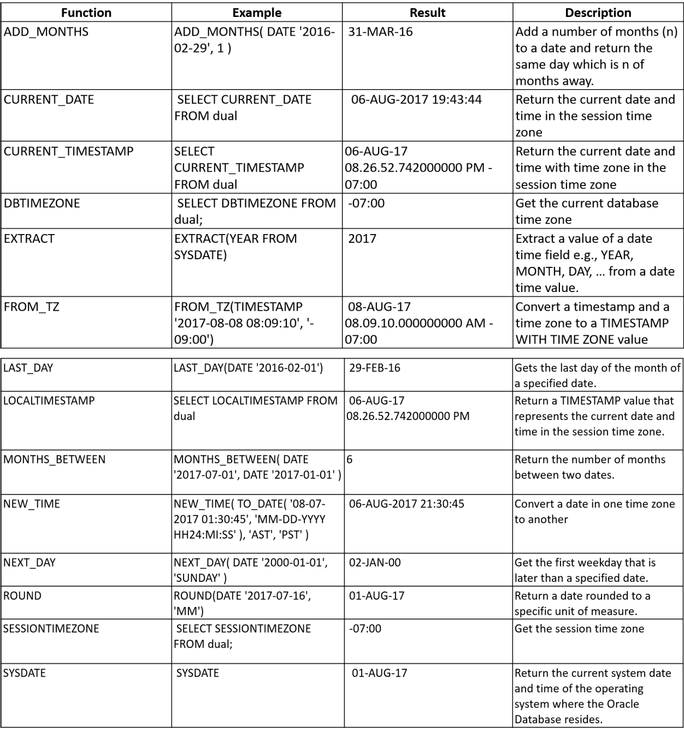

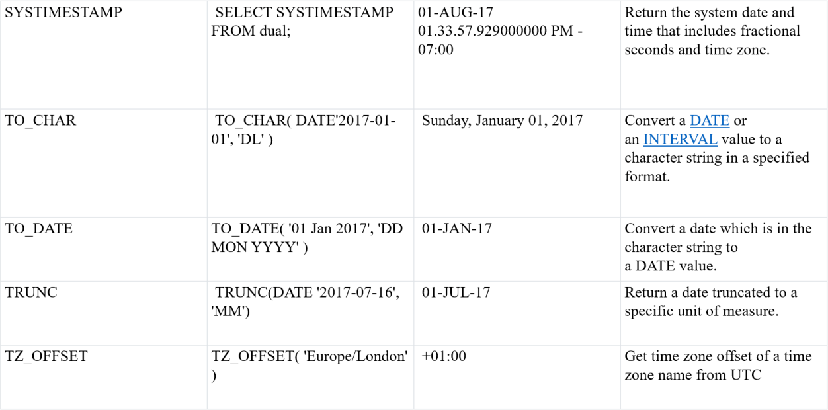

Some important date and time functions are below:
Sysdate: It generates the system date. Ex: Select sysdate from dual;
Output: 05-DEC-2021.

ADD_MONTHS: This function returns a date after adding data with specified no of months. EX: Select ADD_MONTHS („2017-02-29‟,1) from dual;
Output: 31-MAR-17.
Select add_months(sysdate,3) from dual;

Output: 05-MAR-22.

CURRENT_DATE: This function displays the current date.

Ex: Select CURRENT_DATE from dual;

Output: 05-DEC-2021.

NEXT_DAY: This function represents both day and date and returns the day of the next given day.

EX: Select NEXT_DAY(SYSDATE,‟MONDAY‟) from dual;

Output: 07-DEC-21.

LAST_DAY: This function returns a day corresponding last day of months.

EX: Select LAST_DAY (sysdate) from dual;

Output: 31-DEC-21.

MONTHS_BETWEEN: It is used to find no of months between two given dates.

EX: Select MONTHS_BETWEEN(‟16-APRIL-2021‟,‟16-AUGUST-2021) from dual;

Output: -4.

ROUND: It gives the nearest value or round off value for the argument pass. (or) It returns a date rounded to a specific unit of measure.
EX: Select ROUND(‟26-NOV-21‟,‟YYYY‟) from dual;

Output: 01-JAN-22.

TRUNC: This function returns the date with the time(co-efficient) portion of the date truncated to the unit specified.
EX: Select TRUNC (sysdate, ‟MM‟) from dual;

Output: 01-DEC-21.

TO_DATE: This function converts date which is in the character string to a date value.

EX: Select TO_DATE (‟01 jan 2017‟,‟DD MM YYYY‟) from dual;

Output: 01-JAN-17.

TO_CHAR: This function converts DATE or an INTERVAL value to a character string in a specified format.
EX: Select TO_CHAR (sysdate,‟DD MM YYYY‟) from dual;

Output: 05 12 2021.

LEAST: This function displays the oldest date present in the argument list.

EX: Select LEAST(‟01-march-2021‟,‟16-feb-2021‟,‟28-dec-2021‟) from dual;

Output: 01-MAR-21.

GREATEST: This function displays the latest date present in the argument list.

EX: Select GREATEST (‟01-march-2021‟,‟16-feb-2021‟,‟28-dec-2021‟) from dual;

Output: 28-DEC-21.

  - Aggregate Functions:
Aggregate Functions take a collection of values as input and returns a single value.

- Count ()

- Sum ()

- Avg ()

- Max ()

- Min ()

- Count (): This function returns number of rows returned by a query.

Syntax: Select count(column_name)

From table_name Where condition);
Example: Select count (distinct manager_id) from employees;

- Sum (): It will add/ sum all the column values in the query.

Syntax: Select sum (column_name)

From table_name Where condition);
Example: Select sum(salaries) from employees;

- Avg (): Avg function used to calculate average values of the set of rows.

Syntax: Select avg (column_name)

From table_name Where condition);
Example: Select avg(salary) from employees;

- Max (): This function is used to find maximum value from the set of values.

Syntax: Select max (column_name)

From table_name Where condition);
Example: Select max (salary) from employees;

- Min (): This function is used to find minimum value from the set of values.

Syntax: Select min (column_name)

From table_name

Where condition);

Example: Select min (salary) from employees;

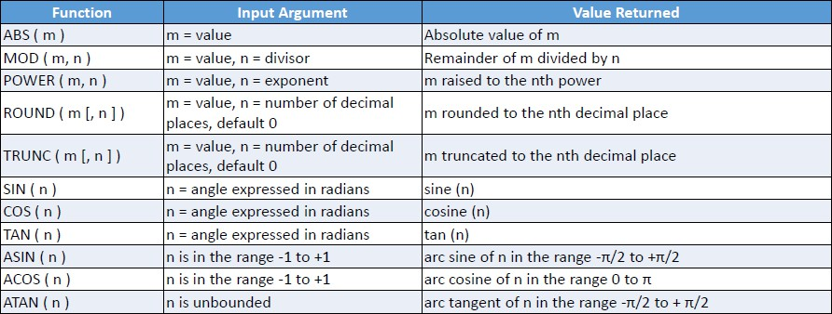
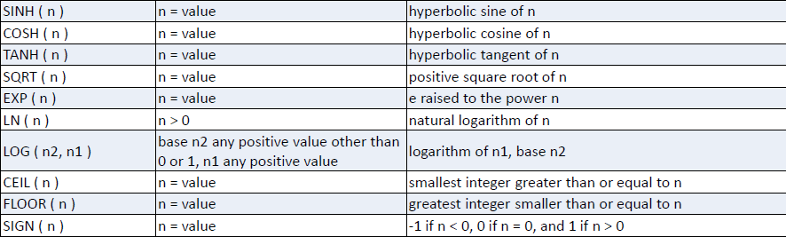
SQL NUMERIC FUNCTIONS:

Numeric functions are used to perform operations on numbers and return numbers. Following are some of the Numeric functions
- ABS (): It returns the absolute value of a number. EX: select ABS (-243.5) from dual; OUTPUT: 243.5
- ACOS (): It returns the cosine of a number. EX: select ACOS (0.25) from dual;
OUTPUT: 1.318116071652818

- ASIN (): It returns the arc sine of a number. EX: select ASIN (0.25) from dual;
OUTPUT: 0.253680255142

- CEIL (): It returns the smallest integer value that is a greater than or equal to a number. EX: select CEIL (25.77) from dual;
OUTPUT: 26

- FLOOR (): It returns the largest integer value that is a less than or equal to a number. EX: select FLOOR (25.75) from dual;
OUTPUT: 25
- TRUNCATE (): This does not work for SQL server. It returns the truncated to 2 places right of the decimal point.
EX: select TRUNCATE (7.53635, 2) from dual;
OUTPUT: 7.53
- MOD (): It returns the remainder when two numbers are divided. EX: select MOD (55,2) from dual;
OUTPUT: 1.
- ROUND (): This function rounds the given value to given number of digits of precision. EX: select ROUND (14.5262,2) from dual;
OUTPUT: 14.53.
- POWER (): This function gives the value of m raised to the power of n. EX: select POWER (4,9) from dual;
OUTPUT: 262144.
- SQRT (): This function gives the square root of the given value n. EX: Select SQRT (576) from dual;
OUTPUT: 24.
- LEAST (): This function returns least integer from given set of integers. EX: select LEAST (1,9,2,4,6,8,22) from dual;
OUTPUT: 1.

- GREATEST (): This function returns greatest integer from given set of integers. EX: select GREATEST (1,9,2,4,6,8,22) from dual;
OUTPUT: 22

STRING CONVERSION FUNCTIONS OF SQL:
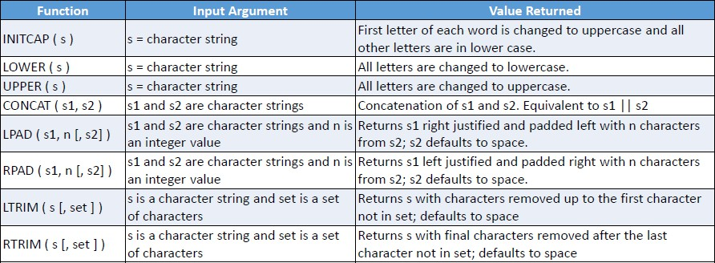

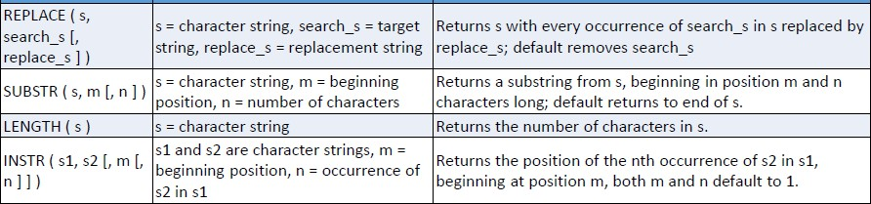

String Functions are used to perform an operation on input string and return the output string. Following are the string functions
- CONCAT (): This function is used to add two words (or) strings.

EX: select „database‟ ||‟ „|| „management system‟ From dual;

OUTPUT: „database management system‟

- INSTR (): This function is used to find the occurrence of an alphabet. EX: instr („database system‟,‟ a‟) from dual; OUTPUT: 2 (the first occurrence of „a‟)
- LOWER (): This function is used to convert the given string into lowercase. EX: select lower („DATABASE‟) from dual;
OUTPUT: database

- UPPER (): This function is used to convert the lowercase string into uppercase. EX: select upper („database „) from dual;
OUTPUT: DATABASE

- LPAD (): This function is used to make the given string of the given size by adding the given symbol. EX: > lpad („system „, 8, „0‟) from dual;
OUTPUT: 00system

- RPAD (): This function is used to make the given string as long as the given size by adding the given symbol on the right.
EX: rpad („system „,8, „0„) from dual;

OUTPUT: system00

- LTRIM (): This function is used to cut the given substring from the original string. EX: ltrim („database „, „data „) from dual;

OUTPUT: base

- RTRIM (): This function is used to cut the given substring from the original string. EX: rtrim („database „, „base „) from dual;
OUTPUT: data.

- INITCAP (): This function returns the string with first letter of each word starts with uppercase.

EX: Select INITCAP („data base management system‟) from dual;

OUTPUT: Data Base Management System.

- LENGTH (): Tis function returns the length of the given string.

EX: select LENGTH („SQ LANGUAGE‟) from dual;

OUTPUT: 11.

- SUBSTR (): This function returns a portion of a string beginning at the character position. EX: select SUBSTR („MY WORLD IS AMAZING‟,12,3) from dual;
OUTPUT: AM.

- TRANSLATE (): This function returns a string after replacing some set of characters into another set. EX: select TRANSLATE („Delhi is the capital of India‟,‟i‟,‟a‟) from dual; OUTPUT: Delha as the capatal andaa.

Review Questions:
  - Why NULL values are needed in databases?
  - Discuss GROUPBY and HAVING clauses with an example. And also give the constraints related to their usage.
  - Consider the SAILOR DATABASE
Sailors (Sid: string, sname: string, rating: integer, age: real) Boats (bid: integer, bname: string, colour: string)
Reserves (Sid: integer, bid: integer, day: date)
Based on the above schema, write the corresponding SQL queries for the following? Find the colours of boats reserved by Lubber.
Find the names of sailors who have reserved at least one boat. Find the names of sailors who have reserved a red or green boat.
Find the names of the sailors who have reserved both a red boat and a green boat.

Find names of sailors who have reserved all boats.
  - Write about the usability of „group by‟ and „having‟ clauses In SQL.
  - How would you use the operators IN, EXISTS, UNIQUE, ANY and ALL in writing nested queries? Why are they useful? Explain with an example.
  - Explain commands with respect to SQL: (i) Rename (ii) Alter (iii) View
  - Explain two aggregate functions of SQL.
  - Explain the following SQL constructs with examples:
(1) order by (2) group by and having (3) as select (4) schema
  - Write SQL Queries for following set of tables:
EMPLOYEE (EmpNo, Name, DoB, Address, Gender, Salary, DNumber) DEPARTMENT (DNumber, Dname, ManagerEmpNo, ManagerStartDate). Display the Age of „male‟ employees.
Display all employees in Department named „Marketing‟. Display the name of highest salary paid „female‟ employee. Which employee is oldest manger in company?
Display the name of department of the employee „SMITH.
  - Describe creating and modifying relations using SQL. Give examples for each.
  - Explain about integrity constraints over relations.
  - Consider the following insurance database, where the primary keys are underlined.
Construct the following SQL queries for this relational database. person (driver-id#, name, address)
car (license, model, year)
accident (report-number, date, location) owns (driver-id#, license)
participated (driver-id, car, report-number, damage-amount)
    - Find the total number of people who owned cars that were involved in accidents in 1989.
    - Find the number of accidents in which the cars belonging to “John Smith” were involved.
    - Add a new accident to the database; assume any values for required attributes.
    - Delete the Mazda belonging to “John Smith”.
    - Update the damage amount for the car with license number “AABB2000” in the accident with report number “AR2197” to $3000.
  - List the SQL functions for string conversions.
  - Write SQL statements for following:
Student (Enrno, name, courseId, emailId, cellno) Course (courseId, course_nm, duration)

- Add a column city in student table.
- Find out list of students who have enrolled in “computer” course.
- List name of all courses with their duration.
- List name of all students start with „a‟.
- List email Id and cell no of all mechanical engineering students.
  - How to define a domain constraint? Give an example.
  - What is an integrity constraint? Explain its enforcement by DBMS with illustrative
  - List the data types supported by SQL.
  - Demonstrate the use of DISTINCT keyword in SQL select statement.
  - Consider the following database schema to write nested queries in SQL Supplier (id, name, city)
Parts (pno, pname, pdescription) Supply (id, pno, cost)
- Find the names of the parts supplied by “RamRaj”
- Find the names of the suppliers who supply “Nuts”
- Find the cost of bolts being supplied by Nagpur suppliers.

References:
- Raghurama Krishnan, Johannes Gehrke, Database Management Systems, 3rd Edition, Tata McGraw Hill.
- C.J. Date, Introduction to Database Systems, Pearson Education.
- Elmasri Navrate, Fundamentals of Database Systems, Pearson Education.

Unit – III
Entity Relationship Model: Introduction, Representation of entities, attributes, entity set, relationship, relationship set, constraints, sub classes, super class, inheritance, specialization, generalization using ER Diagrams.
SQL : Creating tables with relationship, implementation of key and integrity constraints, nested queries, sub queries, grouping, aggregation, ordering, implementation of different types of joins, view(updatable and non- updatable), relational set operations.

INTRODUCTION:
Entity: An entity is something which is described in the database by storing its data, it may be a concrete entity a conceptual entity.
Entity set: An entity set is a collection of similar entities. The Employees entity set with attributes ssn, name, and lot is shown in the following figure.
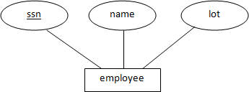
Attribute: An attribute describes a property associated with entities. Attribute will have a name and a value for each entity.
Domain: A domain defines a set of permitted values for a attribute
Entity Relationship Model: An ERM is a theoretical and conceptual way of showing data relationships in software development. It is a database modeling technique that generates an abstract diagram or visual representation of a system's data that can be helpful in designing a relational database.
ER model allows us to describe the data involved in a real-world enterprise in terms of objects and their relationships and is widely used to develop an initial database design.

REPRESENTATION:

ENTITIES:
Entities are represented by using rectangular boxes. These are named with the entity name that they represent.
Fig: Student and Employee entities

ATTRIBUTES:
Attributes are the properties of entities. Attributes are represented by means of ellipses. Every ellipse represents one attribute and is directly connected to its entity.


Types of attributes:
  - Simple attribute − Simple attributes are atomic values, which cannot be divided further. For example, a student's phone number is an atomic value of 10 digits.
  - Composite attribute − Composite attributes are made of more than one simple attribute. For example, a
student's complete name may have first_name and last_name.

  - Derived attribute − Derived attributes are the attributes that do not exist in the physical database, but their values are derived from other attributes present in the database. For example, average_salary in a department should not be saved directly in the database, instead it can be derived. For another example, age can be derived from data_of_birth.
  - Single-value attribute − Single-value attributes contain single value. For example −
Social_Security_Number.

  - Multi-value attribute − Multi-value attributes may contain more than one values. For example, a person can have more than one phone number, email_address, etc.
ER Representation for Attributes:

Attributes are the properties of entities. Attributes are represented by means of ellipses. Every ellipse represents one attribute and is directly connected to its entity (rectangle).
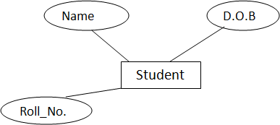

If the attributes are composite, they are further divided in a tree like structure. Every node is then connected to its attribute. That is, composite attributes are represented by ellipses that are connected with an ellipse.
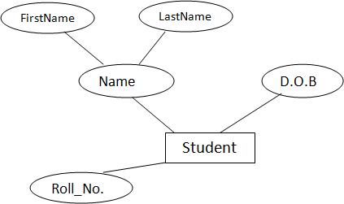
Multi valued attributes are depicted by double ellipse.

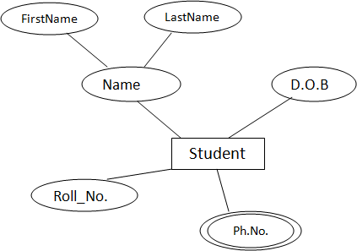

Derived attributes are depicted by dashed ellipse.
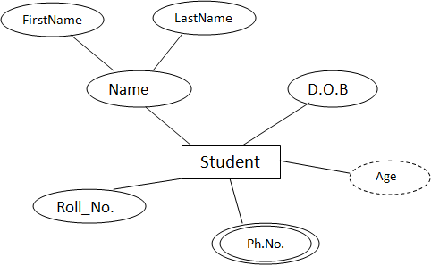

RELATIONSHIP:
Relationships are represented by diamond-shaped box. Name of the relationship is written inside the diamond-box. All the entities (rectangles) participating in a relationship, are connected to it by a line.

Types of relationships:

Degree of Relationship is the number of participating entities in a relationship defines the degree of the relationship. Based on degree the relationships are categorized as

  - Unary = degree 1
  - Binary = degree 2
  - Ternary = degree 3
  - n-ary = degree

Unary Relationship: A relationship with one entity set. It is like a relationship among 2 entities of same entity set. Example: A professor ( in-charge) reports to another professor (Head Of the Dept).

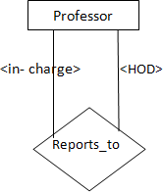

Binary Relationship: A relationship among 2 entity sets. Example: A professor teaches a course and a course is taught by a professor.
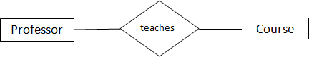
Ternary Relationship: A relationship among 3 entity sets. Example: A professor teaches a course in so and so semester.
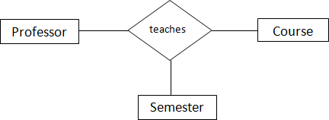

n-array Relationship: A relationship among n entity sets.
E2
R
E3
E1
Cardinality defines the number of entities in one entity set, which can be associated with the number of entities of other set via relationship set. Cardinality ratios are categorized into 4. They are.

- One-to-One relationship: When only one instance of an entities are associated with the relationship, then the relationship is one-to-one relationship. Each entity in A is associated with at most one entity in B and each entity in B is associated with at most one entity in A.

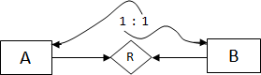

Each professor teaches one course and each course is taught by one professor.
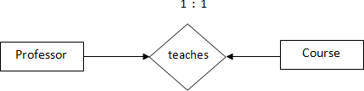
- One-to-many relationship: When more than one instance of an entity is associated with a relationship, then the relationship is one-to-many relationship. Each entity in A is associated with zero or more entities in B and each entity in B is associated with at most one entity in A.
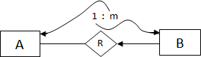
Each professor teaches 0 (or) more courses and each course is taught by at most one professor.
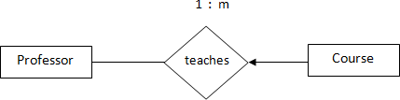
- Many-to-one relationship: When more than one instance of entity is associated with the relationship, then the relationship is many-to-one relationship. Each entity in A is associated with at most one entity in B and each entity in B is associated with 0 (or) more entities in A.
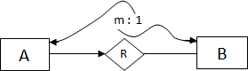

Each professor teaches at most one course and each course is taught by 0 (or) more professors.
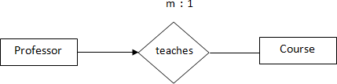
- Many-to-Many relationship: If more than one instance of an entity on the left and more than one instance of an entity on the right can be associated with the relationship, then it depicts many-to-many relationship. Each entity in A is associated with 0 (or) more entities in B and each entity in B is associated with 0 (or) more entities in A.

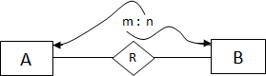

Each professor teaches 0 (or) more courses and each course is taught by 0 (or) more professors.
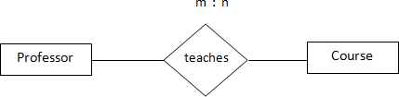

RELATIONSHIP SET:
A set of relationships of similar type is called a relationship set. Like entities, a relationship too can have attributes. These attributes are called descriptive attributes.

PARTICIPATION CONSTRAINTS:
  - Total Participation − If Each entity in the entity set is involved in the relationship then the participation of the entity set is said to be total. Total participation is represented by double lines.
    - Partial participation − If, Not all entities of the entity set are involved in the relationship then such a participation is said to be partial. Partial participation is represented by single lines.
Example: Participation Constraints can be explained easily with some examples. They are as follows.

- Each Professor teaches at least one course. min=1 (Total Participation) max=many (No key)
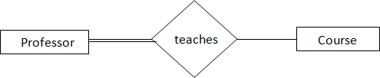
- Each Professor teaches at most one course. min=0 (Partial Participation) max=many (Key)
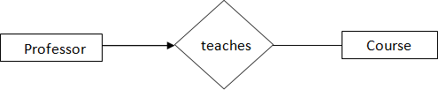
- Each Professor teaches Exactly one course.
min=1 (Total Participation)
max=1 (Key)

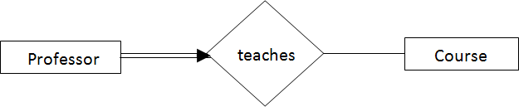
- Each Professor teaches course.
min=0 (Partial Participation) max=many (no Key)
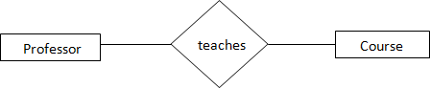
Note: Partial Participation is the default participation.

STRONG AND WEAK ENTITY SETS:
Strong Entity set: If each entity in the entity set is distinguishable or it has a key then such an entity set is known as strong entity set.
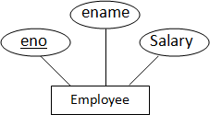

Weak Entity set: If each entity in the entity set is not distinguishable or it doesn't has a key then such an entity set is known as strong entity set.
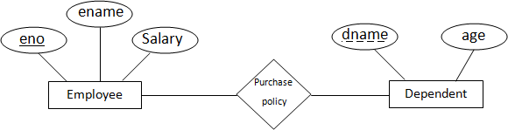
eno is key so it is represented by solid underline. dname is partial key. It can't distinguish the tuples in the Dependent entity set. so dname is represented by dashed underline.
Weak entity set is always in total participation with the relation. If entity set is weak then the relationship is also known as weak relationship, since the dependent relation is no longer needed when the owner left.
Ex: policy dependent details are not needed when the owner (employee) of that policy left or fired from the company or expired. The detailed ER Diagram is as follows.

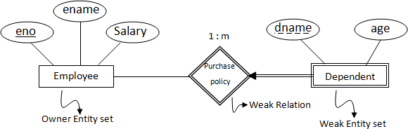

The cardinality of the owner entity set is with weak relationship is 1 : m. Weak entity set is uniquely identifiable by partial key and key of the owner entity set.
Dependent entity set is key to the relation because the all the tuples of weak entity set are associated with the owner entity set tuples.

GENERALIZATION AND SPECIALIZATION
One entity type might be a subtype of another, very similar to subclasses in OO programming. Relationship that is existed between these entities is known as IsA relationship. The two entities related by IsA are always descriptions of the same real-world object. These are typically used in databases to be implemented as Object Oriented Models. The upper entity type is the more abstract entity type (super type) from which the lower entities inherit its attributes.
Properties of Is A:
Inheritance:
- All attributes of the super type apply to the subtype.
- The subtype inherits all attributes of its super type.
- The key of the super type is also the key of the subtype.
Transitivity:
- This property creates a hierarchy of IsA relationships.
Advantages:
- Used to create a more concise and readable E-R diagram.
- It best maps to object oriented approaches either to databases or related applications.
- Attributes common to different entity sets need not be repeated.
- They can be grouped in one place as attributes of the supertype.
- Attributes of (sibling) subtypes are likely to be different.

The process of sub grouping with in a entity set is known as specialization or generalization. Specialization follows top down approach and generalization follows bottom-up approach. Both the speculation and generalization are depicted using a triangle component labeled as IS A.
Generalization: is a bottom-up approach in which two lower level entities combine to form a higher level entity. In generalization, the higher level entity can also combine with other lower level entity to make further higher level entity. In generalization, a number of entities are brought together into one generalized entity based on their similar characteristics. For example, pigeon, house sparrow, crow and dove can all be generalized as Birds.

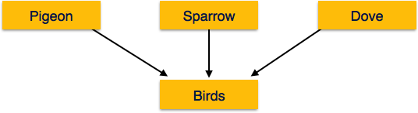
Specialization: is opposite to Generalization. It is a top-down approach in which one higher level entity can be broken down into two lower level entity. In specialization, some higher level entities may not have lower-level entity sets at all. In specialization, a group of entities is divided into sub-groups based on their characteristics. Take a group ‘Person’ for example. A person has name, date of birth, gender, etc. These properties are common in all persons, human beings. But in a company, persons can be identified as employee, employer, customer, or vendor, based on what role they play in the company.
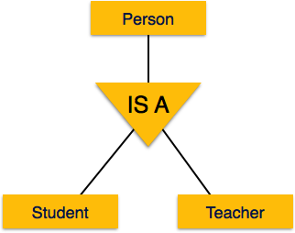
Inheritance: We use all the above features of ER-Model in order to create classes of objects in object-oriented programming. The details of entities are generally hidden from the user; this process known as abstraction. Inheritance is an important feature of Generalization and Specialization. It allows lower-level entities to inherit the attributes of higher-level entities.
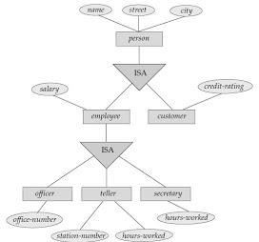

Attribute inheritance is a crucial property where a subclass entity set inherits all the attributes of its super class entity set. Attributes can be additionally specified which is used to give a clear representation though that same attribute is found nowhere in the hierarchy.
Employee and customer can inherit the attributes of Person entity and they have their own attributes like salary for employee and credit_rating for customer. similarly, the entities officer, teller and secretary inherit alll the attributes of employee and they can have their own attributes like office_member for officer, station_number & hours_worked for teller and hours_worked for secretary.
If an entity set has one single higher level entity set then it is termed as single inheritance. If it has multiple higher level entity sets then we can term it as multiple inheritance.

Constraints in Class Hierarchies:
Constraints that can be applied for Class Hierarchies are:
- Condition Constraints
- User Defined Constraints
A Condition Defined Constraint is imposed, while classifying the entities of a higher level entity set to be part of (or) a member of lower level entity sets based on a specified defined constraints.
Example: Every higher level entity in the entity set "Account" is checked using the attribute ''acc_type" to be assigned either to the "SavingsAccount" or to the "CurrentAccount". SavingsAccount and CurrentAccount are lower level entity sets.
If no condition is specified during the process of designing the lower level entity sets, then it is called
user defined constraint.
Disjoint Constraint: This constraint checks whether an entity belongs to only one lower level entity set or not.
Overlapping Constraint: This constraint ensures by testing out that an entity in the higher level entity set belong to more than one lower level entity sets.
Completeness Constraint: This is also called total constraint which specifies whether or not and entity in the higher level entity set must belong if at least one lower level entity set in generalization or specialization.

When we consider the completeness constraint, we come across total and partial constraints. i.e., Total Participation constraint and Partial Participation Constraint.

Total Participation forces that a higher level entity set 's entity(Every entity) must belong to at least one lower level entity set mandatorily.
Ex: An account entity set's entity set must be belong to either savings account entity set or current account entity set.

Partial Participation is rarely found with an entity set because sometimes an entity set in the higher level entity set beside being a member of that higher level entity set, doesn't belong to any of the lower level entity sets immediately until the stipulated period.
Ex: A new employer listed in the higher level entity set but not designated to any one of the available teams that belong to the lower level entity set.

AGGREGATION:
An aggregation is not a ternary relationship but is an attempt to establish the relationship with another relationship set. It is also termed as relationship with in a relationship. Aggregation can be used over a binary, ternary or a quaternary relationship set. Aggregation is denoted using a dashed rectangle.

Aggregation over ternary relationship:
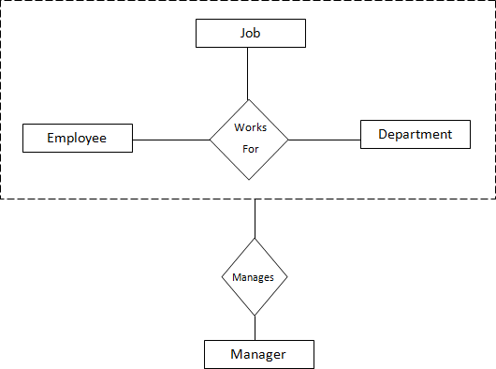

Aggregation over binary Relationships:
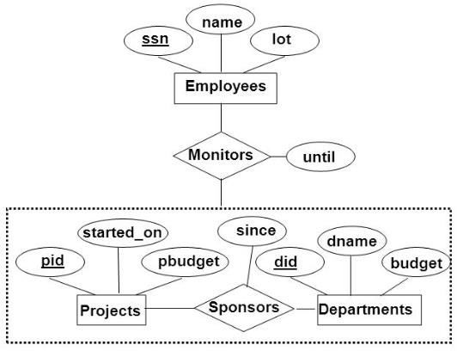
In the examples shown above, we treated the already existed relationship sets "WorksFor" and "Sponsors" as an entity set for defining the new relationship sets "Manages" and "Monitors". A relationship set is participating in another relationship. So it can be termed as aggregation.

TERNARY RELATIONSHIP DECOMPOSED INTO BINARY:
Consider the following ER diagram, representing insurance policies owned by employees at a company. It depicts 3 entity sets Employee, policy and Dependents. The 3 entity sets are associated with a ternary relationship set called Covers. Each employee can own several polices, each policy can be owned by several employees, and each dependent can be covered by several policies.

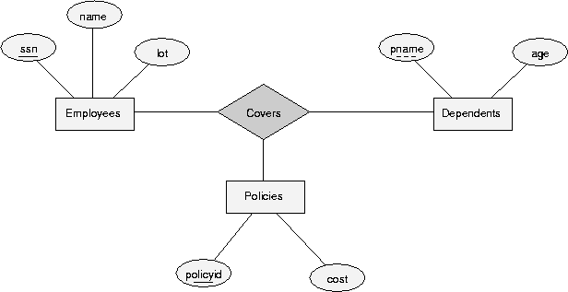

if we wish to model the following additional requirements:

identified by taking pname in conjunction with the policyid of a policy entity (which, intuitively, covers the given dependent).
The best way to model this is to switch away from the ternary relationship set, and instead use two distinct binary relationship sets.
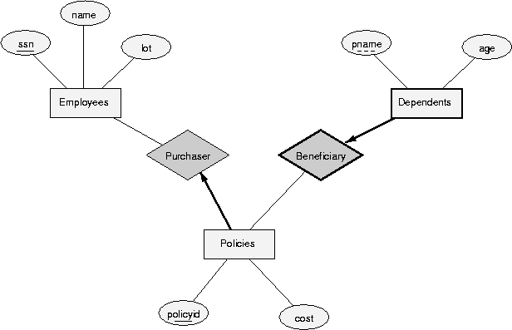

TERNARY VS BINARY: Generally the degree of a relationship set is assessed by counting the no. of nodes or edges that emanate from that relationship set.
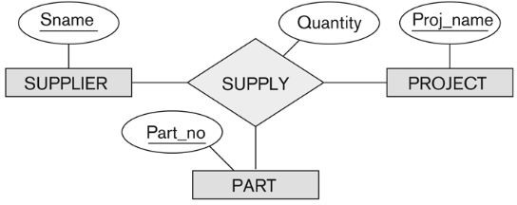

Supply in the ternary relationship set from the first figure, which has a set of relationship instances (s,j,p) which means 's' is a supplier who is supplying part 'p' to a project 'j'.

A ternary relationship represent different information than 3 binary relationship sets do. Here the relationship sets canSupply, uses and supplies substitute the ternary relationship set "supply".
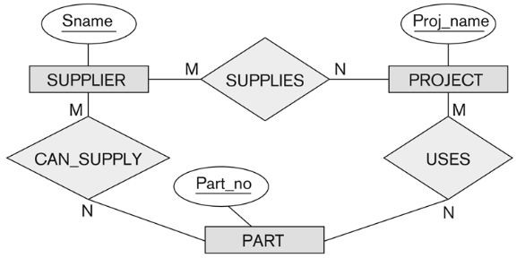

"CANSUPPLY", "USES" and "SUPPLIES" are the three binary relationship sets established where

- Supplier and part which have "CANSUPPLY" binary relationship include an instance (s,p) which says supplier 's' can supply part 'p' to any project.
- "USES" relationship between project and part includes an instance (j,p) which says project 'j' uses part 'p'.
- "SUPPLIES" binary relationship between supplier and project includes an instance (s,j) which says supplier 's' supplies some part to project 'j'.

No combination of binary relationships is an adequate substitute. because there is question "where to add quantity attribute?". Is it to the can-supply or to the uses or to the supplies??

The solution for this is to maintain the same ternary relationship with a weak entity set Supply which has attribute Qty.
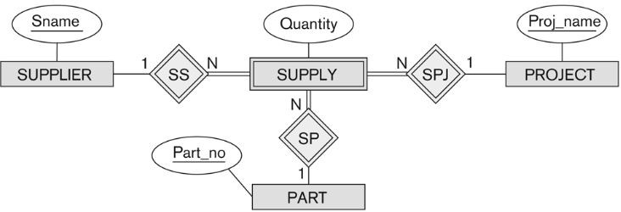

SQL

CREATING TABLES WITH RELATIONSHIPS:
Entity Set: An entity set is mapped to a relation in a straightforward way: Each attribute of the entity set becomes an attribute of the table. Note that we know both the domain of each attribute and the (primary) key of an entity set.
SQL> CREATE TABLE Employees ( ssn CHAR(11), name CHAR(30) , lot INTEGER, PRIMARY KEY (ssn) );
Relationship sets without constraints: To represent a relationship, we must be able to identify each participating entity and give values to the descriptive attributes of the relationship. Thus, the attributes of the relation include:
  - The primary key attributes of each participating entity set, as foreign key fields.
  - The descriptive attributes of the relationship set. The set of non descriptive attributes is a super key for the relation. If there are no key constraints, this set of attributes is a candidate key.
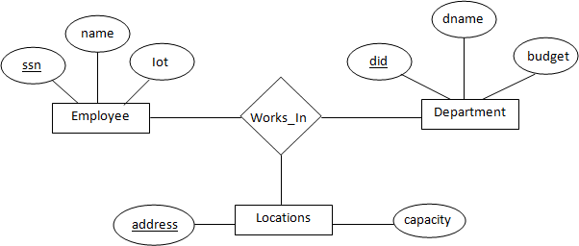
SQL> CREATE TABLE Works_In ( ssn CHAR(11),did INTEGER,
address CHAR(20) ,since DATE, PRIMARY KEY (ssn, did, address), FOREIGN KEY (ssn) REFERENCES Employees,
FOREIGN KEY (address) REFERENCES Locations, FOREIGN KEY (did) REFERENCES Departments);

Another Example:
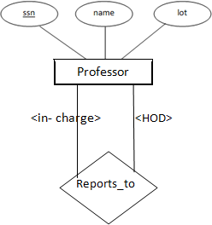

SQL> CREATE TABLE Reports_To ( in_charge_ssn CHAR (11), hod_ssn CHAR (11) ,
PRIMARY KEY (in_charge_ssn,hod_ssn),
FOREIGN KEY (in_charge_ssn) REFERENCES Professor(ssn), FOREIGN KEY (hod_ssn) REFERENCES Professor(ssn) );

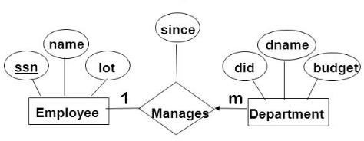
Relationship sets with key constraints: If a relationship set involves n entity sets and some of them are linked via arrows in the ER diagram, the key for anyone of these m entity sets constitutes a key for the relation to which the relationship set is mapped. Hence we have m candidate keys, and one of these should be designated as the primary key.
The table corresponding to Manages has the attributes ssn, did, since. However, because each department has at most one manager, no two tuples can have the same did value but differ on the ssn value. A consequence of this observation is that did is itself a key for Manages; indeed, the set did, ssn is not a key (because it is not minimal). The Manages relation can be defined using the following SQL statement:

SQL> CREATE TABLE Manages (ssn CHAR (11) , did INTEGER, since DATE, PRIMARY KEY (did),
FOREIGN KEY (ssn) REFERENCES Employees, FOREIGN KEY (did) REFERENCES Departments)
A second approach to translating a relationship set with key constraints is often superior because it avoids creating a distinct table for the relationship set. The idea is to include the information about the relationship set in the table corresponding to the entity set with the key, taking advantage of the key constraint. In the Manages example, because a department has at most one manager, we can add the key fields of the Employees tuple denoting the manager and the since attribute to the Departments tuple.
This approach eliminates the need for a separate Manages relation, and queries asking for a department's manager can be answered without combining information from two relations. The only drawback to this approach is that space could be wasted if several departments have no managers. In this case the added fields would have to be filled with null values. The first translation (using a separate table for Manages) avoids this inefficiency, but some important queries require us to combine information from two relations, which can be a slow operation.
The following SQL statement, defining a DepLMgr relation that captures the information in both Departments and Manages, illustrates the second approach to translating relationship sets with key constraints:

SQL> CREATE TABLE DepLMgr ( did INTEGER, dname CHAR(20),
budget REAL, ssn CHAR (11) , since DATE, PRIMARY KEY (did),
FOREIGN KEY (ssn) REFERENCES Employees);

Relationship Sets with Participation Constraints
Every department is required to have a manager, due to the participation constraint, and at most one manager, due to the key constraint.
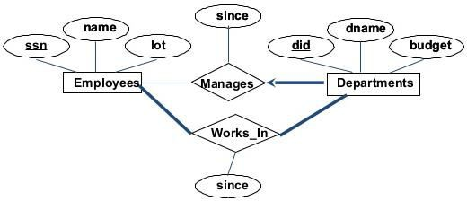
SQL> CREATE TABLE DepLMgr ( did INTEGER, dname CHAR(20) , budget REAL, ssn CHAR(11) NOT NULL, since DATE,
PRIMARY KEY (did),
FOREIGN KEY (ssn) REFERENCES Employees ON DELETE NO ACTION);
It also captures the participation constraint that every department must have a manager: Because ssn cannot take on null values, each tuple of DepLMgr identifies a tuple in Employees (who is the manager). The NO ACTION specification, which is the default and need not be explicitly specified, ensures that an Employees tuple cannot be deleted while it is pointed to by a Dept-Mgr tuple. If we wish to delete such an Employees tuple, we must first change the DepLMgr tuple to have a new employee as manager.

To ensure total participation of Departments in Works_In using SQL, we need an assertion. We have to guarantee that every did value in Departments appears in a tuple of Works_In; further, this tuple of Works_In must also have non-null values in the fields that are foreign keys referencing other entity sets involved in the relationship (in this example, the ssn field). We can ensure the second part of this constraint by imposing the stronger requirement that ssn in Works-ln cannot contain null values.

Weak Entity Sets: A weak entity set always participates in a one-to-many binary relationship and has a key constraint and total participation. The second translation approach is ideal in this case, but we must take into account that the weak entity has only a partial key. Also, when an owner entity is deleted, we want all owned weak entities to be deleted.
Consider the Dependents weak entity set shown in Figure , with partial key pname. A Dependents entity can be identified uniquely only if we take the key of the owning Employees entity and the pname of the Dependents entity, and the Dependents entity must be deleted if the owning Employees entity is deleted.
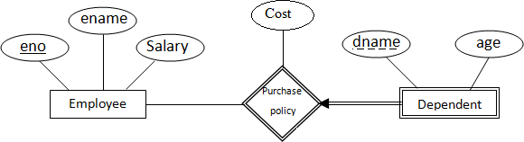

We can capture the desired semantics with the following definition of the Dep_Policy relation: SQL> CREATE TABLE Dep_Policy (pname CHAR(20) , age INTEGER,
cost REAL, eno CHAR (11) , PRIMARY KEY (pname, eno),
FOREIGN KEY (eno) REFERENCES Employees ON DELETE CASCADE );
Observe that the primary key is (pname, eno) , since Dependents is a weak entity. We have to ensure that every Dependents entity is associated with an Employees entity (the owner), as per the total participation constraint on Dependents. That is, eno cannot be null. This is ensured because eno , is part of the primary key. The CASCADE option ensures that information about an employee's policy and dependents is deleted if the corresponding Employees tuple is deleted.

IMPLEMENTATION OF KEY AND INTEGRITY CONSTRAINTS
- NOT NULL: When a column is defined as NOTNULL, then that column becomes a mandatory column. It implies that a value must be entered into the column if the record is to be accepted for storage in the table.
Syntax: CREATE TABLE Table_Name(column_name data_type(size) NOT NULL, );
Example:
SQL> CREATE Table emp2(eno number(5) not null,ename varchar2(10));
Table created.
SQL> desc emp2;

Name |  | Null? |  | Type
ENO |  | NOT NULL |  | NUMBER(5)
ENAME |  |  |  | VARCHAR2(10)

- UNIQUE: The purpose of a unique key is to ensure that information in the column(s) is unique i.e. a value entered in column(s) defined in the unique constraint must not be repeated across the column(s). A table may have many unique keys.
Syntax: CREATE TABLE Table_Name(column_name data_type(size) UNIQUE, ….);
Example:
SQL> CREATE Table emp3(eno number(5) unique,ename varchar2(10));
Table created.
SQL> desc emp3;

Name | Null? | Type
ENO |  | NUMBER(5)
ENAME |  | VARCHAR2(10)
SQL> insert into emp3 values(&eno,'&ename');
Enter value for eno: 1 Enter value for ename: sss
old 1: insert into emp3 values(&eno,'&ename') new 1: insert into emp3 values(1,'sss')
1 row created.

SQL> /
Enter value for eno: 1 Enter value for ename: sas
old 1: insert into emp3 values(&eno,'&ename') new 1: insert into emp3 values(1,'sas')
insert into emp3 values(1,'sas')
ERROR at line 1:
ORA-00001: unique constraint (SCOTT.SYS_C003006) violated
- CHECK: Specifies a condition that each row in the table must satisfy. To satisfy the constraint, each row in the table must make the condition either TRUE or unknown (due to a null).
Syntax: CREATE TABLE Table_Name(column_name data_type(size) CHECK(logical expression), ….);
Example:
SQL> CREATE TABLE student (sno NUMBER (3), name CHAR(10),class CHAR(5),CHECK(class IN(‘CSE’,’CAD’,’VLSI’));

- PRIMARY KEY: A field which is used to identify a record uniquely. A column or combination of columns can be created as primary key, which can be used as a reference from other tables. A table contains primary key is known as Master Table.
  - It must uniquely identify each record in a table.
  - It must contain unique values.
  - It cannot be a null field.
  - It cannot be multi port field.
  - It should contain a minimum no. of fields necessary to be called unique.

Syntax: CREATE TABLE Table_Name(column_name data_type(size) PRIMARY KEY, ….);
Example:
SQL> CREATE TABLE faculty (fcode NUMBER(3) PRIMARY KEY,
fname CHAR(10));

- FOREIGN KEY: It is a table level constraint. We cannot add this at column level. To reference any primary key column from other table this constraint can be used. The table in which the foreign key is defined is called a detail table. The table that defines the primary key and is referenced by the foreign key is called the master table.
Syntax: CREATE TABLE Table_Name ( col_name type(size)
FOREIGN KEY(col_name) REFERENCES table_name
);
Example:
SQL> CREATE TABLE subject (
scode NUMBER (3) PRIMARY KEY,
subname CHAR(10),fcode NUMBER(3), FOREIGN KEY(fcode) REFERENCE faculty );

SUB QUERIES
A Subquery or Inner query or a Nested query is a query within another SQL query and embedded within the WHERE clause. Subquery is used to return data that will be used in the main query as a condition to further restrict the data to be retrieved. Subqueries can be used with the SELECT, INSERT, UPDATE, and DELETE statements along with the operators like =, <, >, >=, <=, IN, BETWEEN, etc.
There are a few rules that subqueries must follow −
- Subqueries must be enclosed within parentheses.
- A subquery can have only one column in the SELECT clause, unless multiple columns are in the main query for the subquery to compare its selected columns.
- An ORDER BY command cannot be used in a subquery, although the main query can use an ORDER BY. The GROUP BY command can be used to perform the same function as the ORDER BY in a subquery.
- Subqueries that return more than one row can only be used with multiple value operators such as the IN operator.
- The SELECT list cannot include any references to values that evaluate to a BLOB, ARRAY, CLOB, or NCLOB.
- A subquery cannot be immediately enclosed in a set function.
- The BETWEEN operator cannot be used with a subquery. However, the BETWEEN operator can be used within the subquery.

Subqueries with the SELECT Statement: Subqueries are most frequently used with the SELECT statement.

Syntax:

SELECT column_name [, column_name ] FROM table1 [, table2 ]
WHERE column_name OPERATOR
(SELECT column_name [, column_name ] FROM table1 [, table2 ] [WHERE])

Example:
Consider the CUSTOMERS table having the following records −

ID | NAME | AGE | ADDRESS | SALARY
1 | Ramesh | 35 | Ahmadabad | 2000.00
2 | Khilan | 25 | Delhi | 1500.00
3 | Kaushik | 23 | Kota | 2000.00
4 | Chaitali | 25 | Mumbai | 6500.00
5 | Hardik | 27 | Bhopal | 8500.00
6 | Komal | 22 | MP | 4500.00
7 | Muffy | 24 | Indore | 10000.00
Now, let us check the following subquery with a SELECT statement. SQL> SELECT * FROM CUSTOMERS
WHERE ID IN (SELECT ID FROM CUSTOMERS WHERE SALARY > 4500) ;

This would produce the following result.

ID | NAME | AGE | ADDRESS | SALARY
4 | Chaitali | 25 | Mumbai | 6500.00
5 | Hardik | 27 | Bhopal | 8500.00
7 | Muffy | 24 | Indore | 10000.00

Subqueries with the INSERT Statement: Subqueries also can be used with INSERT statements. The INSERT statement uses the data returned from the subquery to insert into another table. The selected data in the subquery can be modified with any of the character, date or number functions.
Syntax:
INSERT INTO table_name [ (column1 [, column2 ]) ]
SELECT [ *|column1 [, column2 ] FROM table1 [, table2 ] [ WHERE VALUE OPERATOR]
Example: Consider a table CUSTOMERS_BKP with similar structure as CUSTOMERS table. Now to copy the complete CUSTOMERS table into the CUSTOMERS_BKP table, you can use the following syntax.

SQL> INSERT INTO CUSTOMERS_BKP
SELECT * FROM CUSTOMERS WHERE ID IN (SELECT ID FROM CUSTOMERS) ;

Subqueries with the UPDATE Statement: The subquery can be used in conjunction with the UPDATE statement. Either single or multiple columns in a table can be updated when using a subquery with the UPDATE statement.

Syntax:
UPDATE table SET column_name = new_value [ WHERE OPERATOR [ VALUE ] (SELECT COLUMN_NAME FROM TABLE_NAME [WHERE)] )

Example: Assuming, we have CUSTOMERS_BKP table available which is backup of CUSTOMERS table. The following example updates SALARY by 0.25 times in the CUSTOMERS table for all the customers whose AGE is greater than or equal to 27.

SQL> UPDATE CUSTOMERS SET SALARY = SALARY * 0.25
WHERE AGE IN (SELECT AGE FROM CUSTOMERS_BKP WHERE AGE >= 27 );

This would impact two rows and finally CUSTOMERS table would have the following records.

ID | NAME | AGE | ADDRESS | SALARY
1 | Ramesh | 35 | Ahmadabad | 125.00
2 | Khilan | 25 | Delhi | 1500.00
3 | Kaushik | 23 | Kota | 2000.00
4 | Chaitali | 25 | Mumbai | 6500.00
5 | Hardik | 27 | Bhopal | 2125.00
6 | Komal | 22 | MP | 4500.00
7 | Muffy | 24 | Indore | 10000.00

Subqueries with the DELETE Statement: The subquery can be used in conjunction with the DELETE statement like with any other statements mentioned above.

Syntax:
DELETE FROM TABLE_NAME [ WHERE OPERATOR [ VALUE ] (SELECT COLUMN_NAME FROM TABLE_NAME [ WHERE) ] )

Example: Assuming, we have a CUSTOMERS_BKP table available which is a backup of the CUSTOMERS table. The following example deletes the records from the CUSTOMERS table for all the customers whose AGE is greater than or equal to 27.

SQL> DELETE FROM CUSTOMERS WHERE AGE IN
(SELECT AGE FROM CUSTOMERS_BKP WHERE AGE >= 27 );

This would impact two rows and finally the CUSTOMERS table would have the following records.

ID | NAME | AGE | ADDRESS | SALARY
2 | Khilan | 25 | Delhi | 1500.00
3 | Kaushik | 23 | Kota | 2000.00
4 | Chaitali | 25 | Mumbai | 6500.00
6 | Komal | 22 | MP | 4500.00
7 | Muffy | 24 | Indore | 10000.00

GROUPING
The SQL GROUP BY clause is used in collaboration with the SELECT statement to arrange identical data into groups. This GROUP BY clause follows the WHERE clause in a SELECT statement and precedes the ORDER BY clause.
Syntax: The basic syntax of a GROUP BY clause is shown in the following code block. The GROUP BY clause must follow the conditions in the WHERE clause and must precede the ORDER BY clause if one is used.

SELECT column1, column2 FROM table_name WHERE [ conditions ] GROUP BY column1, column2 ORDER BY column1, column2

Guidelines to use Group By Clause
- If the group function is included in the select clause., we should not use individual result columns.
- The extra non-group functional columns should be declared in the Group By clause.
- Using WHERE clause, rows can be pre executed before dividing them into groups.
- Column aliases can't be used in the Group by clause.
- By Default, rows are sorted by ascending order of columns included in the Group By list.
Examples:
Display the average salary of the departments from Emp table.
SQL> select deptno,AVG(sal) from emp group by deptno;
Display the minimum and maximum salaries of employees working as clerks in each department.
SQL> select deptno,min(sal),max(sal) from emp where job='CLERK' Group by deptno;
Excluding Groups of Results: While using Group By clause, there is a provision to exclude some group results using HAVING clause. HAVING clause is used to specify which groups can be specified. It is used to filter the data which is associated with the group functions.
Syntax:
SELECT column1, column2 FROM table1, table2 WHERE [ conditions ] GROUP BY column1, column2 HAVING [ conditions ]

Sequence of steps:
- First rows are grouped.
- Group functions are applied to that identifies groups.
- Groups that match with the criteria in having clause are displayed.

The HAVING clause can predict Group By clause but it is more logical to declare it after Group By clause. Group By clause can be used without a group function in the SELECT list. If rows need to be restricted based on the result of a Group function, we must have a group by clause as well as Having clause. Existence of Group by clause does not guarantee the existence of HAVING clause but the existence of HAVING clause demands the existence of Group By clause.
Example:
Display the Departments having the min salary of clerks is > 1000
SQL> select deptno, min(sal) from emp where job='CLERK' group by deptno HAVING min(sal)> 1000;
Display the sum of the salaries of the departments.
SQL> select deptno, sum(sal) from emp group by deptno;

AGGREGATION: Aggregation Functions or Group Functions
These function return a single row based on group of rows. These can appear in SELECT list and HAVING clauses only. These operate on sets of rows to give one result per group. The set may be whole table or table split into group.

Guidelines to use Aggregate Functions:
Distinct makes the functions to consider only non duplicate value. All makes the function to consider every value including duplicates.
Syntax:
GroupFunctionName (Distinct/ All columns)

The data types for arguments may be char,varchar, number or Date. All group functions except count(*) ignore NULL values. To substitute a value for NULL value, use the NVL() function. When a group function is declared in a select List, no single row columns should be declared. other columns can be declared but they should be declared in the group by clause.
The list of Aggregate Functions are:

MIN | returns the smallest value in a given column
MAX | returns the largest value in a given column
SUM | returns the sum of the numeric values in a given column
AVG | returns the average value of a given column
COUNT | returns the total number of values in a given column
COUNT(*) | returns the number of rows in a table
Consider the following table:
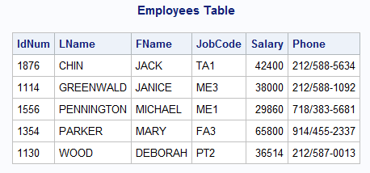

MIN Function:
SQL> select min(Salary) from Employees; OUTPUT:
29860
MIN(SALARY)
MAX Function:
SQL> select max(Salary) from Employees; OUTPUT:
65800
MAX(SALARY)
SUM Function:
SQL> select sum(Salary) from Employees; OUTPUT:
212574
SUM(SALARY)
AVG Function:
SQL> select avg(Salary) from Employees; OUTPUT:
42514.8
AVG(SALARY)
COUNT Function:
SQL> select count(IdNum) from Employees; OUTPUT:
5
COUNT(IDNUM)
COUNT(*) Function:
SQL> select count(*) from Employees; OUTPUT:
5
COUNT(*)

ORDERING: (ORDER BY CLAUSE)
The SQL ORDER BY clause is used to sort the data in ascending or descending order, based on one or more columns. Some databases sort the query results in an ascending order by default.
Syntax:
select column-list from table_name[where condition] [order by column1, column2,..columnn][asc|desc];
Example:
Consider the following table:

ID | NAME | AGE | ADDRESS | SALARY
1 | Ramesh | 35 | Ahmadabad | 2000
2 | Khilan | 25 | Delhi | 1500
3 | Kowshik | 23 | Kota | 2000
4 | Chaitali | 25 | Mumbai | 6500
5 | Hardhik | 27 | Bhopal | 8500
6 | Komal | 22 | MP | 4500
7 | Muffy | 24 | Indore | 10000
SQL > select * from customers order by name, salary; OUTPUT:

ID | NAME | AGE | ADDRESS | SALARY
4 | Chaitali | 25 | Mumbai | 6500
5 | Hardhik | 27 | Bhopal | 8500
3 | Kowshik | 23 | Kota | 2000
2 | Khilan | 25 | Delhi | 1500
6 | Komal | 22 | MP | 4500
7 | Muffy | 24 | Indore | 10000
1 | Ramesh | 35 | Ahmadabad | 2000

IMPLEMENTATION OF JOINS
A JOIN clause is used to combine rows from two or more tables, based on a related column between
them.
Types of SQL JOINS:
There are 4 different types of SQL joins.
- (INNER) JOIN: Returns records that have matching values in both tables
- LEFT (OUTER) JOIN: Return all records from the left table, and the matched records from the right table
- RIGHT (OUTER) JOIN: Return all records from the right table, and the matched records from the left table
- FULL (OUTER) JOIN: Return all records when there is a match in either left or right table
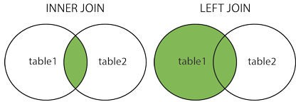

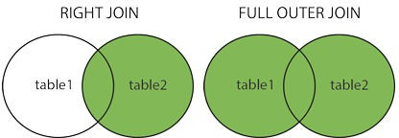
- INNER JOIN: The INNER JOIN keyword selects records that have matching values in both tables
Syntax:
select column_name(s) from table1 inner join table2
on table1.column_name = table2.column_name;

- LEFT JOIN: The LEFT JOIN keyword returns all records from the left table (table1), and the matched records from the right table (table2). The result is NULL from the right side, if there is no match.
Syntax:
select column_name(s)from table1left join table2
on table1.column_name = table2.column_name;
- RIGHT JOIN: The RIGHT JOIN keyword returns all records from the right table (table2), and the matched records from the left table (table1). The result is NULL from the left side, when there is no match.
Syntax:
select column_name(s)from table1right join table2
on table1.column_name table2.column_name;

- FULL JOIN: The FULL OUTER JOIN keyword return all records when there is a match in either left (table1) or right (table2) table records.

Syntax:
select column_name(s)from table1full outer join table2
on table1.column_name = table2.column_name;

- SQL SELF JOIN: A self JOIN is a regular join, but the table is joined with itself.
Syntax:
select column_name(s) from table1 t1, table1 t2 where condition;

EXAMPLES:
Consider the following two tables.
Table 1 − CUSTOMERS Table is as follows.
ID | NAME | AGE | ADDRESS | SALARY
1 | Ramesh | 31 | Ahmadabad | 2000.00
2 | Khilan | 25 | Delhi | 1500.00
3 | Kaushik | 23 | Kota | 2000.00
5 | Hardik | 27 | Mumbai | 6500.00
6 | Komal | 22 | MP | 4500.00
7 | Muffy | 24 | Indore | 10000.00

Table 2 − ORDERS Table is as follows.
OID | DATE | CUSTOMER_ID | AMOUNT
102 | 2009-10-08 00:00:00 | 3 | 3000
100 | 2009-10-08 00:00:00 | 3 | 1500
101 | 2009-11-20 00:00:00 | 2 | 1560
103 | 2008-05-20 00:00:00 | 4 | 2060

Inner Join:
SQL> SELECT id, name, amount, date FROM customers INNER JOIN orders
ON customers.id = orders.customer_id;
This would produce the following result −

ID | NAME | AMOUNT | DATE
3 | Kaushik | 3000 | 2009-10-08-00:00:00
3 | Kaushik | 1500 | 2009-10-08 00:00:00
2 | Khilan | 1560 | 2009-11-20 00:00:00
4 | Chaitali | 2060 | 2008-05-20 00:00:00

Left Join:
SQL> SELECT id, name, amount, date FROM customers LEFT JOIN orders
ON customers.id = orders.customer_id;
This would produce the following result −

ID | NAME | AMOUNT | DATE
1 | Ramesh | NULL | NULL
2 | Khilan | 1560 | 2009-11-20 00:00:00
3 | Kaushik | 3000 | 2009-10-08-00:00:00
3 | Kaushik | 1500 | 2009-10-08 00:00:00
4 | Chaitali | 2060 | 2008-05-20 00:00:00
5 | Hardik | NULL | NULL
6 | Komal | NULL | NULL
7 | Muffy | NULL | NULL

Right Join:
SQL> SELECT id, name, amount, date FROM customers RIGHT JOIN orders
ON customers.id = orders.customer_id;

This would produce the following result −

ID | NAME | AMOUNT | DATE
3 | Kaushik | 3000 | 2009-10-08-00:00:00
3 | Kaushik | 1500 | 2009-10-08 00:00:00
2 | Khilan | 1560 | 2009-11-20 00:00:00
4 | Chaitali | 2060 | 2008-05-20 00:00:00

Full Join:
SQL> SELECT id, name, amount, date FROM customers FULL JOIN orders
ON customers.id = orders.customer_id;
This would produce the following result −

ID | NAME | AMOUNT | DATE
1 | Ramesh | NULL | NULL
2 | Khilan | 1560 | 2009-11-20 00:00:00
3 | Kaushik | 3000 | 2009-10-08-00:00:00
3 | Kaushik | 1500 | 2009-10-08 00:00:00
4 | Chaitali | 2060 | 2008-05-20 00:00:00
5 | Hardik | NULL | NULL
6 | Komal | NULL | NULL
7 | Muffy | NULL | NULL
3 | Kaushik | 3000 | 2009-10-08-00:00:00
3 | Kaushik | 1500 | 2009-10-08 00:00:00
2 | Khilan | 1560 | 2009-11-20 00:00:00
4 | Chaitali | 2060 | 2008-05-20 00:00:00

Self Join:
SQL> SELECT a.id, b.name, a.salary FROM customers a, customers b WHERE a.salary<b.salary
This would produce the following result −

ID | NAME | SALARY
2 | Ramesh | 1500.00
2 | Kaushik | 1500.00
1 | Chaitail | 2000.00
2 | Chaitail | 1500.00
3 | Chaitail | 2000.00
6 | Chaitail | 4500.00

1 | Hardik | 2000.00
2 | Hardik | 1500.00
3 | Hardik | 2000.00
4 | Hardik | 6500.00
6 | Hardik | 4500.00
1 | Komal | 2000.00
2 | Komal | 1500.00
3 | Komal | 2000.00
1 | Muffy | 2000.00
2 | Muffy | 1500.00
3 | Muffy | 2000.00
4 | Muffy | 6500.00
5 | Muffy | 8500.00
6 | Muffy | 4500.00

VIEWS:
A view is nothing more than a SQL statement that is stored in the database with an associated name. A view is actually a composition of a table in the form of a predefined SQL query. A view can contain all rows of a table or select rows from a table. A view can be created from one or many tables which depends on the written SQL query to create a view.
Views, which are a type of virtual tables allow users to do the following −
- Structure data in a way that users or classes of users find natural or intuitive.
- Restrict access to the data in such a way that a user can see and (sometimes) modify exactly what they need and no more.
- Summarize data from various tables which can be used to generate reports.

2 Types of Views Updatable and Read-only -views
Unlike base tables, VIEWs are either updatable or read-only, but not both. INSERT, UPDATE, and DELETE operations are allowed on updatable VIEWs and base tables, subject to any other constraints. INSERT, UPDATE, and DELETE are not allowed on read-only VIEWs, but you can change their base tables, as you would expect. An updatable VIEW is one that can have each of its rows associated with exactly one row in an underlying base table.
When the VIEW is changed, the changes pass unambiguously through the VIEW to that underlying base table. Updatable VIEWs in Standard SQL are defined only for queries that meet these criteria:
- Built on only one table
- No GROUP BY clause
- No HAVING clause
- No aggregate functions
- No calculated columns
- No UNION, INTERSECT, or EXCEPT

- No SELECT DISTINCT clause
- Any columns excluded from the VIEW must be NULL-able or have a DEFAULT in the base table, so that a whole row can be constructed for insertion By implication, the VIEW must also contain a key of the table.

In short, we are absolutely sure that each row in the VIEW maps back to one and only one row in the base table. Some updating is handled by the CASCADE option in the referential integrity constraints on the base tables, not by the VIEW declaration.
The definition of updatability in Standard SQL is actually fairly limited, but very safe. The database system could look at information it has in the referential integrity constraints to widen the set of allowed updatable VIEWs. You will find that some implementations are now doing just that, but it is not common yet.
The SQL Standard definition of an updatable VIEW is actually a subset of the possible updatable VIEWs, and a very small subset at that. The major advantage of this definition is that it is based on syntax and not semantics.
Examples of Updatable and Non-updatable View.
CREATE VIEW view_1 AS SELECT * FROM Table1 WHERE x IN (1,2);
-- updatable, has a key!

CREATE VIEW view_2 AS SELECT * FROM Table1 WHERE x = 1 UNION ALL SELECT * FROM Table1 WHERE x = 2;
-- not updatable!

More about Views:
A view takes up no storage space other than for the definition of the view in the data dictionary. A view contains no data. All the data it shows comes from the base tables.
A view can provide an additional level of table security by restricting access to a set of rows or columns of a table.
A view hides implementation complexity. The user can select from the view with a simple SQL, unaware that the view is based internally on a join between multiple tables.
A view lets you change the data you can access, applying operators, aggregation functions, filters etc. on the base table.
A view isolates applications from changes in definitions of base tables. Suppose a view uses two columns of a base table, it makes no difference to the view if other columns are added, modified or removed from the base table.
To know about the views in your own schema, look up user_views.
The underlying SQL definition of the view can be read via select text from user_views for the view.
Oracle does not enforce constraints on views. Instead, views are subject to the constraints of their base tables.

Creating Views
Database views are created using the CREATE VIEW statement. Views can be created from a single table, multiple tables or another view. To create a view, a user must have the appropriate system privilege according to the specific implementation.
Syntax:
CREATE VIEW view_name AS
SELECT column1, column2. FROM table_name WHERE [condition];
we can include multiple tables in your SELECT statement in a similar way as we use them in a normal SQL SELECT query.
Example:
Consider the CUSTOMERS table having the following records −

ID | NAME | AGE | ADDRESS | SALARY
1 | Ramesh | 32 | Ahmadabad | 2000.00
2 | Khilan | 25 | Delhi | 1500.00
3 | Kaushik | 23 | Kota | 2000.00
4 | Chaitali | 25 | Mumbai | 6500.00
5 | Hardik | 27 | Bhopal | 8500.00
6 | Komal | 22 | MP | 4500.00
7 | Muffy | 24 | Indore | 10000.00
Following is an example to create a view from the CUSTOMERS table. This view would be used to have customer name and age from the CUSTOMERS table.

SQL > CREATE VIEW CUSTOMERS_VIEW AS SELECT name, age FROM CUSTOMERS;

Now, you can query CUSTOMERS_VIEW in a similar way as you query an actual table. Following is an example for the same.
SQL > SELECT * FROM CUSTOMERS_VIEW;
This would produce the following result.

NAME | AGE
Ramesh | 32
Khilan | 25
Kaushik | 23
Chaitali | 25
Hardik | 27
Komal | 22
Muffy | 24
The With Check Option:
The WITH CHECK OPTION is a CREATE VIEW statement option. The purpose of the WITH CHECK OPTION is to ensure that all UPDATE and INSERTs satisfy the condition(s) in the view definition. If they do not satisfy the condition(s), the UPDATE or INSERT returns an error.

Example:
SQL> CREATE VIEW CUSTOMERS_VIEW AS SELECT name, age FROM CUSTOMERS
WHERE age IS NOT NULL WITH CHECK OPTION;
The WITH CHECK OPTION in this case should deny the entry of any NULL values in the view's AGE column, because the view is defined by data that does not have a NULL value in the AGE column.

Updating a View

A view can be updated under certain conditions which are given below −
- The SELECT clause may not contain the keyword DISTINCT.
- The SELECT clause may not contain summary functions.
- The SELECT clause may not contain set functions.
- The SELECT clause may not contain set operators.
- The SELECT clause may not contain an ORDER BY clause.
- The FROM clause may not contain multiple tables.
- The WHERE clause may not contain subqueries.
- The query may not contain GROUP BY or HAVING.
- Calculated columns may not be updated.
- All NOT NULL columns from the base table must be included in the view in order for the INSERT query to function.
So, if a view satisfies all the above-mentioned rules then you can update that view. The following code block has an example to update the age of Ramesh.

SQL > UPDATE CUSTOMERS_VIEW SET AGE = 35 WHERE name = 'Ramesh';

This would ultimately update the base table CUSTOMERS and the same would reflect in the view itself. Now, try to query the base table and the SELECT statement would produce the following result.

ID | NAME | AGE | ADDRESS | SALARY
1 | Ramesh | 35 | Ahmadabad | 2000.00
2 | Khilan | 25 | Delhi | 1500.00
3 | Kaushik | 23 | Kota | 2000.00
4 | Chaitali | 25 | Mumbai | 6500.00
5 | Hardik | 27 | Bhopal | 8500.00
6 | Komal | 22 | MP | 4500.00
7 | Muffy | 24 | Indore | 10000.00

Inserting Rows into a View
Rows of data can be inserted into a view. The same rules that apply to the UPDATE command also apply to the INSERT command. Here, we cannot insert rows in the CUSTOMERS_VIEW because we have not included all the NOT NULL columns in this view, otherwise you can insert rows in a view in a similar way as you insert them in a table.

Deleting Rows from a View
Rows of data can be deleted from a view. The same rules that apply to the UPDATE and INSERT commands apply to the DELETE command.
Following is an example to delete a record having AGE = 22.

SQL > DELETE FROM CUSTOMERS_VIEW WHERE age = 22;

This would ultimately delete a row from the base table CUSTOMERS and the same would reflect in the view itself. Now, try to query the base table and the SELECT statement would produce the following result.

ID | NAME | AGE | ADDRESS | SALARY
1 | Ramesh | 35 | Ahmadabad | 2000.00
2 | Khilan | 25 | Delhi | 1500.00
3 | Kaushik | 23 | Kota | 2000.00
4 | Chaitali | 25 | Mumbai | 6500.00
5 | Hardik | 27 | Bhopal | 8500.00
7 | Muffy | 24 | Indore | 10000.00

Dropping Views
Obviously, where you have a view, you need a way to drop the view if it is no longer needed.
Syntax:
DROP VIEW view_name;
Example:
SQL> DROP VIEW CUSTOMERS_VIEW;

SET OPERATIONS
- These operators are used to combine information of similar datatype from one or more than one table.
- Datatype of the corresponding columns in all the select statement should be same.
- Different types of set commands are
  - UNION
  - UNION ALL
  - INTERSECT
  - MINUS
- Set operators are combine 2 or more queries into one result .
- The result of each SELECT statement can be treated as a set and SQL set operators can be applied on those sets to arrive at a final result.
- SQL statements containing set operators are referred to as compound queries, and each SELECT statements in a command query in referred to as a compound query.
- Set operations are often called vertical joins, as a result combines data from 2 or more SELECT based on columns instead of rows.

Syntax:
<compound query>
{ UNION | UNION ALL | MINUS | INTERSECT }
<compound query>

UNION: Combines the result of 2 select statements into one result set, and then estimates any duplicate rows from that result set.

UNION ALL: Combines the result of 2 SELECT statements into one result set including the duplicates.

INTERSECT: Returns only the rows that are returned by each of two SELECT statements.

MINUS: Takes the result set of each SELECT statement, and removes those rows that are also recommended by a second SELECT statement.

Point Of Concentration:
- The queries are all executed independently but their output is merged.
- Only final queries ends with a semicolon(;).

Rules And Restrictions:
  - The result set of both the queries must have same number of columns.
  - The datatype of each column in the second result set must match the datatype of the corresponding column in the first result set.
  - The 2 SELECT statements may not contain an ORDER BY clause. The final result of the entire set operations can be ordered.
  - The columns used for ordering must be defined through the column number.

Examples:
Display the employees who work in departments 10 and 30with out duplicates.
SQL> SELECT empno, ename from emp where deptno=10 UNION
SELECT empno, ename from emp where deptno=30;

Display the employees who work in departments 10 and 30.
SQL> SELECT empo,ename from emp where deptno=10 UNION ALL
SELECT empno, ename from emp where deptno=30 ;
Display the employees who work in both the departments with deptno 10 and 30.
SQL> SELECT empno, ename from emp where deptno=10 INTERSECT
SELECT empno, ename from emp where deptno=30 ;

Display the employees whose row number is less than 7 but not less than 6.
SQL> SELECT rownum , ename from emp where rownum<7 MINUS
SELECT rownum , ename from emp where rownum<6;

RELATIONAL OPERATIONS
Given this simple and restricted data structure, it is possible to define some very powerful relational operators which, from the users' point of view, act in parallel' on all entries in a table simultaneously, although their implementation may require conventional processing.
Codd originally defined eight relational operators.
- SELECT originally called RESTRICT
- PROJECT
- JOIN
- PRODUCT
- UNION
- INTERSECT
- DIFFERENCE
- DIVIDE
The most important of these are (1), (2), (3) and (8), which, together with some other aggregate functions, are powerful enough to answer a wide range of queries. The eight operators will be described as general procedures - i.e. not in the syntax of SQL or any other relational language. The important point is that they define the result required rather than the detailed process of obtaining it - what but not how.

SELECT: RESTRICTS the rows chosen from a table to those entries with specified attribute values.
SELECT item FROM stock_level WHERE quantity > 100
constructs a new, logical table - an unnamed relation - with one column per row (i.e. item) containing all rows from stock_level that satisfy the WHERE clause.

PROJECT: Selects rows made up of a sub-set of columns from a table.
PROJECT stock_item OVER item AND description
produces a new logical table where each row contains only two columns - item and description. The new table will only contain distinct rows from stock_item; i.e. any duplicate rows so formed will be eliminated.

JOIN: Associates entries from two tables on the basis of matching column values.
JOIN stock_item WITH stock_level OVER item
It is not necessary for there to be a one-to-one relationship between entries in two tables to be joined - entries which do not match anything will be eliminated from the result, and entries from one table which match several entries in the other will be duplicated the required number of times.

PRODUCT: Builds a relation from two specified relations consisting of all possible combinations of rows, one from each of the two relations. For example, consider two relations, A and B, consisting of rows:
A: a | B: d | => | A product B: a d
b | e |  | a e
c |  |  | b d
 |  |  | b e
 |  |  | c d
 |  |  | c e

UNION: Builds a relation consisting of all rows appearing in either or both of the two relations. For example, consider two relations, A and B, consisting of rows:
A: a B: a => A union B: a
  - e b
  - c
e
INTERSECT: Builds a relation consisting of all rows appearing in both of the two relations. For example, consider two relations, A and B, consisting of rows:
A: a B: a => A intersect B: a b e
c
DIFFERENCE: Builds a relation consisting of all rows appearing in the first and not in the second of the two relations. For example, consider two relations, A and B, consisting of rows:
A: a B: a => A - B: b and B - A: e b e c
c

DIVIDE: Takes two relations, one binary and one unary, and builds a relation consisting of all values of one column of the binary relation that match, in the other column, all values in the unary relation.
A: a x B: x => A divide B: a a y y
a z
b x
c y

Of the relational operators 3.2.4. to 3.2.8.defined by Codd, the most important is DIVISION. For example, suppose table A contains a list of suppliers and commodities, table B a list of all commodities bought by a company. Dividing A by B produces a table listing suppliers who sell all commodities

DATABASE MANAGEMENT SYSTEMS

UNIT IV: Schema Refinement (Normalization)

Syllabus:
Schema Refinement (Normalization): Purpose of Normalization or schema refinement, concept of functional dependency, normal forms based on functional dependency(1NF, 2NF and 3 NF), concept of surrogate key, Boyce-codd normal form(BCNF), Lossless join and dependency preserving decomposition, Fourth normal form(4NF), Fifth Normal Form (5NF).

Objectives:
After studying this unit, you will be able to:
    - Discuss the different types of anomalies in a database
    - State what is functional dependency
    - List the different forms of normalization
    - Differentiate among different types of normalization

INTRODUCTION TO SCHEMA REFINEMENT

The Schema Refinement refers to refine the schema by using some technique. The best technique of schema refinement is decomposition.
Normalization means “split the tables into small tables which will contain less number of attributes in such a way that table design must not contain any problem of inserting, deleting, updating anomalies and guarantees no redundancy”.
Normalization or Schema Refinement is a technique of organizing the data in the database. It is a systematic approach of decomposing tables to eliminate data redundancy and undesirable characteristics like Insertion, Update and Deletion Anomalies.
Redundancy: refers to repetition of same data or duplicate copies of same data stored in different locations.
Anomalies: Anomalies refers to the problems occurred after poorly planned and normalized databases where all the data is stored in one table which is sometimes called a flat file database.

Anomalies or problems facing without normalization (problems due to redundancy):
Anomalies refers to the problems occurred after poorly planned and unnormalized databases where all the data is stored in one table which is sometimes called a flat file database. Let us consider such type of schema
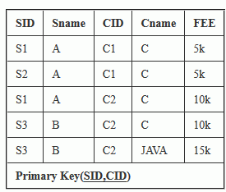
Here all the data is stored in a single table which causes redundancy of data or say anomalies as SID and Sname are repeated once for same CID . Let us discuss anomalies one by one.
Due to redundancy of data we may get the following problems, those are-
- insertion anomalies : It may not be possible to store some information unless some other information is stored as well.
- redundant storage: some information is stored repeatedly
- update anomalies: If one copy of redundant data is updated, then inconsistency is created unless all redundant copies of data are updated.

- deletion anomalies: It may not be possible to delete some information without losing some other information as well.
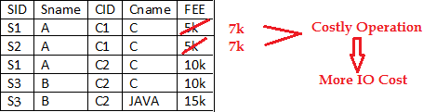
Problem in updation / updation anomaly – If there is updation in the fee from 5000 to 7000, then we have to update FEE column in all the rows, else data will become inconsistent.
Insertion Anomaly and Deletion Anomaly- These anomalies exist only due to redundancy, otherwise they do not exist.
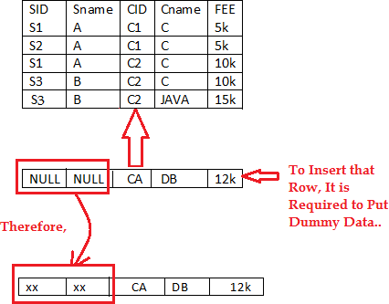
Insertion Anomalies: New course is introduced C4, But no student is there who is having C4 subject.
Because of insertion of some data, It is forced to insert some other dummy data.
Deletion Anomaly:
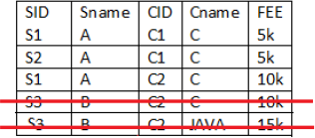
Deletion of S3 student cause the deletion of course. Because of deletion of some data forced to delete some other useful data.

Solutions To Anomalies : Decomposition of Tables – Schema Refinement, shown below.

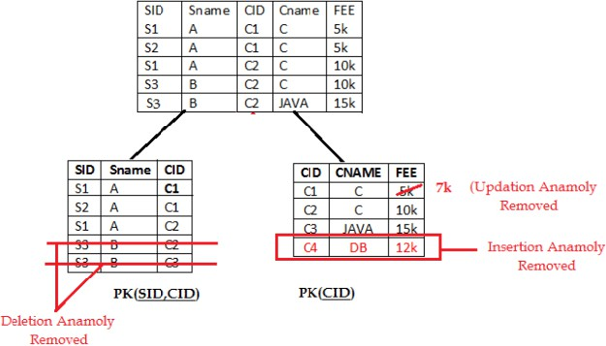

Purpose of Normalization:
- Minimize the redundancy in data.
- Remove insert, update, and delete anomalies during the database activities.
- Reduce the need to organize the data when it is modified or enhanced.
- Normalization reduces a complex user view to a set of small and sub groups of fields or relations. This process helps to design a logical data model known as conceptual data model.

Advantages of Normalization:
  - Greater overall database organization will be gained.
  - The amount of unnecessary redundant data reduced.
  - Data integrity is easily maintained within the database.
  - The database & application design processes are much for flexible.
  - Security is easier to maintain or manage.

Disadvantages of Normalization:
- The disadvantage of normalization is that it produces a lot of tables with a relatively small number of columns. These columns then have to be joined using their primary/foreign key relationship.
- This has two disadvantages.
Performance: all the joins required to merge data slow processing & place additional stress on your hardware.
Complex queries: developers have to code complex queries in order to merge data from different tables.

Concept of Functional Dependency:

Functional Dependencies are fundamental to the process of Normalization i.e., Functional Dependency plays key role in differentiating good database design from bad database designs. A functional dependency is a “type of constraint that is a generalization of the notation of the key”.
Functional Dependency describes the relationship between attributes (columns) in a table. Functional dependency is represented by an arrow sign (→).
In other words, a dependency FD: “X → Y” means that the values of Y are determined by the values of X. Two tuples sharing the same values of X will necessarily have the same values of
Y. An attribute on left hand side is known as “Determinant”. Here X is a Determinant.
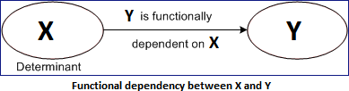

Example [Identifying the FD’s]
A | B | C | D
A1 A1 A2 A2  A3 | B1 B2 B2 B2  B3 | C1 C1 C2 C2  C2 | D1 D2 D2 D3  D4

Case1: A →B
Here A1 belongs to B1 & B2. So A1 does not have unique value in B. So it is not in FD.
Case1: A →C
Here A1→C1 and A2, A3→C2. So A has unique values in B. So it is in FD.
Note: try to find all the possibilities. i.e., A→D, B→C, B→D, and C→D

Reasoning about functional dependencies:
Armstrong Axioms (Inference Rules ) : The term Armstrong axioms refers to the sound and complete set of inference rules or axioms, introduced by William W. Armstrong, that is used to test logical implication of functional dependencies.

Armstrong axioms define the set of rules for reasoning about functional dependencies and also to infer all the functional dependencies on a relational database.

Various axioms rules or inference rules:
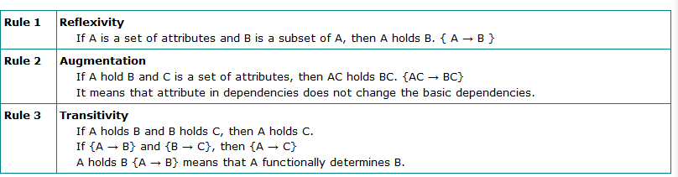
Primary axioms:

Secondary or derived axioms:
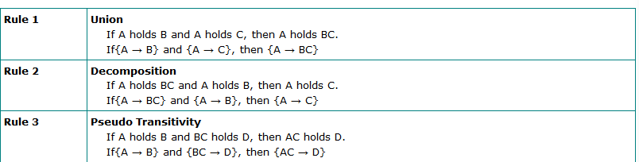

Closure of a Set of Attributes:
Attribute closure of an attribute set can be defined as set of attributes which can be functionally determined from it.
The set of FD’s that is logically implied by F is called the closure of F and written as F+. And it is defined as “If F is a set FD’s on a relation R, the F+, the closure of F by using the inferences axioms that are not contained in F+.
Example: R (A, B, C, D) and set of Functional Dependencies are A→B, B→D, C→B then what is the Closure of A, B, C, D?
Solution: A+ is
A+→ {A, B, D} i.e., A→B, B→D is exists and C is not FD on A. So it is eliminated. B+→ { B, D} i.e., B→D is exists and A, C is not FD on A. So it is eliminated.
C+→ {C, B, D} i.e., C→B, B→D is exists and A is not FD on C. So it is eliminated.

The algorithm for computing the attribute closure of a set X of attributes is shown below
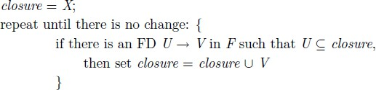

Types of functional dependencies:

- Fully Functional Dependency: A functional dependency is said to be full dependency “if and only if the determinant of the functional dependency if either candidate key or super key, and the dependent can be either prime or non-prime attribute”.
(OR)
Let’s take the functional dependency X → Y (i.e., X determines y). Here Y is said to be fully determinant, if it cannot determine any subset of X.
Example: Consider the following determinant ABC → D i.e., ABC determines D but D is not determined by any subset of A/ BC/C/B/AB i.e., BC→D, C→D, A→D Functional dependencies are not exists. So D is Fully Functional Dependent.

- Partial Functional Dependency: If a non-prime attribute of the relation is getting derived by only a part of the candidate key, then such dependency is known as Partial Dependency.

(OR)
In a relation having more than one key field, a subset of non key fields may depend on all key fields but another subset or a particular non-key field may depend on only one of the key fields. Such dependency is defined as Partial Dependency.
Example: Consider the following determinants AC→P, A→D, D→P. From these determinants P is not fully FD on AC. Because, If we find A+ (means A’s Closure) A→D, D→P i.e., A→P. But we don’t have any requirement of C. C attribute is removed completely. So P is Partially Dependent on AC.
Under the following conditions a table cannot have partial F.D
  - If primary key consists a single attribute
  - If table consists only two attributes
  - If all the attributes in the table are part of the primary key

- Transitive Functional Dependency: If a non-prime attribute of a relation is getting derived by either another non-prime attribute or the combination of the part of the candidate key along with non-prime attribute, then such dependency is defined as Transitive dependency. i.e., in a relation, there may be dependency among non-key fields. Such dependency is called Transitive Functional Dependency.
Example: X→Y, and Y→Z then we can determine X→Z holds.
Under the following Circumstances, a table cannot have transitive F.D
  - If table consists only two attributes
  - If all the attributes in the table are part of the primary key.
- Trivial Functional Dependency: It is basically related to Reflexive rule. i.e., if X is a set of attributes, and Y is subset of X then X→Y holds.
Example: ABC→BC is a Trivial Dependency.

- Multi-Valued Dependency: Consider 3 fields X, Y, and Z in a relation. If for each value of X, there is a well-defined set of values Y and Well-defined set of values of Z and set of values of Y is independent of the set values of Z. This dependency is Multi-valued Dependency. i.e., X →Y / Z.

Prime and non-prime attributes
Attributes which are parts of any candidate key of relation are called as prime attribute, others are non-prime attributes.

Candidate Key:
Candidate Key is minimal set of attributes of a relation which can be used to identify a tuple uniquely.
Consider student table: student(sno, sname,sphone,age)
we can take sno as candidate key. we can have more than 1 candidate key in a table. types of candidate keys:
- simple(having only one attribute)
- composite(having multiple attributes as candidate key)

Super Key:
Super Key is set of attributes of a relation which can be used to identify a tuple uniquely.
  - Adding zero or more attributes to candidate key generates super key.
  - A candidate key is a super key but vice versa is not true. Consider student table: student(sno, sname,sphone,age)
we can take sno, (sno, sname) as super key

Operations performed functional dependencies (applications of closure set of attributes):
- To identify the additional F.D’s.
- To identify the keys.
- To identify the equivalences of the F.D’s
- To identify irreducible set (minimal set) of F.D’s or canonical forms of F.D’s or standard form of F.D’s.

- To identify the additional F.D’s :
To check any F.D’s like A→B can be determined from F1 or not. Complete A+ from F1 is A+ includes B also then; A→B can be derived as a F.D in F1.
Examples:
  - In a schema with attributes A,B,C,D and E the following set of attributes are given A→B, A→C, CD→E, B→D, E→A. Find CD→AC determines from the given FDs or not.

Sol: Given FD is CD→AC find the closure set of CD. CD+ = CDE (∵ CD→ E)
= CDEA (∵ E→ A)
= CDEAB (∵ A→ B)
From the closure set the attributes AC are determined by CD so CD→ AC.

  - Check D→A can be derived from the following FDs or not AB→C, BC→AD, D→E, CF→B.

- Identification of key by using closure set as attributes:
A key attribute: An attribute that is capable of identifying all other attributes in a given table.
- Primary key: It is an unique value attribute in a table to enforce entity integrity and ti identify rows in the table uniquely.
- Composite Primary Key: Sometimes single attribute is not sufficient to identify uniquely the rows in the table so, we combine 2 or more attributes to identify the rows uniquely.
- Candidate keys: Sometimes 2 or more independent attribute or attributes can be used to identify the rows uniquely Eg :( vech no,veng no,purchase date) Either vehicle no or vehicle engine no can be used as a key attribute then they are called as candidate keys one of the candidate key can be elected as primary key.

Example 1: Find candidate keys for the relation R(ABCD) having following FD’s AB→CD, C→A, D→A.
Sol: From the given FD’s, the attribute B is key attribute because it is not in RHS of functional dependency.
B+ = B (not a candidate key, find the combinations of B) AB+ = ABCD (∵ AB→ CD)
BC+ = BCAD (∵ C→ A, AB→ CD) BD+ = BDA (∵ D→ A )
CD+ = CDA (∵ D→ A ) AC+ = AC

AD+ =AD
From the above attributes AB and BC determines all attributes. AB, BC are candidate keys.
Example 2: Find candidate keys for the relation R(ABCDE) having following FD’s A→BC, CD→E, B→D, E→A.
Sol: From the given FD’s, no attribute is key attribute because all are in RHS of functional dependency. So check for all attributes of LHS.
A+ = ABC (∵ A→ BC)
= ABCD (∵ B→ D)
= ABCDE (∵ CD→ E) B+ = BD (∵ B→ D)
E+ = EA (∵ E→ A)
= EABC (∵ A→ BC)
= EABCD (∵ B→ D)
C+ = C
D+ = D
CD+ = CDE (∵ CD→ E)
= CDEA (∵ E→ A)
= CDEAB (∵ A→ BC) BC+ = BCD (∵ B→ D)
= BCDE (∵ CD→ E)
= BCDEA (∵ E→ A)
From the above attributes A, E, CD and BC determines all attributes. A, E, CD, BC are candidate keys.
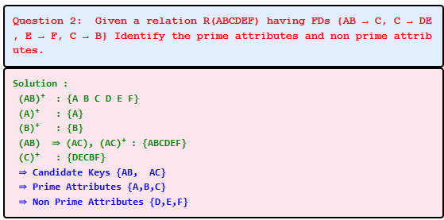

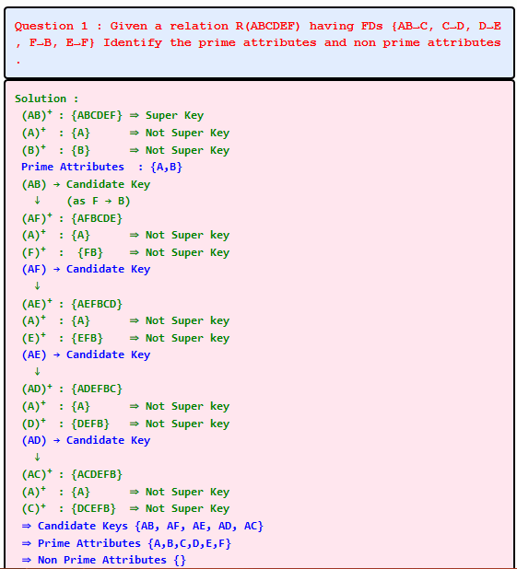
- To identify equivalence of F.D’s :
Different database designers may define different F.D’s sets from the same requirements. To evaluate whether they are equivalent if we are able to derive all F.D’s in G from F and vice- versa.

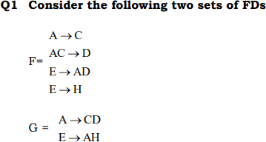
Find the equivalence of two sets of FDs.

Sol:

Step 1: Take set F and enclose all FD’s in G that can be derived from F. A→CD
A+ from F
=A
=AC (∵ A→ C)
=ACD (∵ AC→ D)
∴A → CD can be derived from F

E→AH
E+ from F
=E
=EAD
=EADH
∴ E → AH can be derived from F

Step 2: Take set G and enclose all F.D’s in F that can be derived from
G. A→C
A+ from G
=A
=ACD
A → C can be derived from G

E →AD
E+ from G
=E
=EAH
=EAHCD
E → AH & E → AD can be derived from G
∴G and F are equivalent.

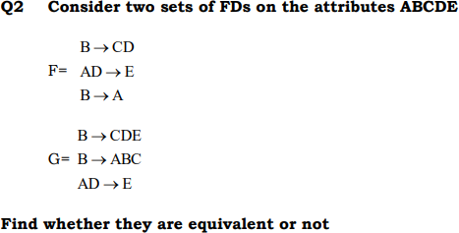

- To identify the irreducible form of FD’s /canonical Form (minimal cover):
We try to minimize the functional dependency. The minimize FD should be equivalent to original FD,
Procedure to find minimal set:
Step 1: Have single attributes on the RHS for every FD.
Step 2: Evaluate all F.D’s in step 1 for their necessity. If they are not necessary, remove them from the list.
Step 3: Evaluate the necessity of the LHS attributes in FD’s obtained from step 2.If they are not necessary remove from FD.
Step 4: Apply the union rule for common to LHS attribute in the FD’s obtained from step
3.Then we will get irreducible set.

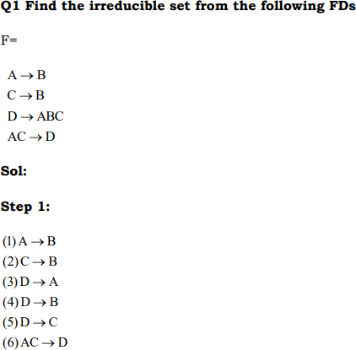
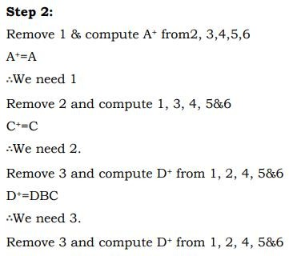

Remove 4 and compute D+ from 1, 2, 4, 5&6
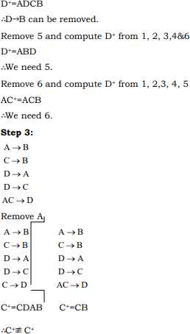
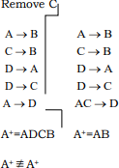

Step 4:
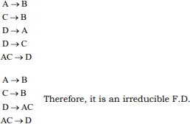

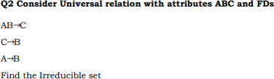

Normal forms based on functional dependency (1NF, 2NF and 3 NF, Boyce- Codd normal form (BCNF), 4NF)

Normalization means “split the tables into small tables which will contain less number of attributes in such a way that table design must not contain any problem of inserting, deleting, updating anomalies and guarantees no redundancy”.
The evolution of Normalization theories / Steps of Normalization / Different Normal Forms
is illustrated below-
- First Normal Form (1NF)
- Second Normal Form (2NF)
- Third Normal Form (3NF)
- Boyce-Codd Normal Form (BCNF)
- Fourth Normal Form (4NF)
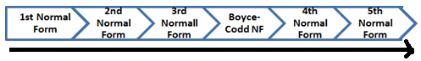
- Fifth Normal Form (5NF).
Points to be Remember
  - 1 NF is a mandatory NF and remaining are the optional
  - If you construct E-R diagrams in to the tables, then 4 NF and 5 NF need not be applied on the table.
  - Practically applied normalization is upto 3NF and very rarely we will go beyond that.
  - 2 NF dealing with the partial dependencies and 3NF is dealing with transitive dependencies.

First Normal Form (1NF): A relation is said to in the 1NF if it is already in un-normalized form and it satisfies the following conditions or rules or qualifications are:
- Each attribute name must be unique.
- Each attribute value must be single or atomic i.e., Single Valued Attributes.
- Each row / record must be unique.
- There is no repeating group’s.
Example: How do we bring an un-normalized table into first normal form? Consider the following relation:
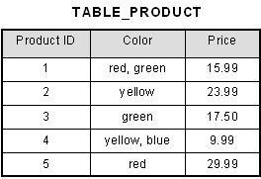
Solution: This table is not in first normal form because the [Color] column can contain multiple values. For example, the first row includes values "red" and "green." To bring this table to first normal form, we split the table into two tables and now we have the resulting tables:
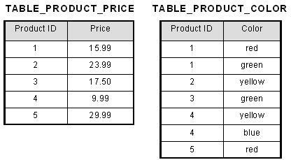

Second Normal Form (2NF): A relation is said to be in 2NF, if it is already in 1st NF and it has no Partial Dependency i.e., no non-prime attribute is dependent on the only a part of the candidate key.
(OR)
A relation is in second normal form if it satisfies the following conditions:
  - It is in first normal form
  - All non-key attributes are fully functional dependent on the primary key.

Note: Partial Functional Dependency: If a non-prime attribute of the relation is getting derived by only a part of the candidate key, then such dependency is known as Partial Dependency

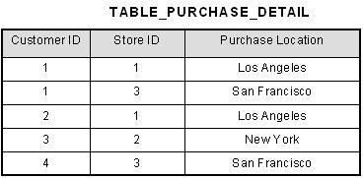
Example: Consider the following relation
- This table has a composite primary key [Customer ID, Store ID]. The non-key attribute is [Purchase Location]. In this case, [Purchase Location] only depends on [Store ID], which is only part of the primary key. Therefore, this table does not satisfy second normal form.
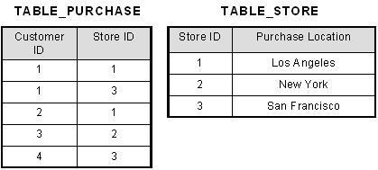
- To bring this table to second normal form, we break the table into two tables, and now we have the following:

Q1 Given relation R(ABCD) and F:{AB→C, B→D} Decompose in into 2NF.
from the given FDs determine primary key. Necessary attributes to include in the key are A, B (because this attributes are not in RHS of FD).
Find the closure set of AB AB+ = ABC
= ABCD (∵ B→ D)
∴ AB is a primary key.
From the FDs B→D is partially depending on AB. So decompose the table. (D is a non-prime attribute derived by a part of the key)
ABCD

ABC AB→C
BD
B→D

Q2 Consider the relation R=ABCDEF and set of FDs are A→ FC, C→D, B→ E Find the key and normalize into 2NF.

Third Normal Form (3NF): A database is in third normal form if it satisfies the following conditions:
  - It is in 2NF.
  - There is no transitive functional dependency
    - By transitive functional dependency, we mean we have the following relationships in the table: A is functionally dependent on B, and B is functionally dependent on C. In this case, C is transitively dependent on A via B. and A non-key attribute is depending on a non-key attribute.

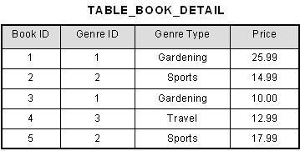
Example: Consider the following relation.
- In the table able, [Book ID] determines [Genre ID], and [Genre ID] determines [Genre Type]. Therefore, [Book ID] determines [Genre Type] via [Genre ID] and we have transitive functional dependency, and this structure does not satisfy third normal form.
- To bring this table to third normal form, we split the table into two as follows:

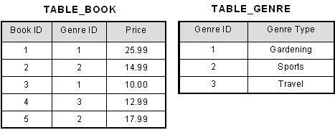

Q1 Given relation R(ABCDE) and F:{AB→C, B→D, D→E} Decompose in into 3NF. from the given FDs determine primary key. Necessary attributes to include in the key are A, B (because this attributes are not in RHS of FD).
Find the closure set of AB AB+ = ABC
= ABCD (∵ B→ D)
= ABCDE (∵ D→ E)
∴ AB is a primary key.
From the FDs B→D is partially depending on AB. So decompose the table. (D is a non-prime attribute derived by a part of the key)
B+ = BDE

ABCD
B+

ABC AB→C
BDE
B→D, D→E

∴ table is in 2NF but not in 3NF. Because D→E is transitive dependency. (No non-key attribute should determining a non-key attribute)
D+ = DE

BD
B→D
BDE

D+ DE
D→E

∴ Table is 3NF.
The relations after decomposing into 3NF. R1: ABC
R2: BD
R3: DE

Q2 Given relation R=ABCDEFGHIJ and the set of FDs are AB→ C, A→DE, B→F, F→GH, D→ IJ Decompose R into 3NF.

Q3(a) Given a set of FDs for the relation schema R(ABCD) with primary key AB under which R is 1NF but not in 2NF
(b) Find FDs such that R is in 2NF but not in 3NF

Sol: R=ABCD
Key=AB
- Atomic values are allowed in 1NF and partial dependency is not allowed in 2NF. The following FDs are allowed.
B→ C, A→C, B→ D, A→ D
(show the FDs which is having partial dependency)
- According to question partial dependencies are not allowed and transitivity dependency is allowed. The following FDs are allowed.
C→ D, D→C

Boyce-Codd normal form (BCNF): A relation is said to be in BCNF, if and only if every determinant should be a candidate key.
- BCNF is the advance version of 3NF. It is stricter than 3NF.
- A table is in 3NF if for every functional dependency X → Y, X is the super key of the table.
- For BCNF, the table should be in 3NF and for every FD, LHS is super key.

Example: Let's assume there is a company where employees work in more than one department. EMPLOYEE table:
emp_id | emp_nationality | emp_dept | dept_type | dept_no_of_emp
1001 | Austrian | Production and planning | D001 | 200
1001 | Austrian | stores | D001 | 250
1002 | American | design and technical support | D134 | 100
1002 | American | Purchasing department | D134 | 600
- In the above table Functional dependencies are as follows: EMP_ID → EMP_COUNTRY and EMP_DEPT → {DEPT_TYPE, EMP_DEPT_NO} Candidate key: {EMP-ID, EMP-DEPT}
- The table is not in BCNF because neither EMP_DEPT nor EMP_ID alone are keys. To convert the given table into BCNF, we decompose it into three tables:
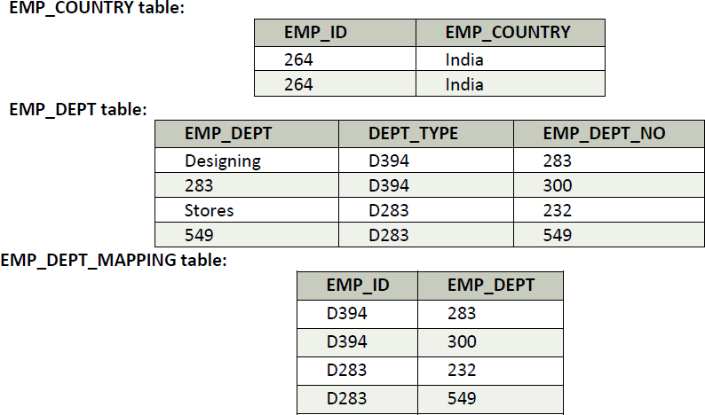

FOR BCNF problems refer your note book.
Q1 Consider the relation schema R(A,B,C), which has the FD B → C. If A is a candidate key for R, is it possible for R to be in BCNF? If so, under what conditions? If not, explain why not.
Sol : The only way R could be in BCNF is if B includes a key, i.e. B is a key for R

Fourth Normal Form (4NF): A relation said to be in 4NF if it is in Boyce Codd normal form and should have no multi-valued dependency.
- For a dependency A→ B, if for a single value of A, multiple value of B exists then the relation will be multi-valued dependency.
- Note: Multi Valued Dependency: A table is said to have multi-valued dependency, if the following conditions are true,
  - For a dependency A → B, if for a single value of A, multiple value of B exists, then the table may have multi-valued dependency.
  - Also, a table should have at-least 3 columns for it to have a multi-valued dependency.
  - And, for a relation R (A, B, C), if there is a multi-valued dependency between, A and B, then B and C should be independent of each other.
- If all these conditions are true for any relation (table), it is said to have multi-valued dependency.

Example
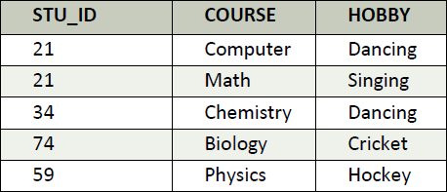
  - The given STUDENT table is in 3NF but the COURSE and HOBBY are two independent entity. Hence, there is no relationship between COURSE and HOBBY. In the STUDENT relation, student with STU_ID, 21 contains two courses, Computer and Math and two hobbies, Dancing and Singing. So there is a Multi-valued dependency on STU_ID, which leads to un-necessary repetition of data.
  - So to make the above table into 4NF, we can decompose it into two tables: STUDENT_COURSE
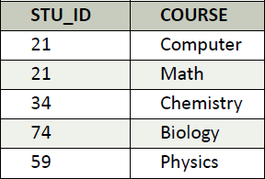

STUDENT_HOBBY
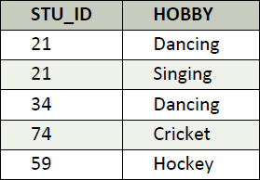

Concept of Surrogate Key:
- Alternate of Primary Key that allows duplication of data’s/records.
- Surrogate key is a unique identification key, it is like an artificial key to production key, because the production key may be alphanumeric or composite key but the surrogate key is always single numeric key.
- A surrogate key has the following characteristics:
- The value is never reused and is unique within the whole system.
- It is system generated and an integer.
- The value cannot be manipulated by the user or application.
- The value is not an amalgam of different values from multiple domains.
- A Surrogate Keys can be generated in a variety of ways, and most databases offers ways to generate surrogate keys.
Example: Oracle uses SEQUENCE, MYSQL uses Auto_Increment, and SQL Server uses IDENTITY.

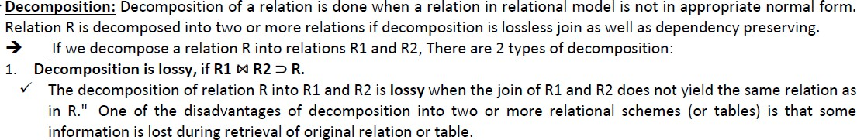
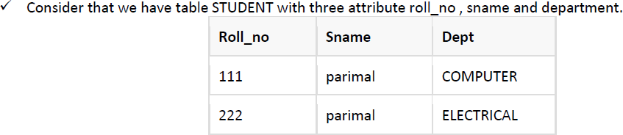
Lossless join and Dependency preserving decomposition:

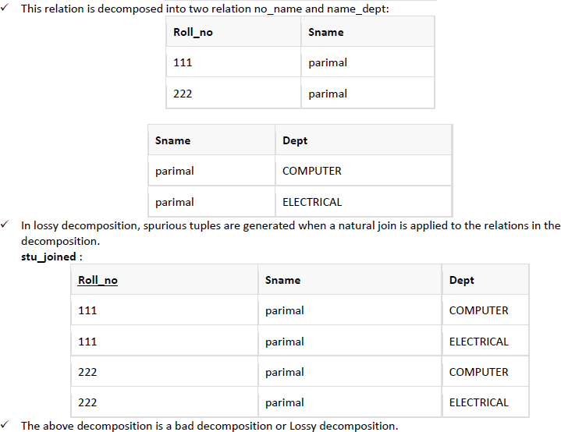
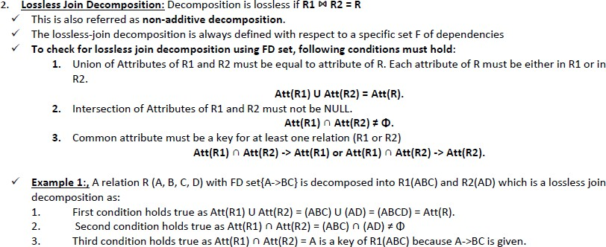

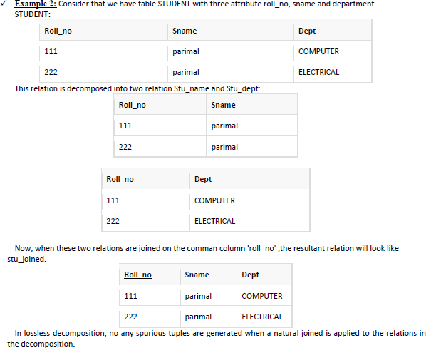
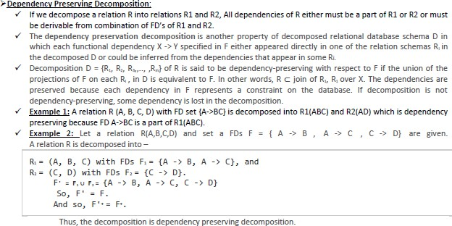

Review Questions
- What is Functional Dependency? Explain types and properties of FD’s.
- What is a normal form? Explain about various normal forms with examples.
- What is normalization? Differentiate between second normal form and third normal form.
- Explain briefly about 3NF, 4NF with suitable examples?
- Explain about Boyce Codd normal form with an example.
- Why normalization is needed? Explain the process of normalization.
- How to compute closure of set of functional dependency? Explain with a suitable example schema.
- What is multi valued dependency? State and explain fourth normal form based on this concept.
- List and explain the inference rules of functional dependencies.
- Explain insertion, deletion, and modification anomalies.
- What is the importance of dependency preservation during decomposition? How to achieve it?
- Consider the relation R on attributes (ABCDE) with functional dependencies:
AB → CDE, AC →BDF, B→C, C→B, C →D, B→E
  - Determine a Key for relation R
  - Find 3NF decomposition for R using normalization process
- Give asset o FDs for the relation schema R(A,B,C,D) with primary key AB under which R is in 1NF but not in 2NF.
- Why is a relation that is in 3NF generally considered good? Explain.
- Discuss about 4NF with suitable example.
- What are the problems caused by redundantly storing information? Explain
- Given Relation, R=(A,B,C,D,E,F,G) and Functional Dependencies
F={ {A,B}→{C}, { A,C}→{B}, {A,D}→{E}, {B}→{D}, { B,C}→{A}, {E}→{F}}.
Check whether the following decomposition of R into R1=(A,B,C), R2=(A,C,D,E) and R3=(A,D,F) is satisfying the lossless Decomposition property.
- What is dependency preservation property for decomposition? Explain why it is important.
- Given a Relation R=(X,Y,Z) and Functional Dependencies are F={ {X,Y}→{Z}, {Z}→{X} } Determine all Candidate keys of R and the normal form of R with proper explanation.
- Define functional dependency? How can you compute the minimal cover for a set of functional dependencies? Explain it with an example.

- Consider schema R = (A, B, C, G, H, I) and the set F of functional dependencies {A→B, A→C, CG →H, CG→I, B→H}. Compute the candidate keys of the schema. Compute the closure of the same.
- Explain 3NF & BCNF. What is the difference between them?
- What is functional dependency? Explain its usage in database design.
- What is a surrogate key? How can it be used for schema refinement?
- How to compute closure of set of functional dependency? Explain with a suitable example schema.
- What is multi valued dependency? State and explain fourth normal form based on this concept.
- Given a set of FDs for the relation schema R(A,B,C,D) with Primary key AB, and D → C or C → D or AC → D or AD → C or BC → D or BD → C. In which normal form is R?
- Discuss the problems caused by redundancy and the purpose of normalization.
- Give relation schemas for the following normal forms
  - 2NF but not in 3NF ii) 3NF but not in BCNF

References:
- Raghurama Krishnan, Johannes Gehrke, Database Management Systems, 3rd Edition, Tata McGraw Hill.
- C.J. Date, Introduction to Database Systems, Pearson Education.
- Elmasri Navrate, Fundamentals of Database Systems, Pearson Education.

.
UNIT-V
TRANSACTION MANAGEMENT

What is a Transaction?
A transaction is an event which occurs on the database. Generally a transaction reads a value from the database or writes a value to the database. If you have any concept of Operating Systems, then we can say that a transaction is analogous to processes.

Although a transaction can both read and write on the database, there are some fundamental differences between these two classes of operations. A read operation does not change the image of the database in any way. But a write operation, whether performed with the intention of inserting, updating or deleting data from the database, changes the image of the database. That is, we may say that these transactions bring the database from an image which existed before the transaction occurred (called the Before Image or BFIM) to an image which exists after the transaction occurred (called the After Image or AFIM).

The Four Properties of Transactions
Every transaction, for whatever purpose it is being used, has the following four properties. Taking the initial letters of these four properties we collectively call them the ACID Properties. Here we try to describe them and explain them.

Atomicity: This means that either all of the instructions within the transaction will be reflected in the database, or none of them will be reflected.

Say for example, we have two accounts A and B, each containing Rs 1000/-. We now start a transaction to deposit Rs 100/- from account A to Account B.
Read A;
A = A – 100;
Write A; Read B;
B = B + 100;
Write B;

DATABASE MANAGEMENT SYSTEM Page 63

Fine, is not it? The transaction has 6 instructions to extract the amount from A and submit it to B. The AFIM will show Rs 900/- in A and Rs 1100/- in B.

Now, suppose there is a power failure just after instruction 3 (Write A) has been complete. What happens now? After the system recovers the AFIM will show Rs 900/- in A, but the same Rs 1000/- in B. It would be said that Rs 100/- evaporated in thin air for the power failure. Clearly such a situation is not acceptable.

The solution is to keep every value calculated by the instruction of the transaction not in any stable storage (hard disc) but in a volatile storage (RAM), until the transaction completes its last instruction. When we see that there has not been any error we do something known as a COMMIT operation. Its job is to write every temporarily calculated value from the volatile storage on to the stable storage. In this way, even if power fails at instruction 3, the post recovery image of the database will show accounts A and B both containing Rs 1000/-, as if the failed transaction had never occurred.

Consistency: If we execute a particular transaction in isolation or together with other transaction, (i.e. presumably in a multi-programming environment), the transaction will yield the same expected result.

To give better performance, every database management system supports the execution of multiple transactions at the same time, using CPU Time Sharing. Concurrently executing transactions may have to deal with the problem of sharable resources, i.e. resources that multiple transactions are trying to read/write at the same time. For example, we may have a table or a record on which two transaction are trying to read or write at the same time. Careful mechanisms are created in order to prevent mismanagement of these sharable resources, so that there should not be any change in the way a transaction performs. A transaction which deposits Rs 100/- to account A must deposit the same amount whether it is acting alone or in conjunction with another transaction that may be trying to deposit or withdraw some amount at the same time.

Isolation: In case multiple transactions are executing concurrently and trying to access a sharable resource at the same time, the system should create an ordering in their execution so that they should not create any anomaly in the value stored at the sharable resource.

DATABASE MANAGEMENT SYSTEM Page 64

There are several ways to achieve this and the most popular one is using some kind of locking mechanism. Again, if you have the concept of Operating Systems, then you should remember the semaphores, how it is used by a process to make a resource busy before starting to use it, and how it is used to release the resource after the usage is over. Other processes intending to access that same resource must wait during this time. Locking is almost similar. It states that a transaction must first lock the data item that it wishes to access, and release the lock when the accessing is no longer required. Once a transaction locks the data item, other transactions wishing to access the same data item must wait until the lock is released.

Durability: It states that once a transaction has been complete the changes it has made should be permanent.

As we have seen in the explanation of the Atomicity property, the transaction, if completes successfully, is committed. Once the COMMIT is done, the changes which the transaction has made to the database are immediately written into permanent storage. So, after the transaction has been committed successfully, there is no question of any loss of information even if the power fails. Committing a transaction guarantees that the AFIM has been reached.

There are several ways Atomicity and Durability can be implemented. One of them is called Shadow Copy. In this scheme a database pointer is used to point to the BFIM of the database. During the transaction, all the temporary changes are recorded into a Shadow Copy, which is an exact copy of the original database plus the changes made by the transaction, which is the AFIM. Now, if the transaction is required to COMMIT, then the database pointer is updated to point to the AFIM copy, and the BFIM copy is discarded. On the other hand, if the transaction is not committed, then the database pointer is not updated. It keeps pointing to the BFIM, and the AFIM is discarded. This is a simple scheme, but takes a lot of memory space and time to implement.

If you study carefully, you can understand that Atomicity and Durability is essentially the same thing, just as Consistency and Isolation is essentially the same thing.

DATABASE MANAGEMENT SYSTEM Page 65

Transaction States
There are the following six states in which a transaction may exist:
Active: The initial state when the transaction has just started execution.

Partially Committed: At any given point of time if the transaction is executing properly, then it is going towards it COMMIT POINT. The values generated during the execution are all stored in volatile storage.

Failed: If the transaction fails for some reason. The temporary values are no longer required, and the transaction is set to ROLLBACK. It means that any change made to the database by this transaction up to the point of the failure must be undone. If the failed transaction has withdrawn Rs. 100/- from account A, then the ROLLBACK operation should add Rs 100/- to account A.

Aborted: When the ROLLBACK operation is over, the database reaches the BFIM. The transaction is now said to have been aborted.

Committed: If no failure occurs then the transaction reaches the COMMIT POINT. All the temporary values are written to the stable storage and the transaction is said to have been committed.

Terminated: Either committed or aborted, the transaction finally reaches this state.

The whole process can be described using the following diagram:

Entry Point
PARTIALLY COMMITTED
COMMITTED
ACTIVE
TERMINATE D
FAILED
ABORTED

DATABASE MANAGEMENT SYSTEM Page 66

Concurrent Execution
A schedule is a collection of many transactions which is implemented as a unit. Depending upon how these transactions are arranged in within a schedule, a schedule can be of two types:
- Serial: The transactions are executed one after another, in a non-preemptive manner.
- Concurrent: The transactions are executed in a preemptive, time shared method.

In Serial schedule, there is no question of sharing a single data item among many transactions, because not more than a single transaction is executing at any point of time. However, a serial schedule is inefficient in the sense that the transactions suffer for having a longer waiting time and response time, as well as low amount of resource utilization.

In concurrent schedule, CPU time is shared among two or more transactions in order to run them concurrently. However, this creates the possibility that more than one transaction may need to access a single data item for read/write purpose and the database could contain inconsistent value if such accesses are not handled properly. Let us explain with the help of an example.

Let us consider there are two transactions T1 and T2, whose instruction sets are given as following. T1 is the same as we have seen earlier, while T2 is a new transaction.

T1
Read A;
A = A – 100;
Write A; Read B;
B = B + 100;
Write B;

T2
Read A;
Temp = A * 0.1; Read C;
C = C + Temp; Write C;

DATABASE MANAGEMENT SYSTEM Page 67

T2 is a new transaction which deposits to account C 10% of the amount in account A.

If we prepare a serial schedule, then either T1 will completely finish before T2 can begin, or T2 will completely finish before T1 can begin. However, if we want to create a concurrent schedule, then some Context Switching need to be made, so that some portion of T1 will be executed, then some portion of T2 will be executed and so on. For example say we have prepared the following concurrent schedule.

T1 T2

Read A;
A = A – 100;
Write A;

Read B;
B = B + 100;
Write B;

Read A;
Temp = A * 0.1; Read C;
C = C + Temp; Write C;

No problem here. We have made some Context Switching in this Schedule, the first one after executing the third instruction of T1, and after executing the last statement of T2. T1 first deducts Rs 100/- from A and writes the new value of Rs 900/- into A. T2 reads the value of A, calculates the value of Temp to be Rs 90/- and adds the value to C. The remaining part of T1 is executed and Rs 100/- is added to B.

It is clear that a proper Context Switching is very important in order to maintain the Consistency and Isolation properties of the transactions. But let us take another example where a wrong Context Switching can bring about disaster. Consider the following example involving the same T1 and T2

DATABASE MANAGEMENT SYSTEM Page 68

T1 T2

Read A;
A = A – 100;

Write A; Read B;
B = B + 100;
Write B;

Read A;
Temp = A * 0.1; Read C;
C = C + Temp; Write C;

This schedule is wrong, because we have made the switching at the second instruction of T1. The result is very confusing. If we consider accounts A and B both containing Rs 1000/- each, then the result of this schedule should have left Rs 900/- in A, Rs 1100/- in B and add Rs 90 in C (as C should be increased by 10% of the amount in A). But in this wrong schedule, the Context Switching is being performed before the new value of Rs 900/- has been updated in A. T2 reads the old value of A, which is still Rs 1000/-, and deposits Rs 100/- in C. C makes an unjust gain of Rs 10/- out of nowhere.

Serializability
When several concurrent transactions are trying to access the same data item, the instructions within these concurrent transactions must be ordered in some way so as there are no problem in accessing and releasing the shared data item. There are two aspects of serializability which are described here:

DATABASE MANAGEMENT SYSTEMS Page 69

Conflict Serializability
Two instructions of two different transactions may want to access the same data item in order to perform a read/write operation. Conflict Serializability deals with detecting whether the instructions are conflicting in any way, and specifying the order in which these two instructions will be executed in case there is any conflict. A conflict arises if at least one (or both) of the instructions is a write operation. The following rules are important in Conflict Serializability:
- If two instructions of the two concurrent transactions are both for read operation, then they are not in conflict, and can be allowed to take place in any order.
- If one of the instructions wants to perform a read operation and the other instruction wants to perform a write operation, then they are in conflict, hence their ordering is important. If the read instruction is performed first, then it reads the old value of the data item and after the reading is over, the new value of the data item is written. It the write instruction is performed first, then updates the data item with the new value and the read instruction reads the newly updated value.
- If both the transactions are for write operation, then they are in conflict but can be allowed to take place in any order, because the transaction do not read the value updated by each other. However, the value that persists in the data item after the schedule is over is the one written by the instruction that performed the last write.

View Serializability:
This is another type of serializability that can be derived by creating another schedule out of an existing schedule, involving the same set of transactions. These two schedules would be called View Serializable if the following rules are followed while creating the second schedule out of the first. Let us consider that the transactions T1 and T2 are being serialized to create two different schedules
S1 and S2 which we want to be View Equivalent and both T1 and T2 wants to access the same data item.
- If in S1, T1 reads the initial value of the data item, then in S2 also, T1 should read the initial value of that same data item.
- If in S1, T1 writes a value in the data item which is read by T2, then in S2 also, T1 should write the value in the data item before T2 reads it.
DATABASE MANAGEMENT SYSTEMS Page 70

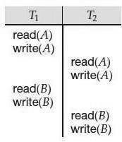

- If in S1, T1 performs the final write operation on that data item, then in S2 also, T1 should perform the final write operation on that data item.

Let us consider a schedule S in which there are two consecutive instructions, I and J , of transactions Ti and Tj , respectively (i _= j). If I and J refer to different data
items, then we can swap I and J without affecting the results of any instruction
in the schedule. However, if I and J refer to the same data item Q, then the order of the two steps may matter. Since we are dealing with only read and write instructions, there are four cases that we need to consider:

I = read(Q), J = read(Q). The order of I and J does not matter, since the same value of Q is read by Ti and Tj , regardless of the order.

I = read(Q), J = write(Q). If I comes before J , then Ti does not read the value of Q that is written by Tj in instruction J . If J comes before I, then Ti reads
the value of Q that is written by Tj. Thus, the order of I and J matters.

I = write(Q), J = read(Q). The order of I and J matters for reasons similar to those of the previous case.

- I = write(Q), J = write(Q). Since both instructions are write operations, the order of these instructions does not affect either Ti or Tj . However, the value obtained by the next read(Q) instruction of S is affected, since the result of only the latter of the two write instructions is preserved in the database. If there is no other write(Q) instruction after I and J in S, then the order of I and J directly affects the final value of Q in the database state that results from schedule S.

Fig: Schedule 3—showing only the read and write instructions.

DATABASE MANAGEMENT SYSTEMS Page 71

We say that I and J conflict if they are operations by different transactions on the same data item, and at least one of these instructions is a write operation. To illustrate the concept of conflicting instructions, we consider schedule 3in Figure above. The write(A) instruction of T1 conflicts with the read(A) instruction of T2. However, the write(A) instruction of T2 does not conflict with the read(B) instruction of T1, because the two instructions access different data items.

Transaction Characteristics

Every transaction has three characteristics: access mode, diagnostics size, and isolation level. The diagnostics size determines the number of error conditions that can be recorded.

If the access mode is READ ONLY, the transaction is not allowed to modify the database. Thus, INSERT, DELETE, UPDATE, and CREATE commands cannot be executed. If we have to execute one of these commands, the access mode should be set to READ WRITE. For transactions with READ ONLY access mode, only shared locks need to be obtained, thereby increasing concurrency.

The isolation level controls the extent to which a given transaction is exposed to the actions of other transactions executing concurrently. By choosing one of four possible isolation level settings, a user can obtain greater concurrency at the cost of increasing the transaction's exposure to other transactions' uncommitted changes.

Isolation level choices are READ UNCOMMITTED, READ COMMITTED, REPEATABLE READ, and SERIALIZABLE. The effect of these levels is summarized in Figure given below. In this context, dirty read and unrepeatable read are defined as usual. Phantom is defined to be the possibility that a transaction retrieves a collection of objects (in SQL terms, a collection of tuples) twice and sees different results, even though it does not modify any of these tuples itself.

In terms of a lock-based implementation, a SERIALIZABLE transaction obtains locks before reading or writing objects, including locks on sets of objects that it requires to be unchanged (see Section 19.3.1), and holds them until the end, according to Strict 2PL.

REPEATABLE READ ensures that T reads only the changes made by committed transactions, and that no value read or written by T is changed by any other transaction until T is complete. However, T could experience the phantom phenomenon; for example, while T examines all

DATABASE MANAGEMENT SYSTEMS Page 72

Sailors records with rating=1, another transaction might add a new such Sailors record, which is missed by T.

A REPEATABLE READ transaction uses the same locking protocol as a SERIALIZABLE transaction, except that it does not do index locking, that is, it locks only individual objects, not sets of objects.

READ COMMITTED ensures that T reads only the changes made by committed transactions, and that no value written by T is changed by any other transaction until T is complete. However, a value read by T may well be modified by another transaction while T is still in progress, and T is, of course, exposed to the phantom problem.

A READ COMMITTED transaction obtains exclusive locks before writing objects and holds these locks until the end. It also obtains shared locks before reading objects, but these locks are released immediately; their only effect is to guarantee that the transaction that last modified the object is complete. (This guarantee relies on the fact that every SQL transaction obtains exclusive locks before writing objects and holds exclusive locks until the end.)

A READ UNCOMMITTED transaction does not obtain shared locks before reading objects. This mode represents the greatest exposure to uncommitted changes of other transactions; so much so that SQL prohibits such a transaction from making any changes itself - a READ UNCOMMITTED transaction is required to have an access mode of READ ONLY. Since such a transaction obtains no locks for reading objects, and it is not allowed to write objects (and therefore never requests exclusive locks), it never makes any lock requests.
The SERIALIZABLE isolation level is generally the safest and is recommended for most transactions. Some transactions, however, can run with a lower isolation level, and the smaller number of locks requested can contribute to improved system performance.
For example, a statistical query that finds the average sailor age can be run at the READ COMMITTED level, or even the READ UNCOMMITTED level, because a few incorrect or missing values will not significantly affect the result if the number of sailors is large. The isolation level and access mode can be set using the SET TRANSACTION command. For example, the following command declares the current transaction to be SERIALIZABLE and READ ONLY:
SET TRANSACTION ISOLATION LEVEL SERIALIZABLE READONLY
When a transaction is started, the default is SERIALIZABLE and READ WRITE.

PRECEDENCE GRAPH

DATABASE MANAGEMENT SYSTEMS Page 73

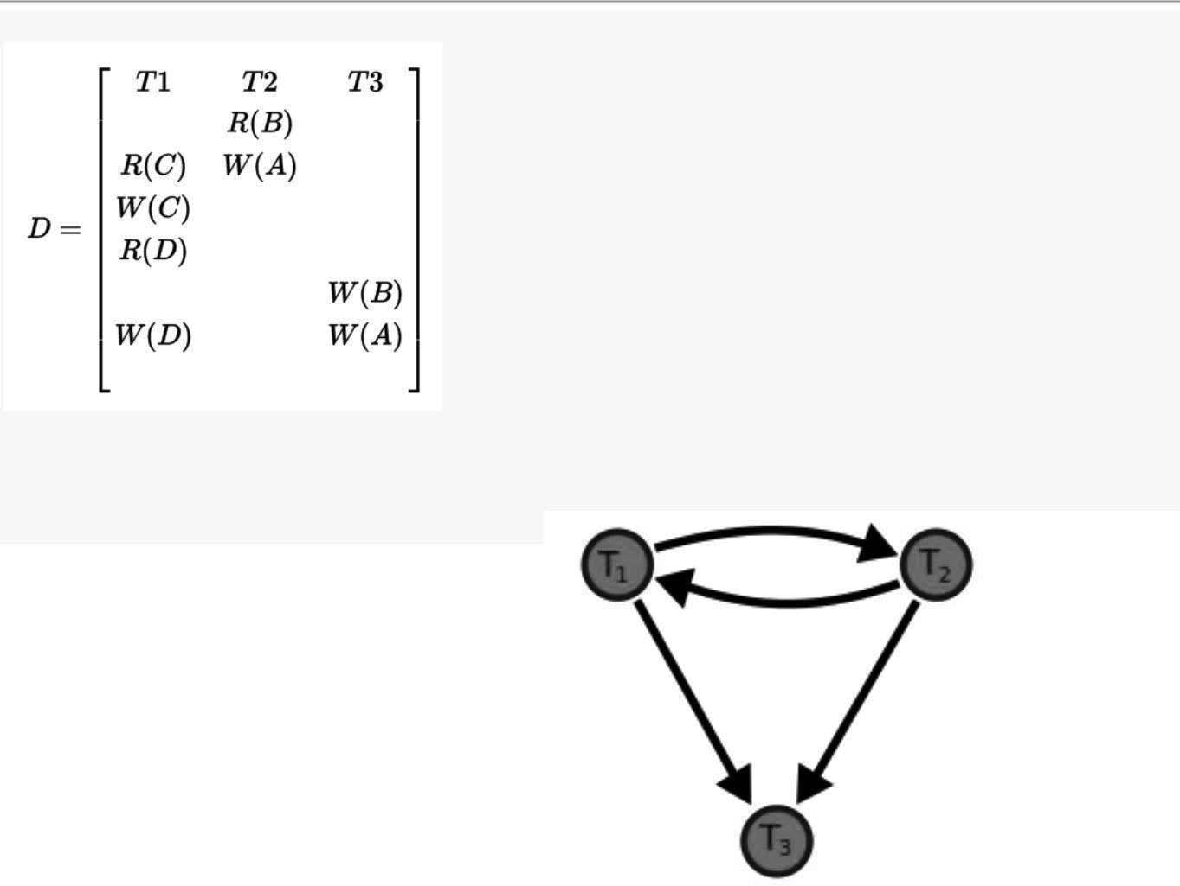

A precedence graph, also named conflict graph and serializability graph, is used in the context of concurrency control in databases.

The precedence graph for a schedule S contains:

A node for each committed transaction in S
An arc from Ti to Tj if an action of Ti precedes and conflicts with one of Tj's actions.

Precedence graph example

A precedence graph of the schedule D, with 3 transactions. As there is a cycle (of length 2; with two edges) through the committed transactions T1 and T2, this schedule (history) is not Conflict serializable.
The drawing sequence for the precedence graph:-

DATABASE MANAGEMENT SYSTEMS Page 74

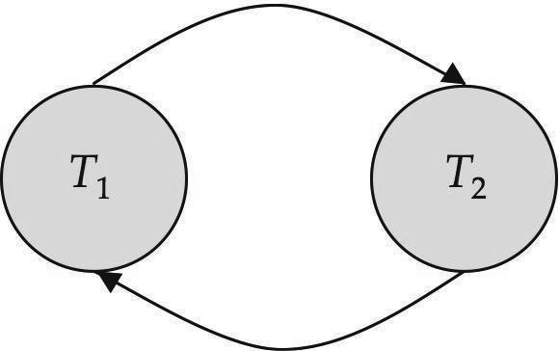

For each transaction Ti participating in schedule S, create a node labelled Ti in the precedence graph. So the precedence graph contains T1, T2, T3
For each case in S where Ti executes a write_item(X) then Tj executes a read_item(X), create an edge (Ti --> Tj) in the precedence graph. This occurs nowhere in the above example, as there is no read after write.
- For each case in S where Ti executes a read_item(X) then Tj executes a write_item(X), create an edge (Ti --> Tj) in the precedence graph. This results in
directed edge from T1 to T2.
- For each case in S where Ti executes a write_item(X) then Tj executes a write_item(X), create an edge (Ti --> Tj) in the precedence graph. This results in directed edges from T2 to T1, T1 to T3, and T2 to T3.
- The schedule S is conflict serializable if the precedence graph has no cycles. As T1 and T2 constitute a cycle, then we cannot declare S as serializable or not and serializability has to be checked using other methods.

TESTING FOR CONFLICT SERIALIZABILITY
  - A schedule is conflict serializable if and only if its precedence graph is acyclic.

  - To test for conflict serializability, we need to construct the precedence graph and to invoke a cycle-detection algorithm.Cycle-detection algorithms exist which take order
n2 time, where n is the number of vertices in the graph.
(Better algorithms take order n + e where e is the number of edges.)

  - If precedence graph is acyclic, the serializability order can be obtained by a topological sorting of the graph. That is, a linear order consistent with the partial order of the graph.

For example, a serializability order for the schedule (a) would be one of either (b) or (c)

DATABASE MANAGEMENT SYSTEMS Page 75

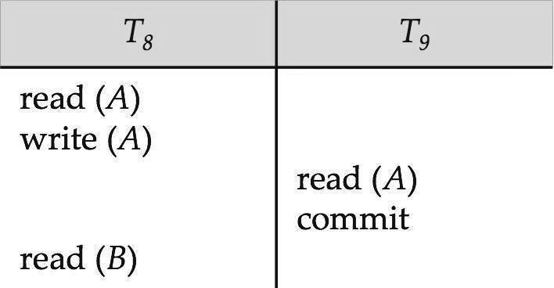
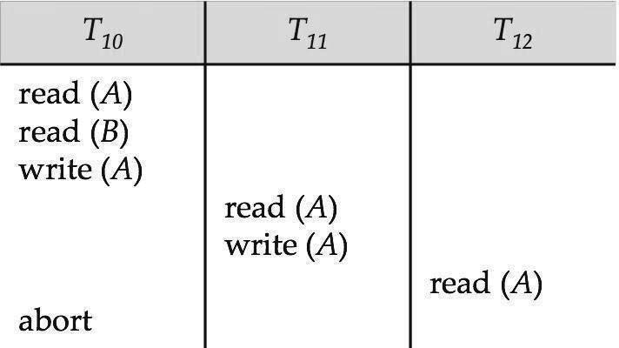

  - A serializability order of the transactions can be obtained by finding a linear order consistent with the partial order of the precedence graph.

RECOVERABLE SCHEDULES
Recoverable schedule — if a transaction Tj reads a data item previously written by a transaction Ti , then the commit operation of Ti must appear before the commit operation of Tj.
The following schedule is not recoverable if T9 commits immediately after the read(A) operation.

If T8 should abort, T9 would have read (and possibly shown to the user) an inconsistent database state. Hence, database must ensure that schedules are recoverable.

CASCADING ROLLBACKS
Cascading rollback – a single transaction failure leads to a series of transaction rollbacks.
Consider the following schedule where none of the transactions has yet committed (so the schedule is recoverable)

If T10 fails, T11 and T12 must also be rolled back.
DATABASE MANAGEMENT SYSTEMS Page 76

Can lead to the undoing of a significant amount of work

CASCADELESS SCHEDULES
Cascadeless schedules — for each pair of transactions Ti and Tj such that Tj reads a data item previously written by Ti, the commit operation of Ti appears before the read operation of Tj.

Every cascadeless schedule is also recoverable

It is desirable to restrict the schedules to those that are cascadeless Example of a schedule that is NOT cascadeless

CONCURRENCY SCHEDULE
A database must provide a mechanism that will ensure that all possible schedules are
both:
Conflict serializable.

Recoverable and preferably cascadeless
A policy in which only one transaction can execute at a time generates serial schedules, but provides a poor degree of concurrency

DATABASE MANAGEMENT SYSTEMS Page 77

Concurrency-control schemes tradeoff between the amount of concurrency they allow and the amount of overhead that they incur

Testing a schedule for serializability after it has executed is a little too late!

Tests for serializability help us understand why a concurrency control protocol is
correct

Goal – to develop concurrency control protocols that will assure serializability.

WEEK LEVELS OF CONSISTENCY
Some applications are willing to live with weak levels of consistency, allowing schedules that are not serializable

accounts
E.g., a read-only transaction that wants to get an approximate total balance of all

E.g., database statistics computed for query optimization can be approximate (why?) Such transactions need not be serializable with respect to other transactions

Tradeoff accuracy for performance

LEVELS OF CONSISTENCY IN SQL
Serializable — default
Repeatable read — only committed records to be read, repeated reads of same record must return same value. However, a transaction may not be serializable – it may find some records inserted by a transaction but not find others.

Read committed — only committed records can be read, but successive reads of record may return different (but committed) values.
Read uncommitted — even uncommitted records may be read.

Lower degrees of consistency useful for gathering approximate information about the
database

Warning: some database systems do not ensure serializable schedules by default

E.g., Oracle and PostgreSQL by default support a level of consistency called snapshot isolation (not part of the SQL standard)

TRANSACTION DEFINITION IN SQL
Data manipulation language must include a construct for specifying the set of actions that comprise a transaction.

DATABASE MANAGEMENT SYSTEMS Page 78

In SQL, a transaction begins implicitly. A transaction in SQL ends by:
Commit work commits current transaction and begins a new one. Rollback work causes current transaction to abort.
In almost all database systems, by default, every SQL statement also commits implicitly if it executes successfully
Implicit commit can be turned off by a database directive

E.g. in JDBC, connection.setAutoCommit(false);

RECOVERY SYSTEM

Failure Classification:
Transaction failure :
Logical errors: transaction cannot complete due to some internal error condition System errors: the database system must terminate an active transaction due to an error
condition (e.g., deadlock)

System crash: a power failure or other hardware or software failure causes the system
to crash.

Fail-stop assumption: non-volatile storage contents are assumed to not be corrupted as result of a system crash

Database systems have numerous integrity checks to prevent corruption of disk data Disk failure: a head crash or similar disk failure destroys all or part of disk storage Destruction is assumed to be detectable: disk drives use checksums to detect failures

RECOVERY ALGORITHMS

Consider transaction Ti that transfers $50 from account A to account B Two updates: subtract 50 from A and add 50 to B

DATABASE MANAGEMENT SYSTEMS Page 79

Transaction Ti requires updates to A and B to be output to the database.

A failure may occur after one of these modifications have been made but before both of them are made.
Modifying the database without ensuring that the transaction will commit may leave the database in an inconsistent state
Not modifying the database may result in lost updates if failure occurs just after transaction commits
Recovery algorithms have two parts

- Actions taken during normal transaction processing to ensure enough information exists to recover from failures

- Actions taken after a failure to recover the database contents to a state that ensures atomicity, consistency and durability

STORAGE STRUCTURE

Volatile storage:

does not survive system crashes examples: main memory, cache memory Nonvolatile storage:
survives system crashes

examples: disk, tape, flash memory, non-volatile (battery backed up) RAM
but may still fail, losing data Stable storage:
a mythical form of storage that survives all failures

approximated by maintaining multiple copies on distinct nonvolatile media

DATABASE MANAGEMENT SYSTEMS Page 80

Stable-Storage Implementation

Maintain multiple copies of each block on separate disks

copies can be at remote sites to protect against disasters such as fire or flooding. Failure during data transfer can still result in inconsistent copies.
Block transfer can result in

Successful completion

Partial failure: destination block has incorrect information Total failure: destination block was never updated
Protecting storage media from failure during data transfer (one solution): Execute output operation as follows (assuming two copies of each block):
- Write the information onto the first physical block.

- When the first write successfully completes, write the same information onto the second physical block.
- The output is completed only after the second write successfully completes.

Copies of a block may differ due to failure during output operation. To recover from
failure:
- First find inconsistent blocks:

  - Expensive solution: Compare the two copies of every disk block.

  - Better solution:

Record in-progress disk writes on non-volatile storage (Non-volatile RAM or special area of disk).

Use this information during recovery to find blocks that may be inconsistent, and only compare copies of these.

Used in hardware RAID systems

DATABASE MANAGEMENT SYSTEMS Page 81

2. If either copy of an inconsistent block is detected to have an error (bad checksum), overwrite it by the other copy. If both have no error, but are different, overwrite the second block by the first block.

DATA ACCESS

Physical blocks are those blocks residing on the disk.
System buffer blocks are the blocks residing temporarily in main memory.

Block movements between disk and main memory are initiated through the following two operations:

input(B) transfers the physical block B to main memory.

output(B) transfers the buffer block B to the disk, and replaces the appropriate physical block there.
We assume, for simplicity, that each data item fits in, and is stored inside, a single
block.

Each transaction Ti has its private work-area in which local copies of all data items accessed and updated by it are kept.

Ti's local copy of a data item X is denoted by xi. BX denotes block containing X

by:
Transferring data items between system buffer blocks and its private work-area done

read(X) assigns the value of data item X to the local variable xi.

write(X) assigns the value of local variable xi to data item {X} in the buffer block. Transactions

Must perform read(X) before accessing X for the first time (subsequent reads can be from local copy)
The write(X) can be executed at any time before the transaction commits

Note that output(BX) need not immediately follow write(X). System can performthe output operation when it seems fit.

DATABASE MANAGEMENT SYSTEMS Page 82

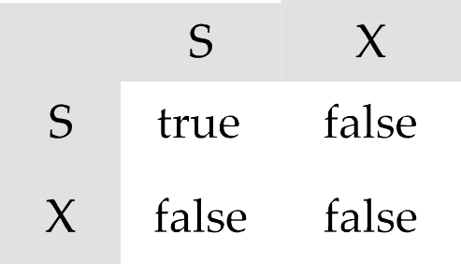

Lock-Based Protocols
A lock is a mechanism to control concurrent access to a data item Data items can be locked in two modes :
- exclusive (X) mode. Data item can be both read as wellas written. X-lock is requested using lock-X instruction.
- shared (S) mode. Data item can only be read. S-lock is requested using lock-S instruction.
Lock requests are made to concurrency-control manager. Transaction can proceed only after request is granted.

Lock-compatibility matrix

- A transaction may be granted a lock on an item if the requested lock is compatible with locks already held on the item by other transactions
- Any number of transactions can hold shared locks on an item,
but if any transaction holds an exclusive on the item no other transaction may hold any lock on the item.
- If a lock cannot be granted, the requesting transaction is made to wait till all incompatible locks held by other transactions have been released. The lock is then granted.
Example of a transaction performing locking:
T2: lock-S(A); read (A); unlock(A); lock-S(B);
read (B); unlock(B); display(A+B)
Locking as above is not sufficient to guarantee serializability — if A and B get updated in-between the read of A and B, the displayed sum would be wrong.
A locking protocol is a set of rules followed by all transactions while requesting and releasing locks. Locking protocols restrict the set of possible schedules.
Consider the partial schedule

DATABASE MANAGEMENT SYSTEMS Page 83

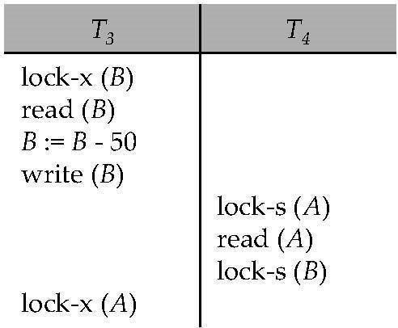

Neither T3 nor T4 can make progress — executing lock-S(B) causes T4 to wait for T3 to release its lock on B, while executing lock-X(A) causes T3 to wait for T4 to release its lock on A.
Such a situation is called a deadlock.
l To handle a deadlock one of T3 or T4 must be rolled back and its locks released.
- The potential for deadlock exists in most locking protocols. Deadlocks are a necessary evil.
- Starvation is also possible if concurrency control manager is badly designed. For example:
- A transaction may be waiting for an X-lock on an item, while a sequence of other transactions request and are granted an S-lock on the same item.
- The same transaction is repeatedly rolled back due to deadlocks.
- Concurrency control manager can be designed to prevent starvation.
THE TWO-PHASE LOCKING PROTOCOL
- This is a protocol which ensures conflict-serializable schedules.
- Phase 1: Growing Phase a.transaction may obtain locks
b.transaction may not release locks
- Phase 2: Shrinking Phase a.transaction may release locks
b.transaction may not obtain locks
- The protocol assures serializability. It can be proved that the transactions can be
serialized in the order of their lock points (i.e. the point where a transaction acquired its final lock).

- Two-phase locking does not ensure freedom from deadlocks

DATABASE MANAGEMENT SYSTEMS Page 84

- Cascading roll-back is possible under two-phase locking. To avoid this, follow a modified protocol called strict two-phase locking. Here a transaction must hold all its exclusive locks till it commits/aborts.
- Rigorous two-phase locking is even stricter: here all locks are held till commit/abort. In this protocol transactions can be serialized in the order in which they commit.
- There can be conflict serializable schedules that cannot be obtained if two-phase locking is used.
- However, in the absence of extra information (e.g., ordering of access to data),two- phase locking is needed for conflict serializability in the following sense:
Given a transaction Ti that does not follow two-phase locking, we can find a transaction Tj that uses two-phase locking, and a schedule for Ti and Tj that is not conflict serializable.

TIMESTAMP-BASED PROTOCOLS
  - Each transaction is issued a timestamp when it enters the system. If an old transaction Ti has time-stamp TS(Ti), a new transaction Tj is assigned time-stamp TS(Tj) such that TS(Ti) <TS(Tj).
  - The protocol manages concurrent execution such that the time-stamps determine the serializability order.
  - In order to assure such behavior, the protocol maintains for each data Q two timestamp values:
a.W-timestamp(Q) is the largest time-stamp of any transaction that executed write(Q) successfully.
b.R-timestamp(Q) is the largest time-stamp of any transaction that executed read(Q) successfully.

  - The timestamp ordering protocol ensures that any conflicting read and write
operations are executed in timestamp order.
  - Suppose a transaction Ti issues a read(Q)
    - If TS(Ti) ≤ W-timestamp(Q), then Ti needs to read a valueof Q that was already overwritten.
n Hence, the read operation is rejected, and Ti is rolled back.
    - If TS(Ti)≥ W-timestamp(Q), then the read operation is executed, and R- timestamp(Q) is set to max(R-timestamp(Q), TS(Ti)).
  - Suppose that transaction Ti issues write(Q).
    - If TS(Ti) < R-timestamp(Q), then the value of Q that Ti is producing was needed previously, and the system assumed that that value would never be produced.
n Hence, the write operation is rejected, and Ti is rolled back.
    - If TS(Ti) < W-timestamp(Q), then Ti is attempting to write an obsolete value of Q. n Hence, this write operation is rejected, and Ti is rolled back.
    - Otherwise, the write operation is executed, and W-timestamp(Q) is set to TS(Ti).

Thomas’ Write Rule

DATABASE MANAGEMENT SYSTEMS Page 85

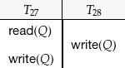

- We now present a modification to the timestamp-ordering protocol that allows greater potential concurrency than does the protocol i.e., Timestamp ordering Protocol . Let us consider schedule 4 of Figure below, and apply the timestamp-ordering protocol. Since T27 starts before T28, we shall assume that TS(T27) < TS(T28). The read(Q) operation of T27 succeeds, as does the write(Q) operation of T28. When T27 attempts its write(Q) operation, we find that TS(T27) < W-timestamp(Q), since Wtimestamp(Q) = TS(T28). Thus, the write(Q) by T27 is rejected and transaction T27 must be rolled back.
- Although the rollback of T27 is required by the timestamp-ordering protocol, it is unnecessary. Since T28 has already written Q, the value that T27 is attempting to write is one that will never need to be read. Any transaction Ti with TS(Ti ) < TS(T28) that attempts a read(Q)will be rolled back, since TS(Ti)<W-timestamp(Q).
- Any transaction Tj with TS(Tj ) > TS(T28) must read the value of Q written by T28, rather than the value that T27 is attempting to write. This observation leads to a modified version of the timestamp-ordering protocol in which obsolete write operations can be ignored under certain circumstances. The protocol rules for read operations remain unchanged. The protocol rules for write operations, however, are slightly different from the timestamp- ordering protocol.

The modification to the timestamp-ordering protocol, called Thomas’ write rule, is this: Suppose that transaction Ti issues write(Q).
  - If TS(Ti ) < R-timestamp(Q), then the value of Q that Ti is producing was previously needed, and it had been assumed that the value would never be produced. Hence, the system rejects the write operation and rolls Ti back.
  - If TS(Ti ) < W-timestamp(Q), then Ti is attempting to write an obsolete value of Q. Hence, this write operation can be ignored.
  - Otherwise, the system executes the write operation and setsW-timestamp(Q) to TS(Ti ).

DATABASE MANAGEMENT SYSTEMS Page 86

    - Read phase. During this phase, the system executes transaction Ti. It reads the values of the various data items and stores them in variables local to Ti. It performs all write operations on temporary local variables, without updates of the actual database.
    - Validation phase. The validation test is applied to transaction Ti. This determines whether Ti is allowed to proceed to the write phase without causing a violation ofserializability.
If a transaction fails the validation test, the system aborts the transaction.
    - Write phase. If the validation test succeeds for transaction Ti, the temporary local variables that hold the results of any write operations performed by Ti are copied to the database. Read-only transactions omit this phase.
MODES IN VALIDATION-BASED PROTOCOLS
- Start(Ti)
- Validation(Ti )
- Finish

MULTIPLE GRANULARITY.

multiple granularity locking (MGL) is a locking method used in database management systems (DBMS) and relational databases.

In MGL, locks are set on objects that contain other objects. MGL exploits the hierarchical nature of the contains relationship. For example, a database may have files, which contain pages, which further contain records. This can be thought of as a tree of objects, where each node contains its children. A lock on such as a shared or exclusive lock locks the targeted node as well as all of its descendants.

Multiple granularity locking is usually used with non-strict two-phase locking to guarantee serializability. The multiple-granularity locking protocol uses these lock modes to ensure serializability. It requires that a transaction Ti that attempts to lock a node Q must follow these rules:
Transaction Ti must observe the lock-compatibility function of Figure above. Transaction Ti must lock the root of the tree first, and can lock it in anymode.
Transaction Ti can lock a node Q in S or IS mode only if Ti currently has the parent of Q
locked in either IX or IS mode.
Transaction Ti can lock a node Q in X, SIX, or IX mode only if Ti currently has the parent of Q locked in either IX or SIX mode.
Transaction Ti can lock a node only if Ti has not previously unlocked any node (that is, Ti is two phase).
Transaction Ti can unlock a node Q only if Ti currently has none of the children of
Q locked.

DATABASE MANAGEMENT SYSTEMS Page 87

STORAGE AND INDEXING : Database file organization, file organization on disk, heap files and sorted files, hashing, single and multi-level indexes, dynamic multilevel indexing using B-Tree and B+ tree, index on multiple keys.

DATABASE FILE ORGANIZATION:
Records and Record Types:
Data is usually stored in the form of records. Each record consists of a collection of related data values or items, where each value is formed of one or more bytes and corresponds to a particular field of the record. Records usually describe entities and their attributes. A collection of field names and their corresponding data types constitutes a record type or record format definition. A data type, associated with each field, specifies the types of values a field can take.
In recent database applications, the need may arise for storing data items that consist of large unstructured objects, which represent images, digitized video or audio streams, or free text. These are referred to as BLOBs (Binary Large Objects). A BLOB data item is typically stored separately from its record in a pool of disk blocks, and a pointer to the BLOB is included in the record.
Files, Fixed-length Records, and Variable-length Records:
A file is a sequence of records. In many cases, all records in a file are of the same record type. If every record in the file has exactly the same size (in bytes), the file is said to be made up of fixed-length records. If different records in the file have different sizes, the file is said to be made up of variable-length records. A file may have variable-length records for several reasons:
- The file records are of the same record type, but
one or more of the fields are of varying size (variable-length fields) (or) one or more of the fields are optional (or)
one or more of the fields may have multiple values for individual records; such a field is called a repeating field and a group of values for the field is often called a repeating group.
- The file contains records of different record types and hence of varying size (mixed file).
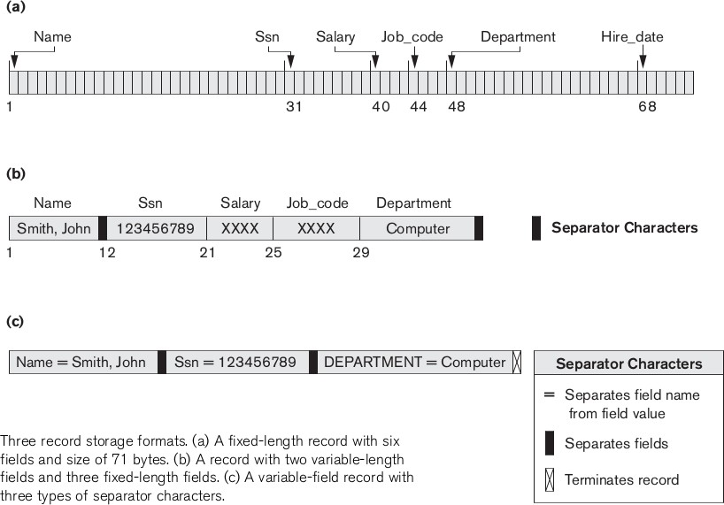

Record Blocking and Spanned Versus Un spanned Records:
The records of a file must be allocated to disk blocks because a block is the unit of data transfer between disk and memory. When the block size is larger than the record size, each block will contain numerous records, although some files may have unusually large records that cannot fit in one block.
Suppose that the block size is B bytes. For a file of fixed-length records of size R bytes, with B > R, we can fit bfr = floor(B/R) records per block, where the floor(x) rounds down the number x to an integer. The value bfr is called the blocking factor for the file. In general, R may not divide B exactly, so we have some unused space in each block equal to B - (bfr * R) bytes
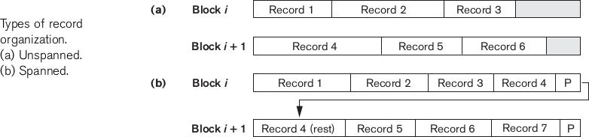
To utilize this unused space, we can store part of a record on one block and the rest on another. A pointer at the end of the first block points to the block containing the remainder of the record in case it is not the next consecutive block on disk. This organization is called spanned, because records can span more than one block. Whenever a record is larger than a block, we must use a spanned organization. If records are not allowed to cross block boundaries, the organization is called un spanned. This is used with fixed-length records having B > R because it makes each record start at a known location in the block, simplifying record processing. For variable-length records, either a spanned or an un spanned organization can be used. If the average record is large, it is advantageous to use spanning to reduce the lost space in each block.
For variable-length records using spanned organization, each block may store a different number of records. In this case, the blocking factor bfr represents the average number of records per block for the file. We can use bfr to calculate the number of blocks b needed for a file of r records:
b = Ceil(r/bfr) blocks where the Ceil(x) rounds the value x up to the next integer.

File Headers
A file header or file descriptor contains information about a file that is needed by the system programs that access the file records. The header includes information to determine the disk addresses of the file blocks as well as to record format descriptions,
To search for a record on disk, one or more blocks are copied into main memory buffers. Programs then search for the desired record or records within the buffers, using the information in the file header. If the address of the block that contains the desired record is not known, the search programs must do a linear search through the file blocks.

File Operations:
Operations on database files can be broadly classified into two categories −
- Update Operations
- Retrieval Operations
Update operations change the data values by insertion, deletion, or update. Retrieval operations, on the other hand, do not alter the data but retrieve them after optional conditional filtering. In both types of operations, selection plays a significant role. Other than creation and deletion of a file, there could be several operations, which can be done on files.
- Open − A file can be opened in one of the two modes, read mode or write mode. In read mode, the operating system does not allow anyone to alter data. In other words, data is read only. Files opened in read mode can be shared among several entities. Write mode allows data modification. Files opened in write mode can be read but cannot be shared.
- Locate − Every file has a file pointer, which tells the current position where the data is to be read or written. This pointer can be adjusted accordingly. Using find (seek) operation, it can be moved forward or backward.
- Read − By default, when files are opened in read mode, the file pointer points to the beginning of the file. There are options where the user can tell the operating system where to locate the file pointer at the time of opening a file. The very next data to the file pointer is read.
- Reset - Sets the file pointer of an open file to the beginning of the file.

- FindNext - Searches for the next record in the file that satisfies the search condition. Transfers the block containing that record into a main memory buffer (if it is not already there). The record is located in the buffer and becomes the current record.

- Delete - Deletes the current record and (eventually) updates the file on disk to reflect the deletion.

- Modify - Modifies some field values for the current record and (eventually) updates the file on disk to reflect the modification.

- Insert - Inserts a new record in the file by locating the block where the record is to be inserted, transferring that block into a main memory buffer (if it is not already there), writing the record into the buffer, and (eventually) writing the buffer to disk to reflect the insertion.
- Write − User can select to open a file in write mode, which enables them to edit its contents. It can be deletion, insertion, or modification. The file pointer can be located at the time of opening or can be dynamically changed if the operating system allows to do so.
- Close − This is the most important operation from the operating system’s point of view. When a request to close a file is generated, the operating system
  - removes all the locks (if in shared mode),
  - saves the data (if altered) to the secondary storage media, and
  - releases all the buffers and file handlers associated with the file.
The organization of data inside a file plays a major role here. The process to locate the file pointer to a desired record inside a file various based on whether the records are arranged sequentially or clustered.

FILES OF UNORDERED RECORDS (HEAP FILES):
In this type of organization, records are placed in the file in the order in which they are inserted, so new records are inserted at the end of the file. This organization is often used with additional access paths, such as the secondary indexes.
Inserting: Inserting a new record is very efficient: the last disk block of the file is copied into a buffer; the new record is added; and the block is then rewritten back to disk. The address of the last file block is kept in the file header.

Searching: searching for a record using any search condition involves a linear search through the file block by block-an expensive procedure. If only one record satisfies the search condition, then, on the average, a program will read into memory and search half the file blocks before it finds the record. For a file of b blocks, this requires searching (b/2) blocks, on average. and b blocks in worst case.
Deleting: To delete a record, a program must first find its block, copy the block into a buffer, then delete the record from the buffer, and finally rewrite the block back to the disk. This leaves unused space in the disk block. Deleting a large number of records in this way results in wasted storage space.
Another technique used for record deletion is to have an extra byte or bit, called a deletion marker, stored with each record. A record is deleted by setting the deletion marker to a certain value. A different value of the marker indicates a valid (not deleted) record. Search programs consider only valid records in a block when conducting their search. Both of these deletion techniques require periodic reorganization of the file to reclaim the unused space of deleted records. During reorganization, the file blocks are accessed consecutively, and records are packed by removing deleted records.
Another possibility is to use the space of deleted records when inserting new records, although this requires extra bookkeeping to keep track of empty locations.
Reading: To read all records in order of the values of some field, we create a sorted copy of the file. Sorting is an expensive operation for a large disk file, and special techniques for external sorting are used.

FILES OF ORDERED RECORDS (SORTED FILES):
We can physically order the records of a file on disk based on the values of one of their fields-called the ordering field. This leads to an ordered or sequential files If the ordering field is also a key field of the file-a field guaranteed to have a unique value in each record-then the field is called the ordering key for the file. Figure shows an ordered file with NAME as the ordering key field.
Ordered records have some advantages over unordered files. They are:
- Reading the records in order of the ordering key values becomes extremely efficient, because no sorting is required.
- Finding the next record from the current one in order of the ordering key usually requires no additional block accesses, because the next record is in the same block as the current one
- Using a search condition based on the value of an ordering key field results in faster access when the binary search technique is used, which constitutes an improvement over linear searches
A binary search for disk files can be done on the blocks rather than on the records. Suppose that the file has b blocks numbered 1, 2, ... , b; the records are ordered by ascending value of their ordering key field; and we are searching for a record whose ordering key field value is K. Assuming that disk addresses of the file blocks are available in the file header. A binary search usually accesses log₂(b) blocks, whether the record is found or not-an improvement over linear searches, where, on the average, (b/2) blocks are accessed when the record is found and b blocks are accessed when the record is not found.

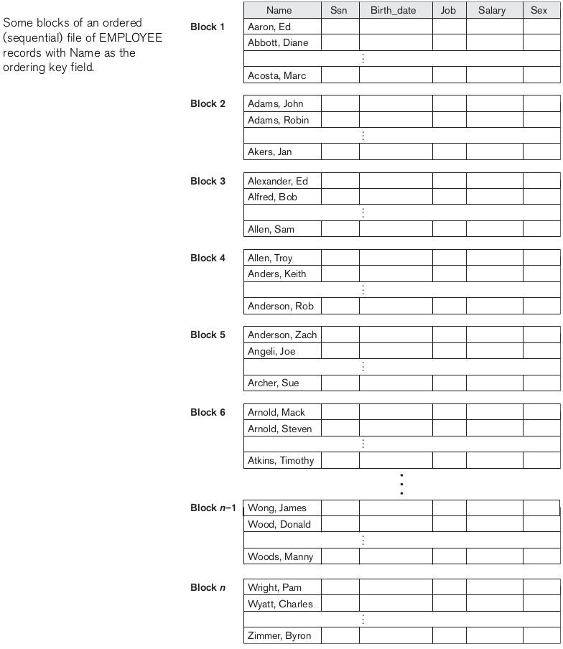
Insertion and deletion: Inserting and deleting records are expensive operations for an ordered file because the records must remain physically ordered. To insert a record, we must find its correct position in the file, based on its ordering field value, and then make space in the file to insert the record in that position. For a large file this can be very time consuming because, on the average, half the records of the file must be moved to make space for the new record. This means that half the file blocks must be read and rewritten after records are moved

among them. For record deletion, the problem is less severe if deletion markers and periodic reorganization are used.
One option for making insertion more efficient is to keep some unused space in each block for new records. However, once this space is used up, the original problem resurfaces.
Modifying: Modifying a field value of a record depends on two factors: (1) the search condition to locate the record and (2) the field to be modified. If the search condition involves the ordering key field, we can locate the record using a binary search; otherwise we must do a linear search. A non ordering field can be modified by changing the record and rewriting it in the same physical location on disk-assuming fixed-length records. Modifying the ordering field means that the record can change its position in the file, which requires deletion of the old record followed by insertion of the modified record.
Reading: Reading the file records in order of the ordering field is quite efficient if we ignore the records in overflow, since the blocks can be read consecutively using double buffering. To include the records in overflow, we must merge them in their correct positions; in this case, we can first reorganize the file, and then read its blocks sequentially.
Ordered files are rarely used in database applications unless an additional access path, called a primary index, is used; this results in an indexed sequential file. This further improves the random access time on the ordering key field. If Ordering attribute is not key then the file is Clustered file.

HASHING:
Another type of primary file organization is based on hashing, which provides very fast access to records on certain search conditions. This organization is usually called a hash file. The search condition must be an equality condition on a single field, called the hash field of the file. In most cases, the hash field is also a key field of the file, in which case it is called the hash key. The idea behind hashing is to provide a function h, called a hash function or randomizing function, that is applied to the hash field value of a record and yields the address of the disk block in which the record is stored.
Internal Hashing:
For internal files, hashing is typically implemented as a hash table through the use of an array of records. For array index range is from 0 to M - 1 have M slots whose addresses correspond to the array indexes. We choose a hash function that transforms the hash field value into an integer between 0 and M - 1.One common hash function is the h(K) = K mod M function.
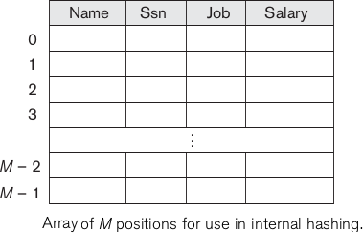
Non integer hash field values can be transformed into integers before the mod function is applied. For character strings, the numeric (ASCII) codes associated with characters can be used in the transformation-for example, by multiplying those code values.

Other hashing functions can be used. One technique, called folding, involves applying an arithmetic function such as addition or a logical function such as exclusive or to different portions of the hash field value to calculate the hash address. Another technique involves picking some digits of the hash field value-for example, the third, fifth, and eighth digits-to form the hash address. to The problem with most hashing functions is that they do not guarantee that distinct values will hash to distinct addresses, because the hash field space-the number of possible values a hash field can take-is usually much larger than the address space-the number of available addresses for records. The hashing function maps the hash field space to the address space.
A collision occurs when the hash field value of a record that is being inserted hashes to an address that already contains a different record. In this situation, we must insert the new record in some other position, since its hash address is occupied. The process of finding another position is called collision resolution. There are numerous methods for collision resolution, including the following:
- Open addressing: Proceeding from the occupied position specified by the hash address, the program checks the subsequent positions in order until an unused (empty) position is found.
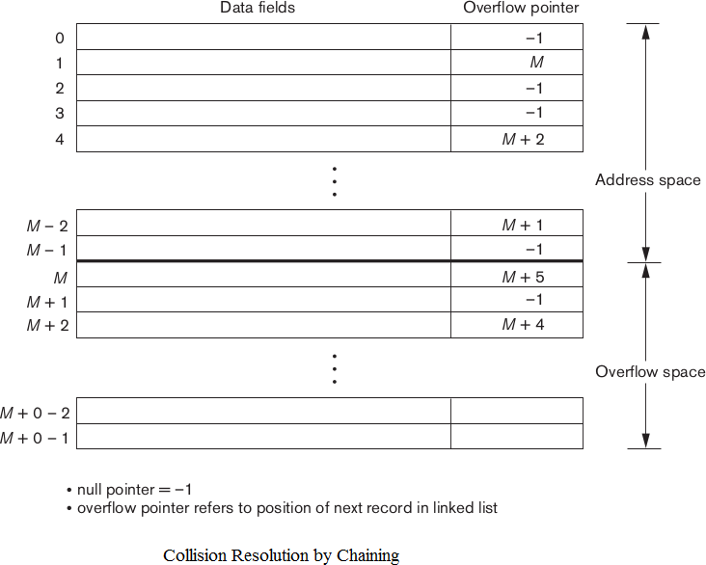
- Chaining: For this method, various overflow locations are kept, usually by extending the array with a number of overflow positions. In addition, a pointer field is added to each record location. A collision is resolved by placing the new record in an unused overflow location and setting the pointer of the occupied hash address location to the address of that overflow location. A linked list of overflow records for each hash address is thus maintained.

- Multiple hashing: The program applies a second hash function if the first results in a collision. If another collision results, the program uses open addressing or applies a third hash function and then uses open addressing if necessary.
Each collision resolution method requires its own algorithms for insertion, retrieval, and deletion of records. The goal of a good hashing function is to distribute the records uniformly over the address space so as to minimize collisions while not leaving many unused locations.

External Hashing for Disk Files:
Hashing for disk files is called external hashing. To suit the characteristics of disk storage, the target address space is made of buckets, each of which holds multiple records. A bucket is either one disk block or a cluster of contiguous blocks. The hashing function maps a key into a relative bucket number, rather than assign an absolute block address to the bucket. A table maintained in the file header converts the bucket number into the corresponding disk block address.
The collision problem is less severe with buckets, because as many records as will fit in a bucket can hash to the same bucket without causing problems. However, we must make provisions for the case where a bucket is filled to capacity and a new record being inserted hashes to that bucket. We can use a variation of chaining in which a pointer is maintained in each bucket to a linked list of overflow records for the bucket. The pointers in the linked list should be record pointers, which include both a block address and a relative record position within the block.
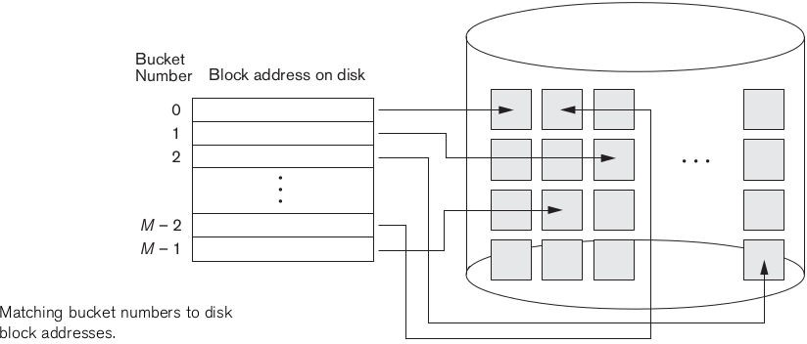
The hashing scheme described is called static hashing because a fixed number of buckets M is allocated. This can be a serious drawback for dynamic files. Suppose that we allocate M buckets for the address space and let m be the maximum number of records that can fit in one bucket then, at most (m * M) records will fit in the allocated space. If number of records turns out to be substantially fewer than (m * M), we are left with a lot of unused space. On the other hand, if the number of records increases to substantially more than (m * M), numerous collisions will result and retrieval will be slowed down because of the long lists of overflow records.
In either case, we may have to change the number of blocks M allocated and then use a new hashing function (based on the new value of M) to redistribute the records. These reorganizations can be quite time consuming for large files.

When using external hashing, searching for a record given a value of some field other than the hash field is as expensive as in the case of an unordered file. Record deletion can be implemented by removing the record from its bucket. If the bucket has an overflow chain, we can move one of the overflow records into the bucket to replace the deleted record. If the record to be deleted is already in overflow, we simply remove it from the linked list.

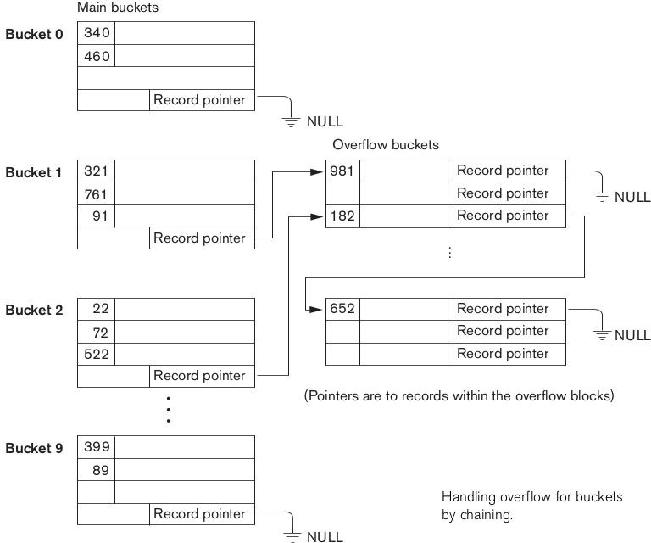

Hashing Techniques That Allow Dynamic File Expansion:
A major drawback of the static hashing scheme just discussed is that the hash address space is fixed.
Hence, it is difficult to expand or shrink the file dynamically. The techniques used in dynamic hashing are:
- Extendible Hashing
- Dynamic Hashing
- Linear Hashing
These hashing schemes take advantage of the fact that the result of applying a hashing function is a nonnegative integer and hence can be represented as a binary number. The access structure is built on the binary representation of the hashing function result, which is a string of bits. We call this the hash value of a record. Records are distributed among buckets based on the values of the leading bits in their hash values.

Extendible Hashing: In extendible hashing, a type of directory-an array of 2^{d} bucket addresses-is maintained, where d is called the global depth of the directory. The integer value corresponding to the first (high-order) d bits of a hash value is used as an index to the array to determine a directory entry, and the address in that entry determines the bucket in which the corresponding records are stored. However, there does not have to be a

distinct bucket for each of the 2^{d} directory locations. Several directory locations with the same first d' bits for their hash values may contain the same bucket address if all the records that hash to these locations fit in a single bucket. A local depth d'-stored with each bucket-specifies the number of bits on which the bucket contents are based.
Bucket splitting: suppose that a new inserted record causes overflow in the bucket whose hash values start with 01-the third bucket, the records will be distributed between two buckets: the first contains all records whose hash values start with 010, and the second all those whose hash values start with 011. Now the two directory locations for 010 and 011 point to the two new distinct buckets. Before the split, they pointed to the same bucket. The local depth d' of the two new buckets is 3, which is one more than the local depth of the old bucket.
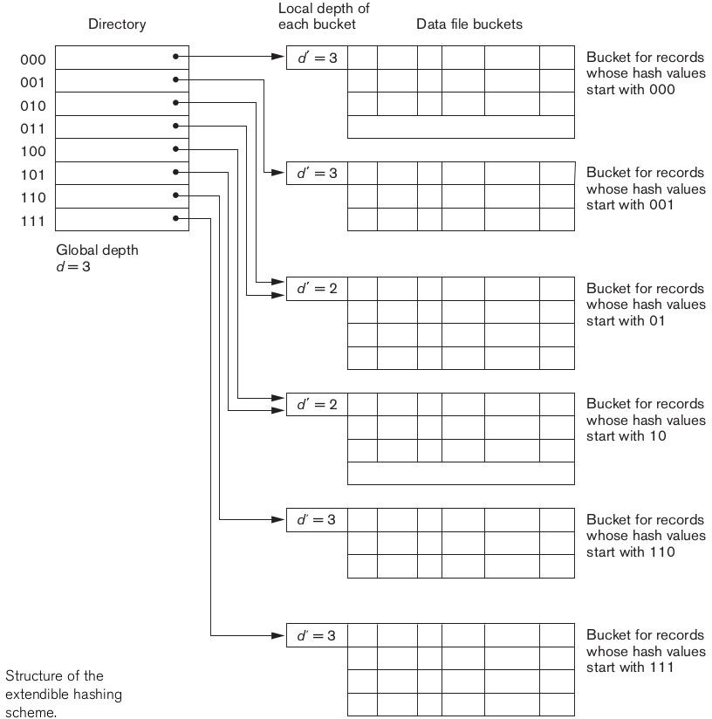

Overflow: If a bucket that overflows and is split used to have a local depth d' equal to the global depth d of the directory, then the size of the directory must now be doubled so that we can use an extra bit to distinguish the two new buckets. For example, if the bucket for records whose hash values start with 111 overflows, the two new buckets need a directory with global depth d = 4, because the two buckets are now labeled 1110 and 1111, and hence their local depths are both 4. The directory size is hence doubled, and each of the other original

locations in the directory is also split into two locations, both of which have the same pointer value as did the original location.
The main advantage of extendible hashing that makes it attractive is that the performance of the file does not degrade as the file grows, as opposed to static external hashing where collisions increase and the corresponding chaining causes additional accesses. In addition, no space is allocated in extendible hashing for future growth, but additional buckets can be allocated dynamically as needed. Another advantage is that splitting causes minor reorganization in most cases, since only the records in one bucket are redistributed to the two new buckets.
A disadvantage is that the directory must be searched before accessing the buckets themselves, resulting in two block accesses instead of one in static hashing. This performance penalty is considered minor.

Dynamic Hashing:
A precursor to extendible hashing was dynamic hashing, in which the addresses of the buckets were either the n- higher order bits or n-1 higher order bits, depending n the total number of keys belonging to the respective bucket. The eventual storage of records in buckets for dynamic hashing is somewhat similar to extendible hashing. The major difference is in the organization of the directory. whereas extendible hashing uses the notion of global depth (higher order d bits) for the flat directory and then combines adjacent collapsible buckets into a bucket of local depth d-1, dynamic hashing maintains a tree structured directory with two types of nodes.
- Internal nodes that have two pointers - the left pointer corresponds to the 0 bit (in the hashed address) and a right pointer corresponding to the 1 bit.
- Leaf nodes - these hold a pointer to the actual bucket with records. An example of the dynamic hashing appears as shown in the figure.
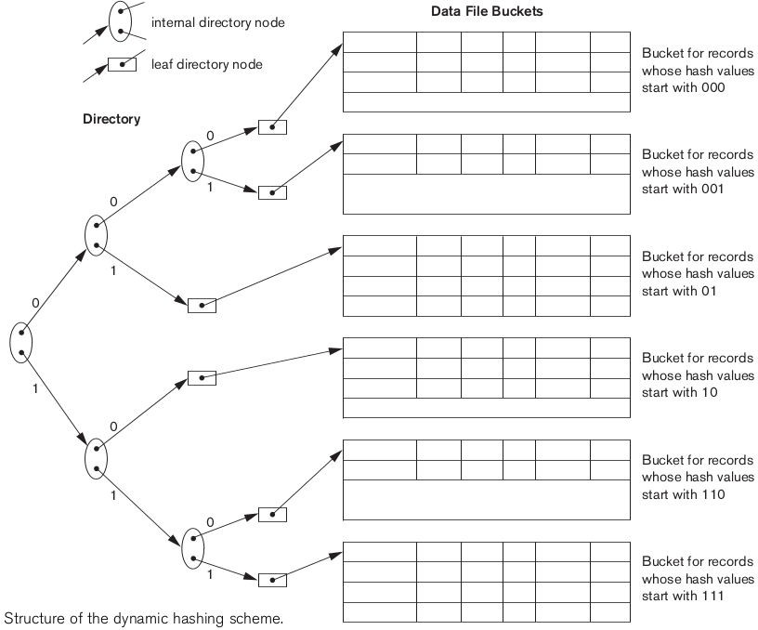

Four buckets are shown ("000","001","110" and "111") with higher order 3 bit addresses (corresponding to the global depth of 3), and two buckets ("01" and "10") are shown with higher order 2 bit addresses (corresponding to the local depth of 2). The latter two are the result of collapsing the "010" and "011" into "01" and collapsing "100" and "101" into "10". Note that the directory nodes are used implicitly to determine local and global depths of buckets in dynamic hashing.
The search for a record given the hashed address involves traversing the directory tree which leads to the bucket holding that record.
Linear Hashing:
The idea behind linear hashing is to allow a hash file to expand and shrink its number of buckets dynamically without needing a directory. Suppose that the file starts with M buckets numbered 0, 1, ... , M - 1 and uses the mod hash function h(K) = K mod M; this hash function is called the initial hash function h_{i}
.Overflow because of collisions is still needed and can be handled by maintaining individual overflow chains for each bucket. However, when a collision leads to an overflow record in any file bucket, the first bucket in the file-bucket 0-is split into two buckets: the original bucket 0 and a new bucket M at the end of the file. The records originally in bucket 0 are distributed between the two buckets based on a different hashing function h_{i+1}(K) = K mod 2M. A key property of the two hash functions h_{i} and h_{i+1} is that any records that hashed to bucket 0 based on hi will hash to either bucket 0 or bucket M based on h_{i+1}; this is necessary for linear hashing to work.
As further collisions lead to overflow records, additional buckets are split in the linear order 1, 2, 3, .... If enough overflows occur, all the original file buckets 0, 1, ... ,M - 1 will have been split, so the file now has 2M instead of M buckets, and all buckets use the hash function h_{i+1} . Hence, the records in overflow are eventually redistributed into regular buckets, using the function h_{i+1} via a delayed split of their buckets. There is no directory; only a value n-which is initially set to 0 and is incremented by 1 whenever a split occurs-is needed to determine which buckets have been split. To retrieve a record with hash key value K, first apply the function hi to K; if h_{i}(K) < n, then apply the function h_{i+1} on K because the bucket is already split. Initially, n = 0, indicating that the function h_{i} applies to all buckets; n grows linearly as buckets are split.

Splitting can be controlled by monitoring the file load factor instead of by splitting whenever an overflow occurs. In general, the file load factor 1can be defined as l= r/(bfr * N), where r is the current number of file records, bfr is the maximum number of records that can fit in a bucket, and N is the current number of file buckets. Buckets that have been split can also be recombined if the load of the file falls below a certain threshold. Blocks are combined linearly, and N is decremented appropriately. The file load can be used to trigger both splits and combinations; in this manner the file load can be kept within a desired range.

Single Level Order Indexes:
An ordered index access structure is similar to that behind the index used in a textbook, which lists important terms at the end of the book in alphabetical order along with a list of page numbers where the term appears in the book. We can search an index to find a list of addresses page numbers in this case-and use these addresses to locate a term in the textbook by searching the specified pages. Without index, searching for a phrase in a text book by shifting through whole textbook is like linear search.
For a file with a given record structure consisting of several fields (or attributes), an index access structure is usually defined on a single field of a file, called an indexing field (or indexing attribute). The index typically stores each value of the index field along with a list of pointers to all disk blocks that contain records with that field value. The values in the index are ordered so that we can do a binary search on the index. The index file is much smaller than the data file, so searching the index using a binary search is reasonably efficient.

There are several types of ordered indexes.
A primary index is specified on the ordering key field of an ordered file of records. An ordering key field is used to physically order the file records on disk, and every record has a unique value for that field. Primary index works for the records having a key field.
A clustering index is used if numerous records in the file can have the same value for the ordering field. A file can have at most one physical ordering field, so it can have at most one primary index or one clustering index, but not both.
A secondary index, can be specified on any non-ordering field of a file. A file can have several secondary indexes in addition to its primary access method.

PRIMARY INDEX:
A primary index is an ordered file whose records are of fixed length with two fields. The first field is of the same data type as the ordering key field-called the primary key-of the data file, and the second field is a pointer to a disk block (a block address). There is one index entry (or index record) in the index file for each block in the data file. Each index entry has the value of the primary key field for the first record in a block and a pointer to that block as its two field values. We will refer to the two field values of index entry i as < K(i),P(i) >.
To create a primary index on the ordered file introduced , we use the NAME field as primary key, because that is the ordering key field of the file (assuming that each value of NAME is unique). Each entry in the index has a NAME value and a pointer. The first three index entries are as follows:
<K(l) = (Aaron,Ed), P(l) = address of block 1>
<K(2) = (Adams.john), P(2) = address of block 2>
<K(3) = (Alexander,Ed), P(3) = address of block 3> Below figure illustrates this primary index.
The total number of entries in the index is the same as the number of disk blocks in the ordered data file. The first record in each block of the data file is called the anchor record of the block, or simply the block anchor.
Indexes can also be characterized as dense or sparse.
A dense index has an index entry for every search key value (and hence every record) in the data file. A sparse (or non-dense) index on the other hand, has index entries for only some of the search values.
A primary index is hence a non-dense (sparse) index, since it includes an entry for each disk block of the data file and the keys of its anchor record rather than for every search value. The index file for a primary index needs substantially fewer blocks than does the data file, for two reasons.
- There are fewer index entries than there are records in the data file.
- Each index entry is typically smaller in size than a data record because it has only two fields; consequently, more index entries than data records can fit in one block. Hence requires fewer block accesses than searching on the data file.
The binary search for an ordered data file required log ₂ b block accesses. where b is the no. of blocks in the data file. But if the primary index file contains b, blocks, then to locate a record with a search key value requires a binary search of that index and access to the block containing that record: a total of log ₂ b_{i} +1 accesses.
A major problem with a primary index-as with any ordered file-is insertion and deletion of records. With a primary index, the problem is compounded because, if we attempt to insert a record in its correct position in the data file, we have to not only move records to make space for the new record but also change some index entries, since moving records will change the anchor records of some blocks.
Solution for this is using an unordered overflow file or using a linked list of overflow records for each block in the data file.

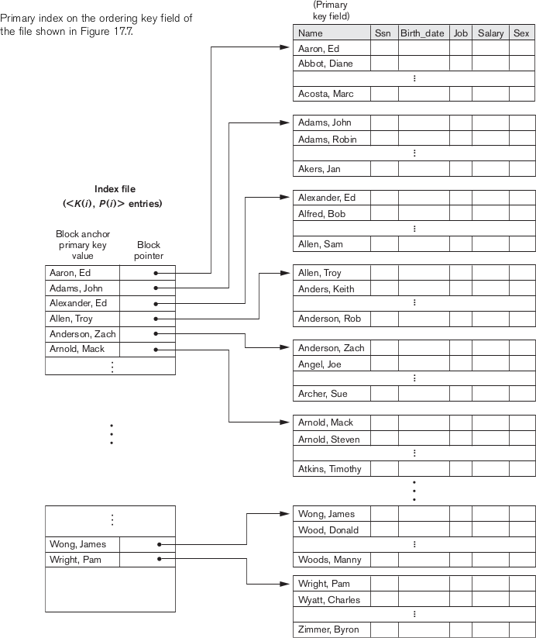

CLUSTERING INDEX:
If records of a file are physically ordered on a non-key field-which does not have a distinct value for each record-that field is called the clustering field. We can create a different type of index, called a clustering index, to speed up retrieval of records that have the same value for the clustering field. This differs from a primary index, which requires that the ordering field of the data file have a distinct value for each record.
A clustering index is also an ordered file with two fields; the first field is of the same type as the clustering field of the data file, and the second field is a block pointer. There is one entry in the clustering index for each distinct value of the clustering field, containing the value and a pointer to the first block in the data file that has a record with that value for its clustering field.

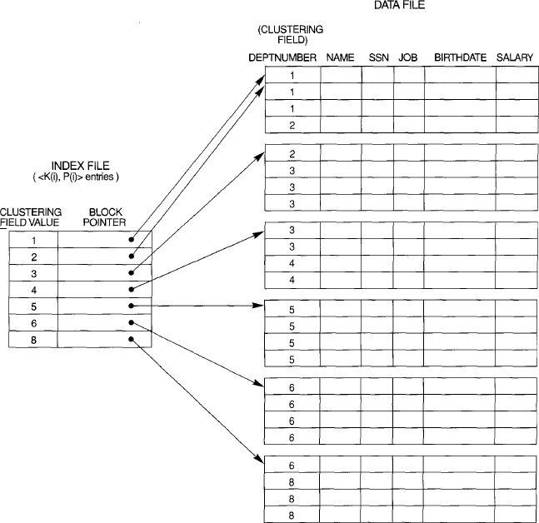
Record insertion and deletion still cause problems, because the data records are physically ordered. To alleviate the problem of insertion, it is common to reserve a whole block (or a cluster of contiguous blocks) for each value of the clustering field; all records with that value are placed in the block (or block cluster). This makes insertion and deletion relatively straightforward.
A clustering index is another example of a non-dense index, because it has an entry for every distinct value of the indexing field which is a non-key by definition and hence has duplicate values rather than for every record in the file.

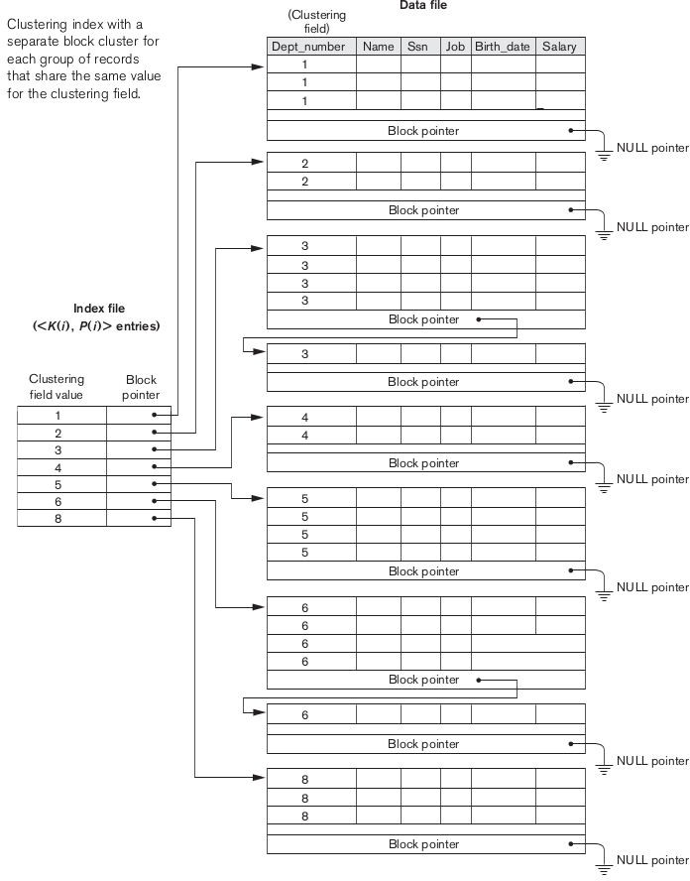

SECONDARY INDEXES:
A secondary index provides a secondary means of accessing a file for which some primary access already exists. The secondary index may be on a field which is a candidate key and has a unique value in every record, or a non key with duplicate values. The index is an ordered file with two fields. The first field is of the same data type as some non ordering field of the data file that is an indexing field. The second field is either a block pointer or a record pointer. There can be many secondary indexes (and hence, indexing fields) for the same file.
We first consider a secondary index access structure on a key field that has a distinct value for every record. Such a field is sometimes called a secondary key. In this case there is one index entry for each record in

the data file, which contains the value of the secondary key for the record and a pointer either to the block in which the record is stored or to the record itself. Hence, such an index is dense.
We again refer to the two field values of index entry i as <K(i), P(i)>. The entries are ordered by value of K(i), so we can perform a binary search. Because the records of the data file are not physically ordered by values of the secondary key field, we cannot use block anchors. P(i) in the index entries are block pointers, not record pointers. Once the appropriate block is transferred to main memory, a search for the desired record within the block can be carried out.
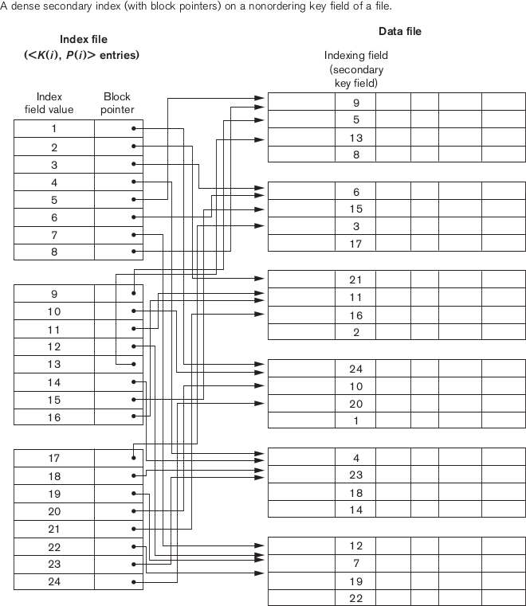
A secondary index usually needs more storage space and longer search time than does a primary index, because of its larger number of entries. However, the improvement in search time for an arbitrary record is much greater for a secondary index than for a primary index.
We can also create a secondary index on a non key field of a file. In this case, numerous records in the data file can have the same value for the indexing field. There are several options for implementing such an index:

- Option 1 is to include several index entries with the same K(i) value-one for each record. This would be a dense index.
- Option 2 is to have variable-length records for the index entries, with a repeating field for the pointer.
<K(i),<P(i,1),P(i,2) P(i,k)>
- Option 3, which is more commonly used, is to keep the index entries themselves at a fixed length and have a single entry for each index field value but to create an extra level of indirection to handle the multiple pointers. In this non dense scheme, the pointer P(i) in index entry <K(i), P(i)> points to a block of record pointers; each record pointer in that block points to one of the data file records with value K(i) for the indexing field. If some value K(i) occurs in too many records, so that their record pointers cannot fit in a single disk block, a cluster or linked list of blocks is used.
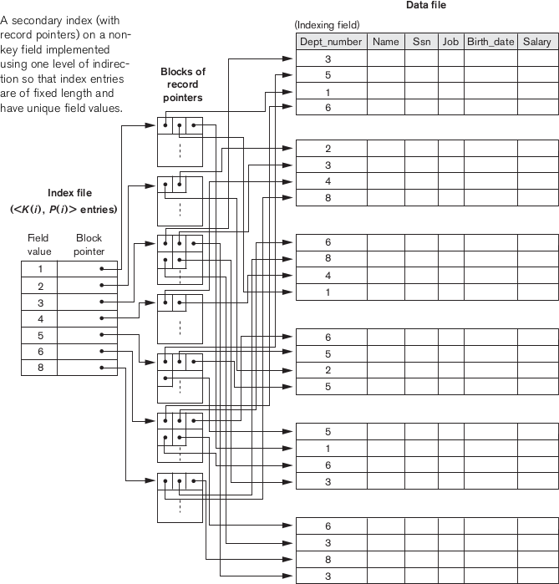

MULTI LEVEL INDEXES:
The idea behind a multilevel index is to reduce the part of the index that we continue to search by bfr_{i}, the blocking factor for the index, which is larger than 2. Hence, the search space is reduced much faster. The value bfr_{i} is called the fan-out of the multilevel index, and we will refer to it by the symbol f₀, Searching a multilevel index requires approximately (log _{fo} b_{i}) block accesses, which is a smaller number than for binary search if the fan-out is larger than 2.

A multilevel index considers the index file, which we will now refer to as the first (or base) level of a multilevel index, as an ordered file with a distinct value for each K(i). Hence we can create a primary index for the first level; this index to the first level is called the second level of the multilevel index. Because the second level is a primary index, we can use block anchors so that the second level has one entry for each block of the first level. The blocking factor bfr_{i} for the second level-and for all subsequent levels-is the same as that for the first-level index, because all index entries are the same size; each has one field value and one block address. If the first level has r₁ entries, and the blocking factor-which is also the fan-out-for the index is bfr_{i} = f₀, then the first level needs ceil((r₁/f₀)) blocks, which is therefore the number of entries r₂ needed at the second level of the index.
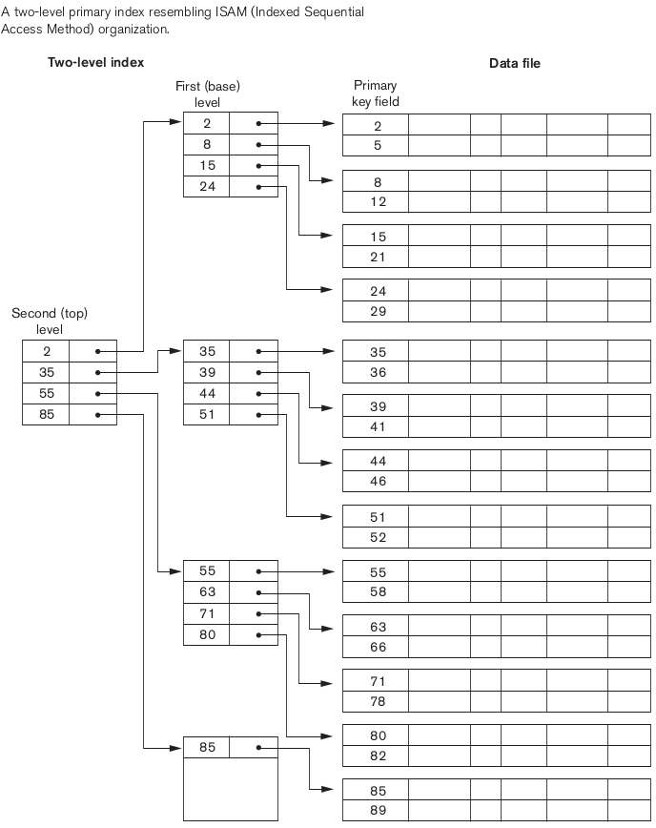
We can repeat this process for the second level. The third level, which is a primary index for the second level, has an entry for each second-level block, so the number of third-level entries is r3 = ceil((r₂/f₀)). Notice that we require a second level only if the first level needs more than one block of disk storage, and, similarly, we require a third level only if the second level needs more than one block. We can repeat the preceding process until all the entries of some index level t fit in a single block. This block at the t^{th} level is called the top index level. Each level reduces the number of entries at the previous level by a factor of f₀-the index fan-out-so we can use the formula l<= (r₁/((f₀)^{t})) to calculate t. Hence, a multilevel index with r₁ first-level entries will have approximately t levels, where t = CEIL((log _{fo} (r₁))).

DYNAMIC MULTILEVEL INDEXES USING B-TREES AND B+-TREES
Search Trees and B-Trees:
A search tree is a special type of tree that is used to guide the search for a record, given the value of one of the record's fields. A search tree is slightly different from a multilevel index. A search tree of order p is a tree such that each node contains at most p - 1 search values and p pointers in the order
<P₁, K₁, P₂, K₂ ... , P_{q-1} , K_{q-1} , P_{q}> , where q <= p; each Pi
is a pointer to a child node (or a null pointer); and each K_{i}, is a search value from some ordered set of values. All search values are assumed to be unique. Two constraints must hold at all times on the search tree:
- Within each node, K₁ < K₂ < K₃ < <K_{q-1} .
- For all values X in the sub tree pointed at by P_{i} we have Ki-1 < X < K, for 1 < i < q; X < K_{i}, for i = 1; and Ki- 1 < X for i = q
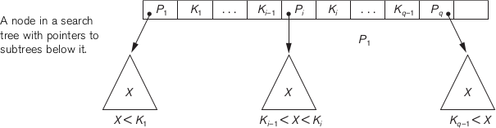

We can use a search tree as a mechanism to search for records stored in a disk file. The values in the tree can be the values of one of the fields of the file, called the search field (which is the same as the index field if a multilevel index guides the search). Each key value in the tree is associated with a pointer to the record in the data file having that value. Alternatively, the pointer could be to the disk block containing that record. The search tree itself can be stored on disk by assigning each tree node to a disk block. When a new record is inserted, we must update the search tree by inserting an entry in the tree containing the search field value of the new record and a pointer to the new record.
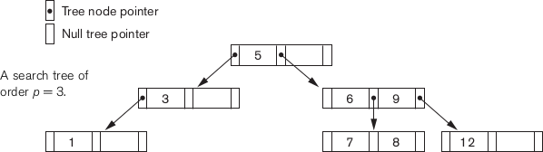

Algorithms are necessary for inserting and deleting search values into and from the search tree while maintaining the preceding two constraints. In general, these algorithms do not guarantee that a search tree is balanced, meaning that all of its leaf nodes are at the same level.
Keeping a search tree balanced is important because it guarantees that no nodes will beat very high levels and hence require many block accesses during a tree search. Keeping the tree balanced yields a uniform search speed regardless of the value of the search key. Another problem with search trees is that record deletion may leave some nodes in the tree nearly empty, thus wasting storage space and increasing the number of levels. The B-tree addresses both of these problems by specifying additional constraints on the search tree.

B-Trees:
The B-tree has additional constraints that ensure that the tree is always balanced and that the space wasted by deletion, if any, never becomes excessive.
More formally, a B-tree of order p, when used as an access structure on a key field to search for records in a data file, can be defined as follows:
- Each internal node in the B-tree is of the form
<P₁,<K₁,Pr₁>,P₂,<K₂,Pr₂> ,<K_{q-1},Pr_{q-1}>,P_{q}>
where q<=p. Each Pi is a tree pointer - a pointer to another node in the B-tree. Each Prj is a data pointer - a pointer to the record whose search key field value is equal to K, (or to the data file block containing that record).
- Within each node, K₁ < K₂< ... < K_{q-1}
- For all search key field values X in the sub tree pointed at by P_{i} (the i^{th} sub tree, see Figure), we have: K_{i-1} < X < K_{i} for 1 < i < q; X < K_{i} for i=1 and K_{i-1} < X for i = q.
- Each node has at most p tree pointers.
- Each node, except the root and leaf nodes, has at least Ceil(p/2) tree pointers. The root node has at least two tree pointers unless it is the only node in the tree.
- A node with q tree pointers, q <= p, has q - 1 search key field values (and hence has q - 1 data pointers).
- All leaf nodes are at the same level. Leaf nodes have the same structure as internal nodes except that all of their tree pointers P, are null.
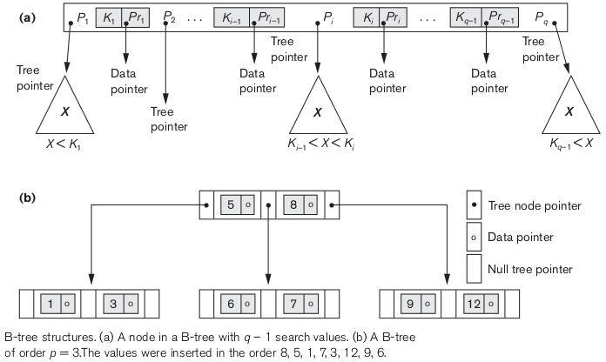

B+Trees:
Most implementations of a dynamic multilevel index use a variation of the B-tree data structure called a B+-tree. In a B-tree, every value of the search field appears once at some level in the tree, along with a data pointer. In a B+-tree, data pointers are stored only at the leaf nodes of the tree; hence, the structure of leaf nodes differs from the structure of internal nodes. The leaf nodes have an entry for every value of the search field, along with a data pointer to the record (or to the block that contains this record) if the search field is a key field. For a non key search field, the pointer points to a block containing pointers to the data file records, creating an extra level of indirection.

The leaf nodes of the W-tree are usually linked together to provide ordered access on the search field to the records. These leaf nodes are similar to the first (base) level of an index. Internal nodes of the B+-tree correspond to the other levels of a multilevel index. Some search field values from the leaf nodes are repeated in the internal nodes of the B+ tree to guide the search.
The structure of the internal nodes of a B+ tree of order p is as follows:
- Each internal node is of the form <P₁,K₁,P₂,K₂,......,P_{q-1},K_{q-1},P_{q}> where q <= P and each P_{i} is a tree pointer.
- Within each internal node, K₁ < K₂ < < K_{q-1}
- For all search field values X in the sub tree pointed at by P_{i}, we have K_{i-1} < X <= K_{i}, for 1 < i < q; X <= K, for i = 1; and K_{i-1} < X for i = q
- Each internal node has at most p tree pointers.
- Each internal node, except the root, has at least Ceil(p/2) tree pointers. The root node has at least two tree pointers if it is an internal node.
- An internal node with q pointers, q <= p, has q - 1 search field values.

The structure of the leaf nodes of a B⁺-tree of order p is as follows:
- Each leaf node is of the form <<K₁,Pr₁>,<K₂,Pr₂>,. <K_{q-1},Pr_{q-1}>,P_{next}>
where q <= p, each Pr_{i}, is a data pointer, and P_{next} points to the next leaf node of the B+-tree.
- Within each leaf node, K₁ < K₂ < < K_{q-1}, q <= p.
- Each Pr, is a data pointer that points to the record whose search field value is K, or to a file block containing the record (or to a block of record pointers that point to records whose search field value is K, if the search field is not a key).
- Each leaf node has at least Ceil(p/2)) values.
- All leaf nodes are at the same level.
The pointers in internal nodes are tree pointers to blocks that are tree nodes, whereas the pointers in leaf nodes are data pointers to the data file records or blocks-except for the P_{next} pointer, which is a tree pointer to the next leaf node. By starting at the leftmost leaf node, it is possible to traverse leaf nodes as a linked list, using the P_{next} pointers. This provides ordered access to the data records on the indexing field.
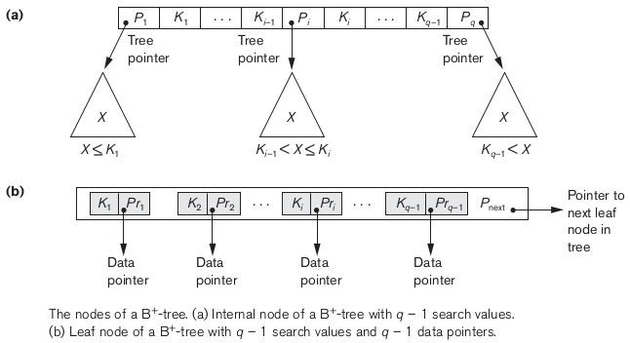

Comparison between B-trees and B+ trees:
Because entries in the internal nodes of a B+-tree include search values and tree pointers without any data pointers, more entries can be packed into an internal node of a B+-tree than for a similar B-tree. Thus, for the same block (node) size, the order p will be larger for the B+-tree than for the B-tree. This can lead to fewer B+-tree levels, improving search time. Because the structures for internal and for leaf nodes of a B+-tree are different, the order p can be different. We will use p to denote the order for internal nodes and P_{leaf} to denote the order for leaf nodes, which we define as being the maximum number of data pointers in a leaf node.
Indexes on Multiple Keys:
If a certain combination of attributes is used very frequently, it is advantageous to set up an access structure to provide efficient access by a key value that is a combination of those attributes. For example: List the employees whose deptno is 4 and age is 59. To find this there are alternative search strategies. They are:
- If deptno has index but not age, then select the records having deptno 4 and then filtering based on age.
- If age had index but not deptno, then select records having age 59 and filter the records based on deptno.
- If both have indexes, then an intersection of these sets of records or pointers yields those records that satisfy both conditions, those records that satisfy both conditions, or the blocks in which records satisfying both conditions are located.
All of these alternatives eventually give the correct result. However, if the set of records that meet each condition (deptno = 4 or age = 59) individually are large, yet only a few records satisfy the combined condition, then none of the above is a very efficient technique for the given search request.
Ordered Index on Multiple Attributes:
In general, if an index is created on attributes <A₁, A₂, ... , A_{n}>, the search key values are tuples with n values:
<v₁, v₂,. , v_{n}>.
A lexicographic ordering of these tuple values establishes an order on this composite search key. For our example, all of department keys for department number 3 precede those for department 4. Thus <3, n> precedes
<4, m> for any values of m and n. The ascending key order for keys with Dna = 4 would be <4, 18>, <4, 19>,
<4,20>, and so on. Lexicographic ordering works similarly to ordering of character strings.
Partitioned Hashing:
Partitioned hashing is an extension of static external hashing that allows access on multiple keys. It is suitable only for equality comparisons; range queries are not supported. In partitioned hashing, for a key consisting of n components, the hash function is designed to produce a result with n separate hash addresses. The bucket address is a concatenation of these n addresses. It is then possible to search for the required composite search key by looking up the appropriate buckets that match the parts of the address in which we are interested.
An advantage of partitioned hashing is that it can be easily extended to any number of attributes. The bucket addresses can be designed so that high order bits in the addresses correspond to more frequently accessed attributes. Additionally, no separate access structure needs to be maintained for the individual attributes. The main drawback of partitioned hashing is that it cannot handle range queries on any of the component attributes.
Grid Files:
Another alternative is to organize the EMPLOYEE file as a grid file. we can construct a grid array with one linear scale (or dimension) for each of the search attributes.
The scales are made in a way as to achieve a uniform distribution of that attribute. Thus, in our example, we show that the linear scale for DNO has DNO = 1, 2 combined as one value a on the scale, while DNO = 5 corresponds to the value 2 on that scale. Similarly, AGE is divided into its scale of 0 to 5 by grouping ages so as

to distribute the employees uniformly by age. The grid array shown for this file has a total of 36 cells. Each cell points to some bucket address where the records corresponding to that cell are stored.
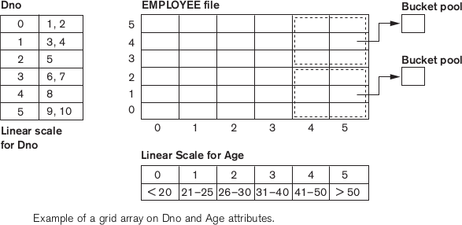
Thus our request for DNO = 4 and AGE = 59 maps into the cell (1, 5) corresponding to the grid array. The records for this combination will be found in the corresponding bucket. This method is particularly useful for range queries that would map into a set of cells corresponding to a group of values along the linear scales. Grid files perform well in terms of reduction in time for multiple key access. However, they represent a space overhead in terms of the grid array structure.
Moreover, with dynamic files, a frequent reorganization of the file adds to the maintenance cost.

