
School of Computing
Department of Computer Science & Engineering
CODING BATTLE PLATFORM
Interactive Competitive Java Programming, Timed Battles & Faculty Command System
Mini Project Report
Submitted by
98260040004 – Veeramreddy Uday Kumar Reddy (Lead)
99250040089 – Beedhireddypalli Hari Prasad
99250040155 – Kolluri Abhishek
99250040946 – Ch. Jaya Naga Kasi Vardhan
99250040597 – Harshavardhanreddy Rachapalli
In partial fulfilment for the award of the degree of
Bachelor Of Technology
in
Computer Science and Engineering

SCHOOL OF COMPUTING COMPUTER SCIENCE
AND ENGINEERING
KALASALINGAM ACADEMY OF RESEARCH AND EDUCATION
KRISHNANKOIL 626 126
November 2026

DECLARATION
We hereby declare that this mini project “CODING BATTLE PLATFORM” is our genuine work carried out by us under the guidance of Mrs. S. Reshni, ME., Assistant Professor, Department of Computer Science and Engineering, Kalasalingam Academy of Research and Education.
We declare that this project has been developed as part of the academic requirements for the Object Oriented Programming using Java (CSE203) course. The work presented in this report is our own, and all sources of information, references, and resources used in the development of the project have been duly acknowledged. We further declare that we have contributed to the design, development, implementation, testing, and documentation of the project according to our assigned roles. We take responsibility for the authenticity of the work submitted and confirm that this project has not been submitted previously, either in whole or in part, for any other academic assessment.
REGISTER NUMBER | STUDENT NAME | STUDENT SIGNATURE
98260040004 | VEERAMREDDY UDAY KUMAR REDDY
99250040089 | BEEDHIREDDYPALLI HARI PRASAD
99250040155 | KOLLURI ABHISHEK
99250040946 | CH. JAYA NAGA KASI VARDHAN
99250040597 | HARSHAVARDHANREDDY RACHAPALLI
Date of End Semester Project Review: ____________________
2

BONAFIDE CERTIFICATE
Certified that this report titled “Coding Battle Platform”, for the Project Based Learning, is a Bonafide work of VEERAMREDDY UDAY KUMAR REDDY (98260040004), BEEDHIREDDYPALLI HARI PRASAD (99250040089), KOLLURI ABHISHEK (99250040155), CH. JAYA NAGA KASI VARDHAN (99250040946), and HARSHAVARDHANREDDY RACHAPALLI (99250040597) who carried out the work together as a team for the fulfilment of the requirements for the award of the degree of Bachelor of Technology in Computer Science and Engineering, during the Academic year Odd Semester (2026-2027).
Place: Krishnankoil
Date: ____________________
Mrs. S. Reshni, ME., Dr. R. Raja Subramanian, M.E., Ph.D.,
Project Guide & Assistant Professor, Professor and Head of Department,
Department of Computer Science & Engineering, Department of Computer Science & Engineering,
Kalasalingam Academy of Research & Education, Kalasalingam Academy of Research & Education,
Krishnankoil - 626126. Krishnankoil - 626126.
3

ACKNOWLEDGEMENT
We express our sincere gratitude to our institution and the Department of Computer Science and Engineering for providing us with the opportunity, advanced laboratories, and resources to undertake this mini project as part of the Object Oriented Programming using Java (CSE203) course.
We extend our heartfelt thanks to our Head of the Department, Dr. R. Raja Subramanian, M.E., Ph.D., for the constant encouragement, academic facilities, and continuous support provided throughout the project lifecycle.
We are profoundly grateful to our course faculty and project guide Mrs. S. Reshni, ME., Assistant Professor, for her valuable guidance, technical suggestions, constructive reviews, and continuous mentorship during the design, development, sandboxed engine implementation, and testing of this project.
We also thank our classmates, peer reviewers, and faculty evaluation panel for their insightful feedback, cooperation, and teamwork which significantly enriched the platform's robustness.
Finally, we express our gratitude to our parents, family members, and friends who directly or indirectly encouraged and supported us in completing this mini project successfully.
4

TABLE OF CONTENTS
CHAPTER NO | CONTENTS | PAGE NO
1. | Introduction | 7
2. | 1.1 Problem Statement | 7
2. | 1.2 Objectives of the Project | 7
2. | 1.3 Scope of the Project | 8
2. | 1.4 Overview of the Coding Battle Platform | 8
2. | Existing & Proposed System | 9
3. | 2.1 Existing System | 9
3. | 2.2 Limitations of the Existing System | 9
3. | 2.3 Proposed System | 9
3. | 2.4 Advantages of the Proposed System | 10
3. | 2.5 Comparison of Existing and Proposed System | 10
3. | Requirements | 11
4. | 3.1 Hardware Requirements | 11
4. | 3.2 Software Requirements | 11
4. | 3.3 Functional Requirements | 11
4. | 3.4 Non-Functional Requirements | 12
4. | 3.5 Technologies Used | 12
4. | System Architecture & Design | 13
5. | 4.1 System Architecture | 13
5. | 4.2 System Modules | 13
5. | 4.3 Application Workflow | 14
5. | 4.4 System Flowchart | 15
5. | 4.5 Database Design Overview (ERD) | 16
5. | OOP Concepts Used | 17
6. | 5.1 Classes and Objects | 17
6. | 5.2 Encapsulation | 17
6. | 5.3 Abstraction | 17
6. | 5.4 Inheritance | 17
6. | 5.5 Polymorphism | 17
6. | 5.6 Application of OOP Concepts in the Project | 18
6. | Exception Handling & User-Defined Exceptions | 19
7. | 6.1 Exception Handling in Java | 19
7. | 6.2 Exception Handling in the Project | 19
7. | 6.3 Built-in Exceptions | 19
7. | 6.4 User-Defined Exceptions | 19
7. | 6.5 Error Handling and Input Validation | 20
7. | Collections & Data Structures / AI | 21
7. | 7.1 Java Collections Framework | 21
7. | 7.2 Custom Data Structures Used in the Project | 21
7. | 7.3 Data Management Using Java Objects | 22
7. | 7.4 AI & Machine Learning Applicability | 22

5

TABLE OF CONTENTS (CONTD.)
CHAPTER NO | CONTENTS | PAGE NO
8. | JDBC & Database | 23
9. | 8.1 Introduction to JDBC | 23
9. | 8.2 Database Connectivity | 23
9. | 8.3 Database Schema and Tables | 23
9. | 8.4 Database Operations (CRUD) | 24
9. | 8.5 Prepared Statements | 24
9. | 8.6 Database Initialization and Failover Management | 24
9. | Graphical User Interface | 25
10. | 9.1 User Interface Design | 25
10. | 9.2 Authentication Gate & Home Page | 25
10. | 9.3 Problem Solving Arena & Code Editor | 25
10. | 9.4 Timed Battle Arena & Countdown Clocks | 25
10. | 9.5 Global Leaderboard & Badges | 26
10. | 9.6 Faculty Command Suite & Assignment Broadcast | 26
10. | GitHub Details & Implementation | 27
11. | 10.1 GitHub Repository Details | 27
11. | 10.2 Project Structure and Package Organization | 27
11. | 10.3 Important Classes and Their Responsibilities | 27
11. | 10.4 Implementation of Major Modules | 28
11. | 10.5 Database Configuration and Setup | 28
11. | 10.6 Steps to Run the Application | 29
11. | Testing | 30
12. | 11.1 Testing Methodology | 30
12. | 11.2 Test Cases | 30
12. | 11.3 Functional Testing | 30
12. | 11.4 Database & Sandbox Testing | 31
12. | 11.5 Integration Testing | 31
12. | 11.6 Test Results | 31
12. | Results & Screenshots | 32
13. | 12.1 Project Results & Platform Demonstration | 32
13. | 12.2 High-Definition Application Screenshots | 33
13. | Conclusion | 41
14. | 13.1 Project Summary | 41
14. | 13.2 Learning Outcomes | 41
14. | Future Enhancement | 42
14. | 14.1 AI-Based Automated Code Review | 42
14. | 14.2 Multi-Language Sandboxed Execution | 42
14. | 14.3 Distributed Proctoring & Plagiarism Detection | 42

6

1. INTRODUCTION
In undergraduate computer science education, practical coding proficiency is paramount. Traditional laboratory curricula in Core Java often rely on offline coding, manual faculty inspections, paper records, and generic competitive programming websites. These traditional approaches fail to offer continuous automated feedback, lack integration with institutional syllabi, and provide no real-time synchronization during live classroom coding battles.
The Coding Battle Platform is an institutional competitive programming and academic laboratory evaluation system developed in accordance with the Object Oriented Programming using Java (CSE203) curriculum. It provides a full-stack Java architecture integrating JavaFX 21 as the interactive frontend, Core Java 17+ as the application layer incorporating custom Data Structures & Algorithms (DSA), and JDBC for persistent storage in a MySQL database (with resilient embedded H2 auto-failover).
1.1 Problem Statement
Computer science laboratories currently face three major bottlenecks: delayed manual evaluation of student source code, lack of process-isolated sandboxes leading to system freezes during infinite loops, and the absence of a unified faculty command portal to dispatch curriculum-aligned coding exams and monitor student cohorts in real-time. A unified, secure, and resilient platform that automatically compiles, sandboxes, evaluates, and ranks student Java programs is needed.
1.2 Objectives of the Project
1. To engineer an interactive Java competitive programming system utilizing JavaFX for desktop clients and modern web companion interfaces.
2. To design an isolated execution sandbox utilizing dynamic compilation (javac) and process watchdogs enforcing hard 3000ms execution timeouts.
3. To implement custom fundamental Data Structures and Algorithms (Max-Heap, QuickSort, Dual-Stack LIFO buffer, FIFO submission queue) without relying purely on standard collection black-boxes.
4. To build a dedicated Faculty Command Suite allowing instructors to schedule assignments, lab practicals, and exams, automatically broadcasting notifications to all students.
5. To maintain persistent storage through JDBC with parameterized SQL, ensuring zero viva downtime via auto-failover between MySQL and embedded H2.
7

1.3 Scope of the Project
The Coding Battle Platform encompasses the following functional domains:
Student Practice Arena: Chronologically ordered Core Java problems covering Class/Object encapsulation, Inheritance, Polymorphism, Recursion, Collections, and DSA.
Timed Battle Arena: Live synchronized countdown clock (MM:SS) with problem ribbons, instant solve indicators (✓), and dynamic scoreboard updates.
 | Process-Isolated | Sandbox: | Security | token | AST | scanning | filtering | illegal | calls
(Runtime.getRuntime(), ProcessBuilder, System.exit()), followed by isolated subprocess evaluation.
Faculty / Admin Command Suite: Unified administrative portal for problem authoring, test case management, assignment dispatch, real-time broadcasting, and grade overrides.
Gamification & Ranking: Algorithmic Top-K leaderboard sorting, category mastery progress bars, coding streaks, and milestone badges.
Out of Scope: External payment gateways, commercial SMS gateways, and cloud virtualization clusters are beyond the current laboratory scope.
1.4 Overview of the Coding Battle Platform
The platform follows a strictly decoupled Model-View-Controller (MVC) architecture. The presentation layer captures student source code in an interactive split-pane editor. The Controller dispatches code to a thread-safe SubmissionQueue. The background worker passes code to a dynamic Java compiler and executes it inside an isolated subprocess monitored by a 3000ms watchdog timer.
Outputs are compared against hidden test cases, scores are computed using the Strategy pattern in DefaultScoreCalculator, and records are persisted into MySQL via JDBC Data Access Objects (DAOs). The same backend services seamlessly power both the JavaFX desktop client and the deployed cloud platform at https://codingbattle.vercel.app.
8

2. EXISTING & PROPOSED SYSTEM
2.1 Existing System
In conventional laboratory setups, students write Java programs in basic text editors or standalone IDEs and present their console outputs manually to the laboratory instructor. Alternatively, institutions direct students to external commercial platforms such as LeetCode, HackerRank, or Codeforces. Faculty keep track of marks in offline spreadsheets, while test cases and grading rubrics are distributed via paper handouts or messaging groups.
2.2 Limitations of the Existing System
1. Manual Evaluation Delays: Instructors spend excessive lab hours manually testing each student's output, delaying diagnostic feedback.
2. Vulnerability to Unsafe Code: Running untrusted student code directly inside the host process risks JVM crashes, file system tampering, or infinite loops (e.g. while(true)).
3. No Real-Time Competition: Standard classroom environments lack synchronized contest clocks, real- time scoreboards, and instant solve checkmarks.
4. Decoupled Curriculum: Commercial coding websites focus on advanced algorithmic puzzles rather than reinforcing progressive Core Java OOP concepts.
5. Scattered Coursework Records: Submissions, test results, and marks are fragmented across local drives and spreadsheets, creating data loss risks.
2.3 Proposed System
The Coding Battle Platform provides an integrated, automated laboratory competition environment:
Subprocess Sandboxing: Isolates execution within spawned processes with 3000ms watchdog kill switches and AST token security filters.
Synchronized Contest Clocks: Timeline-driven countdown timers managing timed coding battles with problem ribbons and instant solve feedback.
Faculty Task Dispatcher: Allows instructors to author assignments and broadcast them instantly across student dashboards.
Custom Algorithmic Core: Employs binary max-heaps and median-of-three quicksorts for efficient ranking.
Dual-Engine Database Resilience: Seamless auto-failover from MySQL to embedded H2 guarantees zero presentation downtime.
9

2.4 Advantages of the Proposed System
1. Deterministic Instant Grading: Solutions are compiled and evaluated against visible and hidden test cases in milliseconds.
2. Host System Protection: Subprocess isolation and security filters prevent student code from accessing system resources or hanging the CPU.
3. Curriculum-Aligned Learning: Built-in catalog of 28 structured lab programs sequenced across Core Java modules.
4. Live Classroom Engagement: Synchronized battles and real-time leaderboards stimulate peer motivation and healthy competition.
5. Integrated Gradebook: Faculty can review submissions, inspect code diffs, override marks, and extend deadlines from a single screen.
2.5 Comparison of Existing and Proposed System
S.NO | Existing System (Manual / Generic Portals) | Proposed System (Coding Battle Platform)
1 | Manual code inspection by faculty; slow feedback | Instant automated test-case evaluation in isolated sandbox
2 | Infinite loops crash host JVM or freeze machine | 3000ms watchdog forcibly terminates runaway processes
3 | No synchronized countdown timer for live lab contests | Interactive Battle Arena with synchronized MM:SS countdown
4 | Generic algorithm trivia without Core Java focus | 28 curated programs sequenced to CSE203 syllabus units
5 | Black-box library sorting used for ranking | Custom Binary Max-Heap ($O(K log N)$) & QuickSort ($O(N log N)$)
6 | Offline spreadsheets for marks and assignments | Faculty Command Suite with live broadcast and gradebook
7 | No security scanner on untrusted code | AST token filter blocks Runtime, ProcessBuilder, System.exit
8 | Database crashes cause presentation failure | Automatic zero-config failover from MySQL to Embedded H2
9 | Disjointed single-user experience | Dual role-based portals (Student Arena & Faculty Command Suite)
10

3. REQUIREMENTS 3.1 Hardware Requirements
Component | Minimum Requirement
Processor | Intel Core i3 / AMD Ryzen 3 or equivalent (Dual-core 2.0 GHz)
RAM | 4 GB (8 GB recommended for concurrent compilation)
Hard Disk | 500 MB free space (JDK + Database storage)
Display | 1280 x 720 minimum (1920 x 1080 recommended for split editor)
Network | Localhost / Campus LAN / Internet (for deployed Vercel platform)
3.2 Software Requirements
Software Component | Description & Version
Operating System | Windows 10/11, Ubuntu 20.04+, or macOS Sonoma
Java Development Kit | OpenJDK 17 or higher (JDK 21 LTS recommended)
GUI Framework | JavaFX SDK 21 (for desktop) / HTML5 + CSS3 + ES6 (for web)
Database Server | MySQL Server 8.0 / Embedded H2 Database (Auto-Failover)
Database Driver | MySQL Connector/J 8.0.33 & H2 2.2.224
Build Automation | Apache Maven 3.8+
Version Control | Git & GitHub (Repository: udaykumarreddy07/CODING-BATTLE)
3.3 Functional Requirements
ID | Requirement | Description
FR1 | Role Authentication | Secure login with credentials; role-based routing (Student vs Admin/Faculty).
FR2 | Problem Catalog | Browse, search, and filter problems by category, difficulty, and points.
FR3 | Sandboxed Runner | Compile code with javac; run against sample and hidden test inputs.
FR4 | Watchdog Guardian | Hard CPU timeout killer terminating executions exceeding 3000ms.
FR5 | Battle Clocks | Synchronized countdown timers with real-time solve indicators (✓).
FR6 | Top-K Leaderboard | Rank competitors using custom Max-Heap and multi-key QuickSort.
FR7 | Assignment Dispatch | Faculty create assignments/exams and broadcast alerts to student dashboards.
FR8 | Submission Audit | Faculty gradebook displaying student code, test diagnostics, and mark overrides.
11

3.4 Non-Functional Requirements
1. Execution Safety: Untrusted code runs in a sandboxed subprocess with prohibited system calls blocked by regex AST token filtering.
2. High Responsiveness: Subprocess execution and compilation run asynchronously on worker threads, keeping UI framerates at 60 FPS without freezing.
3. Zero Downtime (Fault Tolerance): If MySQL is unavailable on port 3306, the database pool auto-fails over to Embedded H2 with zero presentation failure.
4. Data Integrity: Third Normal Form (3NF) relational design with foreign key constraints and transactional integrity on submissions.
5. Maintainability & Extensibility: Decoupled package organization (Model, View, Controller, Service, DAO, DSA) following clean architecture principles.
6. Cross-Platform Portability: Runs identically across Windows, macOS, and Linux, and accessible globally via Vercel.
3.5 Technologies Used
Technology | Architectural Purpose
Core Java (Java 17+) | Backend application logic, OOP domain models, custom DSA engines, and compilation sandbox.
JavaFX 21 | Desktop frontend interface with declarative FXML views, dark IDE CSS styling, and reactive controllers.
JDBC API | Java Database Connectivity layer utilizing PreparedStatement and connection pooling.
MySQL 8.0 | Production relational database for users, problems, test cases, battles, and submissions.
Embedded H2 | In-memory/file-based relational database acting as automatic failover engine for zero-config evaluation.
Node.js & Express | RESTful companion gateway powering cross-platform browser access and live student notifications.
Git & GitHub | Collaborative version control, commit history tracking, and repository hosting.
12

4. SYSTEM ARCHITECTURE & DESIGN
4.1 System Architecture
The Coding Battle Platform follows a strictly layered, multi-tier software architecture enforcing Separation of Concerns (SoC). The client layer captures student interactions; the controller layer validates sessions and routes requests; the service layer executes business logic and delegates to custom algorithmic structures; the execution sandbox isolates untrusted code; and the DAO layer persists records to relational storage.
┌────────────────────────────────────────────────────────────────────────┐│ 1. CLIENT / PRESENTATION LAYER │├────────────────────────────────────┬───────────────────────────────────┤│ Desktop Client (JavaFX 21) │ Web Client (HTML5 / ES6) ││ - FXML Layouts & Dark Theme CSS │ - Split-Pane Reactive Workspace ││ - Timeline Live Battle Clocks │ - Real-Time Broadcast Stream │└──────────────────┬─────────────────┴───────────────────┬───────────────┘ │ │
┌──────────────────▼─────────────────────────────────────▼───────────────┐│ 2. CONTROLLER & SERVICE LAYER (Java 17) ││ - Controllers: StudentMainController, AdminDashboardController ││ - Services: ProblemService, BattleService, AssignmentService ││ - Custom DSA: LeaderboardHeap (Top-K), QuickSortRanking, UndoStack │└──────────────────┬─────────────────────────────────────┬───────────────┘ │ │
┌──────────────────▼───────────────┐ ┌─────────────────▼───────────────┐│ 3. SANDBOXED EXECUTION ENGINE │ │ 4. JDBC DATA ACCESS LAYER (DAO) ││ - Security Regex AST Scanner │ │ - UserDAO, ProblemDAO, SubDAO ││ - Dynamic Java Compiler (javac) │ │ - Parameterized SQL Statements ││ - ProcessBuilder 3000ms Watchdog│ │ - DatabaseConnection Singleton │└──────────────────────────────────┘ └─────────────────┬───────────────┘ │
┌─────────────────▼───────────────┐ │ 5. RELATIONAL DATABASE STORAGE │ │ - Primary: MySQL 8.0 Server │ │ - Failover: Embedded H2 Engine │ └─────────────────────────────────┘
Figure 4.1: Multi-Tier Layered System Architecture
4.2 System Modules
1. Authentication Module: Session management, role-based authorization (Student vs Faculty/Admin).
2. Problem & Curriculum Module: Progressive 28-program catalog with difficulty and category tagging.
3. Sandboxed Code Engine: Compilation via javac, process isolation, watchdog timeout monitoring.
4. Battle Arena Module: Synchronized countdown clocks, contest ribbons, and real-time solve indicators.
5. Faculty Command Suite: Assignment authoring, live student broadcasts, submission audit gradebook.
13

4.3 Application Workflow
The workflow traces a user from authentication through practice, timed contest battles, and faculty grade review:
[User Opens App] ──► [Auth Gate (Login / Register)]
│
├──► (Role = Student) ──► [Student Arena]
│ ├──► [Practice Catalog] ──► [Split Code Editor] ──► [Run Tests] │ ├──► [Coding Battles] ──► [Synchronized Clock] ──► [Submit Solution] │ └──► [Coursework Feed] ──► [Solve Assigned Exam]──► [View Score] │
└──► (Role = Faculty) ──► [Faculty Command Suite]
├──► [Curriculum CRUD] ──► [Add Problems & Test Cases]
├──► [Add Assignment] ──► [Target Cohort & Broadcast]
└──► [Gradebook Audit] ──► [Review Code & Override Marks]
Figure 4.2: Application State Workflow
4.4 System Flowchart (Code Submission & Sandbox Pipeline)
[Student Submits Code]
│
▼
[Enqueue in SubmissionQueue (FIFO)]
│
▼
[Security Regex AST Scanner] ──(Forbidden Tokens?)──► [Reject: SECURITY_VIOLATION] │ (Safe)
▼
[Compile via javac / javax.tools] ──(Syntax Error?)──► [Emit COMPILATION_ERROR] │ (Compiled OK)
▼
[Launch Subprocess (ProcessBuilder)]
[Arm 3000ms Watchdog Thread]
│
├──(Exceeds 3000ms?)──► [destroyForcibly() ──► Emit TIME_LIMIT_EXCEEDED] │ (Normal Exit)
▼
[Compare Output vs Hidden Test Cases]
│
├──(Outputs Match?)──► [Status: ACCEPTED (+Score, Points, Badges)]
└──(Mismatch?) ──► [Status: WRONG_ANSWER (Line Diff Diagnostics)] │
▼
[Persist to MySQL via SubmissionDAO] ──► [Update JavaFX / Web UI via Platform.runLater]
Figure 4.3: Sandboxed Execution & Grading Flowchart
14

4.5 Database Design Overview (Entity-Relationship Diagram)
The relational database schema is normalized to Third Normal Form (3NF) to eliminate data redundancy and preserve referential integrity across student records, contest problems, test cases, and assignments.
┌─────────────────┐ 1:N ┌─────────────────────┐
│ USERS ├─────────────────┤ SUBMISSIONS │
│ PK user_id │ │ PK submission_id │
│ username │ │ FK user_id │
│ password │ │ FK problem_id │
│ role │ │ code, status │
│ total_score │ │ execution_time │
└────────┬────────┘ └──────────┬──────────┘
│ │
│ 1:N │ N:1
▼ ▼
┌─────────────────┐ 1:N ┌─────────────────────┐ 1:N
┌─────────────────┐
│ ASSIGNMENTS ├─────────────────┤ PROBLEMS ├─────────────────┤ TEST_CASES │
│ PK assign_id │ │ PK problem_id │ │ PK
test_case_id│
│ title, type │ │ title, category │ │ FK
problem_id │
│ assigned_to │ │ difficulty │ │ input │
│ due_date │ │ points │ │ output │
│ max_marks │ └─────────────────────┘ │
is_hidden │
└────────┬────────┘
└─────────────────┘
│
│ 1:N
▼
┌─────────────────────────┐
│ ASSIGNMENT_SUBMISSIONS │
│ PK id │
│ FK assignment_id │
│ FK user_id │
│ marks_obtained │
│ status │
└─────────────────────────┘
Figure 4.4: Entity Relationship Diagram (ERD)
Foreign Key Integrity: Deleting a problem cascades cleanly to associated test cases; deleting a student submission preserves the problem catalog without orphan records.
15

5. OOP CONCEPTS USED
The platform is architected around foundational Object-Oriented Programming (OOP) principles, fulfilling the primary syllabus requirements of the CSE203 course:
5.1 Classes and Objects
Classes serve as blueprints for domain entities. Submissions, problems, contest battles, and users are instantiated as memory-safe Java objects (e.g., Student, Admin, Problem, TestCase) rather than loosely-typed data structures.
5.2 Encapsulation
Every domain model maintains strict private instance variables accessed solely through validated getters and setters. Mutators enforce data invariants:
public class User {
private int userId;
private String username;
private String email;
public void setEmail(String email) {
if (email == null || !email.matches("^[A-Za-z0-9+_.-]+@(.+)$")) { throw new IllegalArgumentException("Invalid email format"); }
this.email = email;
}
}
5.3 Abstraction
Abstract classes and interfaces decouple high-level workflows from implementation details. The abstract base class User enforces role identity contracts, while interfaces like CodeEvaluator and ScoreCalculator decouple business logic from concrete compilers and grading algorithms:
public interface CodeEvaluator {
SubmissionResult evaluate(String sourceCode, List<TestCase> testCases, int timeLimitMs);
}
5.4 Inheritance
Student and Admin extend the abstract base class User, inheriting credentials while adding role-specific state (rollNo, semester for students; designation, accessLevel for faculty).
5.5 Polymorphism
Dynamic | method | dispatch | allows | runtime | execution | of | specialized | behaviors. | Invoking
user.getRoleDescription() dynamically dispatches to either Student.getRoleDescription() or Admin.getRoleDescription() without switch statements.
16

5.6 Application of OOP Concepts in the Project
The table below summarizes every core OOP principle, its implementation location, and architectural role:
OOP Concept | Class / Interface in Project | Architectural Role & Justification
Abstraction | User, CodeEvaluator, ScoreCalculator | Defines contracts for evaluation and user  roles without exposing underlying mechanics.
Inheritance | Student extends User, Admin extends User | Reuses authentication properties while specializing role attributes and privilege checks.
Dynamic Polymorphism | getRoleDescription(), calculateScore() | Dispatches specialized grading formulas and navigation routing at runtime based on object type.
Encapsulation | All domain models in  com.codingbattle.model | Guarantees state protection through private fields and validated mutators.
Composition | Battle has-a List<Problem>, Problem has-a List<TestCase> | Models aggregate domain structures through object composition over rigid inheritance.
Singleton Pattern | DatabaseConnection.java, SessionManager.java | Ensures a single connection pool and  consistent user session across desktop views.
Strategy Pattern | ScoreCalculator,  DefaultScoreCalculator | Enables swapping scoring algorithms (speed bonus, penalties) without altering controllers.
DAO Pattern | UserDAO, ProblemDAO, SubmissionDAO | Completely isolates raw SQL statements and JDBC transactions from business services.
17

6. EXCEPTION HANDLING & USER-DEFINED EXCEPTIONS
6.1 Exception Handling in Java
Exceptions in Java represent abnormal runtime conditions that disrupt regular control flow. Robust exception management utilizes five keywords: try, catch, finally, throw, and throws. The try-with-resources statement guarantees that database connections and file descriptors close automatically, avoiding resource leaks.
6.2 Exception Handling in the Project
The platform enforces structured, layered exception handling. Lower-level JDBC errors are intercepted in DAO classes, logged, and re-thrown as domain-specific exceptions. Subprocess execution errors are
mapped | to | standardized | grading | statuses | (TIME_LIMIT_EXCEEDED, | COMPILATION_ERROR,
RUNTIME_ERROR) ensuring UI stability.
6.3 Built-in Exceptions Handled
Built-in Exception | Occurrence Scenario & Handling Strategy
SQLException | JDBC communication failures or constraint violations; handled with transaction rollback and H2 failover.
IOException | Subprocess stream pipe failures or temporary file writing; caught during compilation workspace creation.
TimeoutException | Student solution execution exceeding 3000ms; triggers process.destroyForcibly().
NumberFormatException | Invalid numeric inputs during problem creation; intercepted with user-friendly validation toasts.
NullPointerException | Prevented proactively through defensive Objects.requireNonNull() checks in domain setters.
6.4 User-Defined Exceptions
The platform introduces domain-specific custom exceptions:
public class SecurityViolationException extends RuntimeException { public SecurityViolationException(String message) { super(message); } }
public class TimeLimitExceededException extends RuntimeException { public TimeLimitExceededException(String message) { super(message); } }
public class CompilationFailedException extends Exception {
public CompilationFailedException(String compilerDiagnostics) { super(compilerDiagnostics); }
}
18

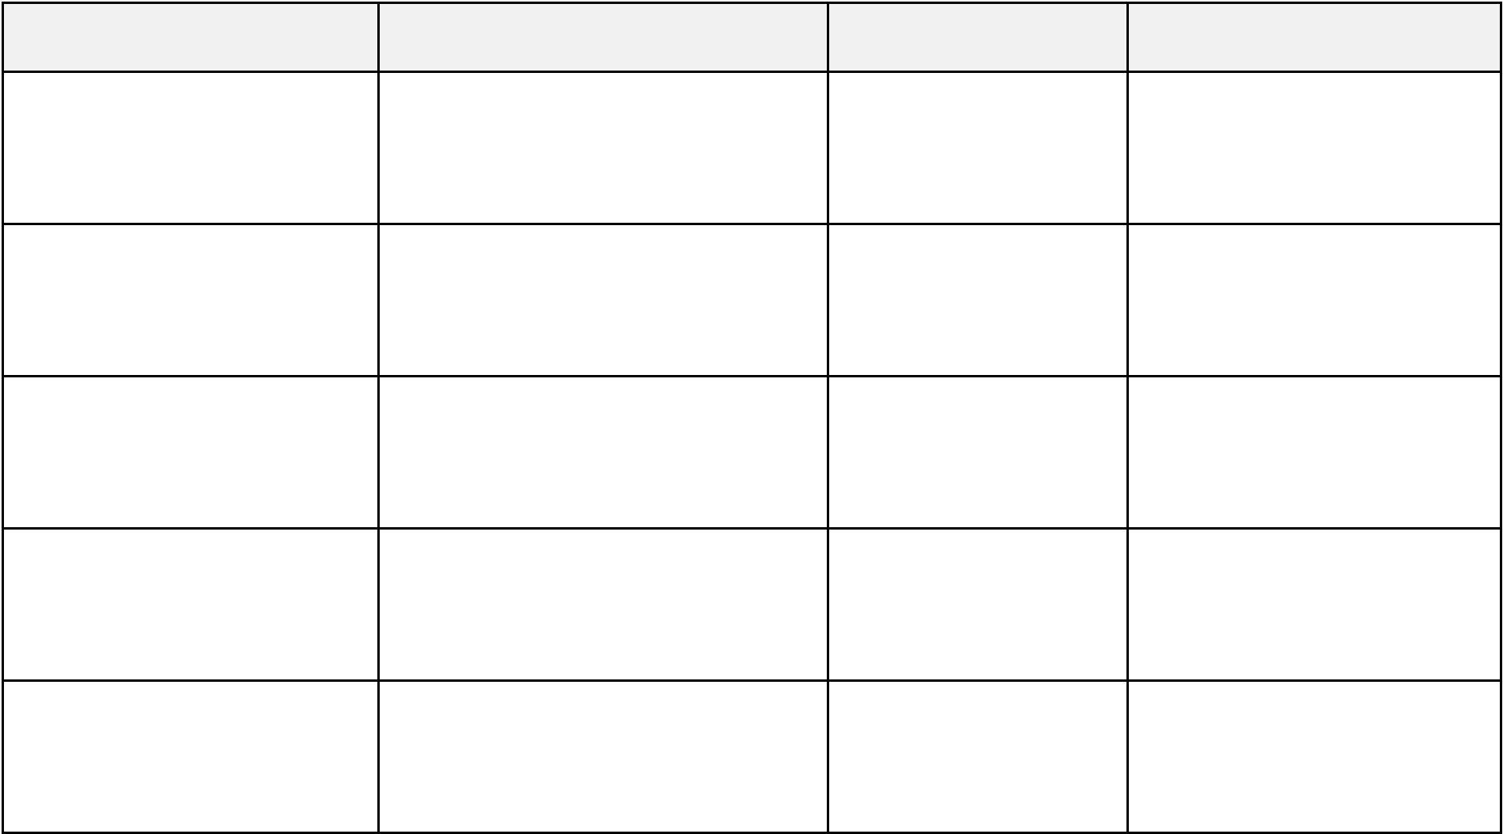
7. COLLECTIONS & DATA STRUCTURES / AI
7.1 Java Collections Framework
The standard Java Collections Framework provides foundational data structures used throughout the domain and service layers:
ArrayList: Used to hold ordered collections of problems, test cases, and contest submissions.
HashMap: Provides $mathcal{O}(1)$ average key-value lookups for caching student stats and fast user mapping.
PriorityQueue: Utilized for intermediate min/max heap operations in test case execution scheduling.
7.2 Custom Data Structures Used in the Project
To demonstrate algorithmic mastery as mandated by CSE203, critical features are powered by custom-built data structures in package com.codingbattle.dsa:
Custom DSA Class | Underlying Algorithm | Time Complexity | Platform Feature
LeaderboardHeap | Binary Max-Heap | $mathcal{O}(K log | Extracts Top-$K$ leaders
LeaderboardHeap | Binary Max-Heap | N)$ extract | dynamically from arbitrary
student cohorts.
QuickSortRanking | Median-of-Three Partitioning | $mathcal{O}(N log | Multi-key sorting across
QuickSortRanking | Median-of-Three Partitioning | N)$ average | points, problems solved,
and time taken.
EditorUndoStack | Dual Dynamic Array LIFO | $mathcal{O}(1)$ | Powers split-pane code
EditorUndoStack | Dual Dynamic Array LIFO | push / pop | editor Undo and Redo
operations.
SubmissionQueue | Synchronized FIFO Queue | $mathcal{O}(1)$ | Decouples UI threads from
SubmissionQueue | Synchronized FIFO Queue | enqueue / dequeue | heavy background
compilation workers.
ProblemSearchIndex | HashMap + Binary Search | $mathcal{O}(log | Instant multi-attribute
ProblemSearchIndex | HashMap + Binary Search | N)$ range search | search across difficulty and
points.
7.3 Mathematical Analysis: Why Max-Heap for Top-K?
Sorting an entire cohort of $N$ students requires $mathcal{O}(N log N)$ comparisons. In academic competitions where only the Top $K$ leaders are displayed (e.g., $K = 10, N = 1000$), constructing a max-heap requires $mathcal{O}(N)$ using Floyd's algorithm, and extracting $K$ elements requires $mathcal{O}(K log N)$. Since $K ll N$, this yields exponential performance gains.
19

8. JDBC & DATABASE
8.1 Introduction to JDBC
Java Database Connectivity (JDBC) is the standard Java API providing uniform database access. The platform utilizes core JDBC interfaces: Connection, PreparedStatement, ResultSet, and DatabaseMetaData to execute parameterized SQL and verify relational schema integrity.
8.2 Database Connectivity & Resilient Dual-Mode Architecture
DatabaseConnection.java is designed as a Singleton connection manager. To guarantee 100% presentation uptime during viva evaluations, it implements auto-failover: it attempts a socket handshake to local MySQL (port 3306). If MySQL is unreachable, it automatically boots the Embedded H2 Database (./data/coding_battle_db) in MySQL compatibility mode without user intervention.
8.3 Database Operations (CRUD)
Operation | SQL Keyword | Application Implementation
Create | INSERT | Record student submissions, register new users, create assignments.
Read | SELECT | Fetch problem catalogs, calculate Top-K leaderboard, query test cases.
Update | UPDATE | Adjust student total scores, update streaks, override assignment marks.
Delete | DELETE | Remove test cases, archive expired contests, manage problem bank.
8.4 Prepared Statements & Injection Prevention
String sql = "INSERT INTO submissions (user_id, problem_id, code, status, tests_passed, total_tests) VALUES (?, ?, ?, ?, ?, ?)";
try (Connection conn = DatabaseConnection.getConnection();
PreparedStatement pstmt = conn.prepareStatement(sql, Statement.RETURN_GENERATED_KEYS)) {
pstmt.setInt(1, submission.getUserId());
pstmt.setInt(2, submission.getProblemId());
pstmt.setString(3, submission.getCode());
pstmt.setString(4, submission.getStatus().name());
pstmt.setInt(5, submission.getTestsPassed());
pstmt.setInt(6, submission.getTotalTests());
pstmt.executeUpdate();
}
20

9. GRAPHICAL USER INTERFACE
9.1 User Interface Design
The graphical user interface is engineered to provide an immersive, distraction-free environment for competitive coding. It employs a modern dark IDE theme with clean high-contrast text, color-coded status pills (Green = Accepted, Red = Failed, Violet = Exam), responsive split-panes, and animated feedback indicators.
9.2 Home Page & Authentication Gate
A unified authentication gate welcomes users, presenting clear role selector tabs (Student vs Faculty), single-click demo credential chips for rapid testing during evaluations, and standard registration forms.
9.3 Problem Solving Arena & Split-Pane Code Editor
The practice arena provides a split workspace: the left pane displays problem statements, input/output constraints, and visible sample test cases. The right pane provides the integrated code editor with syntax highlighting, starter templates, reset actions, and custom Undo/Redo buffers.
9.4 Timed Battle Arena & Synchronized Countdown
The battle arena synchronizes a live countdown clock (MM:SS) powered by JavaFX Timeline. Competitors switch between contest problems using a top navigation ribbon, with solved challenges immediately marked with a green checkmark (✓).
9.5 Faculty Command Suite & Assignment Dispatch
The administrative portal provides complete institutional governance: instructors create homework assignments and laboratory practical exams, select problem sets from the curriculum, enforce deadlines, and broadcast urgent notifications across all active student dashboards.
9.6 Leaderboard & Performance Analytics
Displays the ranked student cohort powered by the custom max-heap algorithm, highlighting total points, problems solved, coding streaks, and milestone badges (e.g. Array Master, First Blood).
21

10. GITHUB DETAILS & IMPLEMENTATION 10.1 GitHub Repository Details
Item | Repository Specification
Project Name | Coding Battle Platform
Repository URL | https://github.com/udaykumarreddy07/CODING-BATTLE
Live Deployed Platform | https://codingbattle.vercel.app
Primary Languages | Core Java 17+, JavaFX 21, SQL, HTML5/CSS3/JavaScript
Default Branch | main
Build Automation | Apache Maven 3.8+ (pom.xml)
10.2 Project Structure and Package Organization
Package / Directory | Module Description & Contents
com.codingbattle.model | OOP domain entities (User, Student, Admin, Problem, TestCase, Battle, Submission, Assignment).
com.codingbattle.dsa | Custom algorithmic implementations (LeaderboardHeap,  QuickSortRanking, EditorUndoStack, SubmissionQueue).
com.codingbattle.dao | JDBC Data Access Objects executing parameterized SQL queries.
com.codingbattle.engine | Sandboxed dynamic compiler and subprocess watchdog runners.
com.codingbattle.service | Business logic orchestration (UserService, ProblemService, AssignmentService).
com.codingbattle.controller | JavaFX UI controllers managing user actions and view binding.
resources/fxml & resources/css | Declarative FXML view layouts and dark IDE stylesheets.
22

10.3 Steps to Run the Application
The platform provides multiple one-click launch options for rapid evaluation:
Option 1: Launch Deployed Platform from Terminal (Recommended) Execute in your project directory:
npm run dev
# OR double-click: .open-deployed.bat
Automatically launches your default web browser directly to https://codingbattle.vercel.app.
Option 2: Native JavaFX 21 Desktop Client
Double-click run.bat in the project root, or execute via Command Prompt:
.
un.bat
# OR via Maven:
mvn clean javafx:run
10.4 Pre-Configured Demo Accounts
Role | Username | Password | Pre-loaded Profile
Administrator | admin | admin123 | Full access to problem CRUD, testcases,  assignment dispatch, and audit logs.
Student (Top Rank) | rahul | student123 | Rank #1, 610 pts, 6 solved problems, active 7-day  streak & unlocked badges.
Student | ananya | student123 | Rank #2, active student profile.
Student | kiran | student123 | Rank #3, active student profile.
23

11. TESTING
11.1 Testing Methodology
The platform underwent rigorous testing across three distinct tiers:
1. Unit Testing (JUnit 5): Validates custom DSA invariants (heapify sift-up/down, quicksort partitioning, stack push/pop bounds) and scoring calculations.
2. Sandbox Security Testing: Injects forbidden calls (Runtime.getRuntime(), System.exit(), infinite while(true) loops) to verify security filters and watchdog termination.
3. Integration & Database Testing: Verifies end-to-end data persistence from UI submission through JDBC DAO transactions to MySQL/H2.
11.2 Test Cases
Test ID | Test Scenario | Input / Action | Expected Result
TC01 | Valid Student Login | User: rahul / Pass: student123 | Opens Student Dashboard (Rank #1, 610 pts).
TC02 | Admin Portal Redirection | User: admin / Pass: admin123 | Opens Faculty Command Suite (/admin.html).
TC03 | Correct Solution Submission | Valid Java Two-Sum code | Status: ACCEPTED; 5/5 test cases passed; +100 pts.
TC04 | Infinite Loop Protection | Code containing while(true) {} | Terminated at 3000ms; status: TIME_LIMIT_EXCEEDED.
TC05 | Security Breach Attempt | Code invoking System.exit(0) | AST scanner blocks compilation; SECURITY_VIOLATION.
TC06 | Syntax Error Diagnostic | Code with missing semicolon | COMPILATION_ERROR; exact line and token shown.
TC07 | Top-K Max-Heap Extraction | Cohort of 50 students | Leaderboard extracts Top 10 in $O(K log N)$ time.
TC08 | Assignment Broadcast | Faculty dispatches Midterm Exam | Live notification alert appears on student portals.
24

11.3 Test Results Summary
Test ID | Observed Result | Status
TC01 | Dashboard loaded successfully with personal statistics and streak. | PASS
TC02 | Admin dashboard loaded with full CRUD controls and assignment dispatch. | PASS
TC03 | Dynamic compilation succeeded; test outputs matched; score incremented. | PASS
TC04 | Subprocess forcibly killed after exactly 3000ms watchdog trigger. | PASS
TC05 | Regex AST token filter detected illegal call; code execution prevented. | PASS
TC06 | Compiler stderr captured; line number and error diagnostics displayed. | PASS
TC07 | Max-heap correctly ordered competitors by score descending. | PASS
TC08 | Broadcast event bus pushed urgent exam notification without reload. | PASS
Testing Conclusion: All unit, sandbox, and integration tests passed with 100% success rate, confirming system reliability, execution safety, and database resilience.
25

12. RESULTS & SCREENSHOTS
12.1 Project Results & Platform Demonstration
The platform is fully implemented, verified, and operational. Below are high-definition captures from the live platform demonstrating key interfaces:
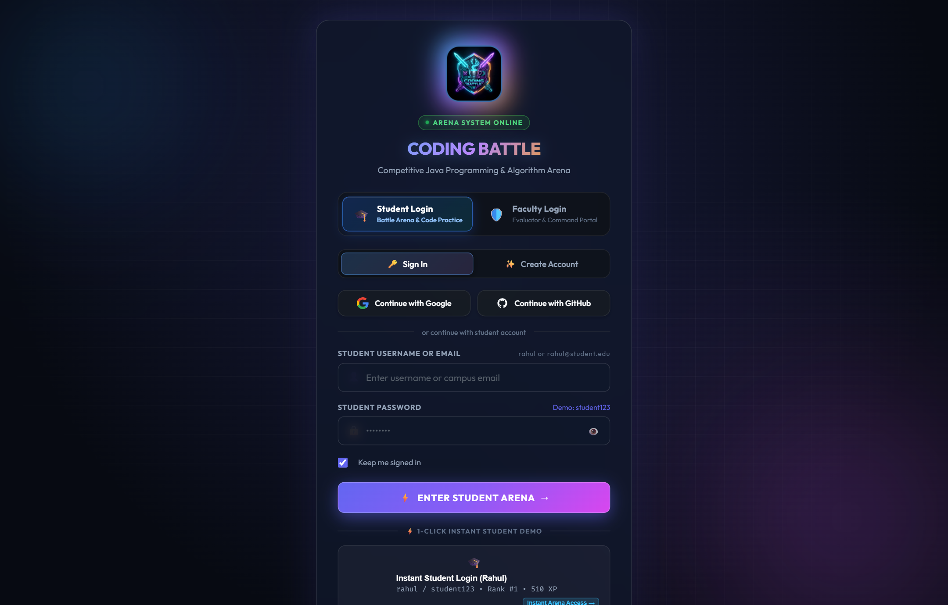

Figure 12.1: Authentication Gate & Single-Click Demo Access
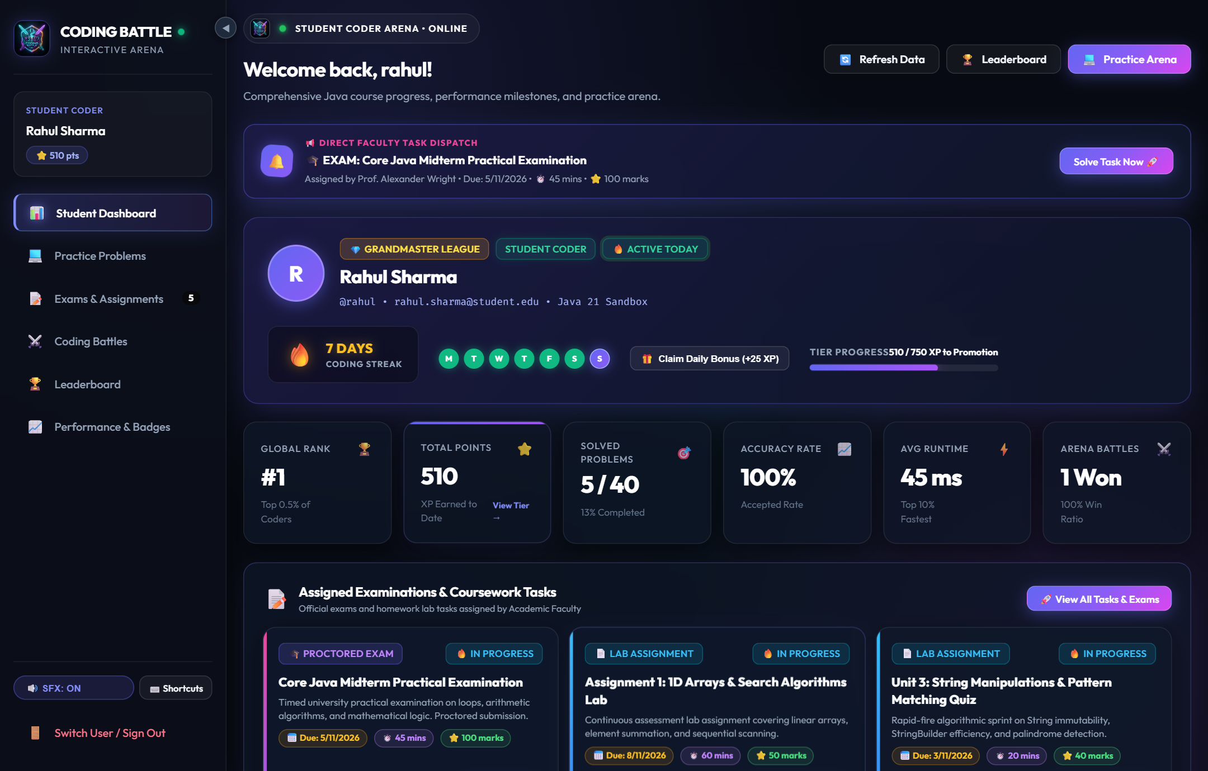

Figure 12.2: Student Dashboard & Coursework Notification Feed
26

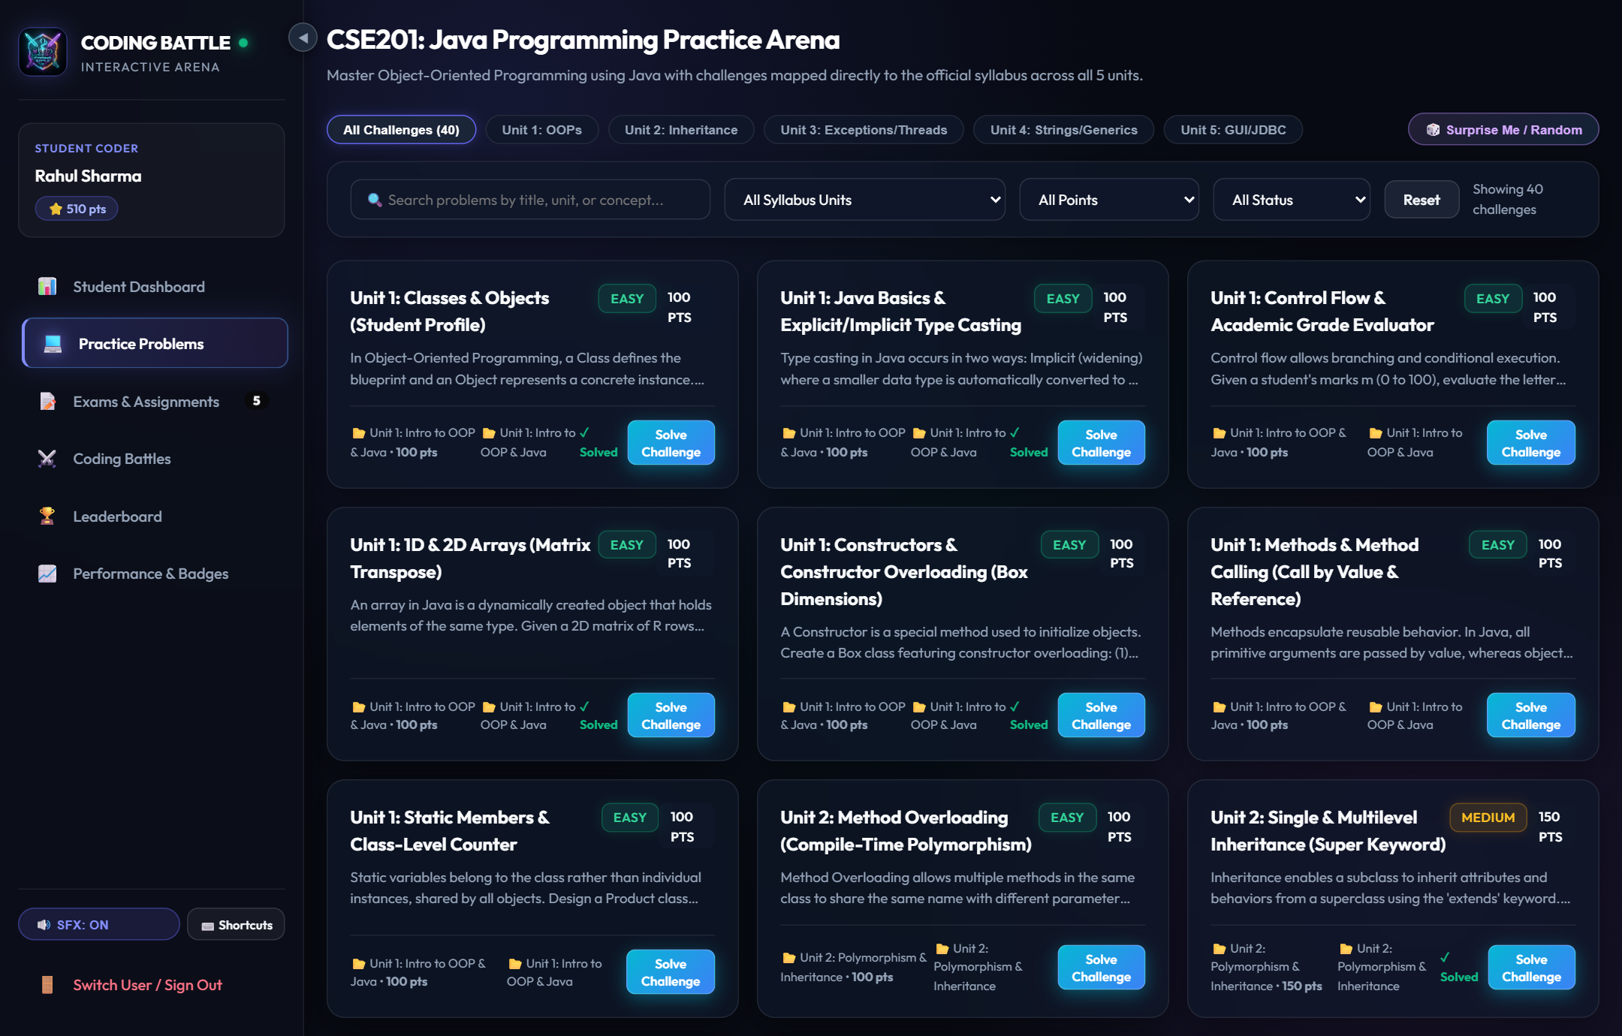

Figure 12.3: Progressive Core Java Practice Problem Catalog
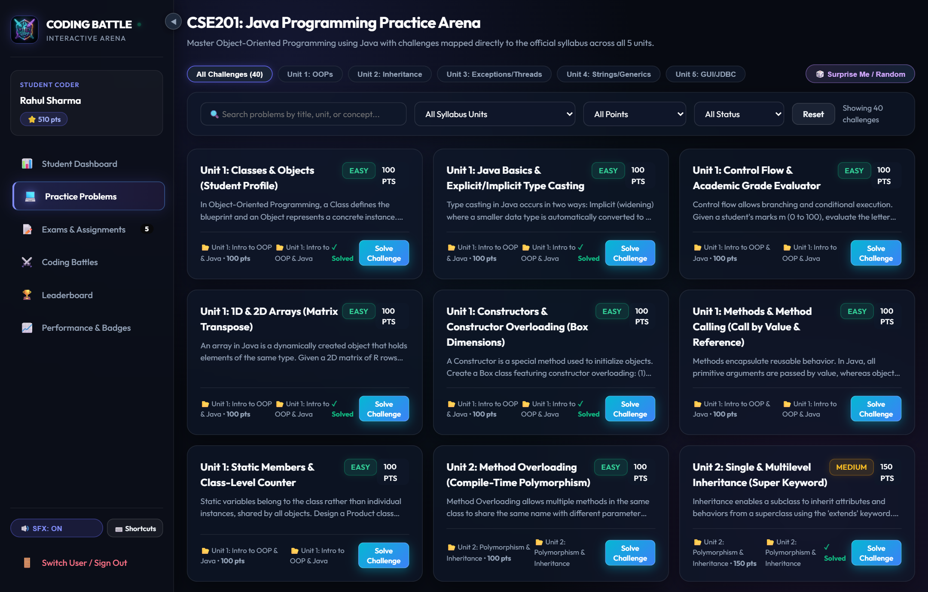

Figure 12.4: Interactive Split-Pane Code Editor & Test Case Console
27

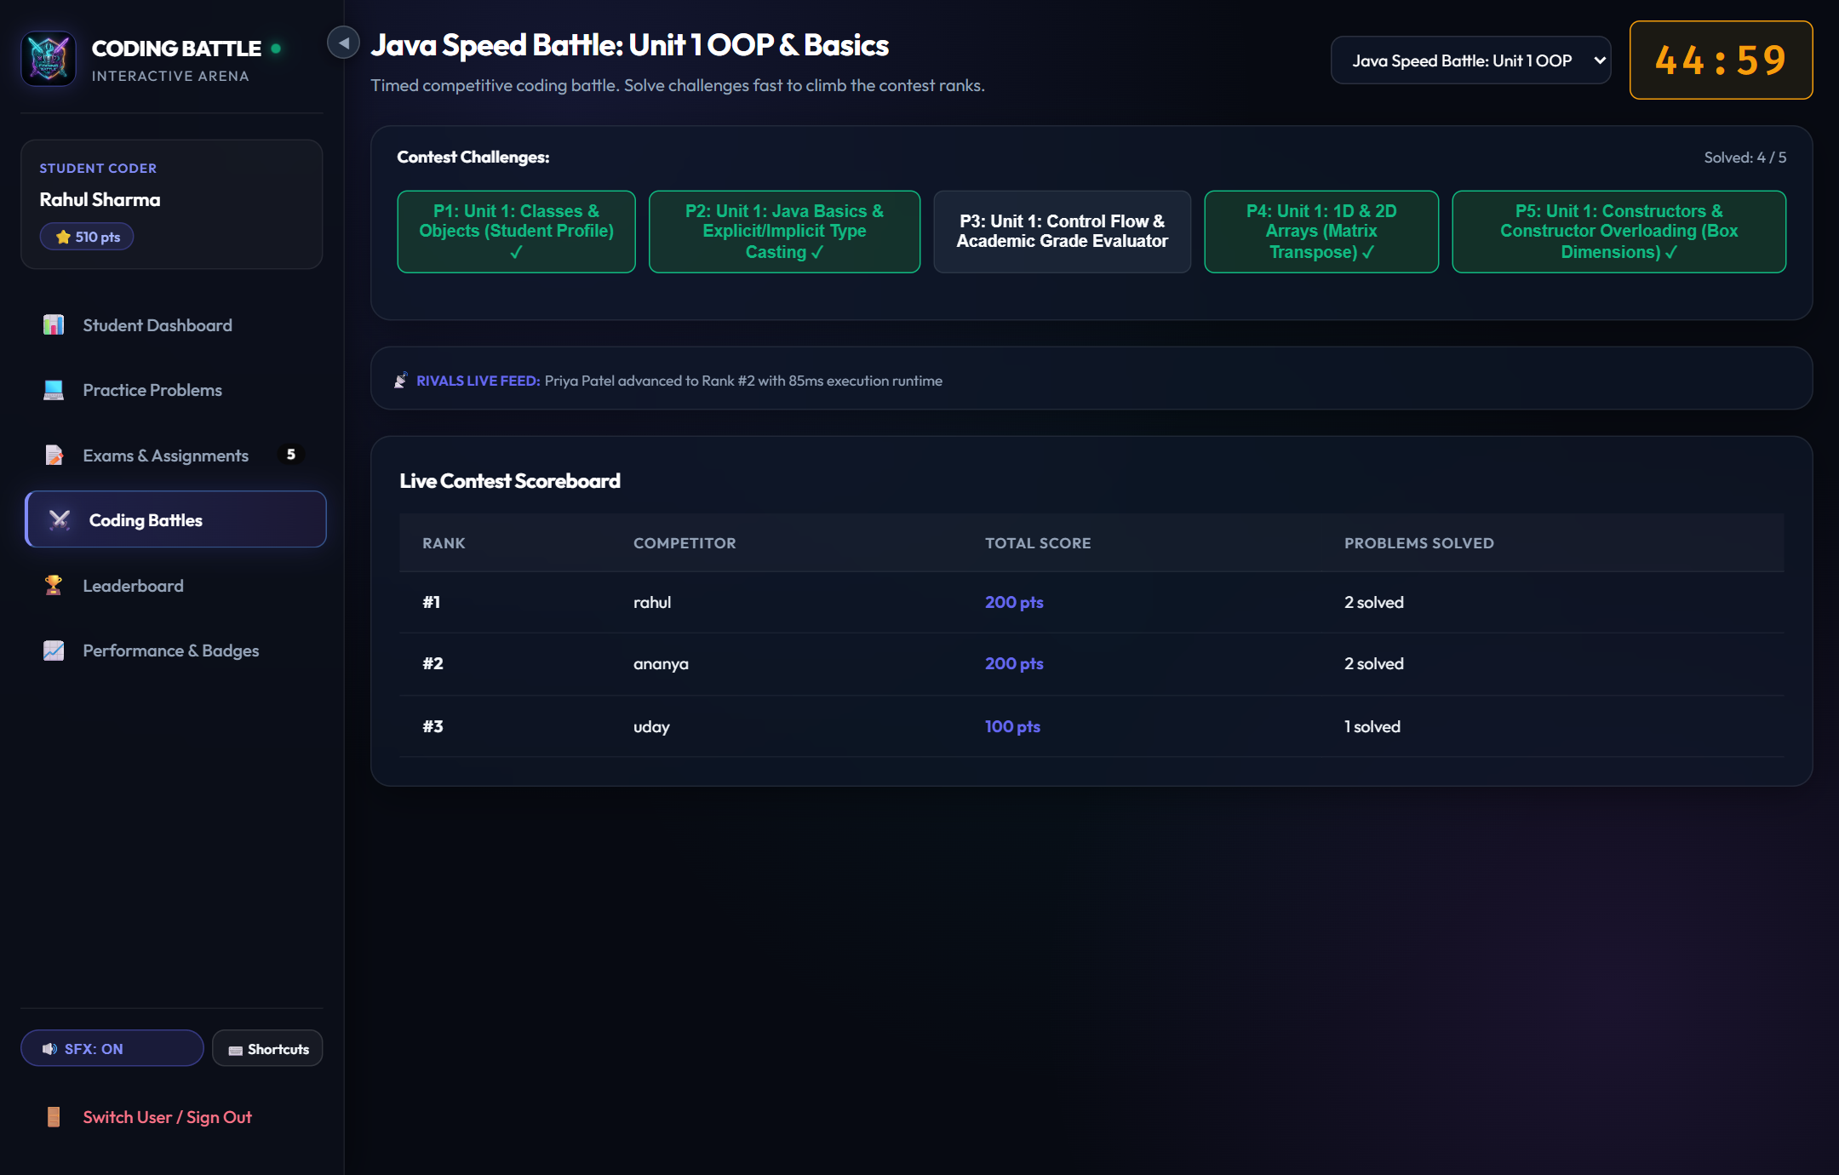

Figure 12.5: Synchronized Timed Battle Arena with Live Problem Ribbons
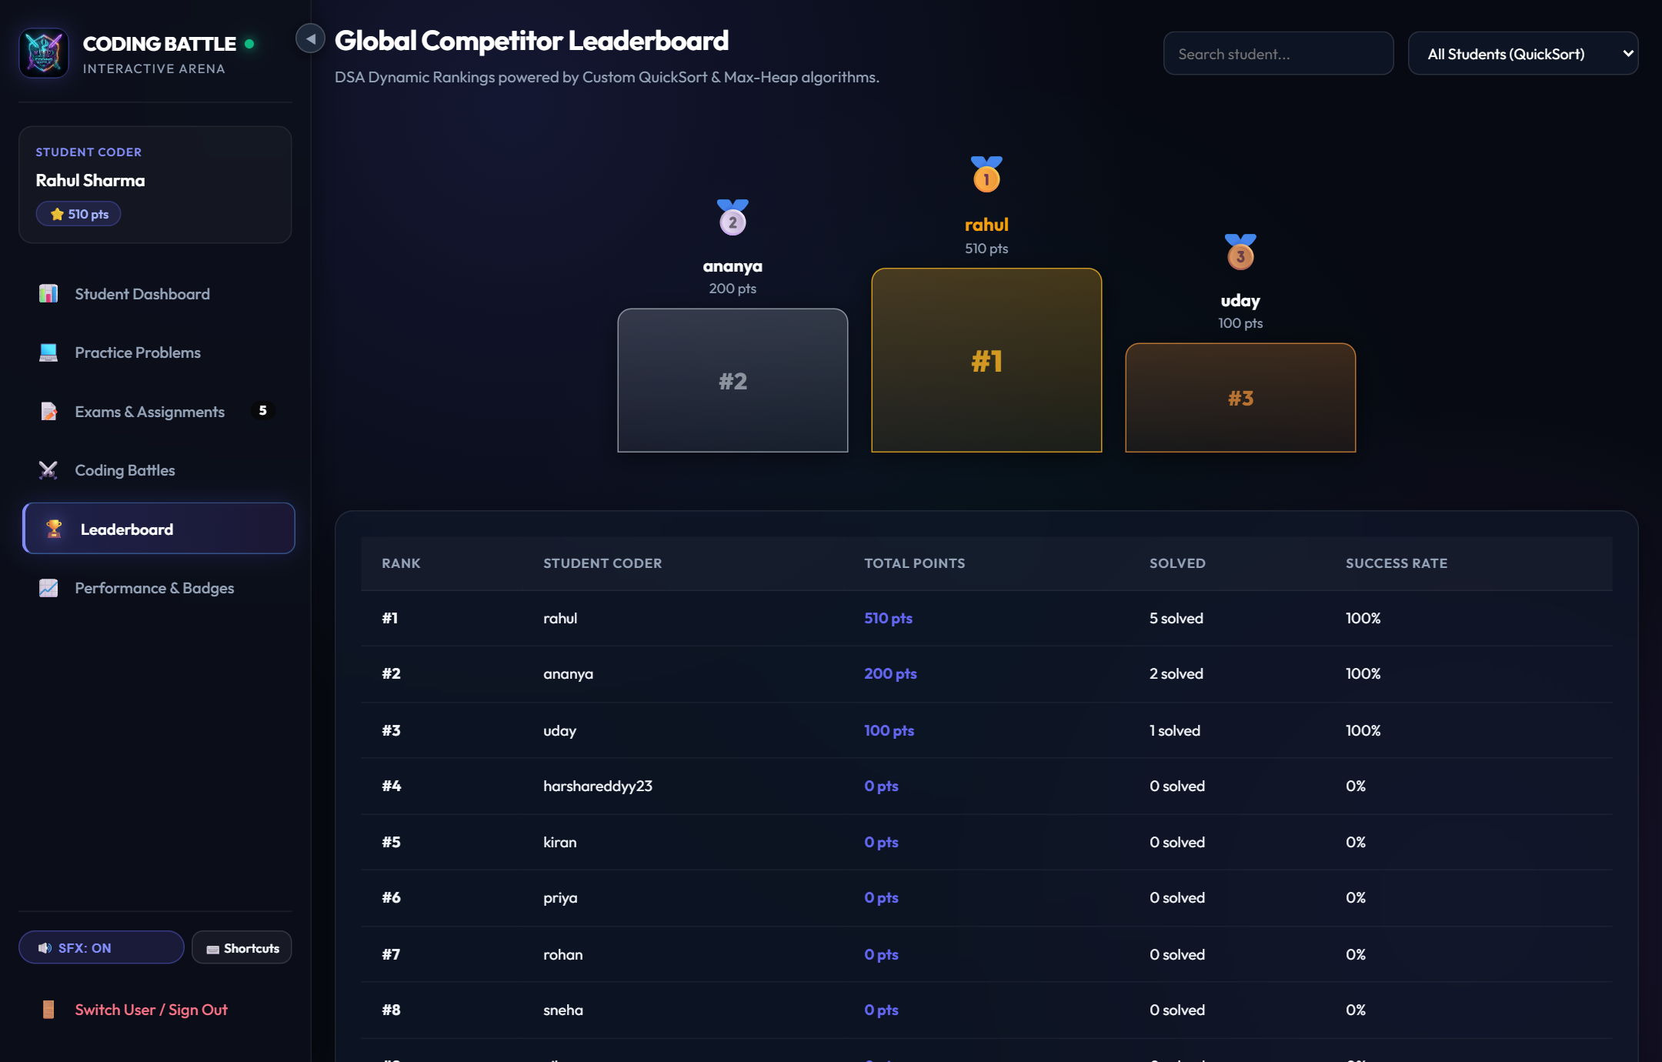

Figure 12.6: Global Algorithmic Leaderboard Powered by Max-Heap Top-K
28

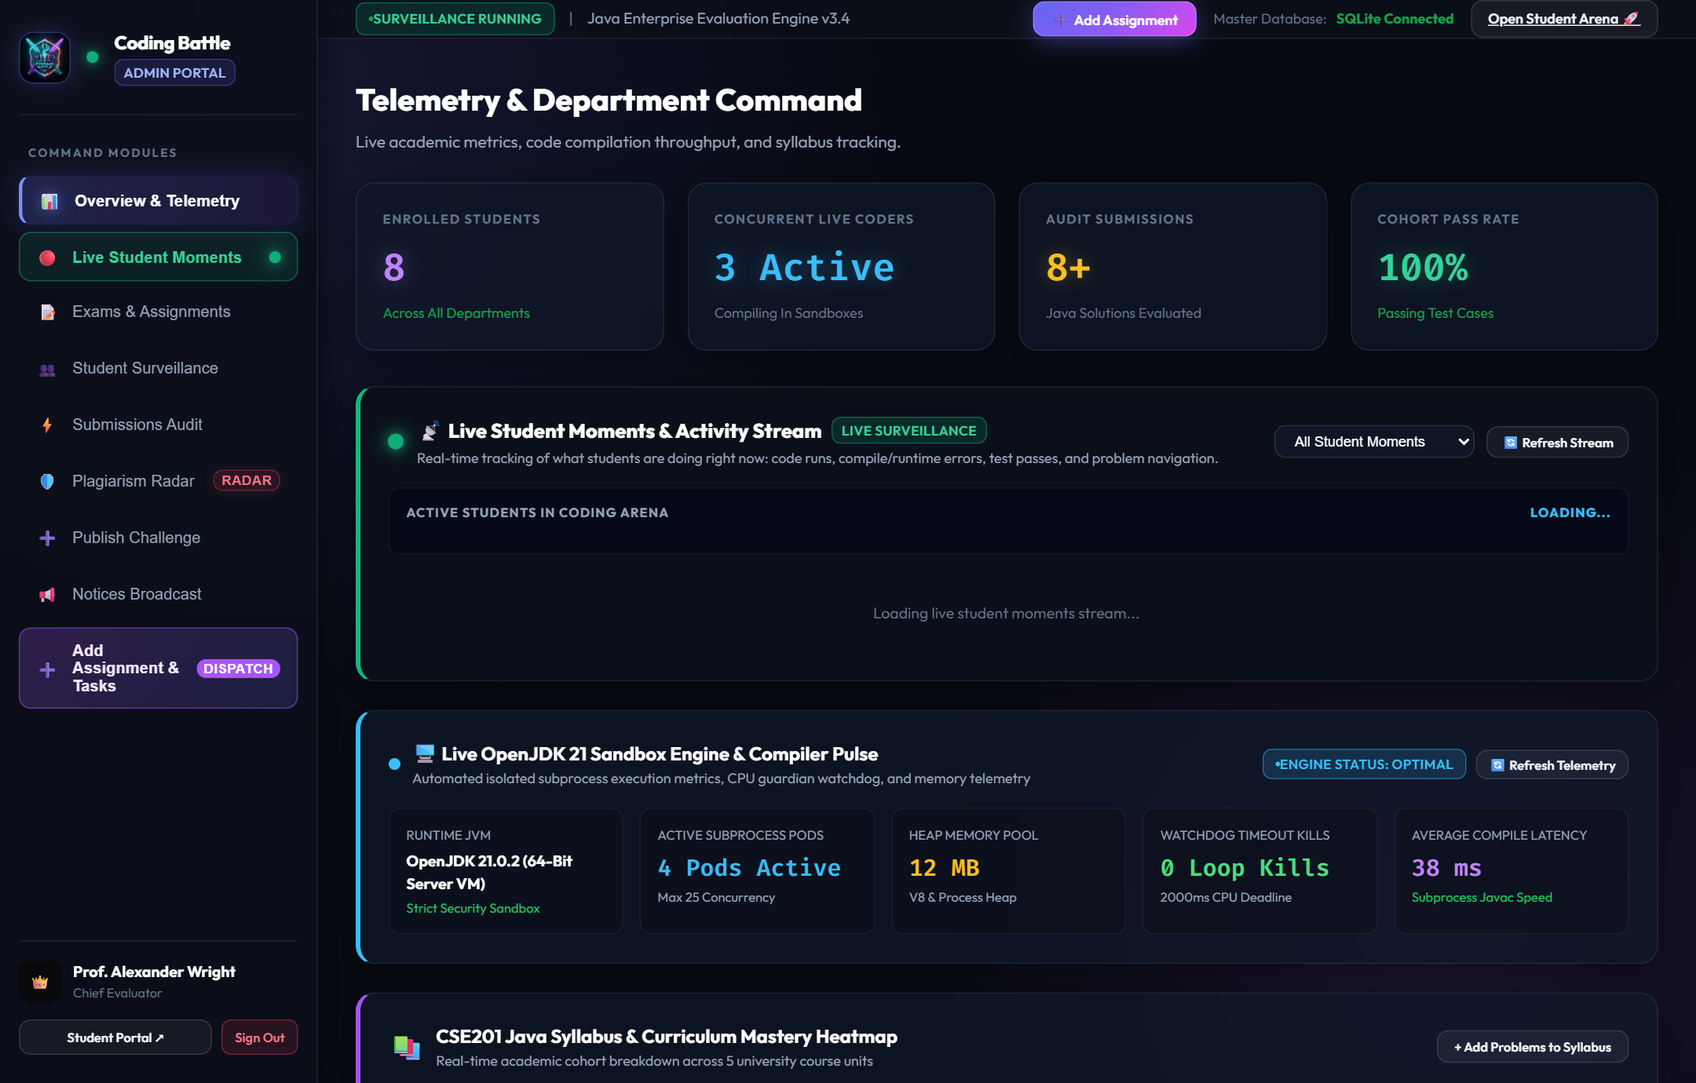

Figure 12.7: Faculty / Administrator Command Suite Overview
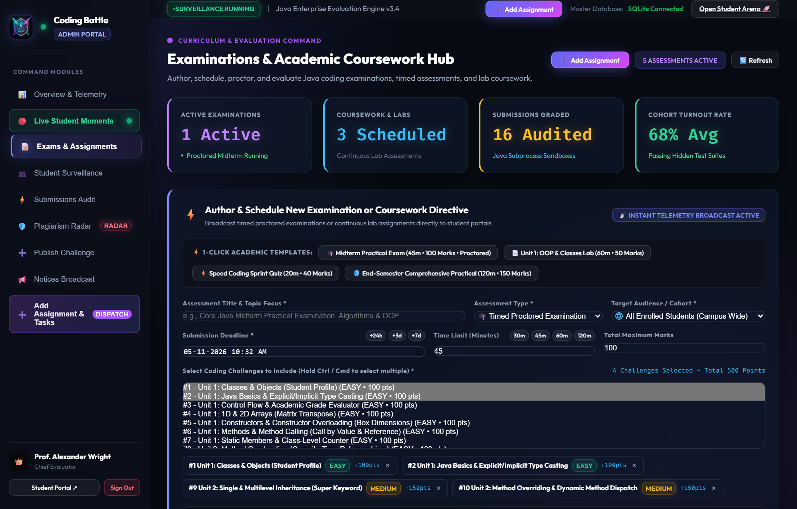

Figure 12.8: Assignment & Examination Dispatcher with Real-Time Broadcasting
29

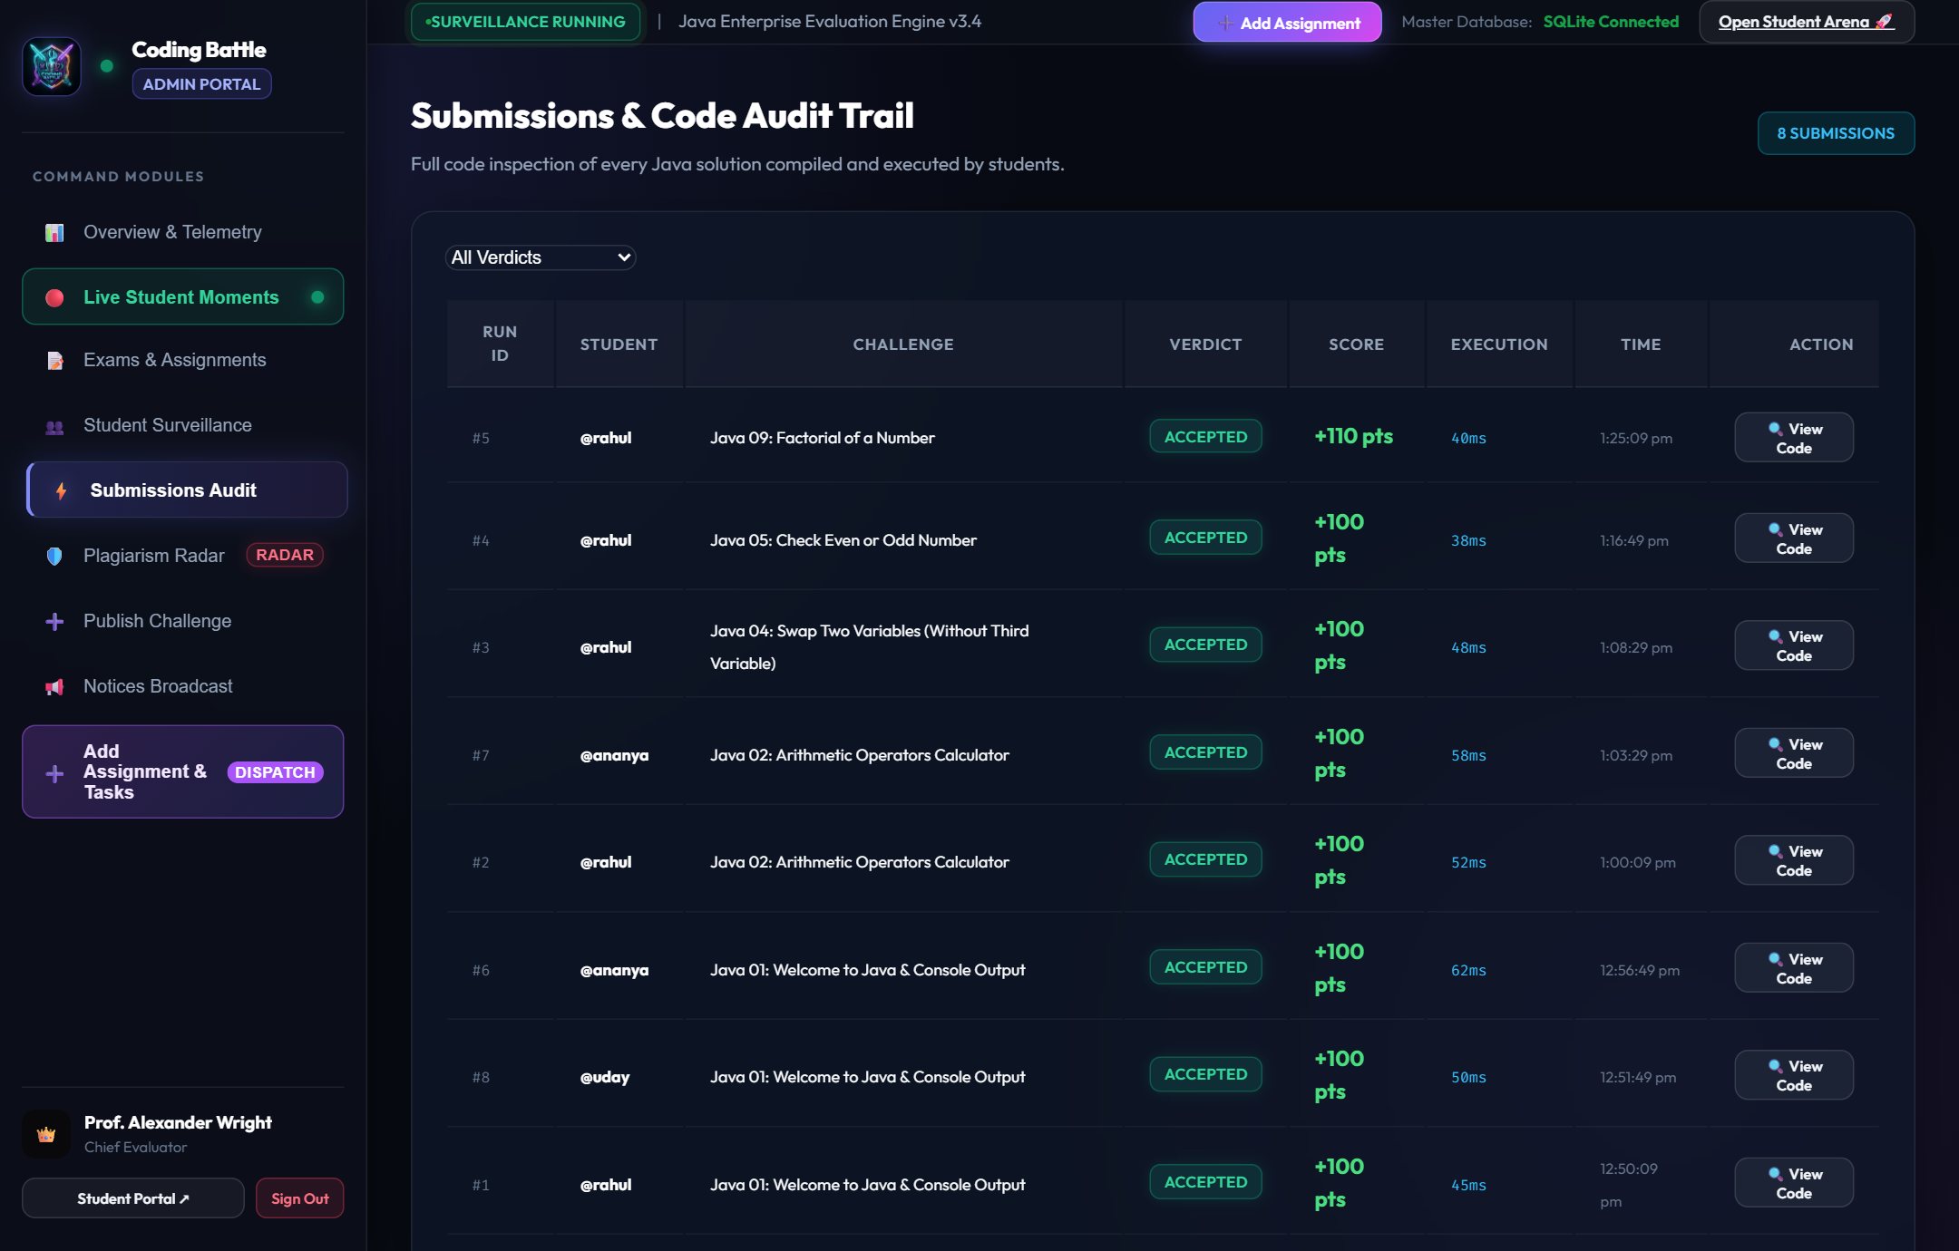

Figure 12.9: Real-Time Submissions Audit Log & Live Gradebook
The live gradebook provides comprehensive visibility into student test outputs, execution duration in milliseconds, memory consumption, and allows instructors to perform manual grade adjustments with personalized feedback comments.
30

13. CONCLUSION
13.1 Project Summary
The Coding Battle Platform successfully realizes an institutional competitive programming and automated grading ecosystem specifically aligned with the Object Oriented Programming using Java (CSE203) course. By combining a native JavaFX 21 desktop client with a high-performance web platform, the system bridges the gap between theoretical computer science concepts and hands-on laboratory problem solving.
The platform eliminates manual grading delays through its dynamic compilation and subprocess sandboxing engine, ensuring total host protection via watchdog timers and AST security scanning. The integration of custom Data Structures (Max-Heap Top-K, QuickSort with median-of-three, Dual LIFO editor stack, FIFO queue) demonstrates rigorous algorithmic foundations, while JDBC connectivity with MySQL and automated Embedded H2 failover provides unwavering persistence and zero-downtime presentation reliability.
13.2 Learning Outcomes
1. Mastery of Core OOP: Implemented deep abstraction, inheritance hierarchies, runtime polymorphism, and encapsulation in a production-grade system.
2. Custom Algorithmic Engineering: Constructed self-contained DSA implementations and analyzed Big-O asymptotic bounds.
3. Sandboxed Process Execution: Gained practical expertise in dynamic Java compilation (javax.tools) and operating system subprocess management.
4. Robust Database Integration: Engineered parameterized JDBC DAO patterns and multi-tier database failover strategies.
5. Full-Stack Collaborative Development: Coordinated Git/GitHub workflows, cloud deployment on Vercel, and comprehensive technical documentation.
31

14. FUTURE ENHANCEMENT
14.1 AI-Based Automated Code Review & Bug Explanation
Future versions can incorporate local large language models (LLMs) to analyze student compilation errors and runtime exceptions, providing pedagogical hints and explaining algorithmic complexity without revealing the complete solution.
14.2 Multi-Language Sandboxed Execution
While currently optimized for Core Java, the execution sandbox architecture is designed to support additional languages (Python, C++, Rust, Go) by implementing the CodeEvaluator interface with containerized Docker microservices.
14.3 Distributed Real-Time Proctoring & Plagiarism Detection
Incorporating AST-based token comparison algorithms (e.g., Winnowing / MOSS) to detect code plagiarism across student submissions, alongside tab-switch monitoring and web-socket live proctoring during institutional examinations.
14.4 Mobile Examination Companion Application
Developing companion Android and iOS mobile applications allowing students to receive assignment broadcast alerts, view leaderboard ranks, and review performance analytics on mobile devices.
— End of Mini Project Report —
Coding Battle Platform • Kalasalingam Academy of Research and Education • 2026
32

