**Asssignment 2**

**1. Using MongoDB database, create a database (Parts A and B):**

Code to create database:

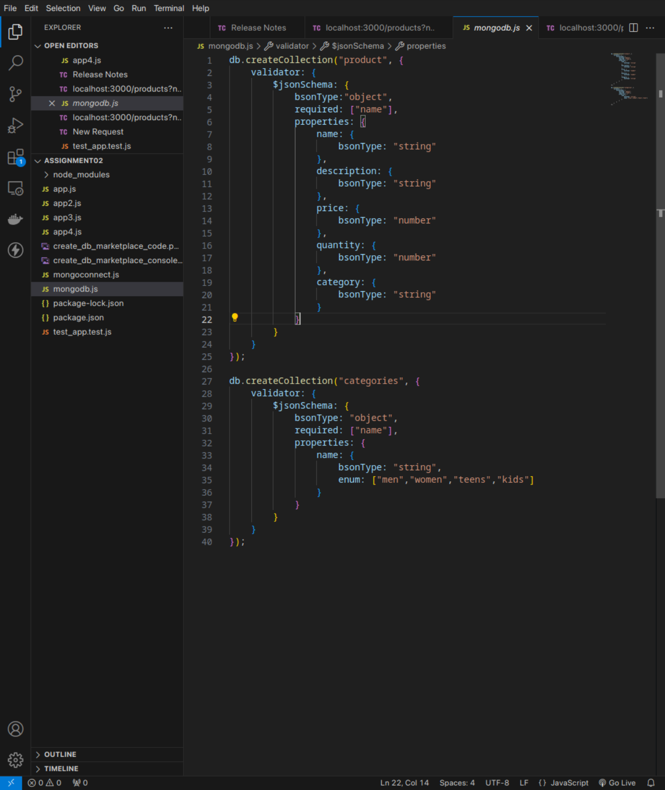

Demonstration of database:

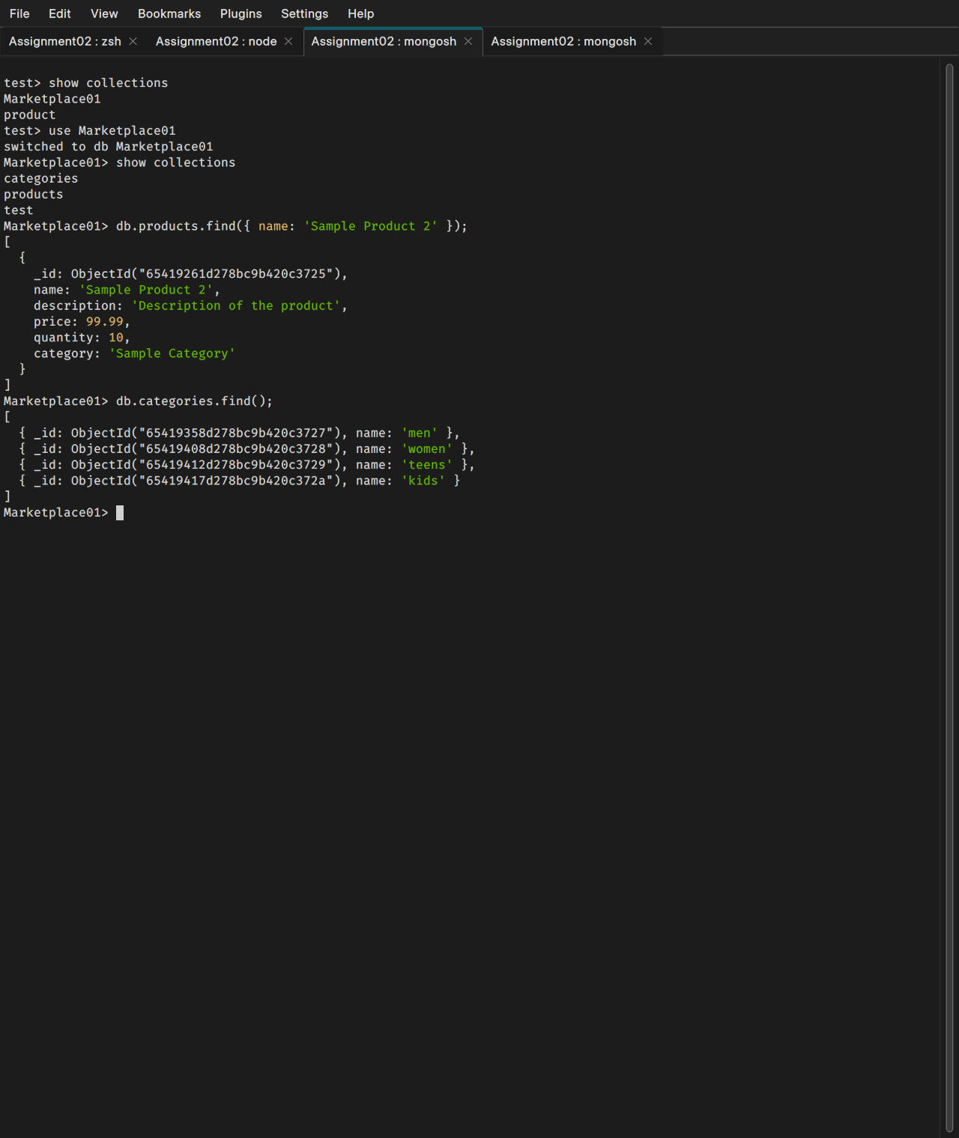

**1. Using MongoDB database, create a database (Part C):**

mongodb://127.0.0.1:27017/Marketplace01

Configuration file with connection address and port:

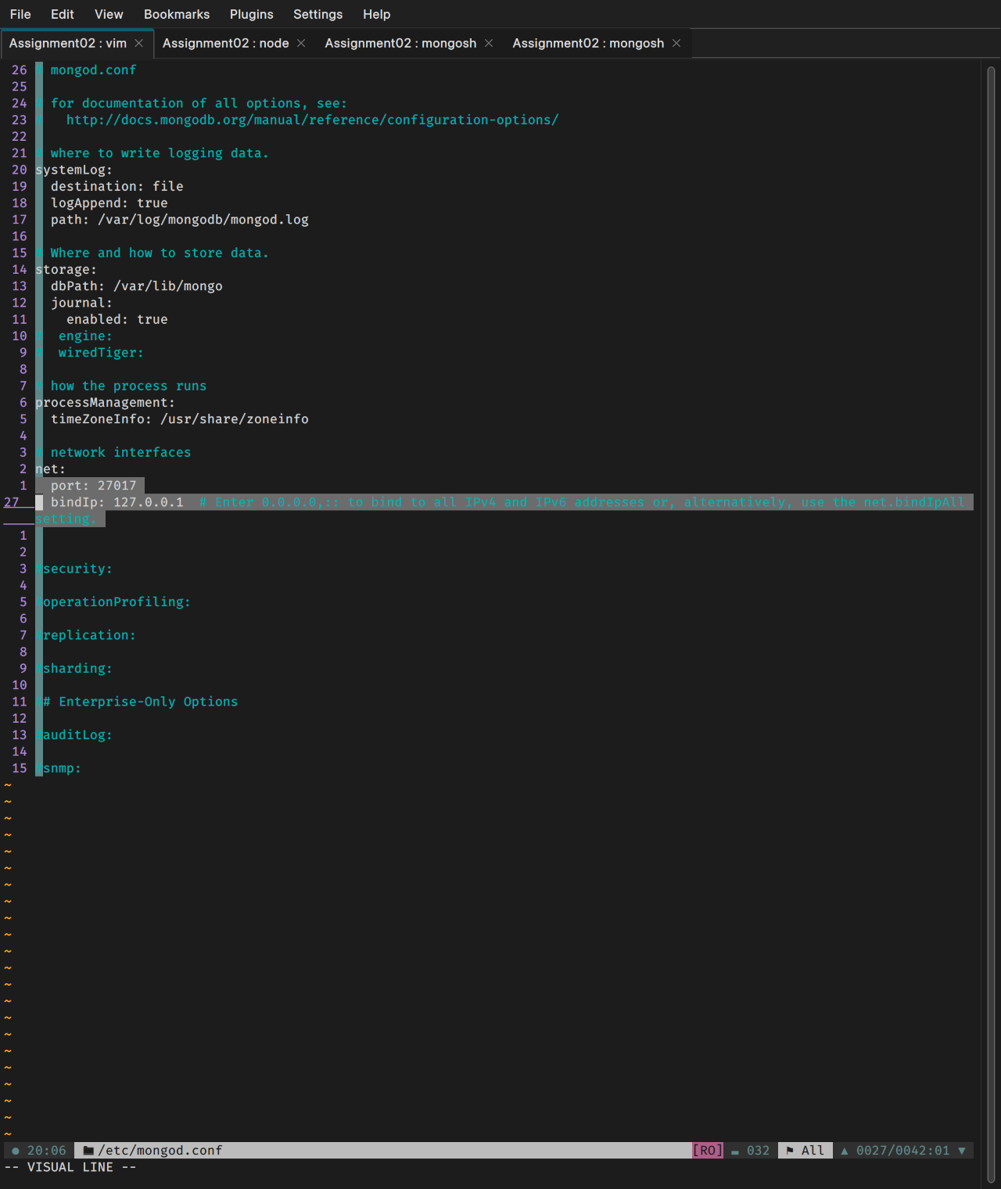

**2. Set up and connect to database. Pass {"message":"Welcome to Dresstore application."} on connection**

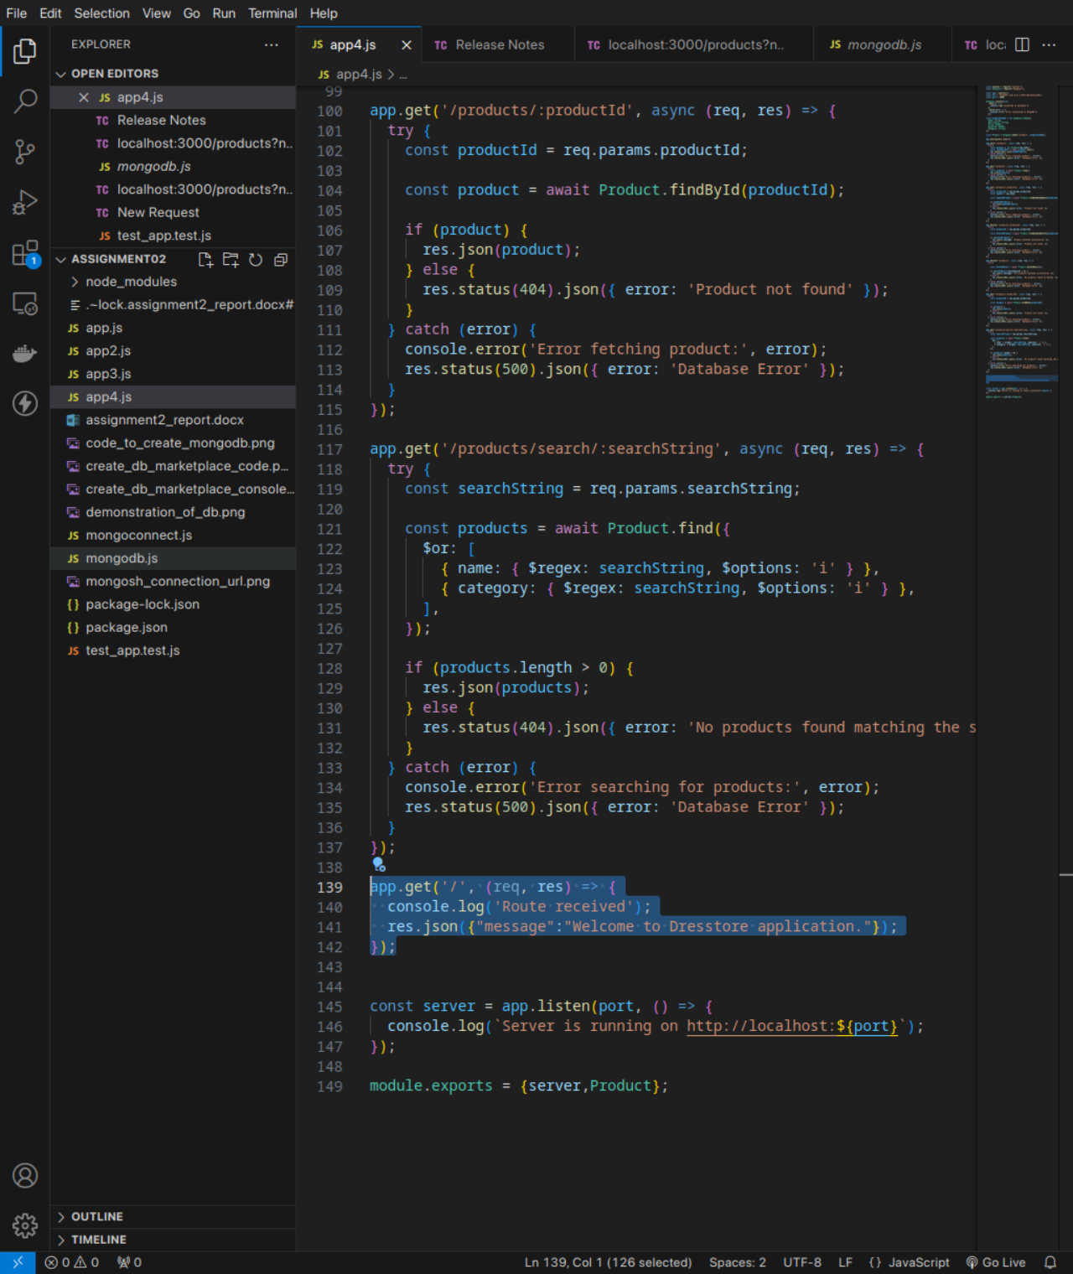

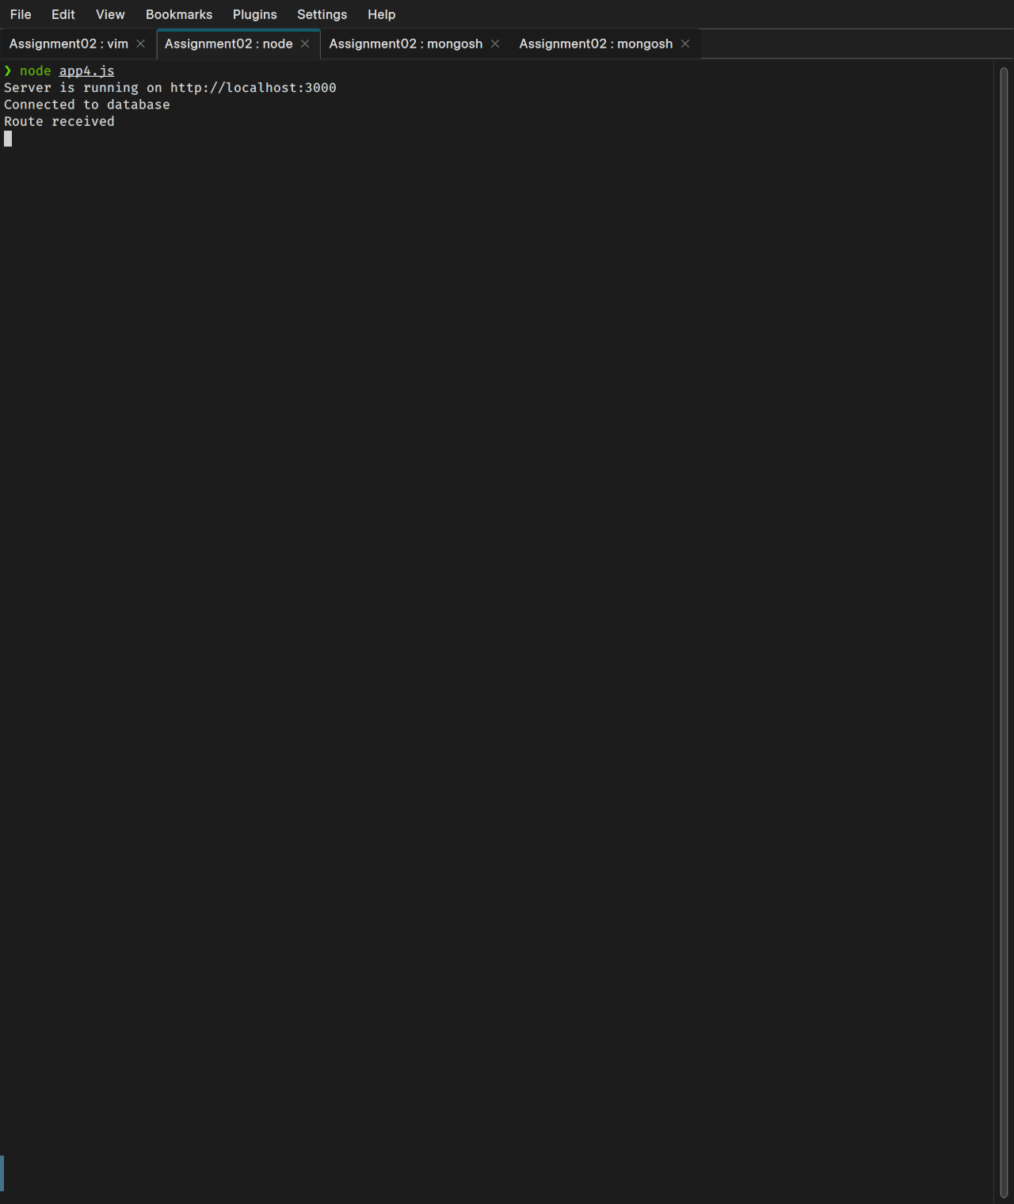

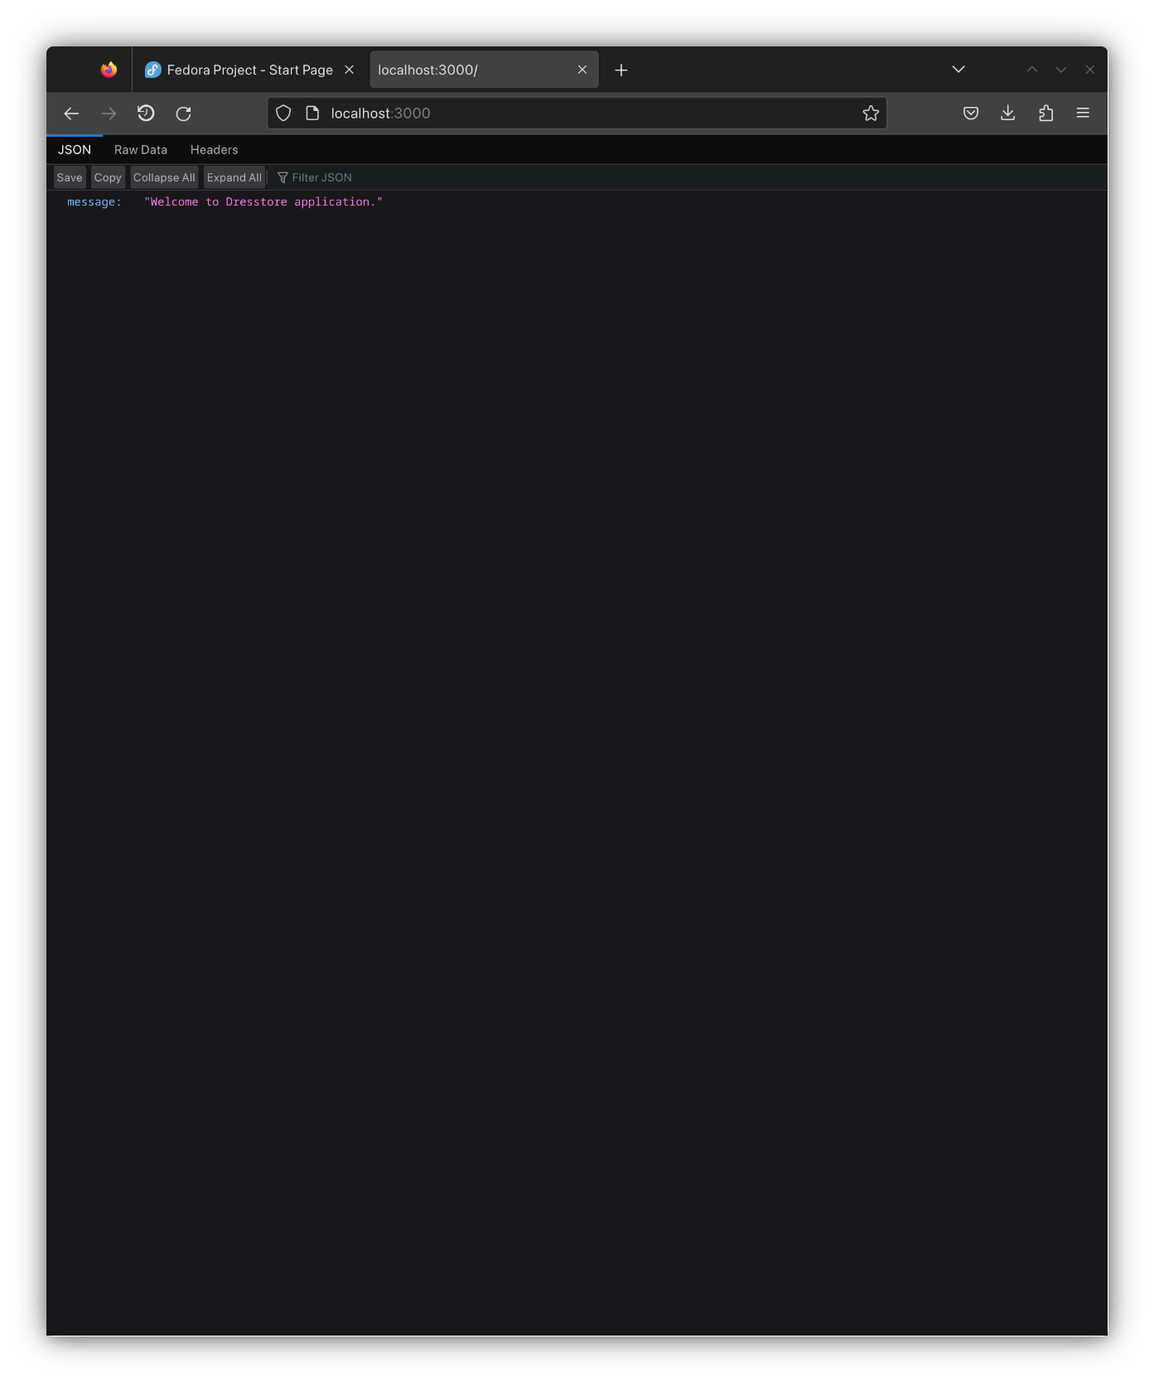

**3,4. Screenshots of API tests with Thunder Client VS Code extension**

**GET**

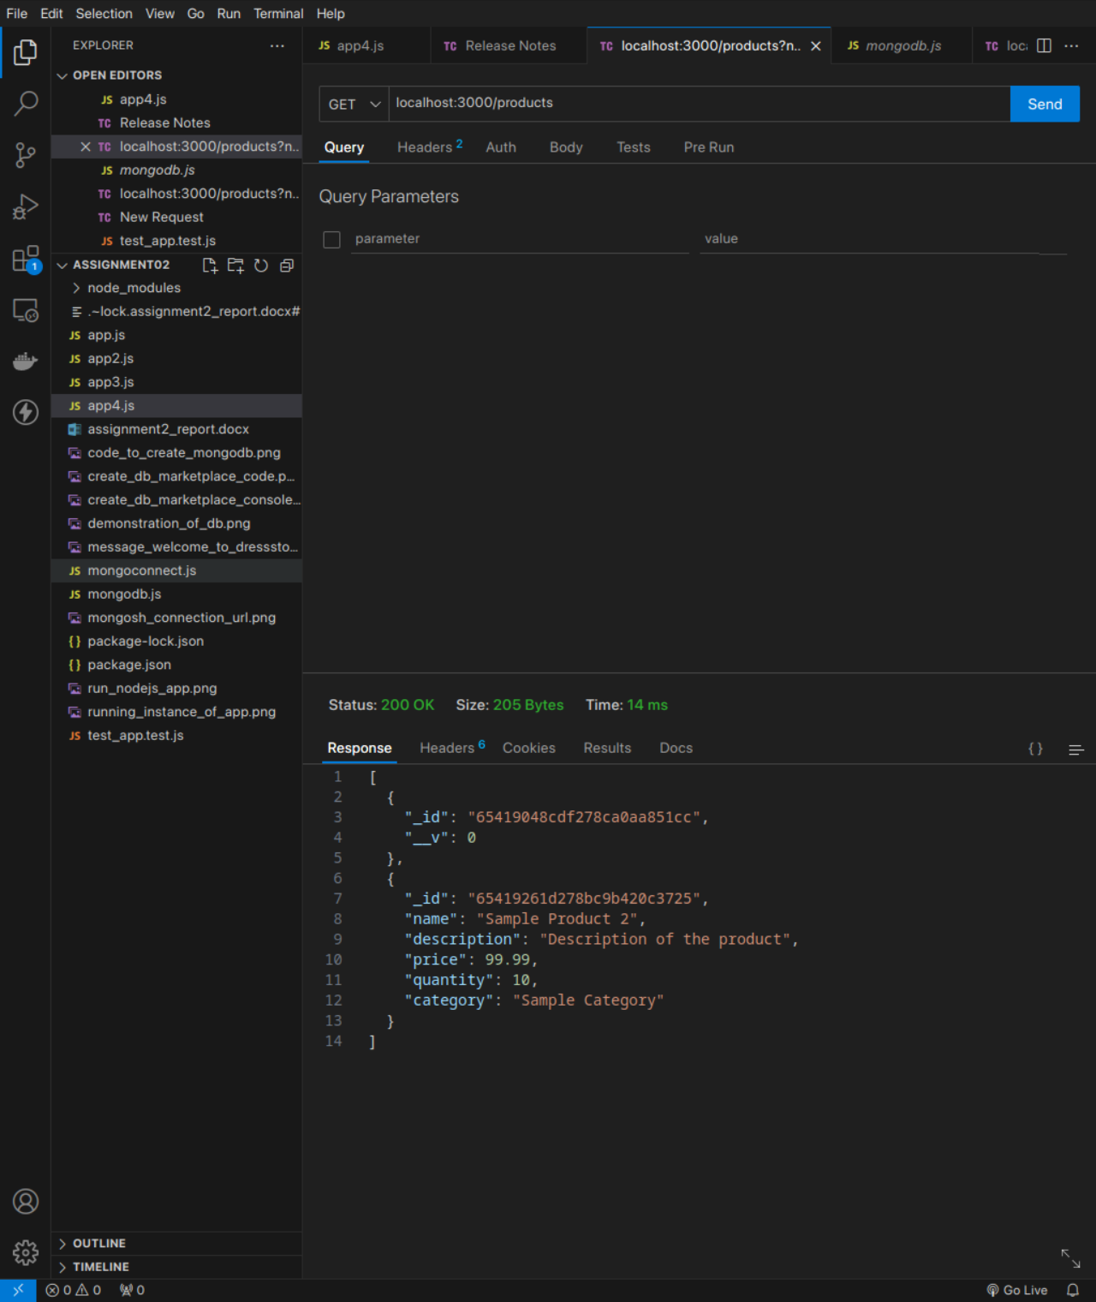

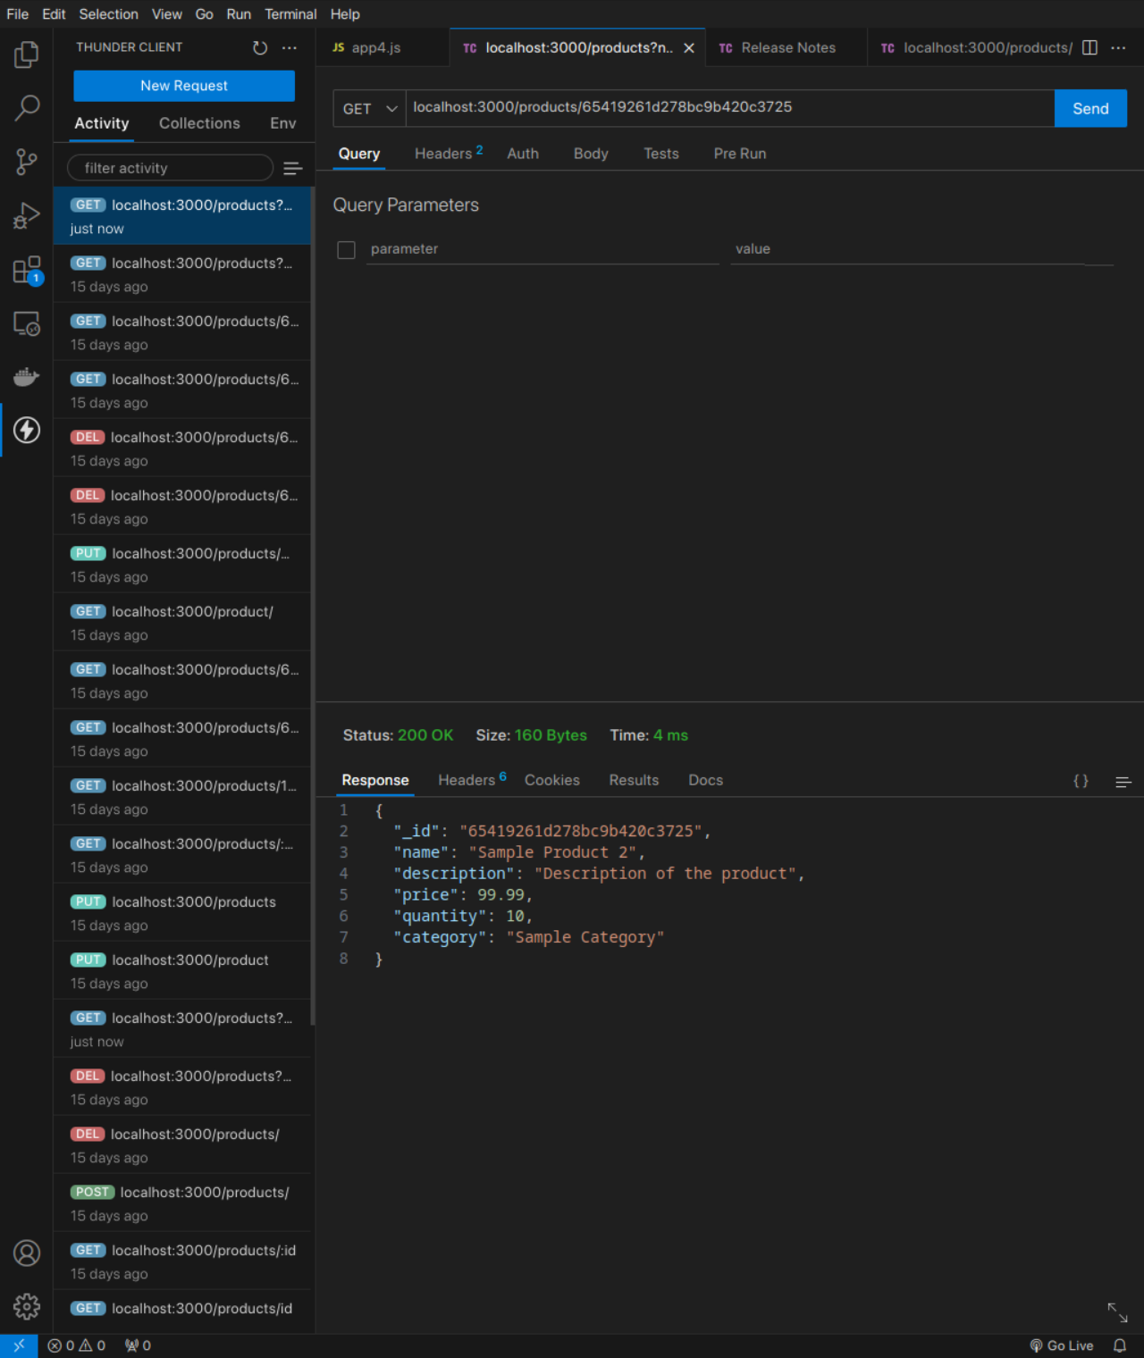

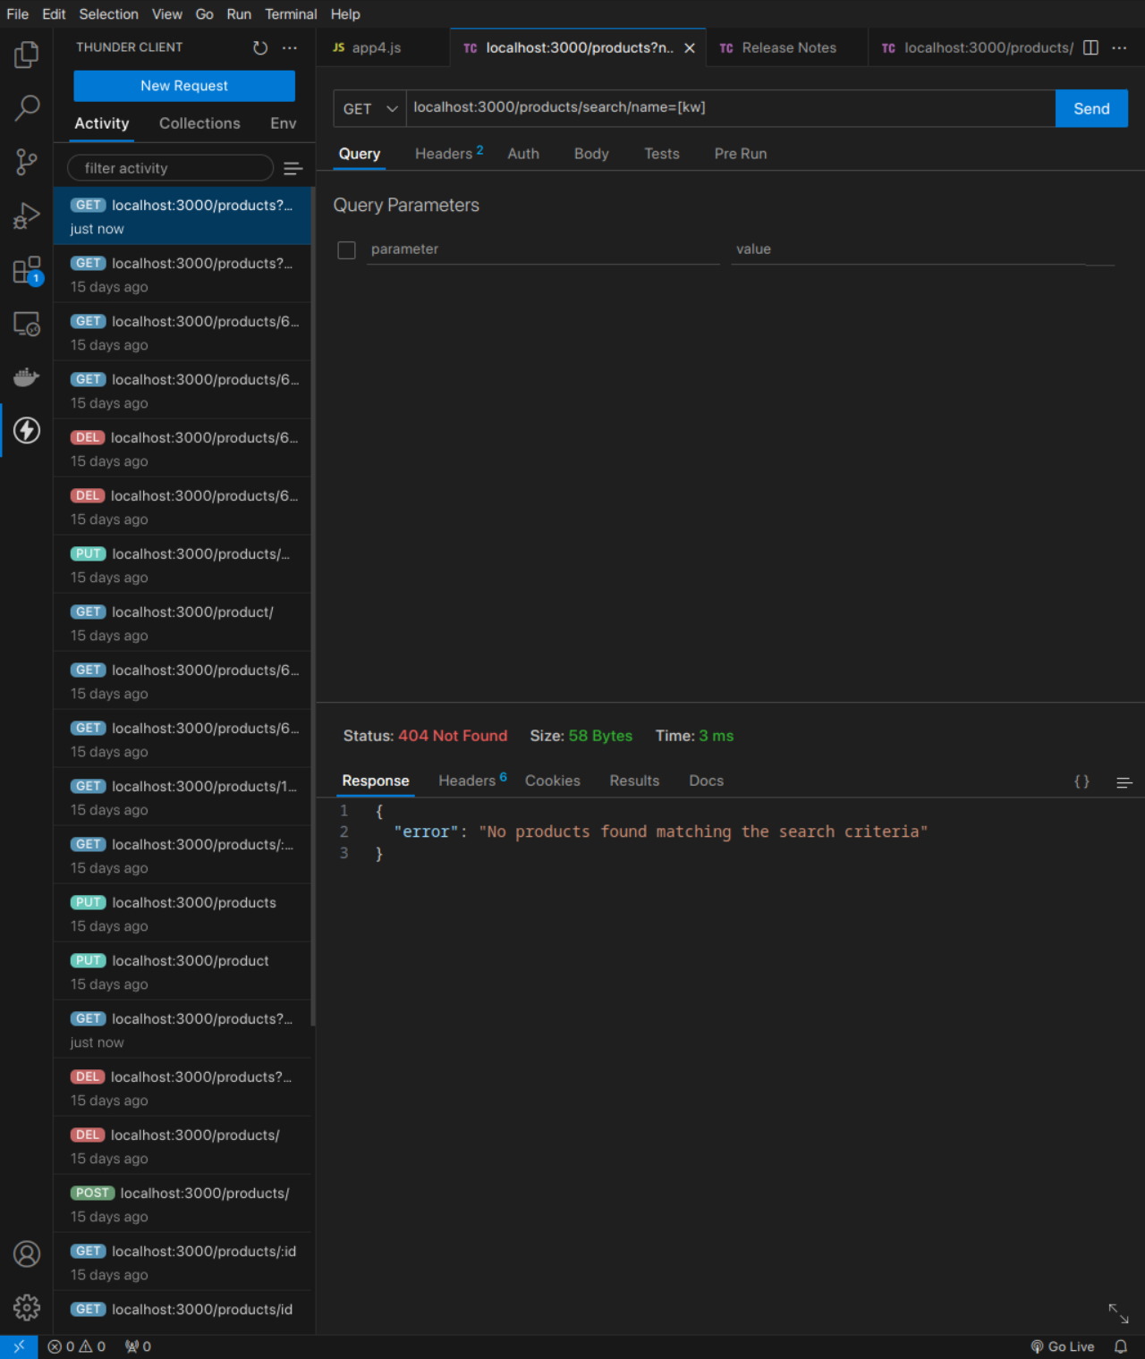

**POST**

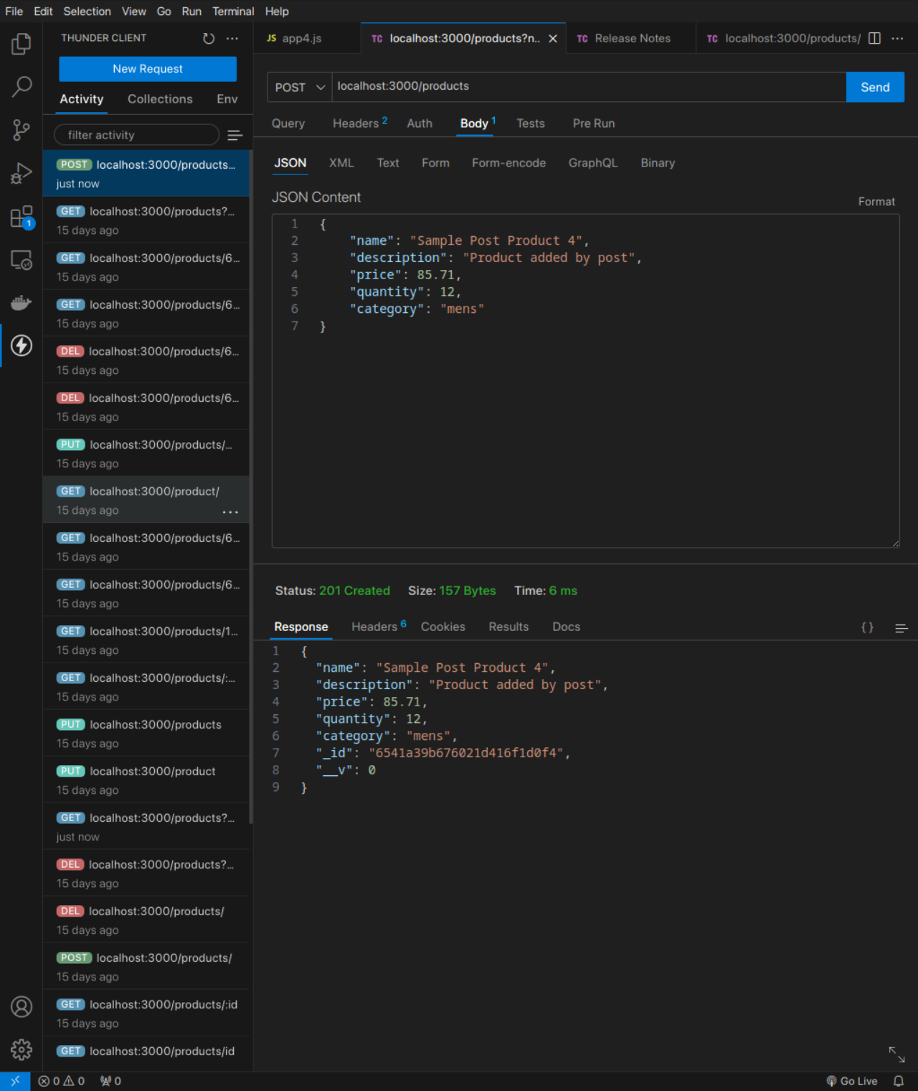

**PUT**

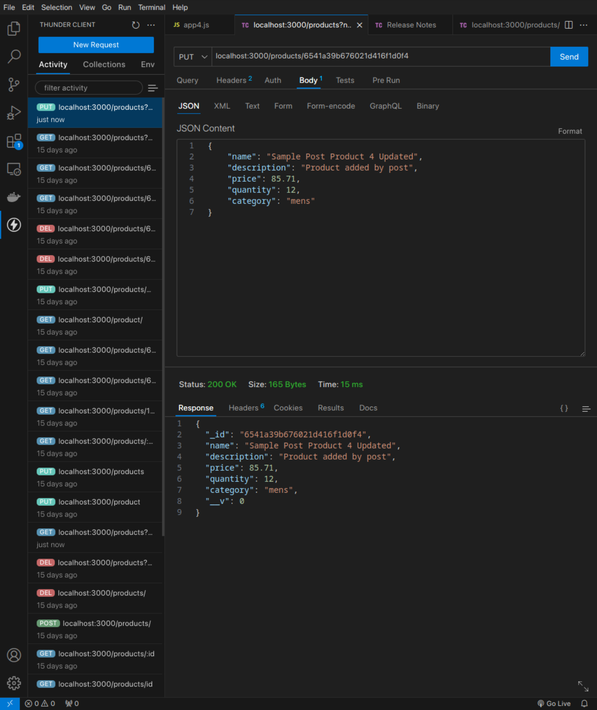

**DELETE**

