17.PDA-AABBC

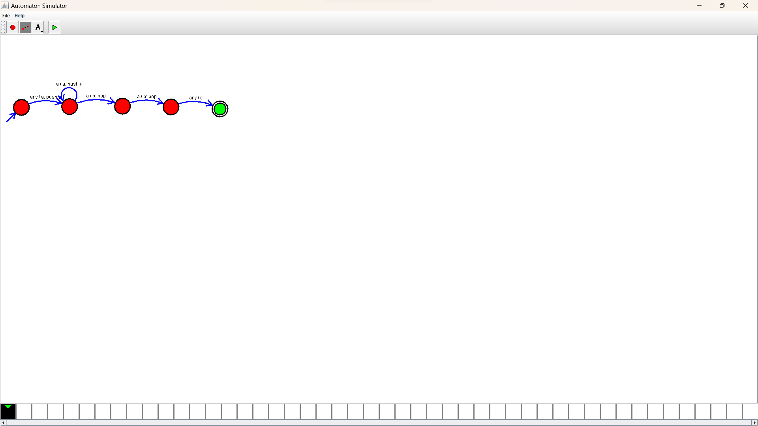Design :

Output:

