Operating Systems Project Report
Submitted By:
Project Team Name: TeamDesiBoyz18094
Team Members:
SJSU ID: 009319466 (Sundeep Budhe)
SJSU ID: 009304776 (Srinivas Belide)
SJSU ID: 009273381 (Srinivasulu Reddy)
SJSU ID: 009175231 (Muhammed Malik)

Objective:
To design a multithread server and multiprocess client that supports the following functions:
- Convert an arbitrary size text file from upper to lower case
- Count the number of characters, words and the number of times each word occurs
- Synchronization mechanism to insure the correctness of the performance.

About the Project:
‘Socket’ is defined as the end point of communication that allows the client/server systems to be developed either on a single machine or across the networks. The project is mainly intended to reinforce the processes, threading concepts and synchronization mechanisms. Client/Server is implemented on the Linux environment and the communication is done using the sockets.

Design:
- Client-Server communication is established via the POSIX sockets
- Sockets are created on the client end that is required to send the requests to the server. Multiple processes are created using the fork () system call. Child process consists the code to create, name and establish a connection using a socket.
- Pthreads are used on the server end that listens to the incoming client connections.
- A test file that consists a group of characters (upper and lower) is used for code testing.
- Server has the code logic that converts all the characters to lower case alphabets and writes the result to the client.

Implementation:

Client-Server Connection:

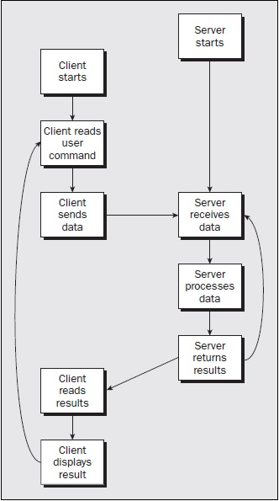

Fig:1 Client-Server

TCP client:

- Creating a socket and establishing a connection with the server involves the following steps :
- Create a socket via the following prototype:
Sockfd= socket (AF_INET, SOCK_STREAM, 0);

AF_INET: Used for programs communicating across the TCP/IP network including the internet
SOCK_STREAM: Reliable connection based two way byte streams that are provided by TCP connection that is established between two end points when connected.

- Naming the socket:
address.sin_family = AF_INET;
address.sin_addr.s_addr = inet_addr ("127.0.0.1");
address.sin_port = 9763;

Sin_family: Specifies the address type. In this case, it is AF_INET
Sin_addr.s_addr: Address of the server to which the Client is supposed to be connected
Sin_port: Specifies the port number.
Loopback address “127.0.0.1” is the computer own network service.

- Establishing the connection to the Server socket:
result = connect (sockfd, (struct sockaddr *)&address, len);

When the connection is successfully established, connect () returns a non-zero value that is stored in the result.

- Character by character is read from the test file on the client and then it is written to the server using the socket descriptor via the child process

TCP Server:
- Socket is created on the server end and steps follow the same as above and additional system calls are expalined below:
- bind() system call is used to name the socket
- listen() creates a queue for the incoming connections
- Server accepts the connections via the system call accept ().

Multi-process client and Multi-threaded server:
Multi-process client:
A multi-process client is created using the fork() system call. The fork() system call is done multiple times by looping it in a while loop to produce multi-process client. Each process connect to the server by connect() system call. Each process opens a given text file with the help of fopen() function and write into the socket character by character by using write() system call. After the file is transferred successfully, the client will read the result from the server by using read() system call. Each client will calculate the turnaround time by taking timestamps using gettimeofday() to measure the performance of the server.

Client:

#include<sys/types.h>
#include<sys/socket.h>
#include<stdio.h>
#include<stdlib.h>
#include<unistd.h>
#include<arpa/inet.h>
#include<netinet/in.h>
#include<fcntl.h>
#include<string.h>
#include <sys/time.h>
#include <sys/resource.h>

int main(int argc ,char *argv[])
{
int sockfd ;
int len,i,j=4,read_count,counter=0;
pid_t pid;
int ch;
char ch2,result_buffer[2000];
struct sockaddr_in address;
struct timeval tim;
int result;
FILE *fp;

/*Time when the program starts */
gettimeofday(&tim, NULL);
double t1=tim.tv_sec+(tim.tv_usec/1000000.0);

while(j!=0)
{
j--;// j=4 for creating multi-process client
counter++;
pid=fork(); //creating child processes

/*socket creation*/
sockfd= socket(AF_INET,SOCK_STREAM,0);
address.sin_family = AF_INET;
address.sin_addr.s_addr = inet_addr("127.0.0.1");
address.sin_port = 9763;
len = sizeof(address);

if(pid==0)
{

/*Opening a file in a read mode*/
fp = fopen(argv[1],"rb");
if(fp==NULL)
{
printf("\nUnable to copy..\n");
return -1;
}

/*Each client connecting to the server*/
result = connect(sockfd,(struct sockaddr *)&address,len);
if(result==-1)
{
perror("oops ! client 1\n");
exit(1);
}

/* Reading character by character from the file and writting it to the server using socket descriptor*/
do
{
ch = getc(fp);
write(sockfd,&ch,sizeof(int));
}while(!feof(fp));
printf("File transferred successfully by client[%d] \n",counter);
bzero(result_buffer, 256);
i=0;

/*Receiving the results from the server*/
printf("\nReceiving meessages from server:\n");
read_count = recv(sockfd, result_buffer, sizeof(result_buffer), 0);
if (read_count < 0)
perror("oops ! Reading");

/*Displaying the result from server*/
printf("%s",result_buffer);

/*Time when the client receives content from the server*/
gettimeofday(&tim, NULL);
double t2=tim.tv_sec+(tim.tv_usec/1000000.0);
printf("********************************************");
printf("turnaround time for client[%d] ---->%.6lf\n",counter, t2-t1); // calculating the turnaround time
printf("********************************************");
close(sockfd);

}
else
{
/*waiting for child to complete */
wait(NULL);
fclose(fp);

}
}

exit(0);
}

Multi-threaded Server:
Multi-threaded server is created by using pthread.h library. Pthread_create() API creates new thread . In multi threaded sever each a connetion is established by using an accept() system call. For a multi-process client the server is looped in a while loop to serve each client. Every time a client request the server accepts the client and process the client. The server will read the information sent by each client and store it in a given file. The server retrieves the contents of the given file to a buffer. Then server has to do applications like word count, sentence count, occurance of each alphabet in a file. For each application a thread is created and processed. To measure the throughput and turnaround time, we take timestamps by using gettimeofday(). The server measures CPU usage by using getrusage(get information about resource utilization ). The server uses mutexes and binary semaphores for synchronization of each threads and to avoid race conditions. The following server program explains through comments.

Server:

#include<sys/types.h>
#include<sys/socket.h>
#include<stdio.h>
#include<stdlib.h>
#include<unistd.h>
#include<arpa/inet.h>
#include<netinet/in.h>
#include<string.h>
#include<fcntl.h>
#include<pthread.h>
#include<time.h>
#include<semaphore.h>
#include <sys/time.h>
#include <sys/resource.h>
#define MAX 2000

pthread_mutex_t work_mutex;

sem_t bin_sem;
int size,thread_count;

char client_buffer[MAX];

void *no_of_words(void *arg)
{
int words=0,i=0;
char *buff, str[15];
buff = (char *)arg;

while( i != strlen(buff))
{
if(buff[i] == ' ')
{

words++;
}
i++;
}
sprintf(str , "%d" , words );

/*Protecting the client buffer from race condition*/
pthread_mutex_lock(&work_mutex);
strcat(client_buffer, "\n\nNumber of words in a file----->");
strcat(client_buffer, str);
pthread_mutex_unlock(&work_mutex);

/*Signaling the main thread that it is done with writing onto client_buffer*/
sem_post(&bin_sem);

pthread_exit(NULL);
}

void *each_alpha_count(void *arg)
{
int i,j,count;
char *alpha;
alpha = (char *) arg;
char buff[15];

/*Protecting the client buffer from race condition*/
pthread_mutex_lock(&work_mutex);
strcat(client_buffer, "\n\nEach alphabet count in a file-----> ");
for(i=0 ; i < strlen(alpha) ; i++)
{
count=0;
if((alpha[i] > 'a' && alpha[i] < 'z' )|| (alpha[i] > 'a' && alpha[i] < 'z' ))
{
for(j=0 ; j < strlen(alpha) ; j++)
{
if(alpha[i] == alpha [j] )
{
count++;
}
else
continue;
}
sprintf(buff, "%c=%d ", alpha[i], count);
strcat(client_buffer, buff);
}
}
pthread_mutex_unlock(&work_mutex);

/*Signaling the main thread that it is done with writing onto client_buffer*/
sem_post(&bin_sem);
pthread_exit(NULL);
}

void *convert_UPPERCASE(void *arg)
{
int i=0;
char *buffer,temp[MAX];
buffer = (char *)arg;
while(buffer[i] != '\0')
{
if(buffer[i] >= 'a' && buffer[i] <= 'z')
{
temp[i]=buffer[i] - 32;
}
else
temp[i] = buffer[i];
i++;
}
temp [i] = '\0';

/*Protecting the client buffer from race condition*/
pthread_mutex_lock(&work_mutex);
strcat(client_buffer, "\n\nLowercase to Uppercase\n");
strcat(client_buffer, temp);
pthread_mutex_unlock(&work_mutex);

/*Signaling the main thread that it is done with writing onto client_buffer*/
sem_post(&bin_sem);
pthread_exit(NULL);
}

void *convert_lowercase(void *arg)
{
int i=0;
char *buffer,temp[MAX];
buffer = (char *)arg;
while(buffer[i] != '\0')
{
if(buffer[i] >= 'A' && buffer[i] <= 'Z')
{
temp[i]=buffer[i] + 32;
}
else
temp[i] = buffer[i];
i++;
}
temp [i] = '\0';

/*Protecting the client buffer from race condition*/
pthread_mutex_lock(&work_mutex);
strcat(client_buffer, "\nUppercase to Lowercase \n");
strcat(client_buffer, temp);
pthread_mutex_unlock(&work_mutex);

/*Signaling the main thread that it is done with writing onto client_buffer*/
sem_post(&bin_sem);
pthread_exit(NULL);
}

void *no_of_sentences(void *arg)
{
char *buff, str[5];
int count=0,i;
buff = (char *)arg;
while(i != strlen(buff))
{
if(buff[i] == '\n')
{
count++;
}
i++;
}

/*Protecting the client buffer from race condition*/
pthread_mutex_lock(&work_mutex);
strcat(client_buffer, "\n\nNumber of sentences ");
sprintf(str , "%d", count);
strcat(client_buffer, str);
pthread_mutex_unlock(&work_mutex);

/*Signaling the main thread that it is done with writing onto client_buffer*/
sem_post(&bin_sem);
pthread_exit(NULL);
}

int main(int argc,char *argv[])
{
char *buffer;
int rc,ch,count,count1,i=1,j,NUM_LOOPS=0;
double duration;
long lSize;
clock_t start,end;
int server_sockfd, client_sockfd;
int server_len, client_len;
pthread_t tid1,tid2,tid3,tid4,tid5;
FILE *fp,*fp1;
struct rusage usage;
struct timeval tim,now;
double involuntary, voluntary, mem_shared;
double sec, usec, sys_sec, sys_usec;

/*Intializing semaphore*/
rc=sem_init(&bin_sem,0,0);
if(rc!=0)
{
perror("sem failed");
exit(EXIT_FAILURE);
}

/*Initializing mutex*/
rc=pthread_mutex_init(&work_mutex, NULL);
if(rc!=0)
{
perror("mutex failed");
exit(EXIT_FAILURE);
}

struct sockaddr_in server_address;
struct sockaddr_in client_address;

/*create an unnamed socket for the server */
server_sockfd = socket(AF_INET, SOCK_STREAM,0);

/*NAME THE SOCKET*/
server_address.sin_family= AF_INET;
server_address.sin_addr.s_addr = inet_addr("127.0.0.1");
server_address.sin_port = 9763;
server_len = sizeof(server_address);
bind(server_sockfd, (struct sockaddr *)&server_address,server_len);

listen(server_sockfd,5);
while(1)
{
start=clock();
printf("\nserver waiting\n");

client_len = sizeof(client_address);
client_sockfd= accept(server_sockfd,(struct sockaddr *)&client_address,(void *)&client_len);
/*Time for calculating for throughput for all clients*/
if(i!=0)
{
gettimeofday(&tim, NULL);
double t1=tim.tv_sec+(tim.tv_usec/1000000.0);
i--;
}

/*Time for calculating each client turnaournd*/
gettimeofday(&now, NULL);
double t3=now.tv_sec+(now.tv_usec/1000000.0);

/*opening a file in write mode*/
fp= fopen(argv[1],"wb");
if(fp ==NULL)
{
printf("File not found!!!\n");
exit(1);
}
fp1= fopen(argv[2],"rb");
if(fp1 ==NULL)
{
printf("File not found!!!\n");
exit(1);
}
count1=0;
do
{
read(client_sockfd,&ch,sizeof(int));
if(ch!=EOF)
{
count1++;
putc(ch,fp);
}
else
break;
}while(1);
memset(client_buffer,'\0',sizeof(client_buffer));
fclose(fp);
size = count1*2;

// declare vertex array
buffer = (char*) calloc(size, sizeof(char));

// read the file to the array
for(i=0; i<size; i++)
fscanf(fp1, "%c", &buffer[i]);

printf("\nReceived File size=%d bytes----->\n",count1);

/*Creating threads for clients*/
pthread_create(&tid1,NULL,no_of_words,buffer);
thread_count++;
pthread_create(&tid2,NULL,each_alpha_count,buffer);
thread_count++;
pthread_create(&tid3,NULL,convert_UPPERCASE,buffer);
thread_count++;
pthread_create(&tid4,NULL,convert_lowercase,buffer);
thread_count++;
pthread_create(&tid5,NULL,no_of_sentences,buffer);
thread_count++;

/*Waiting on the semaphore utill all the threads writes onto client_buffer */
sem_wait(&bin_sem);
sem_wait(&bin_sem);
sem_wait(&bin_sem);
sem_wait(&bin_sem);
sem_wait(&bin_sem);
i=0;
pthread_mutex_lock(&work_mutex);
printf("sending modified content to client----%s \n\n",client_buffer);

count = send(client_sockfd, client_buffer, strlen(client_buffer), 0);
if (count < 0)
error("ERROR writing to socket");
pthread_mutex_unlock(&work_mutex);

pthread_join(tid1,NULL);
pthread_join(tid2,NULL);
pthread_join(tid3,NULL);
pthread_join(tid4,NULL);
pthread_join(tid4,NULL);
if (getrusage(RUSAGE_SELF, &usage) == -1) {
perror("getrusage");
exit(1);
}

/* Resource Utilization*/
voluntary = usage.ru_nvcsw;
involuntary = usage.ru_nivcsw;
sec = usage.ru_utime.tv_sec;
sys_sec = usage.ru_stime.tv_sec;
usec = usage.ru_utime.tv_usec;
sys_usec = usage.ru_stime.tv_usec;
mem_shared= usage.ru_ixrss;

/*Time for calculating throughput for all clients*/
gettimeofday(&tim, NULL);
double t2=tim.tv_sec+(tim.tv_usec/1000000.0);

/*Time for calculating turnaround each client*/
gettimeofday(&tim, NULL);
double t4=now.tv_sec+(now.tv_usec/1000000.0);

/* print difference stats */
printf("*****************************************\n");
printf("number of loops------>%d",++NUM_LOOPS);
printf("turnaround time for client[%d] ---->%.6lf\n",NUM_LOOPS, t4-t3);
//printf("%lf shared memory size",mem_shared );
printf(" throughput %lf ----> threads per second\n",thread_count/(t2-t1));
//printf("%lf total microseconds\n", usec + sys_usec);
printf("voluntary context switches----> %lf \n", voluntary);
printf("involuntary context switches---->%lf \n", involuntary);
printf("*****************************************");
close(client_sockfd);
fclose(fp1);
}
return 0;
}

Performance:
Performance of a server can be measured by calculating the turnaround time, throughput and resource utilization.
Turnaround : amount of time to execute each client by taking timestamps with the help of gettimeofday(&now, NULL);
Throughput: Throughput is simply defined as the number of threads per second that the server can handle.
Resouce utilization: Measuring the rources like context switching by using a pre-defined structure (struct rusage ).

Server output:

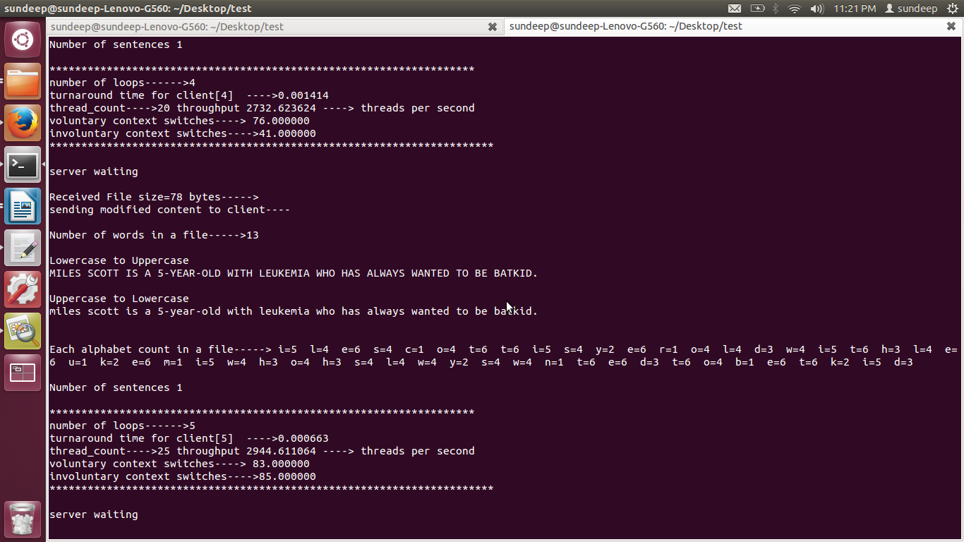

Client output:
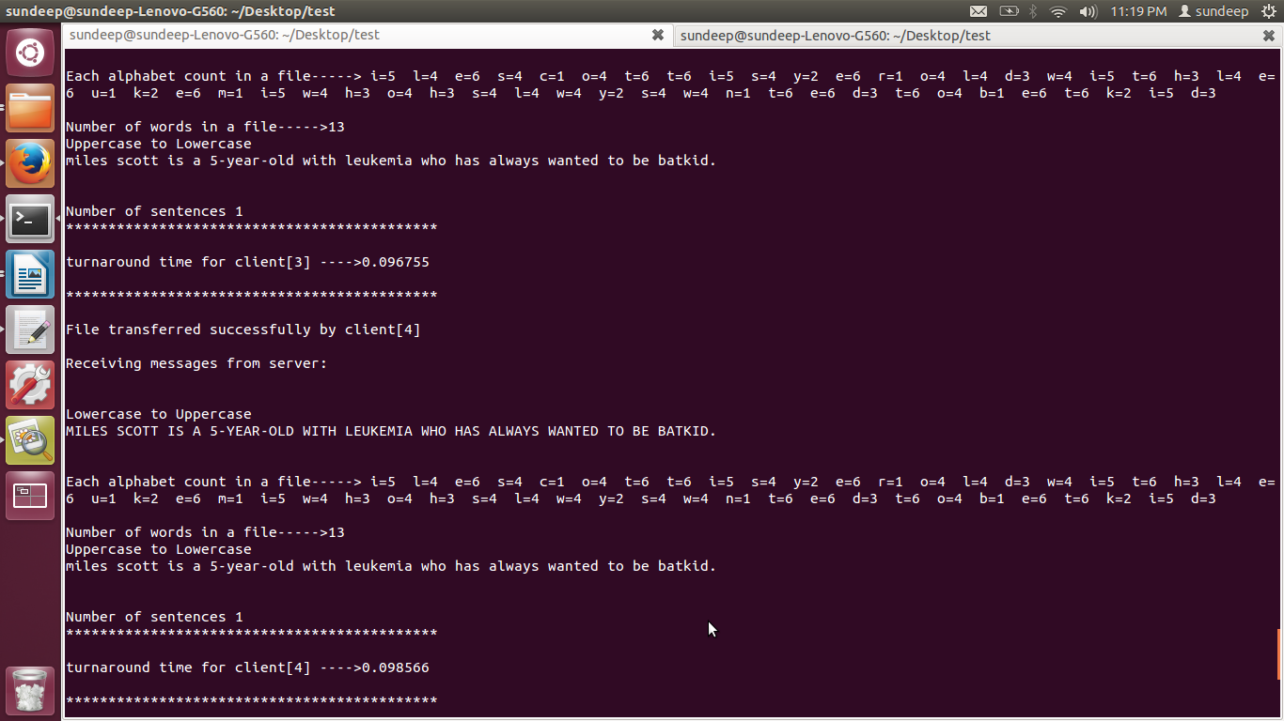

Overall Performance:

Throughput vs number of threads:

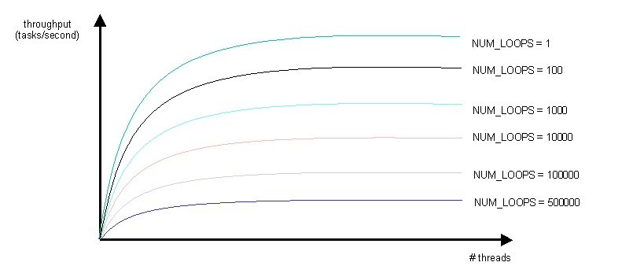
Conclusion:

Multi-process client measures the performance of multi-threaded server with the help of throughput and number of threads created by the multi-threaded server for processing multi-process client. Thus we observed the throughput decreases as the number of the number of clients increases. Because for each client the process has to create several threads for processing. As we observed that throughput decreases as the number of thread increases. The server performance decreases as the number of clients increases.

