AQARFLOW
Daily Status Update - Day 2
Project: AqarFlow - Real Estate Management & Property Operations Platform
Organisation: VIRELEO
Date: 10 November 2026
Development Model: Individual Development Project
Day 2 Focus: Login & Roles

1. Objective for the Day
Finalise the technology stack, prepare the local development environment and project structure, establish the basic application architecture, and implement login/logout, password hashing, protected routes and Admin/Agent permissions.
Work package | Day 2 commitment
Planned activities | Complete login/logout, password hashing, protected routes and backend role checks for Admin and Agent; build the dashboard shell and reusable UI components.
Expected outcome | Admin and Agent can sign in and see only permitted workspace areas.
Current outcome | Implemented locally, with backend permissions and an operational dashboard.

2. Activities Completed
1. Technology stack finalised: Confirmed React.js with TypeScript, Node.js with Express.js, PostgreSQL and REST APIs. VS Code and Git are used for development and version control.
2. Local environment prepared: Configured dependencies, database connectivity, environment examples and startup scripts. Frontend and backend run separately.
3. Project structure established: Organised separate frontend/backend folders and prepared the initial local Git repository and VS Code configuration.
4. Application architecture established: Implemented React Frontend -> Express REST API -> PostgreSQL. Business rules, validation and access checks are enforced by the backend.
5. Login/logout implemented: Admin and Agent can sign in. Logout revokes the current session and clears the browser's stored access token.
6. Password hashing implemented: Passwords are stored as bcrypt hashes rather than plain text.
7. Protected routes and role checks implemented: Unauthenticated access is rejected. Admin manages agency inventory, staff and lead assignments. Agents access their assigned leads, visits and deals, with read-only access to their agency's inventory.

8. Dashboard and reusable UI components prepared: Added role-aware navigation, basic live dashboard counts, shared form controls, status badges and loading/error states.
9. Initial application workflows progressed: Property listings, inquiry capture, basic CRM, visit scheduling and deal tracking are connected in the local MVP.
10. Requirements alignment updated: Confirmed the seven-day MVP boundary and documented the current functionality, business flow and remaining scope. Pakistan/PKR remains the default market and currency.

3. Outcome Against Planned Activities
All five previously planned foundation activities have been completed: technology selection, local setup, frontend/backend structure, basic architecture and initial implementation.
The Day 2 Login & Roles outcome is also implemented locally: Admin and Agent can sign in and access only the functionality permitted by the MVP role rules.

4. Current Project Status
The application is available locally at http://localhost:3000. Its core flow connects property publication, visitor inquiries, lead management, visits and basic deal tracking.
Development has progressed beyond the initial foundation. This is a working local MVP, not completion of the full enterprise application or a production release.

5. Pending Activities and Scope Boundaries
Further screen refinement, responsive-layout improvements, documentation and final handover remain ongoing. The local Git repository is initialised; GitHub remote setup and release handover remain pending.
Rentals, finance, private documents, automation and other advanced modules remain outside the agreed first-week scope. Deployment is currently deferred. No production security or deployment certification is claimed.

Login Screenshots



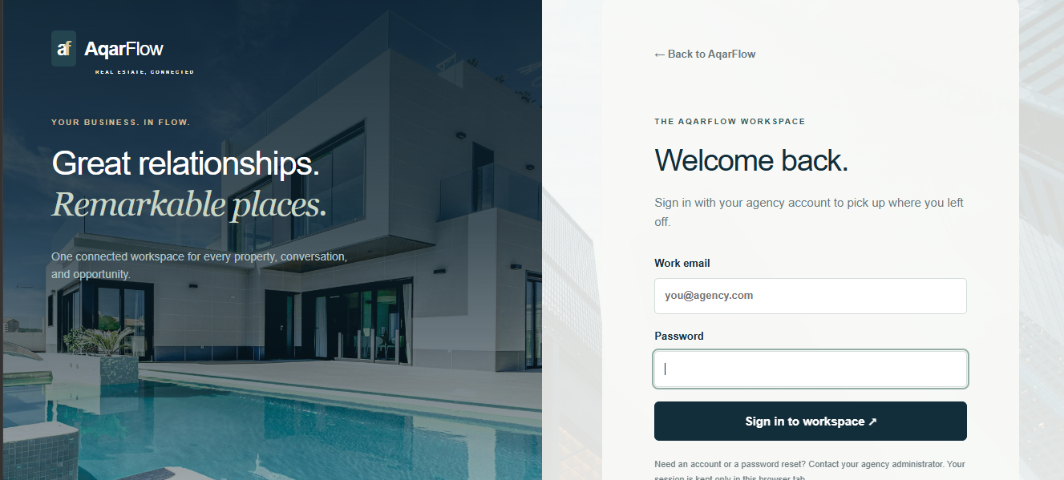

6. Tomorrow's Work Plan - Day 3
1. Review and refine the property create, edit, list and detail screens.
2. Review property fields, status changes, publishing controls and image-upload behaviour against the MVP requirements.
3. Refine public property search, filters and listing presentation.
4. Improve form validation, loading states and success/error messages.
5. Update the implementation documentation with completed work and remaining issues.

