WCAG PDF Scanner - Technical Documentation

1. Introduction
The WCAG PDF Scanner is a desktop utility designed to validate PDF documents against WCAG accessibility standards (PDF/UA-1). It provides a user-friendly interface to scan files, visualize errors, and inspect the logical structure (tags) of PDFs.

2. Technical Architecture
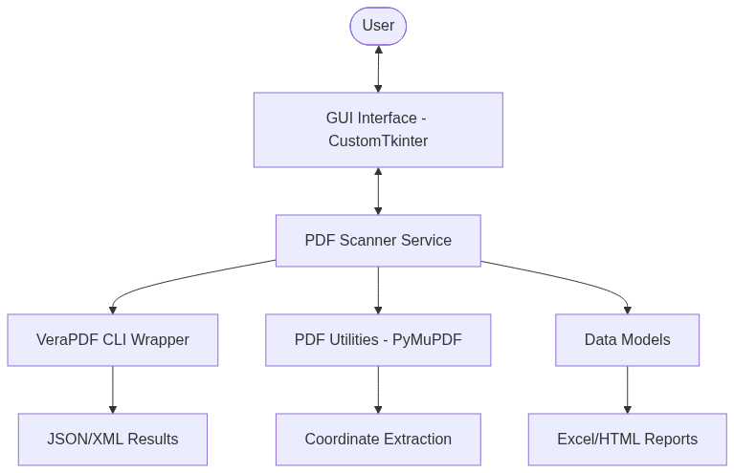

Component Diagram
graph TD
User([User]) <--> GUI[GUI Interface - CustomTkinter]
GUI <--> Scanner[PDF Scanner Service]
Scanner --> VeraPDF[VeraPDF CLI Wrapper]
Scanner --> PDFUtils[PDF Utilities - PyMuPDF]
Scanner --> Models[Data Models]
VeraPDF --> Results[JSON/XML Results]
PDFUtils --> Bbox[Coordinate Extraction]
Models --> Report[Excel/HTML Reports]

Tech Stack
- **Language**: Python 3.10+
- **GUI Framework**: [CustomTkinter](https://github.com/TomSchimansky/CustomTkinter) (Modern UI)
- **PDF Engine**: [PyMuPDF (fitz)](https://pymupdf.readthedocs.io/) (Rendering and tag traversal)
- **Validation Engine**: [VeraPDF](https://verapdf.org/) (Standard-compliant PDF/UA validation)
- **Data Models**: Python Dataclasses

3. Prerequisites
Requirement | Version | Purpose
**Python** | 3.10+ | Core language
**Java (JRE/JDK)** | 8+ | Required by VeraPDF
**VeraPDF** | 1.28.2+ | Compliance engine
**Internet** | Optional | Required only for initial setup

4. System Flowchart (Scan Process)
sequenceDiagram
participant U as User
participant G as GUI
participant S as Scanner Service
participant V as VeraPDF
participant P as PyMuPDF
U->>G: Selects PDF File/Folder
G->>S: Calls scan_files()
S->>V: Runs --flavour ua1 validation
V-->>S: Returns JSON Violations
S->>P: Opens PDF to extract Logical Structure
P-->>S: Returns Nested Tag Tree (H1, P, etc.)
S-->>G: Returns PDFResult Object
G->>U: Displays Success/Failure UI

5. User Journeys

A. Scanning a Single PDF
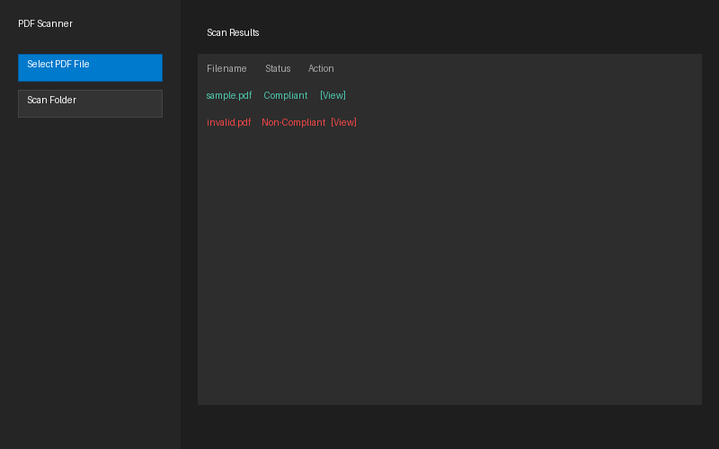
- Launch the application.
- Click **"Select PDF File"**.
- Choose a document and wait for the "Scan Progress" to complete.
- View the status (Compliant/Non-Compliant) in the main table.

B. Inspecting Accessibility Errors
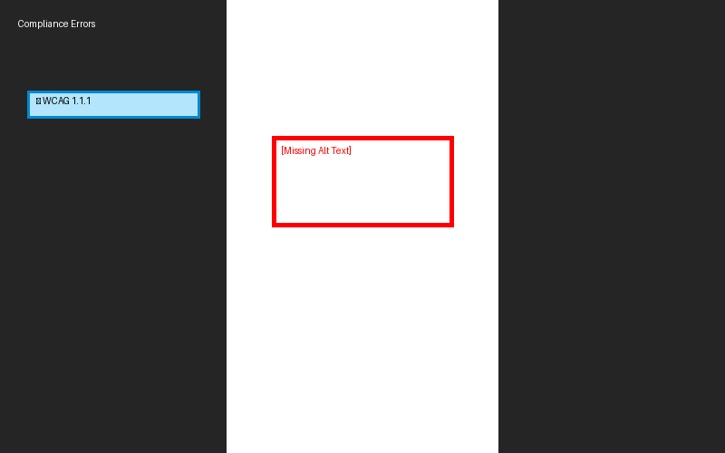
- Click the **"👁 View"** button on any scanned result.
- The **Left Panel** lists all rule violations grouped by page.
- Click an error button to highlight the exact location (image/text) in the **Middle Panel**.

C. Verifying Document Tags
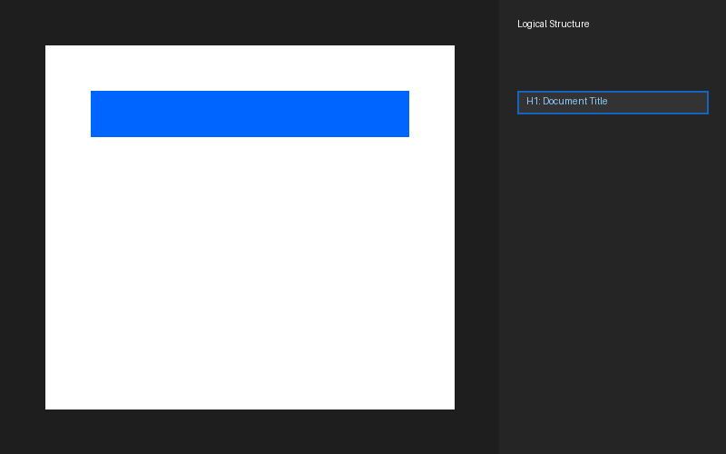
- In the **Right Panel**, see the **Logical Structure** tree.
- Click any tag (e.g., `<H1>`) to jump to that element.
- A **Blue Highlight** will appear over the physical content on the page.

6. Maintenance & Troubleshooting
- **Logs**: Located in `logs/scanner.log`.
- **Temp Files**: Scanned documents are temporarily processed in the `uploads/` folder.
- **VeraPDF Path**: Ensure `VERAPDF_PATH` is correctly set in `config.py` or system environment variables.

