WCAG PDF Scanner - User Guide
This guide provides step-by-step instructions on how to use the WCAG PDF Scanner utility to validate and inspect PDF documents for accessibility compliance.

1. Launching the Application
Run the `main.py` script to start the application. On launch, you will see the main dashboard in Light Mode by default.

The Dashboard
The dashboard is your central hub for selecting files and starting scans.
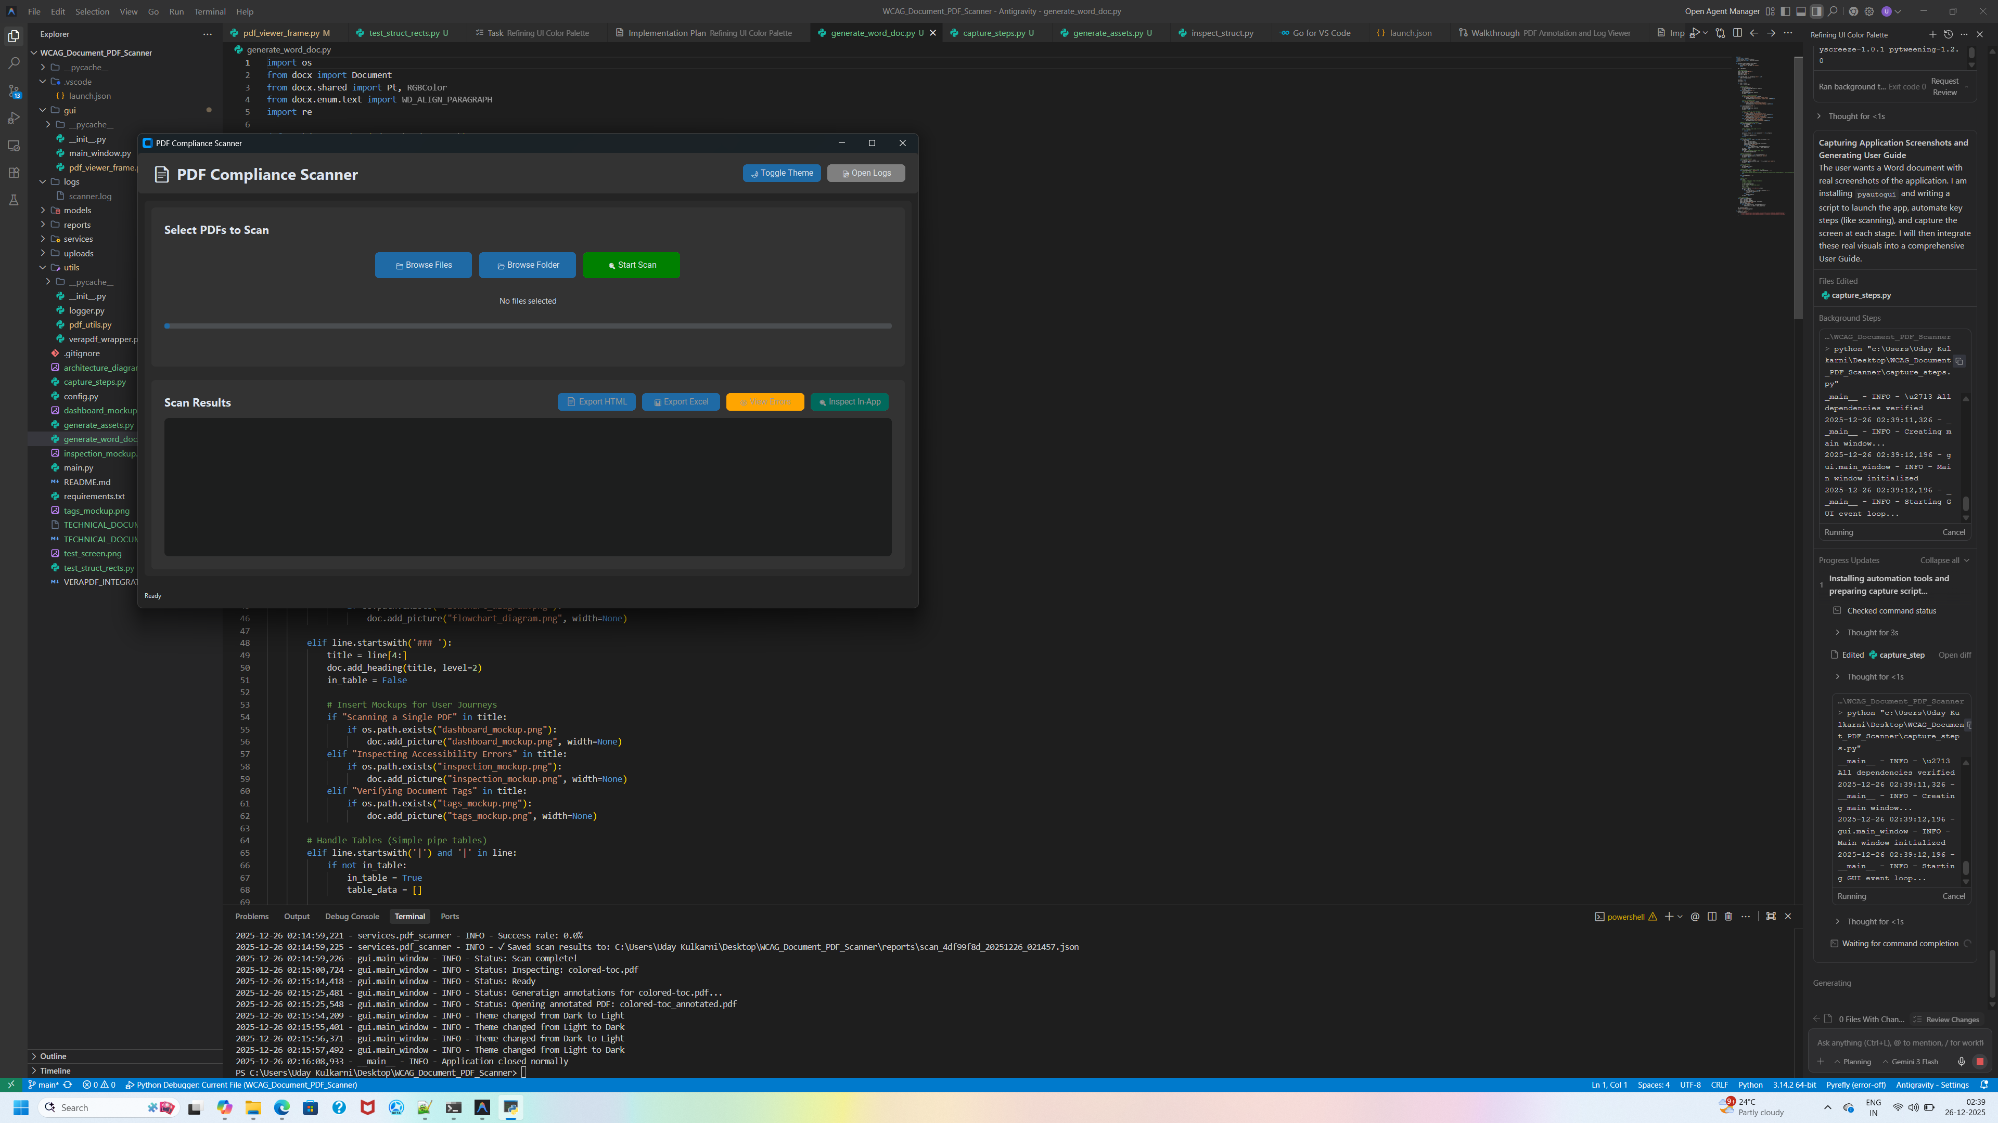

2. Scanning PDF Documents

Step 2.1: Select Files or Folders
- Click **"Browse Files"** to select individual PDF documents.
- Click **"Browse Folder"** to automatically discover all PDFs within a directory (including subfolders).

Step 2.2: Start the Scan
Once files are selected, click the green "Start Scan" button. The progress bar will update as VeraPDF validates each document.

3. Dark Mode Support
For a more comfortable viewing experience, you can toggle the theme using the "Toggle Theme" button in the header.
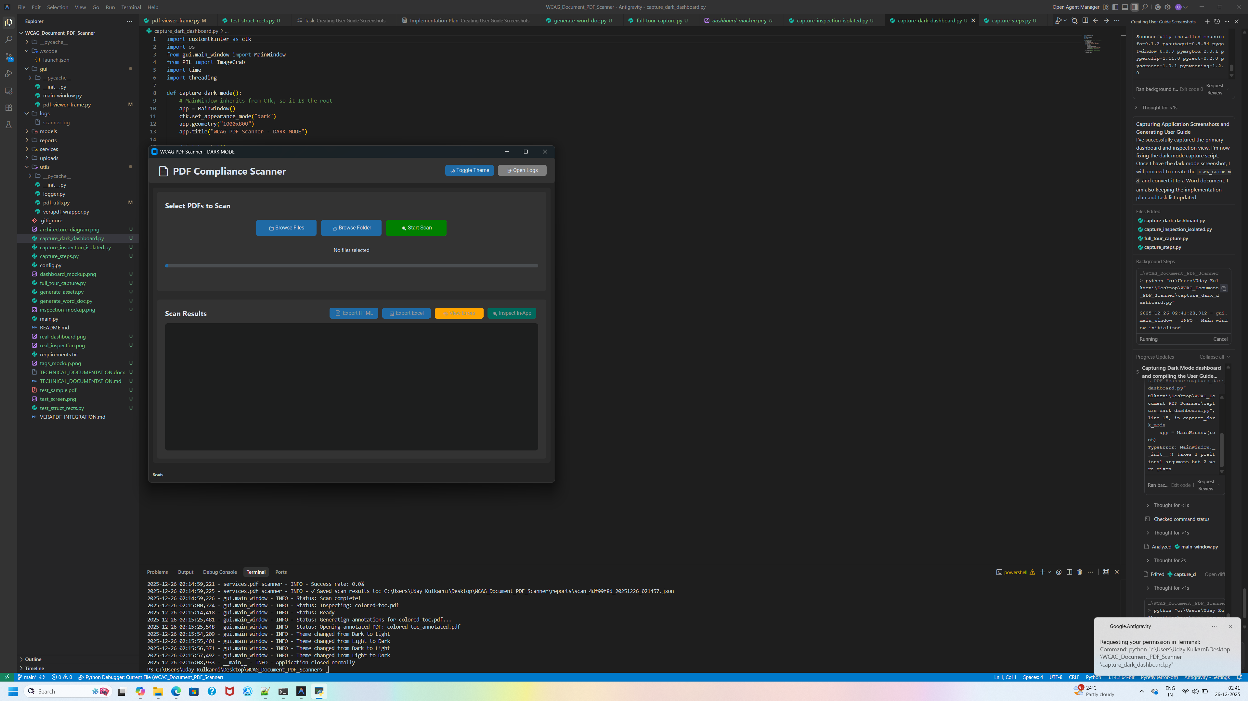

4. Inspecting Results
After the scan completes, your results will appear in the Scan Results table.

Detailed Inspection
To look closer at a specific document, select it and click "Inspect In-App".
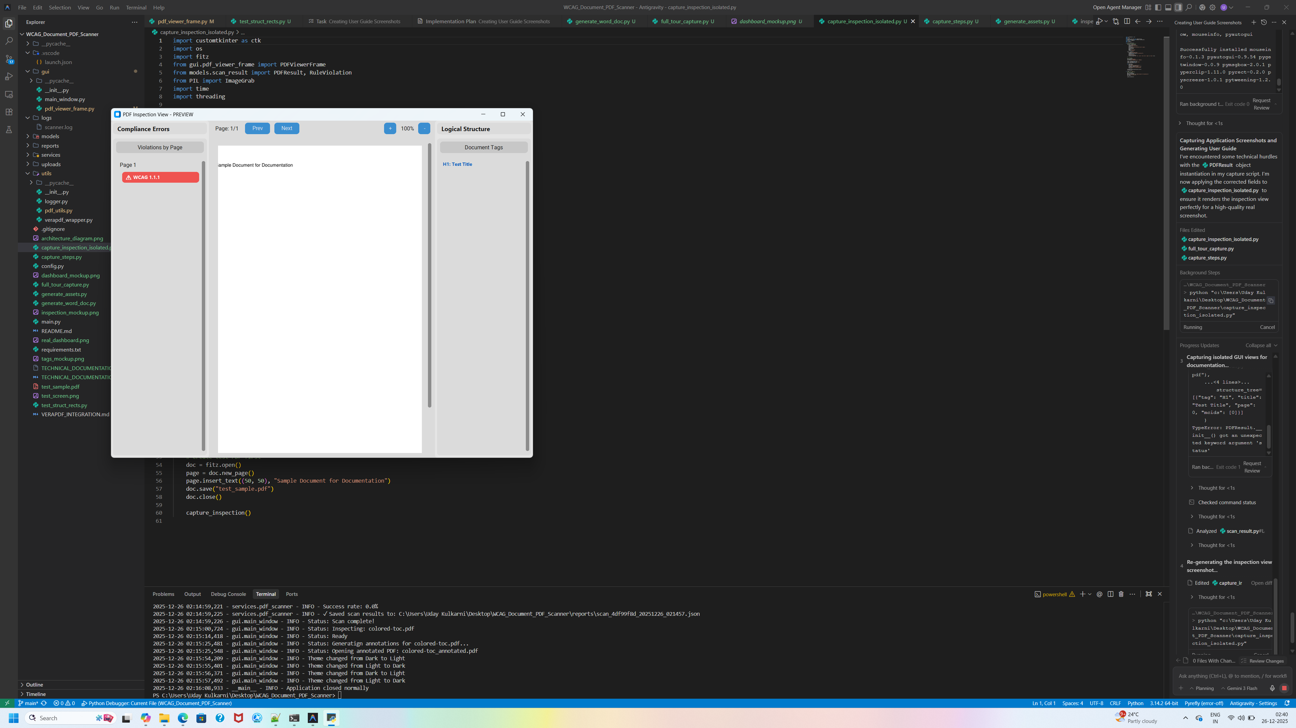

Key Features in Inspection:
- **Compliance Errors (Left)**: View a list of all WCAG violations. Click any error to highlight it on the PDF.
- **PDF Viewer (Middle)**: Real-time visualization of the document with translucent overlays on selected errors.
- **Logical Structure (Right)**: Inspect the physical "tags" (H1, P, Table) of the PDF. Click a tag to jump to its location on the page.

5. Exporting Reports
You can export your findings in two formats:
- **HTML Report**: A clean, interactive summary that opens in your browser.
- **Excel Report**: A detailed spreadsheet containing exact rule IDs, clauses, and failed check counts for every violation.

