DESIGN AND ANALYSIS OF ALGORITHMS
Hackathon Project Report

SCHOOL BUS ROUTE PLANNER
Efficient pickup routes using Dijkstra's Algorithm, Breadth-First Search and Greedy Strategy

Subject | Design and Analysis of Algorithms
Problem Statement | Problem Statement 32: School Bus Route Planner
Core Algorithms | Dijkstra's Algorithm, Breadth-First Search (BFS), Greedy Algorithm
Suggested Technologies | Python, Flask, React, PostgreSQL
Team Name | [Team Name]
Team Members | [Member 1], [Member 2], [Member 3], [Member 4]
Student Name / Roll No. | [Student Name] / [Roll Number]
College / Department | [College Name], Department of [Department]
Academic Year | [20XX – 20XX]
Designation | DAA Hackathon Project

Submitted in partial fulfilment of the course requirements

Abstract
Transporting students safely and on time is one of the most routine yet demanding logistics tasks a school faces. A bus must collect students from many stops spread over a road network, it cannot carry more students than its seating capacity, and some stops, for example those with young children or students with special needs, must be served earlier than others. Planning such routes by hand is slow and tends to produce routes that are longer than necessary or that ignore capacity and priority constraints.
This project presents the School Bus Route Planner, an algorithm-centric prototype that converts the hackathon requirement, create efficient school-bus pickup routes considering stops, road distances, capacity and approximate pickup priorities, into a working planning tool. The road network is modelled as a weighted undirected graph in which stops, road junctions and the school are vertices and roads are edges weighted by distance in kilometres.
Three classical algorithms are combined. Breadth-First Search explores the graph level by level to verify that every stop can be reached from the school and to report minimum-hop paths. Dijkstra's algorithm computes the least-distance path between the school and every stop, and between every pair of stops, because road distances are non-negative. A Greedy strategy then builds each bus route one stop at a time: at every step it picks the feasible unvisited stop with the best score, where the score combines the road distance from the bus's current position with a bonus for higher pickup priority, and a stop is feasible only if the bus still has enough free seats. When a bus cannot take any further stop, the route is closed by returning to the school and a new bus route is started.
The prototype records every choice, so the user can see which stop was selected, why it was selected and how the load and distance changed. Sample results on a seven-stop demonstration network show how capacity, priority weighting and road closures change the routes. The report also analyses the time and space complexity of the design and is honest about its limits: the greedy construction is a heuristic and does not guarantee a globally optimal set of routes.
Keywords: school bus routing, Dijkstra, Breadth-First Search, Greedy algorithm, capacity constraint, pickup priority.

1. Introduction

1.1 Background
A school bus service is a small fleet-routing system. Every morning a number of buses leave the school or depot, travel along public roads, stop at pre-defined pickup points and return to the school with students on board. The cost of the service depends mainly on the total distance travelled, the number of buses used and the time students spend on board. Because the underlying road map can be represented as a graph, the problem is a natural application of graph algorithms studied in Design and Analysis of Algorithms.

1.2 Why Routing Needs Algorithms
Routes drawn manually usually follow habit. This causes several problems: (i) buses travel extra kilometres because stops are visited in a poor order; (ii) one bus is overloaded while another runs half empty; (iii) high-priority stops are served late because nobody has quantified their urgency; and (iv) when a road is closed, the whole plan has to be redrawn by hand. Each of these problems can be expressed as a computation on a graph with numerical weights, which an algorithm can solve in milliseconds.

1.3 Constraints Considered
- Stops: the pickup locations, each with a student count.
- Road distances: non-negative weights on the road segments between stops and junctions.
- Capacity: the maximum number of students a bus can carry on one run.
- Approximate pickup priorities: a small integer level (1 = normal, 2 = medium, 3 = high) that expresses how early a stop should be served. The word approximate is important: priorities guide the choice but are not hard deadlines.

1.4 Motivation
The problem combines three distinct algorithmic ideas in a single, easily visualised scenario. Shortest paths are needed to know the true travelling distance between two stops, because stops are rarely joined by a direct road. Graph traversal is needed to guarantee that the plan only contains stops the buses can actually reach. A greedy decision rule is needed to turn those distances into an ordered route under the capacity limit. This makes the project an ideal vehicle for demonstrating DAA concepts in a form that a non-specialist can understand.

1.5 Role of Algorithms
Table 1: Role of each algorithm in the Route Planner
Algorithm | Question it answers | Used for
BFS | Which stops can the bus reach, and by how few road segments? | Reachability check, minimum-hop paths, detecting disconnected stops
Dijkstra | What is the shortest road distance between two places? | Distance matrix between the school and all stops; actual path to drive
Greedy | Which stop should the bus visit next? | Route construction under capacity and priority

2. Existing and Proposed Approach

2.1 Existing (Manual) Approach
In many schools the transport coordinator assigns stops to buses using local knowledge and a printed map. The order of stops stays the same for years, even when students move or roads change. Distances between stops are estimated, capacity is checked informally and priorities, if any, are remembered rather than recorded.

2.2 Limitations of Simple Routing
- No systematic way to find the shortest road path between two stops.
- Unreachable or cut-off stops are discovered only when a bus fails to arrive.
- Capacity violations and unbalanced loads between buses.
- Priorities are not quantified, so they cannot be traded off against distance.
- Routes are not recomputed quickly after a road closure or a new stop.

2.3 Proposed School Bus Route Planner
The proposed system accepts the stops, roads and fleet settings, builds a weighted graph, and automatically produces pickup routes. BFS validates reachability, Dijkstra provides exact shortest distances, and the Greedy rule builds capacity-feasible routes in which higher-priority stops are favoured. Every selection is logged so that the planner can explain its decisions.

2.4 High-Level Workflow
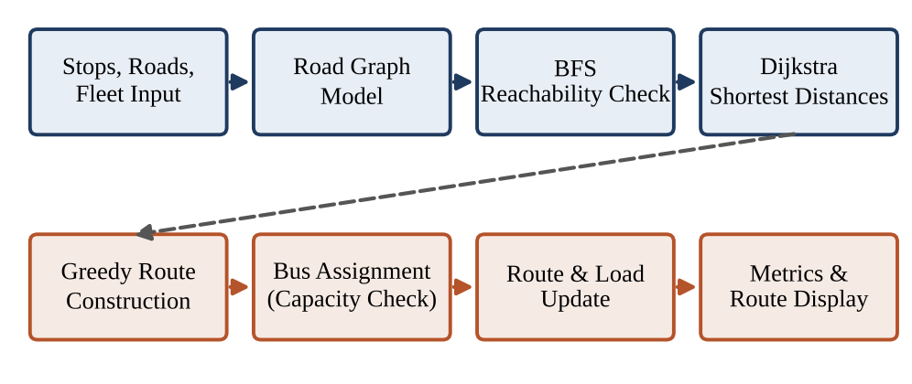
Figure 1: High-level workflow of the School Bus Route Planner
The upper row prepares the data: input is converted into a graph, BFS validates it and Dijkstra turns it into a distance matrix. The lower row creates the routes: the Greedy step chooses stops, the capacity check keeps every bus legal, the load and route are updated, and finally metrics and routes are presented to the user.

3. Problem Statement

3.1 Official Statement
Problem 32: School Bus Route Planner (Core algorithms: Dijkstra, BFS, Greedy; suggested technologies: Python, Flask, React, PostgreSQL). "Create efficient school-bus pickup routes considering stops, road distances, capacity and approximate pickup priorities."

3.2 Problem Definition
Given a school S, a set of pickup stops, a weighted road graph G = (V, E) and buses of capacity Q, find a set of routes, each starting and ending at the school, such that every reachable stop is visited exactly once, no route carries more than Q students, the total distance is small, and stops with higher pickup priority are served earlier where this is reasonable.
Table 2: Problem decomposition
Aspect | Description
Input | Road edges with distances (km); stops with student count and priority (1–3); bus capacity Q; location of the school.
Processing | Build adjacency list; run BFS for reachability; run Dijkstra from the school and each stop; build the stop-to-stop distance matrix; construct routes greedily.
Server/route selection | At each step choose, among unvisited stops that fit in the remaining seats, the one with the lowest score = distance – λ × priority.
Output | Ordered list of stops per bus, route distance, load, actual road path, pickup order and a reason for each choice.
Routing requirements | Every route starts and ends at the school; capacity is never exceeded; unreachable stops are reported, not silently dropped.
Need for optimization | Total distance, number of buses and delay of high-priority stops are competing costs and must be balanced.

3.3 Why the Problem is Hard
Choosing the best order of stops for a single bus is a Travelling-Salesman-type problem, and splitting stops among capacity-limited buses makes it a vehicle-routing problem. Both are NP-hard, so exact solutions are impractical for realistic numbers of stops. This is why polynomial-time heuristics supported by exact shortest-path computation are an appropriate design for a DAA project.

4. Objectives
The project has the following objectives; each is demonstrated by a feature of the prototype and evaluated in Section 12.
- Model the road network as a weighted graph with stops, junctions and the school as vertices.
- Represent stops and buses, including student counts, priorities and seat capacity.
- Check reachability of every stop with BFS and report disconnected stops.
- Compute shortest road distances with Dijkstra's algorithm and recover the actual path.
- Build routes with a Greedy rule that respects capacity and favours high-priority stops.
- Make decisions visible by recording the candidate scores and the reason for each selected stop.
- Reduce unnecessary travel and avoid overloaded buses.
- Present understandable results: route tables, distances, loads and a route map.
- Compare behaviour of BFS and Dijkstra paths, and of distance-only and priority-aware greedy routing.
- Demonstrate practical DAA concepts: graph traversal, shortest paths, greedy strategy and complexity analysis.

Expected Outcomes
After a planning run the user obtains (a) a verified list of reachable stops, (b) the shortest distance between every pair of locations that matter, (c) one route per bus with its load and length, and (d) an explanation that lets them accept, adjust or reject each decision. The planner is intended as a decision-support tool and not as a replacement for the judgement of the transport coordinator.

5. Scope and Limitations

5.1 Scope
- Road network: entering stops, junctions and road distances; non-negative weights only.
- Stop data: student count and approximate priority level for each stop.
- Fleet: a bus capacity applied to every bus; as many bus runs as required.
- Reachability: BFS-based detection of unreachable stops and minimum-hop paths.
- Shortest paths: Dijkstra distance matrix and path reconstruction.
- Greedy routing: capacity-aware, priority-aware route construction starting and ending at the school.
- Performance measurement: distance per route, total distance, number of buses, load and pickup distance of high-priority stops.
- Visualization: route tables and a road-network map showing each bus route.

5.2 Limitations
- The system is an algorithmic prototype, not a production fleet-management product.
- Road distances are supplied by the user; no live map or traffic service is queried and travel time is not modelled separately from distance.
- The greedy construction is a heuristic. It does not guarantee the minimum total distance or the minimum number of buses.
- Priorities are approximate preferences expressed through a weight λ, not strict deadlines.
- All buses are assumed to have the same capacity and a single school location acts as depot and destination.
- Results depend on the input network; the sample figures in this report are for a small demonstration network.
- Features such as time windows, driver shifts and real-time GPS tracking are outside the scope of the problem statement.
These boundaries keep the project aligned with the original problem statement, which asks for routes based on stops, road distances, capacity and approximate priorities, and nothing more.

6. Major Features
Table 3 lists the features of the prototype and the algorithm or component that realises each of them.
Table 3: Major features of the School Bus Route Planner
Feature | Description | Algorithm / Component
Stop and road input | Enter stops, student counts, priorities and road segments with distances; validate values. | Input form (React), validation (Flask)
Road graph construction | Convert the input into an adjacency list holding vertices and weighted edges. | Graph Builder (Python dict of lists)
Reachability check | Verify that each stop can be reached from the school; list disconnected stops; give minimum-hop path. | Breadth-First Search
Shortest-distance computation | Distance from the school and from each stop to every other vertex, with path recovery. | Dijkstra with binary heap (heapq)
Fleet configuration | Set bus capacity and the priority weight λ. | Configuration panel, Flask API
Greedy route construction | Select the next stop by the lowest score = distance – λ × priority among stops that fit. | Greedy Route Planner
Capacity management | Track free seats and close a route when no stop fits; open a new bus run. | Capacity check inside Greedy
Priority handling | Higher-priority stops receive a score bonus so they tend to be picked up earlier. | Priority weight λ
Decision log | Store every candidate score and the chosen stop for each step. | Routing history (PostgreSQL)
Route visualization | Draw each bus route on the road network and list stops in order. | React route map
Performance metrics | Total distance, per-route distance, load, number of buses, high-priority pickup distance. | Metrics Module

Each feature maps to one of the core algorithms or to a supporting component, so no feature is included merely for decoration. The decision log is especially important because it turns the planner from a black box into an explainable tool.

7. Functional Requirements

7.1 Input Requirements
- FR-I1: The school location (depot) and a list of pickup stops with unique identifiers.
- FR-I2: For every stop: number of students (positive integer) and priority level 1–3.
- FR-I3: Road segments: two endpoints and a non-negative distance in km; junction vertices may be added.
- FR-I4: Bus capacity Q (positive integer); every stop's student count must not exceed Q.
- FR-I5: Priority weight λ (distance units per priority level), default 1 km.

7.2 Processing Requirements
- FR-P1: Build the road graph and reject negative or non-numeric distances.
- FR-P2: Run BFS from the school; mark stops that are not reached as unreachable.
- FR-P3: Run Dijkstra from the school and from every reachable stop to obtain the distance matrix.
- FR-P4: Using the Greedy rule, select the next feasible stop, update load and current position.
- FR-P5: Close the route when no unvisited stop fits; add the return leg to the school; open a new route if stops remain.
- FR-P6: Expand each leg into the actual road path using the Dijkstra predecessor map.
- FR-P7: Record every scored candidate and the decision.

7.3 Output Requirements
- FR-O1: Ordered stops for each bus with cumulative pickup distance.
- FR-O2: Load and remaining seats of each bus.
- FR-O3: Route length and total distance of the whole plan.
- FR-O4: Number of buses used and list of unreachable stops, if any.
- FR-O5: Explanation of each selection (candidate scores).
- FR-O6: Route map and result tables for presentation.
Together these requirements describe a complete data path from raw inputs to explainable outputs.

8. Non-Functional Requirements and System Workflow

8.1 Non-Functional Requirements
Table 4: Non-functional requirements
Attribute | Requirement
Performance | Planning for a few hundred stops should finish within seconds on ordinary hardware.
Usability | Forms with clear validation messages; routes and reasons presented in tables and on a map.
Reliability | Invalid input and unreachable stops handled with clear messages; no crash.
Scalability | Adjacency list and heap-based Dijkstra keep the design suitable for larger networks.
Maintainability | Algorithms in separate Python modules, independent of the web layer.
Responsiveness | A re-plan after changing a road or priority returns without a page reload.

8.2 System Workflow
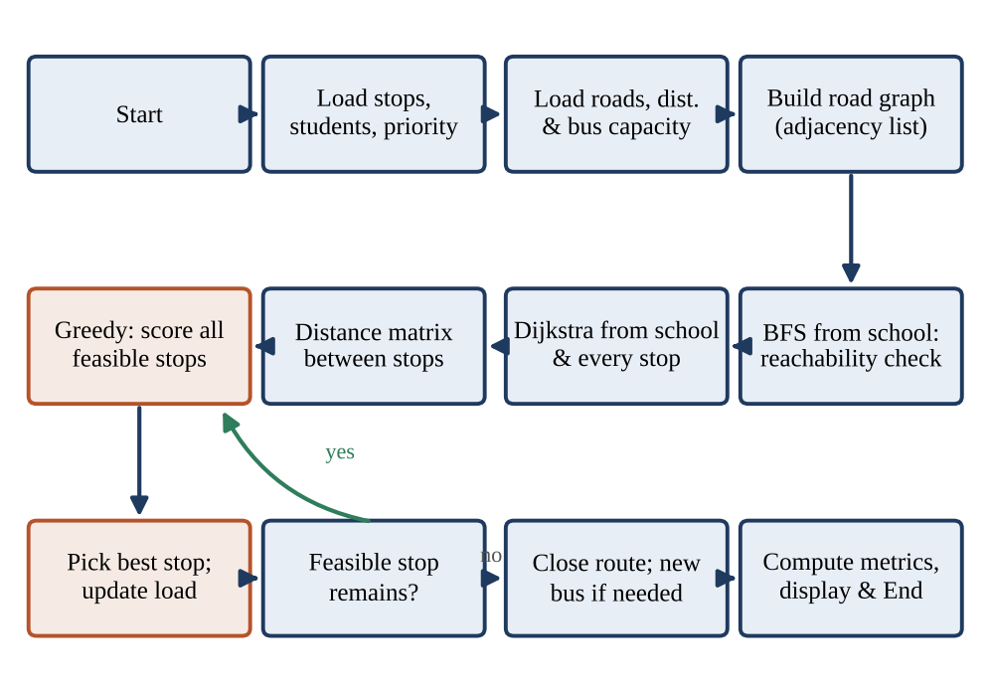
Figure 2: Detailed system workflow
Stages: (1) stops, roads and capacity are loaded; (2) the road graph is built; (3) BFS tests reachability from the school; (4) Dijkstra runs from the school and from every stop; (5) the distance matrix is formed; (6) the Greedy step scores all feasible stops; (7) the best stop is picked and load is updated; (8) while a feasible stop remains, steps 6–7 repeat; (9) otherwise the route is closed and a new bus is started if stops remain; (10) metrics are computed and displayed.

9. Algorithms and Methodology

9.1 Dijkstra's Algorithm
Dijkstra's algorithm finds the least-cost path from a source vertex to all other vertices of a graph whose edge weights are non-negative, which is exactly the case for road distances. It maintains a tentative distance for every vertex, repeatedly settles the unsettled vertex with the smallest tentative distance, and relaxes the edges leaving it: if dist[u] + w(u,v) < dist[v] then dist[v] is improved and the predecessor of v is set to u. A min-priority queue (binary heap) always supplies the cheapest unsettled vertex. The algorithm is itself a greedy algorithm, because settling the cheapest vertex is provably safe when no edge weight is negative.
In the planner, Dijkstra is run from the school and from every stop. The results form a distance matrix d(i, j) that the greedy step uses, and the predecessor maps are used to draw the real road path between consecutive stops.
DIJKSTRA(G, s):
dist[v] = INF for all v; dist[s] = 0; pred[v] = NIL
PQ = min-priority-queue containing (0, s)
while PQ is not empty:
(d, u) = EXTRACT-MIN(PQ)
if u already settled: continue
mark u settled
for each edge (u, v, w) in Adj[u]:
if d + w < dist[v]:
dist[v] = d + w; pred[v] = u
INSERT(PQ, (dist[v], v))
return dist, pred

Worked example (school S to stop F on the demonstration network)
Table 5: Dijkstra trace from S
Step | Vertex settled (dist) | Labels updated
1 | S (0) | A = 3, B = 5
2 | A (3) | J1 = 5, C = 7
3 | B (5) | D = 11 (J1 via B = 8 is worse)
4 | J1 (5) | J2 = 9 (C via J1 = 8 is worse)
5 | C (7) | E = 12
6 | J2 (9) | F = 12 (D via J2 = 11 is equal)
7 | D (11), then E (12), F (12) | no further improvement

The shortest route to F is therefore S → A → J1 → J2 → F with distance 3 + 2 + 4 + 3 = 12 km. Reconstruction follows the predecessors backwards from F.

9.2 Breadth-First Search
Breadth-First Search explores a graph level by level using a FIFO queue: all vertices one road segment from the source are visited first, then those two segments away, and so on. On an unweighted view of the graph it therefore gives the path with the fewest hops and a list of every reachable vertex. In the planner BFS has two jobs: it validates the data before any distance work is done, and it provides a hop-count view of the network for comparison with Dijkstra.
BFS(G, s):
hops[v] = INF for all v; hops[s] = 0; Q = empty queue; ENQUEUE(Q, s)
while Q is not empty:
u = DEQUEUE(Q)
for each neighbour v of u:
if hops[v] == INF:
hops[v] = hops[u] + 1; pred[v] = u; ENQUEUE(Q, v)
return hops, pred // vertices with hops == INF are unreachable

Demonstration road network
Figure 3 shows the seven-stop network used for all examples in this report. Circles are stops labelled with the number of students (st) and priority (P1–P3); small circles J1 and J2 are junctions without students; the square is the school. Edge labels are distances in km. Total students: 74.
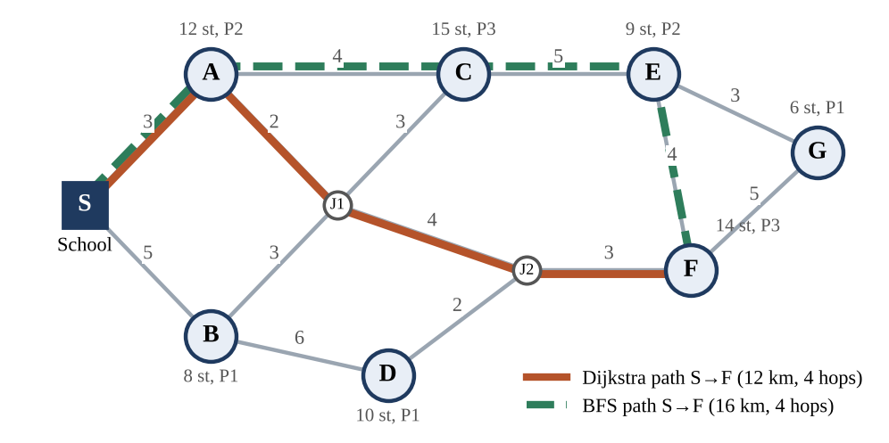
Figure 3: Demonstration road network with Dijkstra and BFS paths from S to F
BFS versus Dijkstra. To reach F, both algorithms need four road segments, but they may choose different paths. BFS has no knowledge of distances and returns S → A → C → E → F (16 km), whereas Dijkstra returns S → A → J1 → J2 → F (12 km). BFS is therefore used for reachability and hop counts, while Dijkstra is used whenever distance matters. In the demonstration network BFS reaches all seven stops, so none is flagged as unreachable.

9.3 Greedy Route Construction
A Greedy algorithm builds a solution step by step, always taking the choice that looks best at that moment and never reconsidering it. Greedy methods are fast and simple to explain, but they yield a global optimum only for problems with special structure. Route construction is not such a problem, so the Greedy rule here is explicitly a heuristic.

Selection rule
Let cur be the bus's current location and U the set of unvisited stops. A stop s in U is feasible if load + students(s) ≤ Q. Among feasible stops the planner selects the stop that minimises
score(s) = d(cur, s) – λ × priority(s)
where d is the Dijkstra distance and λ is the priority weight (default 1 km per level). With λ = 0 the rule is pure nearest-neighbour; larger λ pulls high-priority stops earlier. This criterion is explicitly defined by the implementation and can be changed without altering the rest of the system.
GREEDY-ROUTES(stops U, dist d, capacity Q, lambda):
while U is not empty:
cur = School; load = 0; route = []
loop:
F = { s in U : load + students(s) <= Q }
if F is empty: break
s* = argmin over s in F of ( d[cur][s] - lambda * priority(s) )
append s* to route; load += students(s*); remove s* from U; cur = s*
close route: add leg d[cur][School]
if route is empty: report stops that cannot fit and stop
return all routes

Worked example (Q = 40, λ = 1)
Table 6: Greedy decisions
Bus | From | Chosen | Score | Load | Reason
1 | S | A | 1 | 12 | lowest score among 7 stops (3 – 2)
1 | A | C | 1 | 27 | 4 km but priority 3 (4 – 3)
1 | C | E | 3 | 36 | 5 – 2; no other stop fits in 4 free seats
2 | S | B | 4 | 8 | 5 – 1; lowest among remaining
2 | B | D | 5 | 18 | 6 – 1
2 | D | F | 2 | 32 | 5 – 3; high priority
2 | F | G | 4 | 38 | last stop; fits (38 ≤ 40)

Bus 1 serves A, C, E (36 students, 24 km). Bus 2 serves B, D, F, G (38 students, 36 km).

9.4 Combined Methodology and Complexity Analysis
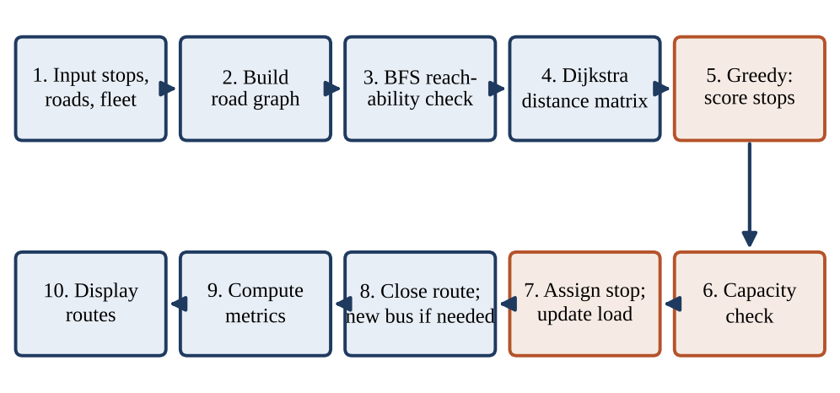
Figure 4: Combined methodology of BFS, Dijkstra and Greedy
BFS makes sure that the input is sound, Dijkstra turns the road map into exact distances, and the Greedy rule uses these distances together with capacity and priority to form routes. Let V and E be the numbers of vertices and edges, and k the number of stops.
Table 7: Complexity of the main operations
Operation | Time | Space
BFS from the school | O(V + E) | O(V)
One Dijkstra run (binary heap) | O((V + E) log V) | O(V)
Dijkstra from school and k stops | O(k (V + E) log V) | O(k²) matrix
One greedy selection (scan feasible stops) | O(k) | O(1)
All greedy selections and route closing | O(k²) | O(k) routes
Path reconstruction for all legs | O(V) per leg | O(V)
Whole planning run | O(k (V + E) log V + k²) | O(V + E + k²)

Discussion. The Dijkstra phase dominates for sparse road networks; the greedy phase is quadratic in the number of stops. Because the greedy rule is a heuristic, its low complexity does not imply optimal routes. These are upper bounds and not measured benchmarks.

10. Technologies Used
The technology choice follows the suggestion in the problem statement (Python, Flask, React, PostgreSQL).
Table 8: Technology stack and purpose
Layer | Technology | Purpose in this project
Frontend | React (JavaScript) | Forms for stops, roads and fleet settings; interactive route map; result tables and decision log.
Frontend | HTML / CSS | Page structure and styling used by the React components.
Backend | Python | Implementation of graph builder, BFS, Dijkstra, Greedy planner and metrics.
Backend | Flask | Lightweight REST API that receives JSON input, calls the algorithm modules and returns routes.
Database | PostgreSQL | Stores stops, road segments, bus settings and planned routes with their decision log.
Algorithms | Dijkstra, BFS, Greedy | Core DAA content: shortest paths, reachability and route construction.
Python library | heapq, collections.deque | Binary heap for Dijkstra's priority queue; FIFO queue for BFS.

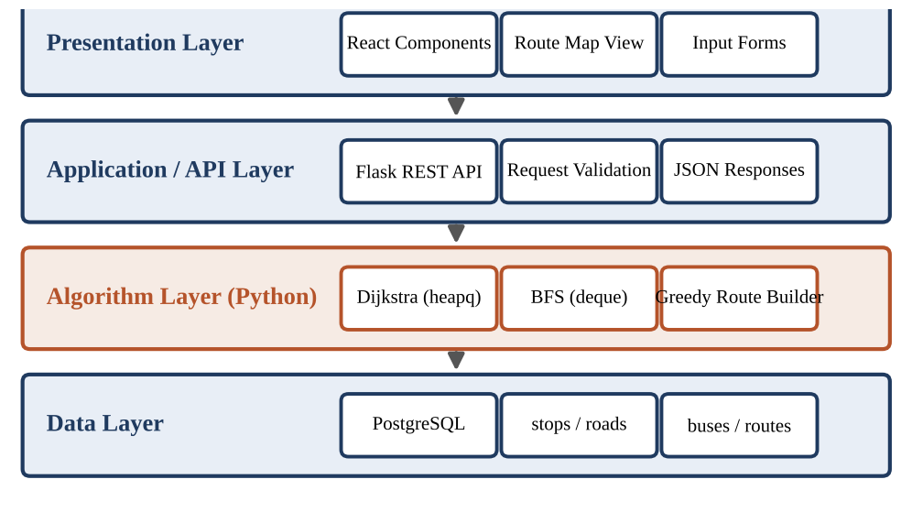
Figure 5: Technology stack of the School Bus Route Planner
Keeping the algorithms in plain Python modules means they can be unit-tested and explained without the web framework, while React and Flask handle only presentation and transport of data.

11. System Implementation
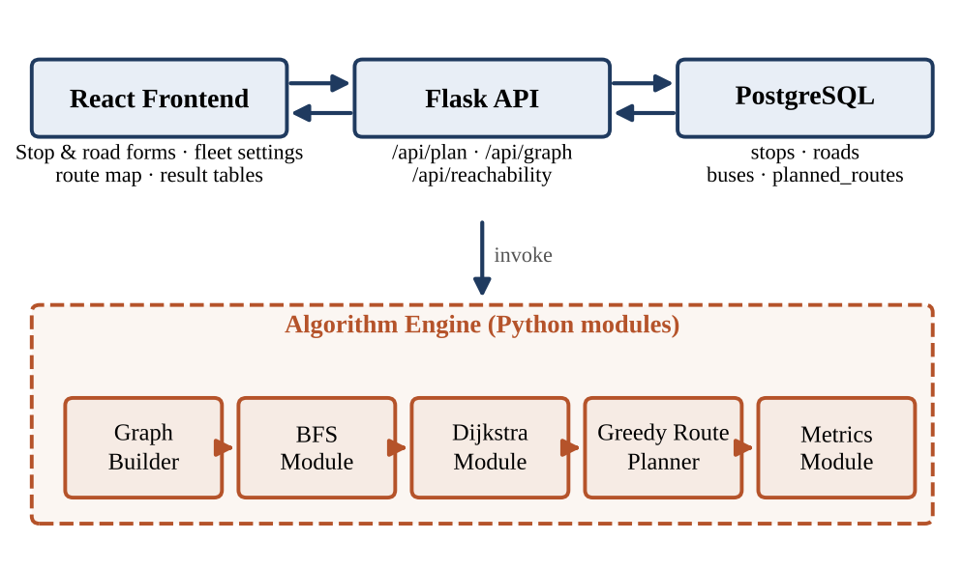
Figure 6: Implementation architecture
Modules. The React frontend sends the road network and settings to the Flask API. The API validates them, stores them in PostgreSQL and calls the algorithm engine: the Graph Builder creates the adjacency list; the BFS module checks reachability; the Dijkstra module builds the distance matrix and predecessor maps; the Greedy Route Planner constructs the routes; and the Metrics module computes distance, load and bus count. The API returns routes and decision logs as JSON, which the frontend renders as tables and a route map.

Representative snippets
# Dijkstra core (Python, heapq)
pq = [(0, src)]
while pq:
d, u = heapq.heappop(pq)
if u in done: continue
done.add(u)
for v, w in graph[u]:
if d + w < dist.get(v, INF):
dist[v] = d + w; pred[v] = u; heapq.heappush(pq, (dist[v], v))

# Greedy selection
feasible = [s for s in left if load + students[s] <= cap]
nxt = min(feasible, key=lambda s: D[cur][s] - lam * priority[s])

Endpoints: POST /api/plan returns routes; POST /api/reachability returns reachable and unreachable stops; GET /api/graph returns the stored network. The implementation shown here is a design outline; the snippets illustrate the logic only.

12. Results
Sample / Demonstration Results. All values below were obtained by running a small reference implementation of the algorithms on the demonstration network of Figure 3 (74 students, 7 stops). They illustrate behaviour and are not field measurements.

Scenario 1: ample capacity (Q = 80, one bus)
Table 9: Distance-only (λ = 0) versus priority-aware (λ = 1) routing
Rule | Stop order | Total km | Reason for selection
Distance-only | A, C, E, G, F, D, B | 36 | Always nearest stop; F (P3) reached after 20 km
Priority-aware | A, C, E, F, D, B, G | 56 | At E, F scores 4 – 3 = 1 < G (3 – 1 = 2), so F first; G is left last and costs 14 km from B

An exhaustive search over all 5,040 orders gives an optimal single tour of 36 km, so the distance-only greedy happens to be optimal here, which is not guaranteed in general.

Scenario 2: capacity Q = 40 (two buses)
Bus 1: S → A → C → E → S, load 36, 24 km. Bus 2: S → B → D → F → G → S, load 38, 36 km. Total 60 km. Both buses respect capacity; the first bus closes because only 4 seats remain and no stop needs fewer than 6.

Scenario 3: smaller buses (Q = 30) and Scenario 4: road closure
With Q = 30 three buses are needed: {A, C} 27 students, 14 km; {B, D, E} 27 students, 32 km; {F, G} 20 students, 32 km; total 78 km. In Scenario 4 the road A–J1 is closed. BFS still reaches all stops, and Dijkstra recomputes the S→F distance from 12 km to 15 km via S → B → J1 → J2 → F.
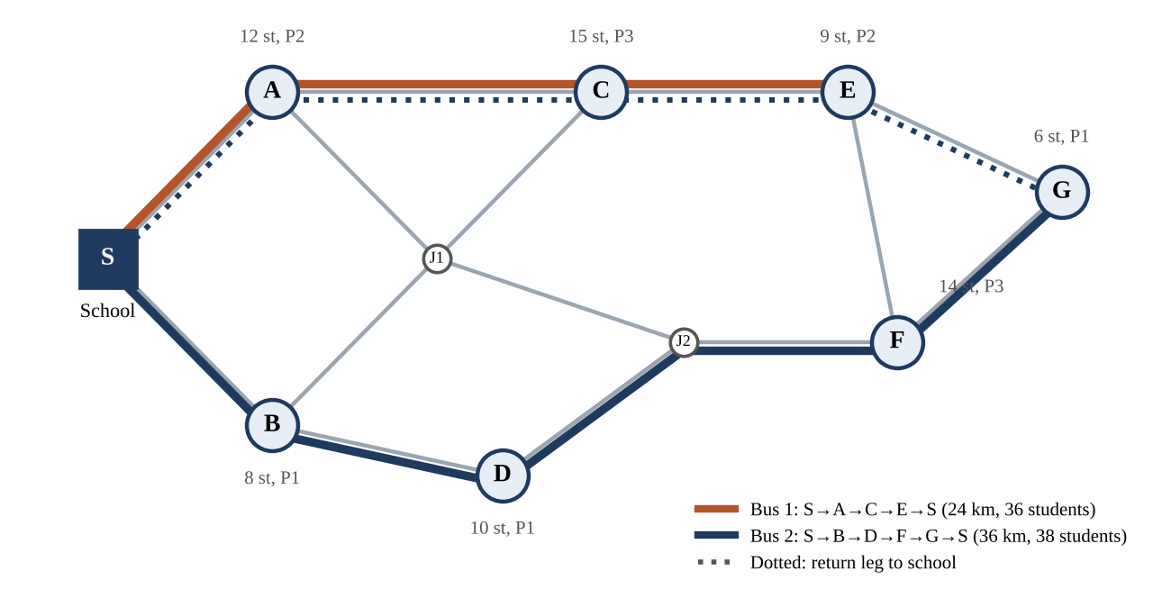
Figure 7: Bus routes for Scenario 2 (Q = 40)

13. Testing and Performance Analysis
Table 10: Test cases (simulated results on the reference implementation)
# | Test case | Input condition | Expected | Simulated result | Status
1 | Single stop | One stop A, 12 students | Route S–A–S | 6 km, 1 bus | Pass
2 | Multiple stops | 7 stops, Q = 80 | All visited once | 56 km, 1 bus | Pass
3 | No stops | Empty stop list | No routes | 0 km, message shown | Pass
4 | High-priority stop | F has P3, λ = 1 | F earlier than with λ = 0 | 20 km → 16 km | Pass
5 | Unequal capacity | Q = 40 versus Q = 30 | More buses for smaller Q | 2 buses vs 3 buses | Pass
6 | Oversized stop | 41 students, Q = 40 | Rejected with message | Rejected | Pass
7 | Far stop | G is 15 km away | Visited without exceeding Q | Last on bus 2 | Pass
8 | Large input | Random graphs, 100–400 stops | Completes; time grows with k | 0.02 s → 0.33 s total | Pass
9 | Unreachable stop | Stop with no road | Flagged by BFS, excluded | Listed as unreachable | Pass
10 | Invalid input | Negative distance | Rejected | Error message | Pass

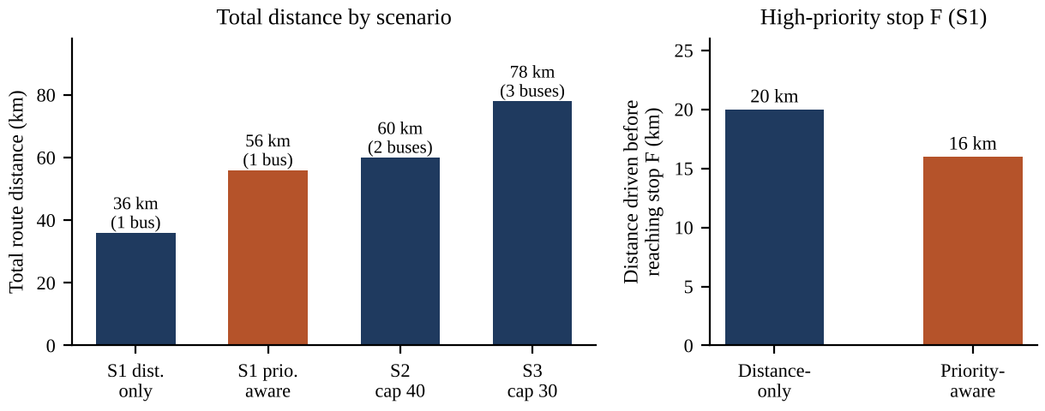
Figure 8: Sample distance results (demonstration data)

Performance observations
- Total distance and buses: smaller capacity increases both (36 → 60 → 78 km).
- Priority trade-off: priority weighting served F 4 km earlier but added 20 km in total.
- Load balance: Q = 40 gives loads of 36 and 38; Q = 30 gives 27, 27 and 20.
- Processing time: in a single timing run of the reference code on random networks with 100, 200 and 400 stops, planning took about 0.02, 0.08 and 0.33 s, dominated by the Dijkstra phase (sample values).

14. Conclusion and Future Scope

14.1 Conclusion
This project addressed Problem 32 by building a School Bus Route Planner that turns stops, road distances, capacity and approximate priorities into explainable pickup routes. BFS contributes reachability checking and hop-count paths; Dijkstra's algorithm provides exact shortest road distances; and the Greedy strategy constructs capacity-feasible routes in which priority is traded against distance through the weight λ. The decision log makes each choice visible.
The demonstration results show that the planner responds sensibly to smaller buses, high-priority stops and closed roads, and the complexity analysis gives O(k (V + E) log V + k²) time for the whole run. The project also shows an honest limit of greedy design: it is fast and understandable but it is a heuristic, and the results are not claimed to be globally optimal. Through the project the DAA concepts of graph representation, graph traversal, shortest paths, greedy choice and complexity analysis were applied to a practical problem.

14.2 Future Scope
The following extensions are possible but are not part of the current prototype:
- Integration with real map and traffic data for travel-time estimates.
- Time windows and school start times for each stop.
- Improvement heuristics such as 2-opt or route re-balancing between buses.
- Mixed fleets with different capacities and dynamic addition or removal of stops.
- Live vehicle tracking and automatic re-planning after delays.
- Machine-learning prediction of boarding numbers and delays.
- Historical analytics dashboards and fault-tolerant deployment.

References
[1] DAA Hackathon Problem Statements, Problem 32: School Bus Route Planner, document provided for this hackathon.
[2] T. H. Cormen, C. E. Leiserson, R. L. Rivest and C. Stein, Introduction to Algorithms, 4th ed. Cambridge, MA, USA: MIT Press, 2022.
[3] A. Levitin, Introduction to the Design and Analysis of Algorithms, 3rd ed. Boston, MA, USA: Pearson, 2012.
[4] S. Dasgupta, C. H. Papadimitriou and U. Vazirani, Algorithms. New York, NY, USA: McGraw-Hill, 2008.
[5] J. Kleinberg and É. Tardos, Algorithm Design. Boston, MA, USA: Pearson, 2006.
[6] E. W. Dijkstra, "A note on two problems in connexion with graphs," Numerische Mathematik, vol. 1, no. 1, pp. 269–271, 1959.
[7] Python Software Foundation, "heapq — Heap queue algorithm," Python Documentation. [Online]. Available: https://docs.python.org/3/library/heapq.html
[8] Python Software Foundation, "collections — Container datatypes (deque)," Python Documentation. [Online]. Available: https://docs.python.org/3/library/collections.html
[9] Pallets Projects, "Flask Documentation." [Online]. Available: https://flask.palletsprojects.com/
[10] Meta Open Source, "React Documentation." [Online]. Available: https://react.dev/
[11] PostgreSQL Global Development Group, "PostgreSQL Documentation." [Online]. Available: https://www.postgresql.org/docs/

