**Contents**

1. **Introduction**
2. **Existing System**
3. **Proposed System**
4. **Requirements**
5. **Methodology**
6. **Implementation**
7. **Snapshot**
8. **Conclusion**
9. **References**

**Introduction**

The Online Course Registration is an web based portal developed in HTML and PHP. It can be used by educational institutes or colleges to maintain the records of students easily. Online Course Registration will allow online submission of student application, student registration, modify student profile and enrol for various courses. Achieving this objective is difficult using a manual system as the information is scattered, can be redundant and collecting relevant information may be very time consuming. Online course Registration Project consists of two functional elements: an enhanced Student module for Registration, Edit Profile, View Course history, Change Password. The project provides facilities like online registration and profile creation of students thus reducing paperwork and automating the record generation process in an educational institution. Online Course Registration Module for registration. Student Information system will store all the details of the students including their background information, CGPA, personal details and all the information

related to their course.

**Existing System**

In the current system all the activities are done manually. Currently student submits hardcopy of filled application form to the college/university, office staff enters all data into excel file and write same in manual register. Issue hall ticket / admit card to student and conduct test for student. In the current system we need to keep a number of records related to the student and want to enter the details of the student and the marks manually. It is very time consuming and costly. Student comes to college and give test for the specified date. Office staff check all the paper calculate results and type all the details for taking printout and display it in college premises. College inform student to check the result, student comes to college and view the results. In this student information management system only the teacher or the school authority views the mark of the student and they want to enter the details of the student. In present Student information System, managing and maintaining the details of the student is a tedious job for any organization. This student information management system project is time consuming and has much cost.

**Proposed System**

Online Course Registration is software which is helpful for students as well as the school authorities. Proposed online course registration system will eliminate all the manual intervention and increase the speed of whole process. In our proposed system we have the provision for adding the details of the students by themselves. So the overhead of the school authorities and the teachers is become less. The objective of Student information System is to allow the administrator of any organization to edit and find out the personal details of a student and allows the student to keep up to date his profile. This student information management system project mainly explains the various actions related to student details. System will allow student to fill the form online, system has inbuilt validation system to validate the entered data. It’ll also facilitate keeping all the records of students, such as their id, name, mailing address, phone number, DOB etc. So all the information about an student will be available in a few seconds. After successful submission, system will give unique registration no for each student.

After analysis the requirement we decide that we need to create following web pages  
  
Home Page, Login Page, My Page Registration, Change Password, Edit Profile   
There are two different users who will be using this product:

1. Administrator
2. Student

Administrator can view and edit the details of any students. Admin can add new users and he can edit and delete a user. The administrator can view student profile details and they can edit their details. A student can register as user and can add edit and delete his profile. The features that are available to the Administrator are:

Admin user have to login into the system to use the system. Admin can enable or disable student account. He can also edit student information in database. He can also search any student in the

system by entering his name or username.

**Requirements**

**Hardware Requirements:**

The standard output device is the colour monitor. It is quite essential for an web application to have this. The mouse is the main input device. A keyboard is also required. Apart from hardware requirements there should be sufficient hard disk space and memory available for proper working of the package.

RAM Requirements : 512 KB

Processor : [Intel® Core™ CPU](https://www.intel.in/content/www/in/en/products/processors/core/i3-processors.html)

[Display Type : VGA/CGA/DVI compatible](https://www.intel.in/content/www/in/en/products/processors/core/i3-processors.html)

System : x32-based processor

**Software Requirements:**

Operating system : Windows 7

**Technology Implemented :** Apache Server

**Language Used                   :**  PHP 5.62 (Developed in Core PHP)

**Database                              :** My SQL

**User Interface Design     :**  HTML, AJAX,JQUERY,JAVASCRIPT

**Web Browser                      :** Mozilla, Google Chrome, IE8,OPERA

**Methodology**

**DATA FLOW DIAGRAM OF ONLINE COURSE REGISTRATION**

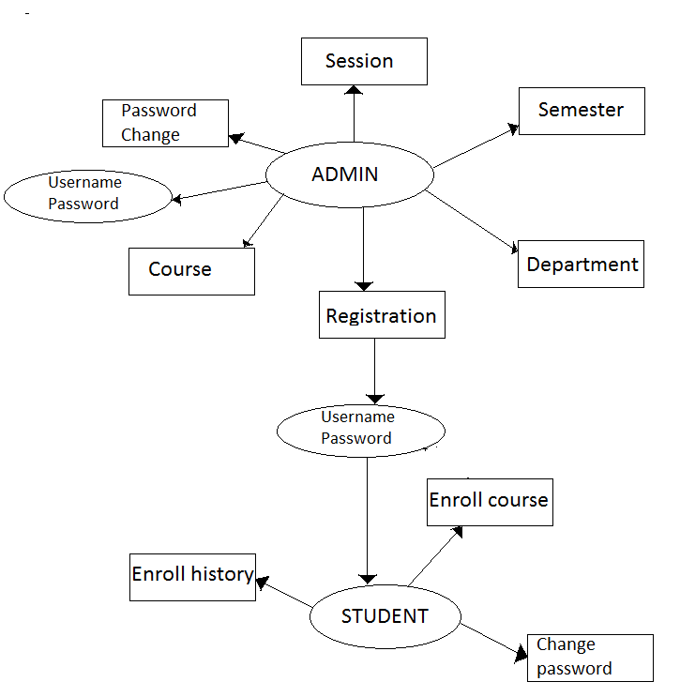

This Project Divided into two modules

* Admin
* Student

**Admin—–**Admin will register the student and provide username,password and pincode.Pincode will be used when a student enrolls for the course. Admin can manage session,semester,departments,course,students,students log Admin Panel Snapshot

**Students–** Student can log in with valid reg no and password provided by admin. Student can enroll for any course and can printout of the registered course. Student panel Snapshot

**Implementation**

HTML is the standard markup language for creating Web pages.

* HTML stands for Hyper Text Markup Language
* HTML describes the structure of a Web page
* HTML consists of a series of elements
* HTML elements tell the browser how to display the content
* HTML elements are represented by tags
* HTML tags label pieces of content such as "heading", "paragraph", "table", and so on
* Browsers do not display the HTML tags, but use them to render the content of the page

PHP is a recursive acronym for "PHP: Hypertext Preprocessor".

* PHP is a server side scripting language that is embedded in HTML. It is used to manage dynamic content, databases, session tracking, even build entire e-commerce sites.
* It is integrated with a number of popular databases, including MySQL, PostgreSQL, Oracle, Sybase, Informix, and Microsoft SQL Server.
* PHP is pleasingly zippy in its execution, especially when compiled as an Apache module on the Unix side. The MySQL server, once started, executes even very complex queries with huge result sets in record-setting time.
* PHP supports a large number of major protocols such as POP3, IMAP, and LDAP. PHP4 added support for Java and distributed object architectures (COM and CORBA), making n-tier development a possibility for the first time.
* PHP is forgiving: PHP language tries to be as forgiving as possible.
* PHP Syntax is C-Like.
* JavaScript is a programming language that can be included on web pages to make them more interactive. You can use it to check or modify the contents of forms, change images, open new windows and write dynamic page content.
* You can even use it with CSS to make DHTML (Dynamic HyperText Markup Language). This allows you to make parts of your web pages appear or disappear or move around on the page.

**Snapshot**

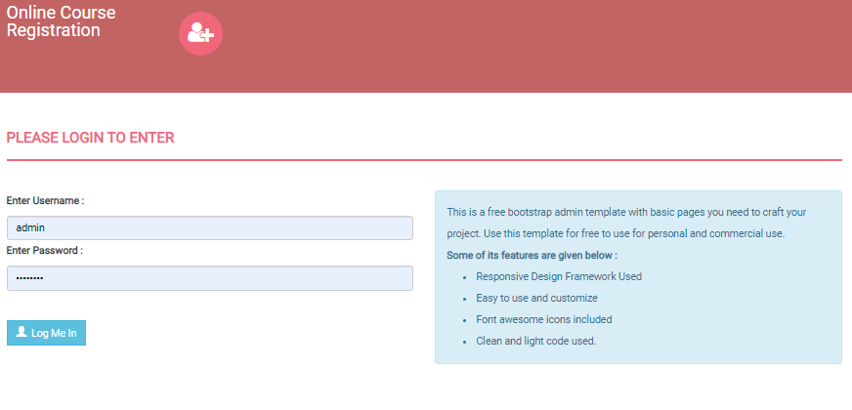**Fig 7.1 Admin Login**

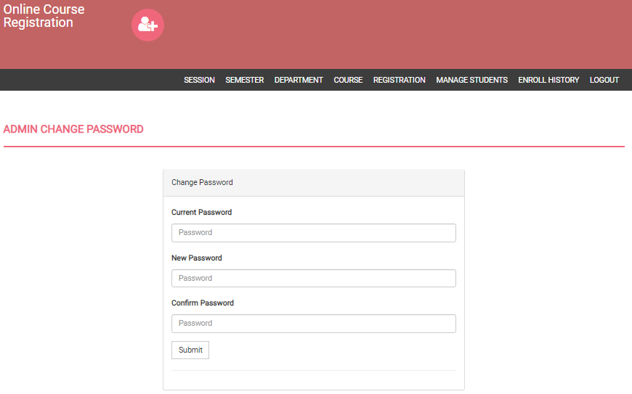

**Fig 7.2 Admin Password change**

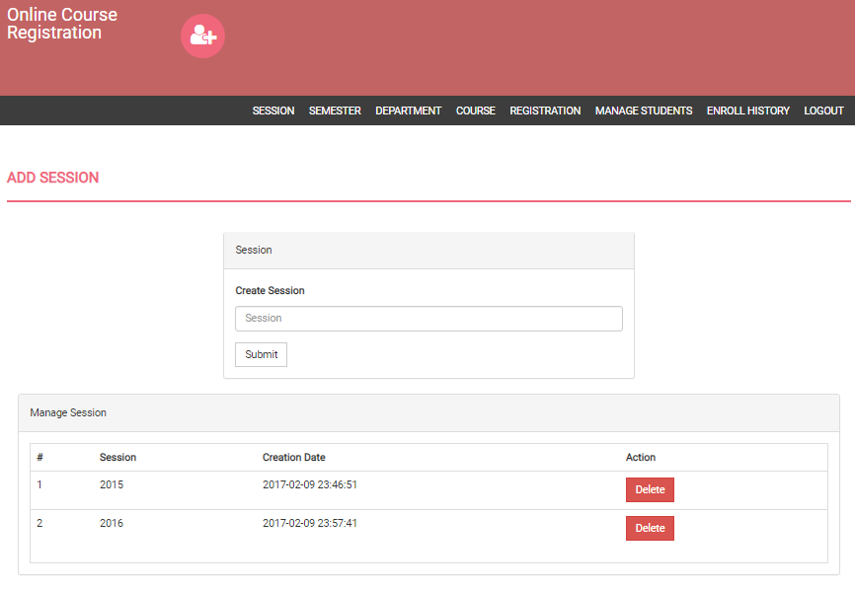**Fig7.3 Sessions**

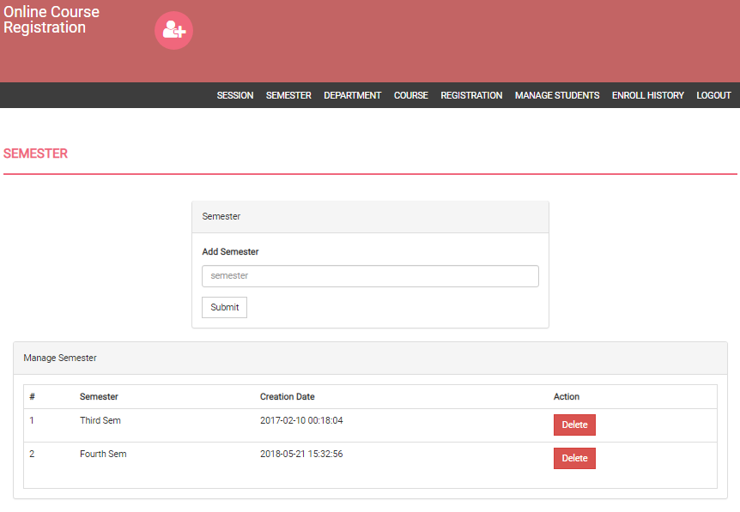**Fig 7.4 Semester**

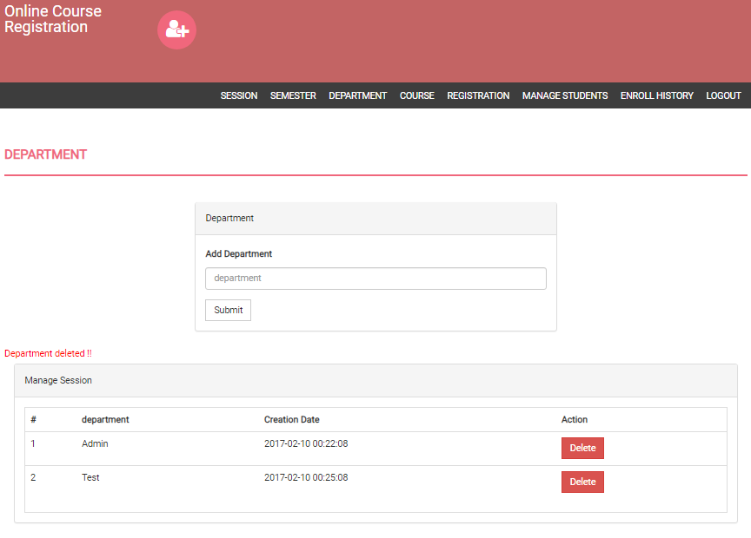**Fig 7.5 Department**

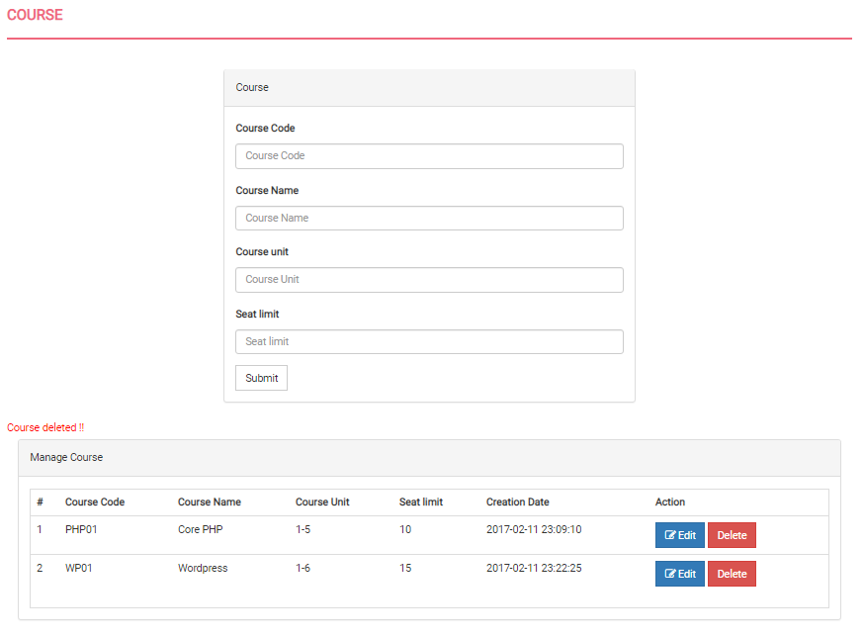**Fig 7.6 Course**

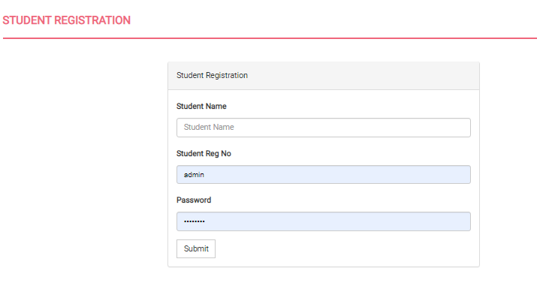

**Fig 7.7 Student Registration**

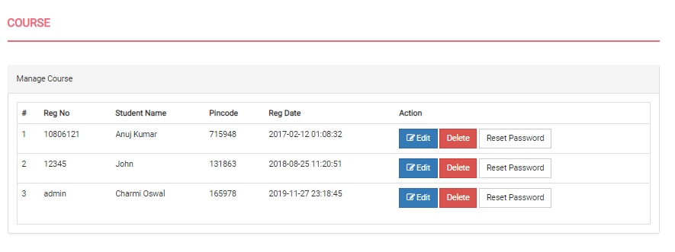

**Fig 7.8 Manage Students**

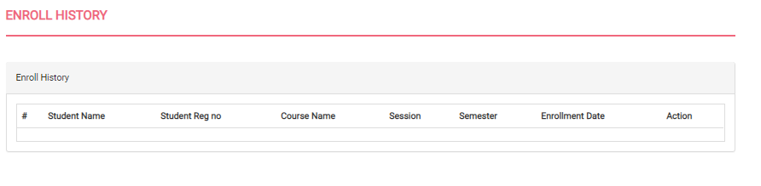

**Fig 7.9 Enroll History**

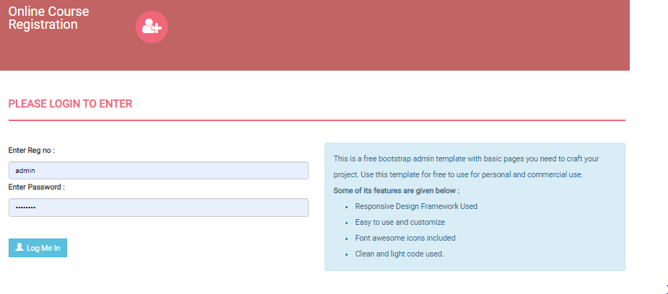

**Fig 7.10 Student Loign**

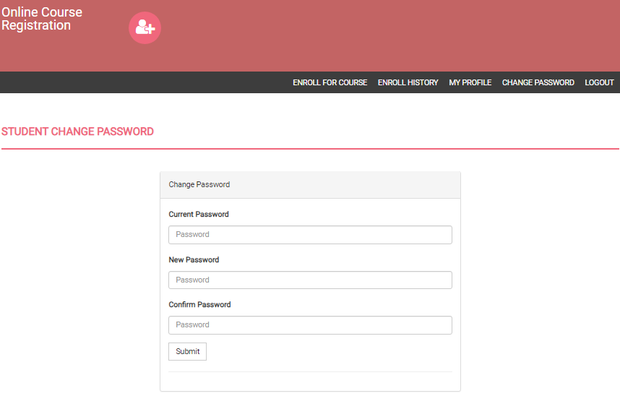

**Fig 7.11 Student change password**

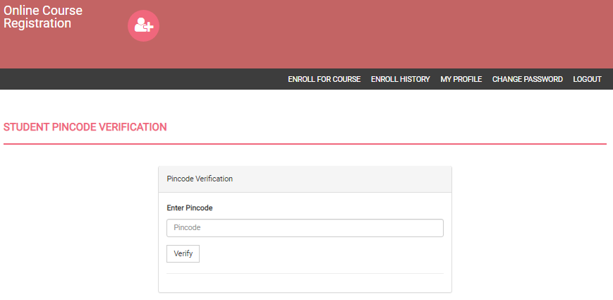

**Fig 7.12 Student pincode Verification**



**Fig 7.13 Student Enrol History**

**Conclusion**

In this project we have created a online course registration system which allows the students to register for various courses online. This reduces all the manual work required to enrol the students to a particular course. The student details such as name, Reg.No, CGPA and the courses enrolled are stored into the database. The system provides an effective way to store and manage the data.

**References**

**1.****Fundamentals of Web Development** – 1st Ed. **Randy Connolly** and Ricardo Hoar

**2.****Robin Nixon**. Learning. PHP, MySQL. & JavaScript. WITH JQUERY, CSS & HTML5

3. <https://www.w3schools.com/css/>