Does attention in drug–target interaction models mark the binding site? An audit across distribution shift, two benchmarks and four models
Mahim Agarwal, supervised by Dr. Chandra Mohan Dasari Draft for supervisor review — 20 September 2026
This is a condensed, venue-neutral draft assembled from the full section drafts in paper/ (introduction, methods, results, discussion, limitations, references), which hold every number with its source file. Nothing here is a new number: each is traceable to a committed analysis file. Section references of the form “Results §5” point into paper/results.md.

Abstract
Attention-based drug–target interaction (DTI) models present attention over the protein as evidence of where the drug binds; we audit that claim. Four attention-based models (three published, including DrugBAN, 2023; one ours) and a no-attention anchor were retrained on identical splits at four levels of shift — random, unseen drug, unseen target, both — three seeds per cell, on DAVIS (60 cells) and at two levels on KIBA (24 cells). Plausibility was scored against UniProt residues, the KLIFS ATP pocket and crystallographic contacts, each against chance, a uniform floor, a positive control and positional, residue-type and drug-identity nulls; faithfulness by size-matched masking in the space each model reads. One of twenty DAVIS cells supported the residue-level claim after Holm correction (HyperAttentionDTI, random split, 1.7× chance) and it did not replicate on KIBA, where none of eight survived. In twelve of twenty-two three-seed cells the seeds disagree about their own verdict; the surviving cell is the only one where all three agree. The 2023 model, the only one whose map changes with the drug, is at chance against the pocket at every level. What replicated was coarser: the older models’ top-ten attention is load-bearing everywhere, and HyperAttentionDTI’s localises the ATP pocket at 1.3–1.5× chance on 422 unseen drugs. Three measurement findings generalise: plausibility depends on an unreported readout choice, masking faithfulness does not transfer across tokenisations, and integrated gradients on the same weights survive correction where attention does not (7/12 DAVIS cells against 1/20; 3/4 on KIBA against 0/8).

1. What the project asks, and why it is worth asking
Attention-based DTI models routinely display attention over the protein sequence and conclude that the model has found the binding site. That claim is usually supported on a random split, by inspecting a handful of examples, from a single training run, and without a chance level. Three things follow that no published figure can settle:
- Does the claim survive distribution shift? Cold-start generalisation — an unseen drug, an unseen target, or both — is the setting these models are built for. An explanation that only works on a random split explains the easy case.
- Does it replicate? Across training seeds, and across datasets.
- Is the verdict about the model, or about how the attention was read out? Between the tensor inside the network and the one number per residue a figure shows, somebody makes reduction choices that no paper reports.
This work is an audit, not a new model. We retrain published models with their authors’ own recipes, score their explanations against annotated ground truth with a chance level, a ceiling, a uniform-attention floor and a battery of nulls, correct once for multiplicity across the whole family, and report what survives.
The subjects. MolTrans (2021), HyperAttentionDTI (2022) and DrugBAN (2023) are published attention-based models whose papers make interpretability claims. ColdSite-DTI is our own model, held to exactly the same standard. DeepDTA (2018) has no attention and is included only as an accuracy anchor, so a reader can see whether the interpretable models pay an accuracy cost. EviDTI (2025, Nature Communications) is audited at the level of its source code without retraining (§3.7).

2. Protocol
Datasets and splits. DAVIS (442 targets, 68 drugs) is the primary benchmark, split four ways: random, cold-drug (unseen drugs), cold-target (unseen targets) and cold-pair (both). KIBA is the replication, at random and cold-drug only — its cold-drug level holds out 422 drugs where DAVIS holds out 13, which is the axis DAVIS is weakest on. Binary labels use one shared threshold per dataset (DAVIS pKd ≥ 7.0, KIBA score ≥ 12.1). Every model sees byte-identical split files.
Cells. 3 training seeds × each (model, level). DAVIS: 60 cells (5 models × 4 levels × 3 seeds). KIBA: 24 cells. Every cell was trained to completion, and every checkpoint has a results file beside it.
A benchmark problem found along the way. In the DAVIS protein file that this literature uses, all 54 mutant targets carry the wild-type sequence (442 targets are 379 distinct sequences), so 12 of 88 cold-target test targets are already seen in training by sequence. Accuracy at the cold levels is therefore reported on targets genuinely unseen by sequence, by re-scoring each checkpoint with its own trainer’s test pass; all 30 recorded AUROCs reproduce exactly. Leakage inflated cold-target AUROC for every model (Results §1b).
Plausibility is precision@10: of the ten residues an explanation ranks highest, how many are binding-site residues? It is always read against that cell’s own chance level (which depends on the proteins, their lengths and site counts) and its ceiling. Three ground truths at different resolutions: UniProt’s annotated residues (fine), the 85-residue KLIFS ATP pocket (coarse), and the residues a drug is measured to contact in its own co-crystal structure (per-pair).
Faithfulness is comprehensiveness minus a size-matched random-masking control: mask the ten attended residues, mask ten random ones, and take the difference. Positive means the attention is load-bearing. The intervention is applied in the space each model reads, which matters (§3.4).
Controls, and why they are the substance of the audit. - a uniform attention map, the metric’s own floor; - a positive control: synthetic explanations of known quality, to establish at what dose a real signal would have been visible — so a null can be distinguished from a weak test; - nulls for position (a map borrowed from another protein), amino-acid preference (attention permuted among residues of the same type) and location within the site-spanning stretch; - a non-kinase transfer panel (60 BindingDB proteins), because both benchmarks are kinases; - alternative readouts of the same checkpoints, one documented choice changed at a time.
Statistics. A split-level permutation test per cell; a cell’s p is the median over its three seeds, never the smallest. Holm–Bonferroni once across each dataset’s whole family (20 cells on DAVIS, 8 on KIBA), never per model. Results are reported as mean ± sd over seeds; a difference smaller than the seed spread is not reported as a difference.

3. Results

3.1 The models predict well; the anchor shows no interpretability tax
DAVIS test AUROC, mean ± sd over three seeds (cold levels on targets unseen by sequence):
model | random | cold-target | cold-drug | cold-pair
DeepDTA (anchor, no attention) | 0.929 ± 0.002 | 0.884 ± 0.003 | 0.692 ± 0.044 | 0.749 ± 0.044
ColdSite-DTI (ours) | 0.924 ± 0.001 | 0.835 ± 0.015 | 0.721 ± 0.008 | 0.607 ± 0.128
HyperAttentionDTI | 0.937 ± 0.005 | 0.893 ± 0.001 | 0.760 ± 0.042 | 0.713 ± 0.050
MolTrans | 0.923 ± 0.002 | 0.833 ± 0.008 | 0.685 ± 0.020 | 0.530 ± 0.024
DrugBAN (2023) | 0.891 ± 0.006 | 0.801 ± 0.012 | 0.695 ± 0.033 | 0.559 ± 0.040
The levels are not a ladder of increasing difficulty: on DAVIS an unseen target costs little and an unseen drug costs a great deal, because DAVIS has only 68 drugs. KIBA, with 422 held-out drugs, shows a much smaller drop (0.086–0.107 against DAVIS’s 0.177–0.238), so DAVIS’s cold-drug severity is a property of its 13-drug split rather than of unseen chemistry. MolTrans at cold-pair predicts at chance (0.530), which is reported beside its explanation scores: an explanation of a prediction no better than chance explains nothing.

3.2 The headline: one cell of twenty survives correction
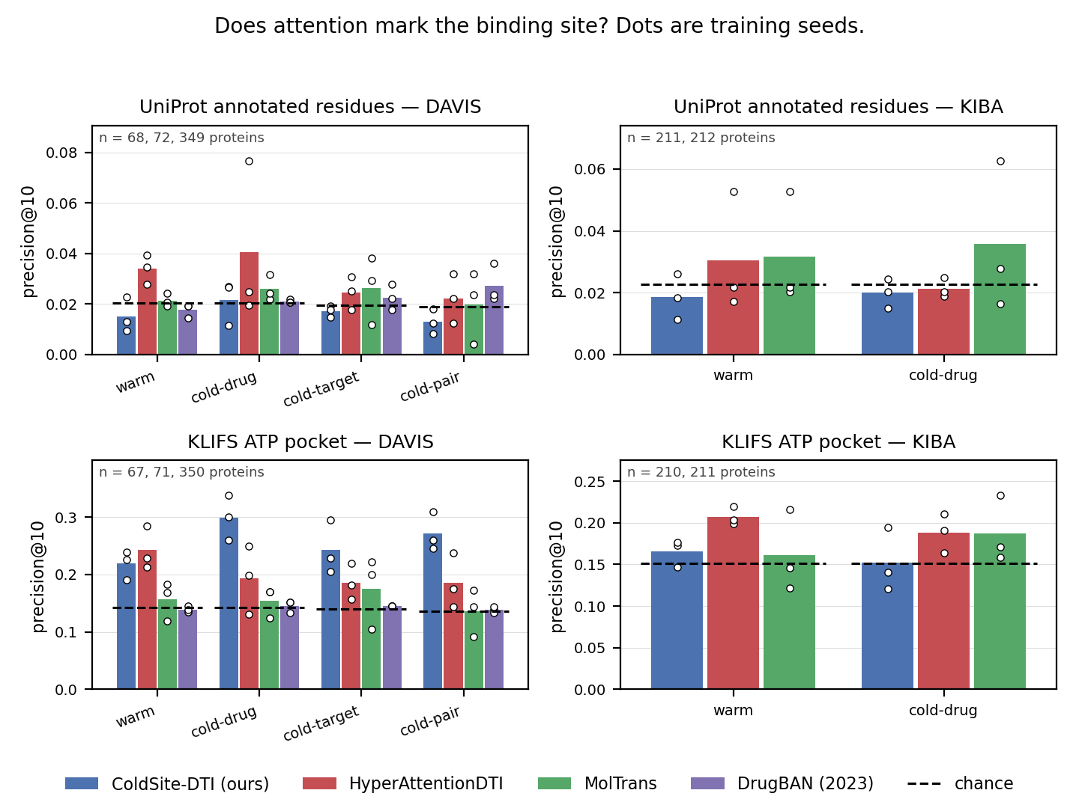
Figure 1
Figure 1. precision@10 for every model, level and dataset, against UniProt’s annotated residues (top) and the KLIFS ATP pocket (bottom). Bars are means over three seeds, circles are the seeds, the dashed segment is that cell’s chance level.
Against UniProt’s annotated residues, with one Holm correction over all twenty DAVIS cells, one cell survives: HyperAttentionDTI on the random split, at 1.7× chance (precision@10 0.034 against 0.020). Re-run at 10,000 permutations its p is 0.0001 — the smallest the test can return — so it survives with a 25-fold margin, and no other verdict changes.
That cell beats every null: a map borrowed from another protein, attention permuted among residues of the same amino acid, and attention permuted within the site-spanning stretch. So on the split published work reports, for the model that generalises best, the claim holds — and it is small: worth an equivalent dose of about 1% of the true annotated sites.
It does not survive shift. The same model reads 1.26× chance at cold-target and 1.18× at cold-pair, beating nothing. MolTrans sits at the uniform control’s floor at every level, and DrugBAN is at chance everywhere (§3.9).
It does not replicate. On KIBA, none of eight cells survives; the same model at the same level is above chance in one seed of three (§3.10).

3.3 Coarse, not fine: the pocket instead of the residues
Against the 85-residue KLIFS ATP pocket the picture is different: HyperAttentionDTI reads 1.70× chance at random and 1.33–1.37× at all three cold levels, and ColdSite-DTI is above chance in all twelve of its DAVIS cells (1.5–2.1×). So attention does carry coarse information — it concentrates on the kinase domain and the pocket region — while missing the annotated residues inside it. Faithful and coarsely plausible, but not finely plausible is the audit’s summary of the two 2021–2022 subjects.

3.4 The attention is used — at the dose we specified
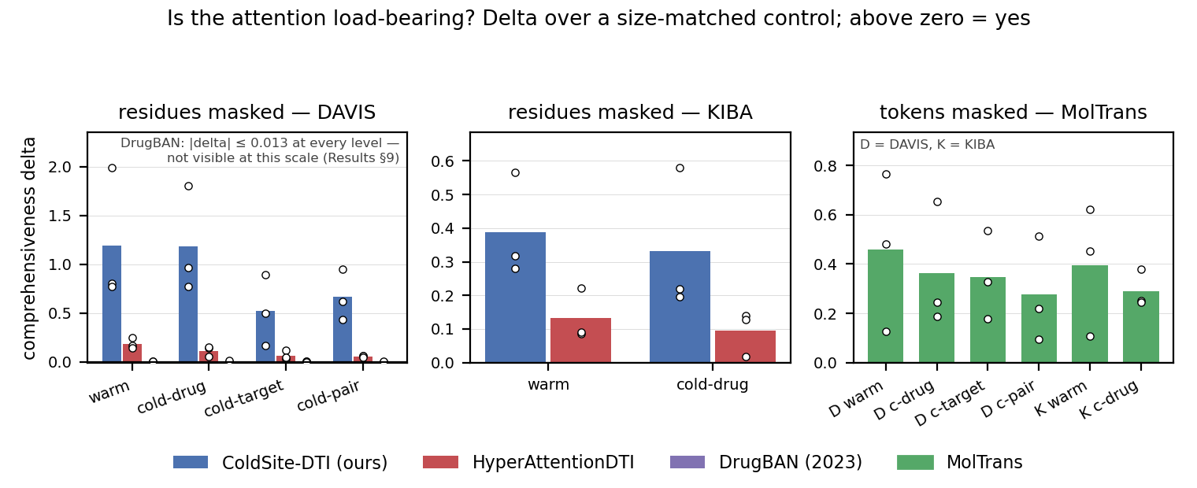
Figure 4
Figure 4. Comprehensiveness minus a size-matched random-masking control. Above zero means masking what the explanation points at moves the prediction more than masking arbitrary input of the same size.
Masking the ten attended residues moves the prediction more than masking ten random ones in every cell of both datasets for the three 2021–2022 models. Two caveats belong with that claim, and both are in the paper:
- The unit must match the model. MolTrans reads sub-word tokens, so masking ten residues re-segments its protein: the attended set changes 48% of its tokens and ten random residues change 95% — a factor of 124 for one protein. Under that mismatched test its delta was negative in 11 of 12 cells, which would have read as “its attention points at residues that matter less than arbitrary ones”. Measured in token space with both arms removing the same number of tokens, the sign reverses in all twelve. A masking metric is only interpretable when both arms are the same size of intervention.
- The dose matters. At k = 50 instead of k = 10, HyperAttentionDTI’s margin survives only at the random split. What is load-bearing under shift is its top ten residues, not its top fifty.

3.5 A single training run cannot support the claim
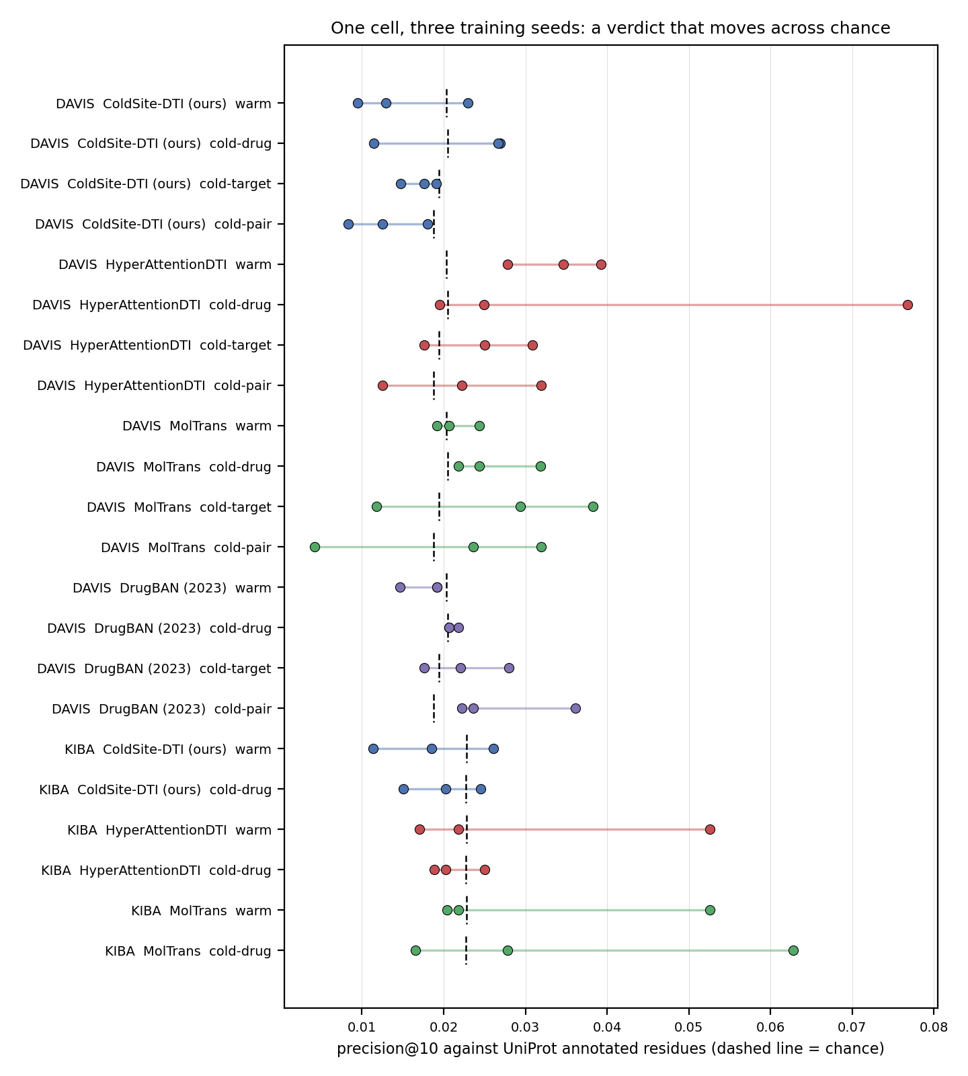
Figure 2
Figure 2. All twenty-two three-seed cells as seed dots against their chance level.
Counted over every cell rather than anecdotally: in 12 of 22 cells the three seeds disagree about their own verdict, and in 21 of 22 the spread across seeds is larger than the cell’s distance from chance. A paper reporting one training run would have had an above-chance, uncorrected result available in twelve of these cells — including cells this audit reports as null.
There is a reassurance inside that number, and it belongs to the method. Exactly one cell has all three seeds above α individually, and it is the same cell that survives Holm correction. Agreement among replicate runs and family-wise error control were computed independently and select the same cell.

3.6 The verdict can belong to the readout, not the model
Scoring the same checkpoints through readouts another author could reasonably have picked (one documented choice changed at a time):
- The top-ten residues of an alternative readout overlap the published readout’s by 2–12%. Two defensible readings of one checkpoint highlight almost disjoint residues.
- One choice moves a verdict across chance: HyperAttentionDTI against the pocket at cold-target reads 0.367 (2.6× chance) under channel-max and 0.081 — below chance — under a receptive-field projection, against 0.186 as published.
- The audit’s own verdicts survive this. No readout of any model clears chance against the annotated residues, and none lifts MolTrans above the pocket’s floor.

3.7 State which inputs the explanation is a function of
Whether an explanation can depend on the drug is a property of the computation graph, not an empirical question — and it is checkable in a minute, before publication.
EviDTI (2025, Nature Communications) presents per-residue attention for four drug–target complexes and concludes that high-attention residues coincide with the binding site. Its attention is computed from the protein’s language-model embedding alone; no drug tensor reaches it. For a fixed protein, every drug yields the identical map, for any weights. The claim is not refuted by a better measurement — it is refuted by the source code.
Applied to our own subjects by measurement (25 proteins, four drugs each, 150 drug pairs):
explanation | top-10 residues shared between different drugs
MolTrans, interaction map (its published artefact) | 1.1 / 10
DrugBAN | 4.5 / 10
HyperAttentionDTI | 9.7 / 10
MolTrans, encoder self-attention | 10.0 / 10 (identical, always)
This check changed our own protocol. MolTrans’s paper visualises the drug × protein interaction map, not the encoder attention we scored by default, so we implemented and scored that map too: it is at chance in every cell of both datasets, so the MolTrans verdict holds whichever map is read. The ordering above is also the paper’s sharpest architectural result: the two explanations that vary most with the drug agree least with where drugs bind. Conditioning an explanation on the drug is necessary for a per-pair claim and buys nothing by itself.

3.8 The gradient finds what the attention misses
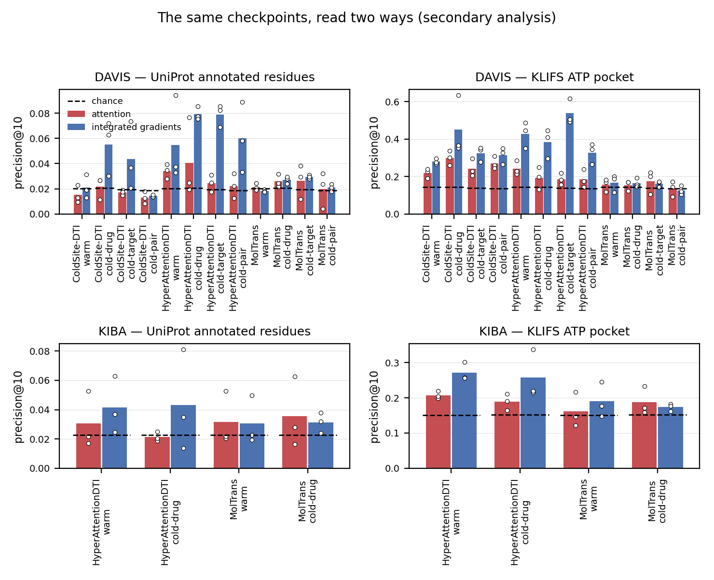
Figure 3
Figure 3. Attention (red) beside integrated gradients (blue) on identical trained weights.
Integrated gradients on the same checkpoints — same ground truth, same proteins, same test, only the explanation changed — survive Holm in 7 of 12 DAVIS cells against 1 of 20 for the attention, and in 3 of 4 KIBA cells against 0 of 8, reaching 1.9–4.1× chance at levels where the attention is at chance. For two of the three models with a gradient arm, the attention therefore under-reports a binding site the model does represent. A weak attention map often indicts the report rather than the model. (The third model is the control for that claim: its gradient and attention agree at the floor, so its failure is the model.)

3.9 Does the verdict bind on a current model? DrugBAN (2023)
The other subjects are from 2021–2022, so the first question a reviewer asks is whether the verdict applies to what people build now. DrugBAN is the answer: interpretability is in its title, its bilinear attention is indexed by drug atom and protein position, and it is maintained and MIT-licensed. Trained on the identical splits with its authors’ recipe, 12 DAVIS cells:
- Plausibility: at chance against both ground truths in all 12 cells. One seed-cell of twelve clears α uncorrected against UniProt, none against the pocket. It is the only subject without even the coarse signal (HyperAttentionDTI is above pocket chance in 9 of 12 seed-cells, ColdSite-DTI in 12 of 12, DrugBAN in 0 of 12).
- Faithfulness: not load-bearing — deltas within ±0.013 of zero, sign flipping between seeds. At k = 50, where the test has three times the power, three of four levels stay at zero and only cold-drug shows a small positive margin.
- Not a readout artefact: its two attention heads have learned the same map, and alternative reductions leave its top residues essentially unchanged.
- Its map does move with the drug (4.5/10), more than any other model’s except MolTrans’s interaction map.
- Controls: no transfer off kinases (0.010–0.012 against its own kinase cells’ 0.018–0.027). Its one above-chance seed-cell (cold-pair, seed 1) beats all four positional nulls, while the other two seeds of that cell beat none — seed dependence reaching even a model that is otherwise at chance. It is scored on 59 of the panel’s 60 proteins: one ligand exceeds the 290-atom cap of DrugBAN’s own data loader, and that row is dropped and reported.
What DrugBAN adds: the audit’s verdict is not an artefact of older architectures. The 2023 model, with the strongest structural case for a per-pair explanation, agrees with binding sites least of all, at every level of shift.

3.10 The replication: KIBA
KIBA was trained and analysed after every DAVIS result was fixed, with the same code and no parameter chosen by looking at KIBA.
DAVIS finding | on KIBA
The one residue-level survivor (1 of 20 cells) | does not replicate — 0 of 8; that cell is above chance in one seed of three
Attention finds the pocket region, including under shift | replicates for HyperAttentionDTI at a 422-drug cold level; seed-dependent for ColdSite-DTI (3 of 6 seed-cells)
Attention is load-bearing at every level | replicates for all three models (18 of 18 cells)
MolTrans sits at the uniform floor | holds in 2 seeds of 3
Cold-drug collapses accuracy | does not replicate — an artefact of DAVIS’s 13-drug split
The gradient beats the attention (7 of 12 cells) | replicates (3 of 4 cells)

4. What this establishes
For the field’s claims. Across two datasets, four models and 84 trained cells, no residue-level attention claim survives family-wise correction and replication. What survives is weaker and worth stating plainly: attention in these models is used by the model, and it concentrates on the pocket region rather than on binding residues. A published figure showing attention peaks at annotated residues, from one seed on a random split, is not evidence for the claim it illustrates.
For interpretability measurement, beyond DTI. Three findings generalise: 1. Attention-based plausibility is largely a property of an unreported readout choice. 2. Masking-based faithfulness does not transfer across tokenisations — and can invert its own sign when the two arms are not size-matched. 3. The gradient of the same weights recovers what the attention misses, so a weak attention map often indicts the report rather than the model.
A cheap check the field can adopt: state which inputs the explanation is a function of. One published claim (EviDTI) fails it on inspection; one of our own readouts failed it too, which is how we caught it.

5. Limitations (stated, not hidden)
- Both benchmarks are kinase panels, so the family confound cannot be stratified away inside them. The 60-protein non-kinase panel is the substitute, and it shows no transfer.
- DAVIS’s sequence problems (mutants carrying wild-type sequences) affect every model; cold-level accuracy is re-scored on genuinely unseen targets, and explanation metrics drop seen-by-sequence and pocketless targets.
- “Load-bearing” is a statement at k = 10, the pre-specified dose; at k = 50 the margins shrink under shift.
- MolTrans is scored through two readouts and neither is privileged; faithfulness and the per-pair contact analysis use the default (encoder) readout only.
- DrugBAN is DAVIS-only and has no integrated-gradient arm (its drug side is a graph).
- ColdSite-DTI’s KIBA cells were added after the rest of the KIBA arm, and are reported as an addition rather than as part of the pre-specified scope. Its pocket signal does not replicate cleanly there — a result against our own model.
- Three seeds per cell is enough to show instability, not to quantify it precisely.

6. Status and open decisions for discussion
Complete: all training (84 cells across two datasets), the full analysis pipeline, both audits with Holm correction, the replication, the controls and nulls, the readout and seed analyses, the figures, and a test suite that passes in both environments. Every number in this draft traces to a committed file, and re-computing the audits on different hardware reproduced every p-value exactly.
Open, for your guidance: 1. Venue. Not chosen. The candidates are Briefings in Bioinformatics (benchmarking and critical-assessment papers, flexible length), Bioinformatics (needs heavy condensing) and ISMB (most competitive, tightest page limit). The choice sets the target length and the citation style, both of which are still open. 2. Length. The full section drafts are ~27,600 words; a journal main text is roughly 5,000–8,000. What belongs in the main text versus a supplement is the largest remaining decision. 3. Framing. Is the paper best presented as an audit of published claims (current framing), or as a benchmark-and-protocol contribution with the audit as its demonstration? 4. Remaining work items: a repository DOI for release, and — optional, not required for the claims — integrated gradients for DrugBAN, DrugBAN on KIBA, and readout variants on KIBA. All analyses the claims rest on are complete.

References (selected; full verified list in paper/references.md)
- Öztürk H, Özgür A, Ozkirimli E. DeepDTA. Bioinformatics 34:i821–i829 (2018).
- Huang K, et al. MolTrans. Bioinformatics 37:830–836 (2021).
- Zhao Q, et al. HyperAttentionDTI. Bioinformatics 38:655–662 (2022).
- Bai P, et al. Interpretable bilinear attention network with domain adaptation improves drug–target prediction (DrugBAN). Nature Machine Intelligence 5:126–136 (2023).
- Zhao Y, et al. Evidential deep learning-based drug-target interaction prediction (EviDTI). Nature Communications 16:6915 (2025).
- Davis MI, et al. Comprehensive analysis of kinase inhibitor selectivity. Nature Biotechnology 29:1046–1051 (2011).
- Tang J, et al. Making sense of large-scale kinase inhibitor bioactivity data sets (KIBA). J. Chem. Inf. Model. 54:735–743 (2014).
- van Linden OPJ, et al. KLIFS. J. Med. Chem. 57:249–277 (2014); Kanev GK, et al. KLIFS: an overhaul after the first 5 years. Nucleic Acids Res. 49:D562–D569 (2021).
- The UniProt Consortium. UniProt in 2025. Nucleic Acids Res. 53:D609–D617 (2025).
- Jain S, Wallace BC. Attention is not Explanation. NAACL-HLT 3543–3556 (2019); Wiegreffe S, Pinter Y. Attention is not not Explanation. EMNLP-IJCNLP 11–20 (2019).
- DeYoung J, et al. ERASER. ACL 4443–4458 (2020) — comprehensiveness and sufficiency.
- Sundararajan M, Taly A, Yan Q. Axiomatic Attribution for Deep Networks. ICML (2017).
- Holm S. A simple sequentially rejective multiple test procedure. Scand. J. Stat. 6:65–70 (1979).

