Synthesis dossier: 106 brain-penetrant AChE inhibitor candidates
All values are computational predictions. None of these molecules has been synthesized or tested. This dossier gives a chemist the structure, the computed route, the predicted properties with their margins and the flags that decide what to measure first.

1. What the set is
The 106 molecules are the complete group, out of 2,700 designed analogues of potent published AChE inhibitors, that passed every gate listed in Section 2 with at least 5 % margin on the tightest gate (median 11 %, 63 molecules at least 10 %). They lie on 63 Bemis-Murcko scaffolds from 34 published parents; 39 carry one matched-pair edit and 67 two. Each is absent from PubChem (exact and same connectivity), ChEMBL (flexmatch) and SureChEMBL, and each has a computed route of 1-6 steps to purchasable starting materials (median route score 0.994). Rank is the margin on the tightest gate; a larger margin means the molecule sits farther inside the model thresholds, not that it is a more potent inhibitor.

2. Gates every molecule passed
Gate | Criterion
BBB permeability | in-loop and audit models >= 0.75; independent Martins model >= 0.513
AChE activity | primary model >= 0.70; both second-pair models >= 0.50; similarity to nearest potent active >= 0.417 (model domain) and < 0.90 (prior art)
Brain exposure | predicted logBB >= -0.45; similarity to logBB training set >= 0.35
Drug-likeness | CNS MPO >= 4; SA score <= 3.5; MW <= 450; no unstable functional group
Toxicity | no endpoint (hERG, Ames, DILI, CYP1A2/2C9/2D6) more than 0.10 worse than the parent
Efflux / exposure | P-gp interaction <= 0.713; exposure surrogate (passive x [1 - P-gp]) >= 0.2485 (donepezil-anchored)
Docking | Vina <= -8.20 kcal/mol and pose coverage of the donepezil footprint >= 0.43 (4EY7; galantamine-anchored)
Structure | stereochemistry defined or justified racemate; protonation rule agrees with Dimorphite-DL at pH 7.4; not a tautomer of a training/reference compound
Novelty | no match in PubChem (exact and same connectivity), ChEMBL (flexmatch) or SureChEMBL
Synthesis | computed route to purchasable starting materials (AiZynthFinder, USPTO policies, ZINC stock)
Margin | at least 5 % slack on every numeric gate above

3. Read this before ordering anything
Flag | What to know
hERG | The classifier probability is high (median 0.85, maximum 0.93), as for the donepezil-like parents, but that model failed its calibration (it could not rank cisapride above donepezil). A second model, a regression on 10,470 ChEMBL potencies, ranked unseen scaffolds well (rho 0.67) and separated ten blockers from ten non-blockers (AUC 1.00) but also failed a pre-specified criterion (cisapride was predicted weaker than donepezil), so neither model can rank these molecules. Measure hERG early: it is the most likely reason a candidate fails.
P-gp and BCRP | Efflux was not measured. The P-gp model is trained on inhibition data and did not separate BBB+ from BBB- compounds (AUC 0.52); the BCRP similarity flag also failed its calibration and flags 1 molecule(s).
Docking | The Vina score separates binders from property-matched decoys only weakly (AUC 0.64). Treat it as a plausibility filter; it is not evidence of potency.
Top-ranked N-ethyl indanones | The four molecules with the largest margins have lost donepezil's benzyl ring and so cannot stack on Trp86. They rank high on predicted brain exposure and BBB margin. Three set members were tested earlier in 2 ns of molecular dynamics, one replica each: two kept their pose, one drifted.
BChE | 30 molecules have a predicted BChE probability >= 0.5. This is not a defect for Alzheimer's disease, but it matters when reading a selectivity assay.
Parent compound | The parent is listed by suppliers for 27 molecules and not for 79. No computed route passes through the parent (each molecule is built from purchasable building blocks), so this does not limit the routes; a chemist may prefer a late-stage modification of a catalogued parent where one exists.
Routes | Routes are computed from literature reaction templates and are hypotheses for a chemist to review. The listed purchasable precursors are those of the best-scoring route.
Prior art | Novelty rests on structure searches in four sources. A structure database cannot see the scope of a patent claim: the eseroline-carbamate series was excluded because its parents sit in patent families on substituted phenserines. All remaining molecules are close analogues of known drugs; freedom to operate needs a patent attorney.

4. First experiments, in order
- Ellman assay for human AChE IC50, donepezil on every plate; BChE counter-screen.
- hERG patch clamp (or a validated binding surrogate) for every compound that is active.
- MDCK-MDR1 permeability with and without a P-gp inhibitor; BCRP transport assay for compounds with efflux ratio > 2.
- Kinetic solubility, microsomal stability and, for the leads, unbound fraction in plasma and brain tissue.
- Begin with the 63 priority-tier molecules (margin 10 % or more) that have a 1-2 step route; tier 1 or 2 is shown under each ID in the table below.

5. Quality checklist for each synthesized compound
- Identity: 1H and 13C NMR and HRMS match the structure in this dossier; record the salt form.
- Purity: at least 95 % by HPLC at two wavelengths before any assay; no residual metal catalyst above assay tolerance.
- Stereochemistry: racemates are labeled as such (every undefined centre lies alpha to a carbonyl and epimerizes); defined centres confirmed by optical rotation or chiral HPLC.
- Record the route actually used and compare with the computed route; report any step that failed.

6. Shortlist of the twenty best molecules for a first synthesis batch
Selection: the 63 priority-tier molecules (margin 10 % or more) were put through every remaining computational check: graph-network probability >= 0.70; docking gates in the original run, in two re-dockings from new seeds and after re-docking with the amine protonated; no PAINS, Brenk or NIH alert; route of at most three steps; no Lipinski or Veber violation. The 45 eligible molecules were ranked on eight axes under 5,000 random weightings, and the twenty with the best median rank (at most two per scaffold, four per parent) are listed. The order inside the list is not firm (median width of the 5th-95th percentile rank interval about 23 positions); the list is robust as a group. All twenty still carry the open issues of Section 3: hERG block and potency are unmeasured.
Best | ID | SMILES | Margin | GNN p | Worst Vina | Steps | Contacts (0-3) | Rank 5-95 %
1 | AD008 | COc1cc2c(cc1SC)CC(CC1CCN(Cc3ccccn3)CC1)C2=O | 17.5 % | 0.94 | -11.5 | 2 | 3 | 1-8
2 | AD009 | COc1cc2c(cc1SC)C(=O)C(CC1CCN(Cc3ccccn3)CC1)C2 | 17.5 % | 0.94 | -11.6 | 2 | 3 | 1-11
3 | AD031 | O=C(CCC1CCN(CC2CC2)CC1)c1cc2c3c(c1)CC(=O)N3CCC2 | 14.3 % | 0.99 | -11.7 | 1 | 2 | 1-19
4 | AD013 | COc1cc2c(cc1OC1CC1)C(=O)C(CC1CCN(Cc3ccccn3)CC1)C2 | 16.8 % | 0.92 | -11.2 | 2 | 3 | 6-22
5 | AD035 | COc1cc2c(cc1OC)C(=O)C(CC1CCN(Cc3ccc(CO)cc3)CC1)C2 | 13.7 % | 0.93 | -11.7 | 2 | 3 | 3-24
6 | AD044 | O=C(CCC1CCN(CCC2CC2)CC1)c1cc2c3c(c1)CCC(=O)N3CCC2 | 12.6 % | 0.99 | -11.6 | 1 | 2 | 1-24
7 | AD042 | O=C(CCC1CCN(CC2CC2)CC1)c1cc2c3c(c1)CCC(=O)N3CCC2 | 12.7 % | 0.99 | -11.6 | 1 | 2 | 3-23
8 | AD014 | COc1cc2c(cc1OC1CC1)CC(CC1CCN(Cc3ccccn3)CC1)C2=O | 16.8 % | 0.92 | -11.0 | 2 | 3 | 9-26
9 | AD004 | CCN1CCC(CC2Cc3cc(OC4CC4)c(OC)cc3C2=O)CC1 | 18.7 % | 0.96 | -10.2 | 1 | 2 | 3-26
10 | AD002 | CCN1CCC(F)(CC2Cc3cc(OC)c(OC4CC4)cc3C2=O)CC1 | 20.5 % | 0.96 | -10.0 | 3 | 2 | 4-35
11 | AD020 | COc1cc2c(cc1C)C(=O)C(Oc1ccc(CN3CCCC3)cc1)C2 | 15.8 % | 0.95 | -11.5 | 3 | 2 | 8-36
12 | AD032 | CCN1CCC(CCC(=O)c2cc3c4c(c2)CC(=O)N4CCC3)CC1 | 14.3 % | 0.99 | -11.1 | 1 | 2 | 5-26
13 | AD003 | CCN1CCC(CC2Cc3cc(OC)c(OC4CC4)cc3C2=O)CC1 | 18.7 % | 0.96 | -9.8 | 1 | 2 | 5-30
14 | AD033 | O=C(CCC1CCN(CCC2CC2)CC1)c1cc2c3c(c1)CC(=O)N3CCC2 | 14.3 % | 1.00 | -11.2 | 1 | 2 | 4-29
15 | AD001 | CCN1CCC(F)(CC2Cc3cc(OC4CC4)c(OC)cc3C2=O)CC1 | 20.5 % | 0.96 | -9.7 | 3 | 2 | 6-39
16 | AD036 | O=C(CCC1CCN(Cc2ccccc2F)CC1)c1ccc2c(c1)OCCO2 | 13.6 % | 0.85 | -12.1 | 2 | 3 | 8-36
17 | AD054 | CCCN1CCC(CCC(=O)c2cc3c4c(c2)CC(=O)N4CCC3)CC1 | 11.1 % | 0.99 | -11.1 | 1 | 2 | 7-32
18 | AD024 | COc1cc2c(cc1C)C(=O)C(Oc1cccc(CN3CCCCC3)c1)C2 | 15.2 % | 0.96 | -11.4 | 3 | 2 | 16-38
19 | AD062 | CCCN1CCC(CCNC(=O)c2ccc3cc(OC)ccc3c2)CC1 | 10.7 % | 0.96 | -10.7 | 1 | 2 | 9-40
20 | AD043 | CCN1CCC(CCC(=O)c2cc3c4c(c2)CCC(=O)N4CCC3)CC1 | 12.6 % | 0.99 | -11.3 | 1 | 2 | 11-35

7. All 106 molecules
Columns: structure; AChE, BBB (in-loop / audit / Martins) probabilities; predicted logBB; margin and tightest gate; Vina and pose coverage; route steps and purchasable precursors; parent supply; flags.
ID | Structure | Predicted values | Margin | Docking | Route (computed) | Flags
AD001  priority tier  shortlist #15 | 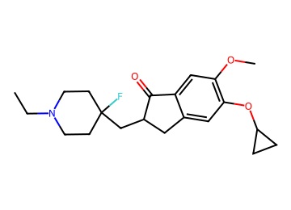  CCN1CCC(F)(CC2Cc3cc(OC4CC4)c(OC)cc3C2=O)CC1 | AChE 0.89; BBB 0.90 / 0.91 / 0.86  logBB 0.43; CNS MPO 4.6; SA 3.4  MW 361; TPSA 39; cLogP 3.8; HBD 0  P-gp 0.39; Kp,uu 0.50  hERG 0.73 (parent 0.88); Ames 0.44; DILI 0.34  edits 2; nearest potent active sim 0.66  GNN activity p 0.96 | 20.5 %  (BBB in-loop) | Vina -10.7  coverage 0.93 | 3 steps (longest sequence), score 0.987  Start from:  COc1cc2c(cc1OC1CC1)CCC2=O  CCOS(=O)(=O)c1ccc(C)cc1  OCC1(F)CCNCC1  Parent: not listed (route does not use it)  Stereo: racemate (alpha to C=O)  Reactions (computed, 3 in total):  1. CCN1CCC(F)(CC2Cc3cc(OC4CC4)c(OC)cc3C2=O)CC1>>COc1cc2c(cc1OC1CC1)CCC2=O.CCN1CCC(F)(C=O)CC1  2. CCN1CCC(F)(C=O)CC1>>CCOS(=O)(=O)c1ccc(C)cc1.O=CC1(F)CCNCC1  3. O=CC1(F)CCNCC1>>OCC1(F)CCNCC1 | hERG predicted high: measure  N-ethyl indanone: no Trp86 ring
AD002  priority tier  shortlist #10 | 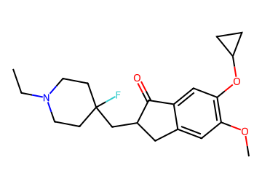  CCN1CCC(F)(CC2Cc3cc(OC)c(OC4CC4)cc3C2=O)CC1 | AChE 0.89; BBB 0.90 / 0.91 / 0.86  logBB 0.43; CNS MPO 4.6; SA 3.4  MW 361; TPSA 39; cLogP 3.8; HBD 0  P-gp 0.39; Kp,uu 0.50  hERG 0.74 (parent 0.88); Ames 0.44; DILI 0.34  edits 2; nearest potent active sim 0.66  GNN activity p 0.96 | 20.5 %  (BBB in-loop) | Vina -10.6  coverage 0.93 | 3 steps (longest sequence), score 0.987  Start from:  COc1cc2c(cc1OC1CC1)C(=O)CC2  CCOS(=O)(=O)c1ccc(C)cc1  OCC1(F)CCNCC1  Parent: not listed (route does not use it)  Stereo: racemate (alpha to C=O)  Reactions (computed, 3 in total):  1. CCN1CCC(F)(CC2Cc3cc(OC)c(OC4CC4)cc3C2=O)CC1>>COc1cc2c(cc1OC1CC1)C(=O)CC2.CCN1CCC(F)(C=O)CC1  2. CCN1CCC(F)(C=O)CC1>>CCOS(=O)(=O)c1ccc(C)cc1.O=CC1(F)CCNCC1  3. O=CC1(F)CCNCC1>>OCC1(F)CCNCC1 | hERG predicted high: measure  N-ethyl indanone: no Trp86 ring
AD003  priority tier  shortlist #13 | 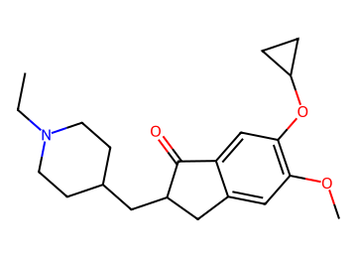  CCN1CCC(CC2Cc3cc(OC)c(OC4CC4)cc3C2=O)CC1 | AChE 0.90; BBB 0.89 / 0.92 / 0.84  logBB 0.43; CNS MPO 4.7; SA 3.0  MW 343; TPSA 39; cLogP 3.7; HBD 0  P-gp 0.37; Kp,uu 0.53  hERG 0.77 (parent 0.90); Ames 0.45; DILI 0.38  edits 2; nearest potent active sim 0.67  GNN activity p 0.96 | 18.7 %  (BBB in-loop) | Vina -9.8  coverage 0.89 | 1 step (longest sequence), score 0.998  Start from:  COc1cc2c(cc1OC1CC1)C(=O)CC2  CCN1CCC(C=O)CC1  Parent: listed by suppliers  Stereo: racemate (alpha to C=O)  Reactions (computed, 1 in total):  1. CCN1CCC(CC2Cc3cc(OC)c(OC4CC4)cc3C2=O)CC1>>COc1cc2c(cc1OC1CC1)C(=O)CC2.CCN1CCC(C=O)CC1 | hERG predicted high: measure  N-ethyl indanone: no Trp86 ring
AD004  priority tier  shortlist #9 | 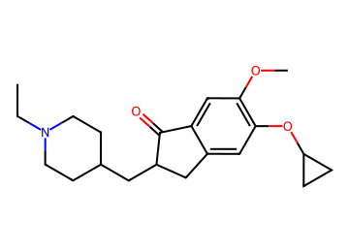  CCN1CCC(CC2Cc3cc(OC4CC4)c(OC)cc3C2=O)CC1 | AChE 0.90; BBB 0.89 / 0.92 / 0.84  logBB 0.43; CNS MPO 4.7; SA 3.0  MW 343; TPSA 39; cLogP 3.7; HBD 0  P-gp 0.37; Kp,uu 0.53  hERG 0.77 (parent 0.90); Ames 0.45; DILI 0.37  edits 2; nearest potent active sim 0.67  GNN activity p 0.96 | 18.7 %  (BBB in-loop) | Vina -10.4  coverage 0.96 | 1 step (longest sequence), score 0.998  Start from:  COc1cc2c(cc1OC1CC1)CCC2=O  CCN1CCC(C=O)CC1  Parent: listed by suppliers  Stereo: racemate (alpha to C=O)  Reactions (computed, 1 in total):  1. CCN1CCC(CC2Cc3cc(OC4CC4)c(OC)cc3C2=O)CC1>>COc1cc2c(cc1OC1CC1)CCC2=O.CCN1CCC(C=O)CC1 | hERG predicted high: measure  N-ethyl indanone: no Trp86 ring
AD005  priority tier | 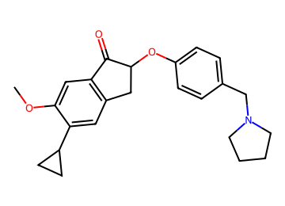  COc1cc2c(cc1C1CC1)CC(Oc1ccc(CN3CCCC3)cc1)C2=O | AChE 0.86; BBB 0.89 / 0.89 / 0.86  logBB 0.46; CNS MPO 4.1; SA 2.9  MW 377; TPSA 39; cLogP 4.4; HBD 0  P-gp 0.61; Kp,uu 0.33  hERG 0.84 (parent 0.86); Ames 0.65; DILI 0.46  edits 2; nearest potent active sim 0.81  GNN activity p 0.94 | 18.0 %  (BBB in-loop) | Vina -11.2  coverage 1.00 | 5 steps (longest sequence), score 0.963  Start from:  OB(O)C1CC1  Fc1ccc(CN2CCCC2)cc1  O=C1CCC(=O)N1Br  COc1ccc(CC(=O)C(=O)O)cc1  Parent: not listed (route does not use it)  Stereo: racemate (alpha to C=O)  Reactions (computed, 5 in total):  1. COc1cc2c(cc1C1CC1)CC(Oc1ccc(CN3CCCC3)cc1)C2=O>>COc1cc2c(cc1Br)CC(Oc1ccc(CN3CCCC3)cc1)C2=O.OB(O)C1CC1  2. COc1cc2c(cc1Br)CC(Oc1ccc(CN3CCCC3)cc1)C2=O>>COc1cc2c(cc1Br)CC(O)C2=O.Fc1ccc(CN2CCCC2)cc1  3. COc1cc2c(cc1Br)CC(O)C2=O>>O=C1CCC(=O)N1Br.COc1ccc2c(c1)C(=O)C(O)C2  4. COc1ccc2c(c1)C(=O)C(O)C2>>COc1ccc(CC(O)C(=O)O)cc1  5. COc1ccc(CC(O)C(=O)O)cc1>>COc1ccc(CC(=O)C(=O)O)cc1 | hERG predicted high: measure
AD006  priority tier | 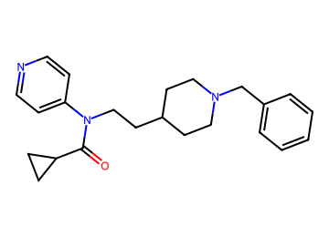  O=C(C1CC1)N(CCC1CCN(Cc2ccccc2)CC1)c1ccncc1 | AChE 0.92; BBB 0.88 / 0.96 / 0.85  logBB 0.48; CNS MPO 4.2; SA 2.2  MW 364; TPSA 36; cLogP 4.1; HBD 0  P-gp 0.60; Kp,uu 0.34  hERG 0.90 (parent 0.90); Ames 0.50; DILI 0.41  edits 1; nearest potent active sim 0.65  GNN activity p 0.93 | 17.8 %  (BBB in-loop) | Vina -10.7  coverage 0.82 | 2 steps (longest sequence), score 0.994  Start from:  O=C(Cl)C1CC1  NCCC1CCN(Cc2ccccc2)CC1  Clc1ccncc1  Parent: not listed (route does not use it)  Stereo: defined  Reactions (computed, 2 in total):  1. O=C(C1CC1)N(CCC1CCN(Cc2ccccc2)CC1)c1ccncc1>>c1ccc(CN2CCC(CCNc3ccncc3)CC2)cc1.O=C(Cl)C1CC1  2. c1ccc(CN2CCC(CCNc3ccncc3)CC2)cc1>>NCCC1CCN(Cc2ccccc2)CC1.Clc1ccncc1 | hERG predicted high: measure  BChE p 0.63
AD007  priority tier | 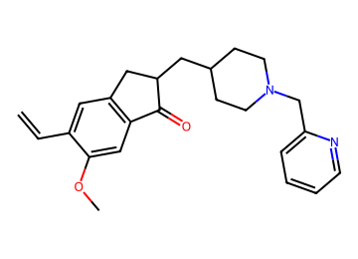  C=Cc1cc2c(cc1OC)C(=O)C(CC1CCN(Cc3ccccn3)CC1)C2 | AChE 0.89; BBB 0.91 / 0.88 / 0.82  logBB 0.41; CNS MPO 4.2; SA 3.1  MW 377; TPSA 42; cLogP 4.4; HBD 0  P-gp 0.68; Kp,uu 0.28  hERG 0.88 (parent 0.89); Ames 0.61; DILI 0.48  edits 2; nearest potent active sim 0.82  GNN activity p 0.92 | 17.8 %  (BBB audit) | Vina -12.1  coverage 1.00 | 2 steps (longest sequence), score 0.994  Start from:  C=CB(OCCCC)OCCCC  COc1cc2c(cc1Br)CCC2=O  OCC1CCN(Cc2ccccn2)CC1  Parent: listed by suppliers  Stereo: racemate (alpha to C=O)  Reactions (computed, 3 in total):  1. C=Cc1cc2c(cc1OC)C(=O)C(CC1CCN(Cc3ccccn3)CC1)C2>>C=Cc1cc2c(cc1OC)C(=O)CC2.O=CC1CCN(Cc2ccccn2)CC1  2. C=Cc1cc2c(cc1OC)C(=O)CC2>>C=CB(OCCCC)OCCCC.COc1cc2c(cc1Br)CCC2=O  3. O=CC1CCN(Cc2ccccn2)CC1>>OCC1CCN(Cc2ccccn2)CC1 | hERG predicted high: measure
AD008  priority tier  shortlist #1 | 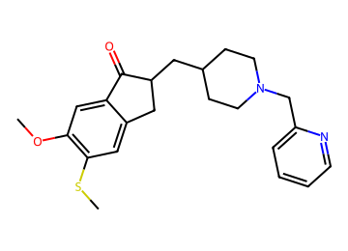  COc1cc2c(cc1SC)CC(CC1CCN(Cc3ccccn3)CC1)C2=O | AChE 0.90; BBB 0.90 / 0.88 / 0.83  logBB 0.50; CNS MPO 4.0; SA 3.1  MW 397; TPSA 42; cLogP 4.5; HBD 0  P-gp 0.69; Kp,uu 0.27  hERG 0.89 (parent 0.89); Ames 0.61; DILI 0.49  edits 1; nearest potent active sim 0.83  GNN activity p 0.94 | 17.5 %  (BBB audit) | Vina -11.8  coverage 1.00 | 2 steps (longest sequence), score 0.994  Start from:  COc1cc2c(cc1Br)CCC2=O  CSSC  OCC1CCN(Cc2ccccn2)CC1  Parent: listed by suppliers  Stereo: racemate (alpha to C=O)  Reactions (computed, 3 in total):  1. COc1cc2c(cc1SC)CC(CC1CCN(Cc3ccccn3)CC1)C2=O>>COc1cc2c(cc1SC)CCC2=O.O=CC1CCN(Cc2ccccn2)CC1  2. COc1cc2c(cc1SC)CCC2=O>>COc1cc2c(cc1Br)CCC2=O.CSSC  3. O=CC1CCN(Cc2ccccn2)CC1>>OCC1CCN(Cc2ccccn2)CC1 | hERG predicted high: measure
AD009  priority tier  shortlist #2 | 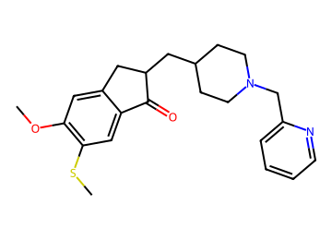  COc1cc2c(cc1SC)C(=O)C(CC1CCN(Cc3ccccn3)CC1)C2 | AChE 0.90; BBB 0.90 / 0.88 / 0.82  logBB 0.50; CNS MPO 4.0; SA 3.1  MW 397; TPSA 42; cLogP 4.5; HBD 0  P-gp 0.69; Kp,uu 0.27  hERG 0.89 (parent 0.89); Ames 0.61; DILI 0.49  edits 1; nearest potent active sim 0.83  GNN activity p 0.94 | 17.5 %  (BBB audit) | Vina -11.6  coverage 1.00 | 2 steps (longest sequence), score 0.994  Start from:  COc1ccc2c(c1)CCC2=O  CSSC  OCC1CCN(Cc2ccccn2)CC1  Parent: listed by suppliers  Stereo: racemate (alpha to C=O)  Reactions (computed, 3 in total):  1. COc1cc2c(cc1SC)C(=O)C(CC1CCN(Cc3ccccn3)CC1)C2>>COc1cc2c(cc1SC)C(=O)CC2.O=CC1CCN(Cc2ccccn2)CC1  2. COc1cc2c(cc1SC)C(=O)CC2>>COc1ccc2c(c1)CCC2=O.CSSC  3. O=CC1CCN(Cc2ccccn2)CC1>>OCC1CCN(Cc2ccccn2)CC1 | hERG predicted high: measure
AD010  priority tier | 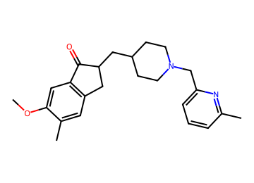  COc1cc2c(cc1C)CC(CC1CCN(Cc3cccc(C)n3)CC1)C2=O | AChE 0.88; BBB 0.92 / 0.88 / 0.85  logBB 0.52; CNS MPO 4.2; SA 3.0  MW 379; TPSA 42; cLogP 4.4; HBD 0  P-gp 0.64; Kp,uu 0.32  hERG 0.88 (parent 0.90); Ames 0.69; DILI 0.57  edits 1; nearest potent active sim 0.89  GNN activity p 0.93 | 17.4 %  (BBB audit) | Vina -12.4  coverage 1.00 | 4 steps (longest sequence), score 0.975  Start from:  Cc1cccc(C=O)n1  O=CC1CCN(Cc2ccccc2)CC1  COc1ccc(CCC(=O)O)cc1C  Parent: not listed (route does not use it)  Stereo: racemate (alpha to C=O)  Reactions (computed, 4 in total):  1. COc1cc2c(cc1C)CC(CC1CCN(Cc3cccc(C)n3)CC1)C2=O>>COc1cc2c(cc1C)CC(CC1CCNCC1)C2=O.Cc1cccc(C=O)n1  2. COc1cc2c(cc1C)CC(CC1CCNCC1)C2=O>>COc1cc2c(cc1C)CC(CC1CCN(Cc3ccccc3)CC1)C2=O  3. COc1cc2c(cc1C)CC(CC1CCN(Cc3ccccc3)CC1)C2=O>>COc1cc2c(cc1C)CCC2=O.O=CC1CCN(Cc2ccccc2)CC1  4. COc1cc2c(cc1C)CCC2=O>>COc1ccc(CCC(=O)O)cc1C | hERG predicted high: measure
AD011  priority tier | 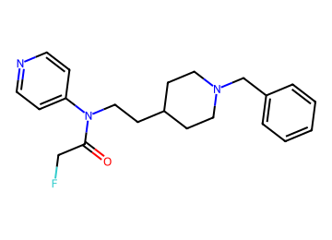  O=C(CF)N(CCC1CCN(Cc2ccccc2)CC1)c1ccncc1 | AChE 0.91; BBB 0.88 / 0.94 / 0.84  logBB 0.35; CNS MPO 4.6; SA 2.4  MW 355; TPSA 36; cLogP 3.7; HBD 0  P-gp 0.53; Kp,uu 0.40  hERG 0.89 (parent 0.90); Ames 0.49; DILI 0.42  edits 2; nearest potent active sim 0.64  GNN activity p 0.93 | 17.4 %  (BBB in-loop) | Vina -9.9  coverage 0.75 | 2 steps (longest sequence), score 0.994  Start from:  O=C(Cl)CF  NCCC1CCN(Cc2ccccc2)CC1  Clc1ccncc1  Parent: not listed (route does not use it)  Stereo: defined  Reactions (computed, 2 in total):  1. O=C(CF)N(CCC1CCN(Cc2ccccc2)CC1)c1ccncc1>>c1ccc(CN2CCC(CCNc3ccncc3)CC2)cc1.O=C(Cl)CF  2. c1ccc(CN2CCC(CCNc3ccncc3)CC2)cc1>>NCCC1CCN(Cc2ccccc2)CC1.Clc1ccncc1 | hERG predicted high: measure  BChE p 0.64
AD012  priority tier | 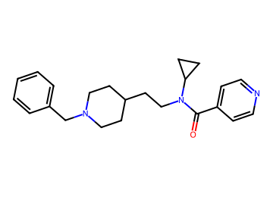  O=C(c1ccncc1)N(CCC1CCN(Cc2ccccc2)CC1)C1CC1 | AChE 0.88; BBB 0.88 / 0.94 / 0.86  logBB 0.52; CNS MPO 4.3; SA 2.2  MW 364; TPSA 36; cLogP 4.0; HBD 0  P-gp 0.57; Kp,uu 0.37  hERG 0.89 (parent 0.92); Ames 0.54; DILI 0.40  edits 2; nearest potent active sim 0.62  GNN activity p 0.73 | 16.9 %  (BBB in-loop) | Vina -10.3  coverage 0.93 | 2 steps (longest sequence), score 0.994  Start from:  O=C(Cl)c1ccncc1  O=C(O)CC1CCN(Cc2ccccc2)CC1  NC1CC1  Parent: not listed (route does not use it)  Stereo: defined  Reactions (computed, 2 in total):  1. O=C(c1ccncc1)N(CCC1CCN(Cc2ccccc2)CC1)C1CC1>>c1ccc(CN2CCC(CCNC3CC3)CC2)cc1.O=C(Cl)c1ccncc1  2. c1ccc(CN2CCC(CCNC3CC3)CC2)cc1>>O=C(O)CC1CCN(Cc2ccccc2)CC1.NC1CC1 | hERG predicted high: measure  BChE p 0.63
AD013  priority tier  shortlist #4 | 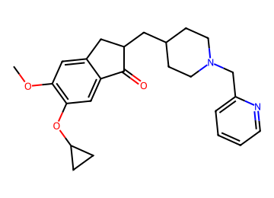  COc1cc2c(cc1OC1CC1)C(=O)C(CC1CCN(Cc3ccccn3)CC1)C2 | AChE 0.91; BBB 0.90 / 0.88 / 0.81  logBB 0.38; CNS MPO 4.0; SA 3.0  MW 407; TPSA 52; cLogP 4.3; HBD 0  P-gp 0.69; Kp,uu 0.26  hERG 0.89 (parent 0.89); Ames 0.62; DILI 0.49  edits 1; nearest potent active sim 0.90  GNN activity p 0.92 | 16.8 %  (BBB audit) | Vina -11.8  coverage 1.00 | 2 steps (longest sequence), score 0.994  Start from:  COc1cc2c(cc1OC1CC1)C(=O)CC2  OCC1CCN(Cc2ccccn2)CC1  Parent: listed by suppliers  Stereo: racemate (alpha to C=O)  Reactions (computed, 2 in total):  1. COc1cc2c(cc1OC1CC1)C(=O)C(CC1CCN(Cc3ccccn3)CC1)C2>>COc1cc2c(cc1OC1CC1)C(=O)CC2.O=CC1CCN(Cc2ccccn2)CC1  2. O=CC1CCN(Cc2ccccn2)CC1>>OCC1CCN(Cc2ccccn2)CC1 | hERG predicted high: measure
AD014  priority tier  shortlist #8 | 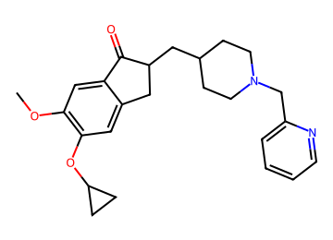  COc1cc2c(cc1OC1CC1)CC(CC1CCN(Cc3ccccn3)CC1)C2=O | AChE 0.91; BBB 0.90 / 0.88 / 0.81  logBB 0.38; CNS MPO 4.0; SA 3.0  MW 407; TPSA 52; cLogP 4.3; HBD 0  P-gp 0.69; Kp,uu 0.26  hERG 0.89 (parent 0.89); Ames 0.62; DILI 0.49  edits 1; nearest potent active sim 0.90  GNN activity p 0.92 | 16.8 %  (BBB audit) | Vina -11.0  coverage 0.89 | 2 steps (longest sequence), score 0.994  Start from:  COc1cc2c(cc1OC1CC1)CCC2=O  OCC1CCN(Cc2ccccn2)CC1  Parent: listed by suppliers  Stereo: racemate (alpha to C=O)  Reactions (computed, 2 in total):  1. COc1cc2c(cc1OC1CC1)CC(CC1CCN(Cc3ccccn3)CC1)C2=O>>COc1cc2c(cc1OC1CC1)CCC2=O.O=CC1CCN(Cc2ccccn2)CC1  2. O=CC1CCN(Cc2ccccn2)CC1>>OCC1CCN(Cc2ccccn2)CC1 | hERG predicted high: measure
AD015  priority tier | 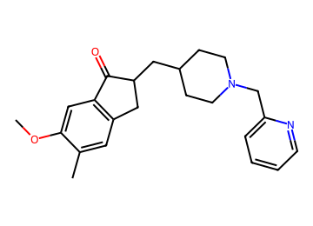  COc1cc2c(cc1C)CC(CC1CCN(Cc3ccccn3)CC1)C2=O | AChE 0.89; BBB 0.92 / 0.87 / 0.85  logBB 0.44; CNS MPO 4.4; SA 2.9  MW 364; TPSA 42; cLogP 4.1; HBD 0  P-gp 0.61; Kp,uu 0.34  hERG 0.87 (parent 0.89); Ames 0.61; DILI 0.54  edits 1; nearest potent active sim 0.88  GNN activity p 0.93 | 16.6 %  (BBB audit) | Vina -11.8  coverage 1.00 | 2 steps (longest sequence), score 0.994  Start from:  COc1ccc(CCC(=O)O)cc1C  OCC1CCN(Cc2ccccn2)CC1  Parent: listed by suppliers  Stereo: racemate (alpha to C=O)  Reactions (computed, 3 in total):  1. COc1cc2c(cc1C)CC(CC1CCN(Cc3ccccn3)CC1)C2=O>>COc1cc2c(cc1C)CCC2=O.O=CC1CCN(Cc2ccccn2)CC1  2. COc1cc2c(cc1C)CCC2=O>>COc1ccc(CCC(=O)O)cc1C  3. O=CC1CCN(Cc2ccccn2)CC1>>OCC1CCN(Cc2ccccn2)CC1 | hERG predicted high: measure
AD016  priority tier | 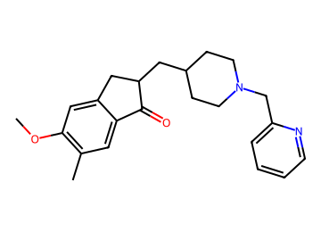  COc1cc2c(cc1C)C(=O)C(CC1CCN(Cc3ccccn3)CC1)C2 | AChE 0.90; BBB 0.92 / 0.87 / 0.84  logBB 0.44; CNS MPO 4.4; SA 2.9  MW 364; TPSA 42; cLogP 4.1; HBD 0  P-gp 0.61; Kp,uu 0.34  hERG 0.87 (parent 0.89); Ames 0.60; DILI 0.54  edits 1; nearest potent active sim 0.88  GNN activity p 0.93 | 16.5 %  (BBB audit) | Vina -12.0  coverage 0.93 | 2 steps (longest sequence), score 0.994  Start from:  COc1cc(CCC(=O)O)ccc1C  OCC1CCN(Cc2ccccn2)CC1  Parent: listed by suppliers  Stereo: racemate (alpha to C=O)  Reactions (computed, 3 in total):  1. COc1cc2c(cc1C)C(=O)C(CC1CCN(Cc3ccccn3)CC1)C2>>COc1cc2c(cc1C)C(=O)CC2.O=CC1CCN(Cc2ccccn2)CC1  2. COc1cc2c(cc1C)C(=O)CC2>>COc1cc(CCC(=O)O)ccc1C  3. O=CC1CCN(Cc2ccccn2)CC1>>OCC1CCN(Cc2ccccn2)CC1 | hERG predicted high: measure
AD017  priority tier | 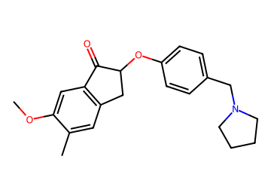  COc1cc2c(cc1C)CC(Oc1ccc(CN3CCCC3)cc1)C2=O | AChE 0.87; BBB 0.89 / 0.87 / 0.87  logBB 0.36; CNS MPO 4.7; SA 2.7  MW 351; TPSA 39; cLogP 3.8; HBD 0  P-gp 0.50; Kp,uu 0.45  hERG 0.83 (parent 0.86); Ames 0.65; DILI 0.53  edits 1; nearest potent active sim 0.86  GNN activity p 0.95 | 16.2 %  (BBB audit) | Vina -11.7  coverage 1.00 | 5 steps (longest sequence), score 0.963  Start from:  Fc1ccc(CN2CCCC2)cc1  COC(Cl)Cl  COc1ccc(CC(=O)C(=O)O)cc1  Parent: not listed (route does not use it)  Stereo: racemate (alpha to C=O)  Reactions (computed, 5 in total):  1. COc1cc2c(cc1C)CC(Oc1ccc(CN3CCCC3)cc1)C2=O>>COc1cc2c(cc1C=O)CC(Oc1ccc(CN3CCCC3)cc1)C2=O  2. COc1cc2c(cc1C=O)CC(Oc1ccc(CN3CCCC3)cc1)C2=O>>COc1cc2c(cc1C=O)CC(O)C2=O.Fc1ccc(CN2CCCC2)cc1  3. COc1cc2c(cc1C=O)CC(O)C2=O>>COc1ccc2c(c1)C(=O)C(O)C2.COC(Cl)Cl  4. COc1ccc2c(c1)C(=O)C(O)C2>>COc1ccc(CC(O)C(=O)O)cc1  5. COc1ccc(CC(O)C(=O)O)cc1>>COc1ccc(CC(=O)C(=O)O)cc1 | hERG predicted high: measure
AD018  priority tier | 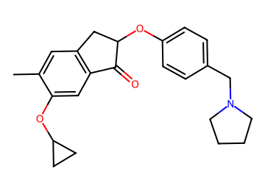  Cc1cc2c(cc1OC1CC1)C(=O)C(Oc1ccc(CN3CCCC3)cc1)C2 | AChE 0.86; BBB 0.89 / 0.88 / 0.87  logBB 0.17; CNS MPO 4.2; SA 2.9  MW 377; TPSA 39; cLogP 4.3; HBD 0  P-gp 0.60; Kp,uu 0.34  hERG 0.85 (parent 0.86); Ames 0.61; DILI 0.48  edits 2; nearest potent active sim 0.73  GNN activity p 0.95 | 15.9 %  (logBB domain) | Vina -11.8  coverage 1.00 | 5 steps (longest sequence), score 0.963  Start from:  Fc1cccc(CN2CCCC2)c1  BrC1CC1  CCOC(=O)C(=O)Cc1ccc(O)c(C)c1  Parent: not listed (route does not use it)  Stereo: racemate (alpha to C=O)  Reactions (computed, 5 in total):  1. Cc1cc2c(cc1OC1CC1)C(=O)C(Oc1ccc(CN3CCCC3)cc1)C2>>Cc1cc2c(cc1OC1CC1)C(=O)C(O)C2.Fc1cccc(CN2CCCC2)c1  2. Cc1cc2c(cc1OC1CC1)C(=O)C(O)C2>>Cc1cc2c(cc1O)C(=O)C(O)C2.BrC1CC1  3. Cc1cc2c(cc1O)C(=O)C(O)C2>>Cc1cc(CC(O)C(=O)O)ccc1O  4. Cc1cc(CC(O)C(=O)O)ccc1O>>Cc1cc(CC(=O)C(=O)O)ccc1O  5. Cc1cc(CC(=O)C(=O)O)ccc1O>>CCOC(=O)C(=O)Cc1ccc(O)c(C)c1 | hERG predicted high: measure
AD019  priority tier | 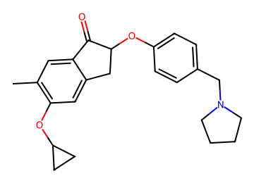  Cc1cc2c(cc1OC1CC1)CC(Oc1ccc(CN3CCCC3)cc1)C2=O | AChE 0.85; BBB 0.89 / 0.88 / 0.87  logBB 0.17; CNS MPO 4.2; SA 2.9  MW 377; TPSA 39; cLogP 4.3; HBD 0  P-gp 0.60; Kp,uu 0.34  hERG 0.85 (parent 0.86); Ames 0.62; DILI 0.48  edits 2; nearest potent active sim 0.73  GNN activity p 0.95 | 15.9 %  (logBB domain) | Vina -11.6  coverage 1.00 | 6 steps (longest sequence), score 0.956  Start from:  Fc1cccc(CN2CCCC2)c1  CC(=O)C(=O)OC(C)(C)C  Cc1ccc(Br)cc1O  BrC1CC1  Parent: not listed (route does not use it)  Stereo: racemate (alpha to C=O)  Reactions (computed, 6 in total):  1. Cc1cc2c(cc1OC1CC1)CC(Oc1ccc(CN3CCCC3)cc1)C2=O>>Cc1cc2c(cc1OC1CC1)CC(O)C2=O.Fc1cccc(CN2CCCC2)c1  2. Cc1cc2c(cc1OC1CC1)CC(O)C2=O>>Cc1ccc(CC(O)C(=O)O)cc1OC1CC1  3. Cc1ccc(CC(O)C(=O)O)cc1OC1CC1>>Cc1ccc(CC(O)C(=O)OC(C)(C)C)cc1OC1CC1  4. Cc1ccc(CC(O)C(=O)OC(C)(C)C)cc1OC1CC1>>Cc1ccc(CC(=O)C(=O)OC(C)(C)C)cc1OC1CC1  5. Cc1ccc(CC(=O)C(=O)OC(C)(C)C)cc1OC1CC1>>CC(=O)C(=O)OC(C)(C)C.Cc1ccc(Br)cc1OC1CC1  6. Cc1ccc(Br)cc1OC1CC1>>Cc1ccc(Br)cc1O.BrC1CC1 | hERG predicted high: measure
AD020  priority tier  shortlist #11 | 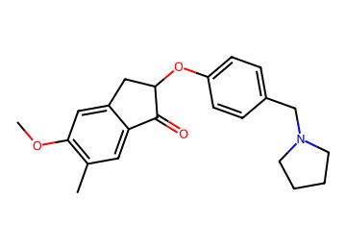  COc1cc2c(cc1C)C(=O)C(Oc1ccc(CN3CCCC3)cc1)C2 | AChE 0.86; BBB 0.88 / 0.87 / 0.86  logBB 0.36; CNS MPO 4.7; SA 2.7  MW 351; TPSA 39; cLogP 3.8; HBD 0  P-gp 0.51; Kp,uu 0.45  hERG 0.83 (parent 0.86); Ames 0.66; DILI 0.53  edits 1; nearest potent active sim 0.86  GNN activity p 0.95 | 15.8 %  (BBB audit) | Vina -11.6  coverage 1.00 | 3 steps (longest sequence), score 0.987  Start from:  C1CCNC1  OCc1ccc(O)cc1  C=C(Br)C(=O)O  COc1ccccc1C  Parent: not listed (route does not use it)  Stereo: racemate (alpha to C=O)  Reactions (computed, 3 in total):  1. COc1cc2c(cc1C)C(=O)C(Oc1ccc(CN3CCCC3)cc1)C2>>COc1cc2c(cc1C)C(=O)C(Oc1ccc(CO)cc1)C2.C1CCNC1  2. COc1cc2c(cc1C)C(=O)C(Oc1ccc(CO)cc1)C2>>COc1cc2c(cc1C)C(=O)C(Br)C2.OCc1ccc(O)cc1  3. COc1cc2c(cc1C)C(=O)C(Br)C2>>C=C(Br)C(=O)O.COc1ccccc1C | hERG predicted high: measure
AD021  priority tier | 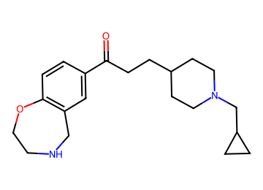  O=C(CCC1CCN(CC2CC2)CC1)c1ccc2c(c1)CNCCO2 | AChE 0.86; BBB 0.87 / 0.93 / 0.81  logBB 0.34; CNS MPO 5.1; SA 2.5  MW 342; TPSA 42; cLogP 3.3; HBD 1  P-gp 0.40; Kp,uu 0.48  hERG 0.77 (parent 0.86); Ames 0.39; DILI 0.37  edits 2; nearest potent active sim 0.50  GNN activity p 0.92 | 15.5 %  (BBB in-loop) | Vina -8.6  coverage 1.00 | 1 step (longest sequence), score 0.998  Start from:  O=C(O)CCC1CCN(CC2CC2)CC1  c1ccc2c(c1)CNCCO2  Parent: not listed (route does not use it)  Stereo: defined  Reactions (computed, 1 in total):  1. O=C(CCC1CCN(CC2CC2)CC1)c1ccc2c(c1)CNCCO2>>O=C(O)CCC1CCN(CC2CC2)CC1.c1ccc2c(c1)CNCCO2 | hERG predicted high: measure
AD022  priority tier | 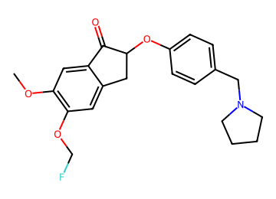  COc1cc2c(cc1OCF)CC(Oc1ccc(CN3CCCC3)cc1)C2=O | AChE 0.94; BBB 0.88 / 0.87 / 0.81  logBB 0.24; CNS MPO 4.5; SA 2.9  MW 385; TPSA 48; cLogP 3.8; HBD 0  P-gp 0.63; Kp,uu 0.32  hERG 0.85 (parent 0.86); Ames 0.63; DILI 0.50  edits 2; nearest potent active sim 0.87  GNN activity p 0.95 | 15.4 %  (BBB audit) | Vina -11.0  coverage 0.86 | 4 steps (longest sequence), score 0.975  Start from:  Fc1ccc(CN2CCCC2)cc1  Cc1ccc(S(=O)(=O)OCF)cc1  COc1ccc(CC(=O)C(=O)O)cc1O  Parent: not listed (route does not use it)  Stereo: racemate (alpha to C=O)  Reactions (computed, 4 in total):  1. COc1cc2c(cc1OCF)CC(Oc1ccc(CN3CCCC3)cc1)C2=O>>COc1cc2c(cc1OCF)CC(O)C2=O.Fc1ccc(CN2CCCC2)cc1  2. COc1cc2c(cc1OCF)CC(O)C2=O>>COc1cc2c(cc1O)CC(O)C2=O.Cc1ccc(S(=O)(=O)OCF)cc1  3. COc1cc2c(cc1O)CC(O)C2=O>>COc1ccc(CC(O)C(=O)O)cc1O  4. COc1ccc(CC(O)C(=O)O)cc1O>>COc1ccc(CC(=O)C(=O)O)cc1O | hERG predicted high: measure
AD023  priority tier | 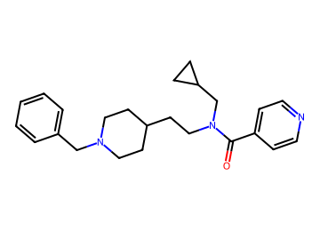  O=C(c1ccncc1)N(CCC1CCN(Cc2ccccc2)CC1)CC1CC1 | AChE 0.88; BBB 0.86 / 0.94 / 0.82  logBB 0.50; CNS MPO 4.1; SA 2.2  MW 378; TPSA 36; cLogP 4.2; HBD 0  P-gp 0.65; Kp,uu 0.30  hERG 0.90 (parent 0.92); Ames 0.52; DILI 0.40  edits 2; nearest potent active sim 0.61  GNN activity p 0.67 | 15.2 %  (BBB in-loop) | Vina -10.6  coverage 0.82 | 2 steps (longest sequence), score 0.994  Start from:  O=C(Cl)c1ccncc1  O=CC1CC1  NCCC1CCN(Cc2ccccc2)CC1  Parent: not listed (route does not use it)  Stereo: defined  Reactions (computed, 2 in total):  1. O=C(c1ccncc1)N(CCC1CCN(Cc2ccccc2)CC1)CC1CC1>>c1ccc(CN2CCC(CCNCC3CC3)CC2)cc1.O=C(Cl)c1ccncc1  2. c1ccc(CN2CCC(CCNCC3CC3)CC2)cc1>>O=CC1CC1.NCCC1CCN(Cc2ccccc2)CC1 | hERG predicted high: measure  BChE p 0.69
AD024  priority tier  shortlist #18 | 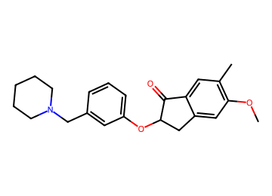  COc1cc2c(cc1C)C(=O)C(Oc1cccc(CN3CCCCC3)c1)C2 | AChE 0.86; BBB 0.89 / 0.86 / 0.88  logBB 0.32; CNS MPO 4.3; SA 2.8  MW 365; TPSA 39; cLogP 4.2; HBD 0  P-gp 0.67; Kp,uu 0.29  hERG 0.85 (parent 0.88); Ames 0.68; DILI 0.50  edits 1; nearest potent active sim 0.87  GNN activity p 0.96 | 15.2 %  (BBB audit) | Vina -12.0  coverage 0.93 | 3 steps (longest sequence), score 0.987  Start from:  COc1ccccc1C  C=C(Oc1cccc(C(=O)O)c1)C(=O)O  C1CCNCC1  Parent: listed by suppliers  Stereo: racemate (alpha to C=O)  Reactions (computed, 3 in total):  1. COc1cc2c(cc1C)C(=O)C(Oc1cccc(CN3CCCCC3)c1)C2>>COc1cc2c(cc1C)C(=O)C(Oc1cccc(C(=O)N3CCCCC3)c1)C2  2. COc1cc2c(cc1C)C(=O)C(Oc1cccc(C(=O)N3CCCCC3)c1)C2>>C=C(Oc1cccc(C(=O)N2CCCCC2)c1)C(=O)O.COc1ccccc1C  3. C=C(Oc1cccc(C(=O)N2CCCCC2)c1)C(=O)O>>C=C(Oc1cccc(C(=O)O)c1)C(=O)O.C1CCNCC1 | hERG predicted high: measure
AD025  priority tier | 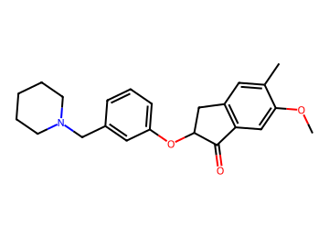  COc1cc2c(cc1C)CC(Oc1cccc(CN3CCCCC3)c1)C2=O | AChE 0.86; BBB 0.89 / 0.86 / 0.88  logBB 0.31; CNS MPO 4.3; SA 2.8  MW 365; TPSA 39; cLogP 4.2; HBD 0  P-gp 0.67; Kp,uu 0.29  hERG 0.85 (parent 0.88); Ames 0.67; DILI 0.50  edits 1; nearest potent active sim 0.87  GNN activity p 0.96 | 15.1 %  (BBB audit) | Vina -11.8  coverage 0.93 | 5 steps (longest sequence), score 0.963  Start from:  Oc1cccc(CN2CCCCC2)c1  CB1OB(C)OB(C)O1  O=C1CCC(=O)N1Br  COc1ccc(CC(=O)C(=O)O)cc1  Parent: listed by suppliers  Stereo: racemate (alpha to C=O)  Reactions (computed, 5 in total):  1. COc1cc2c(cc1C)CC(Oc1cccc(CN3CCCCC3)c1)C2=O>>COc1cc2c(cc1C)CC(O)C2=O.Oc1cccc(CN2CCCCC2)c1  2. COc1cc2c(cc1C)CC(O)C2=O>>COc1cc2c(cc1Br)CC(O)C2=O.CB1OB(C)OB(C)O1  3. COc1cc2c(cc1Br)CC(O)C2=O>>O=C1CCC(=O)N1Br.COc1ccc2c(c1)C(=O)C(O)C2  4. COc1ccc2c(c1)C(=O)C(O)C2>>COc1ccc(CC(O)C(=O)O)cc1  5. COc1ccc(CC(O)C(=O)O)cc1>>COc1ccc(CC(=O)C(=O)O)cc1 | hERG predicted high: measure
AD026  priority tier | 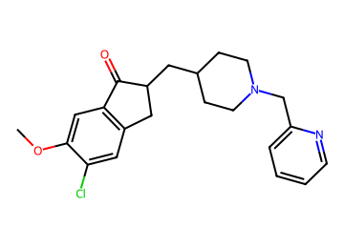  COc1cc2c(cc1Cl)CC(CC1CCN(Cc3ccccn3)CC1)C2=O | AChE 0.91; BBB 0.91 / 0.86 / 0.80  logBB 0.54; CNS MPO 4.1; SA 2.9  MW 385; TPSA 42; cLogP 4.4; HBD 0  P-gp 0.64; Kp,uu 0.31  hERG 0.88 (parent 0.89); Ames 0.61; DILI 0.54  edits 1; nearest potent active sim 0.86  GNN activity p 0.90 | 15.1 %  (BBB audit) | Vina -11.8  coverage 1.00 | 2 steps (longest sequence), score 0.994  Start from:  COc1cc2c(cc1Cl)CCC2=O  OCC1CCN(Cc2ccccn2)CC1  Parent: listed by suppliers  Stereo: racemate (alpha to C=O)  Reactions (computed, 2 in total):  1. COc1cc2c(cc1Cl)CC(CC1CCN(Cc3ccccn3)CC1)C2=O>>COc1cc2c(cc1Cl)CCC2=O.O=CC1CCN(Cc2ccccn2)CC1  2. O=CC1CCN(Cc2ccccn2)CC1>>OCC1CCN(Cc2ccccn2)CC1 | hERG predicted high: measure
AD027  priority tier | 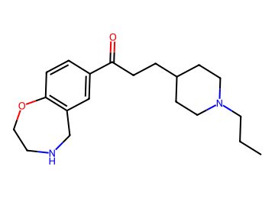  CCCN1CCC(CCC(=O)c2ccc3c(c2)CNCCO3)CC1 | AChE 0.81; BBB 0.89 / 0.89 / 0.85  logBB 0.33; CNS MPO 5.1; SA 2.4  MW 330; TPSA 42; cLogP 3.3; HBD 1  P-gp 0.36; Kp,uu 0.52  hERG 0.80 (parent 0.86); Ames 0.31; DILI 0.33  edits 2; nearest potent active sim 0.48  GNN activity p 0.90 | 14.8 %  (AChE domain) | Vina -8.2  coverage 1.00 | 1 step (longest sequence), score 0.998  Start from:  CCCN1CCC(CCC(=O)O)CC1  c1ccc2c(c1)CNCCO2  Parent: not listed (route does not use it)  Stereo: defined  Reactions (computed, 1 in total):  1. CCCN1CCC(CCC(=O)c2ccc3c(c2)CNCCO3)CC1>>CCCN1CCC(CCC(=O)O)CC1.c1ccc2c(c1)CNCCO2 | hERG predicted high: measure
AD028  priority tier | 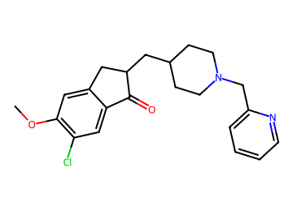  COc1cc2c(cc1Cl)C(=O)C(CC1CCN(Cc3ccccn3)CC1)C2 | AChE 0.92; BBB 0.90 / 0.86 / 0.79  logBB 0.54; CNS MPO 4.1; SA 2.9  MW 385; TPSA 42; cLogP 4.4; HBD 0  P-gp 0.64; Kp,uu 0.32  hERG 0.88 (parent 0.89); Ames 0.61; DILI 0.54  edits 1; nearest potent active sim 0.86  GNN activity p 0.90 | 14.7 %  (BBB audit) | Vina -11.8  coverage 0.93 | 2 steps (longest sequence), score 0.994  Start from:  COc1cc2c(cc1Cl)C(=O)CC2  OCC1CCN(Cc2ccccn2)CC1  Parent: listed by suppliers  Stereo: racemate (alpha to C=O)  Reactions (computed, 2 in total):  1. COc1cc2c(cc1Cl)C(=O)C(CC1CCN(Cc3ccccn3)CC1)C2>>COc1cc2c(cc1Cl)C(=O)CC2.O=CC1CCN(Cc2ccccn2)CC1  2. O=CC1CCN(Cc2ccccn2)CC1>>OCC1CCN(Cc2ccccn2)CC1 | hERG predicted high: measure
AD029  priority tier | 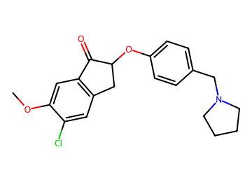  COc1cc2c(cc1Cl)CC(Oc1ccc(CN3CCCC3)cc1)C2=O | AChE 0.90; BBB 0.88 / 0.86 / 0.85  logBB 0.50; CNS MPO 4.3; SA 2.7  MW 372; TPSA 39; cLogP 4.1; HBD 0  P-gp 0.54; Kp,uu 0.41  hERG 0.86 (parent 0.86); Ames 0.64; DILI 0.52  edits 1; nearest potent active sim 0.86  GNN activity p 0.92 | 14.6 %  (BBB audit) | Vina -11.4  coverage 1.00 | 4 steps (longest sequence), score 0.975  Start from:  Fc1ccc(CN2CCCC2)cc1  O=C1CCC(=O)N1Cl  COc1ccc(CC(=O)C(=O)O)cc1  Parent: not listed (route does not use it)  Stereo: racemate (alpha to C=O)  Reactions (computed, 4 in total):  1. COc1cc2c(cc1Cl)CC(Oc1ccc(CN3CCCC3)cc1)C2=O>>COc1cc2c(cc1Cl)CC(O)C2=O.Fc1ccc(CN2CCCC2)cc1  2. COc1cc2c(cc1Cl)CC(O)C2=O>>COc1ccc2c(c1)C(=O)C(O)C2.O=C1CCC(=O)N1Cl  3. COc1ccc2c(c1)C(=O)C(O)C2>>COc1ccc(CC(O)C(=O)O)cc1  4. COc1ccc(CC(O)C(=O)O)cc1>>COc1ccc(CC(=O)C(=O)O)cc1 | hERG predicted high: measure
AD030  priority tier | 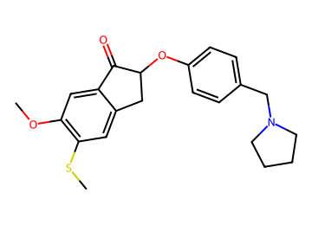  COc1cc2c(cc1SC)CC(Oc1ccc(CN3CCCC3)cc1)C2=O | AChE 0.92; BBB 0.86 / 0.88 / 0.87  logBB 0.44; CNS MPO 4.2; SA 2.9  MW 384; TPSA 39; cLogP 4.2; HBD 0  P-gp 0.62; Kp,uu 0.34  hERG 0.85 (parent 0.86); Ames 0.64; DILI 0.48  edits 1; nearest potent active sim 0.81  GNN activity p 0.96 | 14.5 %  (BBB in-loop) | Vina -10.9  coverage 1.00 | 4 steps (longest sequence), score 0.975  Start from:  CSSC  Fc1ccc(CN2CCCC2)cc1  COc1ccc(CC(=O)C(=O)O)cc1  Parent: not listed (route does not use it)  Stereo: racemate (alpha to C=O)  Reactions (computed, 4 in total):  1. COc1cc2c(cc1SC)CC(Oc1ccc(CN3CCCC3)cc1)C2=O>>COc1ccc2c(c1)C(=O)C(Oc1ccc(CN3CCCC3)cc1)C2.CSSC  2. COc1ccc2c(c1)C(=O)C(Oc1ccc(CN3CCCC3)cc1)C2>>COc1ccc2c(c1)C(=O)C(O)C2.Fc1ccc(CN2CCCC2)cc1  3. COc1ccc2c(c1)C(=O)C(O)C2>>COc1ccc(CC(O)C(=O)O)cc1  4. COc1ccc(CC(O)C(=O)O)cc1>>COc1ccc(CC(=O)C(=O)O)cc1 | hERG predicted high: measure
AD031  priority tier  shortlist #3 | 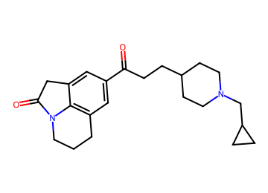  O=C(CCC1CCN(CC2CC2)CC1)c1cc2c3c(c1)CC(=O)N3CCC2 | AChE 0.90; BBB 0.87 / 0.94 / 0.88  logBB 0.34; CNS MPO 4.8; SA 2.6  MW 367; TPSA 41; cLogP 3.6; HBD 0  P-gp 0.47; Kp,uu 0.43  hERG 0.73 (parent 0.84); Ames 0.39; DILI 0.32  edits 2; nearest potent active sim 0.52  GNN activity p 0.99 | 14.3 %  (logBB domain) | Vina -11.7  coverage 1.00 | 1 step (longest sequence), score 0.998  Start from:  O=C(O)CCC1CCN(CC2CC2)CC1  O=C1Cc2cccc3c2N1CCC3  Parent: not listed (route does not use it)  Stereo: defined  Reactions (computed, 1 in total):  1. O=C(CCC1CCN(CC2CC2)CC1)c1cc2c3c(c1)CC(=O)N3CCC2>>O=C(O)CCC1CCN(CC2CC2)CC1.O=C1Cc2cccc3c2N1CCC3 | hERG predicted high: measure  BChE p 0.54
AD032  priority tier  shortlist #12 | 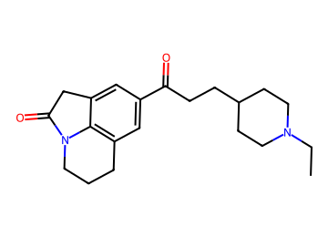  CCN1CCC(CCC(=O)c2cc3c4c(c2)CC(=O)N4CCC3)CC1 | AChE 0.84; BBB 0.86 / 0.93 / 0.87  logBB 0.32; CNS MPO 5.3; SA 2.6  MW 340; TPSA 41; cLogP 3.2; HBD 0  P-gp 0.38; Kp,uu 0.52  hERG 0.75 (parent 0.84); Ames 0.34; DILI 0.32  edits 1; nearest potent active sim 0.48  GNN activity p 0.99 | 14.3 %  (logBB domain) | Vina -11.7  coverage 0.93 | 1 step (longest sequence), score 0.998  Start from:  CCN1CCC(CCC(=O)O)CC1  O=C1Cc2cccc3c2N1CCC3  Parent: not listed (route does not use it)  Stereo: defined  Reactions (computed, 1 in total):  1. CCN1CCC(CCC(=O)c2cc3c4c(c2)CC(=O)N4CCC3)CC1>>CCN1CCC(CCC(=O)O)CC1.O=C1Cc2cccc3c2N1CCC3 | hERG predicted high: measure
AD033  priority tier  shortlist #14 | 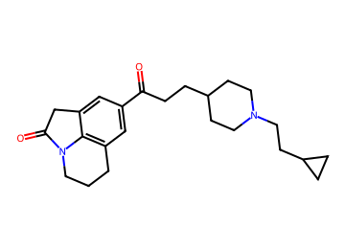  O=C(CCC1CCN(CCC2CC2)CC1)c1cc2c3c(c1)CC(=O)N3CCC2 | AChE 0.89; BBB 0.89 / 0.94 / 0.90  logBB 0.38; CNS MPO 4.4; SA 2.6  MW 381; TPSA 41; cLogP 4.0; HBD 0  P-gp 0.54; Kp,uu 0.38  hERG 0.74 (parent 0.84); Ames 0.37; DILI 0.30  edits 2; nearest potent active sim 0.48  GNN activity p 1.00 | 14.3 %  (logBB domain) | Vina -11.4  coverage 1.00 | 1 step (longest sequence), score 0.998  Start from:  O=C(O)CCC1CCN(CCC2CC2)CC1  O=C1Cc2cccc3c2N1CCC3  Parent: not listed (route does not use it)  Stereo: defined  Reactions (computed, 1 in total):  1. O=C(CCC1CCN(CCC2CC2)CC1)c1cc2c3c(c1)CC(=O)N3CCC2>>O=C(O)CCC1CCN(CCC2CC2)CC1.O=C1Cc2cccc3c2N1CCC3 | hERG predicted high: measure  BChE p 0.54
AD034  priority tier | 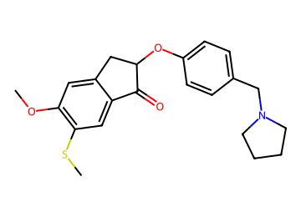  COc1cc2c(cc1SC)C(=O)C(Oc1ccc(CN3CCCC3)cc1)C2 | AChE 0.89; BBB 0.86 / 0.88 / 0.85  logBB 0.44; CNS MPO 4.2; SA 2.9  MW 384; TPSA 39; cLogP 4.2; HBD 0  P-gp 0.62; Kp,uu 0.34  hERG 0.85 (parent 0.86); Ames 0.65; DILI 0.48  edits 1; nearest potent active sim 0.81  GNN activity p 0.96 | 14.3 %  (BBB in-loop) | Vina -11.2  coverage 1.00 | 6 steps (longest sequence), score 0.956  Start from:  COS(=O)(=O)OC  Fc1ccc(CN2CCCC2)cc1  CCOC(=O)C(=O)OCC  CSc1ccc(C)cc1O  Parent: not listed (route does not use it)  Stereo: racemate (alpha to C=O)  Reactions (computed, 6 in total):  1. COc1cc2c(cc1SC)C(=O)C(Oc1ccc(CN3CCCC3)cc1)C2>>COS(=O)(=O)OC.CSc1cc2c(cc1O)CC(Oc1ccc(CN3CCCC3)cc1)C2=O  2. CSc1cc2c(cc1O)CC(Oc1ccc(CN3CCCC3)cc1)C2=O>>CSc1cc2c(cc1O)CC(O)C2=O.Fc1ccc(CN2CCCC2)cc1  3. CSc1cc2c(cc1O)CC(O)C2=O>>CSc1ccc(CC(O)C(=O)O)cc1O  4. CSc1ccc(CC(O)C(=O)O)cc1O>>CSc1ccc(CC(=O)C(=O)O)cc1O  5. CSc1ccc(CC(=O)C(=O)O)cc1O>>CCOC(=O)C(=O)Cc1ccc(SC)c(O)c1  6. CCOC(=O)C(=O)Cc1ccc(SC)c(O)c1>>CCOC(=O)C(=O)OCC.CSc1ccc(C)cc1O | hERG predicted high: measure
AD035  priority tier  shortlist #5 | 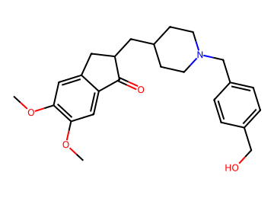  COc1cc2c(cc1OC)C(=O)C(CC1CCN(Cc3ccc(CO)cc3)CC1)C2 | AChE 0.94; BBB 0.85 / 0.85 / 0.78  logBB 0.19; CNS MPO 4.1; SA 2.8  MW 410; TPSA 59; cLogP 3.9; HBD 1  P-gp 0.70; Kp,uu 0.26  hERG 0.90 (parent 0.89); Ames 0.59; DILI 0.43  edits 2; nearest potent active sim 0.83  GNN activity p 0.93 | 13.7 %  (BBB audit) | Vina -12.2  coverage 1.00 | 2 steps (longest sequence), score 0.994  Start from:  OCc1ccc(CCl)cc1  COc1cc2c(cc1OC)C(=O)CC2  CC(C)(C)OC(=O)N1CCC(C=O)CC1  Parent: not listed (route does not use it)  Stereo: racemate (alpha to C=O)  Reactions (computed, 2 in total):  1. COc1cc2c(cc1OC)C(=O)C(CC1CCN(Cc3ccc(CO)cc3)CC1)C2>>OCc1ccc(CCl)cc1.COc1cc2c(cc1OC)C(=O)C(CC1CCN(C(=O)OC(C)(C)C)CC1)C2  2. COc1cc2c(cc1OC)C(=O)C(CC1CCN(C(=O)OC(C)(C)C)CC1)C2>>COc1cc2c(cc1OC)C(=O)CC2.CC(C)(C)OC(=O)N1CCC(C=O)CC1 | hERG predicted high: measure
AD036  priority tier  shortlist #16 | 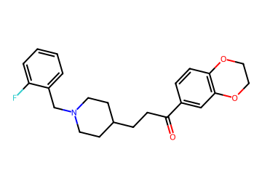  O=C(CCC1CCN(Cc2ccccc2F)CC1)c1ccc2c(c1)OCCO2 | AChE 0.94; BBB 0.85 / 0.89 / 0.80  logBB 0.37; CNS MPO 4.0; SA 2.2  MW 383; TPSA 39; cLogP 4.5; HBD 0  P-gp 0.67; Kp,uu 0.29  hERG 0.86 (parent 0.86); Ames 0.47; DILI 0.51  edits 1; nearest potent active sim 0.63  GNN activity p 0.85 | 13.6 %  (BBB in-loop) | Vina -12.1  coverage 1.00 | 2 steps (longest sequence), score 0.994  Start from:  c1ccc2c(c1)OCCO2  N#CCCC1CCN(Cc2ccccc2F)CC1  CC(=O)O  Parent: not listed (route does not use it)  Stereo: defined  Reactions (computed, 2 in total):  1. O=C(CCC1CCN(Cc2ccccc2F)CC1)c1ccc2c(c1)OCCO2>>O=C(O)CCC1CCN(Cc2ccccc2F)CC1.c1ccc2c(c1)OCCO2  2. O=C(O)CCC1CCN(Cc2ccccc2F)CC1>>N#CCCC1CCN(Cc2ccccc2F)CC1.CC(=O)O | hERG predicted high: measure
AD037  priority tier | 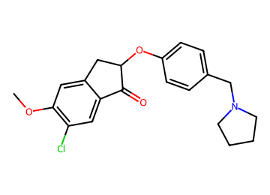  COc1cc2c(cc1Cl)C(=O)C(Oc1ccc(CN3CCCC3)cc1)C2 | AChE 0.90; BBB 0.87 / 0.85 / 0.84  logBB 0.50; CNS MPO 4.3; SA 2.7  MW 372; TPSA 39; cLogP 4.1; HBD 0  P-gp 0.54; Kp,uu 0.41  hERG 0.85 (parent 0.86); Ames 0.65; DILI 0.52  edits 1; nearest potent active sim 0.86  GNN activity p 0.92 | 13.5 %  (BBB audit) | Vina -11.4  coverage 1.00 | 5 steps (longest sequence), score 0.963  Start from:  Fc1ccc(CN2CCCC2)cc1  COC(=O)C(C)=O  COc1cc(Br)ccc1Cl  Parent: not listed (route does not use it)  Stereo: racemate (alpha to C=O)  Reactions (computed, 5 in total):  1. COc1cc2c(cc1Cl)C(=O)C(Oc1ccc(CN3CCCC3)cc1)C2>>COc1cc2c(cc1Cl)C(=O)C(O)C2.Fc1ccc(CN2CCCC2)cc1  2. COc1cc2c(cc1Cl)C(=O)C(O)C2>>COc1cc(CC(O)C(=O)O)ccc1Cl  3. COc1cc(CC(O)C(=O)O)ccc1Cl>>COc1cc(CC(=O)C(=O)O)ccc1Cl  4. COc1cc(CC(=O)C(=O)O)ccc1Cl>>COC(=O)C(=O)Cc1ccc(Cl)c(OC)c1  5. COC(=O)C(=O)Cc1ccc(Cl)c(OC)c1>>COC(=O)C(C)=O.COc1cc(Br)ccc1Cl | hERG predicted high: measure
AD038  priority tier | 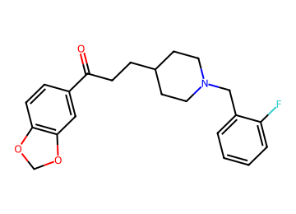  O=C(CCC1CCN(Cc2ccccc2F)CC1)c1ccc2c(c1)OCO2 | AChE 0.92; BBB 0.85 / 0.87 / 0.81  logBB 0.23; CNS MPO 4.2; SA 2.1  MW 369; TPSA 39; cLogP 4.4; HBD 0  P-gp 0.58; Kp,uu 0.38  hERG 0.87 (parent 0.87); Ames 0.48; DILI 0.50  edits 1; nearest potent active sim 0.65  GNN activity p 0.72 | 13.5 %  (BBB in-loop) | Vina -11.8  coverage 0.96 | 2 steps (longest sequence), score 0.994  Start from:  c1ccc2c(c1)OCO2  N#CCCC1CCN(Cc2ccccc2F)CC1  CC(=O)O  Parent: not listed (route does not use it)  Stereo: defined  Reactions (computed, 2 in total):  1. O=C(CCC1CCN(Cc2ccccc2F)CC1)c1ccc2c(c1)OCO2>>O=C(O)CCC1CCN(Cc2ccccc2F)CC1.c1ccc2c(c1)OCO2  2. O=C(O)CCC1CCN(Cc2ccccc2F)CC1>>N#CCCC1CCN(Cc2ccccc2F)CC1.CC(=O)O | hERG predicted high: measure
AD039  priority tier | 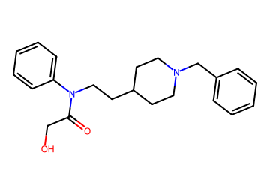  O=C(CO)N(CCC1CCN(Cc2ccccc2)CC1)c1ccccc1 | AChE 0.90; BBB 0.85 / 0.92 / 0.82  logBB 0.09; CNS MPO 5.0; SA 2.1  MW 352; TPSA 44; cLogP 3.3; HBD 1  P-gp 0.49; Kp,uu 0.44  hERG 0.90 (parent 0.91); Ames 0.47; DILI 0.33  edits 2; nearest potent active sim 0.76  GNN activity p 0.69 | 13.4 %  (BBB in-loop) | Vina -10.9  coverage 0.93 | 2 steps (longest sequence), score 0.994  Start from:  OCCC1CCN(Cc2ccccc2)CC1  Nc1ccccc1  ClC(Cl)Cl  O=C(O)CO  Parent: not listed (route does not use it)  Stereo: defined  Reactions (computed, 3 in total):  1. O=C(CO)N(CCC1CCN(Cc2ccccc2)CC1)c1ccccc1>>c1ccc(CN2CCC(CCNc3ccccc3)CC2)cc1.O=C(Cl)CO  2. c1ccc(CN2CCC(CCNc3ccccc3)CC2)cc1>>OCCC1CCN(Cc2ccccc2)CC1.Nc1ccccc1  3. O=C(Cl)CO>>ClC(Cl)Cl.O=C(O)CO | hERG predicted high: measure  BChE p 0.64
AD040  priority tier | 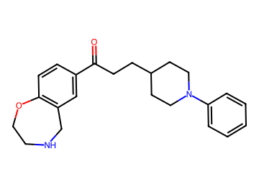  O=C(CCC1CCN(c2ccccc2)CC1)c1ccc2c(c1)CNCCO2 | AChE 0.82; BBB 0.85 / 0.86 / 0.82  logBB 0.24; CNS MPO 4.3; SA 2.3  MW 364; TPSA 42; cLogP 4.0; HBD 1  P-gp 0.62; Kp,uu 0.33  hERG 0.84 (parent 0.86); Ames 0.50; DILI 0.49  edits 2; nearest potent active sim 0.51  GNN activity p 0.89 | 13.2 %  (BBB in-loop) | Vina -9.6  coverage 1.00 | 2 steps (longest sequence), score 0.994  Start from:  c1ccc2c(c1)CNCCO2  O=C(O)CCC1CCNCC1  Brc1ccccc1  Parent: not listed (route does not use it)  Stereo: defined  Reactions (computed, 2 in total):  1. O=C(CCC1CCN(c2ccccc2)CC1)c1ccc2c(c1)CNCCO2>>O=C(O)CCC1CCN(c2ccccc2)CC1.c1ccc2c(c1)CNCCO2  2. O=C(O)CCC1CCN(c2ccccc2)CC1>>O=C(O)CCC1CCNCC1.Brc1ccccc1 | hERG predicted high: measure
AD041  priority tier | 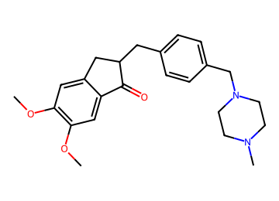  COc1cc2c(cc1OC)C(=O)C(Cc1ccc(CN3CCN(C)CC3)cc1)C2 | AChE 0.94; BBB 0.90 / 0.85 / 0.87  logBB 0.61; CNS MPO 5.2; SA 2.7  MW 395; TPSA 42; cLogP 3.0; HBD 0  P-gp 0.69; Kp,uu 0.27  hERG 0.89 (parent 0.83); Ames 0.62; DILI 0.43  edits 2; nearest potent active sim 0.70  GNN activity p 0.92 | 12.8 %  (BBB audit) | Vina -11.1  coverage 0.93 | 2 steps (longest sequence), score 0.994  Start from:  COc1cc2c(cc1OC)C(=O)CC2  CN1CCN(Cc2ccc(C=O)cc2)CC1  Parent: not listed (route does not use it)  Stereo: racemate (alpha to C=O)  Reactions (computed, 2 in total):  1. COc1cc2c(cc1OC)C(=O)C(Cc1ccc(CN3CCN(C)CC3)cc1)C2>>COc1cc2c(cc1OC)C(=O)/C(=C/c1ccc(CN3CCN(C)CC3)cc1)C2  2. COc1cc2c(cc1OC)C(=O)/C(=C/c1ccc(CN3CCN(C)CC3)cc1)C2>>COc1cc2c(cc1OC)C(=O)CC2.CN1CCN(Cc2ccc(C=O)cc2)CC1 | hERG predicted high: measure
AD042  priority tier  shortlist #7 | 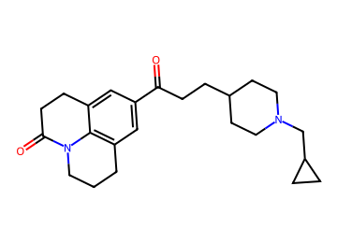  O=C(CCC1CCN(CC2CC2)CC1)c1cc2c3c(c1)CCC(=O)N3CCC2 | AChE 0.90; BBB 0.88 / 0.94 / 0.89  logBB 0.35; CNS MPO 4.4; SA 2.6  MW 381; TPSA 41; cLogP 4.0; HBD 0  P-gp 0.52; Kp,uu 0.38  hERG 0.74 (parent 0.85); Ames 0.38; DILI 0.31  edits 2; nearest potent active sim 0.51  GNN activity p 0.99 | 12.7 %  (logBB domain) | Vina -11.9  coverage 1.00 | 1 step (longest sequence), score 0.998  Start from:  O=C(O)CCC1CCN(CC2CC2)CC1  O=C1CCc2cccc3c2N1CCC3  Parent: not listed (route does not use it)  Stereo: defined  Reactions (computed, 1 in total):  1. O=C(CCC1CCN(CC2CC2)CC1)c1cc2c3c(c1)CCC(=O)N3CCC2>>O=C(O)CCC1CCN(CC2CC2)CC1.O=C1CCc2cccc3c2N1CCC3 | hERG predicted high: measure  BChE p 0.55
AD043  priority tier  shortlist #20 | 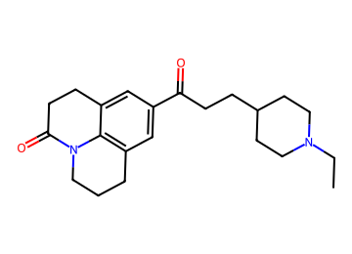  CCN1CCC(CCC(=O)c2cc3c4c(c2)CCC(=O)N4CCC3)CC1 | AChE 0.86; BBB 0.87 / 0.94 / 0.88  logBB 0.30; CNS MPO 4.9; SA 2.5  MW 354; TPSA 41; cLogP 3.6; HBD 0  P-gp 0.43; Kp,uu 0.48  hERG 0.76 (parent 0.85); Ames 0.32; DILI 0.31  edits 1; nearest potent active sim 0.47  GNN activity p 0.99 | 12.6 %  (AChE domain) | Vina -11.6  coverage 0.96 | 1 step (longest sequence), score 0.998  Start from:  CCN1CCC(CCC(=O)O)CC1  O=C1CCc2cccc3c2N1CCC3  Parent: not listed (route does not use it)  Stereo: defined  Reactions (computed, 1 in total):  1. CCN1CCC(CCC(=O)c2cc3c4c(c2)CCC(=O)N4CCC3)CC1>>CCN1CCC(CCC(=O)O)CC1.O=C1CCc2cccc3c2N1CCC3 | hERG predicted high: measure
AD044  priority tier  shortlist #6 | 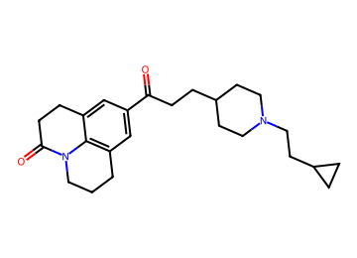  O=C(CCC1CCN(CCC2CC2)CC1)c1cc2c3c(c1)CCC(=O)N3CCC2 | AChE 0.89; BBB 0.89 / 0.94 / 0.90  logBB 0.40; CNS MPO 4.1; SA 2.6  MW 395; TPSA 41; cLogP 4.4; HBD 0  P-gp 0.59; Kp,uu 0.34  hERG 0.75 (parent 0.85); Ames 0.35; DILI 0.30  edits 2; nearest potent active sim 0.47  GNN activity p 0.99 | 12.6 %  (AChE domain) | Vina -11.9  coverage 0.96 | 1 step (longest sequence), score 0.998  Start from:  O=C(O)CCC1CCN(CCC2CC2)CC1  O=C1CCc2cccc3c2N1CCC3  Parent: not listed (route does not use it)  Stereo: defined  Reactions (computed, 1 in total):  1. O=C(CCC1CCN(CCC2CC2)CC1)c1cc2c3c(c1)CCC(=O)N3CCC2>>O=C(O)CCC1CCN(CCC2CC2)CC1.O=C1CCc2cccc3c2N1CCC3 | hERG predicted high: measure  BChE p 0.56
AD045  priority tier | 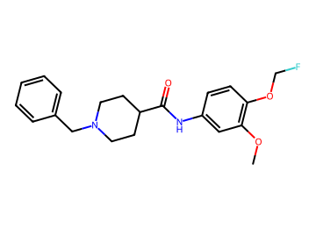  COc1cc(NC(=O)C2CCN(Cc3ccccc3)CC2)ccc1OCF | AChE 0.85; BBB 0.84 / 0.85 / 0.76  logBB -0.04; CNS MPO 4.4; SA 1.9  MW 372; TPSA 51; cLogP 3.9; HBD 1  P-gp 0.61; Kp,uu 0.34  hERG 0.90 (parent 0.92); Ames 0.48; DILI 0.48  edits 2; nearest potent active sim 0.86  GNN activity p 0.79 | 12.5 %  (BBB in-loop) | Vina -10.4  coverage 1.00 | 3 steps (longest sequence), score 0.987  Start from:  O=C(O)C1CCN(Cc2ccccc2)CC1  COc1cc([N+](=O)[O-])ccc1O  Cc1ccc(S(=O)(=O)OCF)cc1  Parent: listed by suppliers  Stereo: defined  Reactions (computed, 3 in total):  1. COc1cc(NC(=O)C2CCN(Cc3ccccc3)CC2)ccc1OCF>>O=C(O)C1CCN(Cc2ccccc2)CC1.COc1cc(N)ccc1OCF  2. COc1cc(N)ccc1OCF>>COc1cc([N+](=O)[O-])ccc1OCF  3. COc1cc([N+](=O)[O-])ccc1OCF>>COc1cc([N+](=O)[O-])ccc1O.Cc1ccc(S(=O)(=O)OCF)cc1 | hERG predicted high: measure
AD046  priority tier | 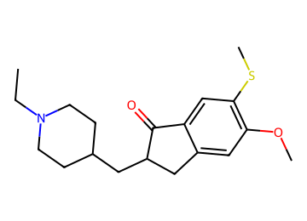  CCN1CCC(CC2Cc3cc(OC)c(SC)cc3C2=O)CC1 | AChE 0.79; BBB 0.88 / 0.91 / 0.85  logBB 0.46; CNS MPO 4.1; SA 3.1  MW 333; TPSA 30; cLogP 3.9; HBD 0  P-gp 0.32; Kp,uu 0.58  hERG 0.77 (parent 0.90); Ames 0.43; DILI 0.37  edits 2; nearest potent active sim 0.61  GNN activity p 0.98 | 12.4 %  (AChE primary) | Vina -10.4  coverage 0.93 | 2 steps (longest sequence), score 0.994  Start from:  CCN1CCC(C=O)CC1  COc1ccc2c(c1)CCC2=O  CSSC  Parent: listed by suppliers  Stereo: racemate (alpha to C=O)  Reactions (computed, 2 in total):  1. CCN1CCC(CC2Cc3cc(OC)c(SC)cc3C2=O)CC1>>COc1cc2c(cc1SC)C(=O)CC2.CCN1CCC(C=O)CC1  2. COc1cc2c(cc1SC)C(=O)CC2>>COc1ccc2c(c1)CCC2=O.CSSC | hERG predicted high: measure
AD047  priority tier | 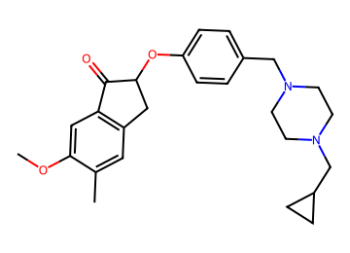  COc1cc2c(cc1C)CC(Oc1ccc(CN3CCN(CC4CC4)CC3)cc1)C2=O | AChE 0.84; BBB 0.88 / 0.84 / 0.86  logBB 0.49; CNS MPO 4.3; SA 2.9  MW 421; TPSA 42; cLogP 3.7; HBD 0  P-gp 0.69; Kp,uu 0.26  hERG 0.86 (parent 0.87); Ames 0.65; DILI 0.50  edits 2; nearest potent active sim 0.71  GNN activity p 0.94 | 11.9 %  (BBB audit) | Vina -10.9  coverage 0.93 | 5 steps (longest sequence), score 0.963  Start from:  Fc1ccc(CN2CCN(CC3CC3)CC2)cc1  COC(Cl)Cl  COc1ccc(CC(=O)C(=O)O)cc1  Parent: not listed (route does not use it)  Stereo: racemate (alpha to C=O)  Reactions (computed, 5 in total):  1. COc1cc2c(cc1C)CC(Oc1ccc(CN3CCN(CC4CC4)CC3)cc1)C2=O>>COc1cc2c(cc1C=O)CC(Oc1ccc(CN3CCN(CC4CC4)CC3)cc1)C2=O  2. COc1cc2c(cc1C=O)CC(Oc1ccc(CN3CCN(CC4CC4)CC3)cc1)C2=O>>COc1cc2c(cc1C=O)CC(O)C2=O.Fc1ccc(CN2CCN(CC3CC3)CC2)cc1  3. COc1cc2c(cc1C=O)CC(O)C2=O>>COc1ccc2c(c1)C(=O)C(O)C2.COC(Cl)Cl  4. COc1ccc2c(c1)C(=O)C(O)C2>>COc1ccc(CC(O)C(=O)O)cc1  5. COc1ccc(CC(O)C(=O)O)cc1>>COc1ccc(CC(=O)C(=O)O)cc1 | hERG predicted high: measure
AD048  priority tier | 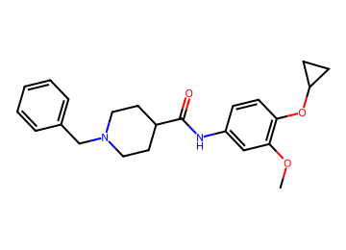  COc1cc(NC(=O)C2CCN(Cc3ccccc3)CC2)ccc1OC1CC1 | AChE 0.84; BBB 0.84 / 0.87 / 0.77  logBB -0.05; CNS MPO 4.1; SA 1.9  MW 380; TPSA 51; cLogP 4.1; HBD 1  P-gp 0.68; Kp,uu 0.28  hERG 0.91 (parent 0.92); Ames 0.50; DILI 0.43  edits 1; nearest potent active sim 0.86  GNN activity p 0.80 | 11.9 %  (BBB in-loop) | Vina -10.8  coverage 0.89 | 2 steps (longest sequence), score 0.994  Start from:  O=C(O)C1CCN(Cc2ccccc2)CC1  COc1cc(N)ccc1F  OC1CC1  Parent: listed by suppliers  Stereo: defined  Reactions (computed, 2 in total):  1. COc1cc(NC(=O)C2CCN(Cc3ccccc3)CC2)ccc1OC1CC1>>O=C(O)C1CCN(Cc2ccccc2)CC1.COc1cc(N)ccc1OC1CC1  2. COc1cc(N)ccc1OC1CC1>>COc1cc(N)ccc1F.OC1CC1 | hERG predicted high: measure
AD049  priority tier | 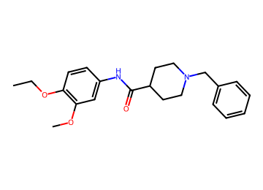  CCOc1ccc(NC(=O)C2CCN(Cc3ccccc3)CC2)cc1OC | AChE 0.82; BBB 0.83 / 0.84 / 0.75  logBB -0.08; CNS MPO 4.3; SA 1.7  MW 368; TPSA 51; cLogP 3.9; HBD 1  P-gp 0.66; Kp,uu 0.30  hERG 0.90 (parent 0.92); Ames 0.43; DILI 0.45  edits 2; nearest potent active sim 0.86  GNN activity p 0.76 | 11.3 %  (BBB in-loop) | Vina -10.8  coverage 1.00 | 1 step (longest sequence), score 0.998  Start from:  O=C(O)C1CCN(Cc2ccccc2)CC1  CCOc1ccc(N)cc1OC  Parent: listed by suppliers  Stereo: defined  Reactions (computed, 1 in total):  1. CCOc1ccc(NC(=O)C2CCN(Cc3ccccc3)CC2)cc1OC>>O=C(O)C1CCN(Cc2ccccc2)CC1.CCOc1ccc(N)cc1OC | hERG predicted high: measure
AD050  priority tier | 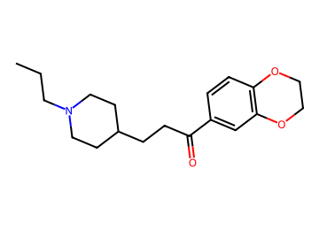  CCCN1CCC(CCC(=O)c2ccc3c(c2)OCCO3)CC1 | AChE 0.78; BBB 0.87 / 0.90 / 0.82  logBB 0.33; CNS MPO 4.9; SA 2.1  MW 317; TPSA 39; cLogP 3.5; HBD 0  P-gp 0.33; Kp,uu 0.57  hERG 0.79 (parent 0.86); Ames 0.31; DILI 0.37  edits 2; nearest potent active sim 0.49  GNN activity p 0.82 | 11.3 %  (AChE primary) | Vina -9.9  coverage 0.68 | 1 step (longest sequence), score 0.998  Start from:  CCCN1CCC(CCC(=O)O)CC1  c1ccc2c(c1)OCCO2  Parent: not listed (route does not use it)  Stereo: defined  Reactions (computed, 1 in total):  1. CCCN1CCC(CCC(=O)c2ccc3c(c2)OCCO3)CC1>>CCCN1CCC(CCC(=O)O)CC1.c1ccc2c(c1)OCCO2 | hERG predicted high: measure
AD051  priority tier | 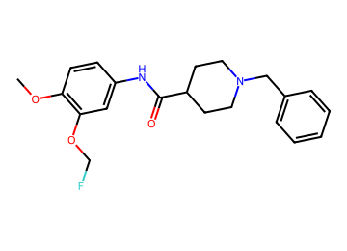  COc1ccc(NC(=O)C2CCN(Cc3ccccc3)CC2)cc1OCF | AChE 0.85; BBB 0.83 / 0.84 / 0.76  logBB -0.05; CNS MPO 4.4; SA 2.0  MW 372; TPSA 51; cLogP 3.9; HBD 1  P-gp 0.59; Kp,uu 0.36  hERG 0.89 (parent 0.92); Ames 0.49; DILI 0.49  edits 2; nearest potent active sim 0.85  GNN activity p 0.79 | 11.2 %  (BBB in-loop) | Vina -10.2  coverage 0.61 | 3 steps (longest sequence), score 0.987  Start from:  O=C(O)C1CCN(Cc2ccccc2)CC1  COc1ccc(NC(C)=O)cc1O  Cc1ccc(S(=O)(=O)OCF)cc1  Parent: listed by suppliers  Stereo: defined  Reactions (computed, 3 in total):  1. COc1ccc(NC(=O)C2CCN(Cc3ccccc3)CC2)cc1OCF>>O=C(O)C1CCN(Cc2ccccc2)CC1.COc1ccc(N)cc1OCF  2. COc1ccc(N)cc1OCF>>COc1ccc(NC(C)=O)cc1OCF  3. COc1ccc(NC(C)=O)cc1OCF>>COc1ccc(NC(C)=O)cc1O.Cc1ccc(S(=O)(=O)OCF)cc1 | hERG predicted high: measure
AD052  priority tier | 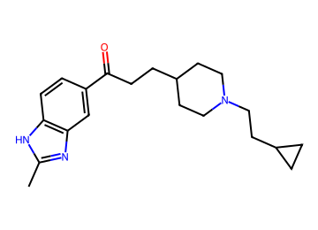  Cc1nc2cc(C(=O)CCC3CCN(CCC4CC4)CC3)ccc2[nH]1 | AChE 0.90; BBB 0.89 / 0.90 / 0.84  logBB 0.42; CNS MPO 4.2; SA 2.4  MW 339; TPSA 49; cLogP 4.3; HBD 1  P-gp 0.47; Kp,uu 0.47  hERG 0.83 (parent 0.88); Ames 0.52; DILI 0.51  edits 2; nearest potent active sim 0.75  GNN activity p 0.94 | 11.1 %  (logBB domain) | Vina -10.8  coverage 0.68 | 1 step (longest sequence), score 0.998  Start from:  O=C(O)CCC1CCN(CCC2CC2)CC1  Cc1nc2ccccc2[nH]1  Parent: not listed (route does not use it)  Stereo: defined  Reactions (computed, 1 in total):  1. Cc1nc2cc(C(=O)CCC3CCN(CCC4CC4)CC3)ccc2[nH]1>>O=C(O)CCC1CCN(CCC2CC2)CC1.Cc1nc2ccccc2[nH]1 | hERG predicted high: measure  BChE p 0.51
AD053  priority tier | 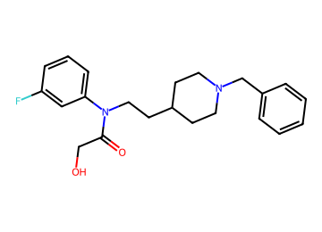  O=C(CO)N(CCC1CCN(Cc2ccccc2)CC1)c1cccc(F)c1 | AChE 0.90; BBB 0.86 / 0.94 / 0.82  logBB 0.12; CNS MPO 4.8; SA 2.2  MW 370; TPSA 44; cLogP 3.5; HBD 1  P-gp 0.56; Kp,uu 0.37  hERG 0.92 (parent 0.92); Ames 0.48; DILI 0.35  edits 2; nearest potent active sim 0.79  GNN activity p 0.82 | 11.1 %  (logBB domain) | Vina -11.3  coverage 0.93 | 2 steps (longest sequence), score 0.994  Start from:  NCCC1CCN(Cc2ccccc2)CC1  Fc1cccc(Br)c1  ClC(Cl)Cl  O=C(O)CO  Parent: not listed (route does not use it)  Stereo: defined  Reactions (computed, 3 in total):  1. O=C(CO)N(CCC1CCN(Cc2ccccc2)CC1)c1cccc(F)c1>>Fc1cccc(NCCC2CCN(Cc3ccccc3)CC2)c1.O=C(Cl)CO  2. Fc1cccc(NCCC2CCN(Cc3ccccc3)CC2)c1>>NCCC1CCN(Cc2ccccc2)CC1.Fc1cccc(Br)c1  3. O=C(Cl)CO>>ClC(Cl)Cl.O=C(O)CO | hERG predicted high: measure  BChE p 0.68
AD054  priority tier  shortlist #17 | 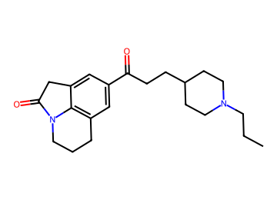  CCCN1CCC(CCC(=O)c2cc3c4c(c2)CC(=O)N4CCC3)CC1 | AChE 0.88; BBB 0.89 / 0.94 / 0.88  logBB 0.31; CNS MPO 4.9; SA 2.6  MW 354; TPSA 41; cLogP 3.6; HBD 0  P-gp 0.45; Kp,uu 0.46  hERG 0.76 (parent 0.84); Ames 0.31; DILI 0.31  edits 2; nearest potent active sim 0.48  GNN activity p 0.99 | 11.1 %  (logBB domain) | Vina -11.1  coverage 1.00 | 1 step (longest sequence), score 0.998  Start from:  CCCN1CCC(CCC(=O)O)CC1  O=C1Cc2cccc3c2N1CCC3  Parent: not listed (route does not use it)  Stereo: defined  Reactions (computed, 1 in total):  1. CCCN1CCC(CCC(=O)c2cc3c4c(c2)CC(=O)N4CCC3)CC1>>CCCN1CCC(CCC(=O)O)CC1.O=C1Cc2cccc3c2N1CCC3 | hERG predicted high: measure
AD055  priority tier | 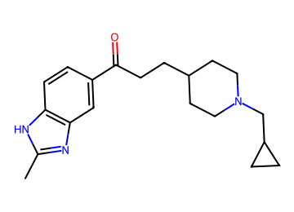  Cc1nc2cc(C(=O)CCC3CCN(CC4CC4)CC3)ccc2[nH]1 | AChE 0.85; BBB 0.86 / 0.91 / 0.80  logBB 0.36; CNS MPO 4.4; SA 2.4  MW 325; TPSA 49; cLogP 4.0; HBD 1  P-gp 0.31; Kp,uu 0.60  hERG 0.83 (parent 0.88); Ames 0.53; DILI 0.54  edits 2; nearest potent active sim 0.75  GNN activity p 0.88 | 11.1 %  (logBB domain) | Vina -10.5  coverage 0.79 | 1 step (longest sequence), score 0.998  Start from:  O=C(O)CCC1CCN(CC2CC2)CC1  Cc1nc2ccccc2[nH]1  Parent: not listed (route does not use it)  Stereo: defined  Reactions (computed, 1 in total):  1. Cc1nc2cc(C(=O)CCC3CCN(CC4CC4)CC3)ccc2[nH]1>>O=C(O)CCC1CCN(CC2CC2)CC1.Cc1nc2ccccc2[nH]1 | hERG predicted high: measure
AD056  priority tier | 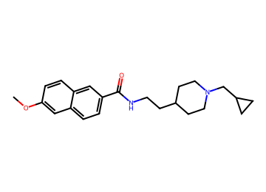  COc1ccc2cc(C(=O)NCCC3CCN(CC4CC4)CC3)ccc2c1 | AChE 0.81; BBB 0.83 / 0.92 / 0.78  logBB 0.45; CNS MPO 4.2; SA 2.1  MW 367; TPSA 42; cLogP 4.1; HBD 1  P-gp 0.58; Kp,uu 0.38  hERG 0.85 (parent 0.89); Ames 0.52; DILI 0.49  edits 2; nearest potent active sim 0.48  GNN activity p 0.95 | 11.0 %  (BBB in-loop) | Vina -11.0  coverage 1.00 | 1 step (longest sequence), score 0.998  Start from:  COc1ccc2cc(C(=O)O)ccc2c1  NCCC1CCN(CC2CC2)CC1  Parent: listed by suppliers  Stereo: defined  Reactions (computed, 1 in total):  1. COc1ccc2cc(C(=O)NCCC3CCN(CC4CC4)CC3)ccc2c1>>COc1ccc2cc(C(=O)O)ccc2c1.NCCC1CCN(CC2CC2)CC1 | hERG predicted high: measure  BChE p 0.69
AD057  priority tier | 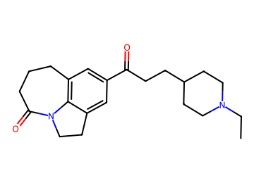  CCN1CCC(CCC(=O)c2cc3c4c(c2)CCN4C(=O)CCC3)CC1 | AChE 0.85; BBB 0.89 / 0.93 / 0.88  logBB 0.31; CNS MPO 4.9; SA 2.5  MW 354; TPSA 41; cLogP 3.6; HBD 0  P-gp 0.43; Kp,uu 0.49  hERG 0.76 (parent 0.85); Ames 0.33; DILI 0.29  edits 1; nearest potent active sim 0.46  GNN activity p 0.99 | 11.0 %  (AChE domain) | Vina -9.1  coverage 1.00 | 2 steps (longest sequence), score 0.994  Start from:  CCN1CCC(CCC(=O)O)CC1  O=C1CN2C(=O)CCCc3cccc1c32  Parent: not listed (route does not use it)  Stereo: defined  Reactions (computed, 2 in total):  1. CCN1CCC(CCC(=O)c2cc3c4c(c2)CCN4C(=O)CCC3)CC1>>CCN1CCC(CCC(=O)O)CC1.O=C1CCCc2cccc3c2N1CC3  2. O=C1CCCc2cccc3c2N1CC3>>O=C1CN2C(=O)CCCc3cccc1c32 | hERG predicted high: measure
AD058  priority tier | 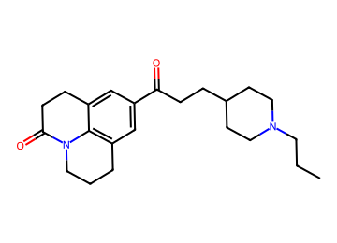  CCCN1CCC(CCC(=O)c2cc3c4c(c2)CCC(=O)N4CCC3)CC1 | AChE 0.89; BBB 0.89 / 0.94 / 0.89  logBB 0.33; CNS MPO 4.4; SA 2.5  MW 369; TPSA 41; cLogP 4.0; HBD 0  P-gp 0.52; Kp,uu 0.40  hERG 0.77 (parent 0.85); Ames 0.30; DILI 0.30  edits 2; nearest potent active sim 0.48  GNN activity p 0.99 | 10.9 %  (logBB domain) | Vina -11.3  coverage 0.93 | 1 step (longest sequence), score 0.998  Start from:  CCCN1CCC(CCC(=O)O)CC1  O=C1CCc2cccc3c2N1CCC3  Parent: not listed (route does not use it)  Stereo: defined  Reactions (computed, 1 in total):  1. CCCN1CCC(CCC(=O)c2cc3c4c(c2)CCC(=O)N4CCC3)CC1>>CCCN1CCC(CCC(=O)O)CC1.O=C1CCc2cccc3c2N1CCC3 | hERG predicted high: measure  BChE p 0.53
AD059  priority tier | 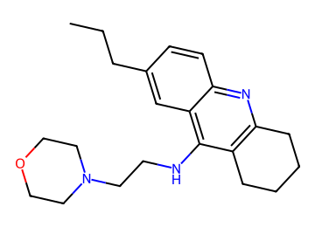  CCCc1ccc2nc3c(c(NCCN4CCOCC4)c2c1)CCCC3 | AChE 0.84; BBB 0.89 / 0.88 / 0.86  logBB 0.31; CNS MPO 4.4; SA 2.4  MW 354; TPSA 37; cLogP 3.8; HBD 1  P-gp 0.50; Kp,uu 0.42  hERG 0.80 (parent 0.77); Ames 0.56; DILI 0.46  edits 2; nearest potent active sim 0.77  GNN activity p 0.82 | 10.9 %  (logBB domain) | Vina -9.9  coverage 0.75 | 2 steps (longest sequence), score 0.994  Start from:  O=CCN1CCOCC1  O=C1CCCCC1  CCCc1ccc(N)c(C#N)c1  Parent: not listed (route does not use it)  Stereo: defined  Reactions (computed, 2 in total):  1. CCCc1ccc2nc3c(c(NCCN4CCOCC4)c2c1)CCCC3>>CCCc1ccc2nc3c(c(N)c2c1)CCCC3.O=CCN1CCOCC1  2. CCCc1ccc2nc3c(c(N)c2c1)CCCC3>>O=C1CCCCC1.CCCc1ccc(N)c(C#N)c1 | hERG predicted high: measure  BChE p 0.84
AD060  priority tier | 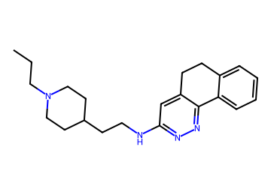  CCCN1CCC(CCNc2cc3c(nn2)-c2ccccc2CC3)CC1 | AChE 0.79; BBB 0.90 / 0.92 / 0.89  logBB 0.54; CNS MPO 4.3; SA 2.5  MW 351; TPSA 41; cLogP 4.2; HBD 1  P-gp 0.60; Kp,uu 0.35  hERG 0.91 (parent 0.91); Ames 0.53; DILI 0.37  edits 2; nearest potent active sim 0.69  GNN activity p 0.94 | 10.9 %  (logBB domain) | Vina -11.5  coverage 0.96 | 1 step (longest sequence), score 0.998  Start from:  CCCN1CCC(CCN)CC1  Clc1cc2c(nn1)-c1ccccc1CC2  Parent: not listed (route does not use it)  Stereo: defined  Reactions (computed, 1 in total):  1. CCCN1CCC(CCNc2cc3c(nn2)-c2ccccc2CC3)CC1>>CCCN1CCC(CCN)CC1.Clc1cc2c(nn1)-c1ccccc1CC2 | hERG predicted high: measure  BChE p 0.69
AD061  priority tier | 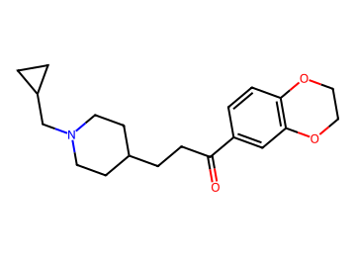  O=C(CCC1CCN(CC2CC2)CC1)c1ccc2c(c1)OCCO2 | AChE 0.85; BBB 0.83 / 0.93 / 0.80  logBB 0.34; CNS MPO 4.9; SA 2.2  MW 329; TPSA 39; cLogP 3.5; HBD 0  P-gp 0.32; Kp,uu 0.57  hERG 0.77 (parent 0.86); Ames 0.38; DILI 0.41  edits 2; nearest potent active sim 0.56  GNN activity p 0.87 | 10.8 %  (BBB in-loop) | Vina -10.2  coverage 0.82 | 1 step (longest sequence), score 0.998  Start from:  O=C(O)CCC1CCN(CC2CC2)CC1  c1ccc2c(c1)OCCO2  Parent: not listed (route does not use it)  Stereo: defined  Reactions (computed, 1 in total):  1. O=C(CCC1CCN(CC2CC2)CC1)c1ccc2c(c1)OCCO2>>O=C(O)CCC1CCN(CC2CC2)CC1.c1ccc2c(c1)OCCO2 | hERG predicted high: measure
AD062  priority tier  shortlist #19 | 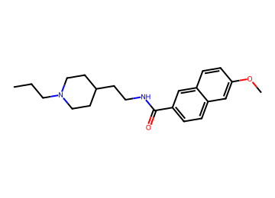  CCCN1CCC(CCNC(=O)c2ccc3cc(OC)ccc3c2)CC1 | AChE 0.77; BBB 0.85 / 0.87 / 0.79  logBB 0.45; CNS MPO 4.3; SA 2.0  MW 354; TPSA 42; cLogP 4.1; HBD 1  P-gp 0.61; Kp,uu 0.35  hERG 0.86 (parent 0.89); Ames 0.45; DILI 0.46  edits 2; nearest potent active sim 0.47  GNN activity p 0.96 | 10.7 %  (AChE primary) | Vina -10.7  coverage 0.96 | 1 step (longest sequence), score 0.998  Start from:  COc1ccc2cc(C(=O)O)ccc2c1  CCCN1CCC(CCN)CC1  Parent: listed by suppliers  Stereo: defined  Reactions (computed, 1 in total):  1. CCCN1CCC(CCNC(=O)c2ccc3cc(OC)ccc3c2)CC1>>COc1ccc2cc(C(=O)O)ccc2c1.CCCN1CCC(CCN)CC1 | hERG predicted high: measure  BChE p 0.66
AD063  priority tier | 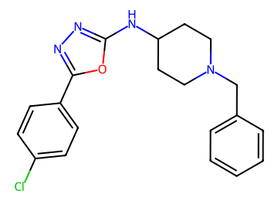  Clc1ccc(-c2nnc(NC3CCN(Cc4ccccc4)CC3)o2)cc1 | AChE 0.77; BBB 0.84 / 0.95 / 0.75  logBB 0.29; CNS MPO 4.0; SA 2.1  MW 369; TPSA 54; cLogP 4.5; HBD 1  P-gp 0.65; Kp,uu 0.29  hERG 0.90 (parent 0.90); Ames 0.46; DILI 0.56  edits 1; nearest potent active sim 0.50  GNN activity p 0.82 | 10.2 %  (logBB domain) | Vina -11.2  coverage 1.00 | 1 step (longest sequence), score 0.998  Start from:  S=C=NC1CCN(Cc2ccccc2)CC1  NNC(=O)c1ccc(Cl)cc1  Parent: not listed (route does not use it)  Stereo: defined  Reactions (computed, 1 in total):  1. Clc1ccc(-c2nnc(NC3CCN(Cc4ccccc4)CC3)o2)cc1>>S=C=NC1CCN(Cc2ccccc2)CC1.NNC(=O)c1ccc(Cl)cc1 | hERG predicted high: measure  BChE p 0.56
AD064  tier 2 | 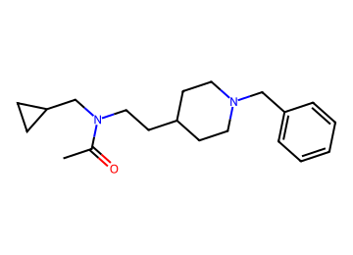  CC(=O)N(CCC1CCN(Cc2ccccc2)CC1)CC1CC1 | AChE 0.77; BBB 0.87 / 0.94 / 0.86  logBB 0.65; CNS MPO 4.1; SA 2.1  MW 314; TPSA 24; cLogP 3.5; HBD 0  P-gp 0.24; Kp,uu 0.65  hERG 0.83 (parent 0.91); Ames 0.41; DILI 0.23  edits 2; nearest potent active sim 0.69  GNN activity p 0.73 | 10.0 %  (AChE primary) | Vina -9.2  coverage 0.93 | 2 steps (longest sequence), score 0.994  Start from:  CC(=O)O  BrCC1CC1  NCCC1CCN(Cc2ccccc2)CC1  Parent: not listed (route does not use it)  Stereo: defined  Reactions (computed, 2 in total):  1. CC(=O)N(CCC1CCN(Cc2ccccc2)CC1)CC1CC1>>CC(=O)O.c1ccc(CN2CCC(CCNCC3CC3)CC2)cc1  2. c1ccc(CN2CCC(CCNCC3CC3)CC2)cc1>>BrCC1CC1.NCCC1CCN(Cc2ccccc2)CC1 | hERG predicted high: measure  BChE p 0.55
AD065  tier 2 | 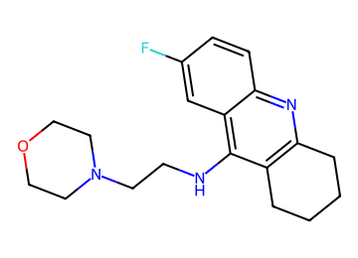  Fc1ccc2nc3c(c(NCCN4CCOCC4)c2c1)CCCC3 | AChE 0.82; BBB 0.89 / 0.92 / 0.88  logBB 0.41; CNS MPO 5.2; SA 2.3  MW 329; TPSA 37; cLogP 3.0; HBD 1  P-gp 0.27; Kp,uu 0.64  hERG 0.82 (parent 0.77); Ames 0.64; DILI 0.49  edits 2; nearest potent active sim 0.78  GNN activity p 0.88 | 9.9 %  (logBB domain) | Vina -9.7  coverage 0.61 | 2 steps (longest sequence), score 0.994  Start from:  ClCCN1CCOCC1  O=C1CCCCC1  N#Cc1cc(F)ccc1N  Parent: not listed (route does not use it)  Stereo: defined  Reactions (computed, 2 in total):  1. Fc1ccc2nc3c(c(NCCN4CCOCC4)c2c1)CCCC3>>ClCCN1CCOCC1.Nc1c2c(nc3ccc(F)cc13)CCCC2  2. Nc1c2c(nc3ccc(F)cc13)CCCC2>>O=C1CCCCC1.N#Cc1cc(F)ccc1N | hERG predicted high: measure  BChE p 0.77
AD066  tier 2 | 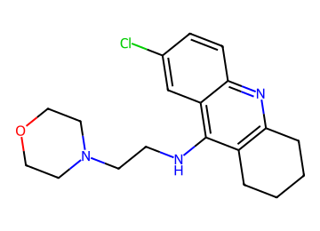  Clc1ccc2nc3c(c(NCCN4CCOCC4)c2c1)CCCC3 | AChE 0.87; BBB 0.91 / 0.92 / 0.88  logBB 0.34; CNS MPO 4.7; SA 2.3  MW 346; TPSA 37; cLogP 3.5; HBD 1  P-gp 0.34; Kp,uu 0.57  hERG 0.79 (parent 0.77); Ames 0.64; DILI 0.50  edits 1; nearest potent active sim 0.78  GNN activity p 0.87 | 9.9 %  (logBB domain) | Vina -9.4  coverage 0.61 | 1 step (longest sequence), score 0.998  Start from:  ClCCN1CCOCC1  Nc1c2c(nc3ccc(Cl)cc13)CCCC2  Parent: not listed (route does not use it)  Stereo: defined  Reactions (computed, 1 in total):  1. Clc1ccc2nc3c(c(NCCN4CCOCC4)c2c1)CCCC3>>ClCCN1CCOCC1.Nc1c2c(nc3ccc(Cl)cc13)CCCC2 | hERG predicted high: measure  BChE p 0.80
AD067  tier 2 | 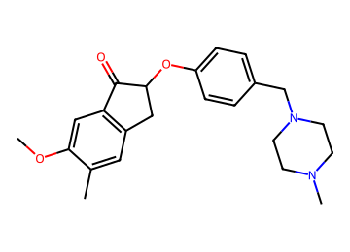  COc1cc2c(cc1C)CC(Oc1ccc(CN3CCN(C)CC3)cc1)C2=O | AChE 0.86; BBB 0.89 / 0.82 / 0.88  logBB 0.47; CNS MPO 5.4; SA 2.8  MW 380; TPSA 42; cLogP 2.9; HBD 0  P-gp 0.61; Kp,uu 0.34  hERG 0.86 (parent 0.87); Ames 0.66; DILI 0.53  edits 1; nearest potent active sim 0.86  GNN activity p 0.94 | 9.8 %  (BBB audit) | Vina -11.8  coverage 1.00 | 5 steps (longest sequence), score 0.963  Start from:  CN1CCN(Cc2ccc(F)cc2)CC1  CB1OB(C)OB(C)O1  O=C1CCC(=O)N1Br  COc1ccc(CC(=O)C(=O)O)cc1  Parent: not listed (route does not use it)  Stereo: racemate (alpha to C=O)  Reactions (computed, 5 in total):  1. COc1cc2c(cc1C)CC(Oc1ccc(CN3CCN(C)CC3)cc1)C2=O>>COc1cc2c(cc1C)CC(O)C2=O.CN1CCN(Cc2ccc(F)cc2)CC1  2. COc1cc2c(cc1C)CC(O)C2=O>>COc1cc2c(cc1Br)CC(O)C2=O.CB1OB(C)OB(C)O1  3. COc1cc2c(cc1Br)CC(O)C2=O>>O=C1CCC(=O)N1Br.COc1ccc2c(c1)C(=O)C(O)C2  4. COc1ccc2c(c1)C(=O)C(O)C2>>COc1ccc(CC(O)C(=O)O)cc1  5. COc1ccc(CC(O)C(=O)O)cc1>>COc1ccc(CC(=O)C(=O)O)cc1 | hERG predicted high: measure
AD068  tier 2 | 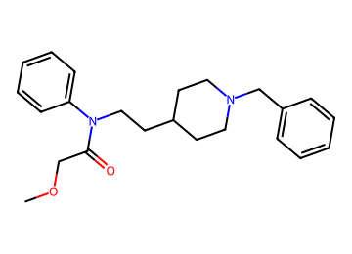  COCC(=O)N(CCC1CCN(Cc2ccccc2)CC1)c1ccccc1 | AChE 0.92; BBB 0.82 / 0.88 / 0.81  logBB 0.51; CNS MPO 4.1; SA 2.1  MW 367; TPSA 33; cLogP 4.0; HBD 0  P-gp 0.63; Kp,uu 0.33  hERG 0.93 (parent 0.91); Ames 0.46; DILI 0.34  edits 2; nearest potent active sim 0.73  GNN activity p 0.89 | 9.7 %  (BBB in-loop) | Vina -10.8  coverage 0.96 | 2 steps (longest sequence), score 0.994  Start from:  COCC(=O)Cl  OCCC1CCN(Cc2ccccc2)CC1  Nc1ccccc1  Parent: not listed (route does not use it)  Stereo: defined  Reactions (computed, 2 in total):  1. COCC(=O)N(CCC1CCN(Cc2ccccc2)CC1)c1ccccc1>>COCC(=O)Cl.c1ccc(CN2CCC(CCNc3ccccc3)CC2)cc1  2. c1ccc(CN2CCC(CCNc3ccccc3)CC2)cc1>>OCCC1CCN(Cc2ccccc2)CC1.Nc1ccccc1 | hERG predicted high: measure  BChE p 0.59
AD069  tier 2 | 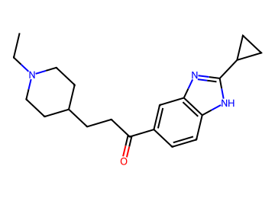  CCN1CCC(CCC(=O)c2ccc3[nH]c(C4CC4)nc3c2)CC1 | AChE 0.80; BBB 0.86 / 0.92 / 0.83  logBB 0.34; CNS MPO 4.3; SA 2.3  MW 325; TPSA 49; cLogP 4.1; HBD 1  P-gp 0.36; Kp,uu 0.54  hERG 0.84 (parent 0.88); Ames 0.48; DILI 0.51  edits 2; nearest potent active sim 0.60  GNN activity p 0.85 | 9.6 %  (logBB domain) | Vina -10.0  coverage 0.71 | 2 steps (longest sequence), score 0.994  Start from:  O=C(O)C1CC1  CCN1CCC(CCC(=O)O)CC1  Nc1ccccc1N  Parent: not listed (route does not use it)  Stereo: defined  Reactions (computed, 2 in total):  1. CCN1CCC(CCC(=O)c2ccc3[nH]c(C4CC4)nc3c2)CC1>>O=C(O)C1CC1.CCN1CCC(CCC(=O)c2ccc(N)c(N)c2)CC1  2. CCN1CCC(CCC(=O)c2ccc(N)c(N)c2)CC1>>CCN1CCC(CCC(=O)O)CC1.Nc1ccccc1N | hERG predicted high: measure
AD070  tier 2 | 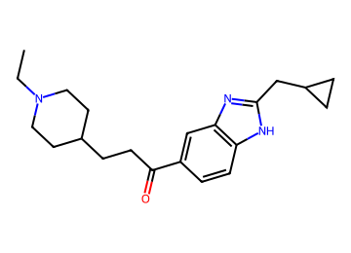  CCN1CCC(CCC(=O)c2ccc3[nH]c(CC4CC4)nc3c2)CC1 | AChE 0.83; BBB 0.82 / 0.91 / 0.79  logBB 0.36; CNS MPO 4.2; SA 2.4  MW 339; TPSA 49; cLogP 4.2; HBD 1  P-gp 0.45; Kp,uu 0.47  hERG 0.85 (parent 0.88); Ames 0.46; DILI 0.50  edits 2; nearest potent active sim 0.60  GNN activity p 0.88 | 9.6 %  (logBB domain) | Vina -10.2  coverage 0.86 | 2 steps (longest sequence), score 0.994  Start from:  CCN1CCC(CCC(=O)O)CC1  CNOC  O=C(O)CC1CC1  Nc1ccc(Br)cc1N  Parent: not listed (route does not use it)  Stereo: defined  Reactions (computed, 3 in total):  1. CCN1CCC(CCC(=O)c2ccc3[nH]c(CC4CC4)nc3c2)CC1>>CCN1CCC(CCC(=O)N(C)OC)CC1.Brc1ccc2[nH]c(CC3CC3)nc2c1  2. CCN1CCC(CCC(=O)N(C)OC)CC1>>CCN1CCC(CCC(=O)O)CC1.CNOC  3. Brc1ccc2[nH]c(CC3CC3)nc2c1>>O=C(O)CC1CC1.Nc1ccc(Br)cc1N | hERG predicted high: measure  BChE p 0.50
AD071  tier 2 | 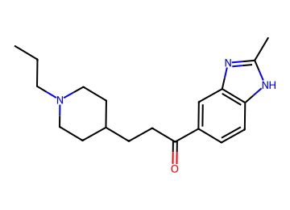  CCCN1CCC(CCC(=O)c2ccc3[nH]c(C)nc3c2)CC1 | AChE 0.78; BBB 0.89 / 0.89 / 0.86  logBB 0.33; CNS MPO 4.4; SA 2.3  MW 313; TPSA 49; cLogP 4.0; HBD 1  P-gp 0.28; Kp,uu 0.63  hERG 0.83 (parent 0.88); Ames 0.49; DILI 0.51  edits 2; nearest potent active sim 0.74  GNN activity p 0.86 | 9.6 %  (logBB domain) | Vina -10.1  coverage 0.96 | 1 step (longest sequence), score 0.998  Start from:  CCCN1CCC(CCC(=O)O)CC1  Cc1nc2ccccc2[nH]1  Parent: not listed (route does not use it)  Stereo: defined  Reactions (computed, 1 in total):  1. CCCN1CCC(CCC(=O)c2ccc3[nH]c(C)nc3c2)CC1>>CCCN1CCC(CCC(=O)O)CC1.Cc1nc2ccccc2[nH]1 | hERG predicted high: measure
AD072  tier 2 | 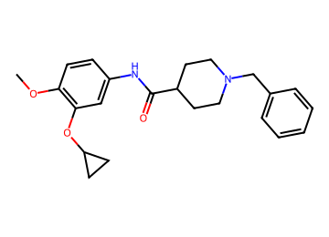  COc1ccc(NC(=O)C2CCN(Cc3ccccc3)CC2)cc1OC1CC1 | AChE 0.84; BBB 0.82 / 0.85 / 0.76  logBB -0.06; CNS MPO 4.1; SA 1.9  MW 380; TPSA 51; cLogP 4.1; HBD 1  P-gp 0.67; Kp,uu 0.30  hERG 0.90 (parent 0.92); Ames 0.52; DILI 0.45  edits 1; nearest potent active sim 0.86  GNN activity p 0.80 | 9.6 %  (BBB in-loop) | Vina -10.8  coverage 1.00 | 2 steps (longest sequence), score 0.994  Start from:  COc1ccc(N)cc1O  BrC1CC1  O=C(O)C1CCN(Cc2ccccc2)CC1  O=S(Cl)Cl  Parent: listed by suppliers  Stereo: defined  Reactions (computed, 3 in total):  1. COc1ccc(NC(=O)C2CCN(Cc3ccccc3)CC2)cc1OC1CC1>>O=C(Cl)C1CCN(Cc2ccccc2)CC1.COc1ccc(N)cc1OC1CC1  2. COc1ccc(N)cc1OC1CC1>>COc1ccc(N)cc1O.BrC1CC1  3. O=C(Cl)C1CCN(Cc2ccccc2)CC1>>O=C(O)C1CCN(Cc2ccccc2)CC1.O=S(Cl)Cl | hERG predicted high: measure
AD073  tier 2 | 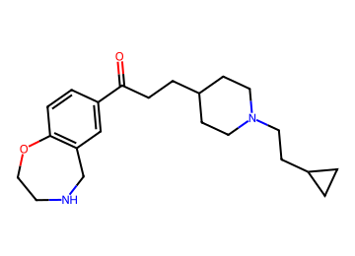  O=C(CCC1CCN(CCC2CC2)CC1)c1ccc2c(c1)CNCCO2 | AChE 0.85; BBB 0.89 / 0.92 / 0.83  logBB 0.42; CNS MPO 4.7; SA 2.5  MW 357; TPSA 42; cLogP 3.6; HBD 1  P-gp 0.49; Kp,uu 0.42  hERG 0.78 (parent 0.86); Ames 0.38; DILI 0.34  edits 2; nearest potent active sim 0.46  GNN activity p 0.95 | 9.3 %  (AChE domain) | Vina -8.5  coverage 0.96 | 1 step (longest sequence), score 0.998  Start from:  O=C(O)CCC1CCN(CCC2CC2)CC1  c1ccc2c(c1)CNCCO2  Parent: not listed (route does not use it)  Stereo: defined  Reactions (computed, 1 in total):  1. O=C(CCC1CCN(CCC2CC2)CC1)c1ccc2c(c1)CNCCO2>>O=C(O)CCC1CCN(CCC2CC2)CC1.c1ccc2c(c1)CNCCO2 | hERG predicted high: measure
AD074  tier 2 | 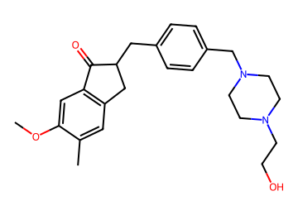  COc1cc2c(cc1C)CC(Cc1ccc(CN3CCN(CCO)CC3)cc1)C2=O | AChE 0.84; BBB 0.86 / 0.82 / 0.82  logBB 0.42; CNS MPO 5.1; SA 2.8  MW 409; TPSA 53; cLogP 2.7; HBD 1  P-gp 0.70; Kp,uu 0.27  hERG 0.86 (parent 0.83); Ames 0.58; DILI 0.43  edits 2; nearest potent active sim 0.55  GNN activity p 0.79 | 9.3 %  (BBB audit) | Vina -11.5  coverage 0.86 | 4 steps (longest sequence), score 0.975  Start from:  OCCN1CCNCC1  O=Cc1ccc(CO)cc1  COc1ccc(CCC(=O)O)cc1C  Parent: not listed (route does not use it)  Stereo: racemate (alpha to C=O)  Reactions (computed, 4 in total):  1. COc1cc2c(cc1C)CC(Cc1ccc(CN3CCN(CCO)CC3)cc1)C2=O>>COc1cc2c(cc1C)CC(Cc1ccc(CO)cc1)C2=O.OCCN1CCNCC1  2. COc1cc2c(cc1C)CC(Cc1ccc(CO)cc1)C2=O>>COc1cc2c(cc1C)C/C(=C\c1ccc(CO)cc1)C2=O  3. COc1cc2c(cc1C)C/C(=C\c1ccc(CO)cc1)C2=O>>COc1cc2c(cc1C)CCC2=O.O=Cc1ccc(CO)cc1  4. COc1cc2c(cc1C)CCC2=O>>COc1ccc(CCC(=O)O)cc1C | hERG predicted high: measure
AD075  tier 2 | 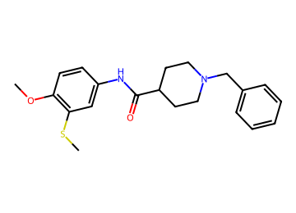  COc1ccc(NC(=O)C2CCN(Cc3ccccc3)CC2)cc1SC | AChE 0.85; BBB 0.82 / 0.84 / 0.77  logBB 0.17; CNS MPO 4.1; SA 1.9  MW 371; TPSA 42; cLogP 4.3; HBD 1  P-gp 0.60; Kp,uu 0.36  hERG 0.90 (parent 0.92); Ames 0.48; DILI 0.47  edits 1; nearest potent active sim 0.79  GNN activity p 0.89 | 9.1 %  (BBB in-loop) | Vina -10.5  coverage 1.00 | 1 step (longest sequence), score 0.998  Start from:  O=C(O)C1CCN(Cc2ccccc2)CC1  COc1ccc(N)cc1SC  Parent: listed by suppliers  Stereo: defined  Reactions (computed, 1 in total):  1. COc1ccc(NC(=O)C2CCN(Cc3ccccc3)CC2)cc1SC>>O=C(O)C1CCN(Cc2ccccc2)CC1.COc1ccc(N)cc1SC | hERG predicted high: measure
AD076  tier 2 | 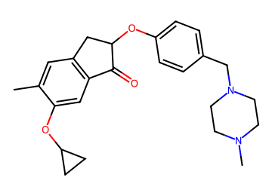  Cc1cc2c(cc1OC1CC1)C(=O)C(Oc1ccc(CN3CCN(C)CC3)cc1)C2 | AChE 0.84; BBB 0.89 / 0.82 / 0.88  logBB 0.30; CNS MPO 4.7; SA 3.0  MW 407; TPSA 42; cLogP 3.5; HBD 0  P-gp 0.64; Kp,uu 0.30  hERG 0.87 (parent 0.87); Ames 0.60; DILI 0.48  edits 2; nearest potent active sim 0.73  GNN activity p 0.93 | 8.9 %  (BBB audit) | Vina -12.3  coverage 1.00 | 6 steps (longest sequence), score 0.956  Start from:  CN1CCN(Cc2ccc(F)cc2)CC1  CB1OB(C)OB(C)O1  O=C1CCC(=O)N1Br  OC1CC1  O=C(O)C(=O)Cc1ccc(F)cc1  Parent: not listed (route does not use it)  Stereo: racemate (alpha to C=O)  Reactions (computed, 6 in total):  1. Cc1cc2c(cc1OC1CC1)C(=O)C(Oc1ccc(CN3CCN(C)CC3)cc1)C2>>Cc1cc2c(cc1OC1CC1)C(=O)C(O)C2.CN1CCN(Cc2ccc(F)cc2)CC1  2. Cc1cc2c(cc1OC1CC1)C(=O)C(O)C2>>CB1OB(C)OB(C)O1.O=C1c2cc(OC3CC3)c(Br)cc2CC1O  3. O=C1c2cc(OC3CC3)c(Br)cc2CC1O>>O=C1CCC(=O)N1Br.O=C1c2cc(OC3CC3)ccc2CC1O  4. O=C1c2cc(OC3CC3)ccc2CC1O>>OC1CC1.O=C1c2cc(F)ccc2CC1O  5. O=C1c2cc(F)ccc2CC1O>>O=C(O)C(O)Cc1ccc(F)cc1  6. O=C(O)C(O)Cc1ccc(F)cc1>>O=C(O)C(=O)Cc1ccc(F)cc1 | hERG predicted high: measure
AD077  tier 2 | 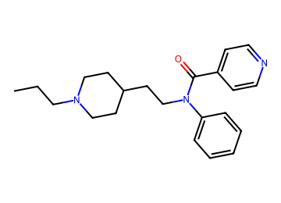  CCCN1CCC(CCN(C(=O)c2ccncc2)c2ccccc2)CC1 | AChE 0.77; BBB 0.91 / 0.93 / 0.90  logBB 0.44; CNS MPO 4.2; SA 2.2  MW 351; TPSA 36; cLogP 4.2; HBD 0  P-gp 0.56; Kp,uu 0.38  hERG 0.91 (parent 0.92); Ames 0.49; DILI 0.40  edits 2; nearest potent active sim 0.63  GNN activity p 0.86 | 8.8 %  (logBB domain) | Vina -9.8  coverage 0.79 | 2 steps (longest sequence), score 0.994  Start from:  O=C(O)c1ccncc1  CCCN1CCC(CCO)CC1  Nc1ccccc1  Parent: not listed (route does not use it)  Stereo: defined  Reactions (computed, 2 in total):  1. CCCN1CCC(CCN(C(=O)c2ccncc2)c2ccccc2)CC1>>O=C(O)c1ccncc1.CCCN1CCC(CCNc2ccccc2)CC1  2. CCCN1CCC(CCNc2ccccc2)CC1>>CCCN1CCC(CCO)CC1.Nc1ccccc1 | hERG predicted high: measure  BChE p 0.63
AD078  tier 2 | 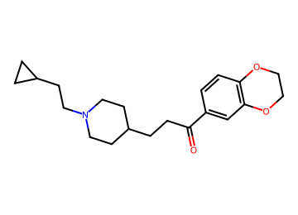  O=C(CCC1CCN(CCC2CC2)CC1)c1ccc2c(c1)OCCO2 | AChE 0.88; BBB 0.86 / 0.93 / 0.82  logBB 0.42; CNS MPO 4.5; SA 2.3  MW 343; TPSA 39; cLogP 3.9; HBD 0  P-gp 0.42; Kp,uu 0.49  hERG 0.77 (parent 0.86); Ames 0.37; DILI 0.38  edits 2; nearest potent active sim 0.45  GNN activity p 0.92 | 8.6 %  (AChE domain) | Vina -10.1  coverage 0.82 | 1 step (longest sequence), score 0.998  Start from:  O=C(O)CCC1CCN(CCC2CC2)CC1  c1ccc2c(c1)OCCO2  Parent: not listed (route does not use it)  Stereo: defined  Reactions (computed, 1 in total):  1. O=C(CCC1CCN(CCC2CC2)CC1)c1ccc2c(c1)OCCO2>>O=C(O)CCC1CCN(CCC2CC2)CC1.c1ccc2c(c1)OCCO2 | hERG predicted high: measure
AD079  tier 2 | 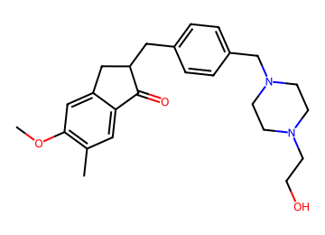  COc1cc2c(cc1C)C(=O)C(Cc1ccc(CN3CCN(CCO)CC3)cc1)C2 | AChE 0.84; BBB 0.86 / 0.81 / 0.82  logBB 0.43; CNS MPO 5.1; SA 2.8  MW 409; TPSA 53; cLogP 2.7; HBD 1  P-gp 0.70; Kp,uu 0.27  hERG 0.86 (parent 0.83); Ames 0.59; DILI 0.43  edits 2; nearest potent active sim 0.55  GNN activity p 0.79 | 8.5 %  (BBB audit) | Vina -11.9  coverage 1.00 | 4 steps (longest sequence), score 0.975  Start from:  OCCN1CCNCC1  O=Cc1ccc(CO)cc1  COc1cc(CCC(=O)O)ccc1C  Parent: not listed (route does not use it)  Stereo: racemate (alpha to C=O)  Reactions (computed, 4 in total):  1. COc1cc2c(cc1C)C(=O)C(Cc1ccc(CN3CCN(CCO)CC3)cc1)C2>>COc1cc2c(cc1C)C(=O)C(Cc1ccc(CO)cc1)C2.OCCN1CCNCC1  2. COc1cc2c(cc1C)C(=O)C(Cc1ccc(CO)cc1)C2>>COc1cc2c(cc1C)C(=O)/C(=C/c1ccc(CO)cc1)C2  3. COc1cc2c(cc1C)C(=O)/C(=C/c1ccc(CO)cc1)C2>>COc1cc2c(cc1C)C(=O)CC2.O=Cc1ccc(CO)cc1  4. COc1cc2c(cc1C)C(=O)CC2>>COc1cc(CCC(=O)O)ccc1C | hERG predicted high: measure
AD080  tier 2 | 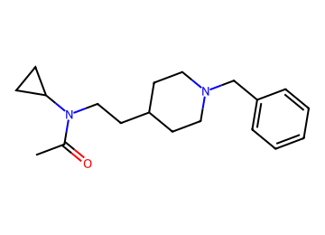  CC(=O)N(CCC1CCN(Cc2ccccc2)CC1)C1CC1 | AChE 0.76; BBB 0.90 / 0.93 / 0.88  logBB 0.65; CNS MPO 4.4; SA 2.1  MW 300; TPSA 24; cLogP 3.3; HBD 0  P-gp 0.20; Kp,uu 0.69  hERG 0.81 (parent 0.91); Ames 0.45; DILI 0.23  edits 2; nearest potent active sim 0.70  GNN activity p 0.76 | 8.4 %  (AChE primary) | Vina -9.9  coverage 0.82 | 2 steps (longest sequence), score 0.994  Start from:  CC(=O)O  O=C(O)CC1CCN(Cc2ccccc2)CC1  NC1CC1  Parent: not listed (route does not use it)  Stereo: defined  Reactions (computed, 2 in total):  1. CC(=O)N(CCC1CCN(Cc2ccccc2)CC1)C1CC1>>CC(=O)O.c1ccc(CN2CCC(CCNC3CC3)CC2)cc1  2. c1ccc(CN2CCC(CCNC3CC3)CC2)cc1>>O=C(O)CC1CCN(Cc2ccccc2)CC1.NC1CC1 | hERG predicted high: measure
AD081  tier 2 | 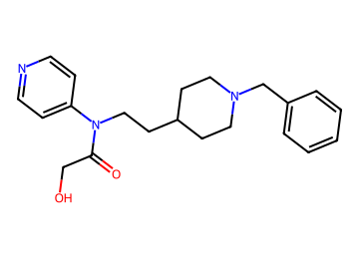  O=C(CO)N(CCC1CCN(Cc2ccccc2)CC1)c1ccncc1 | AChE 0.85; BBB 0.81 / 0.91 / 0.78  logBB -0.06; CNS MPO 5.5; SA 2.3  MW 353; TPSA 57; cLogP 2.7; HBD 1  P-gp 0.46; Kp,uu 0.44  hERG 0.84 (parent 0.90); Ames 0.49; DILI 0.42  edits 2; nearest potent active sim 0.65  GNN activity p 0.66 | 8.4 %  (BBB in-loop) | Vina -10.2  coverage 0.86 | 2 steps (longest sequence), score 0.994  Start from:  NCCC1CCN(Cc2ccccc2)CC1  Clc1ccncc1  ClC(Cl)Cl  O=C(O)CO  Parent: not listed (route does not use it)  Stereo: defined  Reactions (computed, 3 in total):  1. O=C(CO)N(CCC1CCN(Cc2ccccc2)CC1)c1ccncc1>>c1ccc(CN2CCC(CCNc3ccncc3)CC2)cc1.O=C(Cl)CO  2. c1ccc(CN2CCC(CCNc3ccncc3)CC2)cc1>>NCCC1CCN(Cc2ccccc2)CC1.Clc1ccncc1  3. O=C(Cl)CO>>ClC(Cl)Cl.O=C(O)CO | hERG predicted high: measure  BChE p 0.63
AD082  tier 2 | 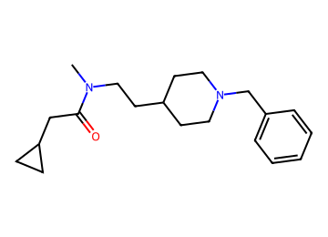  CN(CCC1CCN(Cc2ccccc2)CC1)C(=O)CC1CC1 | AChE 0.76; BBB 0.88 / 0.93 / 0.86  logBB 0.61; CNS MPO 4.1; SA 2.1  MW 314; TPSA 24; cLogP 3.5; HBD 0  P-gp 0.26; Kp,uu 0.63  hERG 0.84 (parent 0.91); Ames 0.39; DILI 0.20  edits 2; nearest potent active sim 0.72  GNN activity p 0.82 | 8.1 %  (AChE primary) | Vina -9.4  coverage 0.82 | 1 step (longest sequence), score 0.998  Start from:  O=C(O)CC1CC1  CNCCC1CCN(Cc2ccccc2)CC1  Parent: not listed (route does not use it)  Stereo: defined  Reactions (computed, 1 in total):  1. CN(CCC1CCN(Cc2ccccc2)CC1)C(=O)CC1CC1>>O=C(O)CC1CC1.CNCCC1CCN(Cc2ccccc2)CC1 | hERG predicted high: measure
AD083  tier 2 | 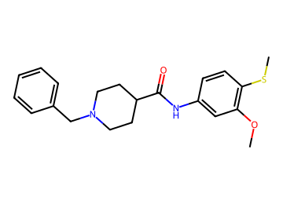  COc1cc(NC(=O)C2CCN(Cc3ccccc3)CC2)ccc1SC | AChE 0.86; BBB 0.81 / 0.84 / 0.77  logBB 0.17; CNS MPO 4.1; SA 1.9  MW 371; TPSA 42; cLogP 4.3; HBD 1  P-gp 0.60; Kp,uu 0.36  hERG 0.90 (parent 0.92); Ames 0.48; DILI 0.47  edits 1; nearest potent active sim 0.79  GNN activity p 0.89 | 8.1 %  (BBB in-loop) | Vina -9.4  coverage 0.79 | 2 steps (longest sequence), score 0.994  Start from:  COc1cc(N)ccc1SC  O=C(O)C1CCN(Cc2ccccc2)CC1  O=S(Cl)Cl  Parent: listed by suppliers  Stereo: defined  Reactions (computed, 2 in total):  1. COc1cc(NC(=O)C2CCN(Cc3ccccc3)CC2)ccc1SC>>O=C(Cl)C1CCN(Cc2ccccc2)CC1.COc1cc(N)ccc1SC  2. O=C(Cl)C1CCN(Cc2ccccc2)CC1>>O=C(O)C1CCN(Cc2ccccc2)CC1.O=S(Cl)Cl | hERG predicted high: measure
AD084  tier 2 | 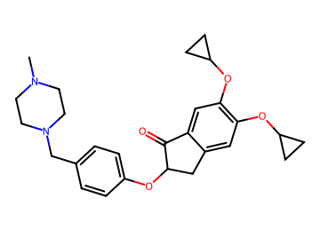  CN1CCN(Cc2ccc(OC3Cc4cc(OC5CC5)c(OC5CC5)cc4C3=O)cc2)CC1 | AChE 0.81; BBB 0.87 / 0.81 / 0.83  logBB 0.16; CNS MPO 4.2; SA 3.1  MW 449; TPSA 51; cLogP 3.7; HBD 0  P-gp 0.68; Kp,uu 0.26  hERG 0.85 (parent 0.87); Ames 0.58; DILI 0.48  edits 2; nearest potent active sim 0.81  GNN activity p 0.91 | 8.0 %  (BBB audit) | Vina -11.6  coverage 1.00 | 5 steps (longest sequence), score 0.963  Start from:  OC1CC1  CN1CCN(Cc2cccc(F)c2)CC1  OC1CC1  O=C(O)C(=O)Cc1ccc(F)c(F)c1  Parent: not listed (route does not use it)  Stereo: racemate (alpha to C=O)  Reactions (computed, 5 in total):  1. CN1CCN(Cc2ccc(OC3Cc4cc(OC5CC5)c(OC5CC5)cc4C3=O)cc2)CC1>>CN1CCN(Cc2ccc(OC3Cc4cc(F)c(OC5CC5)cc4C3=O)cc2)CC1.OC1CC1  2. CN1CCN(Cc2ccc(OC3Cc4cc(F)c(OC5CC5)cc4C3=O)cc2)CC1>>CN1CCN(Cc2cccc(F)c2)CC1.O=C1c2cc(OC3CC3)c(F)cc2CC1O  3. O=C1c2cc(OC3CC3)c(F)cc2CC1O>>O=C1c2cc(F)c(F)cc2CC1O.OC1CC1  4. O=C1c2cc(F)c(F)cc2CC1O>>O=C(O)C(O)Cc1ccc(F)c(F)c1  5. O=C(O)C(O)Cc1ccc(F)c(F)c1>>O=C(O)C(=O)Cc1ccc(F)c(F)c1 | hERG predicted high: measure
AD085  tier 2 | 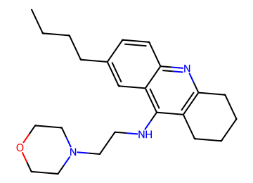  CCCCc1ccc2nc3c(c(NCCN4CCOCC4)c2c1)CCCC3 | AChE 0.85; BBB 0.89 / 0.86 / 0.85  logBB 0.30; CNS MPO 4.0; SA 2.4  MW 368; TPSA 37; cLogP 4.2; HBD 1  P-gp 0.59; Kp,uu 0.34  hERG 0.81 (parent 0.77); Ames 0.54; DILI 0.45  edits 2; nearest potent active sim 0.74  GNN activity p 0.84 | 7.7 %  (logBB domain) | Vina -10.1  coverage 0.86 | 2 steps (longest sequence), score 0.994  Start from:  ClCCN1CCOCC1  O=C1CCCCC1  CCCCc1ccc(N)c(C#N)c1  Parent: not listed (route does not use it)  Stereo: defined  Reactions (computed, 2 in total):  1. CCCCc1ccc2nc3c(c(NCCN4CCOCC4)c2c1)CCCC3>>ClCCN1CCOCC1.CCCCc1ccc2nc3c(c(N)c2c1)CCCC3  2. CCCCc1ccc2nc3c(c(N)c2c1)CCCC3>>O=C1CCCCC1.CCCCc1ccc(N)c(C#N)c1 | hERG predicted high: measure  BChE p 0.88
AD086  tier 2 | 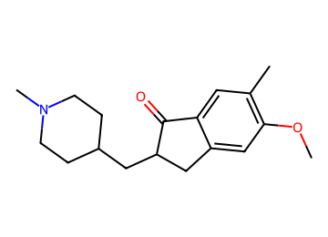  COc1cc2c(cc1C)C(=O)C(CC1CCN(C)CC1)C2 | AChE 0.75; BBB 0.93 / 0.91 / 0.90  logBB 0.31; CNS MPO 4.9; SA 2.9  MW 287; TPSA 30; cLogP 3.1; HBD 0  P-gp 0.15; Kp,uu 0.74  hERG 0.63 (parent 0.87); Ames 0.51; DILI 0.44  edits 2; nearest potent active sim 0.62  GNN activity p 0.97 | 7.3 %  (AChE primary) | Vina -10.6  coverage 0.89 | 2 steps (longest sequence), score 0.994  Start from:  CN1CCC(C=O)CC1  COc1cc(CCC(=O)O)ccc1C  Parent: listed by suppliers  Stereo: racemate (alpha to C=O)  Reactions (computed, 2 in total):  1. COc1cc2c(cc1C)C(=O)C(CC1CCN(C)CC1)C2>>COc1cc2c(cc1C)C(=O)CC2.CN1CCC(C=O)CC1  2. COc1cc2c(cc1C)C(=O)CC2>>COc1cc(CCC(=O)O)ccc1C | hERG predicted high: measure
AD087  tier 2 | 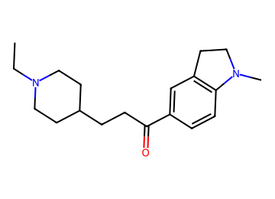  CCN1CCC(CCC(=O)c2ccc3c(c2)CCN3C)CC1 | AChE 0.75; BBB 0.92 / 0.92 / 0.89  logBB 0.78; CNS MPO 4.3; SA 2.2  MW 300; TPSA 24; cLogP 3.4; HBD 0  P-gp 0.23; Kp,uu 0.66  hERG 0.78 (parent 0.88); Ames 0.37; DILI 0.29  edits 1; nearest potent active sim 0.75  GNN activity p 0.96 | 7.3 %  (AChE primary) | Vina -10.0  coverage 0.96 | 1 step (longest sequence), score 0.998  Start from:  CCN1CCC(CCC(=O)O)CC1  CN1CCc2ccccc21  Parent: not listed (route does not use it)  Stereo: defined  Reactions (computed, 1 in total):  1. CCN1CCC(CCC(=O)c2ccc3c(c2)CCN3C)CC1>>CCN1CCC(CCC(=O)O)CC1.CN1CCc2ccccc21 | hERG predicted high: measure
AD088  tier 2 | 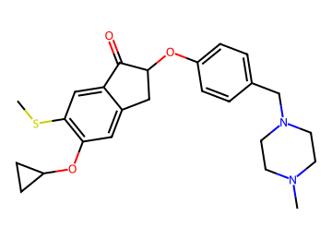  CSc1cc2c(cc1OC1CC1)CC(Oc1ccc(CN3CCN(C)CC3)cc1)C2=O | AChE 0.79; BBB 0.86 / 0.80 / 0.84  logBB 0.28; CNS MPO 4.1; SA 3.1  MW 439; TPSA 42; cLogP 3.9; HBD 0  P-gp 0.69; Kp,uu 0.26  hERG 0.87 (parent 0.87); Ames 0.58; DILI 0.48  edits 2; nearest potent active sim 0.69  GNN activity p 0.95 | 7.2 %  (BBB audit) | Vina -11.7  coverage 1.00 | 5 steps (longest sequence), score 0.963  Start from:  CN1CCN(Cc2ccc(F)cc2)CC1  OC1CC1  O=C(O)C(=O)Cc1ccc(F)c(F)c1  CSC(C)=O  Parent: not listed (route does not use it)  Stereo: racemate (alpha to C=O)  Reactions (computed, 6 in total):  1. CSc1cc2c(cc1OC1CC1)CC(Oc1ccc(CN3CCN(C)CC3)cc1)C2=O>>CSc1cc2c(cc1OC1CC1)CC(O)C2=O.CN1CCN(Cc2ccc(F)cc2)CC1  2. CSc1cc2c(cc1OC1CC1)CC(O)C2=O>>CS.O=C1c2cc(F)c(OC3CC3)cc2CC1O  3. O=C1c2cc(F)c(OC3CC3)cc2CC1O>>OC1CC1.O=C1c2cc(F)c(F)cc2CC1O  4. O=C1c2cc(F)c(F)cc2CC1O>>O=C(O)C(O)Cc1ccc(F)c(F)c1  5. O=C(O)C(O)Cc1ccc(F)c(F)c1>>O=C(O)C(=O)Cc1ccc(F)c(F)c1  6. CS>>CSC(C)=O | hERG predicted high: measure
AD089  tier 2 | 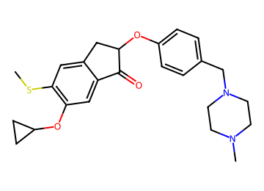  CSc1cc2c(cc1OC1CC1)C(=O)C(Oc1ccc(CN3CCN(C)CC3)cc1)C2 | AChE 0.80; BBB 0.86 / 0.80 / 0.85  logBB 0.28; CNS MPO 4.1; SA 3.1  MW 439; TPSA 42; cLogP 3.9; HBD 0  P-gp 0.69; Kp,uu 0.26  hERG 0.87 (parent 0.87); Ames 0.58; DILI 0.48  edits 2; nearest potent active sim 0.69  GNN activity p 0.95 | 7.2 %  (BBB audit) | Vina -11.7  coverage 1.00 | 5 steps (longest sequence), score 0.963  Start from:  OC1CC1  CN1CCN(Cc2ccc(F)cc2)CC1  O=C(O)C(=O)Cc1ccc(F)c(F)c1  CSC(C)=O  Parent: not listed (route does not use it)  Stereo: racemate (alpha to C=O)  Reactions (computed, 6 in total):  1. CSc1cc2c(cc1OC1CC1)C(=O)C(Oc1ccc(CN3CCN(C)CC3)cc1)C2>>CSc1cc2c(cc1F)C(=O)C(Oc1ccc(CN3CCN(C)CC3)cc1)C2.OC1CC1  2. CSc1cc2c(cc1F)C(=O)C(Oc1ccc(CN3CCN(C)CC3)cc1)C2>>CSc1cc2c(cc1F)C(=O)C(O)C2.CN1CCN(Cc2ccc(F)cc2)CC1  3. CSc1cc2c(cc1F)C(=O)C(O)C2>>CS.O=C1c2cc(F)c(F)cc2CC1O  4. O=C1c2cc(F)c(F)cc2CC1O>>O=C(O)C(O)Cc1ccc(F)c(F)c1  5. O=C(O)C(O)Cc1ccc(F)c(F)c1>>O=C(O)C(=O)Cc1ccc(F)c(F)c1  6. CS>>CSC(C)=O | hERG predicted high: measure
AD090  tier 2 | 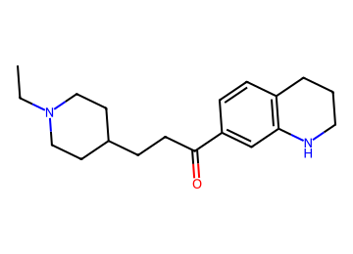  CCN1CCC(CCC(=O)c2ccc3c(c2)NCCC3)CC1 | AChE 0.75; BBB 0.91 / 0.91 / 0.86  logBB 0.85; CNS MPO 4.2; SA 2.3  MW 300; TPSA 32; cLogP 3.7; HBD 1  P-gp 0.27; Kp,uu 0.62  hERG 0.78 (parent 0.87); Ames 0.37; DILI 0.33  edits 1; nearest potent active sim 0.75  GNN activity p 0.94 | 6.9 %  (AChE primary) | Vina -10.3  coverage 0.86 | 2 steps (longest sequence), score 0.994  Start from:  Brc1ccc2c(c1)NCCC2  CCN1CCC(CCC(=O)O)CC1  CNOC  Parent: not listed (route does not use it)  Stereo: defined  Reactions (computed, 2 in total):  1. CCN1CCC(CCC(=O)c2ccc3c(c2)NCCC3)CC1>>CCN1CCC(CCC(=O)N(C)OC)CC1.Brc1ccc2c(c1)NCCC2  2. CCN1CCC(CCC(=O)N(C)OC)CC1>>CCN1CCC(CCC(=O)O)CC1.CNOC | hERG predicted high: measure
AD091  tier 2 | 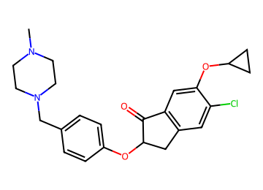  CN1CCN(Cc2ccc(OC3Cc4cc(Cl)c(OC5CC5)cc4C3=O)cc2)CC1 | AChE 0.83; BBB 0.88 / 0.80 / 0.85  logBB 0.31; CNS MPO 4.2; SA 3.0  MW 427; TPSA 42; cLogP 3.8; HBD 0  P-gp 0.67; Kp,uu 0.29  hERG 0.88 (parent 0.87); Ames 0.55; DILI 0.47  edits 2; nearest potent active sim 0.73  GNN activity p 0.89 | 6.7 %  (BBB audit) | Vina -12.2  coverage 1.00 | 5 steps (longest sequence), score 0.963  Start from:  O=C1CCC(=O)N1Cl  CN1CCN(Cc2cccc(F)c2)CC1  OC1CC1  O=C(O)C(=O)Cc1ccc(F)cc1  Parent: not listed (route does not use it)  Stereo: racemate (alpha to C=O)  Reactions (computed, 5 in total):  1. CN1CCN(Cc2ccc(OC3Cc4cc(Cl)c(OC5CC5)cc4C3=O)cc2)CC1>>CN1CCN(Cc2ccc(OC3Cc4ccc(OC5CC5)cc4C3=O)cc2)CC1.O=C1CCC(=O)N1Cl  2. CN1CCN(Cc2ccc(OC3Cc4ccc(OC5CC5)cc4C3=O)cc2)CC1>>CN1CCN(Cc2cccc(F)c2)CC1.O=C1c2cc(OC3CC3)ccc2CC1O  3. O=C1c2cc(OC3CC3)ccc2CC1O>>O=C1c2cc(F)ccc2CC1O.OC1CC1  4. O=C1c2cc(F)ccc2CC1O>>O=C(O)C(O)Cc1ccc(F)cc1  5. O=C(O)C(O)Cc1ccc(F)cc1>>O=C(O)C(=O)Cc1ccc(F)cc1 | hERG predicted high: measure
AD092  tier 2 | 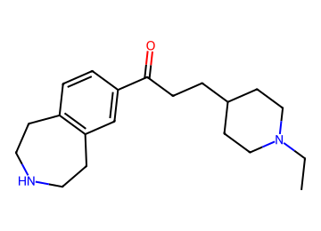  CCN1CCC(CCC(=O)c2ccc3c(c2)CCNCC3)CC1 | AChE 0.75; BBB 0.83 / 0.93 / 0.81  logBB 0.82; CNS MPO 4.9; SA 2.3  MW 314; TPSA 32; cLogP 3.1; HBD 1  P-gp 0.26; Kp,uu 0.62  hERG 0.81 (parent 0.88); Ames 0.34; DILI 0.33  edits 1; nearest potent active sim 0.55  GNN activity p 0.94 | 6.6 %  (AChE primary) | Vina -8.3  coverage 0.93 | 1 step (longest sequence), score 0.998  Start from:  CCN1CCC(CCC(=O)O)CC1  c1ccc2c(c1)CCNCC2  Parent: not listed (route does not use it)  Stereo: defined  Reactions (computed, 1 in total):  1. CCN1CCC(CCC(=O)c2ccc3c(c2)CCNCC3)CC1>>CCN1CCC(CCC(=O)O)CC1.c1ccc2c(c1)CCNCC2 | hERG predicted high: measure
AD093  tier 2 | 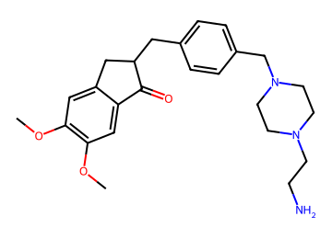  COc1cc2c(cc1OC)C(=O)C(Cc1ccc(CN3CCN(CCN)CC3)cc1)C2 | AChE 0.87; BBB 0.84 / 0.80 / 0.78  logBB -0.21; CNS MPO 5.2; SA 2.8  MW 424; TPSA 68; cLogP 2.4; HBD 1  P-gp 0.68; Kp,uu 0.26  hERG 0.82 (parent 0.83); Ames 0.62; DILI 0.41  edits 2; nearest potent active sim 0.60  GNN activity p 0.86 | 6.5 %  (BBB audit) | Vina -11.3  coverage 0.86 | 3 steps (longest sequence), score 0.987  Start from:  NCCN1CCNCC1  COC(=O)c1ccc(CBr)cc1  COc1cc2c(cc1OC)C(=O)CC2  Parent: not listed (route does not use it)  Stereo: racemate (alpha to C=O)  Reactions (computed, 3 in total):  1. COc1cc2c(cc1OC)C(=O)C(Cc1ccc(CN3CCN(CCN)CC3)cc1)C2>>COc1cc2c(cc1OC)C(=O)C(Cc1ccc(CO)cc1)C2.NCCN1CCNCC1  2. COc1cc2c(cc1OC)C(=O)C(Cc1ccc(CO)cc1)C2>>COC(=O)c1ccc(CC2Cc3cc(OC)c(OC)cc3C2=O)cc1  3. COC(=O)c1ccc(CC2Cc3cc(OC)c(OC)cc3C2=O)cc1>>COC(=O)c1ccc(CBr)cc1.COc1cc2c(cc1OC)C(=O)CC2 | hERG predicted high: measure
AD094  tier 2 | 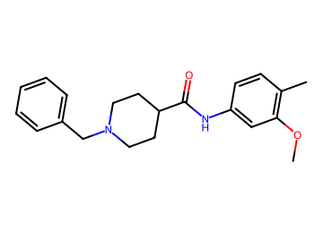  COc1cc(NC(=O)C2CCN(Cc3ccccc3)CC2)ccc1C | AChE 0.85; BBB 0.80 / 0.81 / 0.76  logBB 0.10; CNS MPO 4.5; SA 1.7  MW 338; TPSA 42; cLogP 3.9; HBD 1  P-gp 0.44; Kp,uu 0.51  hERG 0.89 (parent 0.92); Ames 0.48; DILI 0.52  edits 1; nearest potent active sim 0.84  GNN activity p 0.82 | 6.2 %  (BBB in-loop) | Vina -11.1  coverage 1.00 | 1 step (longest sequence), score 0.998  Start from:  CCOC(=O)C1CCN(Cc2ccccc2)CC1  COc1cc(N)ccc1C  Parent: listed by suppliers  Stereo: defined  Reactions (computed, 1 in total):  1. COc1cc(NC(=O)C2CCN(Cc3ccccc3)CC2)ccc1C>>CCOC(=O)C1CCN(Cc2ccccc2)CC1.COc1cc(N)ccc1C | hERG predicted high: measure  BCRP watch
AD095  tier 2 | 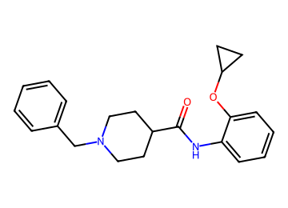  O=C(Nc1ccccc1OC1CC1)C1CCN(Cc2ccccc2)CC1 | AChE 0.78; BBB 0.85 / 0.88 / 0.76  logBB -0.09; CNS MPO 4.3; SA 1.8  MW 350; TPSA 42; cLogP 4.1; HBD 1  P-gp 0.50; Kp,uu 0.44  hERG 0.86 (parent 0.86); Ames 0.46; DILI 0.38  edits 1; nearest potent active sim 0.77  GNN activity p 0.76 | 6.1 %  (logBB domain) | Vina -10.5  coverage 0.89 | 2 steps (longest sequence), score 0.994  Start from:  BrC1CC1  Nc1ccccc1O  O=S(Cl)Cl  O=C(O)C1CCN(Cc2ccccc2)CC1  Parent: listed by suppliers  Stereo: defined  Reactions (computed, 3 in total):  1. O=C(Nc1ccccc1OC1CC1)C1CCN(Cc2ccccc2)CC1>>Nc1ccccc1OC1CC1.O=C(Cl)C1CCN(Cc2ccccc2)CC1  2. Nc1ccccc1OC1CC1>>BrC1CC1.Nc1ccccc1O  3. O=C(Cl)C1CCN(Cc2ccccc2)CC1>>O=S(Cl)Cl.O=C(O)C1CCN(Cc2ccccc2)CC1 | hERG predicted high: measure
AD096  tier 2 | 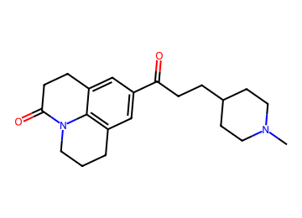  CN1CCC(CCC(=O)c2cc3c4c(c2)CCC(=O)N4CCC3)CC1 | AChE 0.79; BBB 0.90 / 0.93 / 0.91  logBB 0.30; CNS MPO 5.3; SA 2.5  MW 340; TPSA 41; cLogP 3.2; HBD 0  P-gp 0.38; Kp,uu 0.53  hERG 0.71 (parent 0.85); Ames 0.37; DILI 0.32  edits 2; nearest potent active sim 0.47  GNN activity p 0.99 | 6.1 %  (logBB domain) | Vina -11.4  coverage 1.00 | 1 step (longest sequence), score 0.998  Start from:  CN1CCC(CCC(=O)O)CC1  O=C1CCc2cccc3c2N1CCC3  Parent: not listed (route does not use it)  Stereo: defined  Reactions (computed, 1 in total):  1. CN1CCC(CCC(=O)c2cc3c4c(c2)CCC(=O)N4CCC3)CC1>>CN1CCC(CCC(=O)O)CC1.O=C1CCc2cccc3c2N1CCC3 | hERG predicted high: measure
AD097  tier 2 | 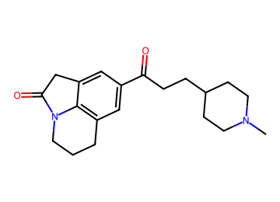  CN1CCC(CCC(=O)c2cc3c4c(c2)CC(=O)N4CCC3)CC1 | AChE 0.74; BBB 0.89 / 0.93 / 0.90  logBB 0.30; CNS MPO 5.6; SA 2.6  MW 326; TPSA 41; cLogP 2.8; HBD 0  P-gp 0.30; Kp,uu 0.61  hERG 0.67 (parent 0.84); Ames 0.39; DILI 0.33  edits 2; nearest potent active sim 0.48  GNN activity p 0.99 | 6.1 %  (AChE primary) | Vina -11.0  coverage 1.00 | 1 step (longest sequence), score 0.998  Start from:  CN1CCC(CCC(=O)O)CC1  O=C1Cc2cccc3c2N1CCC3  Parent: not listed (route does not use it)  Stereo: defined  Reactions (computed, 1 in total):  1. CN1CCC(CCC(=O)c2cc3c4c(c2)CC(=O)N4CCC3)CC1>>CN1CCC(CCC(=O)O)CC1.O=C1Cc2cccc3c2N1CCC3 | hERG predicted high: measure
AD098  tier 2 | 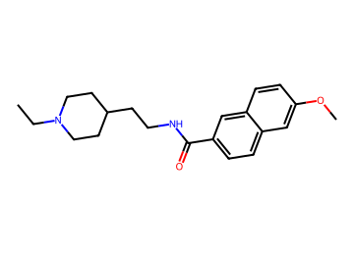  CCN1CCC(CCNC(=O)c2ccc3cc(OC)ccc3c2)CC1 | AChE 0.74; BBB 0.81 / 0.88 / 0.77  logBB 0.42; CNS MPO 4.6; SA 2.0  MW 340; TPSA 42; cLogP 3.7; HBD 1  P-gp 0.44; Kp,uu 0.50  hERG 0.87 (parent 0.89); Ames 0.47; DILI 0.47  edits 1; nearest potent active sim 0.49  GNN activity p 0.96 | 5.8 %  (AChE primary) | Vina -10.6  coverage 0.96 | 1 step (longest sequence), score 0.998  Start from:  COc1ccc2cc(C(=O)O)ccc2c1  CCN1CCC(CCN)CC1  Parent: listed by suppliers  Stereo: defined  Reactions (computed, 1 in total):  1. CCN1CCC(CCNC(=O)c2ccc3cc(OC)ccc3c2)CC1>>COc1ccc2cc(C(=O)O)ccc2c1.CCN1CCC(CCN)CC1 | hERG predicted high: measure  BChE p 0.60
AD099  tier 2 | 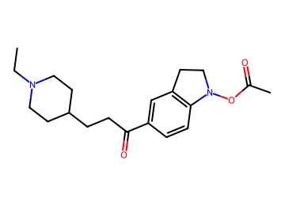  CCN1CCC(CCC(=O)c2ccc3c(c2)CCN3OC(C)=O)CC1 | AChE 0.84; BBB 0.85 / 0.79 / 0.84  logBB 0.23; CNS MPO 5.3; SA 2.6  MW 344; TPSA 50; cLogP 3.2; HBD 0  P-gp 0.34; Kp,uu 0.57  hERG 0.82 (parent 0.88); Ames 0.33; DILI 0.36  edits 2; nearest potent active sim 0.59  GNN activity p 0.92 | 5.8 %  (BBB audit) | Vina -10.2  coverage 0.96 | 3 steps (longest sequence), score 0.987  Start from:  CCN1CCC(CCC(=O)O)CC1  CC(=O)O  O=C1Cc2ccccc2N1O  Parent: not listed (route does not use it)  Stereo: defined  Reactions (computed, 3 in total):  1. CCN1CCC(CCC(=O)c2ccc3c(c2)CCN3OC(C)=O)CC1>>CCN1CCC(CCC(=O)O)CC1.CC(=O)ON1CCc2ccccc21  2. CC(=O)ON1CCc2ccccc21>>CC(=O)O.ON1CCc2ccccc21  3. ON1CCc2ccccc21>>O=C1Cc2ccccc2N1O | hERG predicted high: measure
AD100  tier 2 | 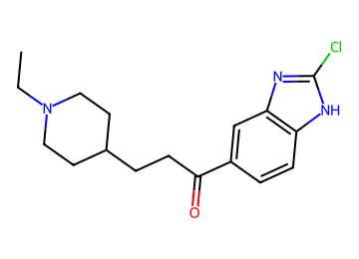  CCN1CCC(CCC(=O)c2ccc3[nH]c(Cl)nc3c2)CC1 | AChE 0.74; BBB 0.86 / 0.93 / 0.86  logBB 0.36; CNS MPO 4.4; SA 2.4  MW 320; TPSA 49; cLogP 3.9; HBD 1  P-gp 0.27; Kp,uu 0.64  hERG 0.84 (parent 0.88); Ames 0.48; DILI 0.56  edits 2; nearest potent active sim 0.64  GNN activity p 0.87 | 5.7 %  (AChE primary) | Vina -10.0  coverage 0.71 | 1 step (longest sequence), score 0.998  Start from:  CCN1CCC(CCC(=O)O)CC1  Clc1nc2ccccc2[nH]1  Parent: not listed (route does not use it)  Stereo: defined  Reactions (computed, 1 in total):  1. CCN1CCC(CCC(=O)c2ccc3[nH]c(Cl)nc3c2)CC1>>CCN1CCC(CCC(=O)O)CC1.Clc1nc2ccccc2[nH]1 | hERG predicted high: measure
AD101  tier 2 | 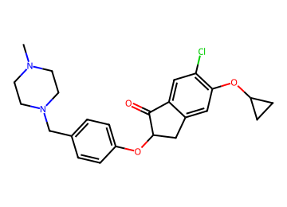  CN1CCN(Cc2ccc(OC3Cc4cc(OC5CC5)c(Cl)cc4C3=O)cc2)CC1 | AChE 0.83; BBB 0.88 / 0.79 / 0.84  logBB 0.31; CNS MPO 4.2; SA 3.0  MW 427; TPSA 42; cLogP 3.8; HBD 0  P-gp 0.66; Kp,uu 0.29  hERG 0.88 (parent 0.87); Ames 0.56; DILI 0.47  edits 2; nearest potent active sim 0.73  GNN activity p 0.89 | 5.4 %  (BBB audit) | Vina -12.0  coverage 1.00 | 5 steps (longest sequence), score 0.963  Start from:  CN1CCN(Cc2ccc(F)cc2)CC1  BrC1CC1  CCOC(=O)C(=O)Cc1ccc(Cl)c(O)c1  Parent: not listed (route does not use it)  Stereo: racemate (alpha to C=O)  Reactions (computed, 5 in total):  1. CN1CCN(Cc2ccc(OC3Cc4cc(OC5CC5)c(Cl)cc4C3=O)cc2)CC1>>CN1CCN(Cc2ccc(F)cc2)CC1.O=C1c2cc(Cl)c(OC3CC3)cc2CC1O  2. O=C1c2cc(Cl)c(OC3CC3)cc2CC1O>>BrC1CC1.O=C1c2cc(Cl)c(O)cc2CC1O  3. O=C1c2cc(Cl)c(O)cc2CC1O>>O=C(O)C(O)Cc1ccc(Cl)c(O)c1  4. O=C(O)C(O)Cc1ccc(Cl)c(O)c1>>O=C(O)C(=O)Cc1ccc(Cl)c(O)c1  5. O=C(O)C(=O)Cc1ccc(Cl)c(O)c1>>CCOC(=O)C(=O)Cc1ccc(Cl)c(O)c1 | hERG predicted high: measure
AD102  tier 2 | 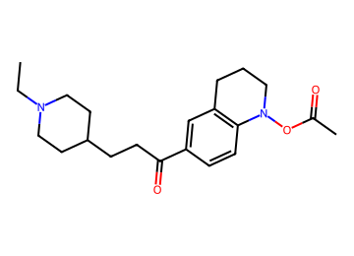  CCN1CCC(CCC(=O)c2ccc3c(c2)CCCN3OC(C)=O)CC1 | AChE 0.85; BBB 0.86 / 0.79 / 0.86  logBB 0.26; CNS MPO 4.9; SA 2.6  MW 358; TPSA 50; cLogP 3.6; HBD 0  P-gp 0.41; Kp,uu 0.51  hERG 0.81 (parent 0.86); Ames 0.31; DILI 0.34  edits 2; nearest potent active sim 0.59  GNN activity p 0.93 | 5.3 %  (BBB audit) | Vina -10.6  coverage 1.00 | 3 steps (longest sequence), score 0.987  Start from:  CCN1CCC(CCC(=O)O)CC1  CC(=O)OC(C)=O  O=C1CCc2ccccc2N1O  Parent: not listed (route does not use it)  Stereo: defined  Reactions (computed, 3 in total):  1. CCN1CCC(CCC(=O)c2ccc3c(c2)CCCN3OC(C)=O)CC1>>CCN1CCC(CCC(=O)O)CC1.CC(=O)ON1CCCc2ccccc21  2. CC(=O)ON1CCCc2ccccc21>>CC(=O)ON1C(=O)CCc2ccccc21  3. CC(=O)ON1C(=O)CCc2ccccc21>>CC(=O)OC(C)=O.O=C1CCc2ccccc2N1O | hERG predicted high: measure  BChE p 0.50
AD103  tier 2 | 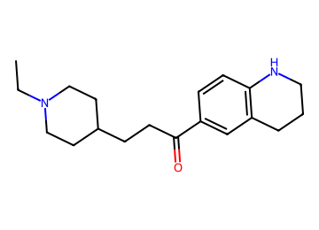  CCN1CCC(CCC(=O)c2ccc3c(c2)CCCN3)CC1 | AChE 0.74; BBB 0.90 / 0.93 / 0.86  logBB 0.88; CNS MPO 4.2; SA 2.3  MW 300; TPSA 32; cLogP 3.7; HBD 1  P-gp 0.25; Kp,uu 0.64  hERG 0.78 (parent 0.87); Ames 0.36; DILI 0.33  edits 1; nearest potent active sim 0.75  GNN activity p 0.94 | 5.2 %  (AChE primary) | Vina -10.4  coverage 0.93 | 1 step (longest sequence), score 0.998  Start from:  CCN1CCC(CCC(=O)O)CC1  c1ccc2c(c1)CCCN2  Parent: not listed (route does not use it)  Stereo: defined  Reactions (computed, 1 in total):  1. CCN1CCC(CCC(=O)c2ccc3c(c2)CCCN3)CC1>>CCN1CCC(CCC(=O)O)CC1.c1ccc2c(c1)CCCN2 | hERG predicted high: measure
AD104  tier 2 | 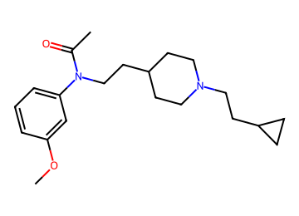  COc1cccc(N(CCC2CCN(CCC3CC3)CC2)C(C)=O)c1 | AChE 0.79; BBB 0.87 / 0.91 / 0.75  logBB 0.50; CNS MPO 4.2; SA 2.3  MW 344; TPSA 33; cLogP 4.0; HBD 0  P-gp 0.48; Kp,uu 0.44  hERG 0.87 (parent 0.93); Ames 0.42; DILI 0.25  edits 2; nearest potent active sim 0.76  GNN activity p 0.95 | 5.0 %  (logBB domain) | Vina -9.9  coverage 0.75 | 2 steps (longest sequence), score 0.994  Start from:  COc1cccc(NC(C)=O)c1  OCCC1CCN(CCC2CC2)CC1  O=S(Cl)Cl  Parent: not listed (route does not use it)  Stereo: defined  Reactions (computed, 2 in total):  1. COc1cccc(N(CCC2CCN(CCC3CC3)CC2)C(C)=O)c1>>ClCCC1CCN(CCC2CC2)CC1.COc1cccc(NC(C)=O)c1  2. ClCCC1CCN(CCC2CC2)CC1>>OCCC1CCN(CCC2CC2)CC1.O=S(Cl)Cl | hERG predicted high: measure  BChE p 0.52
AD105  tier 2 | 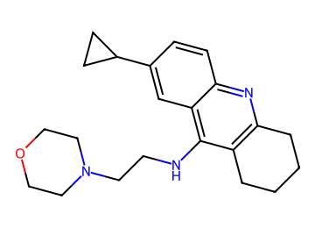  c1cc2nc3c(c(NCCN4CCOCC4)c2cc1C1CC1)CCCC3 | AChE 0.85; BBB 0.92 / 0.90 / 0.86  logBB 0.31; CNS MPO 4.5; SA 2.4  MW 351; TPSA 37; cLogP 3.7; HBD 1  P-gp 0.41; Kp,uu 0.48  hERG 0.78 (parent 0.77); Ames 0.62; DILI 0.47  edits 1; nearest potent active sim 0.74  GNN activity p 0.88 | 5.0 %  (logBB domain) | Vina -10.2  coverage 0.75 | 3 steps (longest sequence), score 0.987  Start from:  ClCCN1CCOCC1  O=C1CCCCC1  OB(O)C1CC1  N#Cc1cc(Br)ccc1N  Parent: not listed (route does not use it)  Stereo: defined  Reactions (computed, 3 in total):  1. c1cc2nc3c(c(NCCN4CCOCC4)c2cc1C1CC1)CCCC3>>ClCCN1CCOCC1.Nc1c2c(nc3ccc(C4CC4)cc13)CCCC2  2. Nc1c2c(nc3ccc(C4CC4)cc13)CCCC2>>O=C1CCCCC1.N#Cc1cc(C2CC2)ccc1N  3. N#Cc1cc(C2CC2)ccc1N>>OB(O)C1CC1.N#Cc1cc(Br)ccc1N | hERG predicted high: measure  BChE p 0.83
AD106  tier 2 | 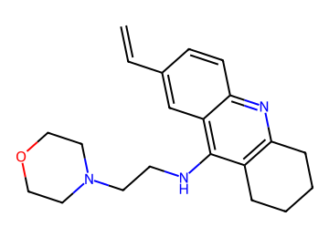  C=Cc1ccc2nc3c(c(NCCN4CCOCC4)c2c1)CCCC3 | AChE 0.83; BBB 0.85 / 0.88 / 0.86  logBB 0.29; CNS MPO 4.7; SA 2.5  MW 337; TPSA 37; cLogP 3.5; HBD 1  P-gp 0.40; Kp,uu 0.53  hERG 0.78 (parent 0.77); Ames 0.65; DILI 0.47  edits 1; nearest potent active sim 0.74  GNN activity p 0.86 | 5.0 %  (logBB domain) | Vina -10.2  coverage 0.68 | 4 steps (longest sequence), score 0.975  Start from:  C1COCCN1  CC(=O)Cl  O=S(Cl)Cl  OCCNc1c2c(nc3ccccc13)CCCC2  Parent: not listed (route does not use it)  Stereo: defined  Reactions (computed, 4 in total):  1. C=Cc1ccc2nc3c(c(NCCN4CCOCC4)c2c1)CCCC3>>CC(=O)c1ccc2nc3c(c(NCCN4CCOCC4)c2c1)CCCC3  2. CC(=O)c1ccc2nc3c(c(NCCN4CCOCC4)c2c1)CCCC3>>CC(=O)c1ccc2nc3c(c(NCCCl)c2c1)CCCC3.C1COCCN1  3. CC(=O)c1ccc2nc3c(c(NCCCl)c2c1)CCCC3>>CC(=O)Cl.ClCCNc1c2c(nc3ccccc13)CCCC2  4. ClCCNc1c2c(nc3ccccc13)CCCC2>>O=S(Cl)Cl.OCCNc1c2c(nc3ccccc13)CCCC2 | hERG predicted high: measure  BChE p 0.79

8. Candidates that were rejected, and why
Reason | Candidates
no computed route to purchasable materials | 64
legacy efflux/exposure gate: P-gp > 0.713 or Kp,uu < 0.2485 | 26
novelty: found in a source or unresolved | 12
prior-art risk: eseroline-carbamate series (substituted phenserine patent family) | 9
Every rejected candidate with its reason is in REJECTED_CANDIDATES_WITH_REASON.csv.

