HireMind AI
Multi-Agent Resume Screening & Job Matching Platform

Documentation Round Submission
Problem Statement PS03

Field | Details
Problem Statement | PS03 — Multi-Agent Resume Screening & Job Matching Platform
Technology Category | NLP + LLM + Agentic AI
Team Name | [YOUR TEAM NAME]
Team Members | [Member 1] · [Member 2] · [Member 3]
Hackathon | [HACKATHON NAME]
Submission Date | 11 September 2026
Document Version | 1.0

1. Executive Summary
HireMind AI is a multi-agent recruitment platform that automates the screening of resumes against job descriptions and produces a ranked, fully explainable list of candidate-role matches. The system is built around five cooperating software agents — a Resume Agent, a Job Agent, a Matching Agent, a Skill Gap Agent and a Recruiter Agent — mirroring the stages a human recruiting team would perform, but at machine speed and with full auditability.
A key architectural decision distinguishes our solution from typical 'LLM-only' screeners: large language models (Google Gemini) are used only for *information extraction and natural-language summarisation*, while the actual ranking decision is produced by a *deterministic, weighted scoring engine*. This gives us the best of both worlds — rich semantic understanding of unstructured resumes, and reproducible, auditable, bias-controllable rankings. The platform runs end-to-end without any API key thanks to a deterministic offline NLP fallback layer, making it robust for live judging.
The deliverable is a complete web application: a React 18 frontend served by a Python FastAPI backend. It satisfies the expected demonstration of PS03 — upload of 10 resumes and 3 job descriptions producing a ranked candidate list — and goes further with per-candidate explainability reports (score breakdown, matched/missing skills, upskilling recommendations, recruiter summary and a raw agent trace of every agent's input/output).

2. Problem Analysis
Recruiters spend an estimated 6-7 seconds on an initial resume scan, and high-volume roles routinely attract hundreds of applications per opening. Manual screening is slow, inconsistent between screeners, and prone to overlooking strong candidates whose resumes phrase skills differently from the job description ('React.js' vs 'React' vs 'ReactJS'). We decomposed the problem into five sub-problems:
- P1 — Heterogeneous input: resumes arrive as free text, PDFs or Word files with wildly different formats, section ordering and vocabularies.
- P2 — Requirement ambiguity: job descriptions mix hard requirements, preferences and marketing language; must-have vs nice-to-have skills must be separated programmatically.
- P3 — Compatibility measurement: skill overlap alone is insufficient — experience level, education and domain keywords all matter, with different importance per role.
- P4 — Actionable feedback: a bare score is not useful. Recruiters need to know *which* skills are missing and how close the candidate is; candidates benefit from upskilling guidance.
- P5 — Explainability and trust: screening affects livelihoods. Any automated ranking must justify itself per decision, must be reproducible, and must not silently depend on an opaque LLM opinion.
These five sub-problems map one-to-one onto the five agents in our solution (Section 4).

3. Research

3.1 Survey of existing approaches
- Keyword/ATS matching (legacy applicant-tracking systems): exact string matching on skills. Fast but brittle — fails on synonyms, abbreviations and formatting variance.
- Semantic embedding similarity: encode resume and JD into vectors and rank by cosine similarity. Handles synonyms well but produces a single opaque number; hard to explain 'why'.
- LLM-only screening: prompt an LLM to rate each candidate. Expressive but non-reproducible (scores drift between runs/models), expensive at scale, and difficult to audit for bias.
- Hybrid agentic systems (state of the art in 2025-26): decompose the workflow into specialised agents with tools, keeping a deterministic core for decisions. Our design follows this pattern.

3.2 Research conclusions that shaped our design
- Extraction is a language-understanding task → best solved by an LLM (Gemini), with rule-based fallback for reliability.
- Ranking is a *decision* task → must be deterministic, weighted and inspectable; weights are published constants.
- A curated skill taxonomy with aliases ('js'→javascript, 'k8s'→kubernetes, 'sklearn'→scikit-learn) plus fuzzy matching neutralises vocabulary mismatch — the single largest source of false negatives in keyword ATS systems.

3.3 Open datasets considered
Per the problem statement's source note, we surveyed public resume and job-description datasets available on open ML repositories (Kaggle's 'Resume Dataset' / 'Updated Resume Dataset' family and Hugging Face job-posting corpora). For the demonstration we deliberately ship a *synthetic* dataset of 10 resumes and 3 job descriptions (no real person's data), which also satisfies the 'no participant data collection' requirement. Should the team scale evaluation to real datasets before finals, each candidate dataset's license, version and access conditions will be verified and recorded before use, as the problem statement requires.

4. Proposed Solution
HireMind AI implements the five-agent pipeline shown below. Resumes and job descriptions are normalised by the extraction agents into a shared schema (canonical skills from a ~130-entry taxonomy, years of experience, education level). The Matching Agent computes a deterministic 0-100 fit score; the Skill Gap Agent converts misses into prioritised, actionable gaps; the Recruiter Agent writes the human summary and recommendation.
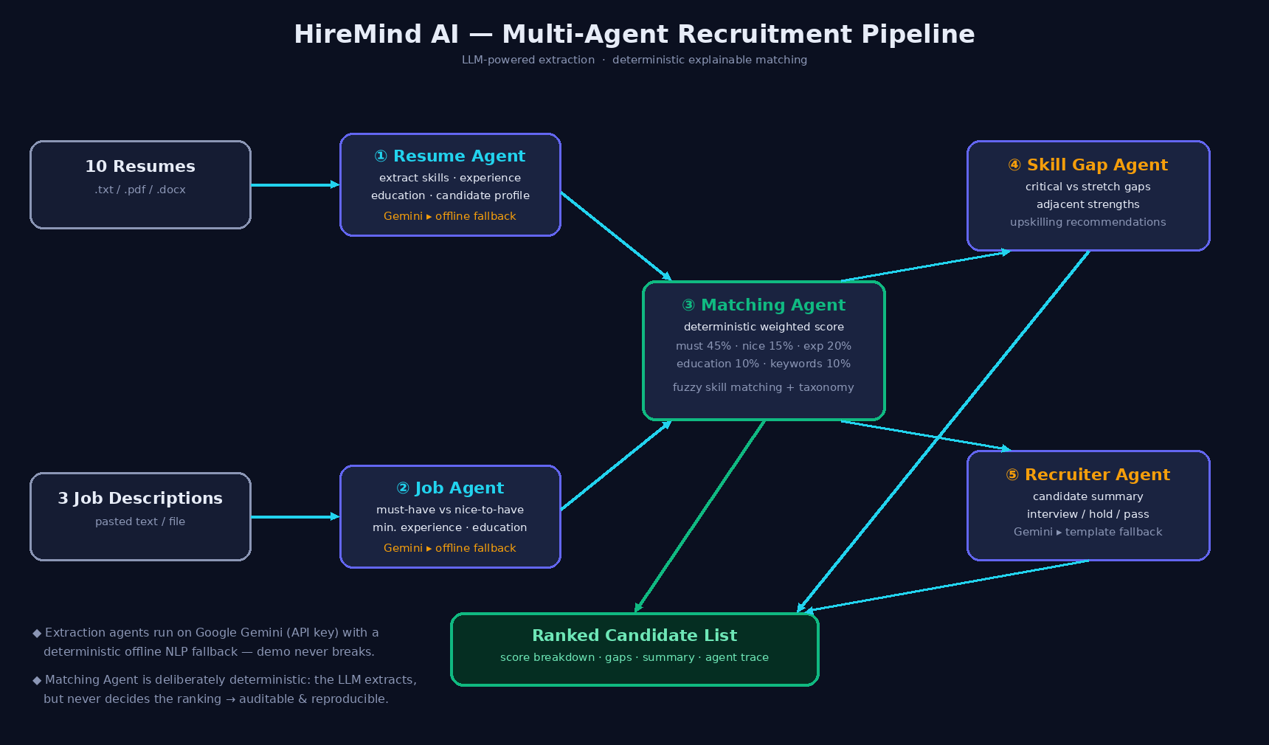

4.1 Agent responsibilities
# | Agent | Input | Output | Engine
1 | Resume Agent | Raw resume (txt/pdf/docx) | Candidate profile: name, canonical skills, years of experience, education, highlights | Gemini JSON-mode, offline heuristics fallback
2 | Job Agent | Raw job description | Requirements: must-have skills, nice-to-have skills, min experience, education | Gemini JSON-mode, offline heuristics fallback
3 | Matching Agent | Profile + requirements | 0-100 score, verdict, per-dimension breakdown, matched/missing skills | Deterministic (always)
4 | Skill Gap Agent | Profile + match result | Critical gaps, stretch gaps, adjacent strengths, upskilling plan | Deterministic rule engine
5 | Recruiter Agent | Profile + requirements + match | Recruiter-style summary + interview/hold/pass recommendation | Gemini, template fallback

4.2 Core design principles
- "LLM extracts, never decides" — language models parse and write; a transparent weighted engine ranks. Same input ⇒ same ranking, every time.
- Dual-mode operation — every LLM agent has a deterministic fallback, so the demo works offline, keyless, and never crashes mid-pitch.
- Single source of truth for skills — a shared taxonomy normalises both LLM output and heuristic scans; matching is engine-agnostic.
- Parallelism where latency matters — Recruiter summaries for all candidates are generated concurrently (thread pool of 5).

5. Technical Flow

5.1 End-to-end sequence
- Step 1 — Intake: recruiter uploads resumes (.txt/.pdf/.docx parsed server-side via pypdf / python-docx) or pastes text; job descriptions are pasted or loaded from the demo set.
- Step 2 — Extraction (Agents 1 & 2): each document is converted to the shared schema; if a Gemini API key is configured the LLM path runs (JSON-mode, schema-prompted), otherwise the offline NLP heuristics run (section scanning, taxonomy alias matching, regex experience/education extraction).
- Step 3 — Scoring (Agent 3): for every candidate×job pair, each dimension is scored 0-1 and combined with published weights; fuzzy matching (normalized containment + difflib ratio ≥ 0.85) links 'React.js' to 'react'.
- Step 4 — Gap analysis (Agent 4): missing must-haves become critical gaps with concrete upskilling recommendations; same-category candidate skills are surfaced as 'adjacent strengths' (e.g. missing Kubernetes but knows Docker).
- Step 5 — Summarisation (Agent 5): a recruiter-style paragraph with strengths, risks and a hire recommendation.
- Step 6 — Presentation: candidates are sorted into the ranked list; the UI exposes every intermediate artifact via an 'Agent Trace' panel.

5.2 Scoring model
Score = Σ (weight × dimension score), renormalised when a dimension is not applicable:
Dimension | Weight | Computation
Must-have skills | 45% | fraction of required must-have skills matched (fuzzy)
Nice-to-have skills | 15% | fraction matched
Experience | 20% | 1.0 if candidate ≥ required years; 0.6×(cand/req) if below; neutral 0.75 when unspecified
Education | 10% | degree-rank comparison (PhD > Master > Bachelor > Diploma); 0.8 when unspecified
Keyword affinity | 10% | JD keywords/titles found in resume text
Verdict bands: ≥80 Strong match · 60-79 Good match · 40-59 Partial match · <40 Weak match.

5.3 REST API surface
Endpoint | Purpose
POST /api/resumes/upload · POST /api/resumes | Register resumes (files or pasted text) → Resume Agent runs
POST /api/jobs | Register a job description → Job Agent runs
POST /api/demo/load | Load bundled 10-resume / 3-JD demo set
POST /api/match {job_id} | Run Matching + Skill Gap + Recruiter agents over all candidates → ranked list
POST /api/reextract | Re-run extraction after adding a Gemini key
GET /api/agents · /api/health · /api/settings | Metadata, health, LLM configuration

6. Technology Stack
Layer | Technology | Rationale
Frontend | React 18 + Vite | Component model ideal for agent cards, ranked lists, detail panels; Vite for fast HMR during the hackathon
Backend | Python 3.13 + FastAPI | Async REST API, automatic OpenAPI docs, trivial JSON handling; served by Uvicorn
LLM | Google Gemini 2.5 Flash (REST, x-goog-api-key) | JSON-mode structured extraction and summarisation; user-supplied key (never hard-coded)
Offline NLP | Regex + curated 130-skill taxonomy + difflib fuzzy matching | Deterministic fallback; alias normalisation
Document parsing | pypdf, python-docx | Accept real-world resume formats
State | In-memory store (swap-in SQLite/Postgres for production) | Zero-setup demo; clean repository pattern for upgrade
Concurrency | ThreadPoolExecutor | Parallel recruiter summaries

7. Implementation

7.1 Repository layout
backend/
main.py FastAPI app: REST API + serves built React app
store.py in-memory store
skills_taxonomy.py canonical skills + alias map + categories
offline_extract.py deterministic extraction heuristics
agents/
llm.py Gemini REST client (JSON mode)
resume_agent.py Agent 1
job_agent.py Agent 2
matching_agent.py Agent 3 (weights, fuzzy matching, verdicts)
skill_gap_agent.py Agent 4 (gaps + upskilling hints)
recruiter_agent.py Agent 5 (LLM / template summaries)
static/ built React frontend
frontend/ React + Vite source (src/components/*)
data/resumes/ 10 synthetic demo resumes
data/jobs/ 3 synthetic demo job descriptions
docs/ this report + architecture diagram
test_pipeline.py end-to-end smoke test (load + match all jobs)

7.2 Demonstration data (expected demonstration of PS03)
The required demonstration — upload of 10 resumes and 3 job descriptions producing a ranked list — is available via one click ("Load demo dataset"). Resumes span ML, data science, frontend, full-stack, backend Java, DevOps, analytics, QA and mobile profiles; JDs cover Senior ML Engineer, Full-Stack Developer and Data Analyst. All demo data is synthetic.

7.3 Verified results (offline mode, reproducible)
The smoke test test_pipeline.py produced the following rankings:
Job | #1 | #2 | #3
Senior ML Engineer | Aarav Sharma — 95.0 (Strong, 7/7 must-have) | Priya Nair — 69.0 (Good) | Divya Reddy — 59.2 (Partial, fresher penalty)
Full-Stack Developer | Sneha Kulkarni — 100.0 (Strong, 5/5) | Rohan Mehta — 81.0 (Strong) | Vikram Singh — 66.2 (Good)
Data Analyst | Karan Patel — 80.7 (Strong) | Priya Nair — 78.0 (Good) | Aarav Sharma — 46.7 (Partial)
The rankings behave sensibly: domain specialists top their own role; a fresh M.Tech ML graduate ranks below experienced peers on the senior ML role (experience dimension); a frontend developer outranks a Java backend engineer for the full-stack role. Identical inputs reproduce identical outputs exactly.

7.4 UI capabilities
- Tab 1 — Resumes: upload/paste; cards show extracted skills, experience, education and the extraction engine badge (Gemini vs offline).
- Tab 2 — Jobs: requirement chips (green = must-have, amber = nice-to-have), experience and education constraints.
- Tab 3 — Matches: job selector, animated 5-agent pipeline strip, ranked cards with per-dimension mini-bars; clicking opens the explainable report: recruiter summary, ✓/✗ skill coverage, weighted score bars, gap & upskilling panel, and the raw Agent Trace JSON.
- Settings: Gemini key + model (stored in browser), 'Re-extract with Gemini', full reset.

8. Explainability & Fairness
- Every score decomposes into five published weighted components with plain-language notes (e.g. '3.5 yrs < 4 yrs required').
- The Agent Trace panel exposes each agent's engine and full JSON output — a match can be audited end-to-end.
- Scoring uses only skills, experience, education and JD keywords; no names, photos, genders, addresses or ages enter the scoring function.
- Deterministic core eliminates run-to-run variance; weights are constants in matching_agent.py and trivially adjustable per organisation.
- Fuzzy + taxonomy matching reduces systematic false-negatives that hurt candidates who use non-standard terminology.

9. Innovation / What differentiates this solution
- Hybrid LLM+deterministic agent design ('LLM extracts, never decides') — explainability by construction, a pattern most LLM screeners lack.
- Dual-engine resilience: identical schema whether Gemini or offline heuristics ran; the demo cannot fail due to missing keys/network.
- Adjacency-aware gap analysis: instead of only listing missing skills, the Skill Gap Agent surfaces same-category strengths and a concrete learning path per gap.
- Shared skill taxonomy (130+ skills, aliases, categories) as the contract between all agents.
- Recruiter-grade output, not just a number: verdict bands, summary prose, interview/hold/pass recommendation.
- One-click, judge-proof demo dataset exactly matching the PS03 expected demonstration.

10. Demo Plan (2-minute judging flow)
- 0:00 — Load demo dataset; point out extraction badges and extracted skills on resume cards.
- 0:30 — Tab 3, run the Matching Pipeline; narrate the five agent steps as the strip animates.
- 0:50 — Show Senior ML Engineer ranking; open #1 (Aarav, 95) and a mid-rank candidate; explain score bars.
- 1:20 — Open the Skill Gap panel: critical gaps + upskilling + adjacent strengths.
- 1:40 — Open Agent Trace to demonstrate full auditability; switch job to show instant re-ranking.

11. Limitations & Future Work
- Offline extraction is heuristic; very unstructured resumes extract fewer skills than the LLM path. Mitigation: dual mode.
- Persistence is in-memory; roadmap: SQLite/Postgres, user accounts, saved match history.
- Roadmap: embedding-based semantic skill similarity as a sixth scoring signal; PDF-layout-aware parsing; side-by-side multi-job comparison board; CSV/PDF export of ranked lists for recruiters.
- Roadmap (fairness): periodic bias audits of weight choices and gap recommendations.

12. Use of External / AI Resources (Disclosure)
- Google Gemini 2.5 Flash — used at runtime (optional, key supplied by user) for Resume/Job extraction and Recruiter summaries; accessed via official REST API.
- AI-assisted development — an agentic coding assistant (Arena.ai Agent Mode) was used to scaffold code, iterate on the UI and draft documentation text; all architectural decisions, scoring design and verification were reviewed and validated by the team.
- Open-source libraries — React, Vite, FastAPI, python-docx, pypdf, Pillow, difflib (see References).
- Demo data — fully synthetic, generated for this submission; no participant or personal data collected, per PS03.
- Public datasets — surveyed on Kaggle/Hugging Face for scale-up; none used without license verification (see 3.3).

13. References
- [1] Google AI for Developers — Gemini API documentation. https://ai.google.dev
- [2] FastAPI documentation. https://fastapi.tiangolo.com
- [3] React documentation. https://react.dev
- [4] Vite documentation. https://vite.dev
- [5] Uvicorn — ASGI server. https://www.uvicorn.org
- [6] python-docx documentation. https://python-docx.readthedocs.io
- [7] pypdf documentation. https://pypdf.readthedocs.io
- [8] Python difflib — sequence matching. https://docs.python.org/3/library/difflib.html
- [9] Kaggle — Resume / job-description datasets (surveyed; verify license before use). https://www.kaggle.com/datasets
- [10] Hugging Face Datasets — job posting corpora (surveyed; verify license before use). https://huggingface.co/datasets

Appendix A — Run instructions
# backend (Python 3.10+)
cd backend && pip install -r requirements.txt
uvicorn main:app --host 0.0.0.0 --port 8000 # serves API + React build
# frontend development (optional)
cd frontend && npm install && npm run dev # Vite, /api proxied to :8000
# end-to-end smoke test
python3 test_pipeline.py
Open http://localhost:8000 → 'Load demo dataset' → Tab 3 → 'Run Matching Pipeline'. Optionally add a Gemini key under Settings to switch extraction/summarisation to LLM mode.

