HireMind AI
Multi-Agent Resume Screening & Job Matching Platform
FINAL PROJECT REPORT — Hackathon Problem Statement PS03

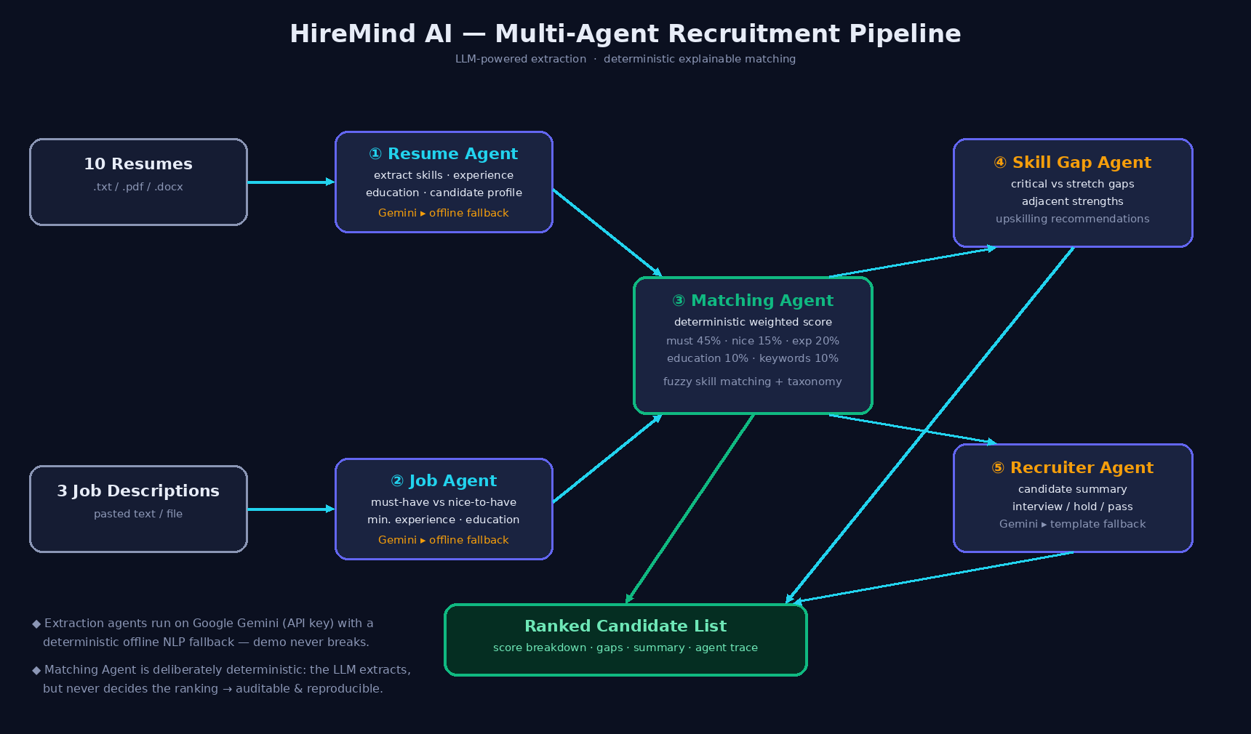
Figure 0 — Five-agent pipeline: LLM-powered extraction around a deterministic, explainable matching core.
Field | Details
Problem Statement | PS03 — Multi-Agent Resume Screening & Job Matching Platform
Technology Category | NLP + LLM + Agentic AI
Team | [YOUR TEAM NAME] — [MEMBERS]
Hackathon | [HACKATHON NAME]
Date / Version | 20 Sept 2026 · v2.0 (final)

1. Executive Summary
HireMind AI is a multi-agent recruitment platform that screens resumes against job descriptions and produces ranked, fully explainable candidate–role matches. Five cooperating agents — Resume, Job, Matching, Skill Gap and Recruiter — mirror a human recruiting team at machine speed.
Architectural signature: “LLM extracts, never decides.” Google Gemini (optional, user-supplied key) performs information extraction and summarisation; the ranking decision is produced by a deterministic weighted engine, giving reproducible, auditable outcomes. A rule-based offline NLP layer makes the platform fully functional without any API key.
The intelligence layer is framework-agnostic: the identical agent codebase is served by two interchangeable backends — Python FastAPI and Django — behind one REST contract, with a React 18 frontend on top. The PS03 required demonstration (10 resumes × 3 job descriptions → ranked lists) passes end-to-end on both, verified by a 72-check automated QA suite (72/72 passing).
2. Problem Analysis
Manual resume screening is slow (≈7 seconds per resume at first pass), inconsistent between screeners, vocabulary-sensitive (“React.js” vs “React”), and opaque to candidates. We decomposed the problem into five sub-problems, each assigned to one agent:
Sub-problem | Agent responsible
P1 Heterogeneous resume formats (txt/pdf/docx, free text) | Resume Agent
P2 Ambiguous JDs (must-have vs nice-to-have separation) | Job Agent
P3 Multi-dimensional compatibility measurement | Matching Agent
P4 Actionable feedback on missing skills | Skill Gap Agent
P5 Explainability, reproducibility & trust | Deterministic core + Agent Trace

3. Research
3.1 Approaches surveyed
- Keyword/ATS matching — fast, brittle to synonyms.
- Embedding similarity — synonym-tolerant but opaque single score.
- LLM-only screening — expressive but non-reproducible and hard to audit.
- Hybrid agentic systems (2025–26 SOTA) — specialised agents around a deterministic decision core; adopted.
3.2 Design conclusions
- Extraction = language task → Gemini with deterministic fallback; all outputs normalised through a shared ~130-skill taxonomy (aliases: js→javascript, k8s→kubernetes, sklearn→scikit-learn).
- Ranking = decision task → published fixed weights; fuzzy matching (containment + difflib ≥ 0.85) removes vocabulary false-negatives.
3.3 Datasets
Kaggle/Hugging Face resume & JD corpora surveyed for scale-up; demonstration uses a fully synthetic 10+3 dataset (no participant data, per PS03). Any real dataset adopted later will have license/version/access conditions verified first, as the source note requires.
4. Proposed Solution
# | Agent | Output | Engine
1 | Resume Agent | Profile: canonical skills, experience, education, highlights | Gemini JSON-mode / offline heuristics
2 | Job Agent | Must-have / nice-to-have skills, min experience, education | Gemini JSON-mode / offline heuristics
3 | Matching Agent | 0–100 score, verdict, per-dimension breakdown | Deterministic (always)
4 | Skill Gap Agent | Critical & stretch gaps, adjacent strengths, learning plan | Deterministic rules
5 | Recruiter Agent | Summary + interview/hold/pass recommendation (parallelised) | Gemini / template

- Dual-mode resilience: identical schema from Gemini or offline path — the demo never breaks on stage.
- Single REST contract implemented twice (FastAPI, Django) over one shared agent codebase.
- Agent Trace: every match carries each agent's engine + full JSON output for audit.
5. Technical Flow & Scoring Model
- Intake → Extraction (Agents 1–2) → Weighted scoring (Agent 3) → Gap analysis (Agent 4) → Summary (Agent 5) → Ranked list + trace.
Dimension | Weight | Computation
Must-have skills | 45% | Fraction matched (fuzzy + taxonomy)
Nice-to-have skills | 15% | Fraction matched
Experience | 20% | 1.0 if ≥ required; 0.6×(cand/req) below; 0.75 unspecified
Education | 10% | Degree-rank comparison (PhD > Master > Bachelor > Diploma)
Keyword affinity | 10% | JD keywords found in resume text

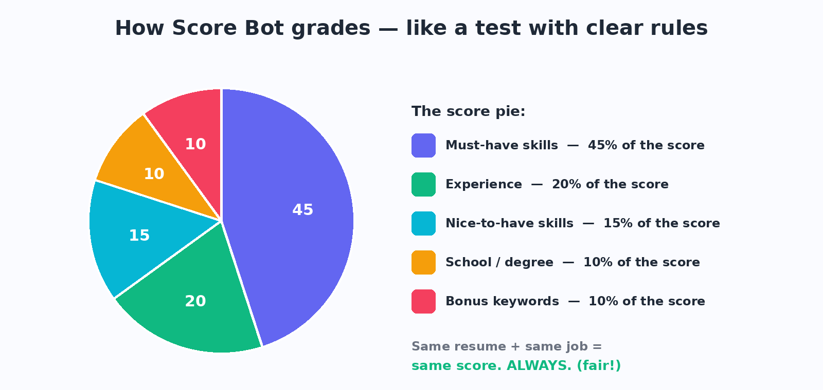
Figure 1 — The score pie: fixed, public slices; same input ⇒ same score, always.
Verdicts: ≥80 Strong · 60–79 Good · 40–59 Partial · <40 Weak. Weights renormalise when a dimension is absent.
6. PROJECT FEATURES
6.1 Core platform features
- Multi-agent AI pipeline — 5 specialised agents (Resume, Job, Matching, Skill Gap, Recruiter) working in sequence.
- Ranked candidate lists — 10 resumes × 3 job descriptions produce sorted, verdict-badged rankings (Strong/Good/Partial/Weak).
- Explainable scores — every 0–100 score decomposes into 5 published weighted dimensions with plain-language notes.
- Skill-gap analysis — critical vs nice-to-have gaps, adjacent strengths, and a concrete upskilling plan per candidate.
- Recruiter summaries — human-readable notes with interview / hold / pass recommendations.
- Agent Trace panel — raw input/output JSON of every agent for any match (full auditability).
- Resume intake — upload .txt / .pdf / .docx or paste text; JDs by paste; per-document engine badge.
- One-click demo dataset — loads the exact PS03 demonstration (10 resumes + 3 JDs) instantly.
- Gemini integration — optional Google Gemini 2.5 Flash extraction/summaries via Settings (key stays in the browser, never hard-coded).
- Offline / no-AI mode — deterministic fallback so the app works with zero keys and zero internet.
6.2 Engineering features
- Dual backend — the same agents + same REST API run on FastAPI (:8000) and Django (:8001); health endpoint reports the flavour.
- Deterministic & reproducible — identical inputs ⇒ identical scores/ordering, every run.
- Fairness by design — scoring never sees names, photos, ages or genders; alias + fuzzy matching removes terminology bias.
- Shared 130-skill taxonomy — single contract normalising LLM output and heuristic scans.
- Parallel recruiter summaries — thread pool keeps matching fast.
- Automated QA — test_pipeline.py + test_everything.py = 72 checks across both backends, all passing.
- Dark, judge-ready React dashboard — tabs, animated pipeline strip, score bars, ✓/✗ chips.
- Production-style delivery — FastAPI/Django serve the built React app; Vite dev proxy for hot reload.
7. Technology Stack
Layer | Technology | Rationale
Frontend | React 18 + Vite | Agent cards, ranked lists, explainable panels; HMR dev
Backend A | Python 3 + FastAPI (Uvicorn) | Async REST, OpenAPI docs, serves React build
Backend B | Django 6 (runserver/WSGI) | Same API contract; proves framework-agnostic agents
LLM | Google Gemini 2.5 Flash (REST) | JSON-mode extraction/summaries; user-supplied key
Offline NLP | Regex + 130-skill taxonomy + difflib | Deterministic fallback & alias normalisation
Parsing | pypdf · python-docx | Real-world resume formats
QA | test_pipeline.py · test_everything.py (72 checks) | Automated verification of both backends

7.1 Repository layout
backend/ FastAPI app + agents/* + skills_taxonomy + offline_extract + store + static/ (React build)
backend_django/ Django project (manage.py, hiremind/{settings,urls,views}) reusing backend/ agents
frontend/ React + Vite source (src/components/*, api.js)
data/resumes/ (10) · data/jobs/ (3) synthetic demo dataset
docs/ reports (PDF/DOCX), pitch deck (PPTX), diagrams, screenshots
test_pipeline.py · test_everything.py
8. REST API (identical on both backends)
Endpoint | Purpose
POST /api/resumes · /api/resumes/upload | Register resumes (paste or multipart files) → Agent 1
POST /api/jobs | Register JD → Agent 2
POST /api/demo/load | Load 10-resume / 3-JD demo set
POST /api/match {job_id} | Agents 3–5 over all candidates → ranked list + traces
POST /api/reextract · POST /api/settings | Re-extraction with Gemini · key/model config
GET /api/agents · /api/health · /api/resumes · /api/jobs | Metadata, health (reports backend), listings
DELETE /api/resumes/{id} · /api/jobs/{id} · /api/reset | Housekeeping

9. Application Screenshots (captured live)
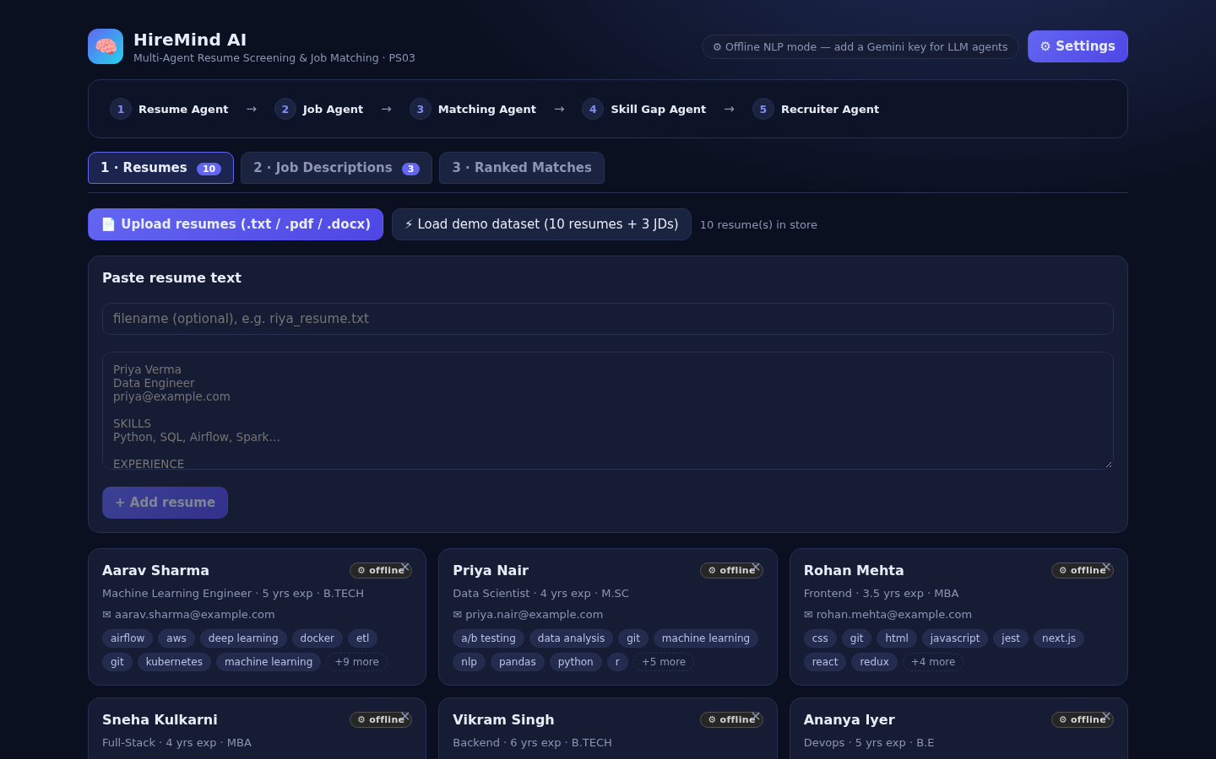
Figure 2 — Resume Agent output: 10 extracted candidate cards.

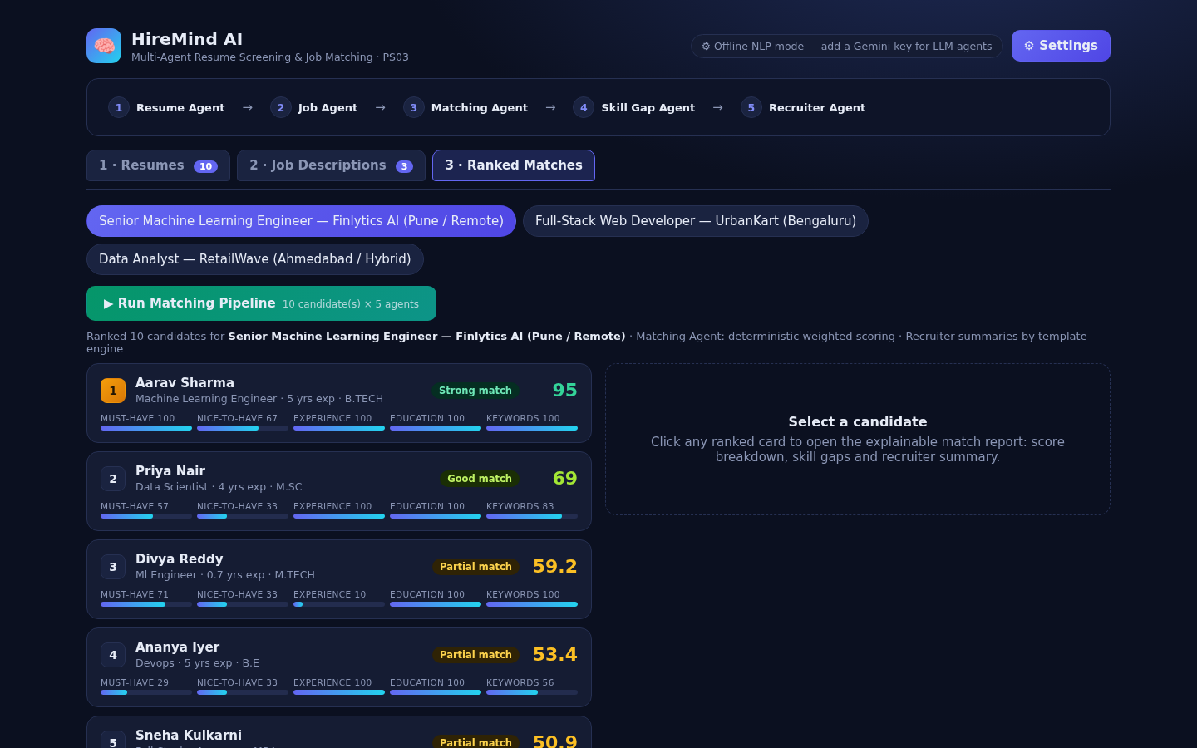
Figure 3 — Ranked list for Senior ML Engineer with verdict badges and score bars.
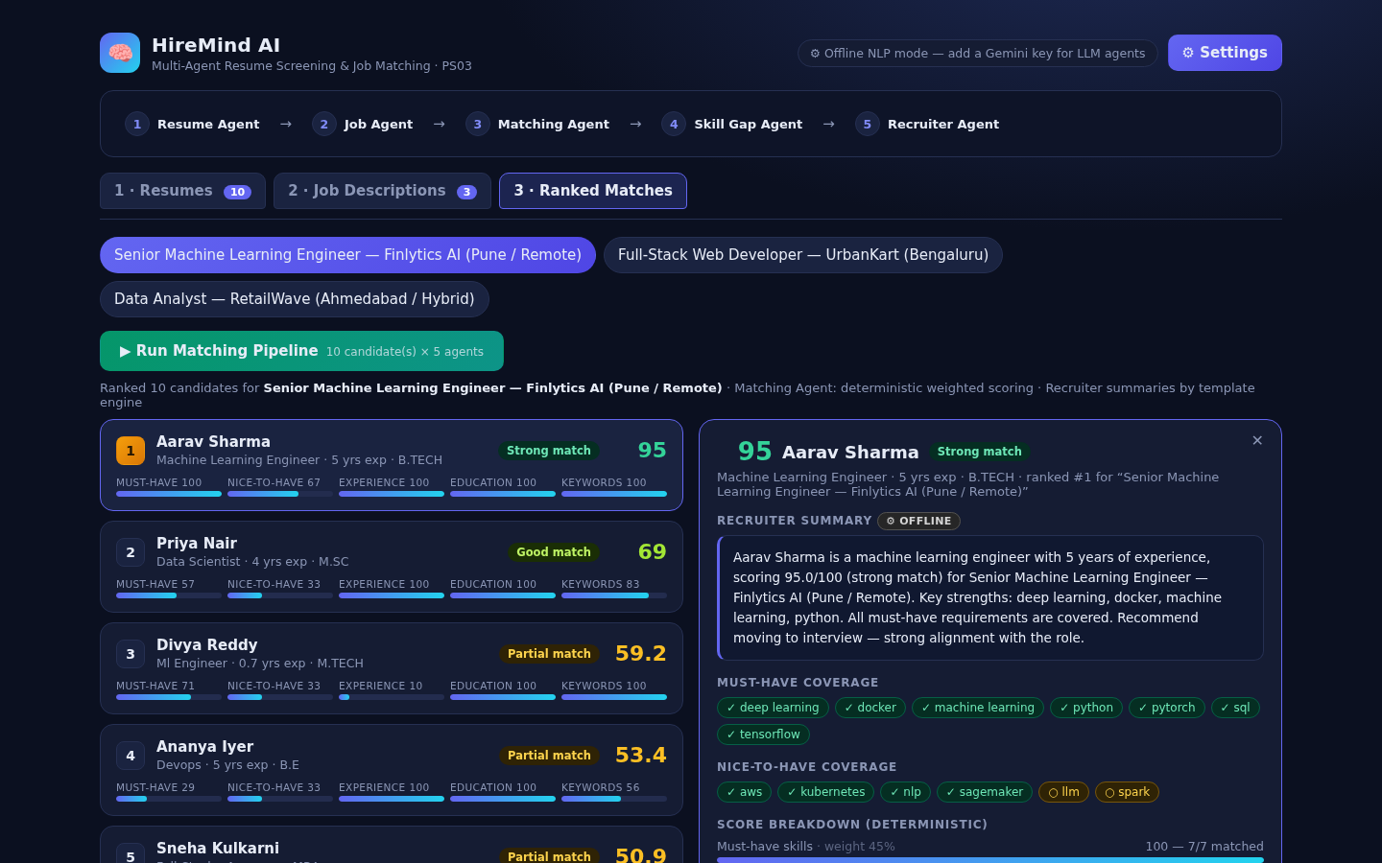
Figure 4 — Explainable match report: summary, ✓/✗ coverage, breakdown, gap plan, trace.
10. Verification & QA (72/72 passing)
Two suites run on both backends. Latest run: 72 passed, 0 failed.
Job | #1 | #2 | #3
Senior ML Engineer | Aarav Sharma — 95.0 Strong (7/7) | Priya Nair — 69.0 Good | Divya Reddy — 59.2 Partial
Full-Stack Developer | Sneha Kulkarni — 100.0 Strong (5/5) | Rohan Mehta — 81.0 Strong | Vikram Singh — 66.2 Good
Data Analyst | Karan Patel — 80.7 Strong | Priya Nair — 78.0 Good | Aarav Sharma — 46.7 Partial

- Identical rankings on FastAPI and Django — the agent layer is provably framework-independent.
- Error paths verified: unknown job/resume → 404; empty inputs → 400; reset/reextract flows pass.
- UI verified by headless-Chromium screenshots; report pages rendered and visually inspected.
11. Explainability, Fairness & Innovation
- Published weights + plain-language notes per dimension; Agent Trace exposes every agent's raw I/O.
- Scoring uses only skills/experience/education/keywords — never names, photos, ages, genders.
- Innovations: “LLM extracts, never decides”; dual-engine resilience; adjacency-aware gap analysis; shared taxonomy contract; dual-backend portability; one-click PS03 demo.
12. Limitations & Roadmap
- Offline heuristics extract fewer skills from very unstructured resumes (mitigated by dual mode).
- In-memory persistence → roadmap: SQLite/Postgres, match history, accounts.
- Roadmap: embedding similarity as 6th signal; layout-aware PDF parsing; multi-job comparison board; CSV/PDF export; fairness audits.
13. VIRTUAL ENVIRONMENT & SETUP
A Python virtual environment (venv) keeps all project dependencies isolated from your system Python. Follow these steps exactly:
13.1 Create the virtual environment (once)
# from the project root
python3 -m venv venv # Linux / macOS
python -m venv venv # Windows
13.2 Activate it (every new terminal)
source venv/bin/activate # Linux / macOS
venv\Scripts\activate # Windows (Command Prompt)
# you should see (venv) at the start of your prompt
13.3 Install dependencies inside (venv)
pip install -r backend/requirements.txt # fastapi, uvicorn, pypdf, python-docx, requests…
pip install django # for the Django backend
13.4 Run the servers (with venv active)
# FastAPI backend + React UI
cd backend && uvicorn main:app --host 0.0.0.0 --port 8000
# OR Django backend + same React UI (separate terminal)
cd backend_django && python manage.py runserver 0.0.0.0 --port 8001
13.5 Frontend development (Node — separate from venv)
cd frontend && npm install && npm run dev # Vite, /api proxied to :8000
13.6 Run the QA suite
python3 test_pipeline.py # end-to-end demo on :8000
python3 test_pipeline.py http://localhost:8001 # same on Django
python3 test_everything.py # full 72-check suite
13.7 When finished
deactivate # leaves the virtual environment
Tip for judging day: activate the venv, start one backend, open the shown URL, click “Load demo dataset”, then “Run Matching Pipeline”.
14. External / AI Resources (Disclosure)
- Google Gemini 2.5 Flash — optional runtime extraction/summaries via official REST API (user key, never hard-coded).
- AI-assisted development — Arena.ai Agent Mode assisted scaffolding/drafting; all design decisions and verification team-reviewed.
- Open-source: React, Vite, FastAPI, Django, python-docx, pypdf, Pillow, reportlab, python-pptx, Playwright, difflib.
- Demo data 100% synthetic; no participant data collected (per PS03).
15. References
- [1] Gemini API — ai.google.dev · [2] FastAPI — fastapi.tiangolo.com · [3] Django — djangoproject.com
- [4] React — react.dev · [5] Vite — vite.dev · [6] pypdf / python-docx docs
- [7] Python difflib — docs.python.org · [8] Python venv docs — docs.python.org/3/library/venv.html
- [9] Kaggle & Hugging Face resume/JD datasets (surveyed; verify licenses before use)

