HireMind AI
The Robot Team that Matches People to Jobs
Project Report · Hackathon Problem PS03 · explained so simply a 10-year-old gets it
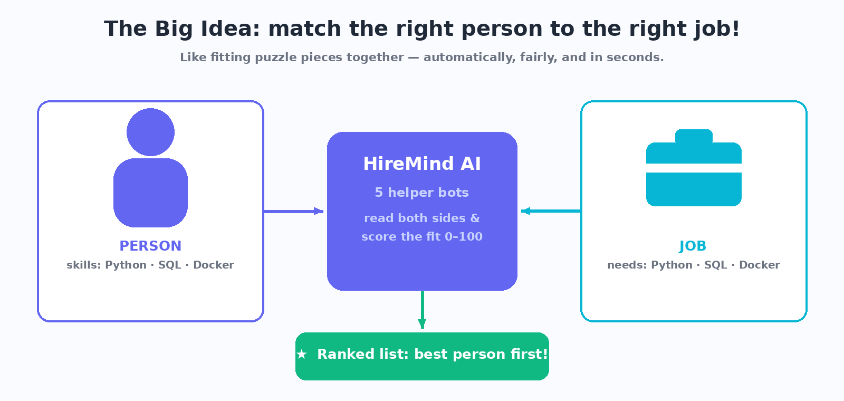
A person's skills and a job's needs are like two puzzle pieces — HireMind AI measures how well they fit.
Team | [YOUR TEAM NAME] — [MEMBERS]
Hackathon | [HACKATHON NAME]
Category | NLP + LLM + Agentic AI
Date | 20 Sept 2026

What's inside
- 1. The Problem — imagine a teacher with 300 homework sheets
- 2. Our Solution — 5 helper bots working like a relay race
- 3. The Score Pie — grading with fixed, visible rules
- 4. A Real Example — Priya vs the ML Engineer job
- 5. Why It Is Fair — two brains: AI reads, math decides
- 6. Try It in 3 Clicks + Who Wins? Everybody!
- 7. The Real App — actual screenshots
- 8. Demo Results — 10 resumes × 3 jobs, ranked
- 9. Tech Stack, What's Next & Honesty Box
- Appendix — the grown-up technical details for judges
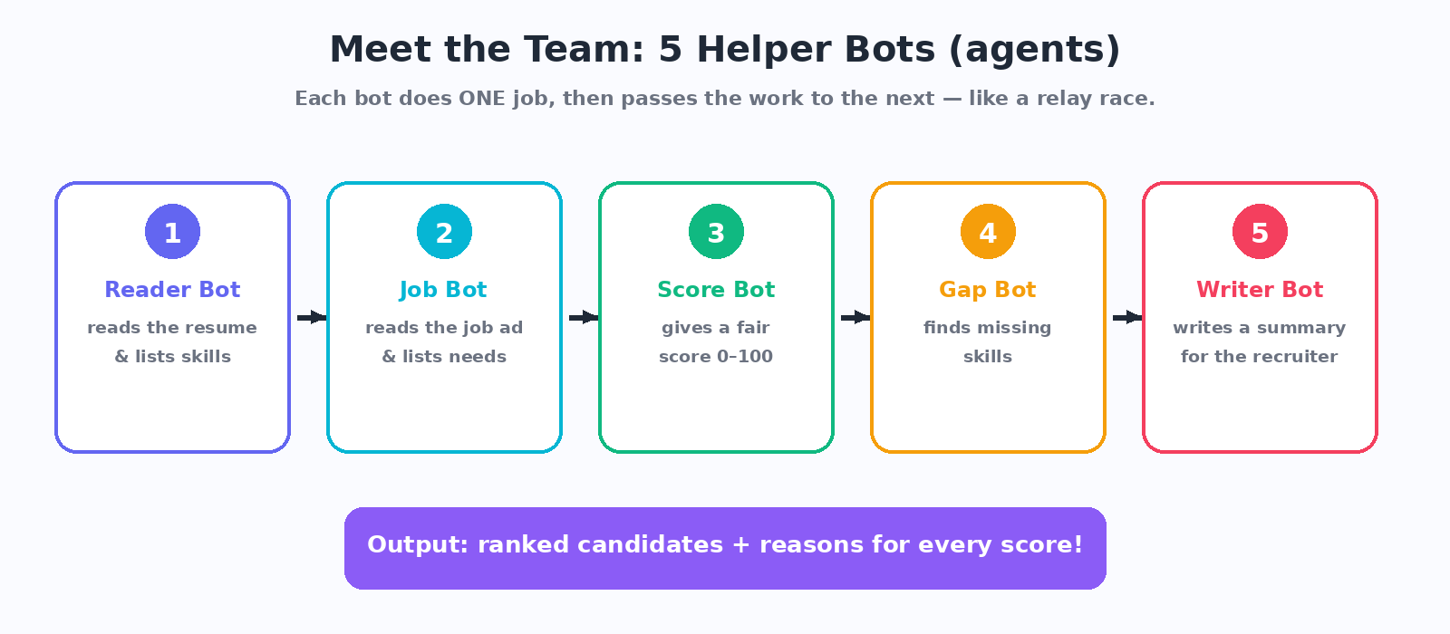
The five agents, one after another — the heart of the whole project.

1. The Problem (imagine this!)
Imagine a teacher who must check 300 homework sheets in one night. That is a recruiter: one job ad can bring hundreds of resumes, and they can look at each for only about 7 seconds.
So three bad things happen:
- Good people get missed just because they wrote a skill differently ("React.js" vs "React").
- Two recruiters can judge the same resume differently — not fair, not consistent.
- Nobody explains why someone was rejected.
Our mission: build a computer team that reads every resume carefully, scores it with clear public rules, and always explains why.
2. Our Solution: 5 Helper Bots
We built HireMind AI: five small programs called agents (think helper robots). Each does one job and passes the work on, like a relay race:
- Reader Bot reads a resume → tidy list of skills, years of practice, school.
- Job Bot reads the job ad → what the job MUST have vs what is extra-nice.
- Score Bot compares both lists → score 0–100 with fixed rules.
- Gap Bot finds missing skills → suggests what to learn next, like a game skill tree.
- Writer Bot writes a friendly summary for the recruiter.
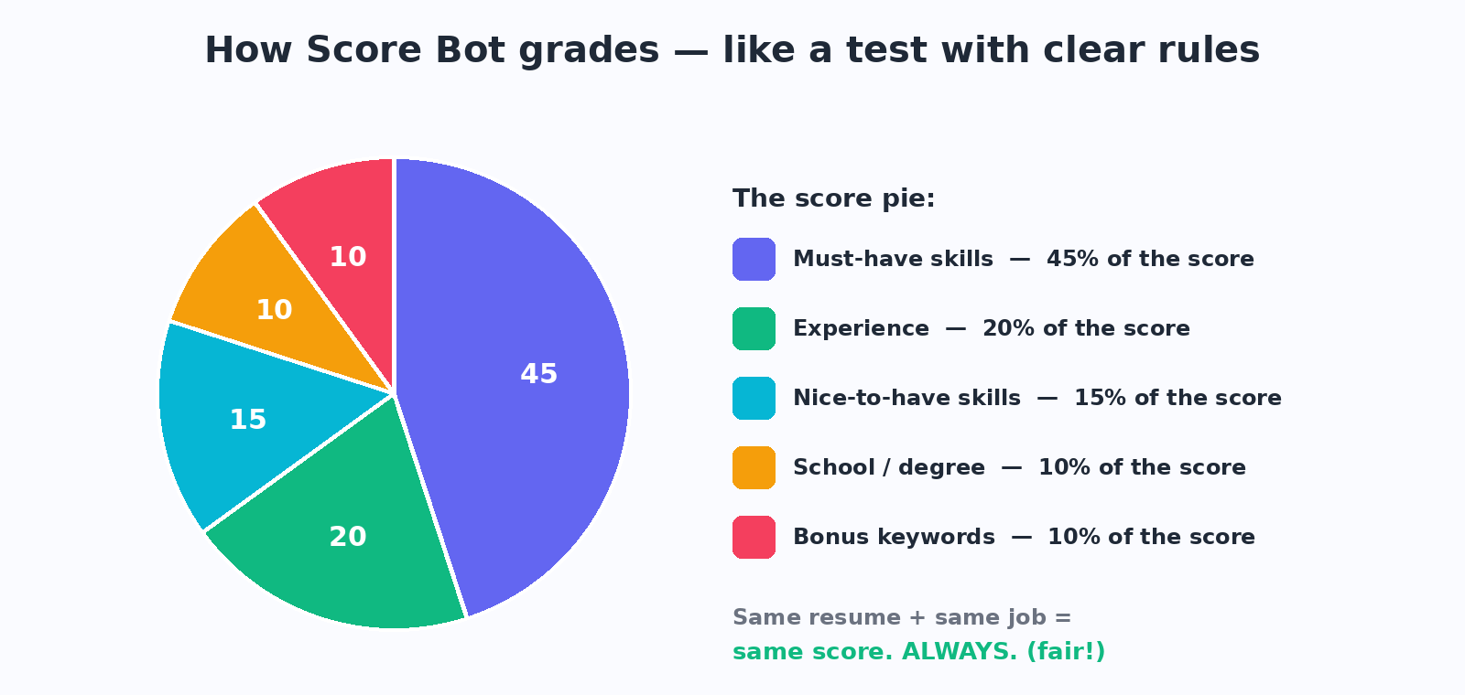
The score is a pie with fixed slices — everyone can see exactly how points are earned.

3. A Real Example from Our Demo
We tested with 10 made-up resumes and 3 made-up job ads. Here is one real match, exactly as the bots computed it:
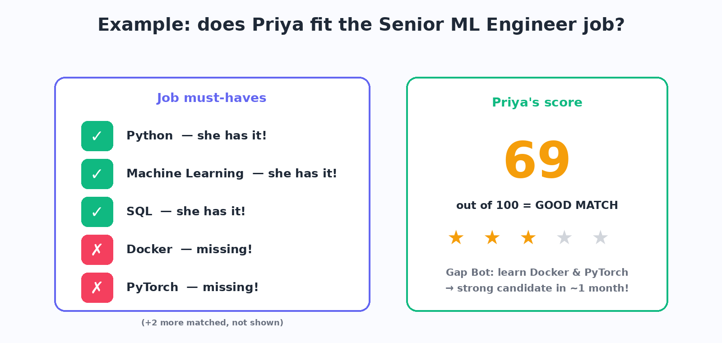
Priya has Python, ML and SQL but no Docker/PyTorch → 69/100 = Good match, plus a learning plan from Gap Bot.
See the magic? A “no” becomes a to-do list: learn Docker and PyTorch, and she becomes a strong candidate.
4. Why It Is Fair and Trustworthy
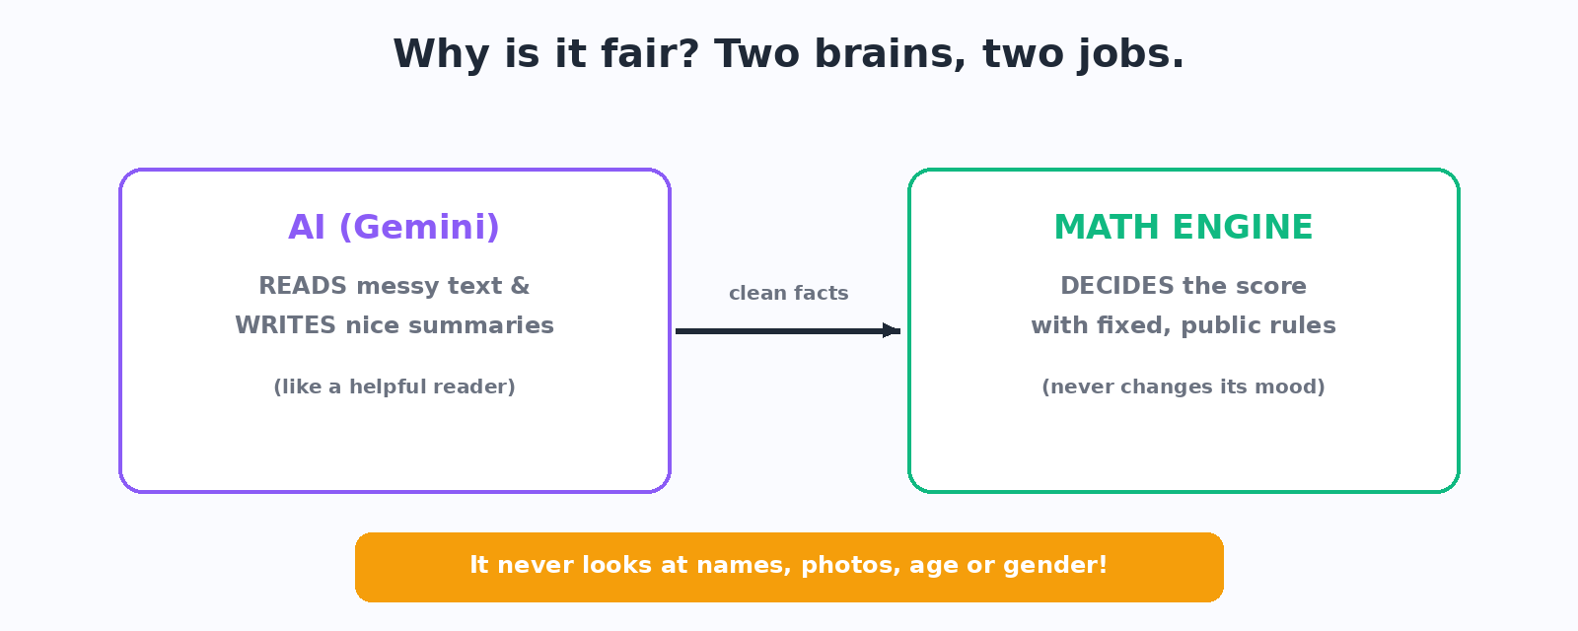
The AI reads and writes. The math decides. Nobody can argue with public, fixed rules.
- It never looks at names, photos, age or gender — only skills, practice and school.
- "React.js", "ReactJS" and "React" count as the same skill (dictionary of 130+ skills).
- Every score shows its working: ✓ matched skills, ✗ missing ones, points per slice.
- Even if the internet or the AI dies, the app still works — a built-in “no-AI” mode.

5. Try It in 3 Clicks — and Who Wins? Everybody!
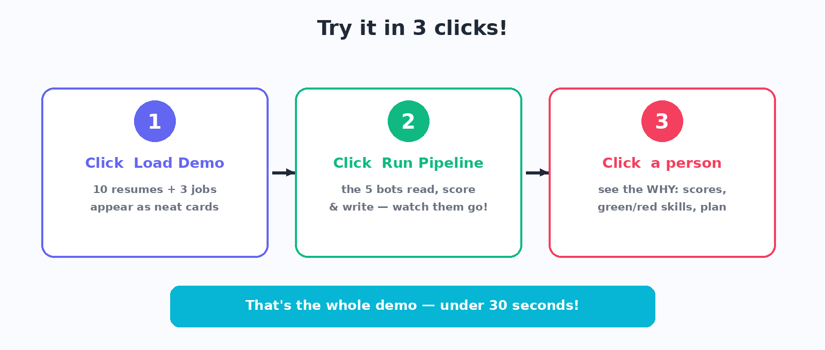
The whole live demo takes under 30 seconds — perfect for judging.
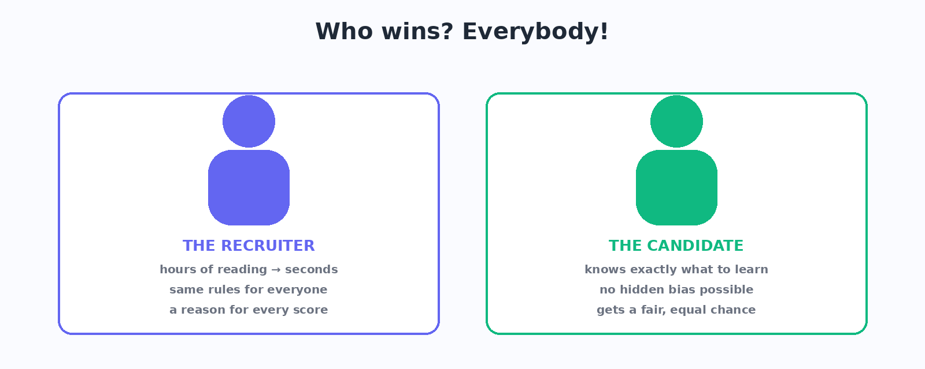
Recruiters save hours and stay fair; candidates get reasons and a learning path.
6. The Real App (actual screenshots)
Everything above is a real working website: a React screen in front, a Python brain behind.
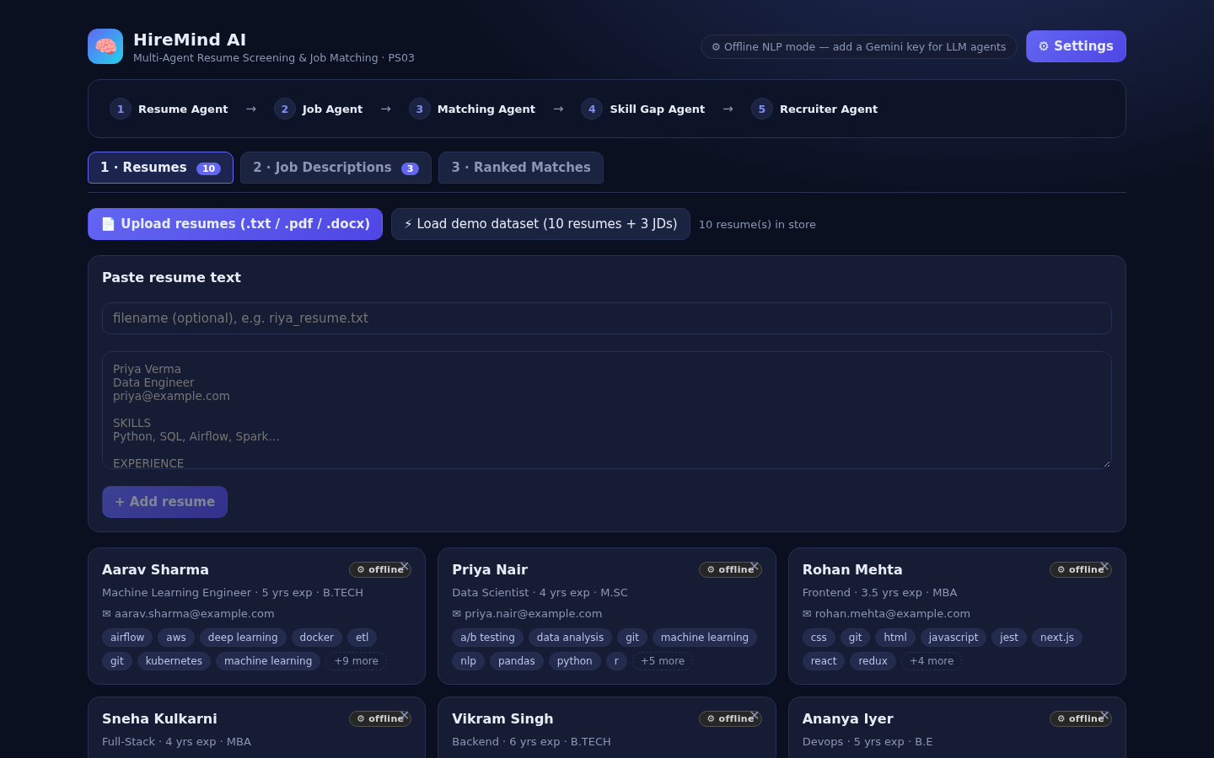
Reader Bot finished: 10 resumes turned into neat cards with skills, years and school.

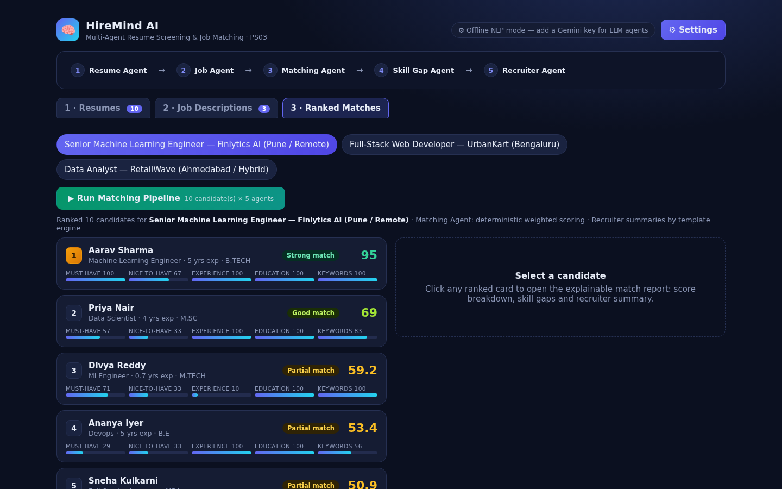
Ranked list for “Senior ML Engineer”: best match on top, mini score bars on every card.
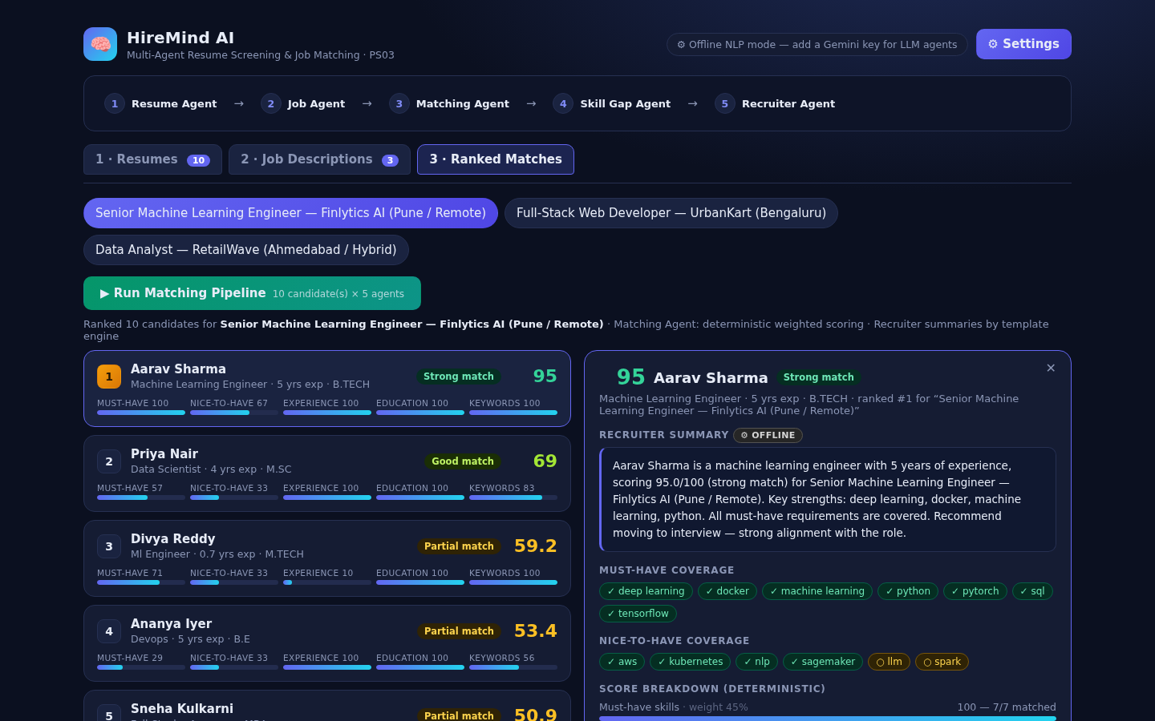
Click a person → the full WHY: green ✓ skills, red ✗ gaps, recruiter note, every bot's work.

7. Demo Results (10 resumes × 3 jobs)
Job | #1 (best) | #2 | #3
Senior ML Engineer | Aarav — 95 Strong | Priya — 69 Good | Divya — 59 Partial
Full-Stack Developer | Sneha — 100 Strong | Rohan — 81 Strong | Vikram — 66 Good
Data Analyst | Karan — 80.7 Strong | Priya — 78 Good | Aarav — 46.7 Partial
Common sense wins: the ML person tops the ML job, the web person tops the web job, the analyst tops the analyst job. A brand-new graduate scores lower on the senior job because practice years count — just like real life.
8. What We Built It With (tech stack)
Part | Tool | In kid words
Front screen | React + Vite | The colorful website you click
Back brain | Python + FastAPI | The kitchen where bots cook
AI reader/writer | Google Gemini 2.5 Flash | Smart helper for messy text (optional)
No-AI mode | Rules + skill dictionary | Backup brain so the demo never breaks
File readers | pypdf · python-docx | Opens PDF and Word resumes
- Folders: backend/ the 5 bots · frontend/ React screens · data/ 10 resumes + 3 jobs · docs/ report, slides, pictures.
9. What's Next & Honesty Box
- Next: save results in a database, compare jobs side-by-side, export PDF lists for recruiters.
- Honesty: demo data is 100% made-up (no real people). Gemini is used only when a key is added. An AI coding assistant helped us type faster — the team chose every rule and checked every result.
- Judges: the grown-up details (weights, API, references) are in the appendix.

Appendix — Technical Details (for judges)
Scoring weights: must-have 45% · nice-to-have 15% · experience 20% · education 10% · keywords 10% (renormalised when a dimension is absent). Fuzzy skill match = alias dictionary + containment + difflib ratio ≥ 0.85. Verdicts: ≥80 Strong, 60–79 Good, 40–59 Partial, <40 Weak. Deterministic ⇒ reproducible.
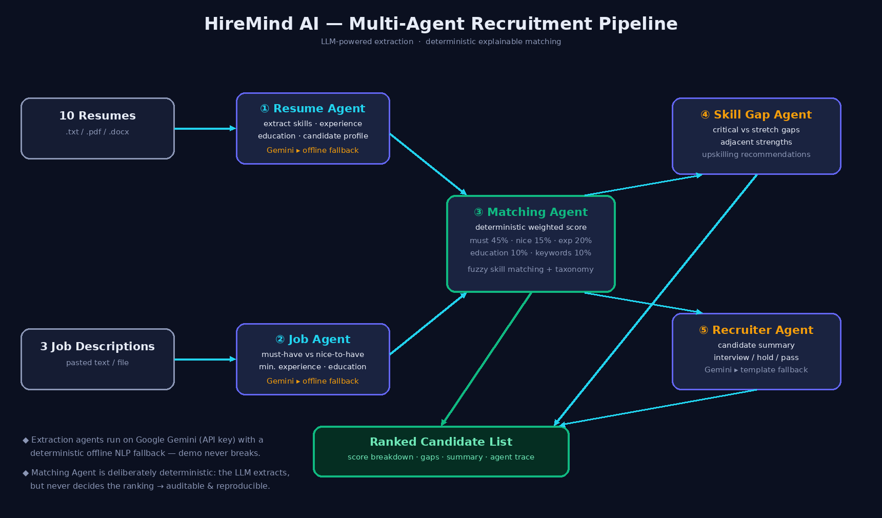
Full technical architecture: Gemini/offline extraction feeds deterministic Matching, Skill Gap and Recruiter agents.
API | What it does
POST /api/resumes[/upload] · /api/jobs | Register documents → Agents 1 & 2
POST /api/demo/load | Load the 10 + 3 demo dataset
POST /api/match {job_id} | Agents 3–5 → ranked list + traces
POST /api/reextract | Re-run extraction after adding a Gemini key
References: [1] Gemini API — ai.google.dev · [2] FastAPI — fastapi.tiangolo.com · [3] React — react.dev · [4] Vite — vite.dev · [5] python-docx / pypdf docs · [6] Python difflib · [7] Kaggle & Hugging Face resume/JD datasets (surveyed; verify licenses before use).
Run it: cd backend && pip install -r requirements.txt && uvicorn main:app --host 0.0.0.0 --port 8000 → open http://localhost:8000 → Load demo dataset → Run Matching Pipeline.

