LAB EXPERIMENT RECORD
Set 1: Monthly Sales Data

Department | AIDS
Course Code / Course Name | DSA0602/ Data Handling and Visualization
Experiment | Data Visualization using R
Name | M Uday Kumar Reddy
Register Number | 192473022
Date | 29 September 2026
Day | Tuesday

Aim
To visualize monthly sales data using a line chart, bar chart, and scatter plot, and to build an interactive dashboard using R and Shiny.
Dataset: Monthly Sales
Month | Sales ($)
January | 15000
February | 18000
March | 22000
April | 20000
May | 23000

PROGRAM 1: Line Chart of Monthly Sales
Create a line chart to visualize the monthly sales. Label the axes and title the chart appropriately.
# Dataset
month <- c("January", "February", "March", "April", "May")
sales <- c(15000, 18000, 22000, 20000, 23000)
# Line Chart
plot(sales,
type = "o",
xaxt = "n",
xlab = "Month",
ylab = "Sales ($)",
main = "Monthly Sales",
col = "blue")
axis(1, at = 1:5, labels = month)
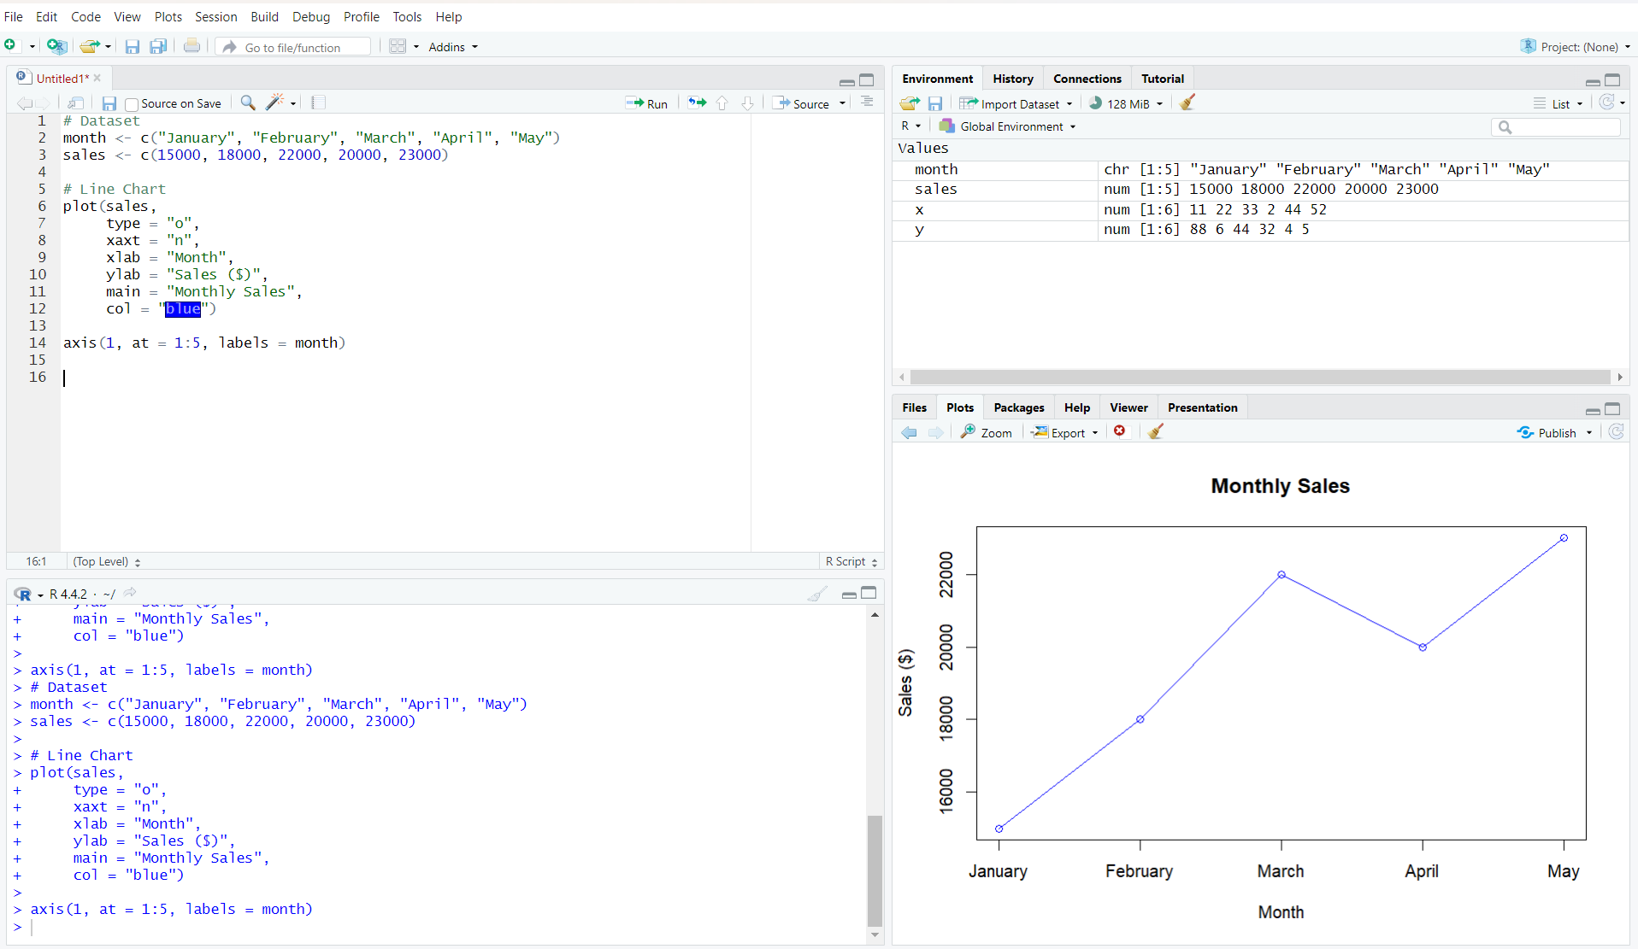
Output 1: Monthly Sales Line Chart
Observation: Sales increase from January to March, decrease slightly in April, and reach the highest value in May.

PROGRAM 2: Bar Chart of Sales
Generate a bar chart to display the sales values for the available months and label the chart elements.
# Dataset
month <- c("January", "February", "March", "April", "May")
sales <- c(15000, 18000, 22000, 20000, 23000)
# Bar Chart
barplot(sales,
names.arg = month,
xlab = "Month",
ylab = "Sales ($)",
main = "Monthly Sales",
col = "skyblue")
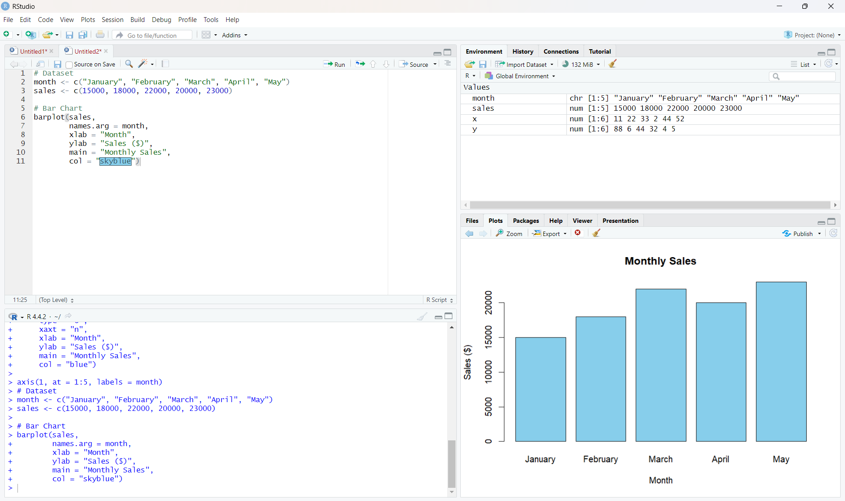
Output 2: Monthly Sales Bar Chart
Observation: The bar chart makes it easy to compare the sales of each month. May has the highest sales and January has the lowest.

PROGRAM 3: Scatter Plot of Advertising Budget vs Monthly Sales
Develop a scatter plot to explore the relationship between advertising budget and monthly sales.
# Dataset
sales <- c(15000, 18000, 22000, 20000, 23000)
advertising <- c(5000, 6000, 7000, 8000, 9000)
# Scatter Plot
plot(advertising, sales,
main = "Advertising Budget vs Monthly Sales",
xlab = "Advertising Budget ($)",
ylab = "Monthly Sales ($)",
pch = 19,
col = "red")
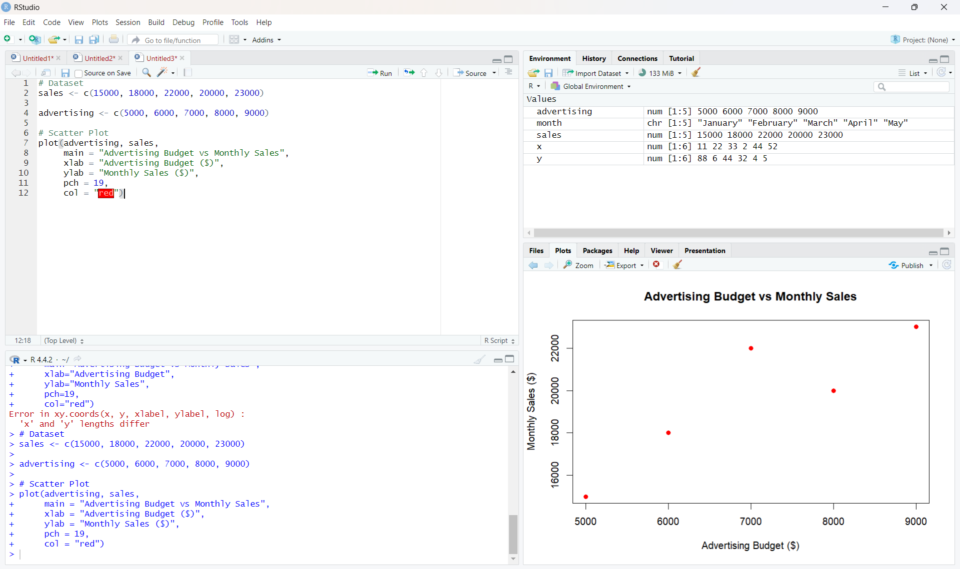
Output 3: Advertising Budget vs Monthly Sales Scatter Plot
Insight: The plotted points show a generally positive relationship: as the advertising budget increases from $5,000 to $9,000, monthly sales also generally increase. This suggests that higher advertising spending is associated with higher sales for the values plotted.
Note: The visible assignment table contains only Month and Sales. The advertising values used in the submitted R program are the five values shown in the user's executed program: 5000, 6000, 7000, 8000, and 9000.

PROGRAM 4: Interactive Sales Dashboard
Build an interactive dashboard combining the line chart and bar chart using the Shiny package.
library(shiny)
month <- c("January", "February", "March", "April", "May")
sales <- c(15000, 18000, 22000, 20000, 23000)
ui <- fluidPage(
titlePanel("Monthly Sales Dashboard"),
sidebarLayout(
sidebarPanel(
selectInput("chart",
"Select Chart:",
choices = c("Line Chart", "Bar Chart"))
),
mainPanel(
plotOutput("salesPlot")
)
)
)
server <- function(input, output) {
output$salesPlot <- renderPlot({
if (input$chart == "Line Chart") {
plot(sales,
type = "o",
xaxt = "n",
xlab = "Month",
ylab = "Sales ($)",
main = "Monthly Sales")
axis(1, at = 1:5, labels = month)
} else {
barplot(sales,
names.arg = month,
xlab = "Month",
ylab = "Sales ($)",
main = "Monthly Sales")
}
})
}
shinyApp(ui = ui, server = server)
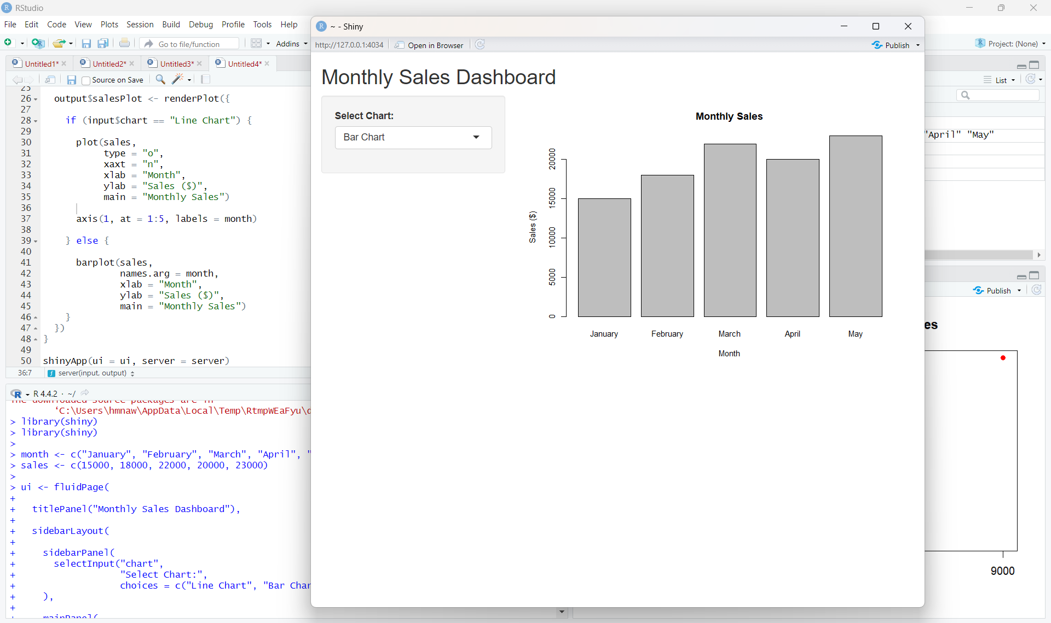
Output 4: Interactive Monthly Sales Dashboard
Observation: The dashboard provides a chart-selection control. Selecting Line Chart displays the monthly trend, while selecting Bar Chart displays the monthly sales comparison.

Procedure
1. Create the required month and sales vectors in R.
2. Use plot() to create the line chart with appropriate axis labels and title.
3. Use barplot() to compare the sales values for the available months.
4. Create advertising-budget and sales vectors of equal length and use plot() for the scatter plot.
5. Install and load the Shiny package, then create the UI and server components for the interactive dashboard.
6. Run the Shiny application and switch between the Line Chart and Bar Chart using the selection box.
Result
The monthly sales data was successfully visualized using line, bar, and scatter charts. An interactive Shiny dashboard was also created to switch between the line chart and bar chart.
Key R Functions Used
Function | Purpose
plot() | Creates line and scatter plots.
axis() | Adds custom axis labels.
barplot() | Creates bar charts.
fluidPage() | Creates the Shiny page layout.
selectInput() | Provides the chart selection control.
renderPlot() | Generates plots dynamically in Shiny.
shinyApp() | Runs the interactive Shiny application.

SET 2: CUSTOMER FEEDBACK ANALYSIS
Dataset: Customer Satisfaction
Dataset: Customer Satisfaction
Customer ID | Age | Satisfaction Score
1 | 25 | 4
2 | 30 | 5
3 | 35 | 3
4 | 28 | 4
5 | 40 | 5

PROGRAM 1: Histogram of Customer Ages
Create a histogram to represent the distribution of customer ages. Label the axes and title the chart.
# Dataset
age <- c(25, 30, 35, 28, 40)
# Histogram
hist(age,
main = "Distribution of Customer Ages",
xlab = "Age",
ylab = "Frequency",
col = "skyblue")
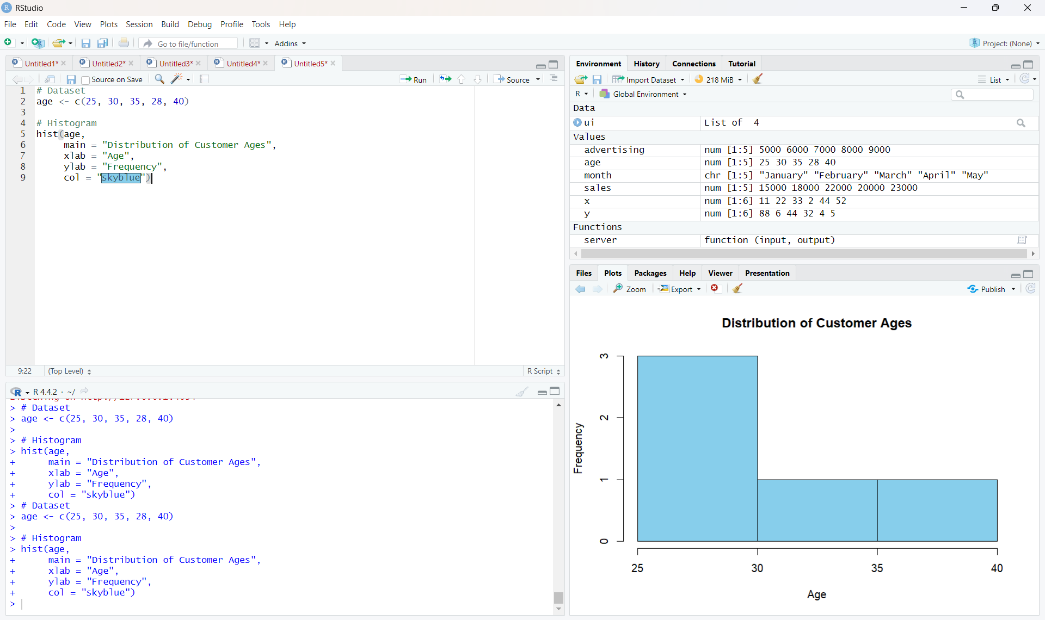
Output 1: Distribution of Customer Ages
Observation: The histogram represents the distribution of the five customer ages in the given dataset.
PROGRAM 2: Pie Chart of Satisfaction Scores
Generate a pie chart to display the overall distribution of customer satisfaction scores and include labels.
# Satisfaction scores
satisfaction <- c(4, 5, 3, 4, 5)
# Calculate frequency
score_count <- table(satisfaction)
# Pie Chart
pie(score_count,
labels = paste(names(score_count), "Score"),
main = "Customer Satisfaction Scores")
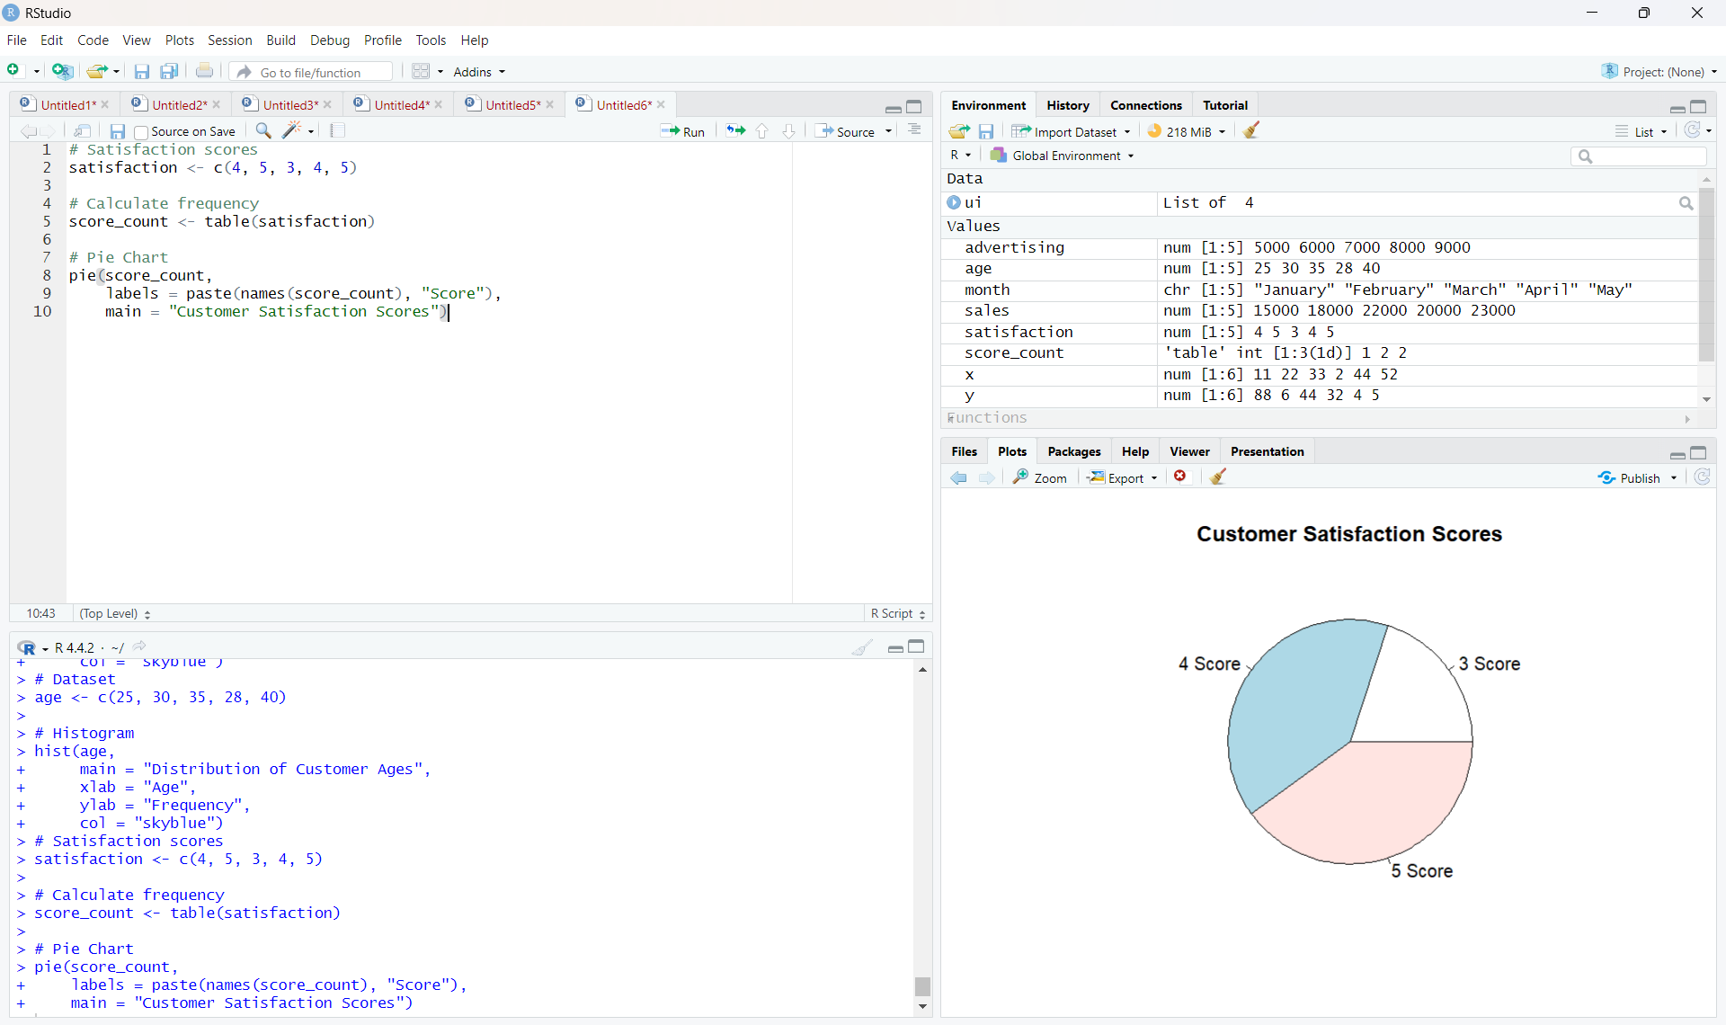
Output 2: Customer Satisfaction Scores Pie Chart
Observation: Scores 4 and 5 each occur twice, while score 3 occurs once.
PROGRAM 3: Stacked Bar Chart by Age Group
Build a stacked bar chart to visualize the distribution of customer satisfaction scores by age group.
# Dataset
age <- c(25, 30, 35, 28, 40)
satisfaction <- c(4, 5, 3, 4, 5)
# Create age groups
age_group <- cut(age,
breaks = c(20, 29, 39, 49),
labels = c("20-29", "30-39", "40-49"))
# Create table
data <- table(age_group, satisfaction)
# Stacked Bar Chart
barplot(data,
beside = FALSE,
main = "Satisfaction Scores by Age Group",
xlab = "Age Group",
ylab = "Number of Customers",
col = c("skyblue", "lightgreen", "orange"),
legend.text = TRUE)
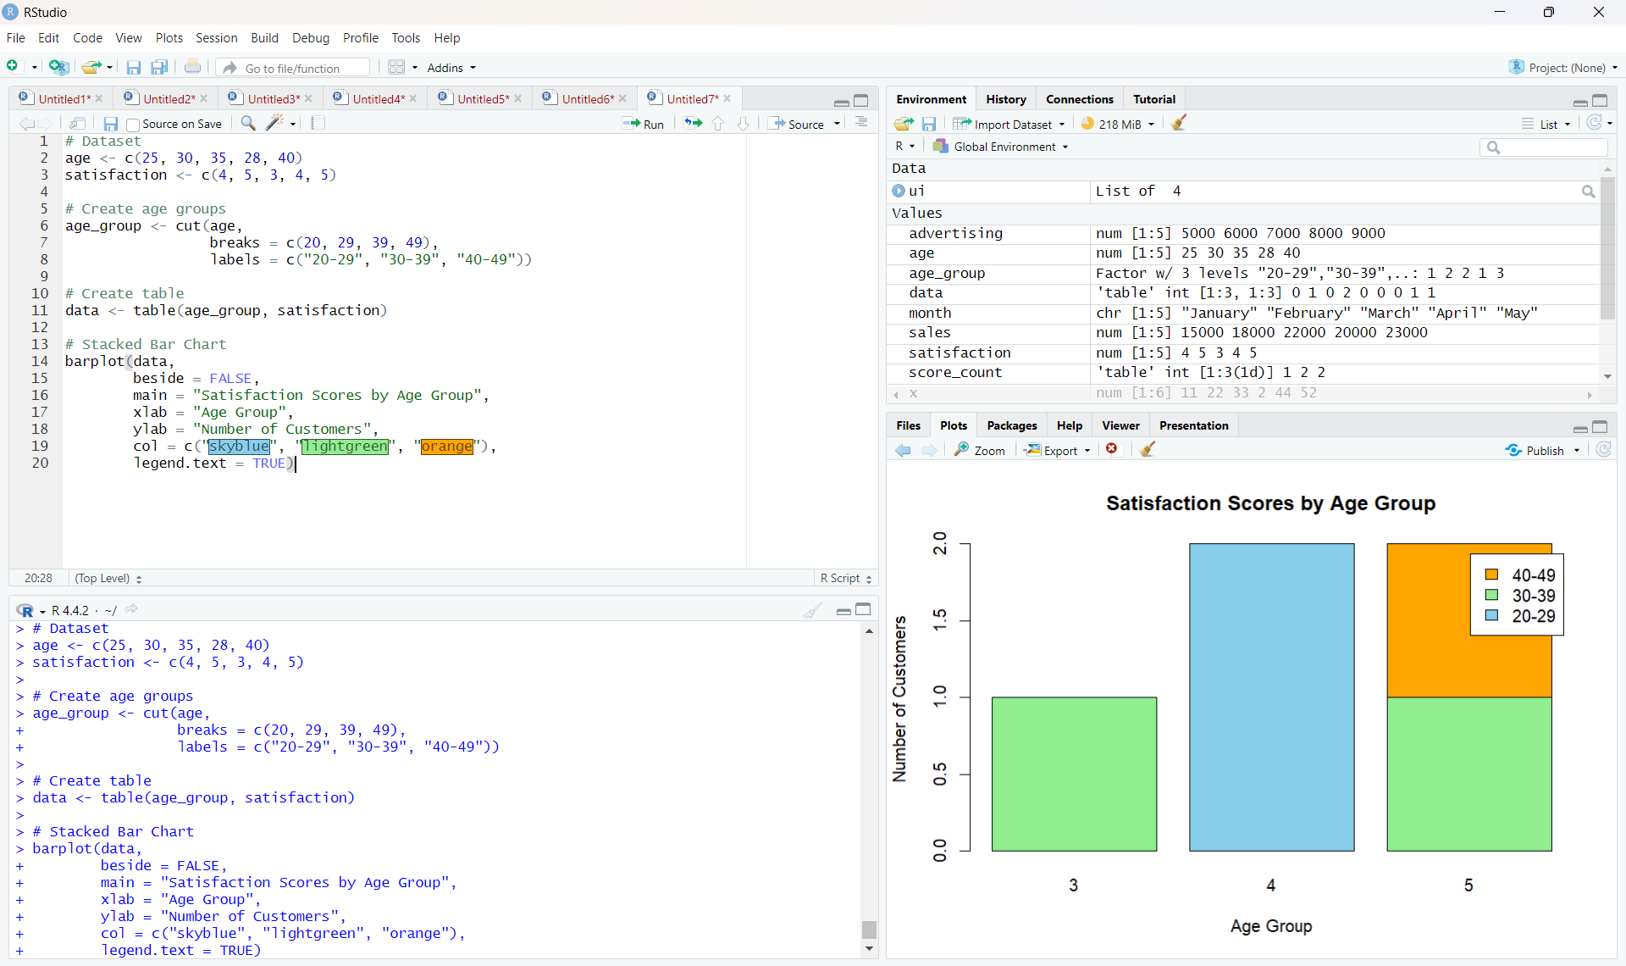
Output 3: Satisfaction Scores by Age Group
Observation: The code creates three age groups and stacks the satisfaction-score frequencies for each group.
Note: The supplied RStudio screenshot is inserted exactly as captured, including its displayed x-axis labels.
PROGRAM 4: Word Cloud of Customer Feedback
Develop a word cloud from open-ended customer feedback to identify prevalent customer sentiments.
library(wordcloud)
library(RColorBrewer)
feedback <- c(
"good service",
"excellent service",
"good experience",
"friendly staff",
"excellent service"
)
words <- unlist(strsplit(tolower(feedback), " "))
word_count <- table(words)
wordcloud(names(word_count),
freq = word_count,
min.freq = 1,
scale = c(3, 0.5),
colors = brewer.pal(8, "Dark2"),
random.order = FALSE)
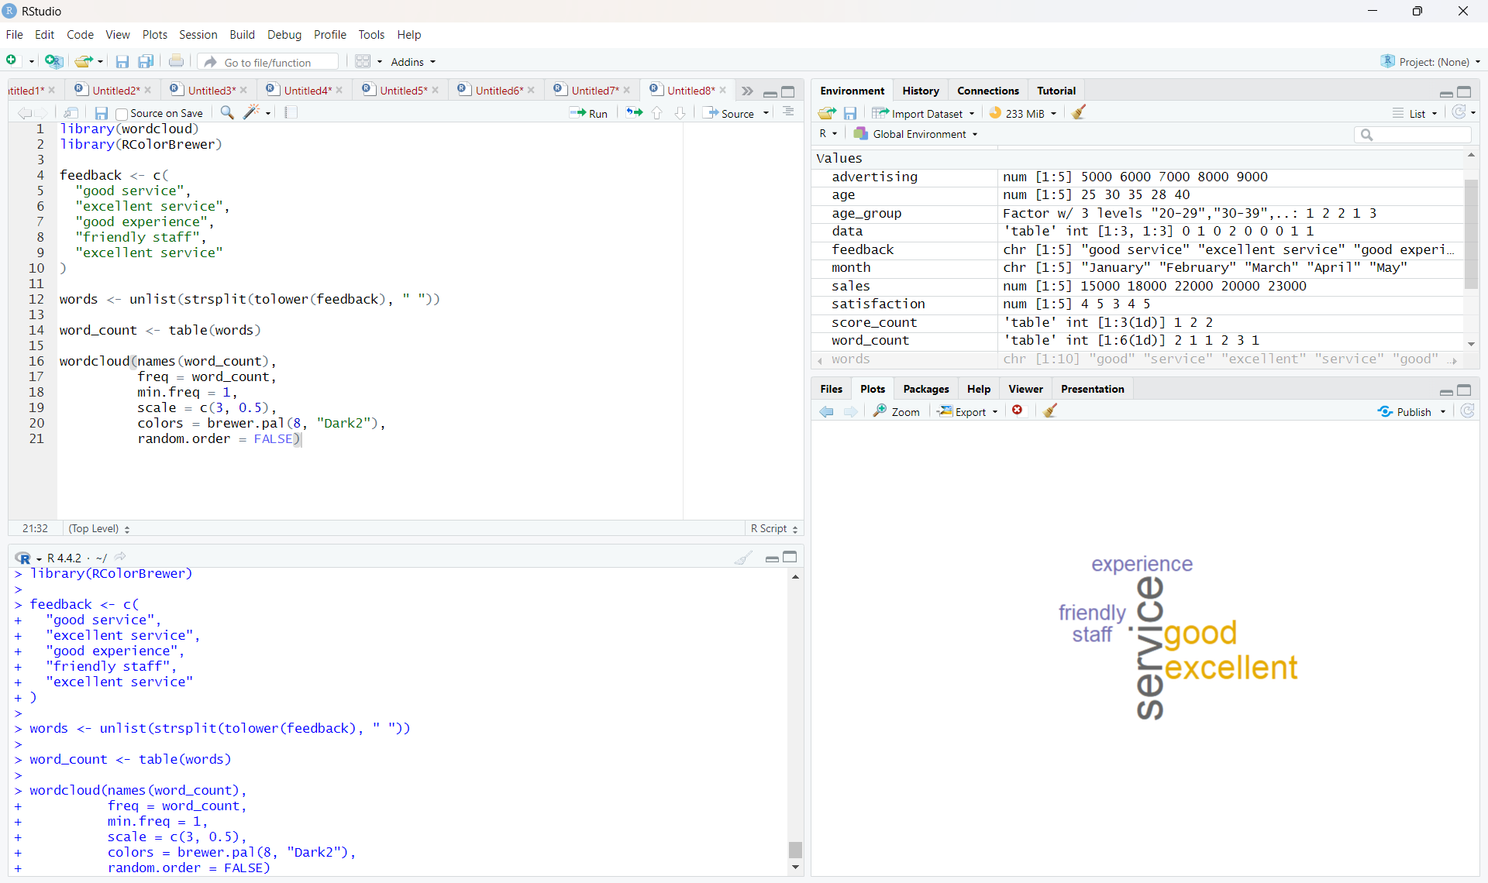
Output 4: Customer Feedback Word Cloud
Observation: The word cloud highlights frequently occurring terms in the supplied sample feedback, including service, excellent, good, friendly, and experience.
Set 2 Procedure
1. Create vectors for customer age and satisfaction score.
2. Use hist() to represent the distribution of customer ages.
3. Use table() and pie() to display the satisfaction score distribution.
4. Create age groups using cut(), form a frequency table, and use barplot() for the stacked bar chart.
5. Prepare open-ended feedback text, count the words, and use wordcloud() to visualize frequent terms.
Set 2 Result
The customer satisfaction data was successfully visualized using a histogram, pie chart, stacked bar chart, and word cloud.

SET 3: EMPLOYEE PERFORMANCE EVALUATION
Dataset: Employee Performance
Aim
To analyse employee performance data using a line chart, bar chart, and scatter plot in R, and to build an interactive dashboard in Tableau.
Dataset: Employee Performance
Employee ID | Department | Years of Service | Performance Score
1 | Sales | 5 | 85
2 | HR | 3 | 92
3 | Marketing | 7 | 78
4 | Sales | 4 | 90
5 | HR | 2 | 76

Supplementary Data: Monthly Sales
Month | Sales (in $)
January | 15000
February | 18000
March | 22000
April | 20000
May | 23000

PROGRAM 1: Line Chart of Employee Performance Trend
Create a line chart to visualize the performance trend of employees over time. Include a legend and labels.
# Dataset
employee_id <- c(1, 2, 3, 4, 5)
score <- c(85, 92, 78, 90, 76)
# Line Chart
plot(employee_id, score,
type = "o",
pch = 19,
col = "blue",
ylim = c(70, 100),
xlab = "Employee ID",
ylab = "Performance Score",
main = "Employee Performance Trend")
# Average line
abline(h = mean(score), col = "red", lty = 2)
# Legend
legend("topright",
legend = c("Performance Score", "Average Score"),
col = c("blue", "red"),
lty = c(1, 2),
pch = c(19, NA))
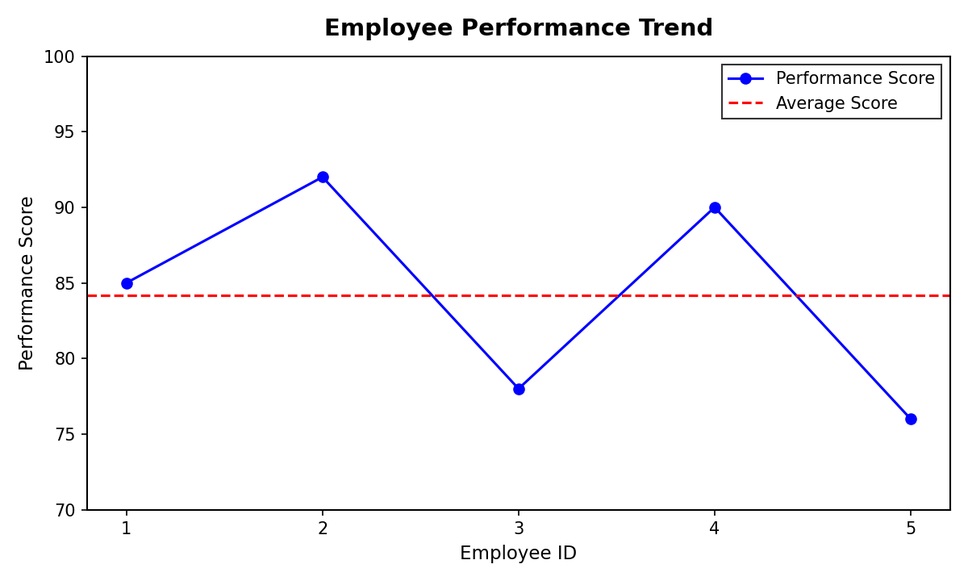
Output 1: Employee Performance Trend Line Chart
Observation: Performance is highest for Employee 2 (92) and lowest for Employee 5 (76). The scores rise from Employee 1 to Employee 2, fall to Employee 3, recover at Employee 4, and drop again at Employee 5. The average score is 84.2, shown by the red dashed line.
Note: The Employee Performance dataset has no date or month column, so the employees are plotted in Employee ID order to show the trend.

PROGRAM 2: Bar Chart of Employees by Department
Generate a bar chart showing the distribution of employees across different departments. Label the chart elements.
# Dataset
department <- c("Sales", "HR", "Marketing", "Sales", "HR")
# Count employees per department
dept_count <- table(department)
# Bar Chart
barplot(dept_count,
xlab = "Department",
ylab = "Number of Employees",
main = "Employees by Department",
col = "skyblue")
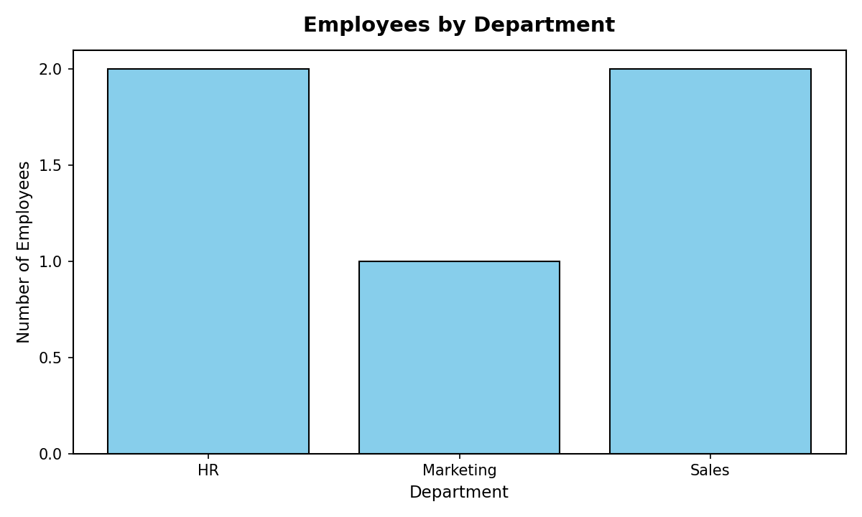
Output 2: Employees by Department Bar Chart
Observation: Sales and HR each have 2 employees, while Marketing has 1 employee.

PROGRAM 3: Scatter Plot of Years of Service vs Performance Score
Build a scatter plot to analyze the correlation between years of service and performance scores. Explain any insights.
# Dataset
years <- c(5, 3, 7, 4, 2)
score <- c(85, 92, 78, 90, 76)
# Scatter Plot
plot(years, score,
main = "Years of Service vs Performance Score",
xlab = "Years of Service",
ylab = "Performance Score",
pch = 19,
col = "red")
# Correlation coefficient
cor(years, score)
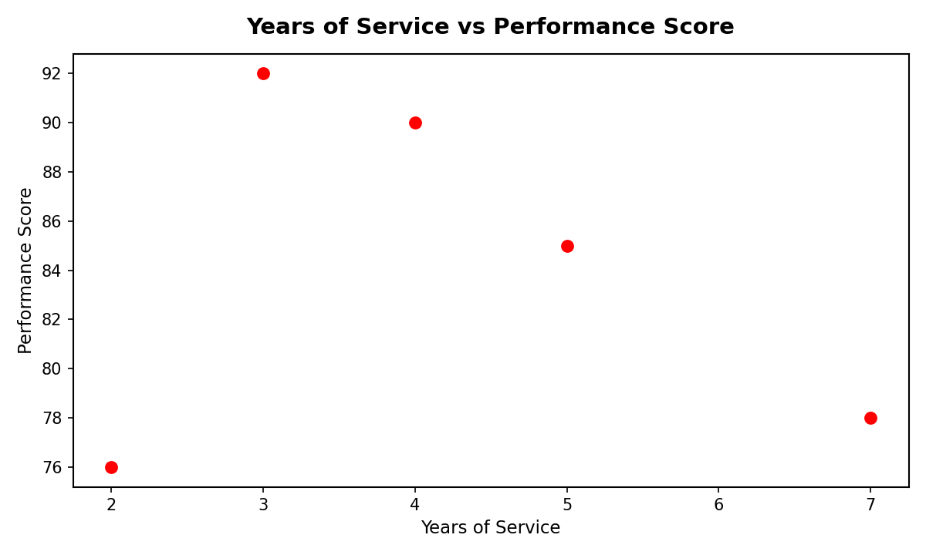
Output 3: Years of Service vs Performance Score Scatter Plot
Insight: The points do not form a clear upward or downward pattern. The correlation coefficient is about -0.17, which is very weak and slightly negative. Employees with more years of service do not necessarily have higher performance scores; for example, the employee with 7 years scored 78, while the employee with 3 years scored 92. With only five records, this result is only indicative, and no firm conclusion can be drawn about a relationship between experience and performance.

PROGRAM 4: Tableau Dashboard for Employee Performance
Develop a Tableau dashboard with the line chart and bar chart for interactive exploration.
Steps in Tableau:
1. Save the Employee Performance dataset as an Excel or CSV file (columns: Employee ID, Department, Years of Service, Performance Score).
2. Open Tableau, choose Connect > Microsoft Excel / Text file, and load the file. Open Sheet 1.
3. Sheet 1 (Line Chart): drag Employee ID to Columns and Performance Score to Rows (use SUM or AVG). Choose the Line mark type, add Department to Color, and add labels for the axes and a title, "Employee Performance Trend".
4. Sheet 2 (Bar Chart): drag Department to Columns and Employee ID to Rows, then change the measure to Count (Distinct). Choose the Bar mark type and title it "Employees by Department".
5. Create a new Dashboard. Drag Sheet 1 and Sheet 2 onto the dashboard area and arrange them side by side.
6. For interactivity, click the bar chart, select "Use as Filter", and add a Department filter (Show Filter) so that selecting a department updates the line chart.
7. Give the dashboard a title, "Employee Performance Dashboard", and save the workbook.

Insert Tableau dashboard screenshot here (Output 4)
Output 4: Employee Performance Tableau Dashboard
Observation: The dashboard shows the performance trend and the department distribution together. Selecting a department in the bar chart filters the line chart, allowing performance to be explored by department.
Set 3 Procedure
1. Create vectors for employee ID, department, years of service, and performance score.
2. Use plot() with type = "o", then abline() and legend() to create the line chart with a legend and labels.
3. Use table() and barplot() to show the number of employees in each department.
4. Use plot() for the scatter plot and cor() to measure the correlation between years of service and performance score.
5. Connect the dataset in Tableau, build the line chart and bar chart sheets, and combine them in a dashboard with filters.
Set 3 Result
The employee performance data was successfully visualized using a line chart, bar chart, and scatter plot in R. A Tableau dashboard combining the line chart and bar chart was created for interactive exploration.
Key Functions Used
Function / Tool | Purpose
plot() | Creates line and scatter plots.
abline() | Adds a horizontal reference line (average).
legend() | Adds a legend to the plot.
table() | Counts employees in each department.
barplot() | Creates the department bar chart.
cor() | Calculates the correlation coefficient.
Tableau Dashboard | Combines sheets with filters for interactive exploration.

