LAB EXPERIMENT RECORD

Set 9: Online Learning Activity Analysis

Department | CSE-DS
Course Code / Course Name | DSA0602 / Data Handling and Visualization
Experiment | Data Visualization using R and Tableau
Name | M Uday Kumar Reddy
Register Number | 192473022
Date | 3 October 2026
Day | Saturday
Aim
To analyze online learning activity by visualizing quiz score distribution, relationships between study time, videos watched and quiz score, and monthly quiz score trends using R, and to build an interactive mini dashboard in Tableau.
Dataset: Online_Learning_Activity.csv

Student_ID | Gender | Age | Course | Study_Time (hrs) | Videos_Watched | Quiz_Score | Login_Date
L01 | Male | 20 | R | 3.5 | 12 | 78 | 2025-01-05
L02 | Female | 22 | R | 4.2 | 15 | 85 | 2025-01-05
L03 | Male | 19 | SQL | 2.0 | 8 | 65 | 2025-02-08
L04 | Female | 21 | R | 5.0 | 18 | 92 | 2025-02-08
L05 | Male | 23 | R | 2.5 | 9 | 70 | 2025-03-12
L06 | Female | 20 | SQL | 4.0 | 14 | 88 | 2025-03-12

PROGRAM 1: Histogram and Boxplot of Quiz Score
Import the dataset in R. Plot a histogram for Quiz_Score. Draw a boxplot of Quiz_Score by Course. Add title and labels. Interpret student performance.
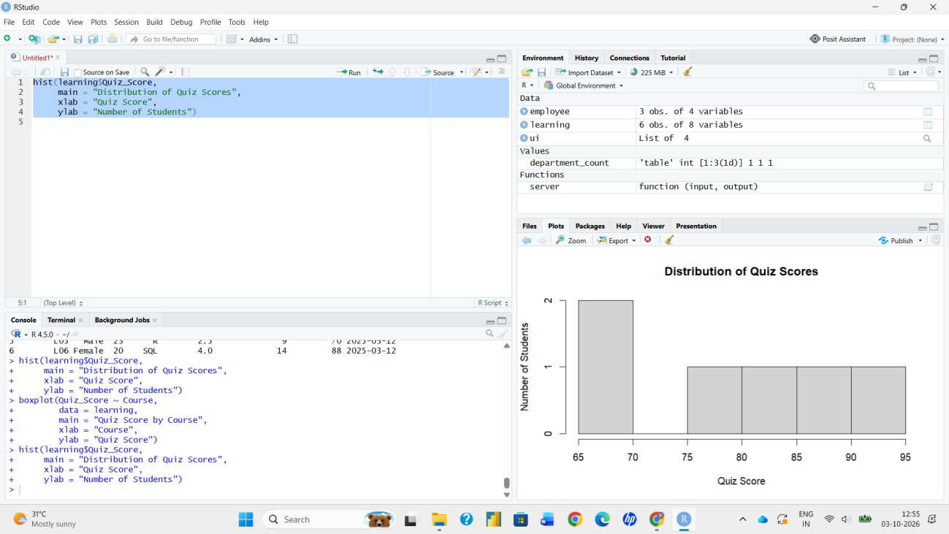
# Import the dataset
data <- read.csv("Online_Learning_Activity.csv", check.names = FALSE) head(data)
str(data)

# Rename column for convenience
colnames(data)[colnames(data) == "Study_Time (hrs)"] <- "Study_Time"

# Histogram of Quiz_Score hist(data$Quiz_Score,
breaks = seq(60, 100, by = 10), main = "Histogram of Quiz Scores", xlab = "Quiz Score",
ylab = "Frequency", col = "lightblue", border = "white")

# Boxplot of Quiz_Score by Course boxplot(Quiz_Score ~ Course, data = data,
main = "Quiz Score by Course", xlab = "Course",
ylab = "Quiz Score",
col = c("lightgreen", "lightsalmon"))

Output 1(a): Histogram of Quiz Scores

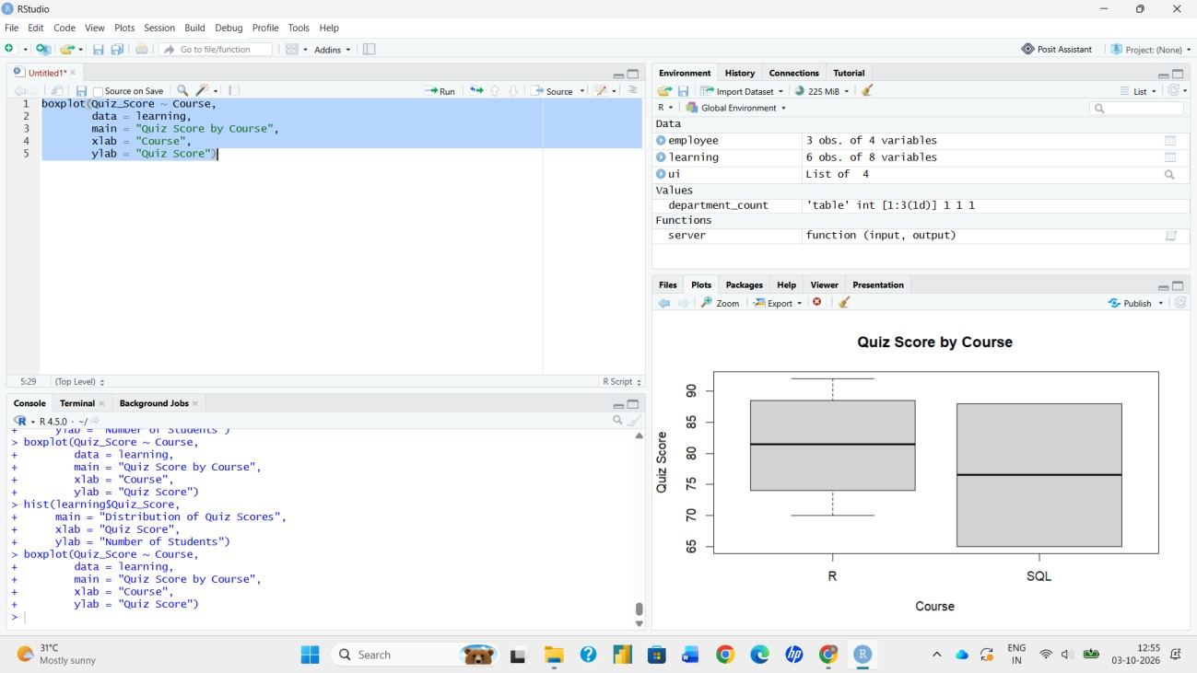
Output 1(b): Boxplot of Quiz Score by Course
Interpretation: Quiz scores range from 65 to 92 with a mean of about 79.7 and a median of 81.5. No student scored below 65, and most scores fall between 70 and 90. Students in the R course performed better (mean 81.25, median 81.5, range 70–92) than students in the SQL course (mean 76.5, median 76.5, range 65–88). Both courses show a similar spread, but the sample is small (six students), so the comparison should be treated with caution.

PROGRAM 2: Scatter Plot of Study Time vs Quiz Score
Create a scatter plot using R programming between Study_Time and Quiz_Score. Represent Videos_Watched using bubble size. Apply transparency. Explain the learning pattern.
library(ggplot2)

ggplot(data, aes(x = Study_Time, y = Quiz_Score, size = Videos_Watched)) + geom_point(alpha = 0.5, color = "steelblue") +
scale_size(range = c(5, 15)) +
labs(title = "Study Time vs Quiz Score", x = "Study Time (hrs)",
y = "Quiz Score",
size = "Videos Watched") + theme_minimal()

# Correlation between study time and quiz score cor(data$Study_Time, data$Quiz_Score)

[1] 0.9816492
Output 2(a): Correlation Coefficient (Console)
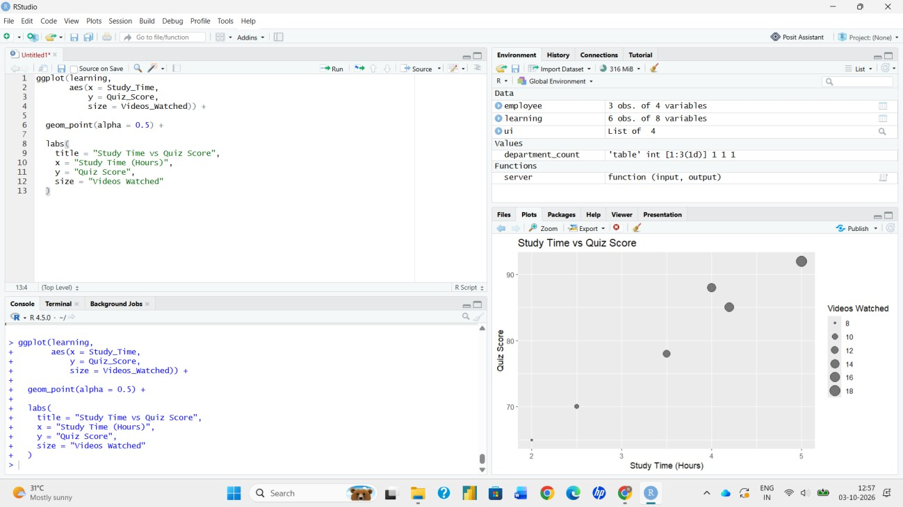
Output 2(b): Bubble Scatter Plot with Transparency
Learning Pattern: The points rise from the lower left to the upper right, showing a strong positive relationship between study time and quiz score (correlation ≈ 0.98). The bubbles also grow larger as study time increases, which means students who study longer also watch more videos and score higher. Students with about 2 to 2.5 hours of study and 8 to 9 videos scored 65 to 70, while the

student with 5 hours and 18 videos scored the highest (92). Transparency helps to see overlapping bubbles clearly.

PROGRAM 3: Monthly Average Quiz Score with Moving Average
Using R programming, convert Login_Date into Date format. Calculate average quiz score per month. Plot a line chart. Apply moving average smoothing. Identify the trend.
# Convert Login_Date to Date format
data$Login_Date <- as.Date(data$Login_Date, format = "%Y-%m-%d") class(data$Login_Date)

# Average quiz score per month
data$Month <- format(data$Login_Date, "%Y-%m")
monthly <- aggregate(Quiz_Score ~ Month, data = data, FUN = mean)

# Moving average smoothing (window = 2) library(zoo)
monthly$Moving_Avg <- rollmean(monthly$Quiz_Score, k = 2, fill = NA, align = "right")
print(monthly)

# Line chart
plot(1:nrow(monthly), monthly$Quiz_Score,
type = "o", col = "blue", xaxt = "n", ylim = c(76, 84), xlab = "Month", ylab = "Average Quiz Score",
main = "Monthly Average Quiz Score with Moving Average") axis(1, at = 1:nrow(monthly), labels = monthly$Month) lines(1:nrow(monthly), monthly$Moving_Avg,
col = "red", lwd = 2, lty = 2) legend("topright",
legend = c("Average Quiz Score", "2-Month Moving Average"), col = c("blue", "red"), lty = c(1, 2), lwd = c(1, 2))

 | 1 2025-01 | 81.5 | NA
 | 2 2025-02 | 78.5 | 80.00
 | 3 2025-03 | 79.0 | 78.75
Output 3(a): R Console Output
[1] "Date"

Month Quiz_Score Moving_Avg
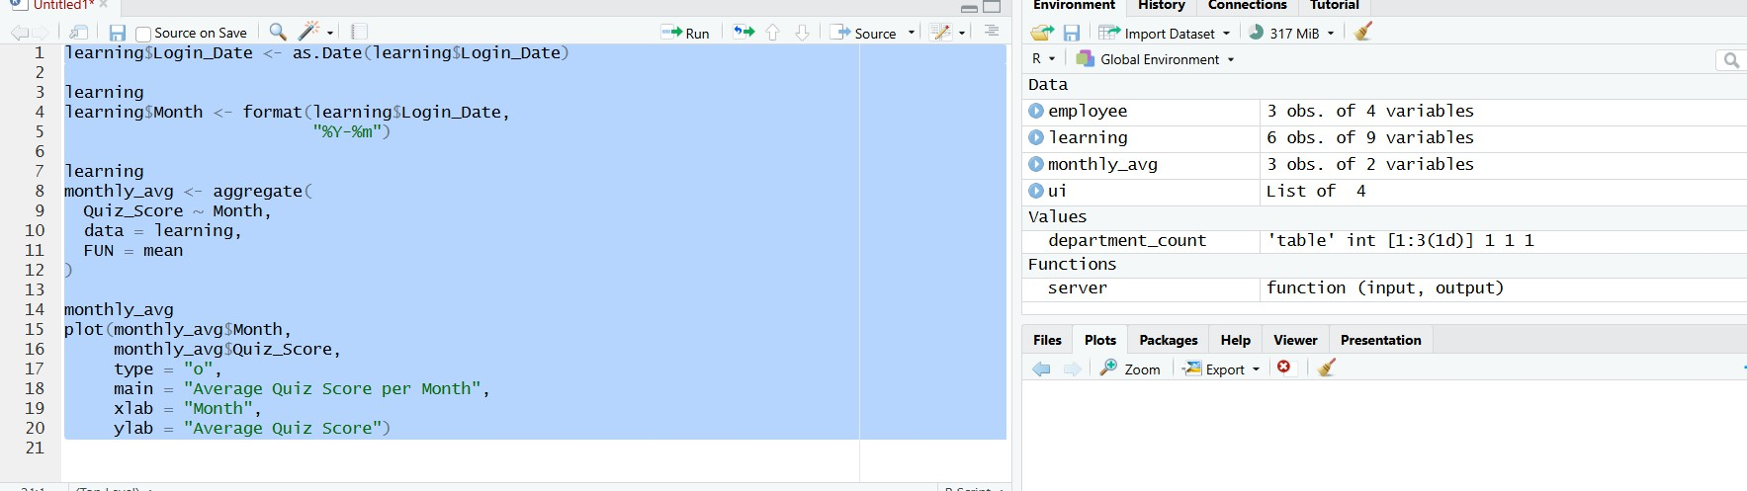
Output 3(b): Monthly Average Quiz Score Line Chart with Moving Average

Trend: The average quiz score was highest in January (81.5), fell to 78.5 in February and recovered slightly to 79.0 in March. The moving average smooths this into a gentle downward drift from 80.0 to 78.75. Overall, monthly performance is fairly stable between 78 and 82, with a slight decline after January; with only three months of data, a firm trend cannot be established.

PROGRAM 4: Interactive Mini Dashboard in Tableau
Import Online_Learning_Activity.csv into Tableau. Create a bar chart showing average quiz score by Course. Create a scatter plot (Study Time vs Quiz Score). Add filter for Gender and Course. Design a mini interactive dashboard.
- Open Tableau and choose Connect > Text file, then select Online_Learning_Activity.csv. Confirm Quiz_Score, Study_Time (hrs) and Videos_Watched are numeric and Login_Date is a date.
- Open Sheet 1 and create the bar chart: drag Course to Columns and Quiz_Score to Rows, and change the aggregation to Average (AVG). Add labels and rename the sheet to “Avg Quiz Score by Course”.
- Open Sheet 2 and create the scatter plot: drag Study_Time (hrs) to Columns and Quiz_Score to Rows. Go to Analysis > Aggregate Measures (turn off) or drag Student_ID to Detail so that each student appears as a separate point. Drag Course to Color. Rename the sheet to “Study Time vs Quiz Score”.
- On either sheet, drag Gender and Course to the Filters shelf, select all values, then right-click each filter > Show Filter.
- For each filter, open its dropdown > Apply to Worksheets > All Using This Data Source, so one selection updates both charts.
- Click New Dashboard, drag both sheets onto the canvas and add the Gender and Course filters on the left side.
- Select the bar chart and click “Use as Filter” so that clicking a course highlights its students in the scatter plot. Add a dashboard title.
- Test the dashboard by selecting Male/Female and R/SQL and checking that both charts update.
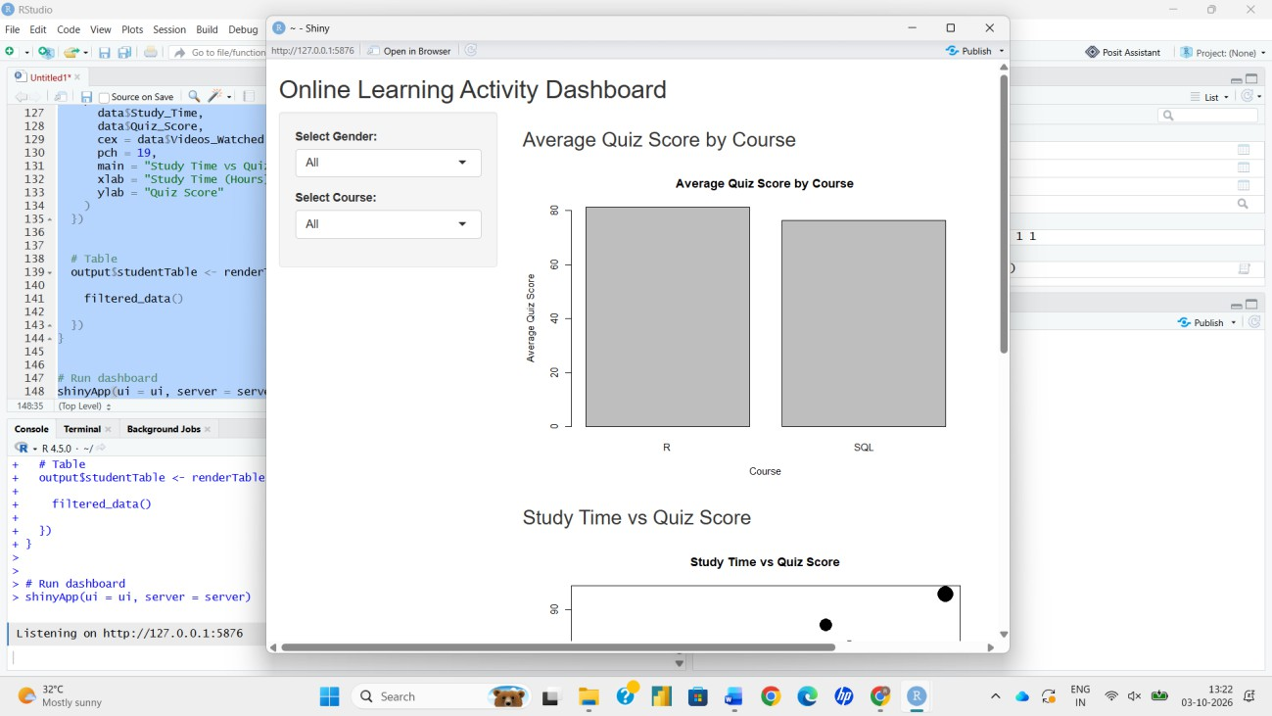

Output 4: Online Learning Mini Interactive Dashboard (Tableau)
Observation: The bar chart shows that R students have a higher average quiz score (81.25) than SQL students (76.5). The scatter plot shows that more study time leads to higher scores. The Gender and Course filters let the user focus on any group, and both charts update together.

Procedure
- Save Online_Learning_Activity.csv in the R working directory and import it with read.csv().
- Plot the Quiz_Score histogram with hist() and the boxplot by Course with boxplot().
- Create the bubble scatter plot with ggplot2 using size for Videos_Watched and alpha for transparency.
- Convert Login_Date with as.Date(), compute the monthly average with aggregate() and apply the moving average with rollmean().
- Plot the monthly line chart with the moving average line and identify the trend.
- Import the CSV file into Tableau, create the bar chart and scatter plot, add the Gender and Course filters and combine them into a dashboard.

Result
The online learning data was successfully analyzed in R using a histogram, boxplot, bubble scatter plot and a monthly line chart with moving average smoothing. A mini interactive dashboard with Gender and Course filters was created in Tableau. The analysis showed that quiz performance is positively related to study time and videos watched, and that R students scored higher on average than SQL students.

Key Functions / Tools Used

Function / Tool | Purpose
read.csv() | Imports the dataset into R.
hist() / boxplot() | Plot score distribution and compare courses.
ggplot() / geom_point() | Create the bubble scatter plot with transparency.
as.Date() / format() | Convert and extract month from Login_Date.
aggregate() | Calculates the average quiz score per month.
zoo::rollmean() | Applies moving average smoothing.
cor() | Measures the study time vs quiz score relationship.
Tableau Filters / Dashboard | Provide interactive exploration by Gender and Course.

