LAB EXPERIMENT RECORD

Set 19: Survey Responses Analysis

Department | CSE-DS
Course Code / Course Name | DSA0602 / Data Handling and Visualization
Experiment | Data Visualization using R and Tableau
Name | M Uday Kumar Reddy
Register Number | 192473022
Date | 13 October 2026
Day | Tuesday

Aim
To analyse survey responses using a grouped bar chart, a stacked bar chart and a data table, and to combine them into an interactive Tableau dashboard.

Dataset: Survey Responses

Survey ID | Question 1 | Question 2 | Question 3
1 | A | B | C
2 | B | A | D
3 | C | A | B

PROGRAM 1: Grouped Bar Chart for Question 1
Create a grouped bar chart to visualize the distribution of answers for Question 1. Label the chart elements.
library(ggplot2)

# Dataset
survey <- data.frame( SurveyID = c(1, 2, 3), Q1 = c("A", "B", "C"),
Q2 = c("B", "A", "A"),
Q3 = c("C", "D", "B")
)

# Grouped Bar Chart (Question 1)
ggplot(survey, aes(x = Q1, fill = factor(SurveyID))) + geom_bar(position = "dodge") +
labs(title = "Question 1: Distribution of Answers", x = "Answer Option",
y = "Number of Responses", fill = "Survey ID")

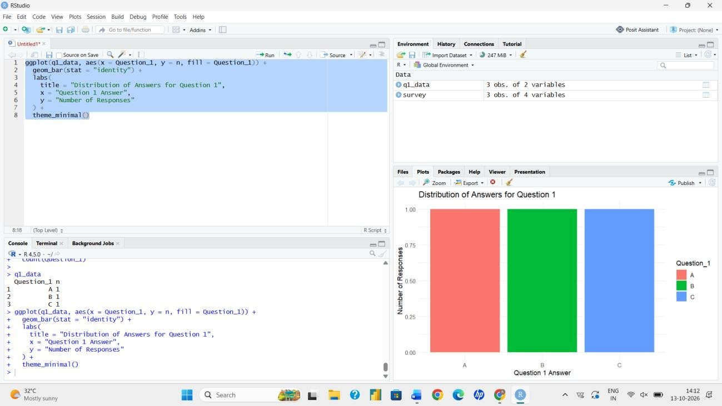
Output 1: Grouped Bar Chart for Question 1
Observation: Each answer option (A, B and C) for Question 1 was chosen by exactly one respondent, so the responses are evenly spread. Option D was not selected.

PROGRAM 2: Stacked Bar Chart for All Questions
Generate a stacked bar chart to represent the overall distribution of responses for all three questions.
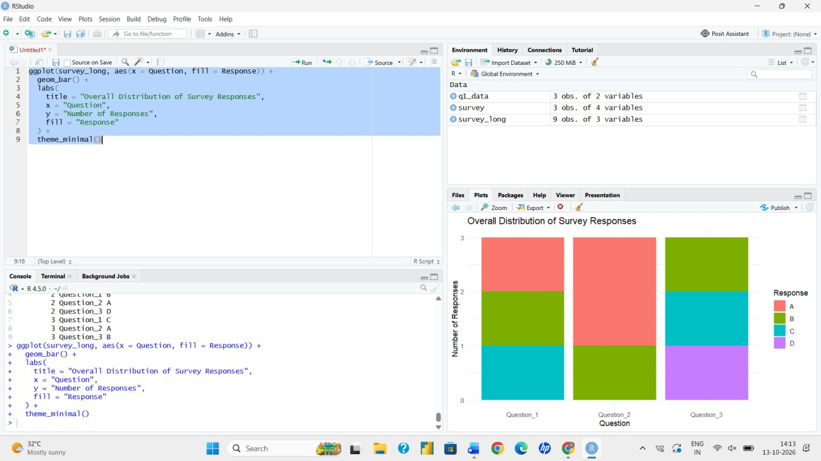
library(ggplot2) library(tidyr)

# Convert data to long format
long <- pivot_longer(survey, cols = c(Q1, Q2, Q3),
names_to = "Question", values_to = "Answer")

# Stacked Bar Chart
ggplot(long, aes(x = Question, fill = Answer)) + geom_bar(position = "stack") +
labs(title = "Overall Response Distribution (Q1-Q3)", x = "Question",
y = "Number of Responses", fill = "Answer")

Output 2: Stacked Bar Chart for Questions 1 to 3
Observation: Every question received three responses. Option A appears twice in Question 2, while Question 3 has one response each for B, C and D.

PROGRAM 3: Survey Response Table
Build a table to show the survey response data for each survey. Label the table elements.
# Display the survey table print(survey)

# Formatted table with labelled columns
colnames(survey) <- c("Survey ID", "Question 1", "Question 2", "Question 3") knitr::kable(survey, caption = "Survey Response Data")

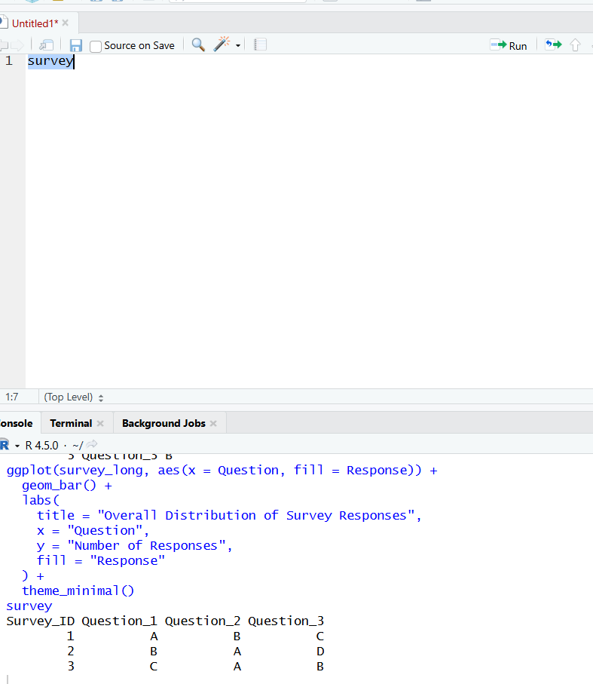
Output 3: Survey Response Table
Observation: The table lists the answers given by each survey respondent, with Survey ID as the row label and the three questions as column labels.

PROGRAM 4: Interactive Tableau Dashboard
Develop a Tableau dashboard combining the grouped bar chart, stacked bar chart and table for interactive exploration of survey responses.

Steps followed in Tableau:
- Connect to the data source: Data > Connect to Data > Text file / Excel, and load the survey dataset.
- Select Survey ID, then right-click the Question 1 to Question 3 columns and choose Pivot to get Question and Answer fields.
- Sheet 1 (grouped bar): place Answer on Columns, Survey ID on Columns next to it, and CNT(Survey ID) on Rows; drag Survey ID to Color.
- Sheet 2 (stacked bar): place Question on Columns, CNT(Survey ID) on Rows, and Answer on Color to stack the segments.
- Sheet 3 (table): drag Survey ID to Rows, Question to Columns, and Answer to Text.
- Create a new Dashboard, drag the three sheets onto it, and arrange them with titles.
- Select 'Use as Filter' on each chart so that clicking a bar highlights the matching survey records in the other views. Add Survey ID and Question filters for further exploration.
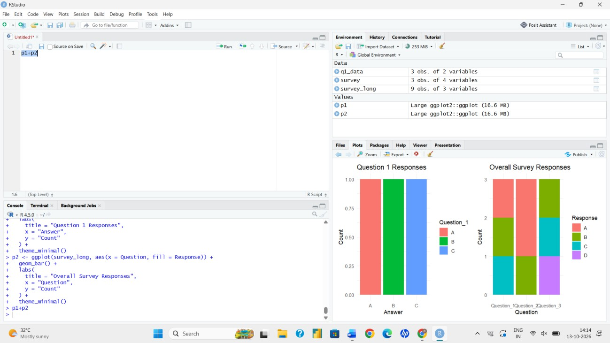
Output 4: Survey Responses Dashboard (layout of the Tableau dashboard)
Observation: The dashboard combines all three views on a single page. Selecting an answer in one chart filters the other views, which makes the response patterns easy to explore.

Procedure
- Create the survey data frame with Survey ID and Questions 1 to 3.
- Use geom_bar(position = "dodge") to draw the grouped bar chart for Question 1.
- Reshape the data with pivot_longer() and use geom_bar(position = "stack") for the stacked chart.
- Display the data as a labelled table using print() or kable().
- Load the data in Tableau, build the three sheets and combine them into a dashboard with filter actions.

Result
The survey responses were successfully visualized with a grouped bar chart, a stacked bar chart and a table. A Tableau dashboard combined the three views for interactive exploration.

Key Functions Used

Function / Feature | Purpose
ggplot() / geom_bar() | Creates grouped (dodge) and stacked bar charts.
pivot_longer() | Reshapes question columns into long format.
labs() | Adds title and axis labels.
kable() | Produces a formatted table.
Tableau Dashboard | Combines sheets with interactive filters.

