LAB EXPERIMENT RECORD

Set 20: Stock Analysis

Department | CSE-DS
Course Code / Course Name | DSA0602 / Data Handling and Visualization
Experiment | Data Visualization using R and Tableau
Name | M Uday Kumar Reddy
Register Number | 192473022
Date | 13 October 2026
Day | Tuesday

Aim
To visualize stock prices of three companies using a line chart, bar chart and table, and to build an interactive Tableau dashboard.

Dataset: Stock Prices

Date | Stock A | Stock B | Stock C
2023-01-01 | 100 | 150 | 120
2023-01-02 | 105 | 152 | 118
2023-01-03 | 110 | 148 | 122

PROGRAM 1: Line Chart of Stock Prices
Create a line chart to visualize the stock prices of three companies (Stock A, Stock B and Stock C) over a specific time period. Label the axes and title the chart.
# Dataset
date <- as.Date(c("2023-01-01", "2023-01-02", "2023-01-03"))
stockA <- c(100, 105, 110)
stockB <- c(150, 152, 148)
stockC <- c(120, 118, 122)

# Line Chart
plot(date, stockB, type = "o", col = "green", ylim = c(95, 160), xlab = "Date", ylab = "Stock Price",
main = "Stock Prices of Three Companies") lines(date, stockA, type = "o", col = "red") lines(date, stockC, type = "o", col = "blue")
legend("topright", legend = c("Stock A", "Stock B", "Stock C"), col = c("red", "green", "blue"), lty = 1, pch = 1)

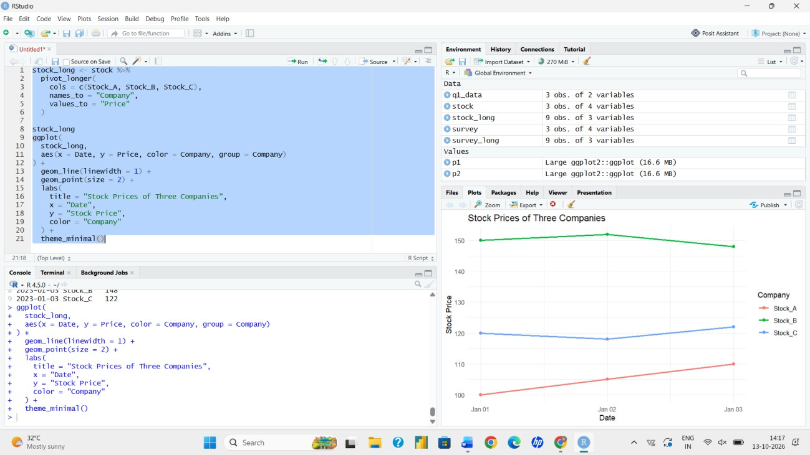
Output 1: Stock Prices Line Chart
Observation: Stock A rises steadily from 100 to 110. Stock B stays the highest but falls to 148 on the last day. Stock C stays between 118 and 122.

PROGRAM 2: Bar Chart of Daily Percentage Change (Stock A)
Generate a bar chart showing the daily percentage change in stock prices for Stock A. Label the chart elements.
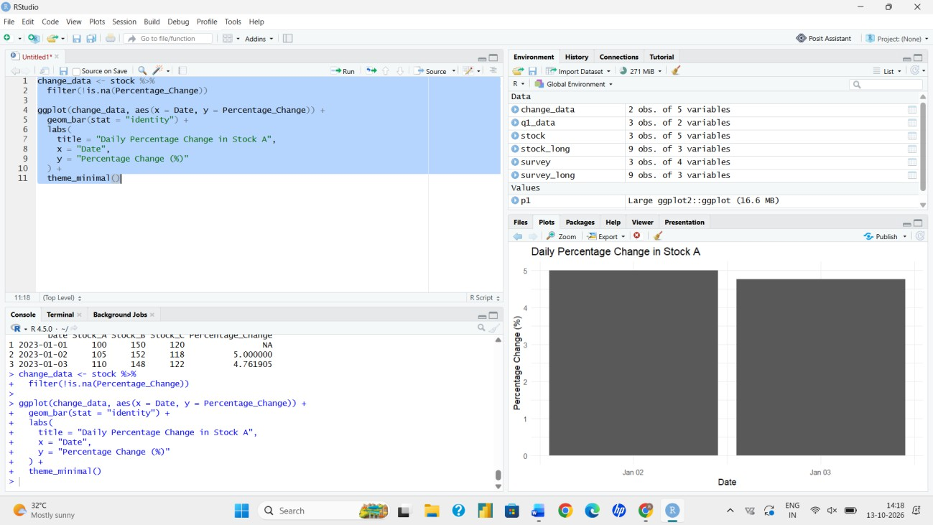
# Daily percentage change for Stock A
pct_change <- diff(stockA) / head(stockA, -1) * 100 print(pct_change) # 5.00 4.76

# Bar Chart barplot(pct_change,
names.arg = format(date[-1]), xlab = "Date",
ylab = "Daily Change (%)",
main = "Stock A: Daily Percentage Change", col = "steelblue")

Output 2: Stock A Daily Percentage Change
Observation: Stock A increased by 5.00% on 2023-01-02 and by 4.76% on 2023-01-03. No percentage change can be calculated for 2023-01-01 because it is the first day.

PROGRAM 3: Stock Price Table
Build a table to display the stock price data for each company over the given period. Label the table elements.

stocks <- data.frame(Date = date,
StockA = stockA, StockB = stockB, StockC = stockC)
colnames(stocks) <- c("Date", "Stock A", "Stock B", "Stock C") print(stocks)
knitr::kable(stocks, caption = "Stock Price Data")
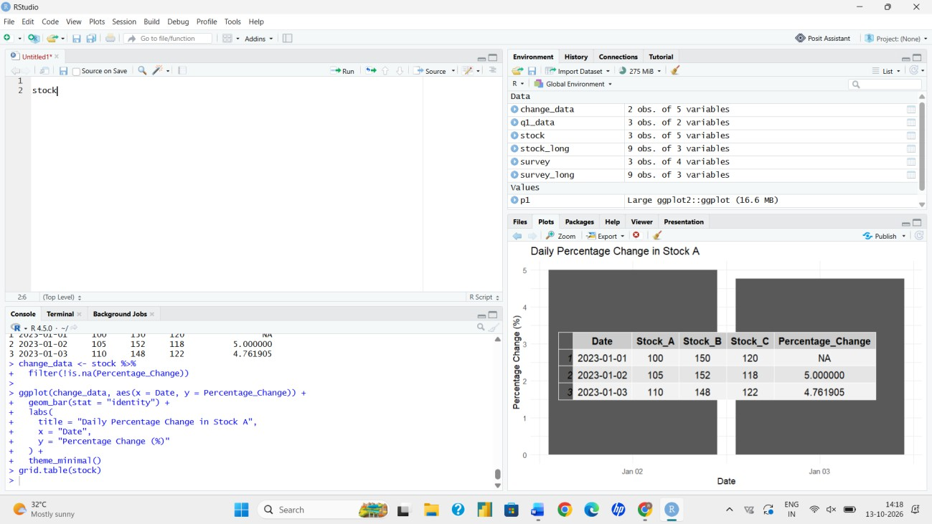
Output 3: Stock Price Table
Observation: The table gives the closing price of each company for the three dates, with Date as the row label and each stock as a column.

PROGRAM 4: Interactive Tableau Dashboard
Develop a Tableau dashboard combining the line chart, bar chart and table for interactive exploration of stock prices.

Steps followed in Tableau:
- Import the stock price file into Tableau and confirm that Date is recognised as a date field.
- Select Stock A, Stock B and Stock C, and choose Pivot to create Stock and Price fields.
- Sheet 1 (line chart): place Date on Columns, Price on Rows, and Stock on Color.
- Sheet 2 (bar chart): filter to Stock A, then create a calculated field 'Daily % Change' using the Percent Difference quick table calculation on Price, and place it on Rows with Date on Columns.
- Sheet 3 (table): place Date on Rows, Stock on Columns and Price on Text.
- Create a Dashboard and drag the three sheets onto it. Add a Date filter and a Stock filter, and enable 'Use as Filter' on the line chart.
- Add titles and axis labels, then save the workbook.
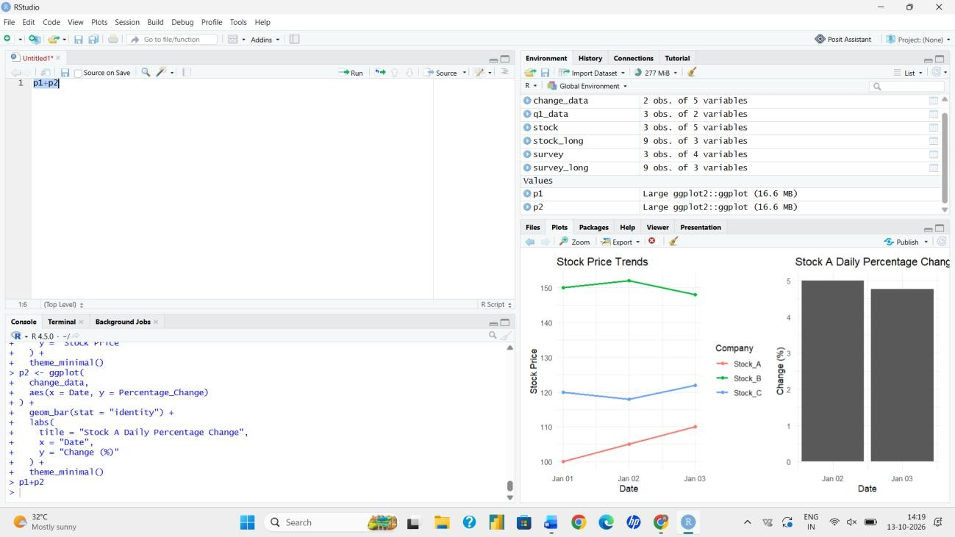
Output 4: Stock Prices Dashboard (layout of the Tableau dashboard)
Observation: The dashboard shows price trends, Stock A's daily change and the raw data together. The Date and Stock filters let the user focus on a particular company or period.

Procedure
- Create date and stock price vectors in R.
- Use plot() and lines() to draw the three-stock line chart with labelled axes and a legend.
- Calculate Stock A's daily percentage change using diff() and plot it with barplot().
- Combine the vectors in a data frame to display the stock price table.
- Load the data in Tableau, build three sheets and combine them into an interactive dashboard.

Result
The stock prices were successfully visualized with a line chart, a bar chart and a table. A Tableau dashboard combined these views with filters for interactive exploration.

Key Functions Used

Function / Feature | Purpose
plot() / lines() | Draws and overlays line charts.
legend() | Adds a legend to the chart.
diff() | Calculates differences between consecutive values.
barplot() | Creates bar charts.
data.frame() / kable() | Builds and displays tables.
Tableau Dashboard | Combines sheets with filters.

