LAB EXPERIMENT RECORD

Set 21: Energy Consumption Analysis

Department | CSE-DS
Course Code / Course Name | DSA0602 / Data Handling and Visualization
Experiment | Data Visualization using R and Tableau
Name | M Uday Kumar Reddy
Register Number | 192473022
Date | 13 October 2026
Day | Tuesday

Aim
To analyse energy consumption data using R (histogram, density plot, scatter plot and bar chart) and to build an interactive dashboard in Tableau.
Dataset: Energy_Consumption_Data.csv

Sector | Region | Month | Temp (°C) | Units (kWh) | Cost (₹) | Renewable (%) | Peak Hrs
Residential | North | Jan | 15 | 320 | 2100 | 22 | 4
Commercial | South | Jan | 24 | 540 | 3600 | 18 | 6
Industrial | West | Feb | 20 | 880 | 5900 | 12 | 8
Residential | East | Feb | 18 | 350 | 2300 | 25 | 5
Commercial | North | Mar | 28 | 610 | 4100 | 20 | 7
Industrial | South | Mar | 30 | 920 | 6200 | 15 | 9

PROGRAM 1: Histogram and Density Plot of Units_Consumed
Import the dataset in R. Plot a histogram and density plot for Units_Consumed. Compare consumption patterns.
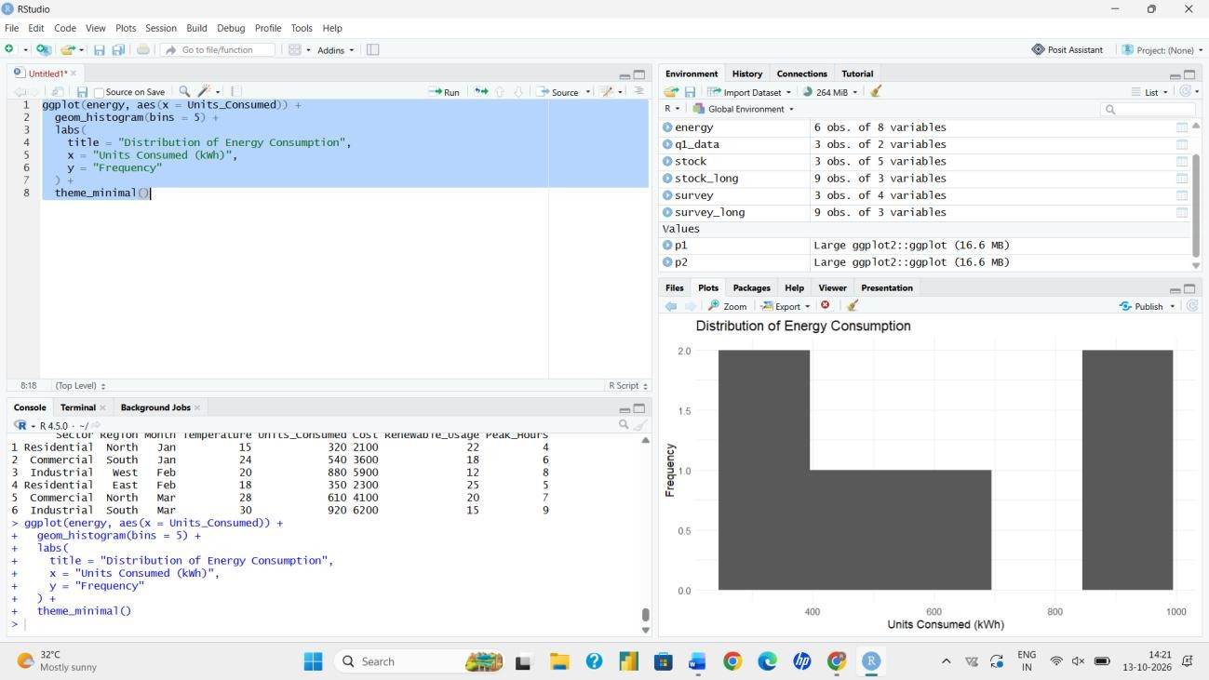
library(ggplot2)

# Import dataset
energy <- read.csv("Energy_Consumption_Data.csv") head(energy)

# Histogram with density curve ggplot(energy, aes(x = Units_Consumed)) +
geom_histogram(aes(y = after_stat(density)),
binwidth = 100, fill = "lightblue", colour = "white") + geom_density(colour = "red", linewidth = 1) +
labs(title = "Histogram and Density Plot of Units Consumed", x = "Units Consumed (kWh)",
y = "Density")

Output 1: Histogram and Density Plot of Units Consumed
Observation: Consumption ranges from 320 to 920 kWh, with a mean of about 603 kWh. Most Residential and Commercial records fall between 300 and 700 kWh, while the two Industrial records (880 and 920 kWh) form a separate high-consumption group.

PROGRAM 2: Scatter Plot of Temperature vs Units_Consumed
Using R programming, create a scatter plot between Temperature and Units_Consumed. Represent Peak_Hours using bubble size. Apply transparency.
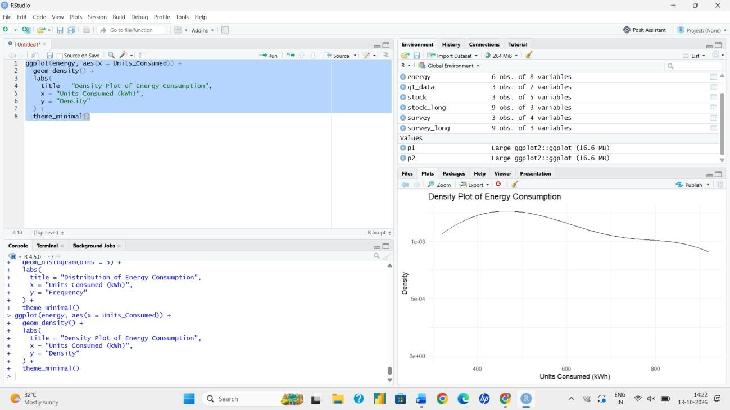
ggplot(energy, aes(x = Temperature, y = Units_Consumed,
size = Peak_Hours)) + geom_point(alpha = 0.6, colour = "steelblue") + scale_size(range = c(4, 14)) +
labs(title = "Temperature vs Units Consumed", x = "Temperature (°C)",
y = "Units Consumed (kWh)", size = "Peak Hours")

Output 2: Temperature vs Units Consumed (bubble size = Peak Hours)
Observation: Consumption generally rises with temperature, from 320 kWh at 15 °C to 920 kWh at 30 °C. The largest bubbles (8 and 9 peak hours) belong to the highest-consumption records (880 and 920 kWh), so longer peak periods go with higher energy use.

PROGRAM 3: Average Renewable Usage by Sector
Using R, calculate the average Renewable_Usage for each Sector. Create a bar chart. Interpret renewable energy adoption.
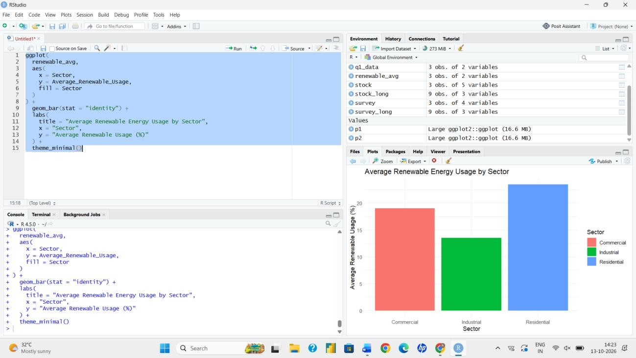
# Average renewable usage by sector
avg_renew <- aggregate(Renewable_Usage ~ Sector, data = energy, FUN = mean) print(avg_renew)
# Sector Renewable_Usage # 1 Commercial 19.0
# 2 Industrial 13.5
# 3 Residential 23.5

# Bar Chart
ggplot(avg_renew, aes(x = Sector, y = Renewable_Usage, fill = Sector)) + geom_bar(stat = "identity", width = 0.6) +
labs(title = "Average Renewable Usage by Sector", x = "Sector",
y = "Average Renewable Usage (%)")

Output 3: Average Renewable Usage by Sector
Interpretation: The Residential sector has the highest renewable adoption (23.5%), followed by Commercial (19.0%). The Industrial sector has the lowest (13.5%) despite consuming the most energy. Industry therefore offers the greatest scope for increasing renewable energy use.

PROGRAM 4: Interactive Tableau Dashboard
Import Energy_Consumption_Data.csv into Tableau. Create a line chart for monthly energy usage trends. Create a heatmap (Sector vs Region vs Units). Add filters for Month and Sector. Design an interactive dashboard.

Steps followed in Tableau:
- Open Tableau, choose Connect > Text file, and import Energy_Consumption_Data.csv.
- Sheet 1 (line chart): drag Month to Columns and SUM(Units_Consumed) to Rows. Sort Month as Jan, Feb, Mar and add Sector to Color if required.
- Sheet 2 (heatmap): drag Region to Columns, Sector to Rows and SUM(Units_Consumed) to Color and Label. Set the Marks type to Square.
- Right-click Month and Sector in each sheet and choose Show Filter. Apply the filters to all worksheets using this data source.
- Create a new Dashboard, drag in both sheets, and show the Month and Sector filters on the dashboard.
- Enable 'Use as Filter' on the heatmap so that selecting a cell updates the line chart.
- Add a dashboard title and save the workbook.
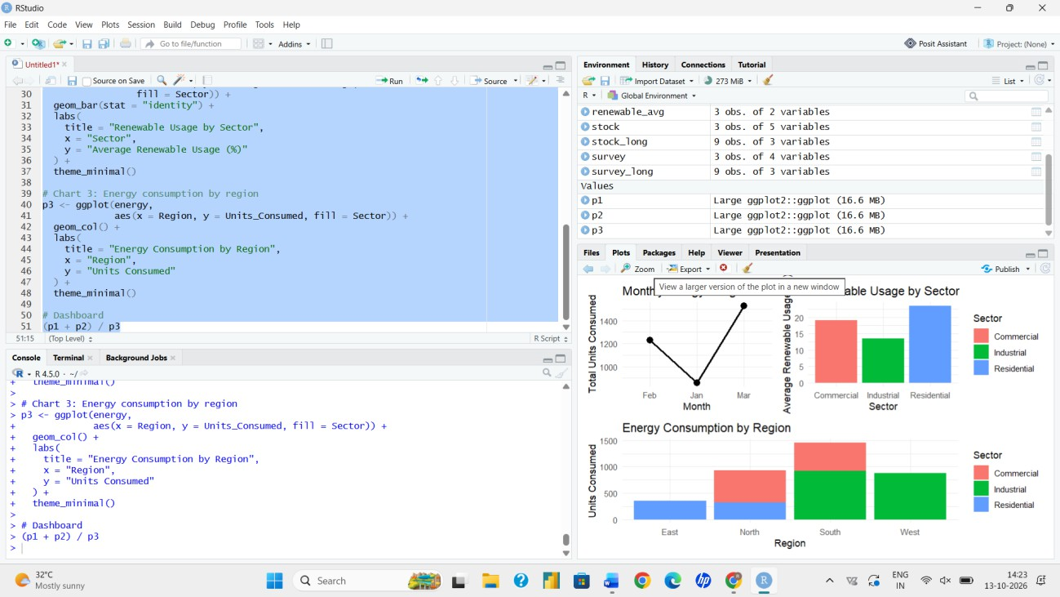
Output 4: Energy Consumption Dashboard (layout of the Tableau dashboard)
Observation: Total monthly consumption rises from 860 kWh in January to 1,230 kWh in February and 1,530 kWh in March. The heatmap shows that Industrial records in West and South have the highest usage, and the filters update both views.

Procedure
- Import Energy_Consumption_Data.csv into R using read.csv().
- Plot a histogram with a density curve for Units_Consumed.
- Create a scatter plot of Temperature vs Units_Consumed using Peak_Hours as bubble size with alpha transparency.
- Use aggregate() to find average Renewable_Usage by Sector and plot it as a bar chart.
- Load the CSV in Tableau, build the line chart and heatmap, add Month and Sector filters, and assemble the dashboard.

Result
The energy consumption data was analysed in R using a histogram, density plot, bubble scatter plot and bar chart. A Tableau dashboard with a line chart, heatmap and Month and Sector filters was also designed.

Key Functions Used

Function / Feature | Purpose
read.csv() | Imports the CSV dataset.
geom_histogram() / geom_density() | Plots the distribution of Units_Consumed.
geom_point(alpha, size) | Scatter plot with transparency and bubble size.
aggregate() | Calculates group-wise averages.
geom_bar(stat = "identity") | Draws bars from calculated values.
Tableau Filters / Dashboard | Provide interactive exploration.

