LAB EXPERIMENT RECORD

Set 13: Geographic Data

Department | CSE-DS
Course Code / Course Name | DSA0602 / Data Handling and Visualization
Experiment | Data Visualization using Tableau
Name | M Uday Kumar Reddy
Register Number | 192473022
Date | 8 October 2026
Day | Thursday

Aim
To visualize geographic data using a map chart, a scatter plot and a table, and to build an interactive Tableau dashboard that combines them for exploring the relationship between population, temperature and elevation.

Dataset: Geographic Data

City | Population | Avg. Temperature | Elevation
City A | 500000 | 75 | 1000
City B | 700000 | 68 | 800
City C | 600000 | 80 | 1200

Note: The dataset does not contain coordinates and "City A/B/C" are not recognised by Tableau's geocoder. Latitude and Longitude columns must be added to the data source for the map. Sample values used: City A (13.08, 80.27), City B (19.08, 72.88), City C (28.61, 77.21). These are assumed values for demonstration only.

PROGRAM 1: Map Chart of City Distribution
Create a map chart to visualize the distribution of cities on a geographic map. Label the map elements.

Steps in Tableau:
- Open Tableau and connect to the Excel/CSV file containing City, Population, Avg. Temperature, Elevation, Latitude and Longitude.
- Go to Sheet 1 and rename it "Map Chart".
- Drag Longitude to Columns and Latitude to Rows (set both to Dimension/continuous if prompted).
- Drag City to Detail and then to Label so each city name appears on the map.
- Drag Population to Size and Avg. Temperature to Color to encode both measures.
- Use Map > Map Layers to choose a background style, and add the title "Distribution of Cities".

- Show the Size and Color legends and add tooltips with Population, Temperature and Elevation.
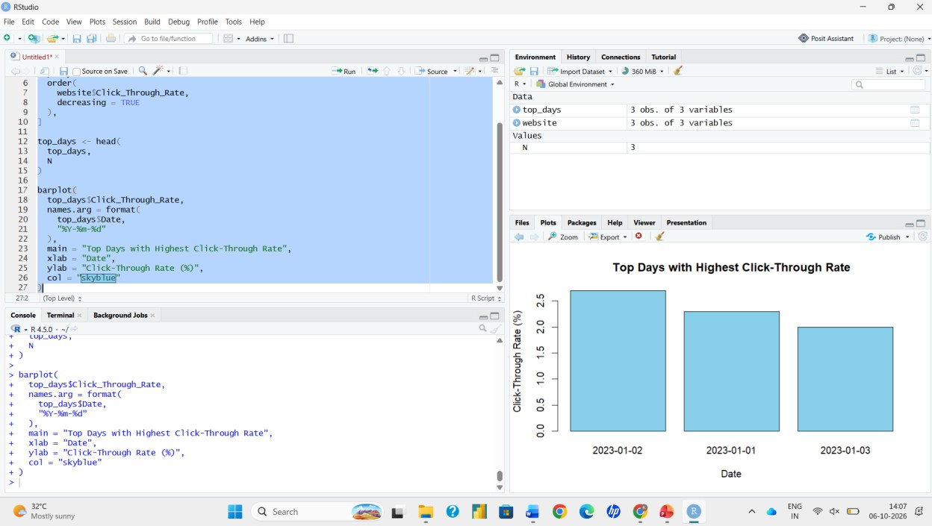
Output 1: Map Chart of City Distribution
Observation: The map shows the three cities as labelled points. Bubble size represents population (City B is the largest) and colour represents average temperature (City C is the warmest).

PROGRAM 2: Scatter Plot of Temperature vs Population
Generate a scatter plot to explore the relationship between average temperature and population size. Explain any insights.

Steps in Tableau:
- Create a new sheet and rename it "Scatter Plot".
- Drag Avg. Temperature to Columns and Population to Rows.
- Turn off Analysis > Aggregate Measures so every city is plotted as an individual point.
- Drag City to Label and Color to identify each point.
- Edit axis titles: "Average Temperature (°F)" and "Population". Set the chart title "Avg. Temperature vs Population".
- Optionally add a trend line from the Analytics pane.

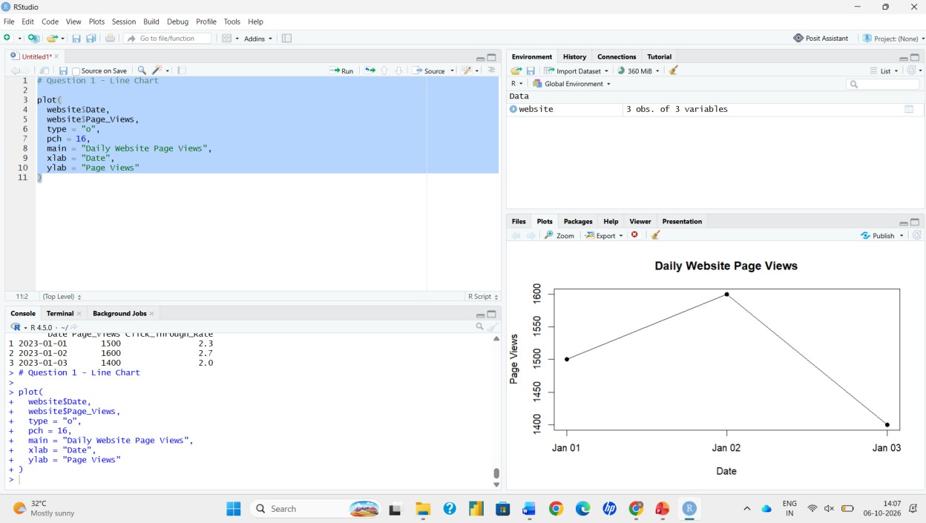
Output 2: Scatter Plot of Avg. Temperature vs Population
Insight: The points show a weak negative relationship (correlation ≈ -0.58): City B has the lowest temperature (68) and the highest population (700000), City C has the highest temperature (80) with 600000, and City A is in between on temperature (75) with the lowest population (500000). With only three cities, this cannot be treated as a reliable trend.
Interestingly, temperature rises with elevation here (800 → 68, 1000 → 75, 1200 → 80).

PROGRAM 3: Table of Geographic Data
Build a table to display the geographic data for each city. Label the table elements.

Steps in Tableau:
- Create a new sheet and rename it "Geographic Table".
- Drag City to Rows.
- Drag Measure Names to Columns and Measure Values to Text (keep only Population, Avg. Temperature and Elevation in the Measure Values card).
- Format numbers with thousand separators (right-click > Format) and set the title to "Geographic Data by City".
- Make sure the column headers and row headers are visible.

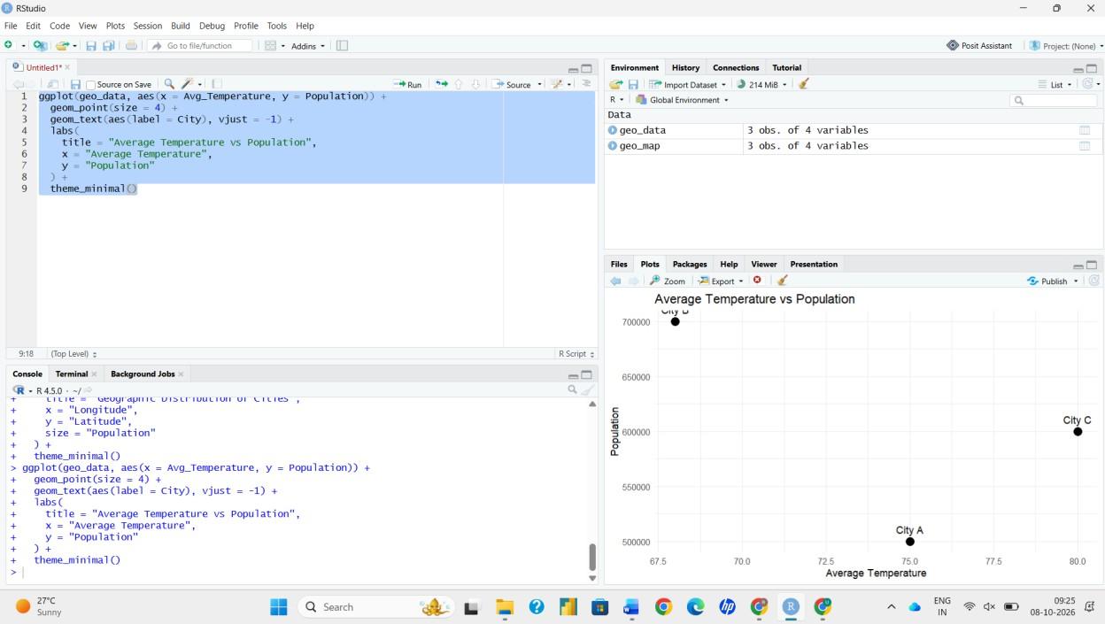
Output 3: Table of Geographic Data
Observation: The table lists each city with its population, average temperature and elevation, giving exact values that complement the map and scatter plot.

PROGRAM 4: Interactive Tableau Dashboard
Develop a Tableau dashboard combining the map chart, scatter plot and table for interactive exploration of geographic data.

Steps in Tableau:
- Click New Dashboard at the bottom of the workbook and rename it.
- Set Size to Automatic (or Fixed: Desktop Browser) from the Dashboard pane.
- Drag Map Chart, Scatter Plot and Geographic Table from the Sheets list onto the dashboard canvas.
- Add a Title (Dashboard > Show Title) and arrange the sheets using Tiled layout containers.
- Select the first chart and click Use as Filter so that selecting a city on the map filters the scatter plot and table.
- Use Dashboard > Actions to add a Highlight action, and enable Show Filters on the sheets for dropdown filtering.
- Click different marks to test interactivity and confirm all views update together.

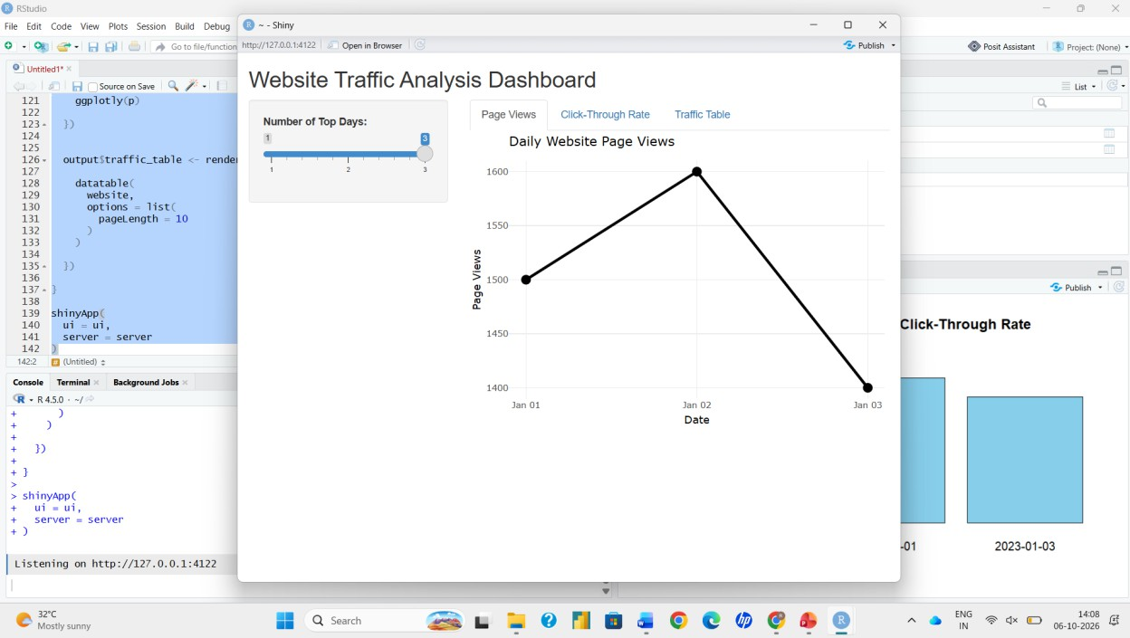
Output 4: Interactive Geographic Data Dashboard
Observation: Selecting a city on the map highlights the same city in the scatter plot and filters the table, allowing quick comparison of population, temperature and elevation.

Procedure
- Prepare the dataset with City, Population, Avg. Temperature, Elevation, Latitude and Longitude and connect it to Tableau.
- Build the map chart using Latitude and Longitude with City as label, Population as size and Avg. Temperature as colour.
- Build the scatter plot with Avg. Temperature on Columns and Population on Rows, with City as label.
- Build the text table using Measure Names and Measure Values.
- Create a new dashboard, add the three sheets and enable Use as Filter and highlight actions.
- Interact with the dashboard by selecting cities and check that all views update.

Result
The geographic data was successfully visualized using a map chart, scatter plot and table, and an interactive Tableau dashboard was created to explore the data.

