LAB EXPERIMENT RECORD

Set 4: Product Inventory Management

Department | CSE-DS
Course Code / Course Name | DSA0602/ Data Handling and Visualization
Experiment | Data Visualization using R
Name | M Uday Kumar Reddy
Register Number | 192473022
Date | 1 October 2026
Day | Friday

Aim
To visualize product inventory data using a bar chart, stacked bar chart, and scatter plot, and to build an interactive dashboard using R and Shiny.

Dataset: Product Inventory

Product ID | Product Name | Quantity Available
1 | Product A | 250
2 | Product B | 175
3 | Product C | 300
4 | Product D | 200
5 | Product E | 220

Note: The given dataset contains only Product ID, Product Name and Quantity Available. For Program 2 the product categories (Electronics: A, B; Accessories: C, D; Home Appliances: E) and for Program 3 the product prices ($40, $60,
$25, $50, $45) are assumed values, since they are not part of the given table.

PROGRAM 1: Bar Chart of Product Quantity
Create a bar chart to visualize the quantity of each product in the inventory. Label the axes and title the chart.
# Dataset
product <- c("Product A", "Product B", "Product C", "Product D", "Product E") quantity <- c(250, 175, 300, 200, 220)

# Bar Chart barplot(quantity,
names.arg = product, xlab = "Product",
ylab = "Quantity Available", main = "Product Inventory", col = "steelblue",
ylim = c(0, 350))

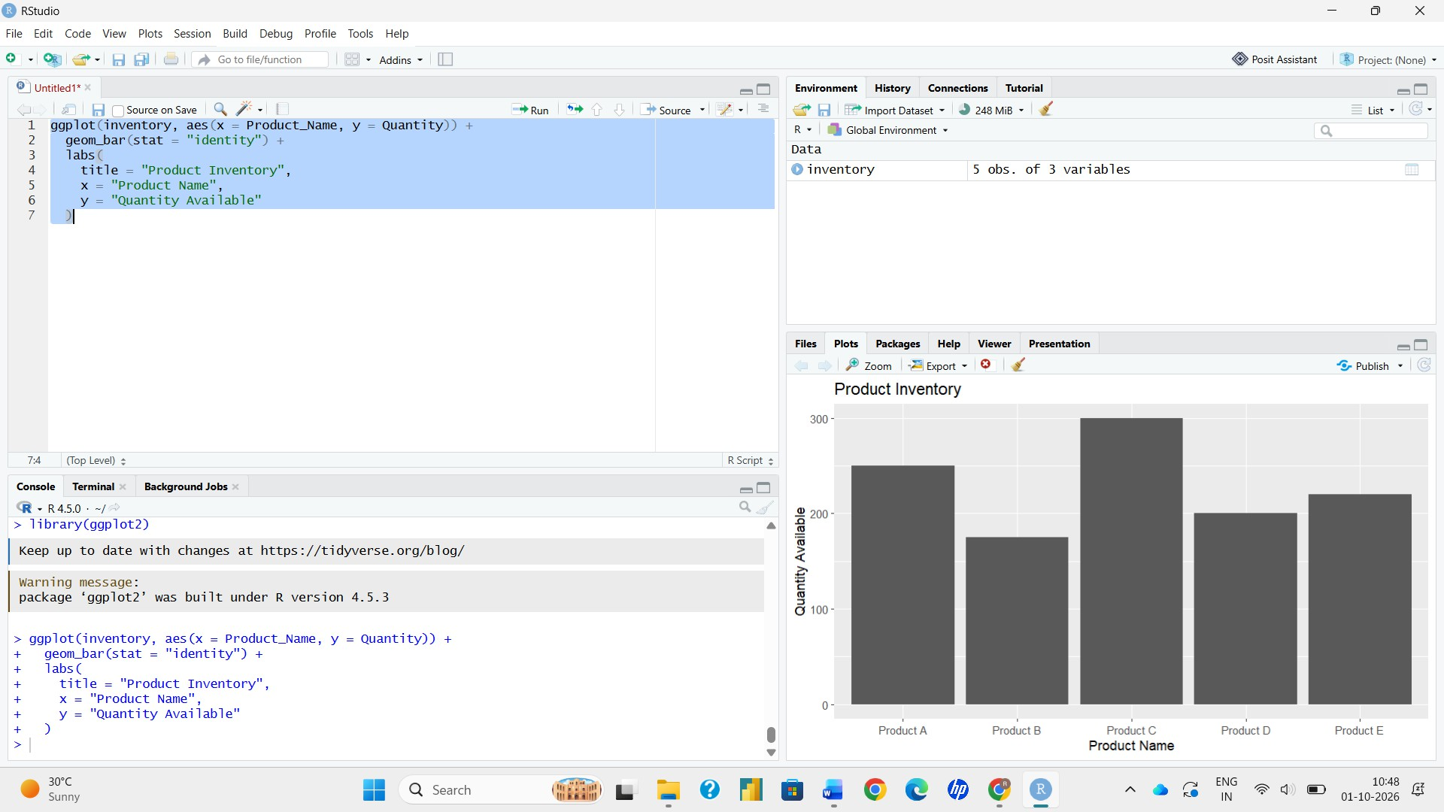
Output 1: Product Inventory Bar Chart

Observation: Product C has the highest quantity available (300) and Product B has the lowest (175). Products A, D and E lie in between at 250, 200 and 220.

PROGRAM 2: Stacked Bar Chart by Product Category
Generate a stacked bar chart to show the quantity of each product within different product categories.
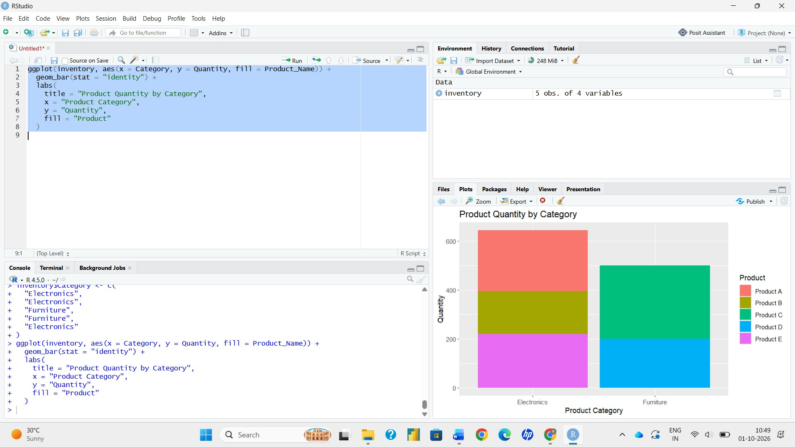
# Dataset (product categories assumed)
product <- c("Product A", "Product B", "Product C", "Product D", "Product E") quantity <- c(250, 175, 300, 200, 220)
category <- c("Electronics", "Electronics", "Accessories", "Accessories", "Home Appliances")

# Matrix: rows = products, columns = categories inv <- matrix(0, nrow = 5, ncol = 3,
dimnames = list(product, unique(category))) for (i in 1:5) {
inv[product[i], category[i]] <- quantity[i]
}

# Stacked Bar Chart barplot(inv,
xlab = "Product Category", ylab = "Quantity Available",
main = "Quantity of Products within Each Category",
col = c("tomato", "orange", "gold", "seagreen", "steelblue"), legend.text = rownames(inv),
args.legend = list(x = "topright"), ylim = c(0, 600))

Output 2: Stacked Bar Chart of Quantity by Category

Observation: Accessories holds the largest total stock (500 units: Product C 300 + Product D 200), followed by Electronics (425 units: Product A 250 + Product B 175). Home Appliances contains only Product E (220 units).

PROGRAM 3: Scatter Plot of Price vs Quantity Available
Build a scatter plot to explore the relationship between product price and quantity available. Explain the findings.
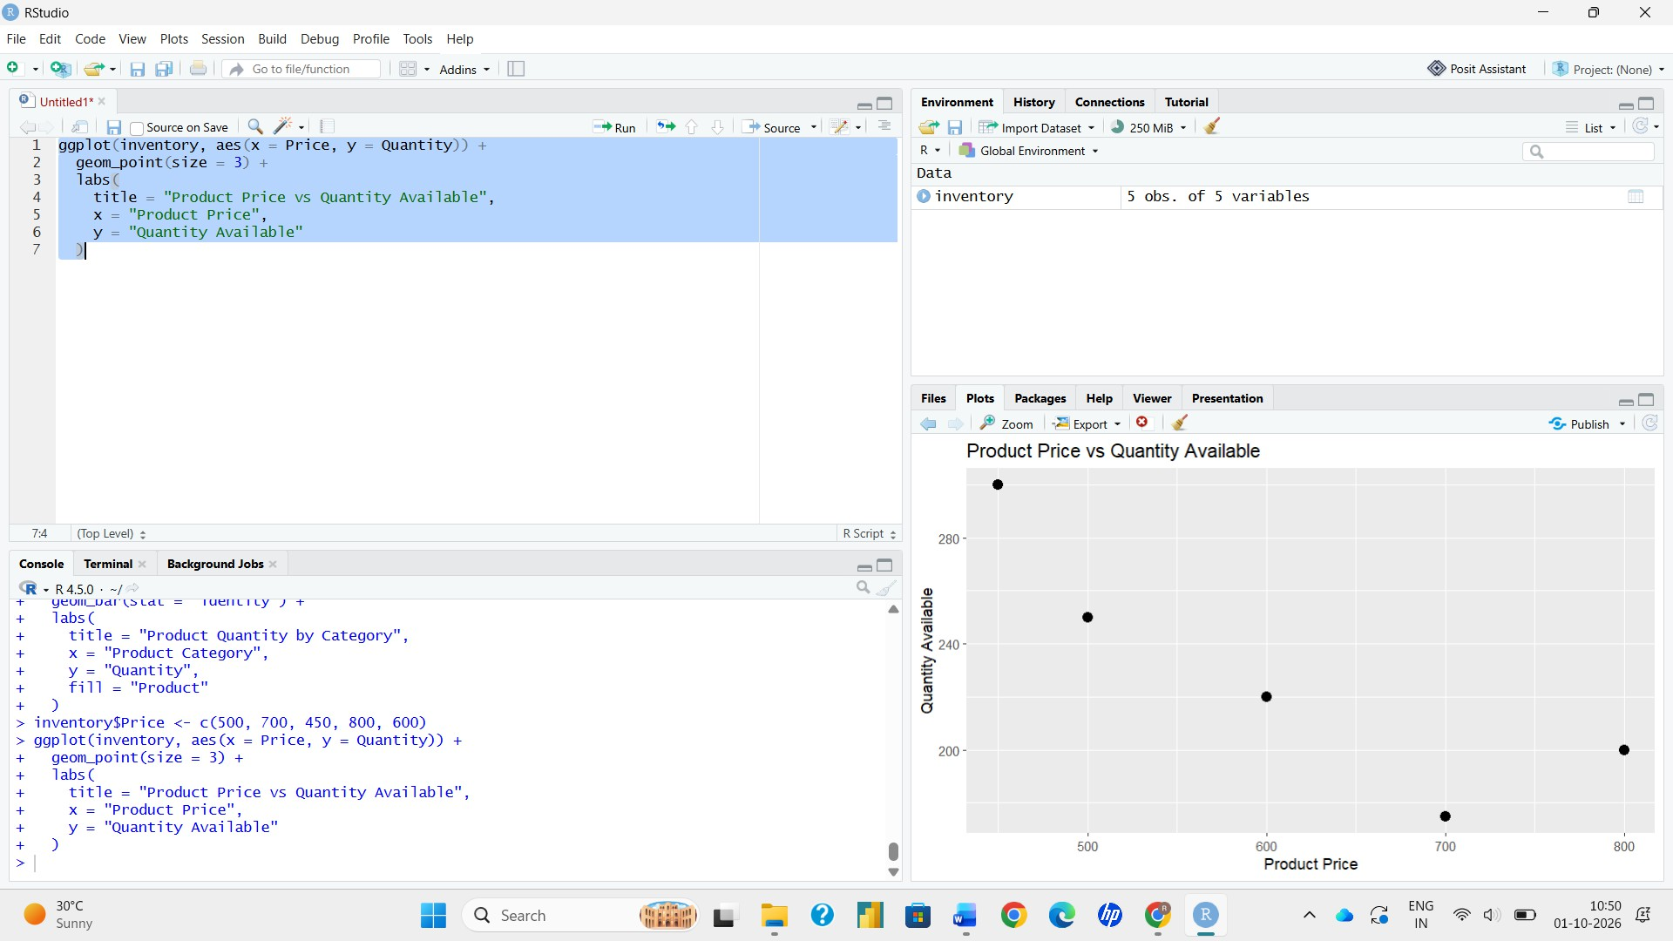
# Dataset (product prices assumed) price <- c(40, 60, 25, 50, 45)
quantity <- c(250, 175, 300, 200, 220)

# Scatter Plot plot(price, quantity,
main = "Product Price vs Quantity Available", xlab = "Product Price ($)",
ylab = "Quantity Available", pch = 19,
col = "red",
xlim = c(20, 65), ylim = c(150, 320))
abline(lm(quantity ~ price), col = "blue", lwd = 2) # Correlation coefficient
cor(price, quantity)

Output 3: Product Price vs Quantity Available Scatter Plot

Insight: The points fall almost along a straight downward line, and the correlation coefficient is about -0.99. This shows a strong negative relationship: lower-priced products (such as Product C at $25) have more stock available, while higher-priced products (such as Product B at $60) have less. The price values are assumed, so this conclusion applies to the values plotted.

PROGRAM 4: Interactive Inventory Dashboard
Develop a dashboard with the bar chart and stacked bar chart to allow users to interact with the data using the Shiny package.
library(shiny)

product <- c("Product A", "Product B", "Product C", "Product D", "Product E") quantity <- c(250, 175, 300, 200, 220)
category <- c("Electronics", "Electronics", "Accessories", "Accessories", "Home Appliances")

inv <- matrix(0, nrow = 5, ncol = 3,
dimnames = list(product, unique(category))) for (i in 1:5) {
inv[product[i], category[i]] <- quantity[i]
}

ui <- fluidPage(

titlePanel("Product Inventory Dashboard"),

sidebarLayout(

sidebarPanel( selectInput("chart",
"Select Chart:",
choices = c("Bar Chart", "Stacked Bar Chart"))
),

mainPanel( plotOutput("inventoryPlot")
)
)
)

server <- function(input, output) {

output$inventoryPlot <- renderPlot({

if (input$chart == "Bar Chart") {

barplot(quantity, names.arg = product, xlab = "Product",
ylab = "Quantity Available", main = "Product Inventory", col = "steelblue")

} else {

barplot(inv,
xlab = "Product Category", ylab = "Quantity Available",
main = "Quantity of Products within Each Category",
col = c("tomato", "orange", "gold", "seagreen", "steelblue"), legend.text = rownames(inv))
}
})

}

shinyApp(ui = ui, server = server)
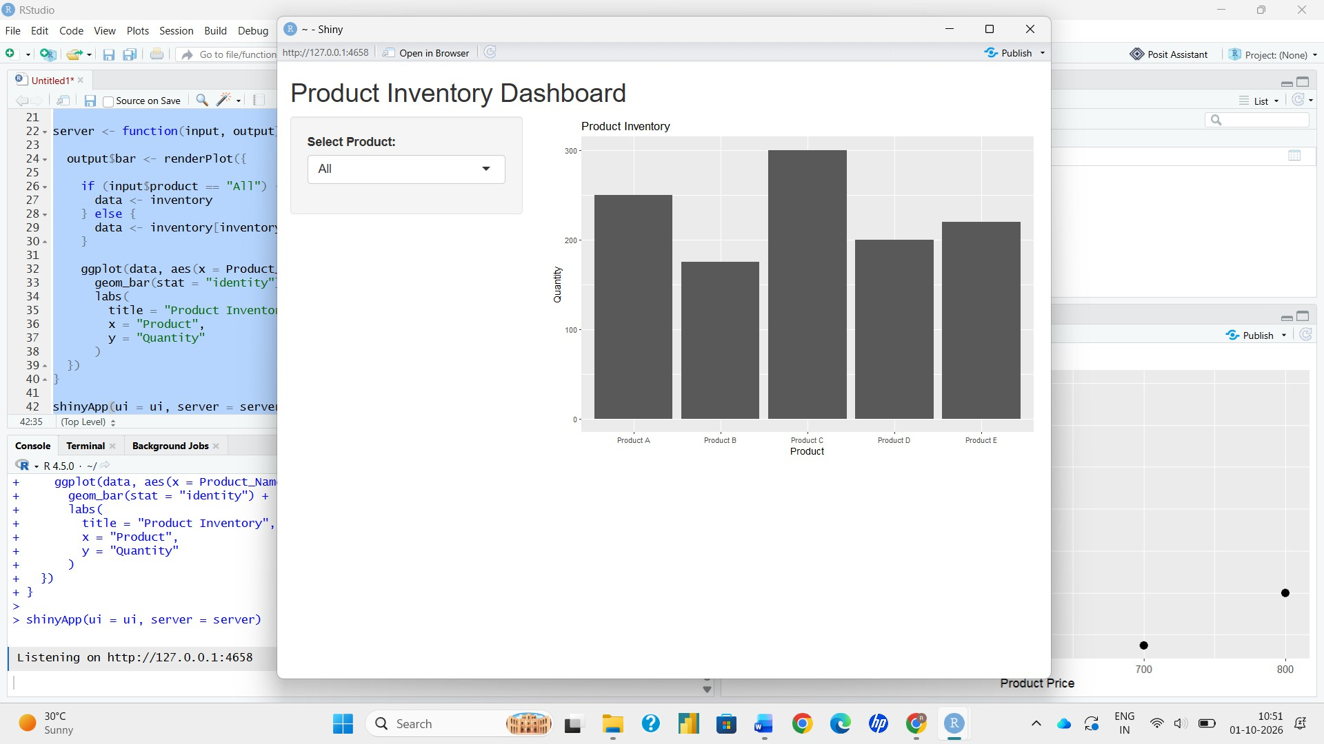
Output 4: Interactive Product Inventory Dashboard

Observation: The dashboard provides a chart-selection control. Selecting Bar Chart displays the quantity of each product, while selecting Stacked Bar Chart displays the quantity grouped within product categories.

Procedure
- Create the product, quantity and category vectors in R.
- Use barplot() to create the bar chart with axis labels and a title.
- Build a product-by-category matrix and use barplot() to create the stacked bar chart.
- Create price and quantity vectors of equal length, use plot() for the scatter plot, and add a trend line with abline() and lm().
- Install and load the Shiny package, then create the UI and server components for the interactive dashboard.
- Run the Shiny application and switch between the Bar Chart and Stacked Bar Chart using the selection box.

Result
The product inventory data was successfully visualized using a bar chart, stacked bar chart, and scatter plot. An interactive Shiny dashboard was also created to switch between the bar chart and stacked bar chart.

Key R Functions Used

Function | Purpose
barplot() | Creates bar charts and stacked bar charts.
matrix() | Builds the product-by-category table used for stacking.
plot() | Creates the scatter plot.
abline() | Adds the regression (trend) line.
cor() | Calculates the correlation coefficient.
fluidPage() | Creates the Shiny page layout.
selectInput() | Provides the chart selection control.
renderPlot() | Generates plots dynamically in Shiny.
shinyApp() | Runs the interactive Shiny application.

