LAB EXPERIMENT RECORD

Set 5: Website Analytics

Department | CSE-DS
Course Code / Course Name | DSA0602/ Data Handling and Visualization
Experiment | Data Visualization using R
Name | M Uday Kumar Reddy
Register Number | 192473022
Date | 2 October 2026
Day | Friday

Aim
To analyze website traffic data using a line chart, bar chart, and stacked area chart, and to build an interactive dashboard using R and Shiny.

Dataset: Website Traffic

Date | Page Views | Click-through Rate
2023-01-01 | 1500 | 2.3%
2023-01-02 | 1600 | 2.7%
2023-01-03 | 1400 | 2.0%
2023-01-04 | 1650 | 2.4%
2023-01-05 | 1800 | 2.6%

Note: The given dataset does not contain user interaction data. For Program 3 the daily likes, shares and comments are assumed values (Likes: 120, 150, 100, 160, 180; Shares: 40, 55, 30, 50, 65; Comments: 20, 25, 15, 30, 35).

PROGRAM 1: Line Chart of Daily Page Views
Create a line chart to visualize the trend in daily page views over time. Label the axes and title the chart.
# Dataset
date <- as.Date(c("2023-01-01", "2023-01-02", "2023-01-03",
"2023-01-04", "2023-01-05"))
views <- c(1500, 1600, 1400, 1650, 1800)

# Line Chart plot(date, views,
type = "o", xlab = "Date",
ylab = "Page Views",
main = "Daily Page Views", col = "blue",
pch = 19)

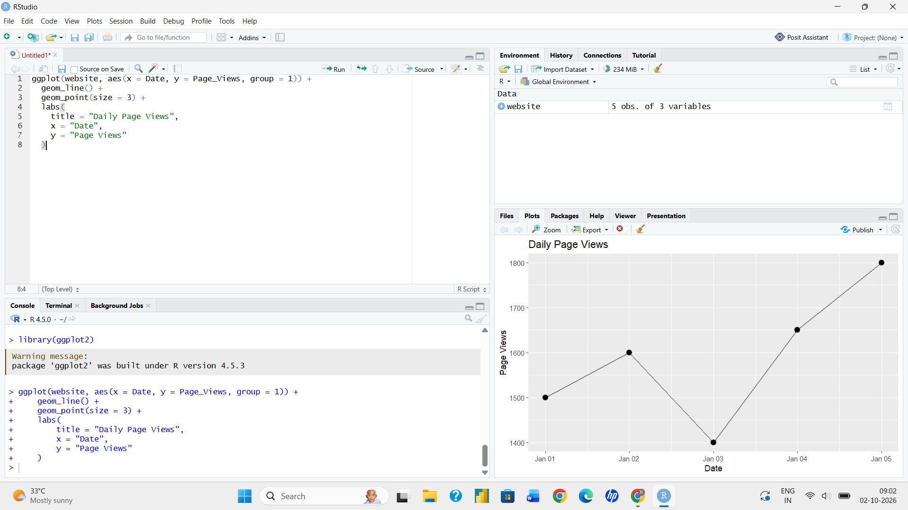
Output 1: Daily Page Views Line Chart

Observation: Page views rise from 1500 on 1 January to 1600 on 2 January, fall to the lowest value (1400) on 3 January, and then increase steadily to the highest value (1800) on 5 January.

PROGRAM 2: Bar Chart of Top N Days by Click-through Rate
Generate a bar chart showing the top N days with the highest click-through rates (here N = 3). Label the chart elements.
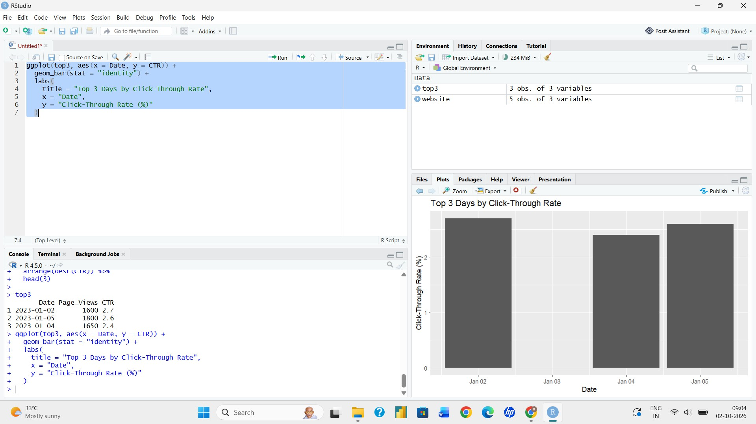
# Dataset
date <- as.Date(c("2023-01-01", "2023-01-02", "2023-01-03",
"2023-01-04", "2023-01-05"))
ctr <- c(2.3, 2.7, 2.0, 2.4, 2.6)

# Top N days with the highest click-through rate N <- 3
top <- order(ctr, decreasing = TRUE)[1:N]

# Bar Chart barplot(ctr[top],
names.arg = format(date[top], "%Y-%m-%d"), xlab = "Date",
ylab = "Click-through Rate (%)",
main = paste("Top", N, "Days by Click-through Rate"), col = "orange",
ylim = c(0, 3))

Output 2: Top 3 Days by Click-through Rate

Observation: The three days with the highest click-through rates are 2 January (2.7%), 5 January (2.6%) and 4 January (2.4%). Changing the value of N in the program changes how many days are shown.

PROGRAM 3: Stacked Area Chart of User Interactions
Develop a stacked area chart to display the distribution of user interactions (likes, shares, comments) on a website.
# Dataset (user interaction values assumed)
date <- as.Date(c("2023-01-01", "2023-01-02", "2023-01-03",
"2023-01-04", "2023-01-05"))
likes <- c(120, 150, 100, 160, 180)
shares <- c(40, 55, 30, 50, 65)
comments <- c(20, 25, 15, 30, 35)

# Cumulative values for stacking c1 <- likes
c2 <- likes + shares
c3 <- likes + shares + comments x <- 1:5

# Stacked Area Chart plot(x, c3,
type = "n",
xaxt = "n", xlab = "Date",
ylab = "Number of Interactions",
main = "Distribution of User Interactions", ylim = c(0, max(c3) + 20))

polygon(c(x, rev(x)), c(c3, rev(c2)), col = "seagreen", border = NA) polygon(c(x, rev(x)), c(c2, rev(c1)), col = "orange", border = NA) polygon(c(x, rev(x)), c(c1, rep(0, 5)), col = "steelblue", border = NA)

axis(1, at = x, labels = format(date, "%b %d")) legend("topleft",
legend = c("Comments", "Shares", "Likes"), fill = c("seagreen", "orange", "steelblue"))

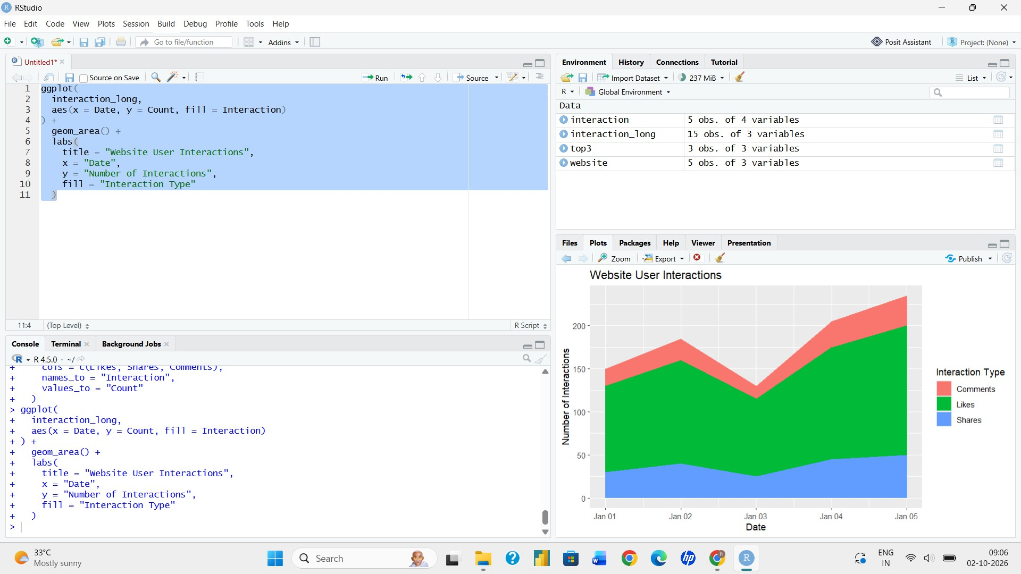
Output 3: Distribution of User Interactions

Observation: Likes form the largest share of interactions on every day, followed by shares and then comments. The total number of interactions is highest on 5 January (280) and lowest on 3 January (145), following the same pattern as the page views.

PROGRAM 4: Interactive Website Traffic Dashboard
Build a dashboard with the line chart and bar chart for interactive exploration of website traffic data using the Shiny package.
library(shiny)

date <- as.Date(c("2023-01-01", "2023-01-02", "2023-01-03",
"2023-01-04", "2023-01-05"))
views <- c(1500, 1600, 1400, 1650, 1800)
ctr <- c(2.3, 2.7, 2.0, 2.4, 2.6)

ui <- fluidPage(

titlePanel("Website Traffic Dashboard"),

sidebarLayout(

sidebarPanel( selectInput("chart",
"Select Chart:",
choices = c("Line Chart", "Bar Chart")),

sliderInput("n",
"Top N days (Bar Chart):",
min = 1, max = 5, value = 3, step = 1)
),

mainPanel( plotOutput("trafficPlot")
)
)
)

server <- function(input, output) {

output$trafficPlot <- renderPlot({

if (input$chart == "Line Chart") {

plot(date, views, type = "o", xlab = "Date",
ylab = "Page Views",
main = "Daily Page Views", col = "blue",
pch = 19)

} else {

top <- order(ctr, decreasing = TRUE)[1:input$n]

barplot(ctr[top],
names.arg = format(date[top], "%Y-%m-%d"), xlab = "Date",
ylab = "Click-through Rate (%)",
main = paste("Top", input$n, "Days by Click-through Rate"), col = "orange")

}
})
}

shinyApp(ui = ui, server = server)
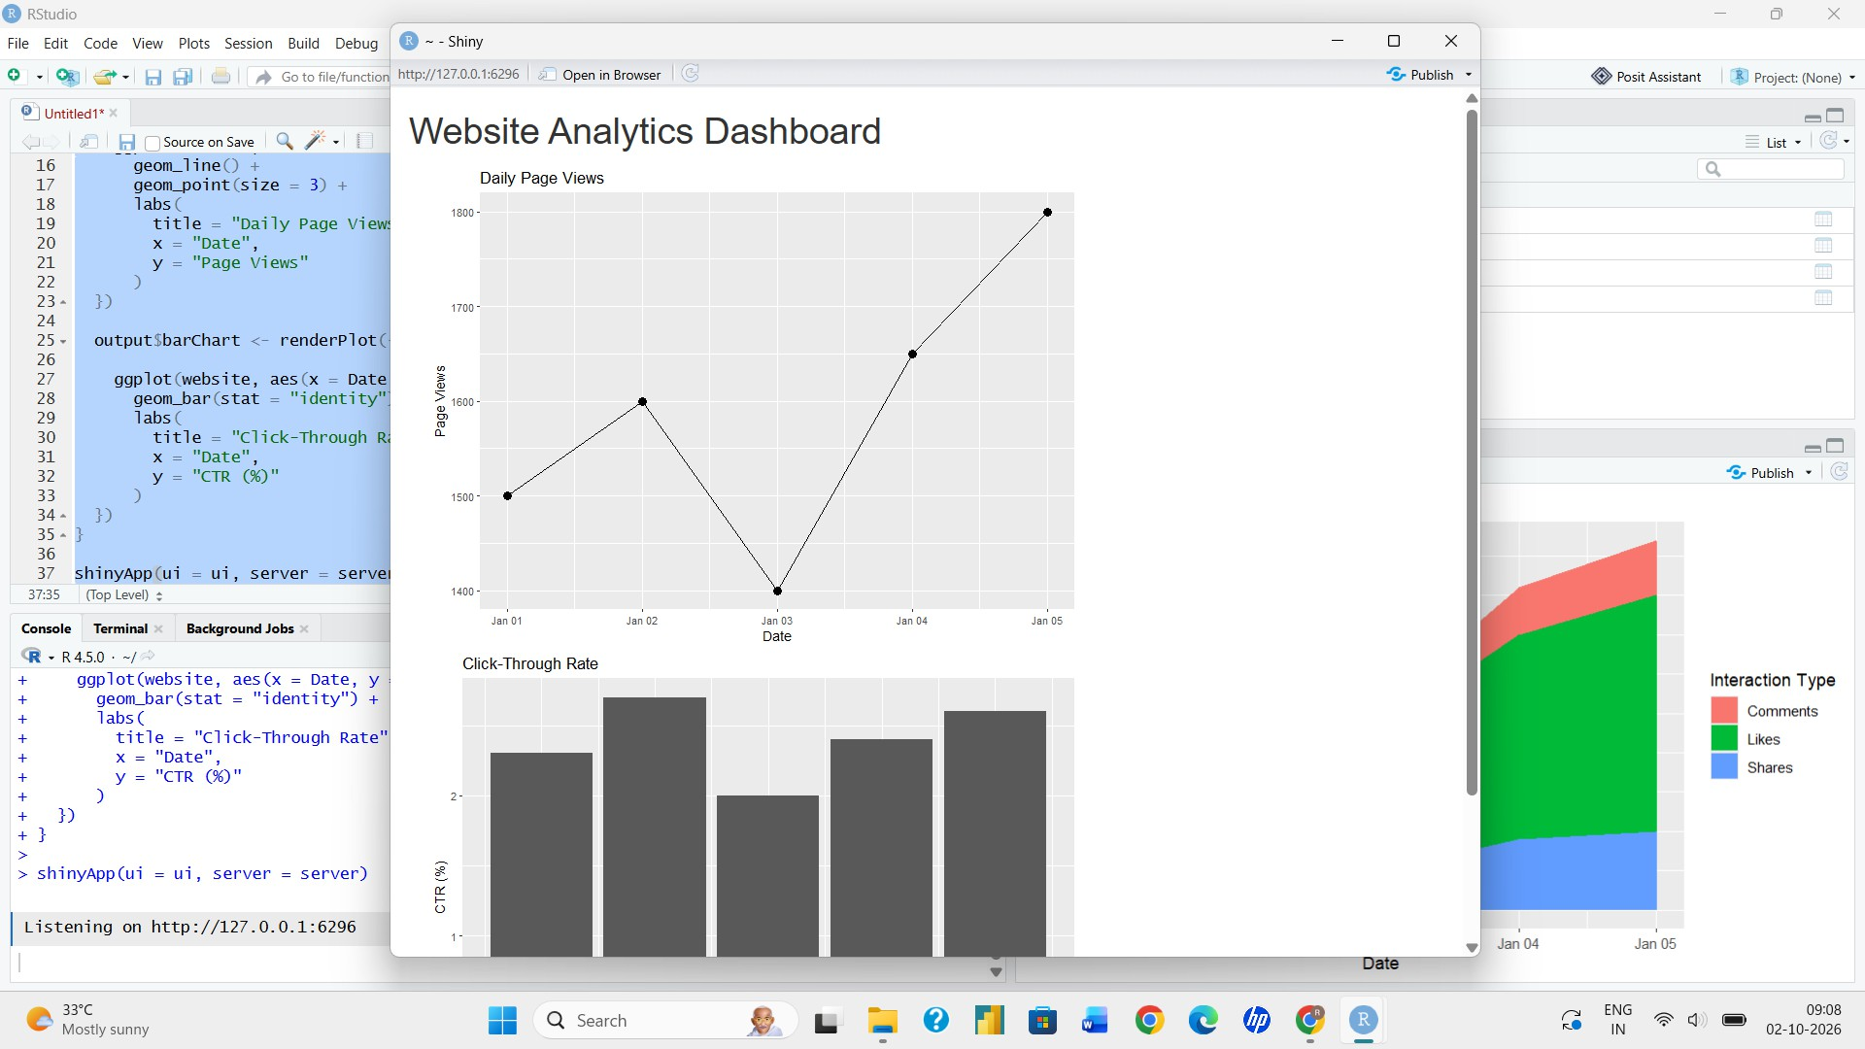
Output 4: Interactive Website Traffic Dashboard

Observation: The dashboard provides a chart-selection control and a slider for N. Selecting Line Chart displays the daily page-view trend, while selecting Bar Chart displays the top N days by click-through rate.

Procedure
- Create the date, page views and click-through rate vectors in R.
- Use plot() with type = "o" to create the line chart of daily page views.
- Use order() to find the top N click-through rates and barplot() to display them.
- Create the likes, shares and comments vectors, calculate cumulative totals, and use polygon() to draw the stacked area chart.
- Install and load the Shiny package, then create the UI and server components for the interactive dashboard.
- Run the Shiny application, switch between the Line Chart and Bar Chart, and change N using the slider.

Result
The website traffic data was successfully visualized using a line chart, bar chart, and stacked area chart. An interactive Shiny dashboard was also created to explore the page-view trend and the top N days by click-through rate.

Key R Functions Used

Function | Purpose
as.Date() | Converts text values into dates.
plot() | Creates line charts and the base of the area chart.
order() | Sorts values to find the top N days.
barplot() | Creates bar charts.
polygon() | Draws the filled areas of the stacked area chart.
legend() | Adds a legend to the chart.
fluidPage() | Creates the Shiny page layout.
selectInput() / sliderInput() | Provide the chart selection and N controls.
renderPlot() | Generates plots dynamically in Shiny.
shinyApp() | Runs the interactive Shiny application.

