LAB EXPERIMENT RECORD

Set 6: Product Sales Analysis

Department | CSE-DS
Course Code / Course Name | DSA0602/ Data Handling and Visualization
Experiment | Data Visualization using R
Name | M Uday Kumar Reddy
Register Number | 192473022
Date | 2 October 2026
Day | Friday

Aim
To analyze monthly product sales using a grouped bar chart, stacked area chart, and data table, and to build an interactive dashboard using R and Shiny.

Dataset: Monthly Product Sales

Product ID | Product Name | January Sales | February Sales | March Sales
1 | Product A | 2000 | 2200 | 2400
2 | Product B | 1500 | 1800 | 1600
3 | Product C | 1200 | 1400 | 1100

PROGRAM 1: Grouped Bar Chart of Quarterly Sales
Create a grouped bar chart to visualize the sales of each product for the first quarter. Label the chart elements.
# Dataset
product <- c("Product A", "Product B", "Product C") jan <- c(2000, 1500, 1200)
feb <- c(2200, 1800, 1400)
mar <- c(2400, 1600, 1100)

# Matrix: rows = months, columns = products sales <- rbind(jan, feb, mar)
colnames(sales) <- product
rownames(sales) <- c("January", "February", "March")

# Grouped Bar Chart barplot(sales,
beside = TRUE, xlab = "Product", ylab = "Sales",
main = "Product Sales in the First Quarter", col = c("skyblue", "orange", "seagreen"), legend.text = rownames(sales),
args.legend = list(x = "topright"), ylim = c(0, 3000))

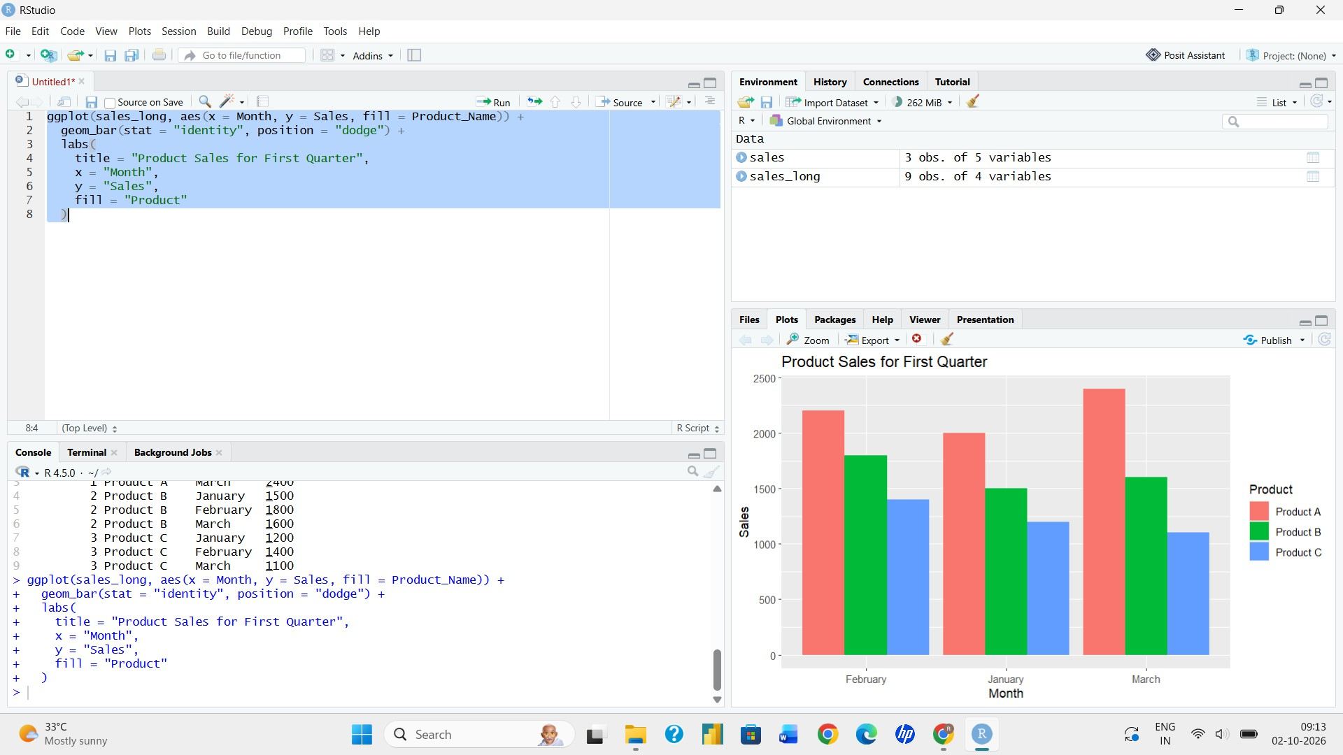
Output 1: Grouped Bar Chart of Product Sales

Observation: Product A has the highest sales in every month and grows steadily from 2000 to 2400. Product B peaks in February (1800), and Product C also peaks in February (1400) before falling to 1100 in March.

PROGRAM 2: Stacked Area Chart of Overall Sales Trend
Generate a stacked area chart to represent the overall sales trend for all products over the three months.
# Dataset
month <- c("January", "February", "March") prodA <- c(2000, 2200, 2400)
prodB <- c(1500, 1800, 1600)
prodC <- c(1200, 1400, 1100)

# Cumulative values for stacking c1 <- prodA
c2 <- prodA + prodB
c3 <- prodA + prodB + prodC x <- 1:3

# Stacked Area Chart plot(x, c3,
type = "n",
xaxt = "n",
xlab = "Month", ylab = "Sales",
main = "Overall Sales Trend of All Products", ylim = c(0, max(c3) + 1500))

polygon(c(x, rev(x)), c(c3, rev(c2)), col = "seagreen", border = NA) polygon(c(x, rev(x)), c(c2, rev(c1)), col = "orange", border = NA) polygon(c(x, rev(x)), c(c1, rep(0, 3)), col = "steelblue", border = NA)

axis(1, at = x, labels = month) legend("topleft",
legend = c("Product C", "Product B", "Product A"), fill = c("seagreen", "orange", "steelblue"))

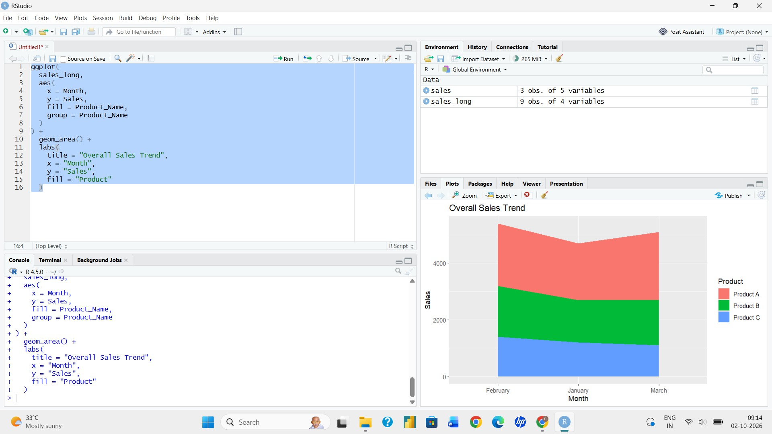
Output 2: Stacked Area Chart of Overall Sales

Observation: Total sales rise from 4700 in January to 5400 in February and then fall to 5100 in March. Product A contributes the largest share of the total in every month.

PROGRAM 3: Table of Monthly Sales Data
Build a table to show the monthly sales data for each product. Label the table elements.
# Dataset
sales_table <- data.frame( Product_ID = c(1, 2, 3),
Product_Name = c("Product A", "Product B", "Product C"), January_Sales = c(2000, 1500, 1200),
February_Sales = c(2200, 1800, 1400),
March_Sales = c(2400, 1600, 1100)
)

# Monthly sales table print(sales_table)
Console output:

Pro  1 | duct_  1 | ID Product_Name January_Sales Fe  Product A 2000 2200 |  |  | bruary_Sales March_Sales  2400
2 | 2 | Product B | 1500 | 1800 | 1600
3 | 3 | Product C | 1200 | 1400 | 1100
 |  |  |  |  | Output 3: Monthly Sales Table

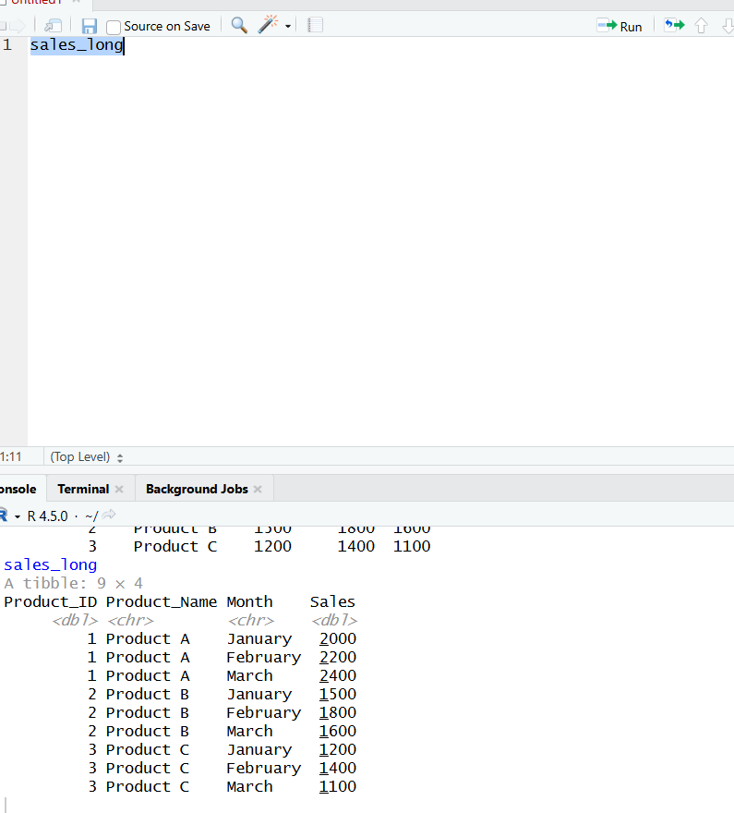
Observation: The table lists the January, February and March sales of every product, with each column labelled by product ID, product name and month.

PROGRAM 4: Interactive Product Sales Dashboard
Develop a dashboard combining the grouped bar chart, stacked area chart, and the table for interactive exploration of sales data using the Shiny package.
library(shiny)

product <- c("Product A", "Product B", "Product C") jan <- c(2000, 1500, 1200)
feb <- c(2200, 1800, 1400)
mar <- c(2400, 1600, 1100)

sales <- rbind(jan, feb, mar) colnames(sales) <- product
rownames(sales) <- c("January", "February", "March")

sales_table <- data.frame( Product_ID = c(1, 2, 3), Product_Name = product, January_Sales = jan, February_Sales = feb, March_Sales = mar
)

ui <- fluidPage(

titlePanel("Monthly Product Sales Dashboard"),

tabsetPanel(
tabPanel("Grouped Bar Chart", plotOutput("groupedPlot")), tabPanel("Stacked Area Chart", plotOutput("areaPlot")), tabPanel("Sales Table", tableOutput("salesTable"))
)
)

server <- function(input, output) {

output$groupedPlot <- renderPlot({ barplot(sales,
beside = TRUE, xlab = "Product", ylab = "Sales",
main = "Product Sales in the First Quarter", col = c("skyblue", "orange", "seagreen"), legend.text = rownames(sales))
})

output$areaPlot <- renderPlot({ x <- 1:3
# Stack the three products across the three months pA <- sales[, 1]; pB <- sales[, 2]; pC <- sales[, 3] s1 <- pA; s2 <- pA + pB; s3 <- pA + pB + pC

plot(x, s3, type = "n", xaxt = "n", xlab = "Month", ylab = "Sales",
main = "Overall Sales Trend of All Products", ylim = c(0, max(s3) + 1500))
polygon(c(x, rev(x)), c(s3, rev(s2)), col = "seagreen", border = NA)

polygon(c(x, rev(x)), c(s2, rev(s1)), col = "orange", border = NA) polygon(c(x, rev(x)), c(s1, rep(0, 3)), col = "steelblue", border = NA) axis(1, at = x, labels = rownames(sales))
legend("topleft", legend = c("Product C", "Product B", "Product A"), fill = c("seagreen", "orange", "steelblue"))
})

output$salesTable <- renderTable({ sales_table
})
}

shinyApp(ui = ui, server = server)
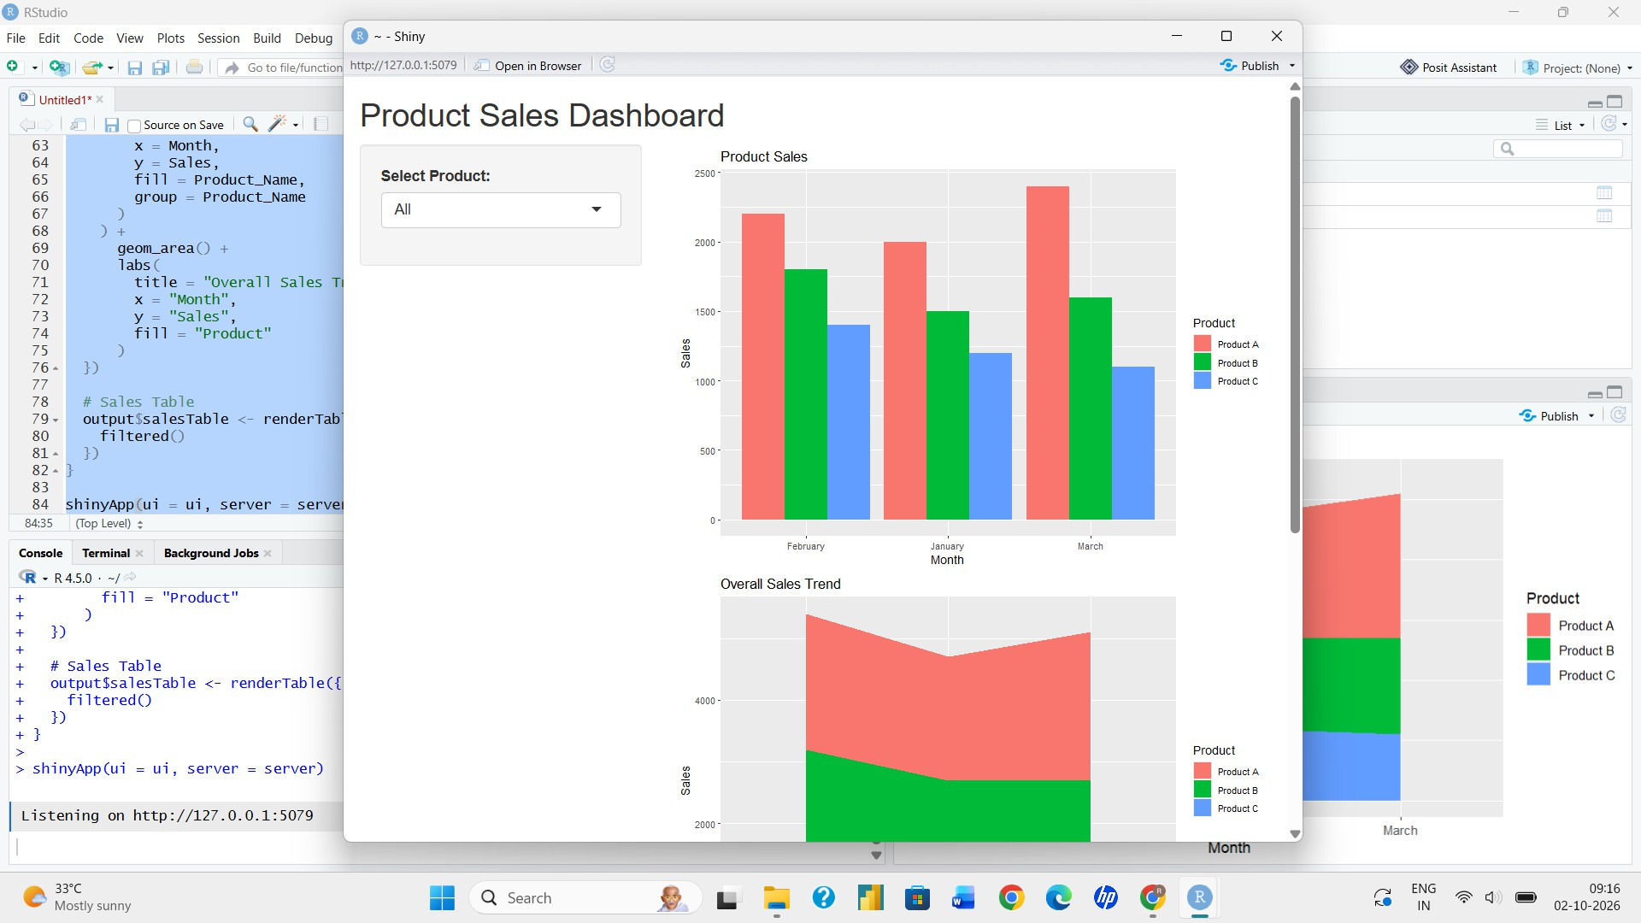
Output 4: Interactive Product Sales Dashboard

Observation: The dashboard has three tabs. Selecting Grouped Bar Chart, Stacked Area Chart or Sales Table displays the corresponding view of the quarterly sales data.

Procedure
- Create the product and monthly sales vectors in R and combine them into a matrix.
- Use barplot() with beside = TRUE to create the grouped bar chart.
- Calculate the cumulative sales of the products and use polygon() to draw the stacked area chart.
- Create a data frame with the product and monthly sales columns and display it using print().
- Install and load the Shiny package, then create the UI with tabsetPanel() and the server components for the dashboard.
- Run the Shiny application and switch between the Grouped Bar Chart, Stacked Area Chart and Sales Table tabs.

Result
The monthly product sales data was successfully visualized using a grouped bar chart, stacked area chart, and table. An interactive Shiny dashboard was also created to explore all three views.

Key R Functions Used

Function | Purpose
barplot() | Creates grouped bar charts (beside = TRUE).
polygon() | Draws the filled areas of the stacked area chart.
data.frame() | Creates the sales table.
print() | Displays the table in the console.
tabsetPanel() / tabPanel() | Create the tabbed dashboard layout.
renderPlot() / renderTable() | Generate plots and tables dynamically in Shiny.
shinyApp() | Runs the interactive Shiny application.

