SET 27: PATIENT HEALTH RISK ANALYSIS
Dataset: Patient Health Risk Data

Department | CSE-DS
Course Code / Course Name | DSA0602 / Data Handling and Visualization
Experiment | Data Visualization using R and Tableau
Name | M Uday Kumar Reddy
Register Number | 192473022
Date | 20 October 2026
Day | Tuesday

Patient_ID | Age | BMI | BP | Cholesterol
P1 | 25 | 22 | 120 | 180
P2 | 40 | 28 | 135 | 210
P3 | 55 | 30 | 145 | 240
P4 | 35 | 26 | 130 | 200
P5 | 60 | 32 | 150 | 260

PROGRAM 1: Scatterplot Matrix of Health Indicators
Question: Using R, create a scatterplot matrix for Age, BMI, BP, and Cholesterol. Examine pairwise relationships to identify strong correlations, clusters, or potential risk patterns.
# Dataset
patients <- data.frame(
Patient_ID = c("P1", "P2", "P3", "P4", "P5"), Age = c(25, 40, 55, 35, 60),
BMI = c(22, 28, 30, 26, 32),
BP = c(120, 135, 145, 130, 150),
Cholesterol = c(180, 210, 240, 200, 260)
)

# Panel function to show correlation values in the upper panel panel.cor <- function(x, y, ...) {
r <- cor(x, y)
text(0.5, 0.5, sprintf("%.2f", r), cex = 1 + 2 * abs(r))
}

# Scatterplot matrix pairs(patients[, 2:5],
main = "Scatterplot Matrix of Patient Health Indicators", pch = 19, col = "#E15759",
upper.panel = panel.cor)

# Correlation matrix round(cor(patients[, 2:5]), 3)

Output 1: Scatterplot Matrix
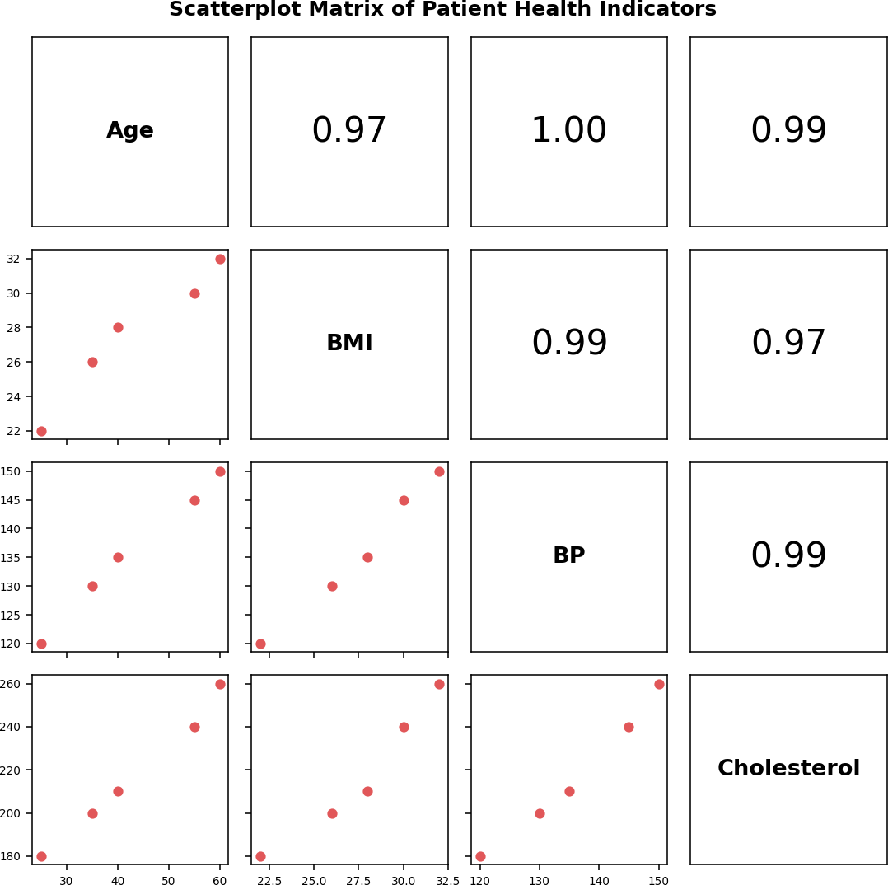

Console output
- round(cor(patients[, 2:5]), 3)
Age BMI BP Cholesterol
Age 1.000 0.974 0.996
BMI 0.974 1.000 0.991
BP 0.996 0.991 1.000
Cholesterol 0.994 0.969 0.990
0.994
0.969
0.990
1.000

Observation: All six pairs of indicators are very strongly and positively correlated (r from 0.969 to 0.996). Age and BP (0.996) and Age and Cholesterol (0.994) are the strongest pairs. The points form a near-straight upward line in every panel, so older patients have higher BMI, blood pressure and cholesterol together. There are two loose groups: P1, P2 and P4 (younger, lower values) and P3 and P5 (older, with the highest values on every indicator), which marks P3 and P5 as the potential high-risk pattern. Because all indicators rise together, they are highly collinear, and with only five patients these correlations should be treated as indicative.

PROGRAM 2: Q-Q Plot and ECDF of Cholesterol
Question: Construct Q-Q plot and ECDF for Cholesterol levels to assess distribution behaviour. Comment on normality assumption and skewness.
chol <- patients$Cholesterol par(mfrow = c(1, 2))

# Normal Q-Q plot qqnorm(chol,
main = "Normal Q-Q Plot of Cholesterol",
xlab = "Theoretical Quantiles", ylab = "Sample Quantiles", pch = 19, col = "#4E79A7")
qqline(chol, col = "#E15759", lwd = 2)

# ECDF with the normal CDF overlaid plot(ecdf(chol),
main = "ECDF of Cholesterol",
xlab = "Cholesterol (mg/dL)", ylab = "Cumulative Probability", col = "#4E79A7", lwd = 2)
curve(pnorm(x, mean(chol), sd(chol)), add = TRUE, col = "#E15759", lwd = 2, lty = 2)
legend("topleft", legend = c("ECDF", "Normal CDF"),
col = c("#4E79A7", "#E15759"), lty = c(1, 2), lwd = 2)
par(mfrow = c(1, 1))

# Normality test and skewness shapiro.test(chol)
skew <- (sum((chol - mean(chol))^3) / length(chol)) / (sum((chol - mean(chol))^2) / length(chol))^1.5
skew

Output 2: Q-Q Plot and ECDF
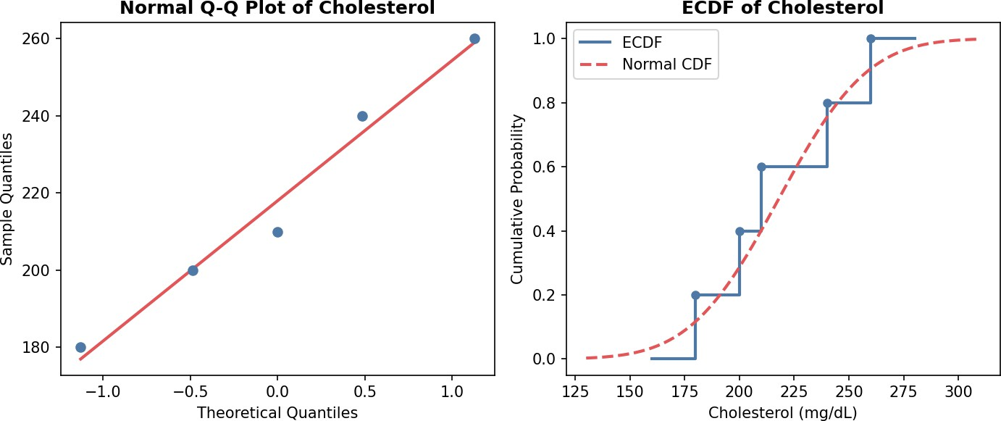

Console output
- shapiro.test(chol)
Shapiro-Wilk normality test data: chol
W = 0.96741, p-value = 0.8584

- skew
[1] 0.2018051

Observation: The Q-Q points lie close to the reference line and the ECDF follows the normal CDF curve closely, so cholesterol is consistent with a normal distribution. The Shapiro-Wilk test agrees (W = 0.967, p = 0.858, so normality is not rejected). The skewness is 0.20, which is a very slight right skew and well within the range usually treated as symmetric (between -0.5 and 0.5). The normality assumption is reasonable, but with only five observations the test has little power, so this should be rechecked on a larger sample.

PROGRAM 3: Bar Chart of Average Health Indicators
Question: Using R, create a bar chart showing the average values of each health indicator (Age, BMI, BP, Cholesterol). Include axis labels, a descriptive title, and distinct colors for each bar.
How do these averages relate to general patient health risk?
# Average of each indicator
avg <- colMeans(patients[, 2:5]) print(avg)

# Bar chart with a distinct colour per bar bp <- barplot(avg,
main = "Average Value of Each Health Indicator", xlab = "Health Indicator",
ylab = "Average Value",
col = c("#4E79A7", "#F28E2B", "#E15759", "#59A14F"),
ylim = c(0, 250)) text(bp, avg, labels = avg, pos = 3)

Output 3: Average Health Indicators Bar Chart
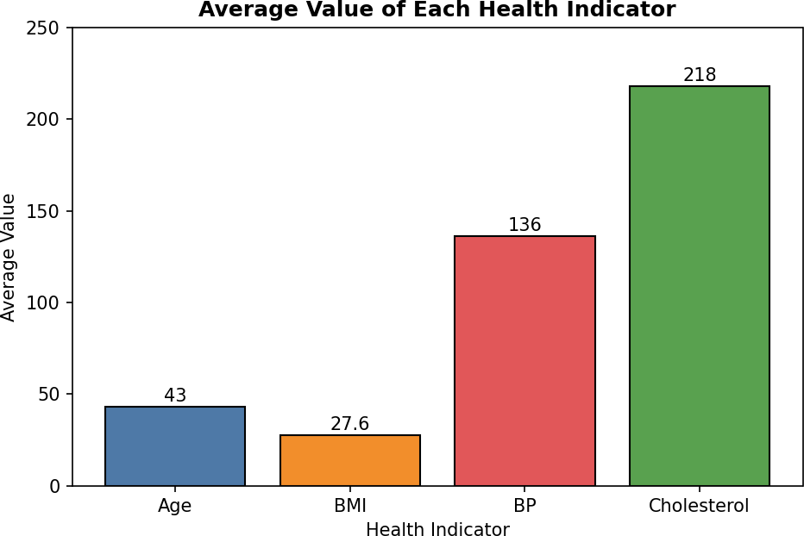

Console output

- print(avg)  Age | BMI | BP Cholesterol
43.0 | 27.6 | 136.0 218.0

Observation: The average patient is 43 years old with a BMI of 27.6, blood pressure of 136 and cholesterol of 218. Compared with common clinical guidelines, an average BMI of 27.6 falls in the overweight range (25 to 29.9), an average BP of 136 is in the stage 1 hypertension range (130 to 139), and an average cholesterol of 218 is borderline high (200 to 239). So on average the group sits above healthy values on all three clinical indicators, which indicates an elevated cardiovascular risk for the group as a whole. The bars use different units and scales, so they should be compared with clinical thresholds rather than with each other.

PROGRAM 4: Interactive Patient Risk Dashboard in Tableau
Question: Create an interactive Tableau dashboard with a heatmap highlighting high-risk patients and an Age filter for exploring risk patterns. Include hover tooltips showing all health

indicators. Analyze which patients are highest risk, how age affects risk, and how this dashboard can aid healthcare professionals in prioritizing care.
Calculated fields (Analysis > Create Calculated Field)
// Risk Score (0 to 7): points from each indicator, +1 for age 50 or over (IF [BMI] >= 30 THEN 2 ELSEIF [BMI] >= 25 THEN 1 ELSE 0 END)
+ (IF [BP] >= 140 THEN 2 ELSEIF [BP] >= 130 THEN 1 ELSE 0 END)
+ (IF [Cholesterol] >= 240 THEN 2 ELSEIF [Cholesterol] >= 200 THEN 1 ELSE 0 END)
+ (IF [Age] >= 50 THEN 1 ELSE 0 END)

// Risk Level
IF [Risk Score] >= 5 THEN "High"
ELSEIF [Risk Score] >= 2 THEN "Moderate" ELSE "Low" END

// Scaled indicators for the heatmap colour (one per indicator) (SUM([Age]) - {MIN([Age])}) / ({MAX([Age])} - {MIN([Age])})
// repeat for BMI, BP and Cholesterol -> Age Idx, BMI Idx, BP Idx, Chol Idx

Tableau Steps
- Open Tableau and connect to the patient data file (Excel/CSV). Confirm that Age, BMI, BP and Cholesterol are numeric measures and Patient_ID is a dimension.
- Create the calculated fields Risk Score, Risk Level, and the four scaled fields Age Idx, BMI Idx, BP Idx and Chol Idx (shown above).
- Create a worksheet named "Risk Heatmap". Drag Patient_ID to Rows and the four scaled fields to the view so Measure Names is on Columns and Measure Values is on Color. In the Marks card choose Square.
- Edit the colour to a sequential red palette so higher scaled values are darker. Put the Risk Level field on Detail, and add the original SUM(Age), SUM(BMI), SUM(BP) and SUM(Cholesterol) to Text or Detail so actual values show in the cells.
- Customise the Tooltip (click Tooltip in the Marks card) to show all indicators, for example: Patient: <Patient_ID>, Age: <SUM(Age)>, BMI: <SUM(BMI)>, BP: <SUM(BP)>, Cholesterol:
<SUM(Cholesterol)>, Risk Score: <Risk Score>, Risk Level: <Risk Level>.
- Create a worksheet named "Risk Score by Patient". Put Patient_ID on Rows and Risk Score on Columns, choose Bar, colour by Risk Level (High = dark red, Moderate = orange, Low = blue) and sort descending.
- Add the Age filter: drag Age to Filters, choose the At Least / Range option, right-click the filter and select Show Filter, then set it to Apply to Worksheets > All Using This Data Source.
- Create a new Dashboard, set the size to Automatic, drag in the heatmap and the risk score bar chart, and add the title "Patient Health Risk Dashboard".
- Select the heatmap and enable Use as Filter, show the Age slider and a Risk Level legend, and keep the tooltips on.
- Test the dashboard: move the Age slider, hover over cells to read the tooltip and click a patient to highlight their risk score.

Risk scoring results

Patient_ID | Age | BMI | BP | Cholesterol | Risk Score | Risk Level
P1 | 25 | 22 | 120 | 180 | 0 | Low
P2 | 40 | 28 | 135 | 210 | 3 | Moderate
P3 | 55 | 30 | 145 | 240 | 7 | High
P4 | 35 | 26 | 130 | 200 | 3 | Moderate
P5 | 60 | 32 | 150 | 260 | 7 | High

Output 4: Patient Health Risk Dashboard (layout preview)
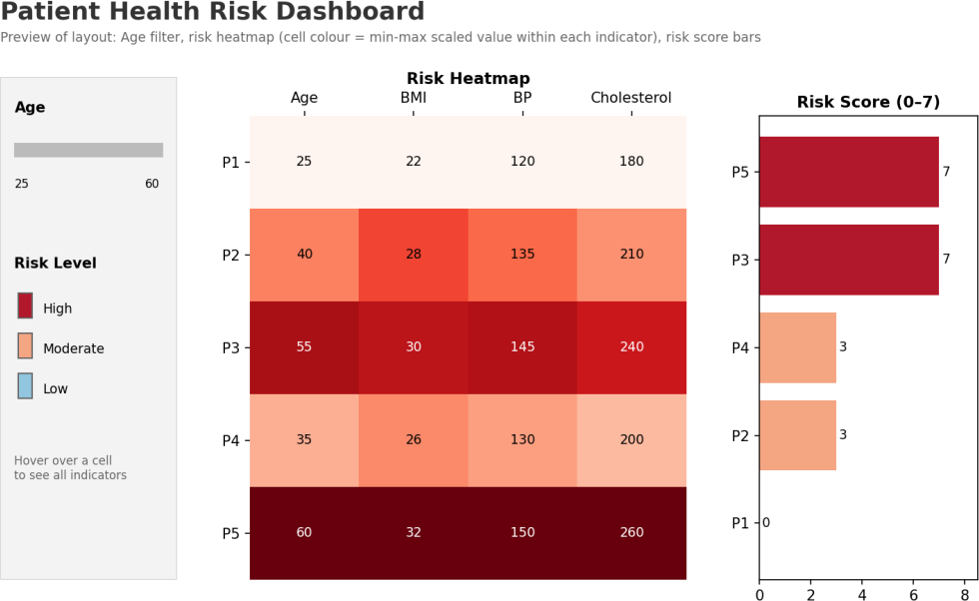

Observation: P5 and P3 are the highest-risk patients (both score 7 of 7 and are classed High), and P5 is the most urgent because that patient has the highest value on every indicator (Age 60, BMI 32, BP 150, Cholesterol 260). P2 and P4 are Moderate (score 3), and P1 is Low (score 0). Risk rises sharply with age: the risk score and age have a correlation of about 0.98, and all patients aged 55 or above are High risk while those under 45 are Low or Moderate. The dashboard helps healthcare professionals because the heatmap shows at a glance which patients are high on several indicators at once, the Age filter lets them focus on a group such as patients over 50, and the tooltip gives the full readings without leaving the view. Patients can then be ordered by risk score so that follow-up and lifestyle or medical intervention go first to P5 and P3. The scoring thresholds are simple guideline-based cut-offs used for screening and prioritisation, not a clinical diagnosis.

Procedure
- Create the patient data frame (Patient_ID, Age, BMI, BP, Cholesterol) in R.
- Draw the scatterplot matrix with pairs() and print the correlation matrix with cor().

- Draw the normal Q-Q plot with qqnorm() and qqline(), plot the ECDF with ecdf(), and run shapiro.test() and compute skewness for Cholesterol.
- Calculate the average of each indicator with colMeans() and draw a coloured bar chart with barplot().
- Import the data into Tableau and create the Risk Score, Risk Level and scaled indicator calculated fields.
- Build the risk heatmap and risk score bar chart worksheets with tooltips.
- Combine them in a dashboard with an Age filter and Use as Filter enabled.
- Test the dashboard interactivity and analyse the high-risk patients.

Result
The Patient Health Risk data was successfully analysed using a scatterplot matrix (all indicators strongly correlated, r above 0.96), a Q-Q plot and ECDF (cholesterol approximately normal, skewness 0.20), and a bar chart of average indicators (average BMI, BP and cholesterol all above healthy ranges). An interactive Tableau dashboard with a risk heatmap, Age filter and tooltips identified P5 and P3 as the highest-risk patients and showed that risk increases with age.

