LAB EXPERIMENT RECORD

Set 4: Product Inventory Management
Department | AIML
Course Code / Course Name | DSA0602 / Data Handling and Visualization
Experiment | Data Visualization using R and Tableau
Name | M Uday Kumar Reddy
Register Number | 192473022
Date | 1 October 2026
Day | Thursday

Aim
To visualize product inventory data using a bar chart, stacked bar chart, and scatter plot in R, and to build an interactive dashboard in Tableau.

Dataset: Product Inventory
Product ID | Product Name | Quantity Available
1 | Product A | 250
2 | Product B | 175
3 | Product C | 300
4 | Product D | 200
5 | Product E | 220

Supplementary Data: Category and Price (assumed)
Product Name | Category | Price ($)
Product A | Electronics | 50
Product B | Electronics | 80
Product C | Home | 30
Product D | Home | 60
Product E | Office | 40

Note: The assignment table contains only Product ID, Product Name, and Quantity Available. The Category and Price values above are assumed sample values used for Programs 2 and 3.

PROGRAM 1: Bar Chart of Product Quantity
Create a bar chart to visualize the quantity of each product in the inventory. Label the axes and title the chart.
# Dataset product <- c("Product A", "Product B", "Product C", "Product D", "Product E") quantity <- c(250, 175, 300, 200, 220)

# Bar Chart barplot(quantity, names.arg = product, xlab = "Product", ylab = "Quantity
Available", main = "Product
Inventory", col = "skyblue")
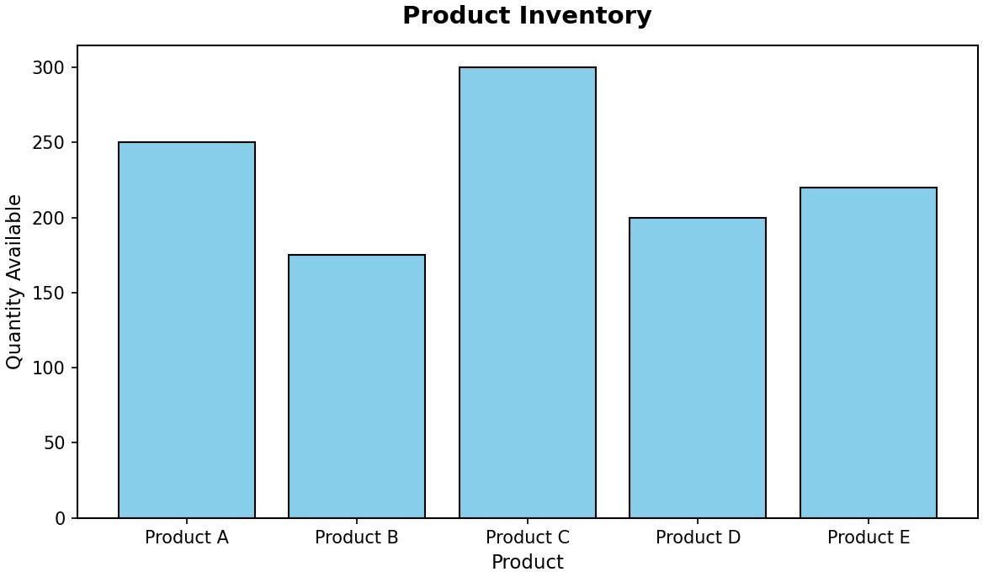

Output 1: Product Inventory Bar Chart
Observation: Product C has the highest quantity (300 units) and Product B has the lowest (175 units). Products A, D, and E lie in between at 250, 200, and 220 units.

PROGRAM 2: Stacked Bar Chart by Product Category
Generate a stacked bar chart to show the quantity of each product within different product categories.
# Quantity of each product within each category inventory <- matrix(c(250, 175, 0, 0, 0,
0, 0, 300, 200, 0,
0, 0, 0, 0, 220), nrow = 5,
dimnames = list( c("Product A", "Product B", "Product C", "Product
D", "Product E"), c("Electronics", "Home", "Office")))

# Stacked Bar Chart barplot(inventory, beside = FALSE, xlab = "Product Category", ylab = "Quantity Available", main = "Inventory by Product Category", col = c("skyblue", "lightgreen", "orange", "pink", "plum"), ylim = c(0, 600),

legend.text = rownames(inventory), args.legend = list(x = "topright"))
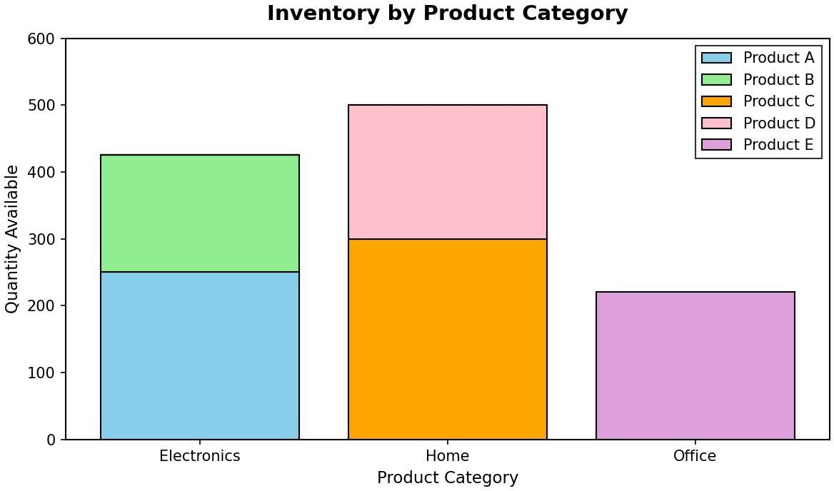
Output 2: Inventory by Product Category (Stacked Bar Chart)
Observation: The Home category holds the most stock (500 units: Product C 300 and Product D 200), followed by Electronics (425 units: Product A 250 and Product B 175). Office has 220 units, all from Product E.

PROGRAM 3: Scatter Plot of Price vs Quantity Available
Build a scatter plot to explore the relationship between product price and quantity available. Explain the findings.
# Dataset price <- c(50, 80, 30, 60,
40) quantity <- c(250, 175, 300, 200,
220)

# Scatter Plot plot(price, quantity, main = "Product Price vs Quantity Available", xlab = "Product Price ($)", ylab = "Quantity Available", pch = 19, col = "red")

# Correlation coefficient cor(price, quantity)

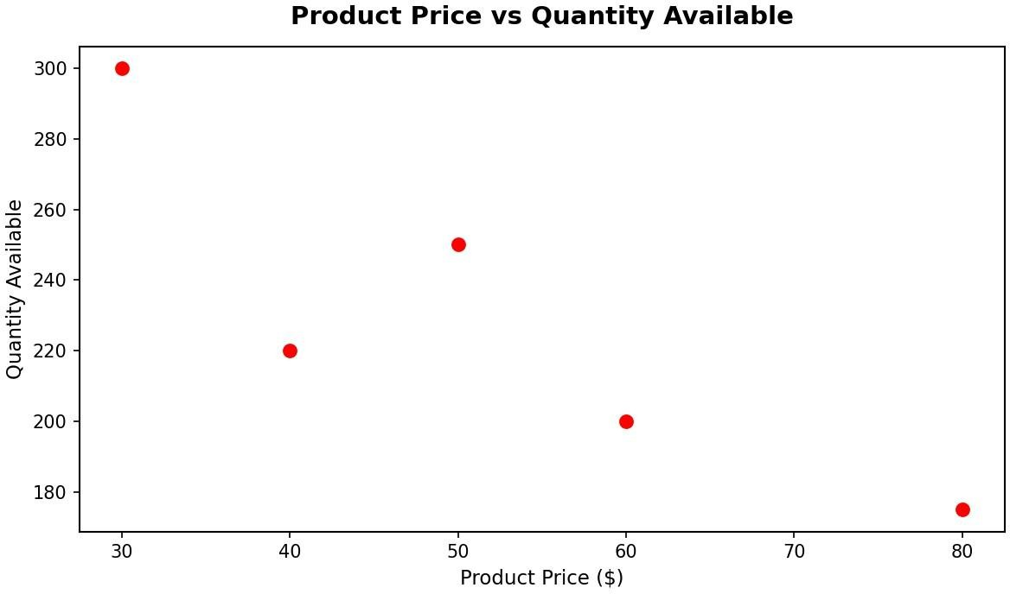
Output 3: Product Price vs Quantity Available Scatter Plot
Insight: The points slope downward: as the product price increases, the quantity available decreases. The correlation coefficient is about -0.87, a strong negative relationship. For example, Product C ($30) has 300 units in stock while Product B ($80) has only 175 units. Cheaper products are stocked in larger quantities, which may reflect higher demand for lower-priced items. Since the price values are assumed and only five products are used, this is an indication rather than a firm conclusion.

PROGRAM 4: Tableau Dashboard for Product Inventory
Develop a Tableau dashboard with the bar chart and stacked bar chart to allow users to interact with the data.

Steps in Tableau:
- Save the inventory data as an Excel or CSV file with the columns Product ID, Product Name, Category, Price, andQuantity Available.
- Open Tableau, choose Connect > Microsoft Excel / Text file, and load the file. Open Sheet 1.
- Sheet 1 (Bar Chart): drag Product Name to Columns and Quantity Available to Rows (SUM). Choose the Bar marktype and title the sheet "Product Inventory".
- Sheet 2 (Stacked Bar Chart): drag Category to Columns, Quantity Available to Rows (SUM), and Product Name toColor. This stacks each product inside its category. Title the sheet "Inventory by Category".
- Create a new Dashboard, drag Sheet 1 and Sheet 2 onto it, and arrange them side by side.
- For interactivity, select "Use as Filter" on both charts and add a Category filter (Show Filter), so clicking a barupdates the other chart.
- Title the dashboard "Product Inventory Dashboard" and save the workbook.

Insert Tableau dashboard screenshot here (Output 4)

Output 4: Product Inventory Tableau Dashboard
Observation: The dashboard shows total quantity per product and the category-wise stacking together. Selecting a bar or a category filters both charts, so users can explore the inventory interactively.

Set 4 Procedure
- Create vectors for the product names, quantities, and prices.
- Use barplot() to display the quantity of each product.
- Create a product-by-category matrix and use barplot() with beside = FALSE for the stacked bar chart.
- Use plot() for the scatter plot of price against quantity and cor() to measure the relationship.
- Connect the dataset in Tableau, build the two sheets, and combine them in a dashboard with filters.

Set 4 Result
The product inventory data was successfully visualized using a bar chart, stacked bar chart, and scatter plot in R. A Tableau dashboard combining the bar chart and stacked bar chart was created for interactive exploration.

Key Functions Used
Function / Tool | Purpose
barplot() | Creates the bar chart and stacked bar chart.
matrix() | Builds the product-by-category quantity table.
plot() | Creates the scatter plot.
cor() | Calculates the correlation coefficient.
Tableau Dashboard | Combines sheets with filters for interactive exploration.

SET 5: WEBSITE ANALYTICS

Dataset: Website Traffic

Aim
To analyse website traffic data using a line chart, bar chart, and stacked area chart in R, and to build an interactive dashboard in Tableau.

Dataset: Website Traffic
Date | Page Views | Click-through Rate
2023-01-01 | 1500 | 2.3%
2023-01-02 | 1600 | 2.7%
2023-01-03 | 1400 | 2.0%
2023-01-04 | 1650 | 2.4%
2023-01-05 | 1800 | 2.6%

Supplementary Data: User Interactions (assumed)
Date | Likes | Shares | Comments
2023-01-01 | 300 | 120 | 60
2023-01-02 | 340 | 140 | 70
2023-01-03 | 280 | 100 | 50
2023-01-04 | 360 | 150 | 80
2023-01-05 | 400 | 170 | 90
Note: The assignment table contains only Date, Page Views, and Click-through Rate. The likes, shares, and comments values above are assumed sample values used for Program 3.

PROGRAM 1: Line Chart of Daily Page Views
Create a line chart to visualize the trend in daily page views over time. Label the axes and title the chart.
# Dataset date <- as.Date(c("2023-01-01", "2023-01-02", "2023-01-03", "2023-01-04", "2023-01-
05")) page_views <- c(1500, 1600, 1400, 1650, 1800)

# Line Chart plot(date, page_views, type = "o", xlab = "Date", ylab =
"Page Views", main = "Daily Page Views", col = "blue")

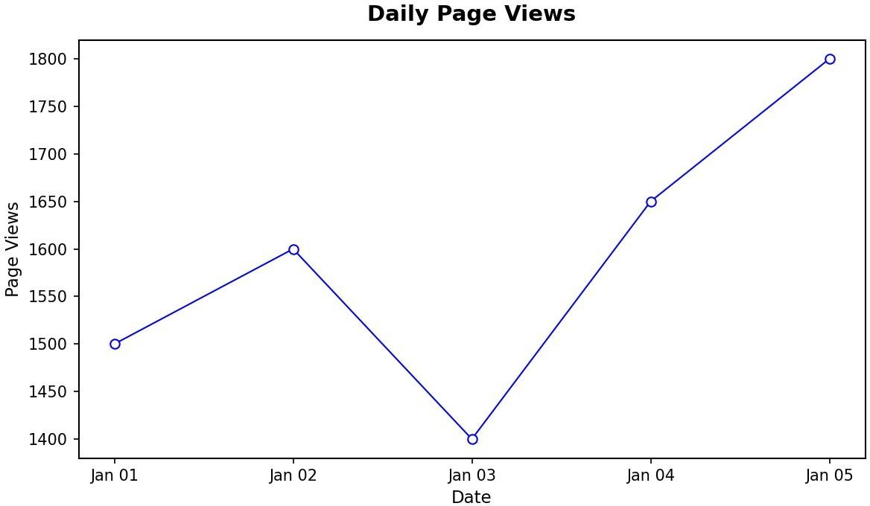

Output 1: Daily Page Views Line Chart
Observation: Page views rise from 1500 on January 1 to 1600 on January 2, fall to the lowest value of 1400 on January 3, and then increase to 1650 and finally 1800, the highest value, on January 5.

PROGRAM 2: Bar Chart of Top N Days by Click-through Rate
Generate a bar chart showing the top N days with the highest click-through rates. Label the chart elements.
# Dataset date <- as.Date(c("2023-01-01", "2023-01-02", "2023-01-03", "2023-01-04", "2023-01-
05")) ctr <- c(2.3, 2.7, 2.0, 2.4, 2.6) traffic <-
data.frame(date, ctr)

# Select the top N days N <- 3
top_days <- head(traffic[order(-traffic$ctr), ], N)

# Bar Chart barplot(top_days$ctr, names.arg = format(top_days$date, "%Y-%m-%d"), xlab = "Date", ylab = "Click-through Rate (%)",
main = "Top 3 Days by Click-through Rate", col
= "lightgreen", ylim = c(0, 3))

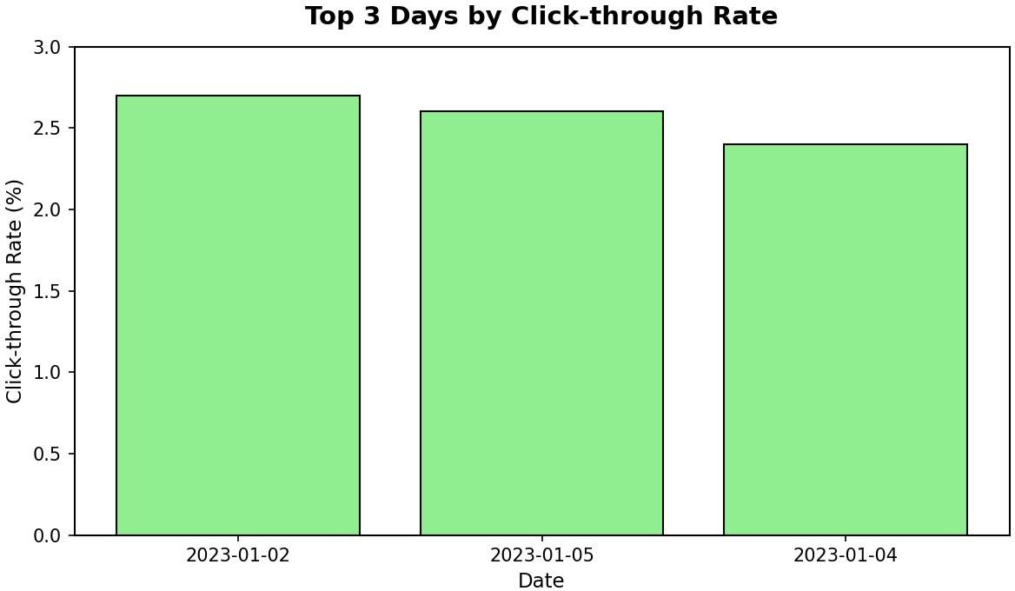

Output 2: Top 3 Days by Click-through Rate
Observation: With N = 3, the best days are 2023-01-02 (2.7%), 2023-01-05 (2.6%), and 2023-01-04 (2.4%). January 2 has the highest click-through rate, while January 3 (2.0%) is the lowest overall.

PROGRAM 3: Stacked Area Chart of User Interactions
Develop a stacked area chart to display the distribution of user interactions (likes, shares, comments) on a website.
library(ggplot2)

# Dataset (assumed interaction counts) date <-as.Date(c("2023-01-01", "2023-01-02", "2023-01-03",
"2023-01-04", "2023-01-05"))

interactions <- data.frame( Date = rep(date, times = 3),
Type = rep(c("Likes", "Shares", "Comments"), each = 5), Count = c(300, 340, 280, 360, 400,
120, 140, 100, 150, 170,
60, 70, 50, 80, 90))

interactions$Type <- factor(interactions$Type,
levels = c("Likes", "Shares", "Comments"))

# Stacked Area Chart ggplot(interactions, aes(x = Date, y = Count, fill = Type)) + geom_area() + labs(title = "User Interactions on Website", x = "Date", y = "Number of Interactions", fill = "Interaction")

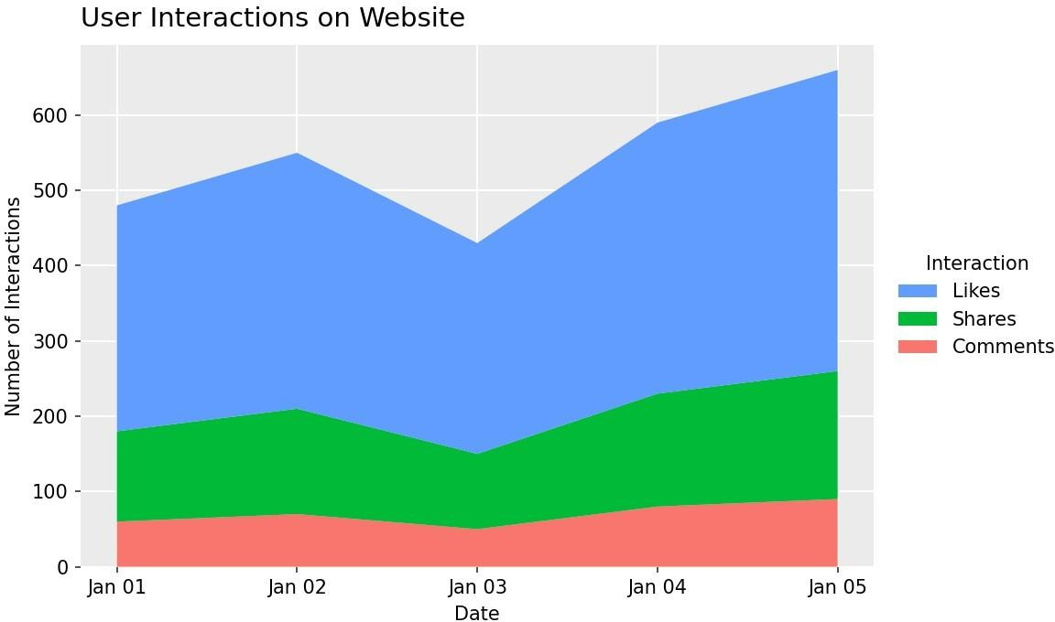

Output 3: User Interactions Stacked Area Chart
Observation: Likes form the largest share of interactions every day, followed by shares and then comments. Total interactions dip on January 3 and reach their peak on January 5, following the same pattern as page views.

PROGRAM 4: Tableau Dashboard for Website Traffic
Build a Tableau dashboard with the line chart and bar chart for interactive exploration of website traffic data.

Steps in Tableau:
- Save the website traffic data as an Excel or CSV file with the columns Date, Page Views, and Click-through Rate(store the rate as a number, for example 2.3).
- Open Tableau, connect to the file, and make sure Date is set to the Date data type.
- Sheet 1 (Line Chart): drag Date to Columns (Day, continuous) and Page Views to Rows (SUM). Choose the Linemark type and title the sheet "Daily Page Views".
- Sheet 2 (Bar Chart): drag Date to Columns and Click-through Rate to Rows (AVG). Sort the bars in descendingorder. To show only the top N days, right-click Date on the Filters shelf > Top > By field > Top 3 by Click-through Rate. Title the sheet "Top Days by Click-through Rate".
- Create a new Dashboard, drag Sheet 1 and Sheet 2 onto it, and arrange them one above the other.
- Select "Use as Filter" on the bar chart and add a Date range filter so users can explore different periods.
- Title the dashboard "Website Traffic Dashboard" and save the workbook.

Insert Tableau dashboard screenshot here (Output 4)

Output 4: Website Traffic Tableau Dashboard
Observation: The dashboard shows the page-view trend and the best click-through days together. Selecting a day in the bar chart or changing the date filter updates the view for interactive exploration.

Set 5 Procedure
- Create vectors for the dates, page views, and click-through rates.
- Use plot() with type = "o" to draw the line chart of daily page views.
- Sort the data with order(), select the top N rows with head(), and use barplot() to draw the bar chart.
- Create a long-format data frame of likes, shares, and comments, and use ggplot() with geom_area() for thestacked area chart.
- Connect the dataset in Tableau, build the line chart and bar chart sheets, and combine them in a dashboard.

Set 5 Result
The website traffic data was successfully visualized using a line chart, bar chart, and stacked area chart in R. A Tableau dashboard combining the line chart and bar chart was created for interactive exploration.

Key Functions Used
Function / Tool | Purpose
as.Date() | Converts text into Date values.
plot() | Creates the line chart.
order() / head() | Sorts the data and selects the top N rows.
barplot() | Creates the bar chart.
ggplot() + geom_area() | Creates the stacked area chart.
Tableau Dashboard | Combines sheets with filters for interactive exploration.

SET 6: PRODUCT SALES ANALYSIS

Dataset: Monthly Product Sales

Aim
To analyse monthly product sales using a grouped bar chart, stacked area chart, and data table in R, and to build an interactive dashboard in Tableau.

Dataset: Monthly Product Sales
Product ID | Product Name | January Sales | February Sales | March Sales
1 | Product A | 2000 | 2200 | 2400
2 | Product B | 1500 | 1800 | 1600
3 | Product C | 1200 | 1400 | 1100

PROGRAM 1: Grouped Bar Chart of Quarterly Sales
Create a grouped bar chart to visualize the sales of each product for the first quarter. Label the chart elements.
# Dataset (rows = months, columns = products) sales <- matrix(c(2000, 2200, 2400,
1500, 1800, 1600,
1200, 1400, 1100), nrow =
3, dimnames = list( c("January", "February", "March"),
c("Product A", "Product B", "Product C")))

# Grouped Bar Chart barplot(sales, beside = TRUE, xlab = "Product", ylab = "Sales ($)", main = "Quarterly Sales by Product", col = c("skyblue", "lightgreen", "orange"), ylim = c(0, 2600),
legend.text = rownames(sales), args.legend
= list(x = "topright"))
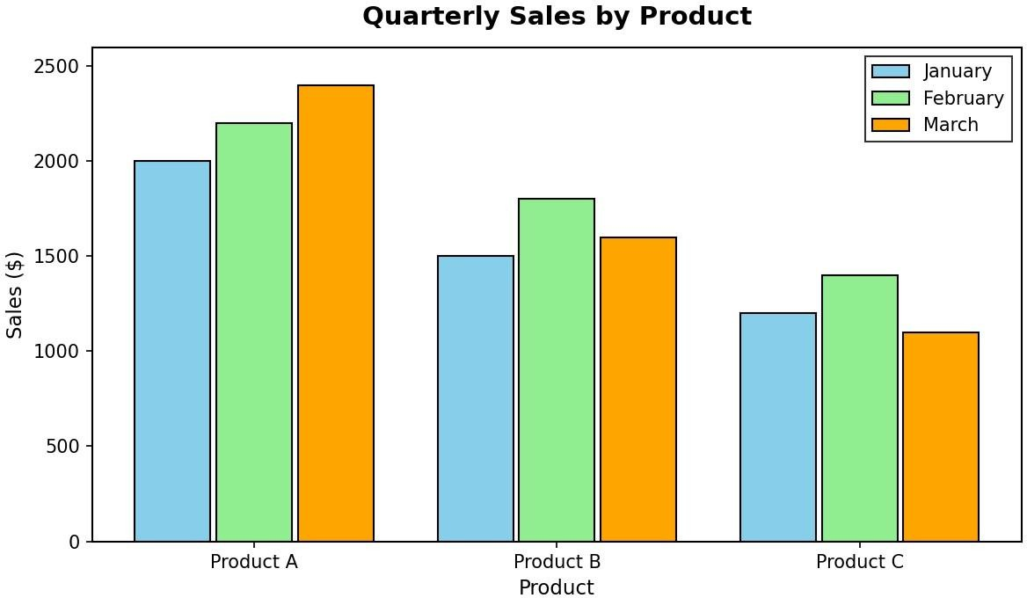

Output 1: Quarterly Sales by Product (Grouped Bar Chart)
Observation: Product A has the highest sales in every month and grows steadily from 2000 to 2400. Product B peaks in February (1800) and Product C also peaks in February (1400) before falling in March.

PROGRAM 2: Stacked Area Chart of Overall Sales Trend
Generate a stacked area chart to represent the overall sales trend for all products over the three months.
library(ggplot2)

# Long-format dataset sales_long <- data.frame( Month = rep(c("January", "February", "March"), times = 3),
Product = rep(c("Product A", "Product B", "Product C"), each = 3), Sales = c(2000, 2200, 2400,
1500, 1800, 1600,
1200, 1400, 1100))

sales_long$Month <- factor(sales_long$Month,
levels = c("January", "February", "March"))

# Stacked Area Chart ggplot(sales_long, aes(x = Month, y = Sales, fill = Product, group = Product)) + geom_area() + labs(title = "Overall Sales Trend (Jan - Mar)", x = "Month", y = "Sales ($)")
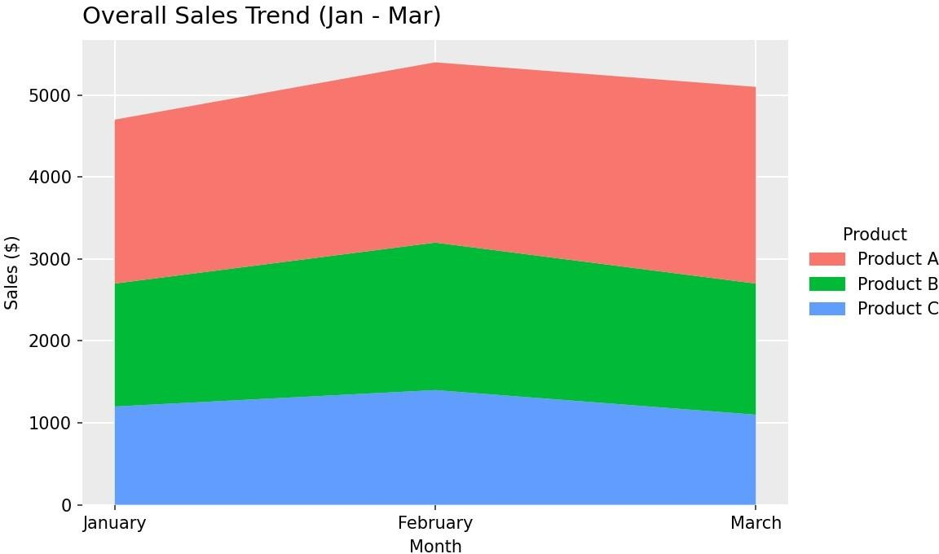

Output 2: Overall Sales Trend (Stacked Area Chart)
Observation: Combined sales of all three products are 4700 in January, rise to 5400 in February, and dip to 5100 in March. Product A forms the largest band throughout.

PROGRAM 3: Table of Monthly Sales Data
Build a table to show the monthly sales data for each product. Label the table elements.

# Dataset sales_data <-data.frame( Product_ID = c(1, 2, 3),
Product_Name = c("Product A", "Product B", "Product C"), January_Sales = c(2000, 1500, 1200),
February_Sales = c(2200, 1800, 1400),
March_Sales = c(2400, 1600, 1100))

# Total sales for the quarter
sales_data$Total_Sales <- rowSums(sales_data[, 3:5])

# Display the table print(sales_data)
Product ID | Product Name | January Sales | February Sales | March Sales | Total Sales
1 | Product A | 2000 | 2200 | 2400 | 6600
2 | Product B | 1500 | 1800 | 1600 | 4900
3 | Product C | 1200 | 1400 | 1100 | 3700
Output 3: Monthly Product Sales Table
Observation: The table lists each product's sales for January, February, and March with the quarterly total. Product A has the highest total (6600), followed by Product B (4900) and Product C (3700).

PROGRAM 4: Tableau Dashboard for Product Sales
Develop a Tableau dashboard combining the grouped bar chart, stacked area chart, and the table for interactive exploration of sales data.

Steps in Tableau:
- Save the sales data as an Excel or CSV file. In Tableau, select the January, February, and March Sales columns,right-click, and choose Pivot to create the fields Pivot Field Names (Month) and Pivot Field Values (Sales).
- Sheet 1 (Grouped Bar Chart): drag Product Name to Columns, then Month, and Sales to Rows (SUM). Drag Monthto Color. Title the sheet "Quarterly Sales by Product".
- Sheet 2 (Stacked Area Chart): drag Month to Columns and Sales to Rows (SUM). Choose the Area mark type anddrag Product Name to Color to stack the products. Title the sheet "Overall Sales Trend".
- Sheet 3 (Table): drag Product Name to Rows, Month to Columns, and Sales to Text. Use Analysis > Totals > ShowRow Grand Totals to add the quarterly total.
- Create a new Dashboard and drag all three sheets onto it, arranging the two charts at the top and the table atthe bottom.
- For interactivity, select "Use as Filter" on the charts and add a Product Name filter (Show Filter) so every viewupdates together.
- Title the dashboard "Product Sales Dashboard" and save the workbook.

Insert Tableau dashboard screenshot here (Output 4)

Output 4: Product Sales Tableau Dashboard
Observation: The dashboard combines the product comparison, the overall monthly trend, and the detailed table. Selecting a product or a month filters all three views at once.

Set 6 Procedure
- Create a matrix of monthly sales with months as rows and products as columns.
- Use barplot() with beside = TRUE to draw the grouped bar chart.
- Convert the data into long format and use ggplot() with geom_area() to draw the stacked area chart.
- Create a data frame with data.frame(), add a total column with rowSums(), and display it with print().
- Connect the dataset in Tableau, pivot the month columns, build the three sheets, and combine them in adashboard.

Set 6 Result
The monthly product sales data was successfully visualized using a grouped bar chart, stacked area chart, and data table in R. A Tableau dashboard combining all three views was created for interactive exploration.

Key Functions Used
Function / Tool | Purpose
matrix() | Builds the month-by-product sales table.
barplot() | Creates the grouped bar chart (beside = TRUE).
ggplot() + geom_area() | Creates the stacked area chart.
data.frame() | Builds the sales data table.
rowSums() | Calculates the total sales for each product.
Tableau Dashboard | Combines sheets with filters for interactive exploration.

