DSA06 DATA HANDLING AND VISUALIZATION | Activity: Correlation Detective | Slot D
R.No: 23 Reg. No: 192473022 Name: MANGALAMADAKA UDAY KUMAR REDDY
Time: 20 to 25 minutes | Total: 20 marks | Tool: R (ggplot2 / base R)
Case File CD-D23: The Hospital ward Case [20 marks]
Evidence: Code to Create the Case File (not edited)
set.seed(109431)
n <- 14
outside_temp <- round(rnorm(n, 33.8, 3.2), 1)
cold_drinks <- round(199 + 53.3 * (0.95 * (outside_temp - 33.8) / 3.2
+ 0.33 * rnorm(n)), 0)
heat_admits <- round(9 + 3.2 * (-0.91 * (outside_temp - 33.8) / 3.2
+ 0.42 * rnorm(n)), 0)
ward_dev <- round(seq(-3.8, 3.8, length.out = n)[order(runif(n))], 1)
discomfort <- round(3.0 + 7.6 * (ward_dev / 3.8)^2 + rnorm(n, 0, 0.3), 1)
nurses <- round(rnorm(n, 14, 3.2), 0)
med_errors <- round(4 + 1.6 * (0.14 * (nurses - 14) / 3.2
+ 0.99 * rnorm(n)), 0)
nurses[12] <- 24; med_errors[12] <- 9 # row 12 typed in by a trainee
case <- data.frame(outside_temp, cold_drinks, heat_admits, ward_dev,
discomfort, nurses, med_errors)
The 14 records produced by this code (temp = outside_temp, drinks = cold_drinks, admits = heat_admits, dev = ward_dev, disc. = discomfort, errors = med_errors):
Row | temp | drinks | admits | dev | disc. | nurses | errors
1 | 31.1 | 145 | 11 | -0.9 | 3.9 | 8 | 4
2 | 25.3 | 104 | 17 | -3.8 | 10.6 | 14 | 4
3 | 35.8 | 214 | 8 | -0.3 | 3.0 | 15 | 5
4 | 29.9 | 158 | 14 | -2.6 | 6.4 | 14 | 5
5 | 37.9 | 286 | 6 | 3.2 | 8.5 | 14 | 4
6 | 36.6 | 263 | 5 | 0.3 | 2.7 | 11 | 4
7 | 34.8 | 212 | 10 | -2.0 | 5.0 | 15 | 6
8 | 34.5 | 232 | 8 | -3.2 | 8.3 | 15 | 2
9 | 32.9 | 181 | 10 | 0.9 | 3.0 | 15 | 2
10 | 31.8 | 172 | 11 | 1.5 | 4.5 | 10 | 3
11 | 30.9 | 160 | 12 | 2.0 | 5.5 | 15 | 6
12 | 35.7 | 217 | 7 | 3.8 | 10.4 | 24 | 9
13 | 36.7 | 244 | 6 | 2.6 | 7.1 | 14 | 5
14 | 30.8 | 144 | 13 | -1.5 | 4.3 | 17 | 5

Task 1 - The Matrix [4 marks]
library(ggplot2)
cm <- round(cor(case), 2); cm
nrow(case) # n
choose(7, 2) # distinct pairs
cm_long <- as.data.frame(as.table(cm))
ggplot(cm_long, aes(Var1, Var2, fill = Freq)) +
geom_tile(colour = "white") +
geom_text(aes(label = sprintf("%.2f", Freq)), size = 3) +
scale_fill_gradient2(low = "red", mid = "white", high = "blue",
limits = c(-1, 1), name = "r") +
labs(x = NULL, y = NULL, title = "Correlogram") +
theme(axis.text.x = element_text(angle = 45, hjust = 1))
Correlation matrix (7 x 7, rounded to 2 decimals; column headers abbreviated as above):
 | temp | drinks | admits | dev | disc. | nurses | errors
outside_temp | 1.00 | 0.95 | -0.97 | 0.58 | -0.13 | 0.18 | 0.14
cold_drinks | 0.95 | 1.00 | -0.94 | 0.50 | 0.01 | 0.11 | 0.02
heat_admits | -0.97 | -0.94 | 1.00 | -0.61 | 0.12 | -0.11 | -0.07
ward_dev | 0.58 | 0.50 | -0.61 | 1.00 | 0.02 | 0.25 | 0.36
discomfort | -0.13 | 0.01 | 0.12 | 0.02 | 1.00 | 0.49 | 0.31
nurses | 0.18 | 0.11 | -0.11 | 0.25 | 0.49 | 1.00 | 0.65
med_errors | 0.14 | 0.02 | -0.07 | 0.36 | 0.31 | 0.65 | 1.00

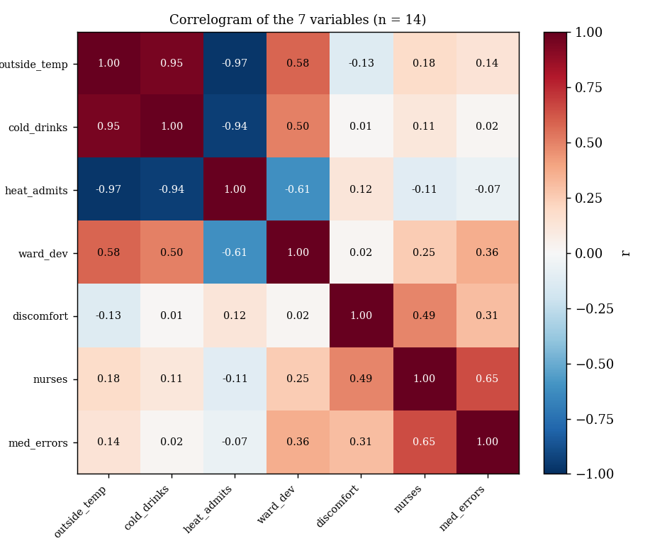
Answer: n = 14 daily records and 7 variables, so the number of distinct pairs of variables = 7 x 6 / 2 = 21. The 7 x 7 matrix is symmetric with 1.00 on the diagonal.
Task 2 - The Strongest Clues [3 marks]
m <- cm; m[lower.tri(m, diag = TRUE)] <- NA
which(m == max(m, na.rm = TRUE), arr.ind = TRUE)
which(m == min(m, na.rm = TRUE), arr.ind = TRUE)
Clue | Pair | r | Strength
Strongest positive | outside_temp and cold_drinks | +0.95 | Strong (above 0.7)
Strongest negative | outside_temp and heat_admits | -0.97 | Strong (above 0.7)

Both strongest clues involve outside_temp. Hotter days go with more cold-drink sales and, in this file, with fewer heat-related admissions (the negative sign is what the data show).
Task 3 - The Deceptive Zero [4 marks]
ggplot(case, aes(ward_dev, discomfort)) +
geom_point(size = 2.5) +
geom_smooth(method = "lm", se = FALSE, colour = "red") +
geom_smooth(method = "lm", formula = y ~ x + I(x^2),
se = FALSE, colour = "blue")
cor(case$ward_dev, case$discomfort)
fit2 <- lm(discomfort ~ ward_dev + I(ward_dev^2), data = case)
summary(fit2)$r.squared
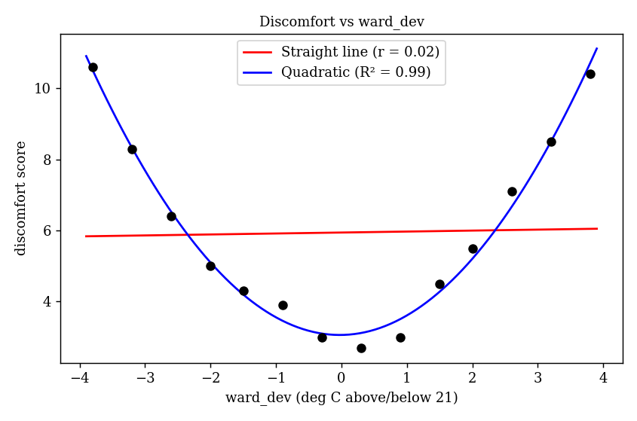
Answer: The straight-line correlation is r = 0.02, essentially zero. The quadratic fit (discomfort = 3.06 + 0.027 x ward_dev + 0.523 x ward_dev squared) has R-squared = 0.99. r misses the relationship because r measures only straight-line association, and discomfort is U-shaped (high when the ward is much colder or much hotter than 21 degrees C and lowest near 0), so the rising and falling halves cancel out.
Task 4 - The Outlier Alibi [4 marks]
ggplot(case, aes(nurses, med_errors)) +
geom_point(size = 2.5) +
geom_text(aes(label = seq_len(nrow(case))), vjust = -0.8, size = 3)
which.max(case$nurses) # suspicious row
cor(case$nurses, case$med_errors) # all rows
cor(case$nurses[-12], case$med_errors[-12]) # without row 12
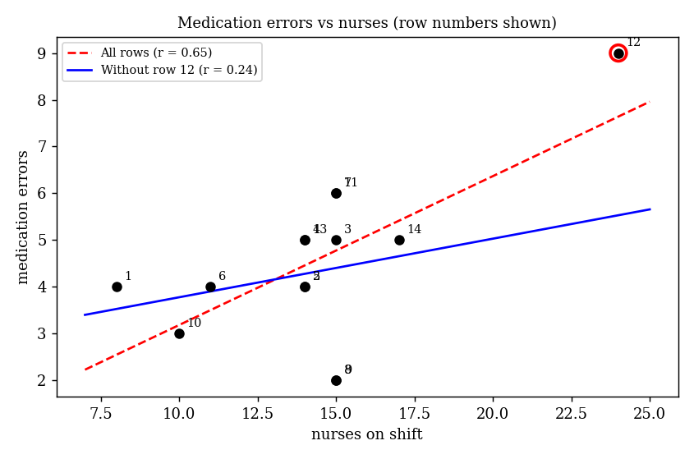
Answer: The wrong-looking record is row 12 (nurses = 24 and med_errors = 9; every other row has 8 to 17 nurses and at most 6 errors), the one typed in by a trainee. r for all rows = 0.65 and r without row 12 = 0.24. This single record turned a weak relationship (0.24) into an apparently moderate one (0.65), inflating r by about 0.41.
Task 5 - The Prime Suspect [5 marks]
cor(case$cold_drinks, case$heat_admits)
cor(case$outside_temp, case$cold_drinks)
cor(case$outside_temp, case$heat_admits)
rx <- resid(lm(cold_drinks ~ outside_temp, data = case))
ry <- resid(lm(heat_admits ~ outside_temp, data = case))
cor(rx, ry) # partial correlation
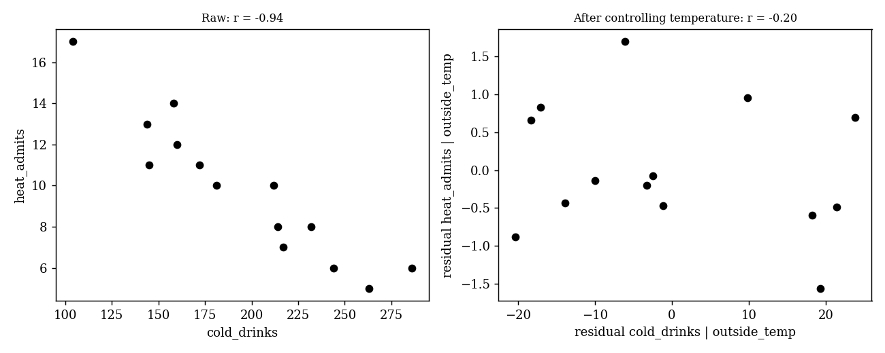
Correlation | r
r(cold_drinks, heat_admits) | -0.94
r(outside_temp, cold_drinks) | +0.95
r(outside_temp, heat_admits) | -0.97
Partial r(cold_drinks, heat_admits | outside_temp) | -0.20

Verdict: Once outside temperature is held constant, the link between cold-drink sales and heat-related admissions shrinks from -0.94 to -0.20, so most of it comes from outside_temp driving both. Cold drinks do not cause heat admissions; temperature is the hidden driver (a confounder), and correlation alone cannot prove cause.
Study design that could test causation: A randomised crossover trial: randomly assign days (or wards) to have cold drinks supplied or withheld, keep the temperature balanced by randomisation, and compare heat-related admissions between the two conditions.

