DSA06 DATA HANDLING AND VISUALIZATION | Activity: Identify Seasonality Patterns | Slot D
R.No: 23 Reg. No: 192473022 Name: MANGALAMADAKA UDAY KUMAR REDDY
Time: 20 to 25 minutes | Total: 20 marks | Tool: R (ggplot2 / base R)
Series SP-D23: Emergency arrivals [20 marks]
Evidence: Code to Create the Series (not edited)
set.seed(80296)
m <- 24 # observations per cycle (hourly data)
n <- m * 6 # 6 full cycles
t <- 1:n
trend <- 12.4 + 0.019 * t
er_arrivals <- round(trend + 5.8 * cos(2 * pi * (t - 23) / m)
+ rnorm(n, 0, 1.3), 0)
x <- ts(er_arrivals, frequency = m, start = c(1, 1))
Task 1 - Look at the Series [3 marks]
plot(x, ylab = "Patients arriving per hour", main = "Emergency arrivals")
length(x); frequency(x); length(x) / frequency(x)
fit <- lm(er_arrivals ~ 1:n)
coef(fit)[2] # slope per hour
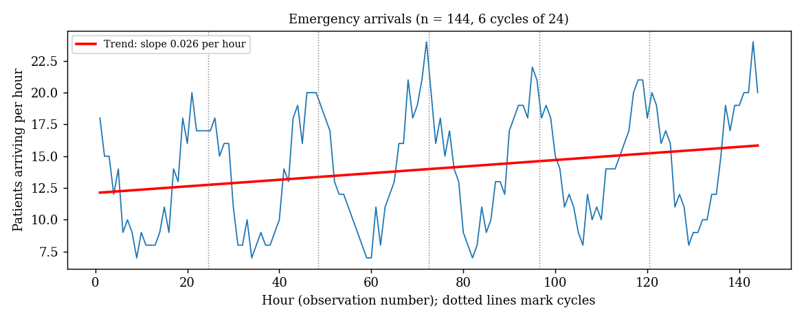
Answer: n = 144 hourly observations, the cycle length is 24 observations, and there are 144 / 24 = 6 full cycles. The fitted slope is +0.026 patients per hour (intercept 12.11), so the overall trend is rising, but only slightly (about 0.6 extra arrivals per hour more at the end of each day). The large swing within each cycle is much bigger than this trend.
Task 2 - The Seasonal Pattern [4 marks]
dec <- decompose(x)
round(dec$figure, 2)
which.max(dec$figure); max(dec$figure) # peak
which.min(dec$figure); min(dec$figure) # trough
max(dec$figure) - min(dec$figure) # seasonal swing
plot(dec)
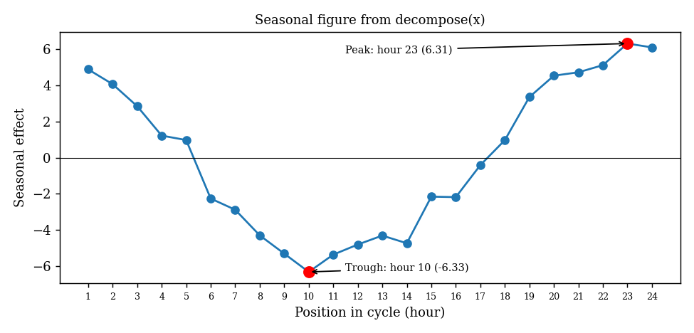
Item | Hour in cycle | Seasonal value
Peak | 23 | +6.31
Trough | 10 | -6.33
Seasonal swing (peak minus trough) |  | 12.64 patients per hour

The seasonal figure (hours 1 to 24) is: 4.88, 4.06, 2.85, 1.22, 0.97, -2.27, -2.89, -4.30, -5.32, -6.33, -5.37, -4.81, -4.32, -4.74, -2.16, -2.19, -0.42, 0.97, 3.35, 4.53, 4.72, 5.12, 6.31, 6.10. Arrivals are highest late in the cycle (hours 22 to 24, going on into the early hours) and lowest around hours 9 to 14.
Task 3 - Is It Consistent? [3 marks]
library(ggplot2)
df <- data.frame(value = as.numeric(x), pos = as.numeric(cycle(x)),
cyc = factor(rep(1:6, each = 24)))
ggplot(df, aes(pos, value, group = cyc, colour = cyc)) +
geom_line() + geom_point(size = 1) +
labs(x = "Position in cycle (hour)", y = "Arrivals per hour",
colour = "Cycle")
peak <- which.max(dec$figure) # 23
hi <- tapply(df$value, df$cyc, which.max) # hour of highest value
d <- abs(hi - peak); sum(pmin(d, 24 - d) <= 1)
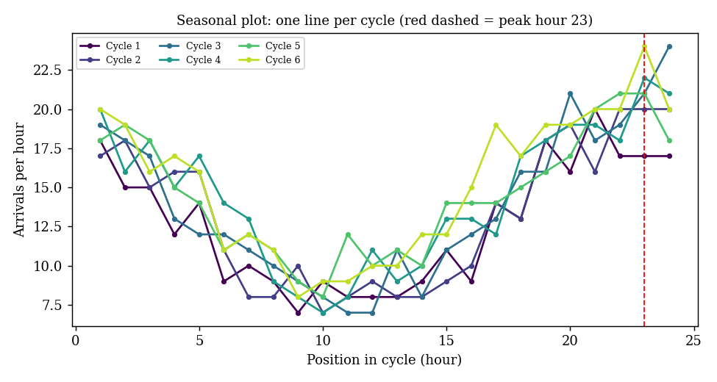
Cycle | Highest value | Hour(s) of the highest value | Within 1 hour of hour 23?
1 | 20 | 21 | No (2 hours away)
2 | 20 | 22, 23, 24 | Yes
3 | 24 | 24 | Yes
4 | 22 | 23 | Yes
5 | 21 | 22, 23 | Yes
6 | 24 | 23 | Yes

Answer: The highest value falls within one hour of the peak hour (hour 23) in 5 of the 6 cycles; only cycle 1 peaks at hour 21. The six lines have the same shape (a low in the middle of the cycle and a high near its end), so the pattern is consistent.
Task 4 - Confirm with Autocorrelation [4 marks]
d <- resid(lm(er_arrivals ~ 1:n))
a <- acf(d, lag.max = 24, plot = FALSE)
a$acf[25] # lag 24 (index = lag + 1)
a$acf[13] # lag 12
2 / sqrt(n)
acf(d, lag.max = 24)
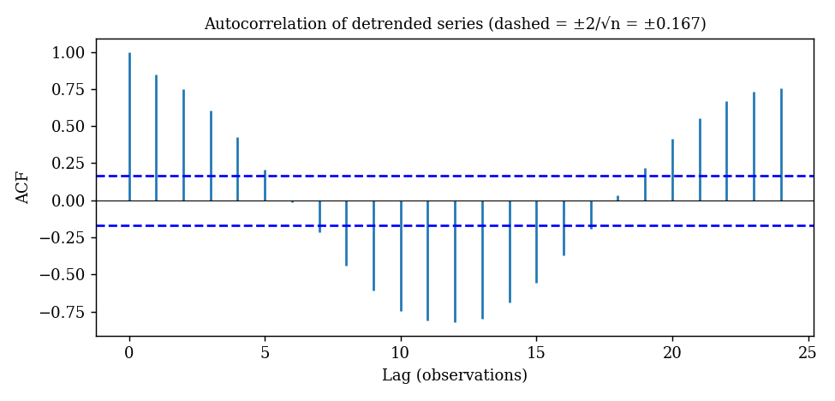
Quantity | Value
Autocorrelation at lag 24 | +0.75
Autocorrelation at lag 12 | -0.82
Significance bound 2 / sqrt(n) = 2 / sqrt(144) | 0.167

Answer: Both values are far outside the bound of plus or minus 0.167. The strong positive autocorrelation at lag 24 (0.75) means that each hour resembles the same hour one cycle earlier, and the strong negative value at lag 12 (-0.82) means that an hour is the opposite of the hour half a cycle away (a peak is paired with a trough). Together they show a clear seasonal cycle with period 24.
Task 5 - Additive or Multiplicative? [6 marks]
rng <- function(v) max(v) - min(v)
r1 <- rng(er_arrivals[1:24]); r6 <- rng(er_arrivals[121:144])
r1; r6; r6 / r1
dec_a <- decompose(x, type = "additive")
adjusted <- x - dec_a$seasonal
coef(lm(as.numeric(adjusted) ~ 1:n))[2] # slope per hour
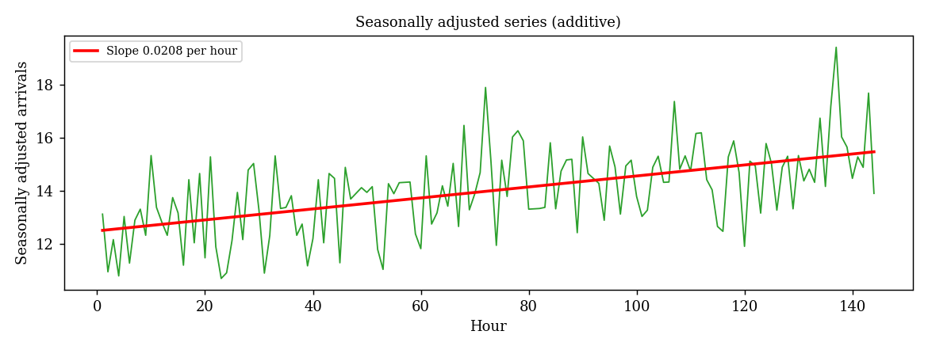
Quantity | Value
Range of the first cycle (20 - 7) | 13
Range of the last cycle (24 - 8) | 16
Ratio (last / first) | 1.23
Slope of seasonally adjusted series | +0.0208 per hour

Type and justification [2]: Additive. The ratio of 1.23 is only modestly above 1, and the range of a single cycle is noisy because it depends on two single hours (the six cycle ranges are 13, 13, 17, 15, 13 and 16, which go up and down rather than growing steadily). The overall level rose by only about 20% (cycle means from 12.6 to 15.2), yet the seasonal swing stays at roughly 12 to 14 patients per hour in every cycle. A multiplicative season would have a swing that widens in proportion to the level, so a constant-size swing around a slowly rising level points to an additive season.
Slope after removing the season [2]: The additive adjustment (x minus the seasonal figure) leaves a slope of +0.021 patients per hour, close to the raw slope of 0.026, so the trend is small and steady.
Advice to management [2]: Plan staffing around the fixed 24-hour pattern, with the most staff in hours 21 to 24 (peak at hour 23, about 6 patients per hour above average) and the fewest around hour 10 (about 6 below average), and add a small allowance for the slow upward trend of about 0.5 more arrivals per hour each day.

