DSA0601 – Data Handling and Visualization
Activity: Identify Skewness using Violin Plots | Slot D
Name: Mangalamadaka Uday Kumar Reddy Reg. No: 192473022
Question Paper
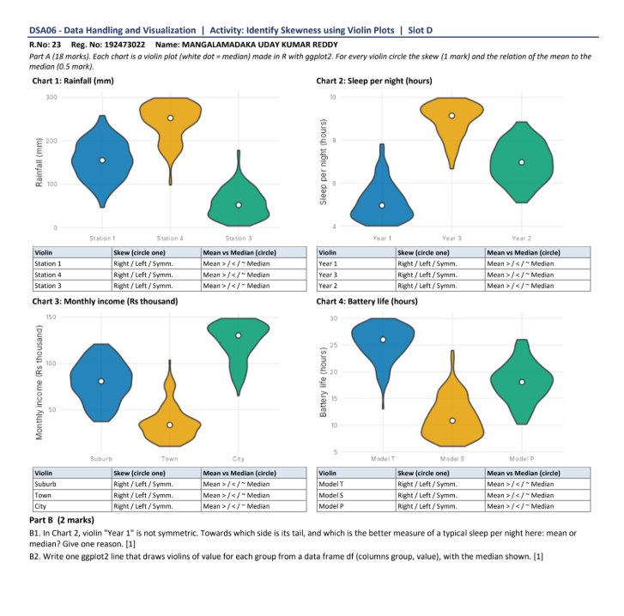

Part A – Skewness and Mean vs Median (18 marks)
Rule used: a violin with a long tail towards higher values is right skewed (mean > median); a long tail towards lower values is left skewed (mean < median); a balanced shape is symmetric (mean ≈ median).
Chart 1: Rainfall (mm)
Violin | Skew | Mean vs Median
Station 1 | Symmetric | Mean ≈ Median
Station 4 | Left skew | Mean < Median
Station 3 | Right skew | Mean > Median
Station 4 is widest near the top with a tail down to about 100 mm; Station 3 is widest near the bottom with a tail up to about 175 mm.
Chart 2: Sleep per night (hours)
Violin | Skew | Mean vs Median
Year 1 | Right skew | Mean > Median
Year 3 | Left skew | Mean < Median
Year 2 | Symmetric | Mean ≈ Median
Year 1 is bunched at 4–5 hours with a tail up to about 8; Year 3 is bunched at 9–10 hours with a tail down to about 6.5.
Chart 3: Monthly income (Rs thousand)
Violin | Skew | Mean vs Median
Suburb | Symmetric | Mean ≈ Median
Town | Right skew | Mean > Median
City | Left skew | Mean < Median
Town has most people at low incomes with a tail up to about 100; City has most at high incomes with a tail down to about 65.
Chart 4: Battery life (hours)
Violin | Skew | Mean vs Median
Model T | Left skew | Mean < Median
Model S | Right skew | Mean > Median
Model P | Symmetric | Mean ≈ Median
Model T is bunched at 25–30 hours with a tail down to about 13; Model S is bunched at 6–12 hours with a tail up to about 24.
Part B (2 marks)
B1. In Chart 2, violin "Year 1" is not symmetric. Towards which side is its tail, and which is the better measure of a typical sleep per night here: mean or median? Give one reason.
Answer: The tail is towards the higher values (upper side, i.e. right skew), because a few students sleep much longer than the rest. The median is the better measure of a typical sleep per night, because the long upper tail pulls the mean upwards, whereas the median is not affected by extreme values and stays at the centre of the bulk of the data.
B2. Write one ggplot2 line that draws violins of value for each group from a data frame df (columns group, value), with the median shown.
Answer:
ggplot(df, aes(x = group, y = value, fill = group)) + geom_violin() + stat_summary(fun = median, geom = "point", colour = "white", size = 3)

