**JAX WS**

**STUB BASED CONSUMER**

For this create a quickstart based maven project.

Make sure your provider application is up and running.

My provider application is running at

<http://localhost:3434/CFA-WS-RI/medicine?wsdl>

Add the below dependency as part of pom.xml

<dependency>

<groupId>com.sun.xml.ws</groupId>

<artifactId>jaxws-rt</artifactId>

<version>2.1.4</version>

</dependency>

Now create a **build.xml** file for writing ant script to run wsimport tool.keep this file at root directory of your project.

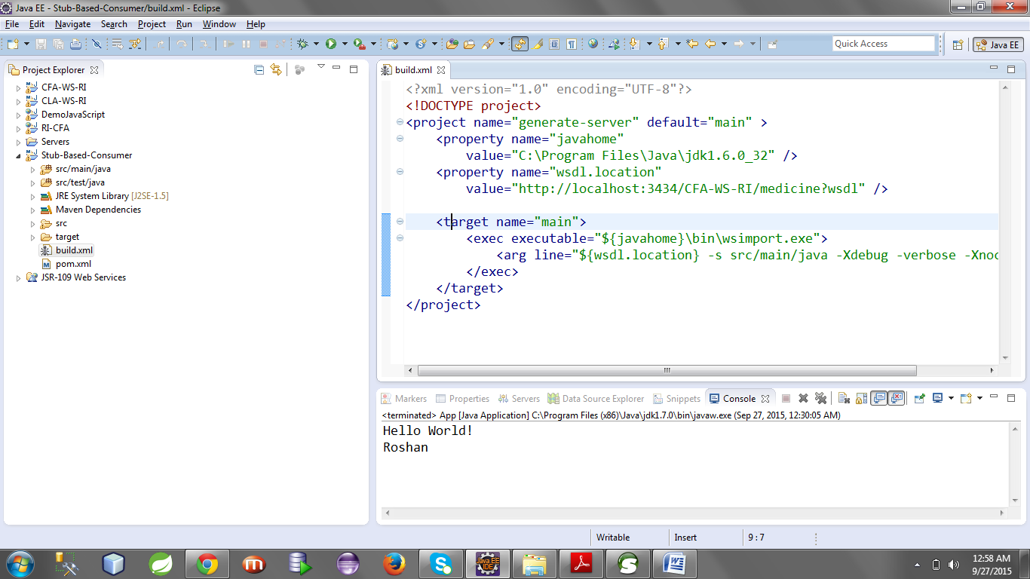

**build.xml**

<?xml version="1.0" encoding="UTF-8"?>

<!DOCTYPE project>

<project name="generate-client" default="main" >

<property name="javahome"

value="C:\Program Files\Java\jdk1.6.0_32" />

<property name="wsdl.location"

value="http://localhost:3434/CFA-WS-RI/medicine?wsdl" />

<target name="main">

<exec executable="${javahome}\bin\wsimport.exe">

<arg line="${wsdl.location} -s src/main/java -Xdebug -verbose -Xnocompile" />

</exec>

</target>

</project>

Right click on **build.xml** and **Run as > ant build.**

It will generate types and wsdl related classes.

It also generated sei interface that will hold the stub object.

It will generate the service class through which we can access a specific port to get the stub object.

All the above classes will be generated as part of src/main/java

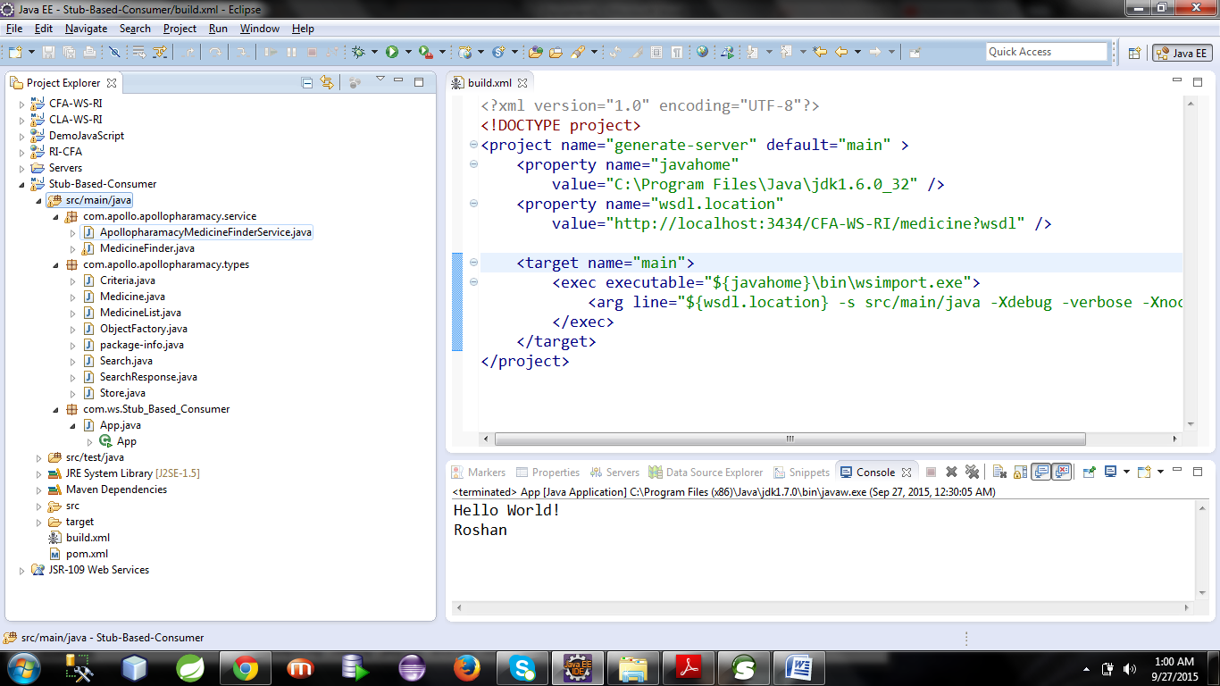

The class App.java contains a empty main method in which we will write the logic to consume the webservice.

**App.java**

**package** com.ws.Stub_Based_Consumer;

**import** com.apollo.apollopharamacy.service.ApollopharamacyMedicineFinderService;

**import** com.apollo.apollopharamacy.service.MedicineFinder;

**import** com.apollo.apollopharamacy.types.Criteria;

**import** com.apollo.apollopharamacy.types.MedicineList;

**import** com.apollo.apollopharamacy.types.Store;

/**

* Hello world!

*

*/

**public** **class** App

{

**public** **static** **void** main( String[] args )

{

System.*out*.println( "Hello World!" );

ApollopharamacyMedicineFinderService service=**new** ApollopharamacyMedicineFinderService();

MedicineFinder finder=service.getApollopharamacySOAPPort();

Criteria c=**new** Criteria();

c.setDrugsId("123456");

c.setGeneric(**true**);

c.setManufacturer("RANBAXY");

c.setMedicineName("Stopach");

c.setUnits(100);

Store s=**new** Store();

s.setAgent("Apollo");

s.setStoreId("AP-2345");

MedicineList medList=finder.search(c, s);

System.*out*.println(medList);

}

}

Note : override the **toString()** in MedicineList.java and in Medicine.java

Now run the application and you will get the medicine list in your console.