**Question 1: Use finance to Extract Stock Data**

**Reset the index, save, and display the first five rows of the tesla_data dataframe using the head function. Upload a screenshot of the results and code from the beginning of Question 1 to the results below.**

[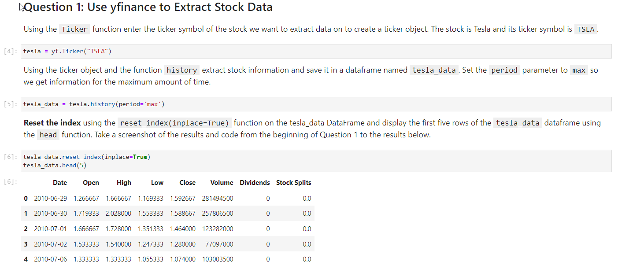](https://blogger.googleusercontent.com/img/a/AVvXsEi_teQ0J0t3qdvKjxH3TLrmtTyvKR6fzlmzbRDWDa7ldZjt4qQvYmgA2Fa_XVll4gQdeUbKrNN-VWLWCoCKBfvs7ID79vgtXlbOYuFNi1J6RVNrGDOSTr4BgPfxQ3E9eWNRPmtmMjmulhcqkVWpF-ju1bGZVchlrAjuLovefNlkW90drVVH2c4MKZrekmk)

**Question 2: Use Web scraping to Extract Tesla Revenue Data**

**Display the last five rows of the tesla_revenue dataframe using the tail function. Upload a screenshot of the results.**

[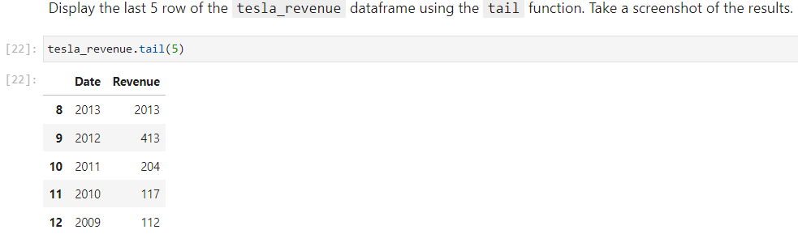](https://blogger.googleusercontent.com/img/a/AVvXsEjV97t-hUgHlZe09DNX6p3jWlvPLCCVk7VhgY1q-Xk3uCCABHK9emwaIiJ9TB4tzeVQbpQwr0xcPcDmonq1Pf8OxOdv9TI_LiV2f4F2ZkZ8whM2WwLHGMpUdU-ax7MINzs3tjtMW2DwzcYVfWXDXR6T4PQhjPyovxuRqYs3_i1Cyj_4u8BFZfpnKZps0g8)

**Question 3: Use finance to Extract Stock Data**

**Reset the index, save, and display the first five rows of the gme_data dataframe using the head function. Upload a screenshot of the results and code from the beginning of Question 1 to the results below.**

[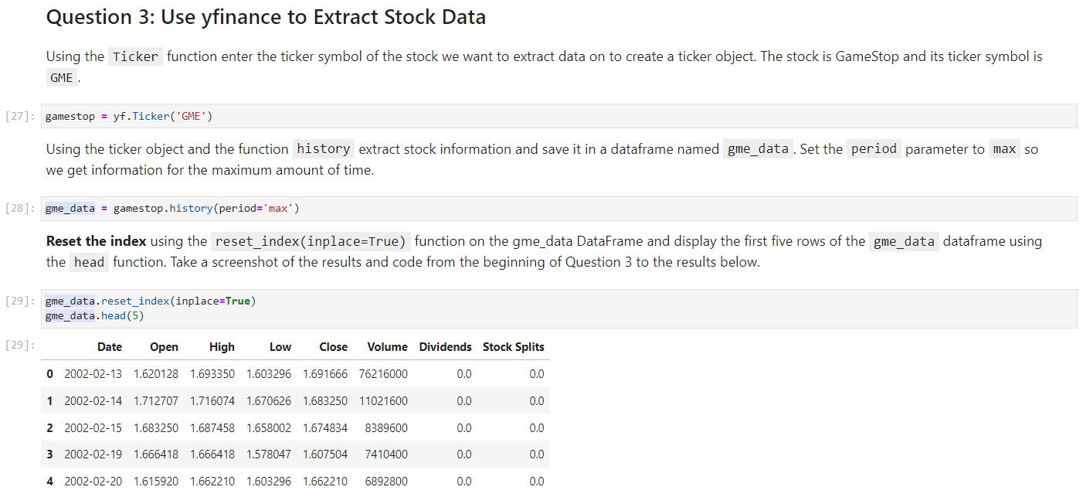](https://blogger.googleusercontent.com/img/a/AVvXsEhf9pe8sD6guLQxWAfQuOHGlqsbVNZgbXQXxCaexXOCA-dPnRHXuCO9p4MpXn628yh3-XlAw7Nus-TuqYtWQUuMdeoZNzOLhOff6BA6S1IBQpJdwqmXe_S_cRDKKnkDSTkQ5GAXNcYoCNVQtJ0mkyun4QZOJtGb3Txv5iWG-FWlVocs1f1YEaHhUBFLl9Q)

**Question 4: Use Webscraping to Extract GME Revenue Data**

**Display the last five rows of the gme_revenue dataframe using the tail function. Upload a screenshot of the results.**

[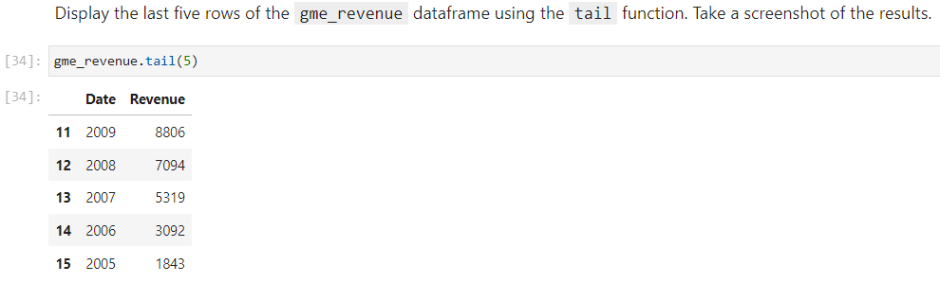](https://blogger.googleusercontent.com/img/a/AVvXsEjTYKnnavex5nYJTknPgwb5BCCZkpGbtV5qCKpCdhzKWkV77kK5yqawzG0Jg_2sj0yDLHc301YuiEiV66L1KWM1Ag7GpB35WYjsESEr2mS-G6bnVHYioA5ATIgYjUC5Xykpe5TRmupqJoQbMImyWyvZ6s9RMCDKYyM3NvzLHQxvzMK_uUeLpo6tdrcJEN4)

**Question 5: Plot Tesla Stock Graph**

**Use the make_graph function to graph the Tesla Stock Data, also provide a title for the graph.**

**Upload a screenshot of your results.**

[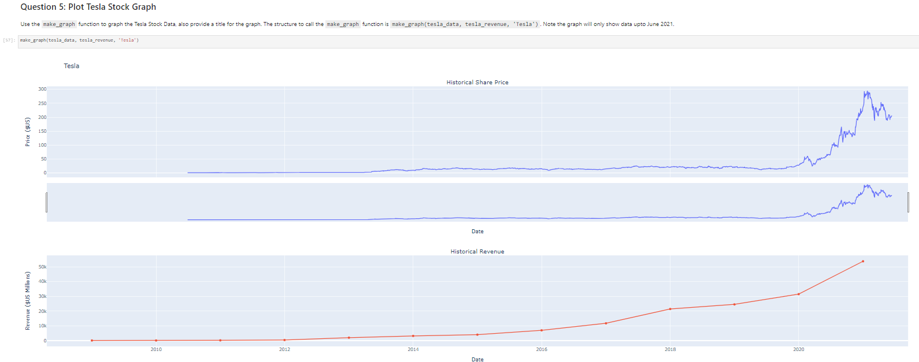](https://blogger.googleusercontent.com/img/a/AVvXsEi2QKIapHJY0c5S0rp7UpgkHlJHCVUUa4Qt3OyzspyjL3NT8XDZ8OPFbjs_j8_IjpEbRwYMBbTnP8GcHcgtwQsDaCv1rqJCHkcXn4t5qCSDLmjJlp5Q3_z7nc3-oHekjgqVqrrE0emESz2hxQA4AqQTefp1-RvSvzknMp_Ps9wJePrz22lsxbi4H8x4svg)

**Question 6: Plot GameStop Stock Graph**

**Use the make_graph function to graph the GameStop Stock Data, also provide a title for the graph.**

**Upload a screenshot of your results.**

[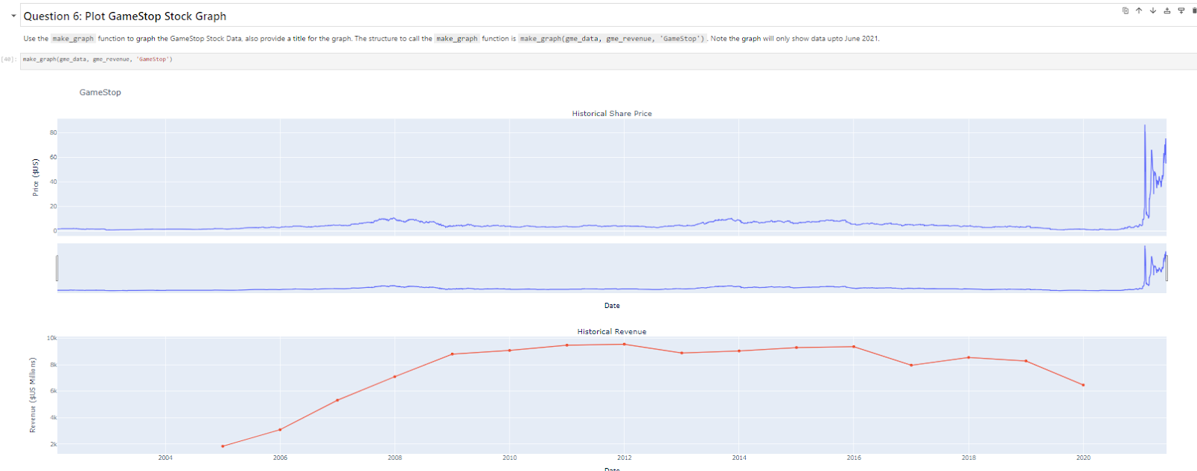](https://blogger.googleusercontent.com/img/a/AVvXsEjN6dn9wZUVjm2g-37VNOJKABEXfMQ_XEygHypk2DxYsvK2fIv5JHWEqKzkYjgio5OK7VBp2sBozCAp3aH0W3lZUnzhH6Vsarm60n1p2RYU9wl5ehD0oAnntRgNP53UwJRe0IxqoYv8DlBx1XMXpQ1Wgf9ion6tbviwqNNUd74I1gSr9i9pdgbsn2mtcsc)

