|  |  |  |
| --- | --- | --- |
| Name | : | Boddapu Uday Sankar |
| Statement generated on | : | 2023-08-27 17:55:43.688945 |
| Credit Amount | : | ₹ 500000.0 |
| Debit Amount | : | ₹ 151691.02 |
| Balance Amount | : | ₹ 2953350.68 |
| Account ID | : | 1 |

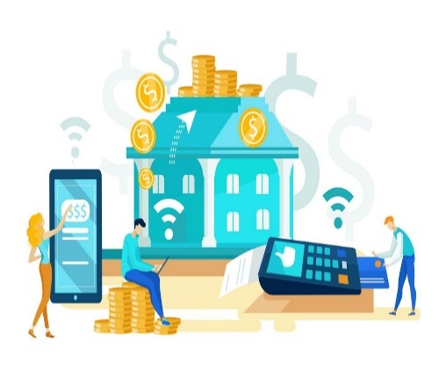

**Transaction Details**

|  |  |  |  |  |
| --- | --- | --- | --- | --- |
| **ID** | **Description** | **Date-time** | **Credit** | **Debit** |
| 3431 | Salary deposit from employer using Net banking | 2023-08-01_06:09 | 100000.0 |  |
| 3429 | Online subscription renewal using credit card | 2023-07-30_08:12 |  | 497.21 |
| 3428 | UPI payment for Bharat petrol | 2023-07-28_18:29 |  | 596.28 |
| 3426 | UPI payment for HP petrol | 2023-07-23_20:40 |  | 574.63 |
| 3425 | Debit card purchase at electronics store | 2023-07-21_13:03 |  | 7570.54 |
| 3424 | Online shopping transaction using Debit card | 2023-07-18_04:11 |  | 13253.62 |
| 3423 | Online subscription renewal using credit card | 2023-07-14_14:19 |  | 815.34 |
| 3422 | UPI payment for HP petrol | 2023-07-12_08:11 |  | 1671.72 |
| 3421 | Credit card payment for utilities | 2023-07-08_17:33 |  | 3121.43 |
| 3420 | UPI payment for vegetables | 2023-07-04_21:37 |  | 508.65 |
| 3418 | Salary deposit from employer using Net banking | 2023-07-01_15:32 | 100000.0 |  |
| 3417 | UPI transfer to ABC | 2023-06-29_15:32 |  | 3016.3 |
| 3416 | Transfer to another bank account using net banking | 2023-06-27_17:30 |  | 23464.02 |
| 3413 | UPI payment for Bharat petrol | 2023-06-18_05:42 |  | 787.86 |
| 3412 | Credit card reward points redemption | 2023-06-14_11:08 |  | 593.7 |
| 3411 | UPI payment for HP petrol | 2023-06-11_01:27 |  | 1358.96 |
| 3409 | Credit card payment for travel booking | 2023-06-05_11:55 |  | 5490.44 |
| 3407 | Salary deposit from employer using Net banking | 2023-06-01_20:54 | 100000.0 |  |
| 3406 | Mobile recharge via UPI | 2023-05-29_20:54 |  | 280.43 |
| 3402 | Mobile recharge via UPI | 2023-05-22_16:10 |  | 363.71 |
| 3400 | Credit card payment for travel booking | 2023-05-20_09:04 |  | 11662.23 |
| 3399 | Debit card transaction for clothing | 2023-05-16_14:17 |  | 1701.63 |
| 3398 | Online shopping transaction using UPI | 2023-05-13_02:36 |  | 4716.2 |
| 3397 | Debit card purchase at grocery store | 2023-05-09_04:12 |  | 2538.89 |
| 3395 | Debit card transaction for clothing | 2023-05-04_05:48 |  | 798.61 |
| 3394 | Credit card payment for utilities | 2023-05-02_06:33 |  | 2151.54 |
| 3392 | Salary deposit from employer using Net banking | 2023-05-01_13:43 | 100000.0 |  |
| 3386 | Bill payment via net banking | 2023-04-20_12:11 |  | 13304.27 |
| 3385 | Online subscription renewal using credit card | 2023-04-19_03:31 |  | 735.27 |
| 3384 | UPI payment for HP petrol | 2023-04-15_06:25 |  | 1174.06 |
| 3380 | Credit card payment for travel booking | 2023-04-05_17:53 |  | 11785.63 |
| 3377 | Salary deposit from employer using Net banking | 2023-04-01_00:18 | 100000.0 |  |
| 3374 | Debit card transaction for clothing | 2023-03-23_12:36 |  | 1564.19 |
| 3370 | Charity donation via net banking | 2023-03-19_08:53 |  | 1370.89 |
| 3367 | Online shopping transaction using credit card | 2023-03-13_18:30 |  | 34222.77 |