Assignment-8: Function and Class Templates Function Template
- Write a function template to swap two variables of any data type. Code-
#include <iostream> using namespace std;

// Function template template <typename T>
void swapValues(T &a, T &b) { T temp = a;
a = b;
b = temp;
}

int main() { int x, y;

cout << "Enter two integers: "; cin >> x >> y;

cout << "Before swap: x = " << x << ", y = " << y << endl;

swapValues(x, y);

cout << "After swap: x = " << x << ", y = " << y << endl;

return 0;
}
OUTPUT-
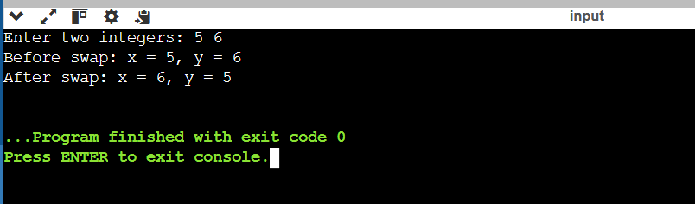
- Write a function template to find the minimum element in an array. Code- #include <iostream>
using namespace std;

// Function template to find minimum element template <typename T>
T findMin(T arr[], int n) { T min = arr[0];

for (int i = 1; i < n; i++) { if (arr[i] < min) {
min = arr[i];
}
}

return min;
}

int main() { int n;

cout << "Enter number of elements: "; cin >> n;

int arr[n];

cout << "Enter elements: "; for (int i = 0; i < n; i++) {
cin >> arr[i];
}

cout << "Minimum element = " << findMin(arr, n) << endl;

return 0;
}
OUTPUT-
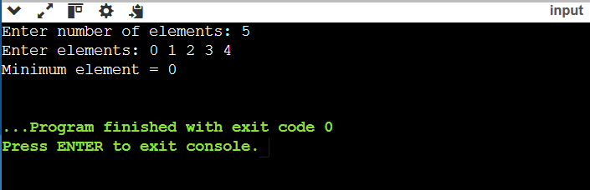
- Write a function template to sort an array using bubble sort. Code-
#include <iostream> using namespace std;

// Function template for Bubble Sort template <typename T>
void bubbleSort(T arr[], int n) { for (int i = 0; i < n - 1; i++) {
for (int j = 0; j < n - i - 1; j++) { if (arr[j] > arr[j + 1]) {
// swap
T temp = arr[j]; arr[j] = arr[j + 1]; arr[j + 1] = temp;
}
}
}
}

int main() { int n;

cout << "Enter number of elements: "; cin >> n;

int arr[n];

cout << "Enter elements: "; for (int i = 0; i < n; i++) {
cin >> arr[i];
}

bubbleSort(arr, n);

cout << "Sorted array: "; for (int i = 0; i < n; i++) { cout << arr[i] << " ";
}

return 0;
}
OUTPUT-
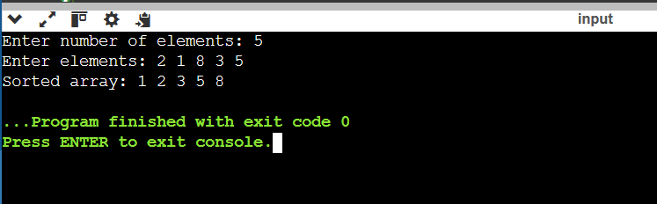
- Write a function template to perform linear search. Code-
#include <iostream> using namespace std; template <typename T>
int linearSearch(T arr[], int n, T key) { for (int i = 0; i < n; i++) {
if (arr[i] == key) { return i;
}
}
return -1;
}

int main() { int n;

cout << "Enter number of elements: "; cin >> n;

int arr[n];

cout << "Enter elements: "; for (int i = 0; i < n; i++) {
cin >> arr[i];
}

int key;
cout << "Enter element to search: "; cin >> key;

int result = linearSearch(arr, n, key);

if (result != -1)
cout << "Element found at index: " << result << endl; else
cout << "Element not found!" << endl;

return 0;
}
OUTPUT-

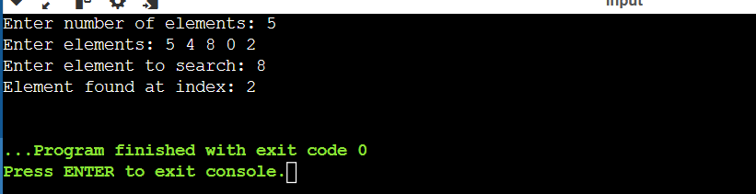
- Design overloaded versions of a function template process() such that:
  - Accepts a single parameter
  - Accepts two parameters of the same type
  - Accepts two parameters of different types
Code-
#include <iostream> using namespace std;

template <typename T> void process(T a) {
cout << "Single parameter: " << a << endl;
}

template <typename T> void process(T a, T b) {
cout << "Two parameters (same type): " << a << ", " << b << endl;
}

template <typename T, typename U> void process(T a, U b) {
cout << "Two parameters (different types): " << a << ", " << b << endl;
}

int main() {

int a, b; double c;

cout << "Enter one integer: "; cin >> a;
process(a);

cout << "Enter two integers: "; cin >> a >> b;
process(a, b);

cout << "Enter an integer and a double: "; cin >> a >> c;
process(a, c);

return 0;
}
Output-
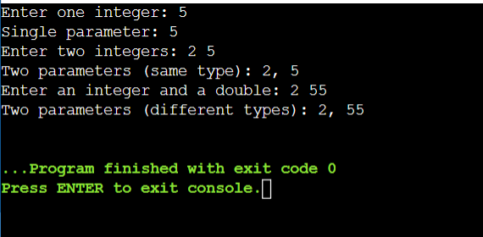

Class Template

- Develop a class template for stack with push and pop operations. #include <iostream>
using namespace std;

template <class T> class Stack {
T arr[100]; int top;

public:
Stack() { top = -1; }

void push(T x) { if(top == 99) {
cout << "Stack Overflow\n"; return;
}
arr[++top] = x;
}

void pop() { if(top == -1) {
cout << "Stack Underflow\n"; return;
}
cout << "Popped: " << arr[top--] << endl;
}

void display() {

if(top == -1) {
cout << "Stack is empty\n"; return;
}
for(int i = top; i >= 0; i--) { cout << arr[i] << " ";
}
cout << endl;
}
};

int main() { Stack<int> s; int choice, val;

do {
cout << "1.Push 2.Pop 3.Display 4.Exit\n"; cin >> choice;

switch(choice) { case 1:
cin >> val; s.push(val); break;
case 2:
s.pop(); break;
case 3:
s.display();

break;
}
} while(choice != 4);

return 0;
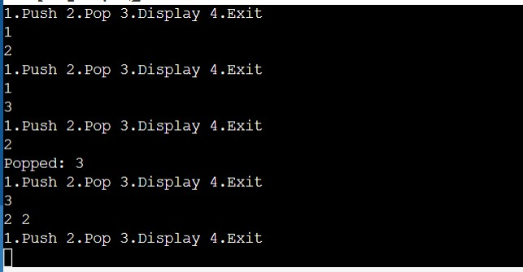
}

- Develop a class template for queue with enqueue and dequeue operations. #include <iostream>
using namespace std;

template <class T> class Queue {
T arr[100]; int front, rear;

public:
Queue() { front = 0;
rear = -1;

}

void enqueue(T x) { if(rear == 99) {
cout << "Queue Overflow\n"; return;
}
arr[++rear] = x;
}

void dequeue() { if(front > rear) {
cout << "Queue Underflow\n"; return;
}
cout << "Dequeued: " << arr[front++] << endl;
}

void display() { if(front > rear) {
cout << "Queue is empty\n"; return;
}
for(int i = front; i <= rear; i++) { cout << arr[i] << " ";
}
cout << endl;
}
};

int main() { Queue<int> q; int choice, val;

do {
cout << "1.Enqueue 2.Dequeue 3.Display 4.Exit\n"; cin >> choice;

switch(choice) { case 1:
cin >> val; q.enqueue(val); break;
case 2:
q.dequeue(); break;
case 3:
q.display(); break;
}
} while(choice != 4);

return 0;
}

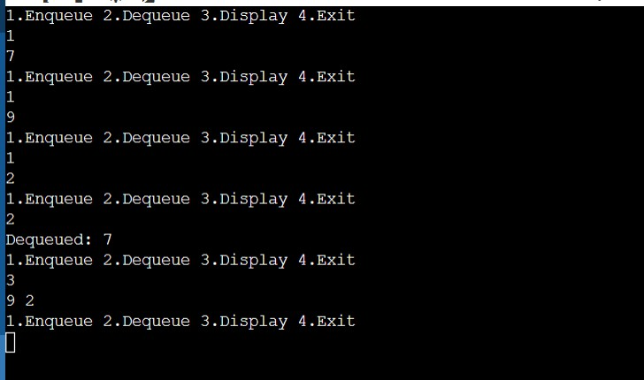
- Create a class template to store and display a pair of values. #include <iostream>
using namespace std;

template <class T1, class T2> class Pair {
T1 a; T2 b;

public:
void setValues(T1 x, T2 y) {
a = x;
b = y;
}

void display() {
cout << "Pair: " << a << ", " << b << endl;

}
};

int main() {
Pair<int, double> p; int x;
double y;

cout << "Enter first value (int): "; cin >> x;
cout << "Enter second value (double): "; cin >> y;

p.setValues(x, y); p.display();

return 0;
}
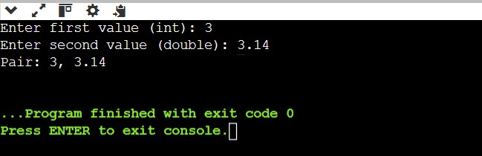
- Create a class template for basic arithmetic operations. #include <iostream>
using namespace std;

template <class T>

class Arithmetic { T a, b;

public:
void setValues(T x, T y) {
a = x;
b = y;
}

void add() {
cout << "Addition: " << a + b << endl;
}

void subtract() {
cout << "Subtraction: " << a - b << endl;
}

void multiply() {
cout << "Multiplication: " << a * b << endl;
}

void divide() { if(b == 0) {
cout << "Division by zero not allowed\n"; return;
}
cout << "Division: " << a / b << endl;
}
};

int main() { Arithmetic<double> obj; double x, y;

cout << "Enter two numbers: "; cin >> x >> y;

obj.setValues(x, y);

obj.add(); obj.subtract(); obj.multiply(); obj.divide();

return 0;
}
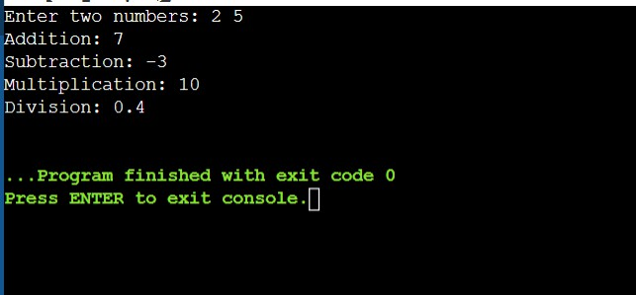
- Create a class template to input and display array elements.

#include <iostream>

using namespace std;

template <class T> class Array {
T arr[100]; int n;

public:
void input() { cin >> n;
for(int i = 0; i < n; i++) { cin >> arr[i];
}
}

void display() {
for(int i = 0; i < n; i++) { cout << arr[i] << " ";
}
cout << endl;
}
};

int main() { Array<int> obj;

cout << "Enter number of elements and elements:\n"; obj.input();

cout << "Array elements:\n"; obj.display();

return 0;
}
