Assignment-9: File Management
- Write a C++ program to write number 1 to 200 in a data file NUM.TXT. Code-
#include <iostream> #include <fstream> using namespace std; int main(){
ofstream file;
file.open ("NUM.TXT");
if (!file){
cout<<"File did not open successfully"<<endl;
}
for (int i=1;i<201;i++){ file<<i<<endl;
}
file.close();
cout<<"Numers written to NUM.TXT successfully"<<endl; return 0;
}
Output-
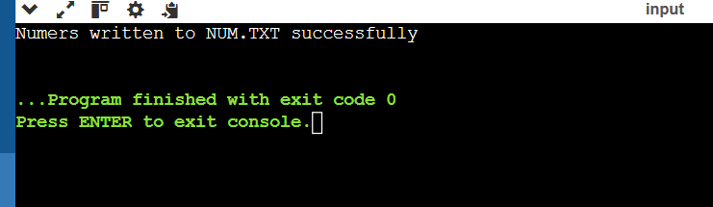

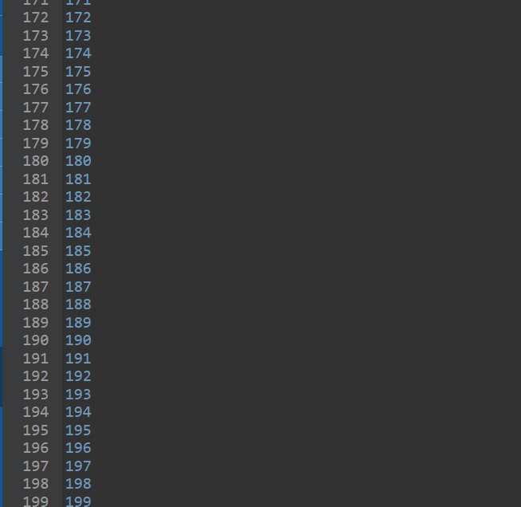

- Write a user-defined function in C++ to read the content from a text file NOTES.TXT, count and display the number of alphabets present in it.

Code- #include <iostream> #include <fstream>
using namespace std;
int countalphabets(){
ifstream file("NOTES.TXT");

if (!file){
cout << "File did not open" << endl; return 0;
}

char ch;
int count = 0;

while(file.get(ch)){
if ((ch >= 'A' && ch <= 'Z') || (ch >= 'a' && ch <= 'z')){ count++;
}
}
file.close(); return count;
}

int main(){
int total = countalphabets();
cout << "Number of alphabets = " << total << endl; return 0;
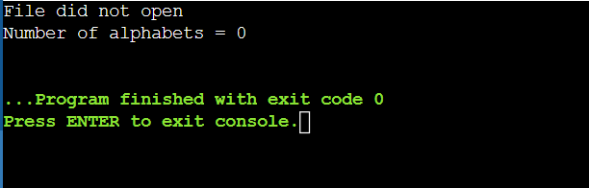
} OUTPUT-

- Write a program to perform read/write binary I/O operation on a file (i.e. write the object of the class to a file)
Code-
#include <iostream> #include <fstream> using namespace std; class Student {
int roll;
char name[20]; public:
void input() {
cout << "Enter roll number: "; cin >> roll;

cout << "Enter name: "; cin >> name;
}
void display() {
cout << "Roll: " << roll << ", Name: " << name << endl;
}
};
int main() { Student s;
ofstream fout("STUDENT.DAT", ios::binary); s.input();
fout.write((char*)&s, sizeof(s)); fout.close();
ifstream fin("STUDENT.DAT", ios::binary); fin.read((char*)&s, sizeof(s));
cout << "\nData read from file:\n"; s.display();
fin.close(); return 0;
} OUTPUT-
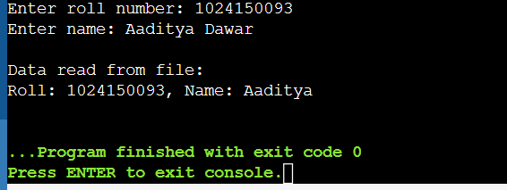
- Write a program to copy the contents of one file to another.

Code-
#include <iostream> #include <fstream> using namespace std;
int main() {
ifstream fin("NUM.TXT"); ofstream fout("TARGET.TXT");
if (!fin || !fout) {

cout << "Error opening file!" << endl; return 1;
}
char ch;
while (fin.get(ch)) { fout.put(ch);
}
fin.close();
fout.close();
cout << "File copied successfully." << endl; return 0;
}
OUTPUT-
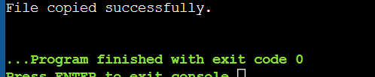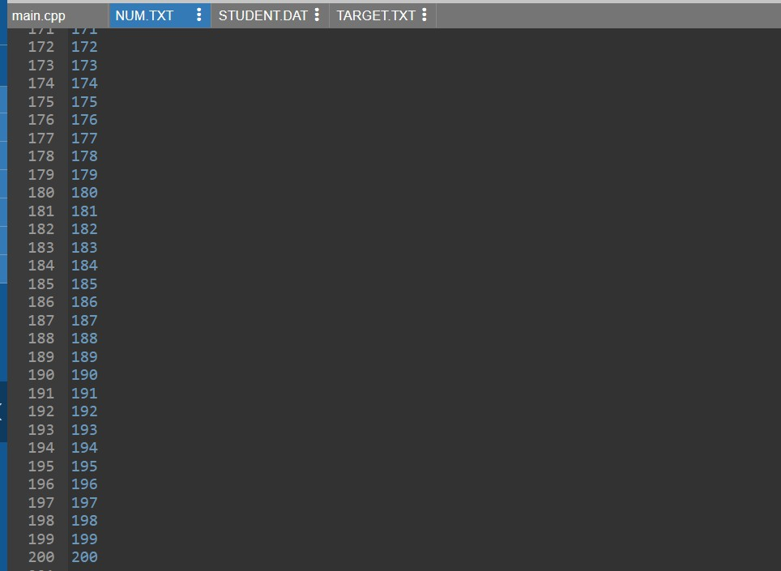

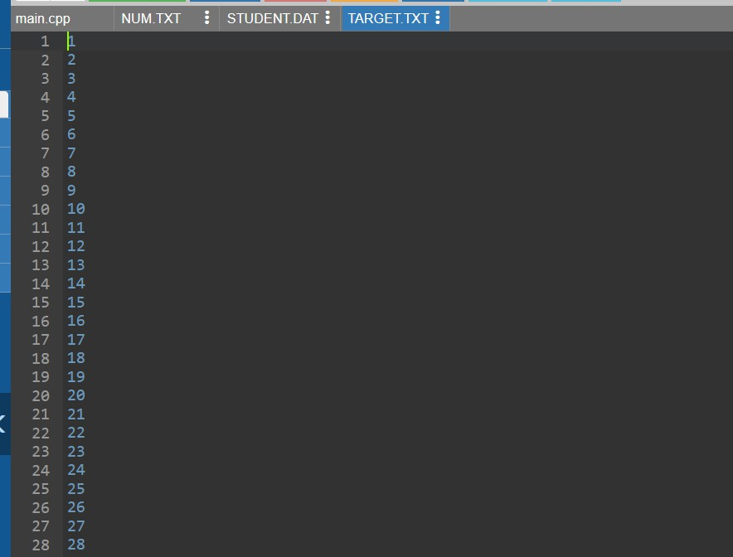

- Write a program to implement I/O operations on characters. I/O operations include inputting a string, calculating the length of the string, storing the string in a file and fetching the stored characters from it.

Code-
#include <iostream> #include <fstream> using namespace std;
int main() { char str[100];
cout << "Enter a string: "; cin.getline(str, 100);
int length = 0;
for (int i = 0; str[i] != '\0'; i++) { length++;
}

cout << "Length of string = " << length << endl; ofstream fout("DATA.TXT");

if (!fout) {
cout << "Error opening file!" << endl; return 1;
}
fout << str; fout.close();

ifstream fin("DATA.TXT"); if (!fin) {
cout << "Error opening file!" << endl; return 1;
}
char ch;
cout << "\nData read from file:\n";
while (fin.get(ch)) { cout << ch;
}

fin.close();
return 0;
}
OUTPUT-
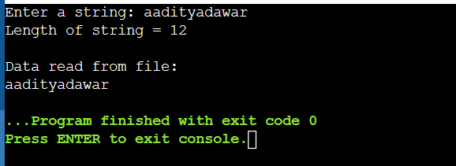
- (a) Create a file A-Z and read 10th character using seekg(). Code-

#include <iostream> #include <fstream> using namespace std;

int main() {
ofstream fout("file.txt");
for(char ch = 'A'; ch <= 'Z'; ch++) { fout << ch;
}
fout.close();

ifstream fin("file.txt"); fin.seekg(9, ios::beg);

char ch; fin.get(ch);

cout << "10th character is: " << ch;

fin.close(); return 0;
}
OUTPUT-

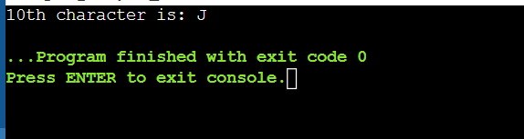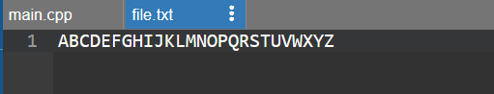
  - Overwrite 5th number using seekp(). #include <iostream>
#include <fstream> using namespace std;

int main() {
ofstream fout("file.txt");
for(char ch = 'A'; ch <= 'Z'; ch++) { fout << ch;
}
fout.close();

char newChar;
cout << "Enter character to overwrite at 5th position: "; cin >> newChar;

fstream file("file.txt", ios::in | ios::out);

file.seekp(4, ios::beg);

file.put(newChar);

file.close();

ifstream fin("file.txt"); char ch; while(fin.get(ch)) {
cout << ch;
}
fin.close();

return 0;
}
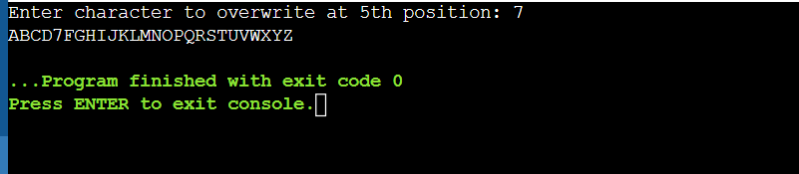
  - Find file size using tellg(). #include <iostream>
#include <fstream> using namespace std;

int main() {
ofstream fout("file.txt");
for(char ch = 'A'; ch <= 'Z'; ch++) {

fout << ch;
}
fout.close();

ifstream fin("file.txt"); fin.seekg(0, ios::end); int size = fin.tellg();

cout << "File size is: " << size << " bytes";

fin.close(); return 0;
}
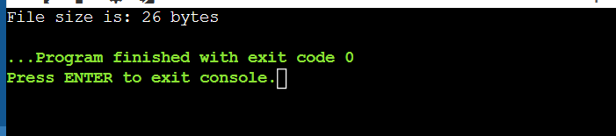
  - Read last character using seekg(). #include <iostream>
#include <fstream> using namespace std;

int main() {
ofstream fout("file.txt");
for(char ch = 'A'; ch <= 'Z'; ch++) { fout << ch;

}
fout.close();

ifstream fin("file.txt"); fin.seekg(-1, ios::end);

char ch; fin.get(ch);

cout << "Last character is: " << ch;

fin.close(); return 0;
}
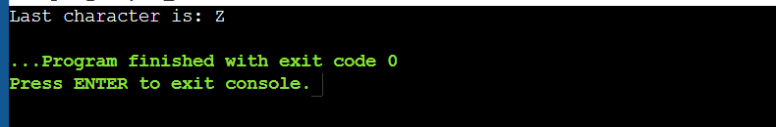
  - Create a file data.txt with multiple lines. Read the file and:
    - Move the pointer to the 10th byte using seekg()
    - Display the current position using tellg().
    - Read and display the remaining content. #include <iostream>
#include <fstream> using namespace std;

int main() {

ofstream fout("data.txt"); fout << "This is line one.\n"; fout << "This is line two.\n";
fout << "This is line three.\n"; fout.close();

ifstream fin("data.txt");

fin.seekg(9, ios::beg);

cout << "Current position: " << fin.tellg() << endl;

char ch; while(fin.get(ch)) {
cout << ch;
}

fin.close(); return 0;
}

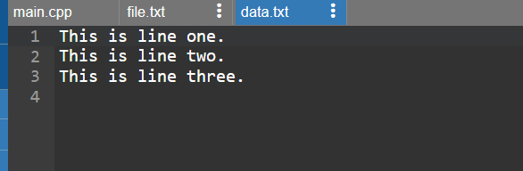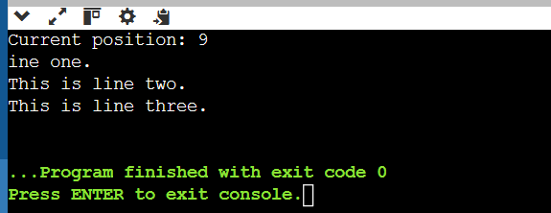
  - Write a program to:
    - Create a file with text "HelloWorld"
    - After writing each character, display the current position of the put pointer using tellp().
    - Replace "World" with "C++" using random access #include <iostream>
#include <fstream> using namespace std;

int main() {
fstream file("data.txt", ios::out | ios::in | ios::trunc);

string str = "HelloWorld"; for(char ch : str) {

file.put(ch);
cout << file.tellp() << endl;
}

file.seekp(5, ios::beg);
file.write("C++", 3);

file.close();

ifstream fin("data.txt"); char ch; while(fin.get(ch)) {
cout << ch;
}
fin.close();

return 0;
}

