**A Project report On** **UI DESIGN: STUDENT LOAN AND BUSINESS MEET APPLICATION**

*6-Month Summer Internship Report submitted towards the partial fulfilment of the degree*

**Bachelor of Technology**

SUBMITTED BY

**KATNKUR UDAY KUMAR**

**21CS002386**

*Under the Guidance of*

**Faculty Supervisor: Industry Supervisor:**

Ms. Poonam Saini Mr. RAM KUMAR

Assist. Professor TL& Senior designer

Sir Padampat Singhania University EDVEDHA EDUTECH PVT LTD



**Faculty of Computing and Informatics**

**Sir Padampat Singhania University Udaipur 313601 Rajasthan India**

**DECLARATION**

I **K. UDAY KUMAR** student of B.Tech.(CSE-AIML), hereby declare that the 6-Month Industrial Internship project report titled “**UI UX DESIGN: STUDENT LOAN AND BUSINESS MEET APPLICATTIONS**” is an authentic record of my own work carried out at  **Edvedha Pvt Ltd.** as requirement of Industry Internship Project which is submitted by me under the guidance of **Mr. RAM KUMAR (Edvedha Global Pvt Ltd)** and Ms. Poonam Saini **, Assist. Professor, SPSU** during January to March 2025 to the Faculty of Computing and Informatics, Sir Padampat Singhania University, Udaipur, towards the partial fulfilment of the requirement for the award of the degree of Bachelor of Technology, has not been previously formed the basis for the award of any degree, diploma or other similar title or recognition.

Name and signature of Student: Katankur Uday Kumar

Enrolment Number: 21CS002386

Place: Maple Celestia, Plot No.49, Jayabheri Enclave, Gachibowli, Hyderabad, Telangana 500032

Date:

Certified that the above statement made by the student is correct to the best of our knowledge and belief

**Prof.Sunil Kumar(Assist. Professor)**

Faculty Supervisor

**CERTIFICATE**

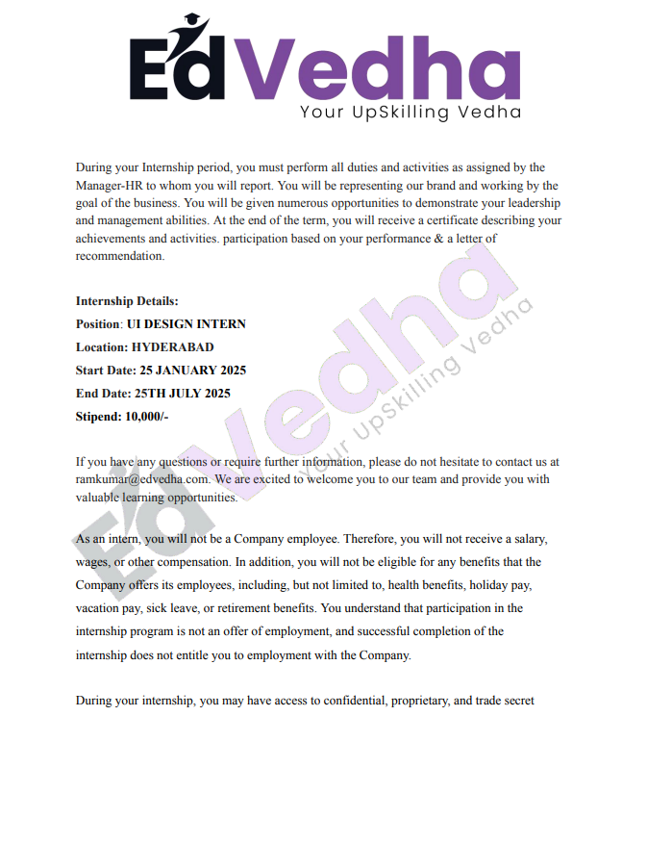 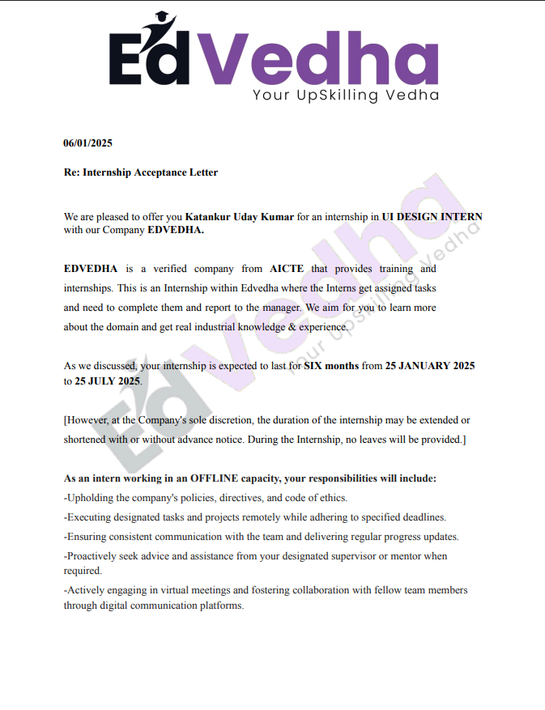

**ACKNOWLEDGEMENT**

I, **K. UDAY KUMAR (21CS002386),** would like to express my heartfelt appreciation to all those who have played a role in the advancement and realization of this project focusing on **UI UX DESIGN: STUDENT LOAN AND BUSINESS MEET APPLICATTIONS** Your continuous support and guidance have been instrumental in the successful completion of this academic endeavour.

I am deeply grateful to my esteemed Industry Supervisor **Mr. Ram Kumar (Senior designer)** and my faculty advisor, **Ms. Poonam Saini**, whose unwavering support, insightful feedback, and encouragement have been invaluable throughout this journey. Your mentorship has profoundly influenced the direction and progress of this project endeavour. Thank you for your invaluable insights, thought-provoking discussions, and for providing clarity to my ideas.

I extend my sincere thanks to the faculty members of the **Faculty of Computing and Informatics** at Sir Padampat Singhania University, Udaipur, for their expertise and guidance, which have significantly enriched the methodologies and approaches employed in this project.

Special appreciation is also extended to my peers for their collaborative efforts, brainstorming sessions, and constructive critiques, all of which have contributed to refining and improving this project.

I am grateful for the unwavering support and dedication of everyone involved. Together, we are making significant contributions towards the advancement of autonomous vehicle technology and the enhancement of road safety.

K. Uday Kumar

21CS002386

**ABSTRACT**

This project report details the development of innovative user interface (UI) designs for two specialized applications: a student loan management platform and a business meet tool, each addressing distinct user challenges through intuitive, user-centric design principles. **The student loan application** targets students overwhelmed by the complexity of navigating loan options, repayment plans, and financial aid, which often leads to confusion and anxiety about future debt. To mitigate these issues, the application provides a streamlined interface featuring personalized loan calculators that allow users to explore repayment scenarios, clear visualizations of repayment options to demystify financial implications, and guided workflows to simplify the application process, empowering students to make informed decisions with reduced stress.

The **business meeting application**, designed for a firm with numerous employees and multiple projects, addresses the challenge of managing diverse discussion groups for project-related activities such as development, project management, and deployment. Inspired by platforms like Slack and Microsoft Teams, it offers a robust chatting tool supporting individual and group chats. Key features include the ability to attach various media types (e.g., images, videos, PDFs), initiate video and audio calls, mention users in group chats, differentiate between public and private groups, mark chats as favourites, and a notification centre to alert users about mentions and missed calls. These features ensure efficient collaboration and seamless workflow management across both web and native mobile platforms (iOS/Android).

Developed **using industry-standard tools such as Figma, Marvel, Adobe XD, and wireframing techniques,** the UI designs emphasize accessibility, responsiveness, and modern aesthetics. The iterative design process incorporated user feedback to refine functionality and enhance usability. For the student loan application, the focus was on creating an inclusive interface that caters to users with varying levels of financial literacy. For the business meeting application, the design prioritized cross-platform consistency, ensuring employees can access the tool seamlessly from any device, whether in the office or on the go.

**CONTENTS**

**DECLARATION i**

**CERTIFICATE** ii

**ACKNOWLEDGEMENT** iii

**ABSTRACT i**v

**TABLE OF CONTENTS** v

**LIST OF TABLES** vi

**LIST OF FIGURES** vii

**LIST OF ABBREVIATIONS** viii

**CHAPTER 1 1**

**INTRODUCTION 1**

1.1 Background Information **1**

1.2 Problem Statement **1**

1.3 Existing Solutions and Their Limitations **2**

1.4 Project Objective **2**

**CHAPTER 2 3**

**2.1 LITERATURE SURVEY**

2.1.1 Dynamic Team Structuring in Enterprise Systems **3**

2.1.2 Project-Employee Mapping and Responsibility Tracking **3**

2.1.3 Visual Analytics in Project Management **4**

2.1.4 Cross-Functional Collaboration and Scalability **5**

2.1.5 Comparative Analysis of Existing Research and Our Project **6**

**2.2 Software Requirement Specification 7**

2.2.1 Functional Requirements **7**

2.2.2 Non-Functional Requirements **8**

2.2.3 Software & Libraries Used **9**

2.2.4 Comparative Analysis with Existing Systems **10**

2.2.5 Future Enhancements

**CHAPTER 3 11**

**SOFTWARE DESIGN 11**

**3.1 Objectives and Scope of the Project 11**

**3.1.1 Objectives 11**

**3.1.2 Scope of the Project 12**

**3.2 SMART Goals (Specific, Measurable, Achievable, Relevant, Time-Bound) 12**

**3.3 Limitations of the System 13**

**CHAPTER 4 14**

**METHODOLOGY 14**

**4.1 Design Process and Methods 14**

**4.1.1 Development Methodology 15**

**4.2 High-Level Architecture of the System 16**

**4.2.1 System Architecture 16**

**4.3 Component Interaction & Data Flow 17**

**4.4 Development and Iteration Plan 17**

**CHAPTER 5 18**

**TECHNOLOGY STACK 18**

**5.1 Overview 18**

**5.2 Frontend Technology Stack 18**

**5.3 Backend Technology Stack 19**

**5.4 Database Management System (DBMS) 19**

**5.5 Data Visualization & Analytics 19**

**5.6 Cloud and DevOps Tools 20**

**5.7 Hardware Requirements 20**

**5.8 Rationale Behind Technology Choices 20**

**5.9 Summary 21**

**CHAPTER 6 21**

**PROJECT WORK BREAKDOWN STRUCTURE (WBS) 21**

**6.1 Work Breakdown Structure Overview 22**

**6.2 Phases and Tasks Breakdown 22**

**6.2.1 Phase 1: Research & Planning 22**

**6.2.2 Phase 2: Core Feature Development 22**

**6.2.3 Phase 3: Full-Stack Development (Frontend & Backend) 22**

**6.2.4 Phase 4: Deployment & Optimization 23**

**6.3 Work Breakdown Structure Gantt Chart 23**

**CHAPTER 7 24**

**EXPECTED OUTCOMES AND DELIVERABLES 24**

**7.1 Expected Outcomes 24**

**7.2 Deliverables 24**

**7.3 Challenges & Mitigation Strategies 25**

**7.4 UI/UX Design Overview 26 7.5 System Architecture Overview 26**

**CHAPTER 8 27**

**CONCLUSION 27**

**8.1 Summary of Key Points 27**

**8.2 Importance of the Project 28**

**8.3 Future Scope 28**

**REFERENCES 29**

**APPENDIX**

**ANNEXURE**

**ANNEXURE-I MONTHLY ATTENDANCE REPORT [FROM BIOMETRIC / FROM**

**INDUSTRY MENTOR]**

**ANNEXURE-II FEEDBACK FORM FROM SUPERVISOR WITH PROPER SIGNATURE**

**and STAMP [of Supervisor/Organization]**

**LIST OF FIGURES**

**Figure No. Description Page No.**

Chapter 2

2.1 Overview of the Employee Based Management System 10

Chapter 4

4.1 methodology overview flowchart 14

Chapter 6

6.1 work Breakdown Structure (WBS) 21

6.2 Gantt chart 23

Chapter 7

7.1 wireframes of employee and administrator 26 7.2 overall architecture working system model 27

Chapter 8

8.1 overall view of the system 28

**LIST OF TABLES**

**Table No. Description Page No**

Chapter 2

2.1 comparative analysis 6

2.2 Performance Comparison 7

2.3 Software analysis 9

Chapter 3

3.1 smart goals 12

Chapter 5

5.1 hardware analysis 20

Chapter 6

6.1 research analysis 22

6.2 core functional modules 22

6.3 full stack development 22

6.4 deployment analysis 23

Chapter 7

7.1 analysis between challenges and mitigations 25

**LIST OF ABBREVIATIONS**

**ABBREVIATION DESCRIPTION**

CRUD Create, Read, Update, Delete

UI/UX User Interface / User Experience

WBS Work Breakdown Structure

API Application Programming Interface

GDPR General Data Protection Regulation

RBAC Role-based access control

HTD hierarchical task decomposition

ONA Organizational Network Analysis

ERP Enterprise Resource Planning

KPI Key performance indicators

JWT JSON Web Token

MERN MongoDB ExpressJS ReactJS NodeJS

DBMS Database Management System

FCM Firebase Cloud Messaging

TLS Transport Layer Security

# CHAPTER 1

# INTRODUCTION

#### The rising complexity of student loan systems has increased the burden on students, who often face confusion and anxiety when navigating loan applications and repayment options. Traditional platforms, such as government or bank websites, frequently present information in ways that are not user-friendly, particularly for those with limited financial literacy. Similarly, in modern workplaces, effective communication is vital for firms managing multiple projects and distributed teams. While tools like Slack and Microsoft Teams provide robust solutions, firms with specific needs may require customized platforms to optimize collaboration.

#### This project addresses two design challenges: simplifying the student loan application process for students and enhancing communication efficiency for a firm with multiple projects. The student loan application aims to make financial information accessible and understandable, while the business communication tool seeks to streamline project-related discussions. Existing solutions, such as government portals for loans or general-purpose chat platforms for businesses, often fall short in addressing these specific user needs, justifying the development of tailored UI designs.

#### 1.1 Background Information

#### The landscape of student loans has become increasingly complex, with a variety of loan types, repayment options, and financial aid programs available. This complexity often overwhelms students, who may lack the financial literacy to navigate traditional platforms like government or bank websites. These platforms tend to present information in dense, technical formats, exacerbating students' anxiety about their financial future.

#### Similarly, businesses managing multiple projects with dynamic team structures face significant communication challenges. As teams form and evolve based on project needs, firms require flexible tools to maintain efficient collaboration. Existing enterprise communication solutions, while robust, often fail to fully address the specific workflows of such organizations, leading to inefficiencies and miscommunication.

#### 1.2 Problem Statement

This project tackles two pressing issues:

* **Student Loan Application**: Students struggle to navigate the intricate student loan system, resulting in confusion and anxiety about managing debt.
* **Business Meeting Application**: Firms with multiple projects and dynamic teams face difficulties in maintaining effective communication, impacting productivity and project success

#### 1.3 Existing Solutions and Their Limitations

**Student Loan Management:**

* **Current Solutions**: Platforms like StudentAid.gov, private lender websites (e.g., Sallie Mae, Navient), and third-party financial advisory apps provide loan-related services.
* **Limitations**:

• Inaccessible **Language**: Information is often laden with financial jargon (e.g., "accrued interest," "deferment") that confuses novice users.

• Lack **of Interactivity**: Few platforms offer dynamic tools—like real-time repayment calculators or scenario planners—to help users explore options actively.

• Poor **Visualization**: Repayment plans are typically presented as static tables or text blocks, making it hard for students to visualize trade-offs or long-term consequences.

• Accessibility **Gaps**: Many systems fail to comply with modern accessibility standards (e.g., WCAG 2.1), excluding users who rely on screen readers, keyboard navigation, or simplified layouts.

• One**-Size-Fits-All Approach**: Generic designs ignore the diverse needs of students, from undergraduates to graduate borrowers with unique financial profiles.

**Business Communication:**

* **Current Solutions**: Widely used tools include Slack, Microsoft Teams, Zoom, and project management hybrids like Asana or Basecamp.
* **Limitations**:
  + - **Generic Functionality**: These platforms cater to broad audiences, lacking the flexibility to adapt to niche workflows, such as dynamic team restructuring or project-specific communication needs.
    - **Customization Shortfalls**: Options to tailor interfaces or features (e.g., role-based permissions, project-specific chat groups) are limited, forcing teams to adapt to the tool rather than vice versa.
    - **Feature Overload**: Robust systems often overwhelm smaller teams with unnecessary complexity, such as advanced bots or integrations irrelevant to their goals.
    - **Integration Challenges**: Seamless connectivity with existing project management tools is inconsistent, leading to fragmented workflows and data silos.
    - **Scalability Issues**: Some tools struggle to balance simplicity for small teams with the robustness required for larger, evolving organizations.

These limitations underscore the need for specialized, user-centric solutions that prioritize clarity, adaptability, and integration.

#### 1.4 Project Objective

The overarching goal of this project is to design and develop two applications that overcome the deficiencies of existing systems, delivering tailored, innovative solutions:

1. **Student Loan Management Platform**:
   * **Purpose**: To simplify the loan application and management process, enabling students to make informed financial decisions with confidence.
   * **Key Features**:
     + A streamlined interface that breaks down complex loan information into digestible, jargon-free content.
     + Interactive tools, such as a repayment calculator and visual dashboards, to simulate repayment scenarios and compare loan options.
     + Accessibility-first design, ensuring compatibility with assistive technologies and diverse user needs.
     + Guided workflows that walk users through the application process step-by-step, reducing errors and uncertainty.
2. **Business Communication Tool**:
   * **Purpose**: To enhance collaboration and communication efficiency for firms with multiple projects and dynamic team structures.
   * **Key Features**:
     + Customizable chat functionalities, including individual and group messaging organized by project or team roles.
     + Support for media attachments (e.g., documents, images, videos) and real-time features like video/audio calls and notifications.
     + Integration with existing project management systems to unify workflows and reduce operational friction.
     + Scalable design that adapts to the evolving needs of growing organizations, from small startups to established enterprises.

Both applications will employ innovative UI design principles—such as minimalist layouts, intuitive navigation, and responsive cross-platform performance—to ensure usability, accessibility, and a seamless user experience. By addressing the specific pain points of students and project-driven businesses, this project aims to set a new standard for specialized application design.

# CHAPTER 2

**Literature Review**

# In order to design effective and user-centric UI solutions for both the Student Loan Application and the Business Meet Chat Application, a comprehensive literature review was conducted. This involved the analysis of existing applications, modern UI/UX strategies, and cognitive theories related to digital interface design.

# 2.1 Student Loan Management Applications

To understand the challenges students face, popular student loan management platforms such as **FAFSA**, **Navient**, and **MyFedLoan** were analyzed:

* **FAFSA (Free Application for Federal Student Aid):** While highly informative, FAFSA’s interface is often criticized for being text-heavy and intimidating for first-time users. Navigation involves multiple steps with little real-time guidance, increasing confusion among applicants.
* **Navient & MyFedLoan:** These platforms offer loan management and repayment tracking, but their interfaces tend to prioritize data over usability. They lack interactive dashboards or contextual tips, resulting in higher cognitive effort for users.

These findings revealed a clear need for an **intuitive, interactive**, and **user-guided interface** that simplifies the loan application process and provides visual clarity on financial responsibilities.

**Key Takeaways:**

* Users need **simplified navigation**, **visual representations** (graphs, progress bars), and **personalized assistance** (e.g., chatbots or AI suggestions).
* Error prevention and feedback mechanisms are minimal in current solutions.

### 2.2 UI/UX Strategies in Enterprise Communication Tools

### To design the Business Meet Chat App, industry-standard communication tools such as Slack, Microsoft Teams, and Notion were analysed:

* **Slack:** Uses a clean, intuitive layout with modular conversations (channels, threads) to minimize clutter. Strong use of visual hierarchy and colour coding enhances usability.
* **Microsoft Teams:** Offers deep integration with Office tools and effective group/individual chat segregation. The learning curve, however, is steep due to the dense interface.
* **Notion:** Known for its minimal UI and multi-functional design (notes, tasks, wiki). It excels at contextual organization and user customization.
* These apps demonstrate the importance of **modular design**, **clarity between private and group communications**, and **seamless integration** of features like media sharing, mentions, and notifications.

**Key Takeaways:**

* Emphasize **modularity**, **intuitive workflows**, and **quick switching** between contexts (individual vs. group chat).
* Maintain clear **visual distinctions** (private/public groups, pinned items).
* Use **progressive disclosure** to avoid overwhelming users with too much at once.

**2.3 Application of Design Psychology and Usability Standards**

Foundational principles from **Nielsen Norman Group**, **Don Norman**, and **Cognitive Load Theory** were used to shape the design process:

* **Cognitive Load Minimization:** Interfaces should minimize the mental effort required to perform tasks. The proposed designs use progressive disclosure, visual hierarchy, and user-friendly navigation.
* **Feedback and Affordance:** Users receive real-time visual feedback on actions (e.g., message sent, file uploaded), increasing usability and user satisfaction.
* **Accessibility:** Design choices follow **Web Content Accessibility Guidelines (WCAG 2.1)** to ensure inclusivity, such as readable font sizes, adequate contrast ratios, and alternative text for images.

| **Application/Source** | **Key Takeaways** |
| --- | --- |
| FAFSA | Complex flow, text-heavy, lacks real-time guidance |
| Navient/MyFedLoan | Data-centric, poor mobile experience, low interactivity |
| Slack | Effective chat structure, visual cues, productivity boosters |
| Microsoft Teams | Rich in features, but UI can be overwhelming |
| Notion | Minimalist, flexible, user-controlled interface |
| Design Psychology | Reduce cognitive load, provide feedback, prioritize clarity |

**TABLE 1: Summary of Findings**

**2.4 Software Requirement Specification**

**2.4.1 Functional Requirements**

* **Student Loan Application**:
  + User registration and login for secure access.
  + A streamlined loan application form.
  + A repayment calculator to explore scenarios.
  + Accessible financial aid information.
  + Visualizations of loan options.
  + A guided workflow for step-by-step assistance.
* **Business Meeting Application**:
  + Individual and group chat functionalities.
  + Support for media attachments (e.g., images, documents).
  + Video and audio call capabilities.
  + User mentions for direct communication.
  + Favourite chat lists for quick access.
  + A notification center for real-time updates.

**2.4.2 Non-Functional Requirements**

* **Performance**: Real-time communication with minimal latency for the business app; fast load times for the loan app.
* **Usability**: Intuitive interfaces suitable for users with varying technical or financial expertise.
* **Accessibility**: Compliance with standards like WCAG to ensure inclusivity.

**2.4.3 Software & Libraries Used**

* **Design Tools**: Figma for collaborative prototyping, Marvel for rapid prototyping, Adobe XD for high-fidelity designs, and wireframing tools for initial layouts.
* **Development**: HTML5, CSS3, and JavaScript for web interfaces; React for dynamic frontends; Flutter for cross-platform mobile apps.

**2.4.4 Future Enhancements**

* **Student Loan Application**: Potential integration with financial advisory services to offer personalized guidance.
* **Business Meeting Application**: Adding advanced analytics to track team performance and communication patterns.

# CHAPTER 3

# Software Design

# Design Process

The design process began with user research, including interviews with students for the loan application and firm employees for the communication tool. Personas were created to guide design decisions, followed by wireframing, prototyping, user testing, and iterative refinements based on feedback.

**Methods**

* **User Research**: Surveys and interviews to gather requirements.
* **Persona Creation**: Detailed user profiles to inform design.
* **Wireframing**: Low-fidelity layouts to define structure.
* **Prototyping**: Interactive prototypes using Figma and Adobe XD.
* **User Testing**: Usability tests to validate designs.
* **Iteration**: Refinements based on feedback.

**Diagrams**

**FIG 1: DESIGN THINKING**

**FIG 2: 5 STAGE -PROCEES UI DEVELOPMENT   
  
NOTE:** These stages are not always sequential. Designers will find the stages

often occur in parallel and see repeated use on an iterative basis.

**Development Plan**

|  |  |  |
| --- | --- | --- |
| **Phase** | **Duration** | **Deliverable** |
| Research | 2 weeks | Requirements document, personas |
| Wireframing | 3 weeks | Low-fidelity wireframes |
| Prototyping | 4 weeks | High-fidelity prototypes |
| Refinement | 3 weeks | Refined designs |
| Documentation | 1 week | Design documentation, presentation |

**TABLE 2: Development Plan**

# CHAPTER 4

**Design Methodology**

The design methodology followed for this project aligns with widely accepted UI/UX design processes and frameworks. This methodology combines **user-centered design thinking** and **iterative development** to create innovative, functional, and aesthetically appealing interfaces for both the Student Loan Application and the Business Meet Chat Application

* **4.1 Design Thinking Process**

**FIG 3: USER JOURNEY**

**1. Empathize**

* **Objective:** Understand the problems, needs, and goals of the users.
* **Method:** Conducted **Quantitative and Qualitative Research.** user interviews, gathered feedback from students and working professionals
* **Insights:** Students found loan terms and repayment options confusing. Professionals struggled with managing multiple project chat channels.



**FIG 4: QUANTITATIVE RESEARCH**

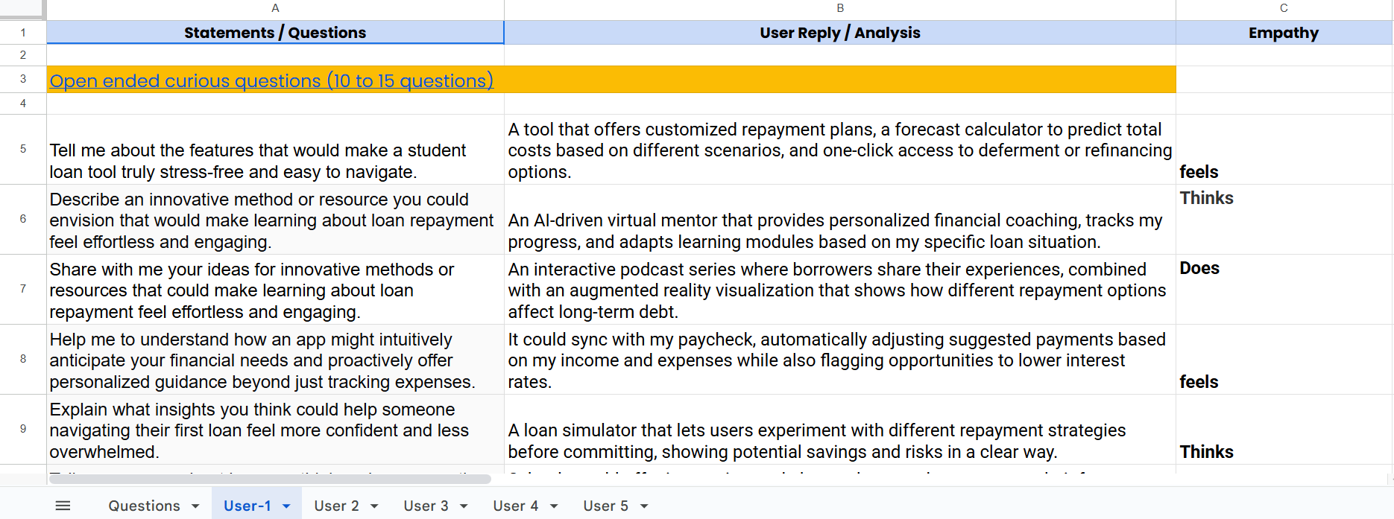

**FIG 5: Qualitative** RESEARCH

**2. Define**

* **Objective:** Narrow down the user needs into specific problem statements.,
* **For Student Loan App:**
  + “Students need an intuitive tool to navigate and manage loan-related information without being overwhelmed.”
* **For Business Meet App:**
  + “Professionals need a centralized and clean communication platform to manage multiple project-based conversations effectively.”
* **Methods:** **Empathy Mapping, Create Personas.**

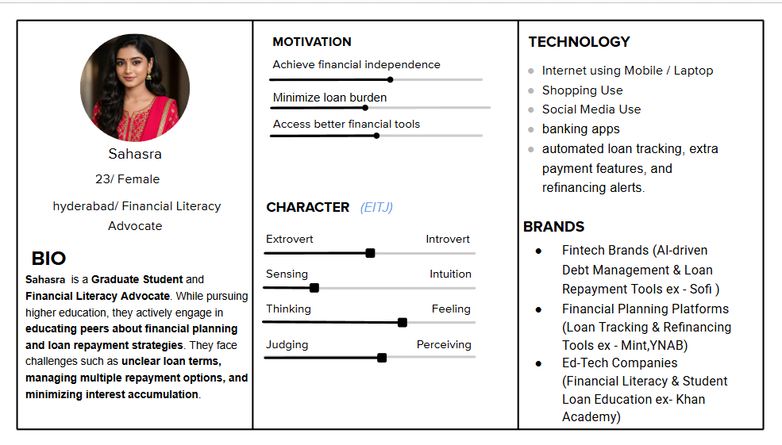

**FIG 6:USER PERSONAS**

**3. Ideate**

* **Objective:** Generate multiple design solutions to address the user pain points.
* **Activities:**
  + Brainstorming sessions using Miro and FigJam.
  + **Cr**eating User Story, Ideation Workshop
  + Scope Document
  + Card Sorting
  + User ﬂow / Task ﬂow

FIG 7: **User Story**

FIG 7: **Scope Document**

FIG 7: **CARD SORTING**



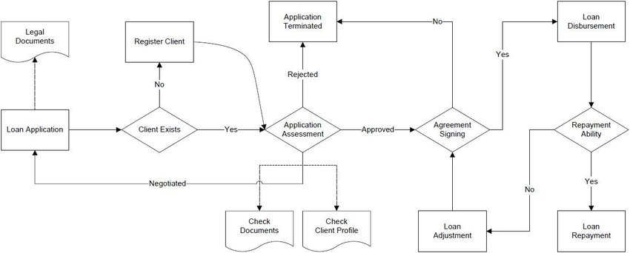

FIG 8: TASK FLOW FOR STUDENT LOAN APP

FIG 8: TASK FLOW FOR BUSINESS MEET APPLICATION

1. **Prototype**

**Activities**:

* + Develop low-fidelity prototypes (e.g., wireframes in Figma) to explore layout and navigation.
  + Create high-fidelity prototypes with visual design and interactions (e.g., using Adobe XD).
  + Iterate based on internal feedback and design reviews.

**Deliverables**: Low, Mid and high-fidelity prototypes, design specifications.

* **Tools Used:** Figma, Adobe XD, Marvel
* **Output:**
  + **Student Loan App:** Interactive dashboard mockups, repayment calculators, chatbot UI for financial guidance.
  + **Business Meet App:** Group chat layouts, user tagging system, notification centre design, voice/video call UI.

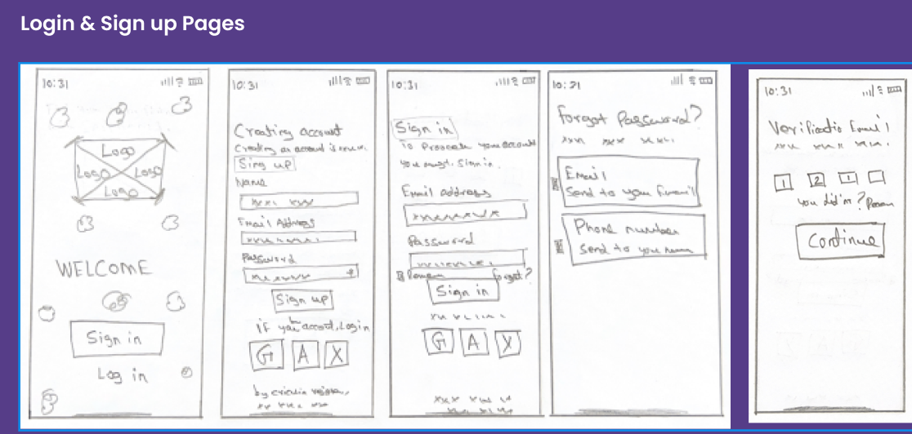

FIG 9: Low fidelity prototype

FIG 10: Mid fidelity prototype

FIG 11: high-fidelity prototype

1. **Test**

**Objective**: Validate designs with users and refine based on feedback.

* **User Testing:** Conducted informal usability testing with 10+ users in both domains.
* **Feedback:** Helped refine navigation flow, improve labeling clarity, and adjust visual hierarchy.
* **Iteration:** Updated mockups and interactions based on feedback before finalizing designs.

**4.3 Tools & Design Justification**

* **Figma:** Used for real-time collaboration and version control of wireframes and high-fidelity designs.
* **Adobe XD**: Helped in refining visual components and animating transitions.
* **Marvel:** Facilitated the creation of clickable prototypes for usability testing.
* **Miro:** Employed for brainstorming sessions and journey mapping.

## 4.2 High-Level Architecture

## The UI architecture for both applications was designed using a component-based and mobile-first approach, ensuring consistency, scalability, and accessibility across platforms.

## Student Loan Application Architecture:

## Dashboard View: Displays current loan status, payment due dates, and progress bar.

## Loan Planner: Interactive calculator for planning repayment timelines.

## Help Center: Contextual FAQ section with chatbot support.

## Notifications: Real-time alerts for upcoming payments or updates.

## Business Meet Chat Application Architecture:

## Channel List: Sidebar with individual and group chat threads.

## Chat Window: Central area for conversations, media sharing, tagging, and calls.

## Call Module: Popup interface for voice and video calling.

## Profile Views: Detailed user/group profiles with attachments, pinned chats, and activity logs.

## Notification Center: Displays mentions, missed calls, and alerts.

**Fig 12: High-Level Architecture Loan app UI design**

**4.5 Development Iteration Plan**

**The UI design process was executed in iterative sprints as follows:**

| **Sprint** | **Timeline** | **Activities** | **Deliverables** |
| --- | --- | --- | --- |
| Sprint 1 | Week 1–2 | User Research, Persona Development | Empathy Maps, Problem Statements |
| Sprint 2 | Week 3 | Sketching, Wireframing (Low-Fidelity) | Wireframe Screens for All Key Interfaces |
| Sprint 3 | Week 4–5 | High-Fidelity UI Design, Colour/Component Setup | Styled UI Screens |
| Sprint 4 | Week 6 | Prototyping with Marvel/Figma | Interactive Clickable Prototypes |
| Sprint 5 | Week 7 | Usability Testing, Feedback Collection | Usability Reports, Issues Logged |
| Sprint 6 | Week 8 | Iterations & Final Documentation | Final UI Kit, Exported Designs, Report |

**TABLE 3:** Development Iteration Plan

CHAPTER 5

# Technology Stack

This chapter outlines the complete set of technologies, platforms, and tools used during the design and development of the UI/UX prototypes for both applications. Each tool was selected based on its strengths in enhancing collaboration, productivity, prototyping efficiency, and design accuracy.

* **Design Tools**: Figma (collaboration), Adobe XD (high-fidelity designs).
* **Prototyping Tools**: Marvel (interactive mockups), InVision (testing).
* **Collaboration**: Miro (brainstorming), Jira (task management).
* **Hardware**: High-resolution monitors, graphic tablets.

| **Tool** | **Purpose** | **Rationale** |
| --- | --- | --- |
| Figma | Wireframing, UI Design, Prototyping | Cloud-based collaborative platform ideal for real-time team collaboration. Offers reusable components and live preview functionality. |
| Adobe XD | High-fidelity UI design, animation, and interaction prototyping | Used for polished interface design and animations. Supports advanced vector editing and micro-interactions. |
| Marvel | Clickable prototypes, testing flows | Simple and effective for creating quick interactive prototypes and sharing with testers or stakeholders. |
| Miro | Brainstorming, user journey mapping, collaborative whiteboarding | Used during the ideation and planning phases to map out flows, features, and personas. |
| FigJam | Design collaboration, ideation workflows | Integrated with Figma for real-time brainstorming, sticky notes, and flow diagrams. |

**TABLE 4:** Software Tools and Design Platforms

**5.2 Hardware Requirements**

| **Hardware** | **Purpose** | **Rationale** |
| --- | --- | --- |
| **Laptop/Desktop** | Running design tools like Figma, XD | Minimum requirement for design software; ensures performance during rendering of high-fidelity designs. |
| **Smartphone (iOS/Android)** | Testing mobile responsiveness and touch UX | Essential for verifying mobile UI behavior and user flow accuracy. |
| **Tablet (optional)** | Prototype reviews, touch-based testing | Used for testing responsive layouts and gesture-based interactions. |

**TABLE 5:** **Hardware Requirements**

**5.3 Prototyping and Testing Tools**

| **Tool** | **Purpose** | **Rationale** |
| --- | --- | --- |
| **Figma Prototypes** | Flow simulation, click testing | Fast, no-code method to simulate app behavior and transitions. |
| **Marvel App** | Creating presentation-ready prototypes | Easy export and sharing with stakeholders and testers. |
| **InVision (optional)** | Review and feedback collection | Useful for getting annotated feedback from collaborators. |

**TABLE 6:** **Prototyping and Testing Tools**

5.4 Additional Tools Used

| **Tool** | **Purpose** | **Rationale** |
| --- | --- | --- |
| **Google Docs/Sheets** | Content writing, flow documentation, WBS planning | Enables structured documentation and collaborative editing. |
| **Draw.io / Lucidchart** | Flowcharts and system architecture diagrams | Used to visually map the design system and user journeys. |
| **Zoom / Google Meet** | Stakeholder feedback, usability testing interviews | Facilitated remote design discussions and live testing. |

**TABLE 7:** **Prototyping and Testing Tools**

**5.5 Rationale for Tool Selection**

* **Cross-Platform Flexibility:** Figma and Adobe XD were chosen for their compatibility with multiple OS environments and real-time collaboration.
* **Low Learning Curve:** Tools like Marvel and Miro are intuitive, ensuring faster onboarding for all team members.
* **Industry Relevance:** All tools used are widely adopted in the design industry, ensuring that the outputs are compatible with development pipelines.
* **Collaborative Design Workflow:** Real-time updates, commenting, and version tracking in Figma and FigJam helped maintain productivity in a team setting.

**Additional Enhancements**

* **Accessibility**: Adhere to WCAG 2.1 (e.g., screen reader support).
* **Risk Management**: Mitigate delays with regular reviews and developer consultations.
* **Metrics**: Track KPIs (e.g., task completion rates, time-on-task).
* **Scalability**: Design for future features (e.g., multilingual support).

# CHAPTER 6

# Project Work Breakdown Structure (WBS)

The Project Work Breakdown Structure (WBS) outlines the organization of tasks, design phases, and key technical features developed during the creation of the **Student Loan Application** and **Business Meet Chat Application**. It presents the logical structure of the work, assigns roles, and ensures timely and organized execution of design efforts.

**6.1 Key Technical Features**

**Student Loan Application**

1. **Dashboard Interface:** Presents a summary of loan status, due dates, and repayment progress through intuitive cards and progress bars.
2. **Loan Calculator:** Enables users to simulate repayment plans based on interest rates, tenure, and loan amounts.
3. **Interactive Help Center:** Provides contextual help via chatbot and FAQs tailored to the user’s journey.
4. **Notification System:** Sends real-time alerts for upcoming payment deadlines or changes in loan terms.
5. **Personalized Profile Section:** Allows users to view their loan history, edit preferences, and manage communication settings.

**Business Meet Chat Application**

1. **Individual and Group Chat:** Supports both private and project-based team communications.
2. **Media Sharing Module:** Enables attachment of files such as documents, images, videos, and audio.
3. **Audio/Video Calling:** Allows real-time communication via voice or video in both individual and group settings.
4. **Mention and Tagging Feature:** Lets users tag team members within a group chat, improving clarity and response speed.
5. **Notification Center:** Tracks mentions, missed calls, and unread messages across channels.
6. **Favorites and Pinned Chats:** Offers quick access to important conversations or files.
7. **Profile Views:** Displays profile details, chat history, social links, and shared files for individuals or groups.

**6.1 Key Technical Features**

**Student Loan Application**

1. **Dashboard Interface:** Presents a summary of loan status, due dates, and repayment progress through intuitive cards and progress bars.
2. **Loan Calculator:** Enables users to simulate repayment plans based on interest rates, tenure, and loan amounts.
3. **Interactive Help Center:** Provides contextual help via chatbot and FAQs tailored to the user’s journey.
4. **Notification System:** Sends real-time alerts for upcoming payment deadlines or changes in loan terms.
5. **Personalized Profile Section:** Allows users to view their loan history, edit preferences, and manage communication settings.

**Business Meet Chat Application**

1. **Individual and Group Chat:** Supports both private and project-based team communications.
2. **Media Sharing Module:** Enables attachment of files such as documents, images, videos, and audio.
3. **Audio/Video Calling:** Allows real-time communication via voice or video in both individual and group settings.
4. **Mention and Tagging Feature:** Lets users tag team members within a group chat, improving clarity and response speed.
5. **Notification Center:** Tracks mentions, missed calls, and unread messages across channels.
6. **Favourite and Pinned Chats:** Offers quick access to important conversations or files.
7. **Profile Views:** Displays profile details, chat history, social links, and shared files for individuals or groups.

**6.2 Contribution of Features to Project Objectives**

Each feature was designed to directly support the project’s core objectives:

* **Clarity and Simplification:** The student loan dashboard and calculator simplify complex financial data, making it more digestible for students.
* **Efficiency and Productivity:** Chat functionalities, tagging, and media sharing in the business application streamline communication within teams.
* **User Empowerment:** Profile customization, notifications, and help modules enable users to control their experience and stay informed.
* **Accessibility and Usability:** UI elements were optimized for cross-platform consistency and ease of navigation on both mobile and desktop.

**6.3 Design Task Phases / Modules**

The project was divided into structured design phases to enhance workflow, accountability, and outcome quality:

**Design Modules**

1. **Module 1 – Research & Requirement Gathering**
2. **Module 2 – Information Architecture & Wireframes**
3. **Module 3 – High-Fidelity UI Design**
4. **Module 4 – Interactive Prototypes**
5. **Module 5 – Usability Testing and Iteration**
6. **Module 6 – Final Documentation and Handoff**

**6.4 Timeline and Deliverables**

| **Phase** | **Timeline** | **Tasks** | **Deliverables** |
| --- | --- | --- | --- |
| Phase 1: Research & Planning | Week 1-2 | User interviews, market analysis, persona creation | User personas, problem statements, feature list |
| Phase 2: Wireframing | Week 3-5 | Sketches, low-fidelity screens, journey maps | Wireframes for all core screens |
| Phase 3: UI Design | Week 6–7 | High-fidelity visual design, branding, layout tuning | Complete screen designs in Figma / Adobe XD |
| Phase 4: Prototyping | Week 8-10 | Link screens, simulate flows, add transitions | Clickable prototypes in Marvel/Figma |
| Phase 5: Usability Testing | Week 11-12 | Testing with users, issue logging, feedback integration | Test reports, improvement checklist |
| Phase 6: Final Review & Handoff | Week 13 | Final documentation, export assets, design guide | Final design system, annotated screen specs |

6.5 Visual Representation

If included in your final report, you may create a **WBS chart or Gantt chart** using tools like:

* **Draw.io**
* **Lucidchart**
* **Microsoft Excel or Google Sheets**

Design Project

├── Phase 1: Research

├── Phase 2: Wireframes

├── Phase 3: UI Design

├── Phase 4: Prototyping

├── Phase 5: Testing

└── Phase 6: Documentation

# CHAPTER 7

# Expected Outcomes and Deliverables

This chapter presents the anticipated results and final outputs of the project, along with a detailed overview of the user interface and user experience elements designed. It also outlines potential challenges that may arise during or after the design process and strategies to mitigate them.

# Expected Outcomes

The expected outcome of this project is the delivery of two well-structured, user-centered UI/UX design solutions:

# Student Loan Application UI Design: A simplified, intuitive interface that guides students through complex loan information.

# Functional modules including a loan calculator, repayment progress tracker, personalized dashboard, and contextual chatbot support.

# Enhanced usability across mobile and desktop platforms to support accessibility for all users.

# A design that reduces user confusion and promotes financial literacy among students.

# Business Meet Chat Application UI Design:

# A comprehensive communication platform UI inspired by tools like Slack and Microsoft Teams.

# Features such as one-on-one and group chat, media sharing, mentions, calling, and user profiles.

# A modern and clean interface that improves team collaboration and project communication efficiency.

# Modular design supporting scalable integration for mobile and web interfaces.

# 7.2 Deliverables

# The final deliverables of the project include the following:

# Wireframes:

# Low-fidelity sketches showing layout structure and user flow for both applications.

# High-Fidelity UI Designs:

# Fully designed interface screens created using Figma and Adobe XD for both mobile and desktop formats.

# Interactive Prototypes:

# Clickable, testable prototypes using Marvel and Figma that simulate real application usage.

# Design System and Style Guide:

# A consistent set of UI components, typography, color schemes, and iconography for each app.

# User Flow Diagrams and Journey Maps:

# Visual documents showing how users move through the application.

# Final Report Documentation:

# A complete project report detailing the design process, tools used, challenges faced, and justifications.

**7.3 Final Design Solution Overview**

**Student Loan Application – Key UI/UX Features:**

* **Clean Dashboard:** Displays loan summary, payment reminders, and status indicators.
* **Loan Planner Tool:** Allows users to experiment with different repayment plans and timelines.
* **Chatbot Assistance:** Offers real-time help and loan-related tips.
* **Responsive Design:** Ensures mobile and desktop usability with consistent experience.

**Business Meet Chat Application – Key UI/UX Features:**

* **Channel-Based Communication:** Users can create or join group chats per project.
* **Media & Document Sharing:** Upload, preview, and share documents within the chat.
* **Mention & Tagging System:** Highlight team members in group conversations.
* **Call Integration:** Supports video and audio calling directly from the chat interface.
* **Notification Center:** Alerts for mentions, missed calls, and message highlights.
* **User & Group Profiles:** Includes chat history, pinned items, and profile customization.

7.4 Potential Challenges and Mitigation Strategies

| **Challenge** | **Mitigation Strategy** |
| --- | --- |
| Ensuring consistent UI across multiple screen sizes | Used a responsive design grid system and tested across device formats. |
| User overload due to feature-rich designs | Applied progressive disclosure to reveal information only when needed. |
| Balancing simplicity with functionality | Prioritized core features and removed non-essential clutter. |
| Limited real-user testing | Conducted remote usability tests with peers and recorded feedback. |
| Accessibility compliance (color contrast, readability) | Followed WCAG 2.1 guidelines and used tools like Stark for validation. |

# CHAPTER 8

# Conclusion

This project focused on the design and development of innovative UI/UX solutions for two critical and real-world applications: a **Student Loan Application** and a **Business Meet Chat Application**. Through the application of user-centred design principles, design thinking methodology, and industry-standard tools such as Figma, Adobe XD, and Marvel, the project aimed to solve genuine user problems while delivering intuitive, responsive, and visually appealing user interfaces.

The **Student Loan Application** was designed to help students better understand, plan, and manage their loans without feeling overwhelmed. Features such as a simplified dashboard, loan calculator, and guided assistance through chatbot interactions ensure that the user experience remains smooth, educational, and stress-free.

The **Business Meet Chat Application** addressed the communication challenges faced by professionals working on multiple projects. The app offers clean navigation, individual and group chat systems, media sharing capabilities, tagging, and video/audio call integration—making it a practical alternative to mainstream tools like Slack and Teams.

By using a structured design methodology that included research, ideation, prototyping, and user testing, the project delivered complete, high-fidelity prototypes for both applications. These designs not only meet functional needs but also prioritize usability, accessibility, and efficiency.

* 1. **Summary of Key Points**

This project presented a comprehensive approach to solving real-world usability issues through innovative UI/UX design. Two key application domains were explored:

* Student Loan Application: Designed to support students in understanding and managing their financial aid and loan responsibilities through a simplified, guided interface. Key features include a loan calculator, dashboard visualization, chatbot support, and notification system.
* Business Meet Chat Application: Aimed to streamline communication for teams working on multiple projects. It offers features such as individual and group chat, media sharing, mentions, voice/video calls, and user profile management—all within a clean and organized interface.

The project followed a structured design methodology involving user research, ideation, wireframing, prototyping, and usability testing. Tools like Figma, Adobe XD, Marvel, and Miro were utilized to create responsive and collaborative design environments. A detailed work breakdown structure (WBS) was followed to divide tasks into manageable modules with defined deliverables and timelines.

The final deliverables included high-fidelity prototypes, wireframes, user flow diagrams, and a complete design system for both applications. Each element was carefully crafted to enhance usability, accessibility, and user satisfaction.

# 8.2 Importance of the Project

This project is important because it tackles two domains that significantly impact everyday users—**education finance** and **workplace communication**. Students often face stress and confusion navigating loan systems, and a clean, supportive design can help reduce that anxiety. Similarly, professionals frequently juggle various communication tools, leading to inefficiencies that this app seeks to resolve.

The outcome of this project is not just a visual design but a comprehensive, thoughtfully crafted user experience. It demonstrates how effective UI/UX design can simplify complex systems, empower users, and ultimately improve the quality of digital interactions. These designs are implementation-ready and serve as strong foundations for future development and deployment in real-world applications.

# 8.3 Future Scope

The current project lays a strong foundation for real-world development and deployment of both applications. However, several opportunities exist for future expansion and enhancement:

* **Integration with Real-Time Data and APIs:** Future development can include API integration to connect the Student Loan App with live financial data, real-time repayment plans, or government portals such as FAFSA.
* **AI-Powered Assistance:** The chatbot in the student loan app could be upgraded with AI/NLP capabilities to offer smarter, conversational guidance and personalized recommendations.
* **Scalability and Multi-Language Support:** Adding language options will increase accessibility for a broader user base, particularly in educational institutions and multinational organizations.
* **Cross-Platform Application Development:** The UI designs can be translated into functioning mobile and web applications using technologies like React Native, Flutter, or Swift for deployment.
* **Advanced Collaboration Features in Business Meet App:** Features such as shared whiteboards, task management plugins, and calendar integrations could enhance its value in remote work environments.
* **Security and Privacy Implementation:** Future development should emphasize secure data handling, user authentication, and compliance with data protection regulations such as GDPR or FERPA.

# References:

1. Norman, D. A. (2013). *The Design of Everyday Things: Revised and Expanded Edition*. Basic Books.
2. Nielsen, J., & Budiu, R. (2012). *Mobile Usability*. New Riders.
3. Hartson, H. R., & Pyla, P. S. (2012). *The UX Book: Agile UX Design for a Quality User Experience*. Morgan Kaufmann.
4. Kuniavsky, M. (2010). *Smart Things: Ubiquitous Computing User Experience Design*. Elsevier.
5. McCarthy, J., & Wright, P. (2004). *Technology as Experience*. MIT Press.
6. Benyon, D. (2013). *Designing Interactive Systems: A Comprehensive Guide to HCI, UX and Interaction Design*. Pearson Education.
7. Saffer, D. (2010). *Designing for Interaction: Creating Smart Applications and Clever Devices*. New Riders.
8. Cooper, A., Reimann, R., & Cronin, D. (2007). *About Face 3: The Essentials of Interaction Design*. Wiley.
9. Frick, T. (2013). *Mobile Web Design and Development: A Complete Guide to Creating and Designing Mobile Websites*. O'Reilly Media.
10. Preece, J., Rogers, Y., & Sharp, H. (2015). *Interaction Design: Beyond Human-Computer Interaction*. Wiley.
11. Allen, R., & Landay, J. A. (2002). *Designing Mobile Interfaces: Usability and User Experience in Mobile App Design*. Addison-Wesley.
12. Buchanan, R. (2001). *Design and the New Economy*. Design Issues, 17(4), 3-11.
13. Wolfram, S. (2002). *A New Kind of Science*. Wolfram Media.
14. Brignull, H. (2013). *The Art of UX Design: Principles, Practices, and Process*. O'Reilly Media.
15. Iskold, A. (2017). *The Mobile App Design and Development Process*. TechCrunch.

**GitHub Repository:**

**Monthly Attendance Report**

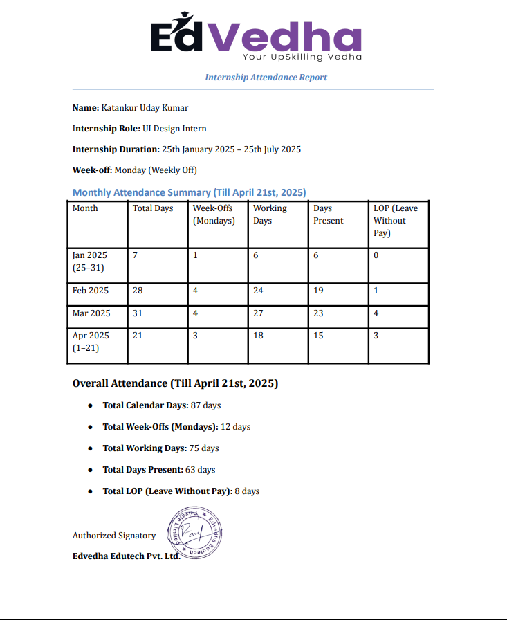

**Feedback Form**

