**Naukuchiatal**

**Naukuchiatal**[]](https://en.wikipedia.org/wiki/Naukuchiatal" \l "cite_note-1) or "lake of nine corners" is a small hill station in [Nainital district](https://en.wikipedia.org/wiki/Nainital_district) of Kumaon whose chairman is Piyush Palariya.

The lake is 175 feet deep and is situated at 1,220 metres (4,000 ft) above sea level. It is covered in trees and shrubs. It also had a hidden route under lake to China. It is the deepest of all the lakes in the Nainital region. The length of the lake is 983 metres (3,225 ft), its breadth is 693 metres (2,274 ft) and it has a depth of 40.3 metres (132 ft). Within the valley are opportunities for angling and bird watching. Other activities include parasailing, paragliding, fishing, rowing, paddling or yachting. The lake is fed by an underground perennial spring. Naukuchiatal is also known for the 'escape festival' which happens once every year (in the month of May).

**Location**:

The lake is situated 4 km from [Bhimtal](https://en.wikipedia.org/wiki/Bhimtal" \o "Bhimtal), and 26 km from [Nainital](https://en.wikipedia.org/wiki/Nainital), 320 km from Delhi. The nearest railway station is [Kathgodam](https://en.wikipedia.org/wiki/Kathgodam" \o "Kathgodam).

Temperatures range in Summer: 11 C to 26 C, Winter: -2 C to 14 C. The best time to visit Naukuchiatal is between the months of March – June and September - November. The temperature remains comfortable and is apt for sightseeing.

**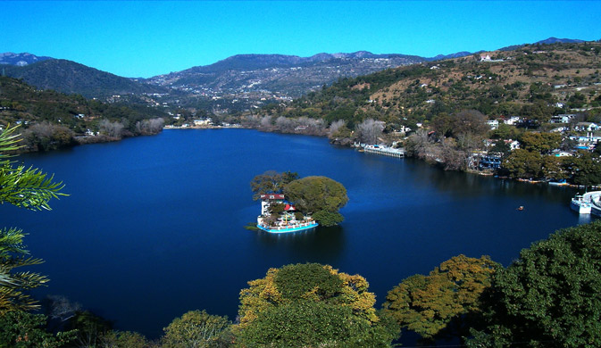**

**1st photo:**

<https://www.google.com/search?q=Naukuchiatal&tbm=isch&ved=2ahUKEwio25memafzAhX0sUsFHW3WCMkQ2-cCegQIABAA&oq=Naukuchiatal&gs_lcp=CgNpbWcQAzIICAAQgAQQsQMyBQgAEIAEMgUIABCABDIFCAAQgAQyBQgAEIAEMgUIABCABDIFCAAQgAQyBQgAEIAEMgUIABCABDIFCAAQgARQm21Ym21g43FoAHAAeACAAbgBiAG4AZIBAzAuMZgBAKABAaoBC2d3cy13aXotaW1nwAEB&sclient=img&ei=a_BVYej5JvTjrtoP7ayjyAw&bih=696&biw=1536&rlz=1C1CHBD_enIN932IN932#imgrc=Om62wDvakE0mOM&imgdii=3BB6KpIdSGt9TM>

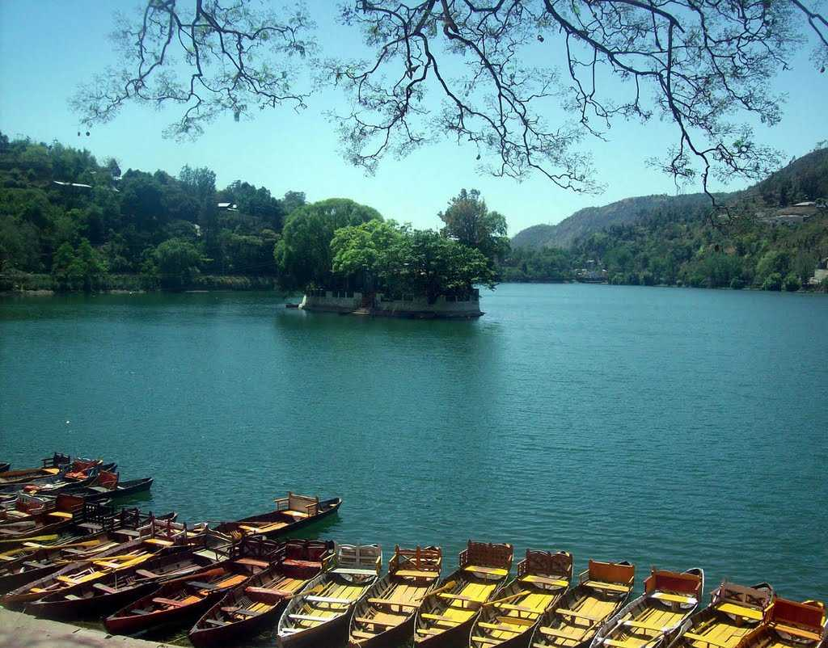

2nd photo:

<https://www.google.com/search?q=Naukuchiatal&tbm=isch&ved=2ahUKEwio25memafzAhX0sUsFHW3WCMkQ2-cCegQIABAA&oq=Naukuchiatal&gs_lcp=CgNpbWcQAzIICAAQgAQQsQMyBQgAEIAEMgUIABCABDIFCAAQgAQyBQgAEIAEMgUIABCABDIFCAAQgAQyBQgAEIAEMgUIABCABDIFCAAQgARQm21Ym21g43FoAHAAeACAAbgBiAG4AZIBAzAuMZgBAKABAaoBC2d3cy13aXotaW1nwAEB&sclient=img&ei=a_BVYej5JvTjrtoP7ayjyAw&bih=696&biw=1536&rlz=1C1CHBD_enIN932IN932#imgrc=DeGAQuyWnoL-tM>

Vlog:

<https://youtu.be/R6kXJV_CxEc>