**Yumesamdong**

Yumesamdong is a valley on the Lachung river about 15Kms ahead of Yumthang. The place is close to the Chinese border. Yumesamdong is an hour drive beyond Yumthang through the rugged mountain road (15300ft), an area where the sweet fragrance of Azalea permeates the air. Heady, invigorating and exhilarating, but words still to fail to explain the experience of being at Yumesamdong.

A forest rest house is the only permanent residence in the valley. During the spring months, the area blooms with rhododendrons, [primulas](https://en.wikipedia.org/wiki/Primula), [poppies](https://en.wikipedia.org/wiki/Poppy), [iris](https://en.wikipedia.org/wiki/Iris_(plant)) and other flora. During the summer months, villagers take their cattle to these heights to graze (a practice known as *[yaylag](https://en.wikipedia.org/wiki/Yaylag" \o "Yaylag) pastoralism*). In view of increasing number of tourists, there is possibility of [environmental degradation](https://en.wikipedia.org/wiki/Environmental_degradation) in near future.[[5]](https://en.wikipedia.org/wiki/Yumthang_Valley_of_Flowers#cite_note-5) Skiing is conducted in the valley.

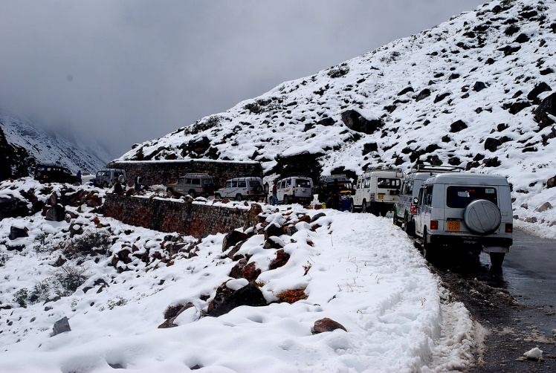

2nd photo:

<https://www.google.com/search?q=yumesamdong+valley+wikipedia&rlz=1C1CHBD_enIN932IN932&hl=en&sxsrf=AOaemvIRk7KbCkMz3raQ-vXFM5L6ZpiynQ:1633015763528&source=lnms&tbm=isch&sa=X&ved=2ahUKEwjO2fzjgafzAhXYXisKHQ_vC2cQ_AUoA3oECAEQBQ&cshid=1633016044805761&biw=1536&bih=696&dpr=1.25#imgrc=CB3j3vGHIpE51M>

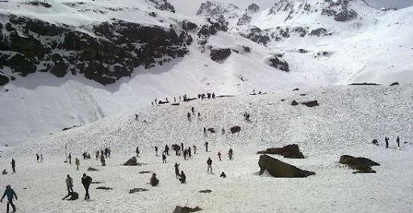

1st photo:

<https://www.google.com/search?q=Yumesamdong&rlz=1C1CHBD_enIN932IN932&sxsrf=AOaemvL_J-UvQVxvEOGzWOUY1pwmdCLz5Q:1633015134604&source=lnms&tbm=isch&sa=X&ved=2ahUKEwjNxIq4_6bzAhVBWX0KHZ3cCMcQ_AUoAXoECAEQAw&biw=1536&bih=696&dpr=1.25#imgrc=dCBZvCdUSjZB_M>

Vlog:

<https://youtu.be/88nm5B5Zprs>